[CPSC 473-01] Assignment 6

Van Nguyen

Uday Shah

4/10/2016

# Git Repository

Sad

# Miscellaneous

Homework is in folder HW5/Express

The version of Express used in the book does not match the most current version of Express (which I’m using). When I called the server I got the following error: Most middleware (like json) is no longer bundled with Express and must be installed separately. Please see <https://github.com/senchalabs/connect#middleware>. In order to resolve this, I had to add a package.json to download the appropriate dependencies and call the body-parser differently then used in the book.

To install the dependencies I typed: (calls package.json)

$npm install

## Calls to Curl

Call to curl (POST):

curl --silent --request POST --header "Content-Type: application/json" --data '{"call":"heads"}' "http://localhost:3000/flip" | python -m json.tool

Possible values of call:

1. heads
2. tails

Call to curl (DELETE):

curl –X DELETE “http://localhost:3000/stats”

# Redis Tutorial Screenshot

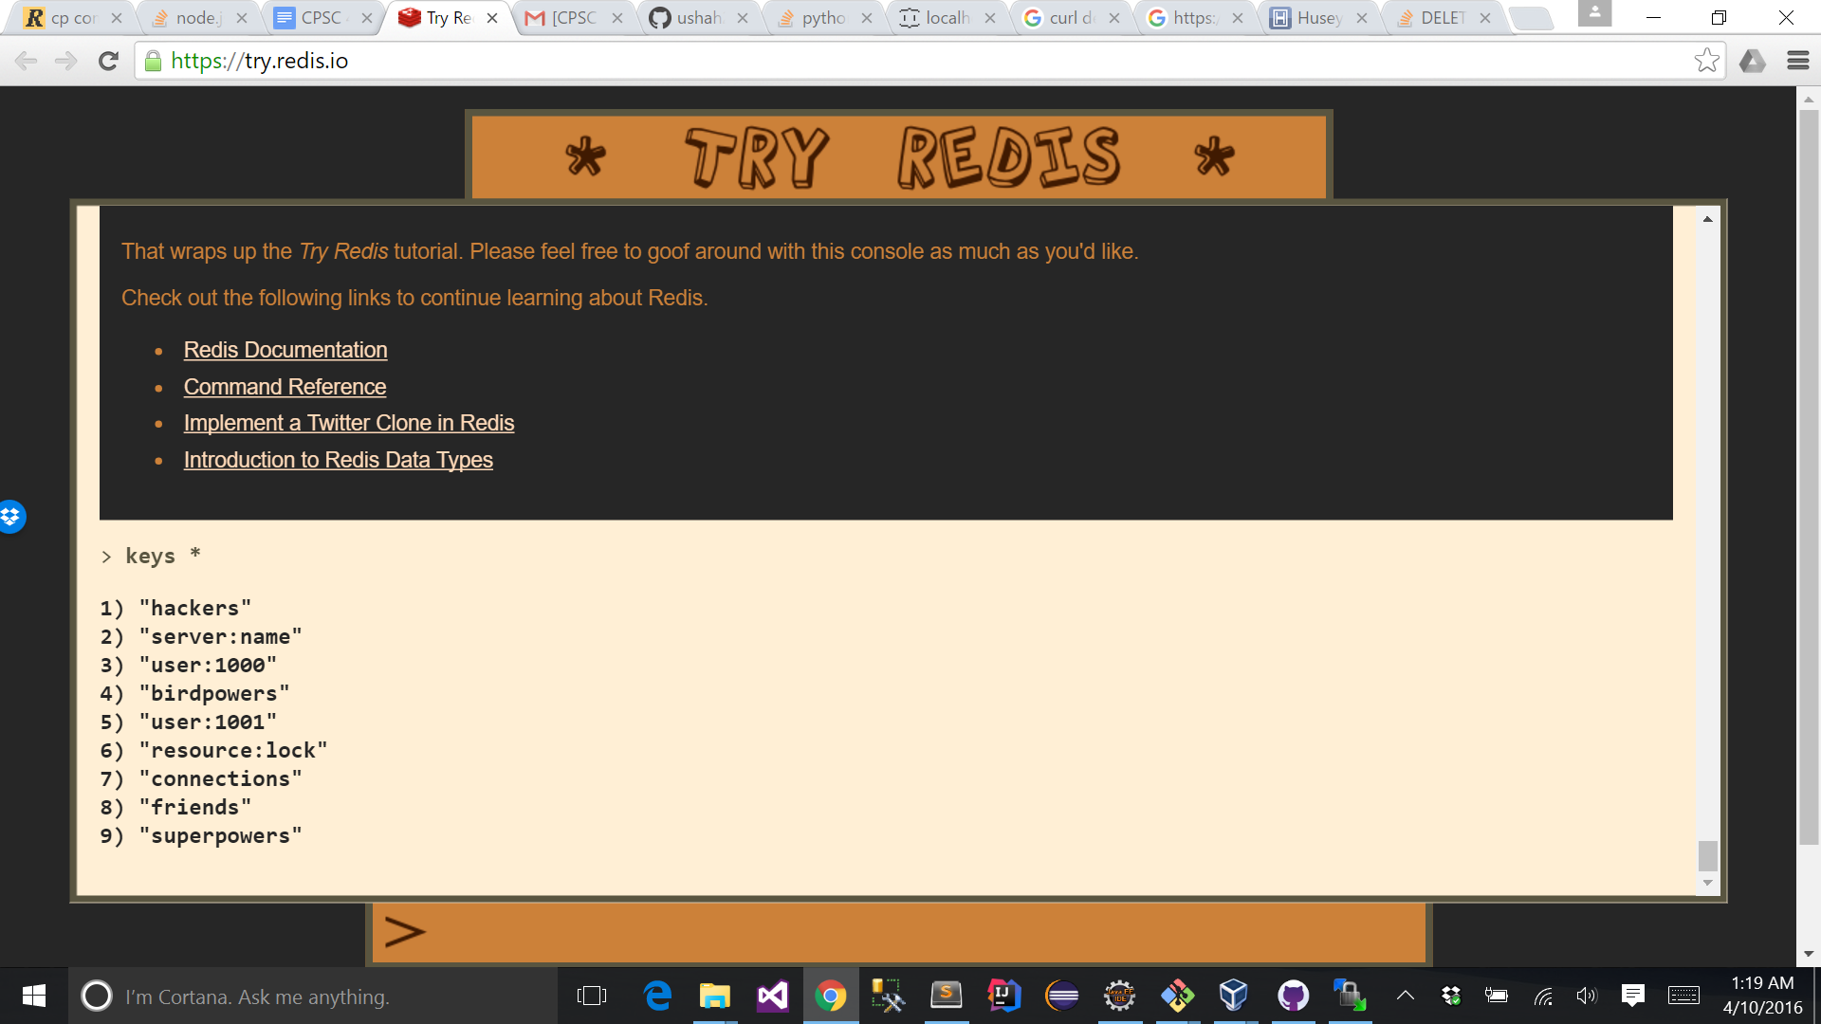

# API in Action

## Round 1

Call to Curl

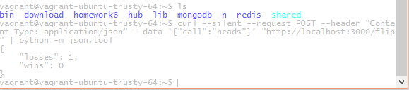

Console log

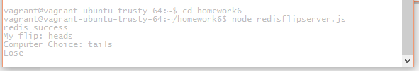

Client Side

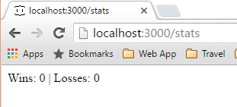

Database

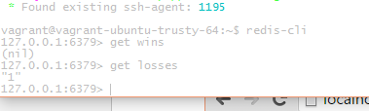

## Round a Bunch

Call to Curl

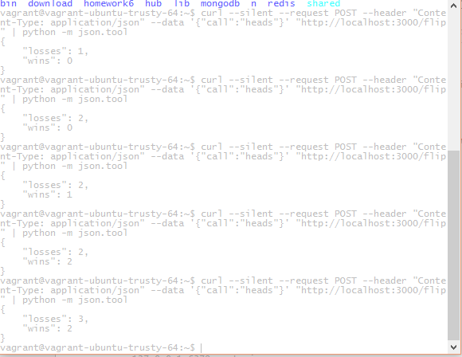

Console Log

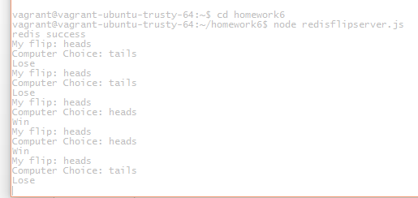

Client Side

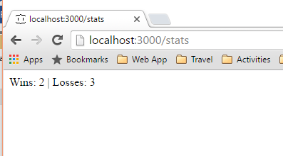

Database

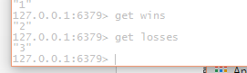

## Reset Redis

Call to Curl

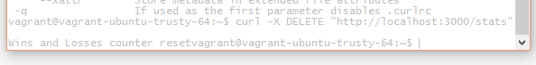

Database

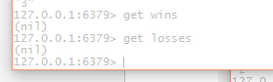

Client Side

