

CPSC 473 Project 2

MadLibs



May 2, 2016

Group Members

Van Nguyen

Indra Saputra

Sha Lu

David Hoxie

Jason M

# Project Description

This project creates a web application where one or more people can get together and play a MadLibs-type table top game.

# Project Github Link

https://github.com/indra411/T6CPSC473.git

# Instructions

1. Pull project files from Github
   1. Create a directory
   2. $git init
   3. $git pull <https://github.com/indra411/T6CPSC473.git> master
2. Load the project files to your vagrant box
3. Navigate to the folder
4. Install all of the dependencies
   1. npm install
5. Type in the command “foreman start”
   1. Will call a Procfile that will initialize everything for you.
6. Navigate to localhost:8000

# Caveats

1. The game is structured so that there always must be at least 1 player in the game
2. A player hosts a game but the true host is the server
3. True host references the entity that asks for input and outputs a completed story

# Functionality Walkthrough

## Home Page: index.html

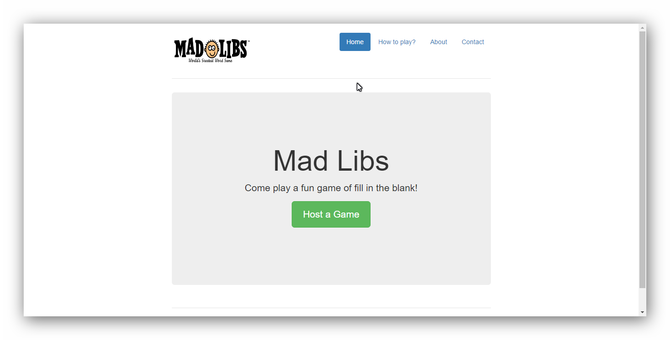

## Host View:

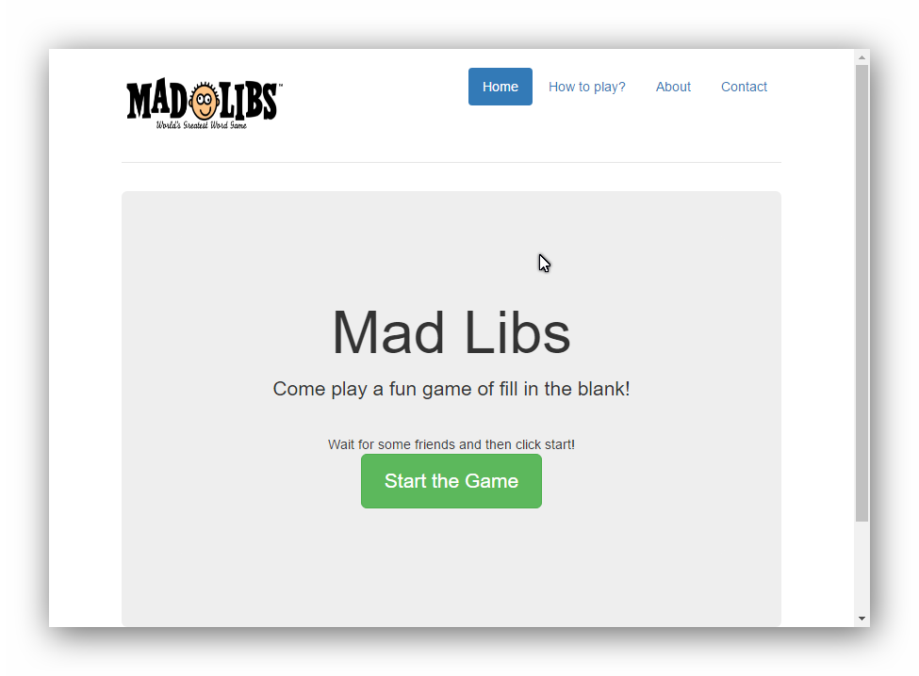

## Host View



## Player View

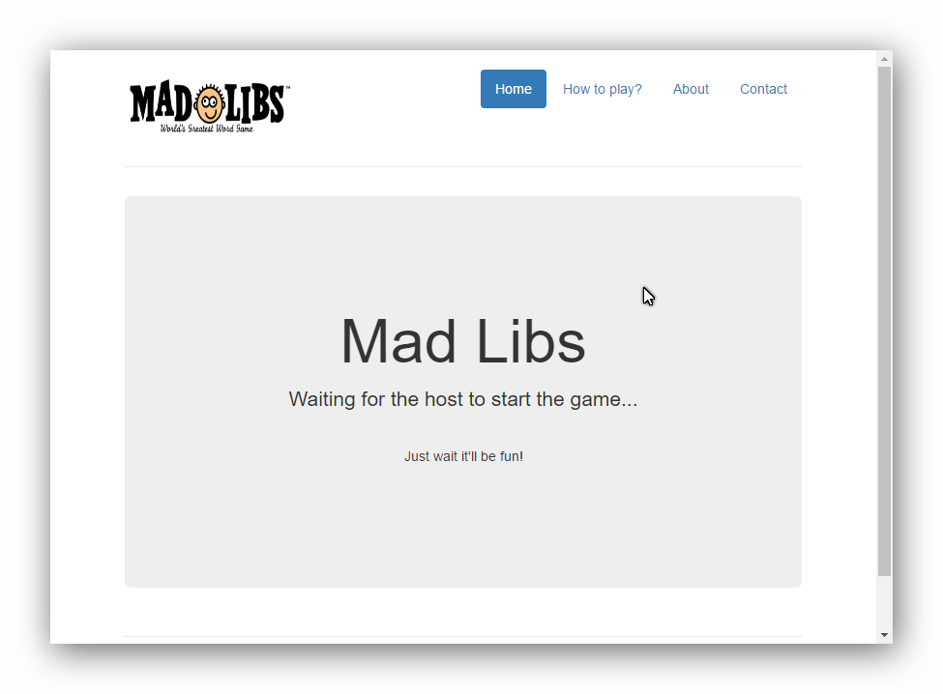

## Input Screen

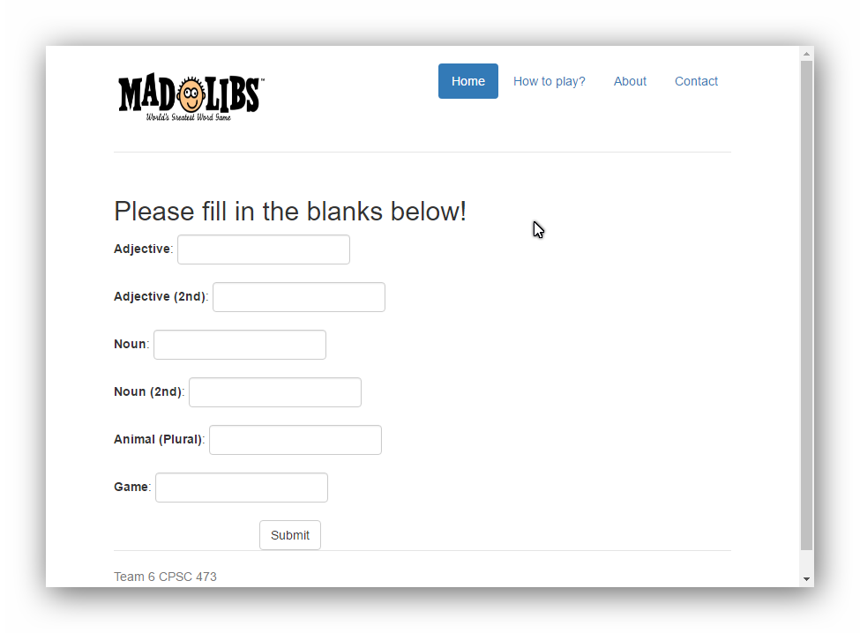

## Wait Screen

Once a user inputs their values, they must wait for all other players to finish inputting theirs.

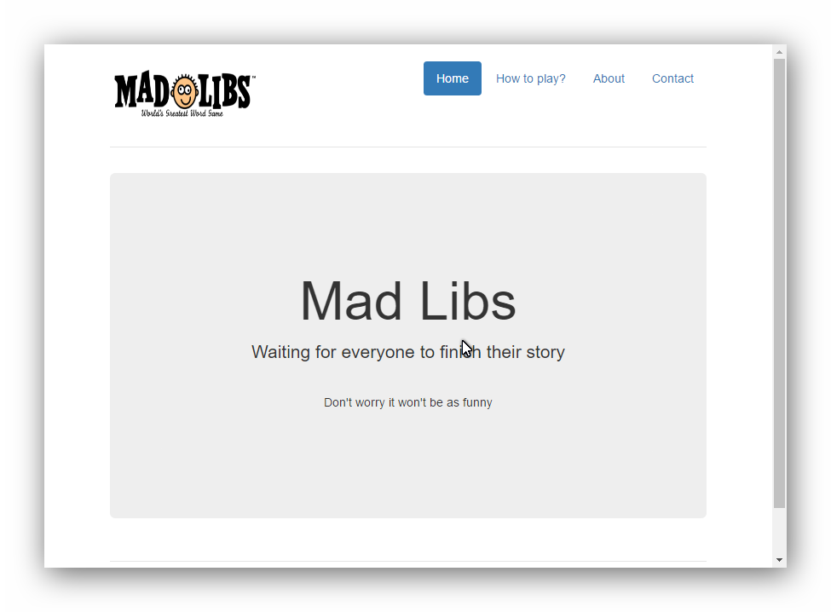

## Completed Stories

## 