**DAY-3 TASK**

Problem-1

Given an integer array nums, move all 0's to the end of it while maintaining the relative order of the non-zero elements.

**Note** that you must do this in-place without making a copy of the array.

**Example 1:**

**Input:** nums = [0,1,0,3,12]

**Output:** [1,3,12,0,0]

**Example 2:**

**Input:** nums = [0]

**Output:** [0]

**Constraints:**

* 1 <= nums.length <= 104
* -231 <= nums[i] <= 231 - 1

Problem-2

You have n coins and you want to build a staircase with these coins. The staircase consists of k rows where the ith row has exactly i coins. The last row of the staircase **may be** incomplete.

Given the integer n, return *the number of****complete rows****of the staircase you will build*.

**Example 1:**



**Input:** n = 5

**Output:** 2

**Explanation:** Because the 3rd row is incomplete, we return 2.

**Example 2:**

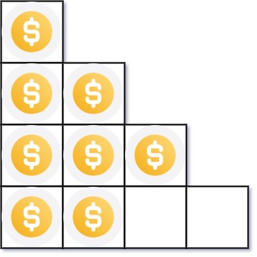

**Input:** n = 8

**Output:** 3

**Explanation:** Because the 4th row is incomplete, we return 3.

**Constraints:**

* 1 <= n <= 231 - 1