**DAY-5 TASK**

Problem-1

Given the root of a binary tree, *determine if it is a valid binary search tree (BST)*.

A **valid BST** is defined as follows:

* The left subtree of a node contains only nodes with keys **less than** the node's key.
* The right subtree of a node contains only nodes with keys **greater than** the node's key.
* Both the left and right subtrees must also be binary search trees.

**Example 1:**

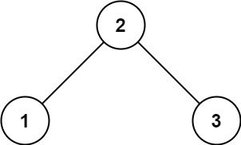

**Input:** root = [2,1,3]

**Output:** true

**Example 2:**

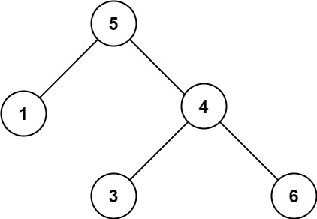

**Input:** root = [5,1,4,null,null,3,6]

**Output:** false

**Explanation:** The root node's value is 5 but its right child's value is 4.

**Constraints:**

* The number of nodes in the tree is in the range [1, 104].
* -231 <= Node.val <= 231 - 1

Problem-2

Given the roots of two binary trees p and q, write a function to check if they are the same or not.

Two binary trees are considered the same if they are structurally identical, and the nodes have the same value.

**Example 1:**

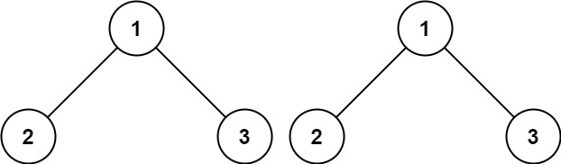

**Input:** p = [1,2,3], q = [1,2,3]

**Output:** true

**Example 2:**

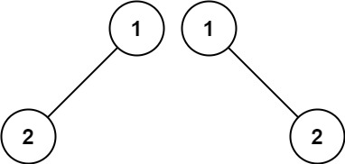

**Input:** p = [1,2], q = [1,null,2]

**Output:** false

**Example 3:**

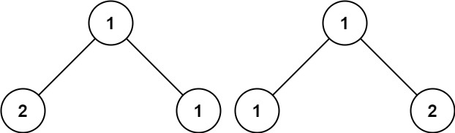

**Input:** p = [1,2,1], q = [1,1,2]

**Output:** false

**Constraints:**

* The number of nodes in both trees is in the range [0, 100].
* -104 <= Node.val <= 104