**Screen shots of tasks output**

**Task 1:**

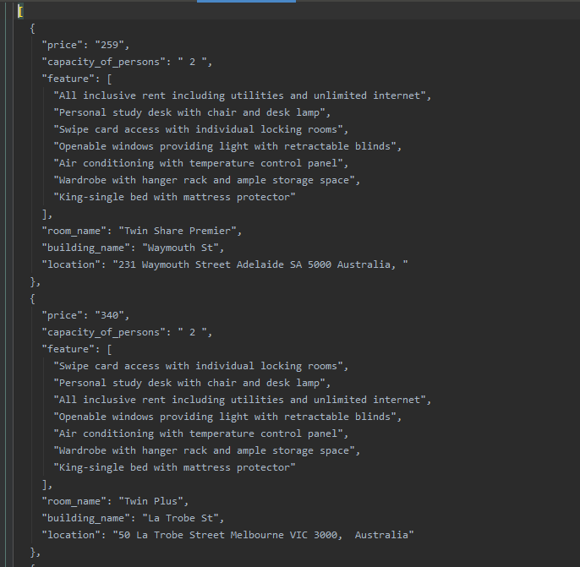

**Task 2:**

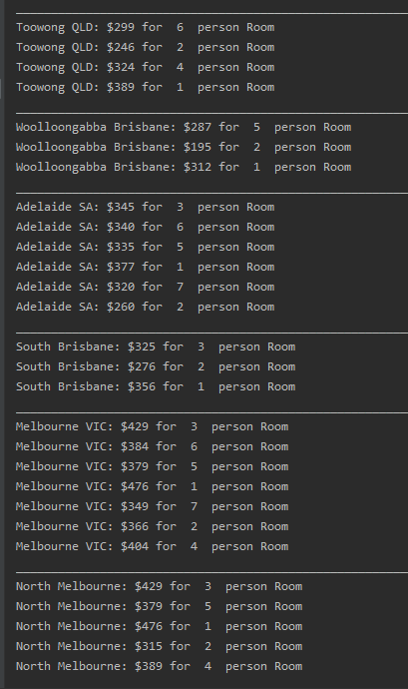

**Bonus Task:**

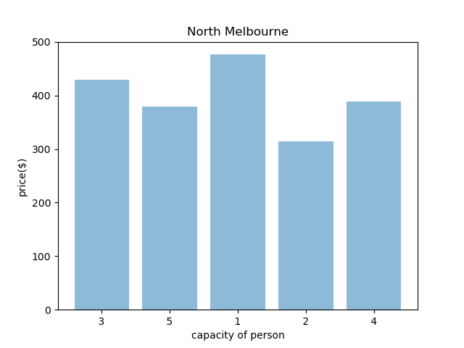

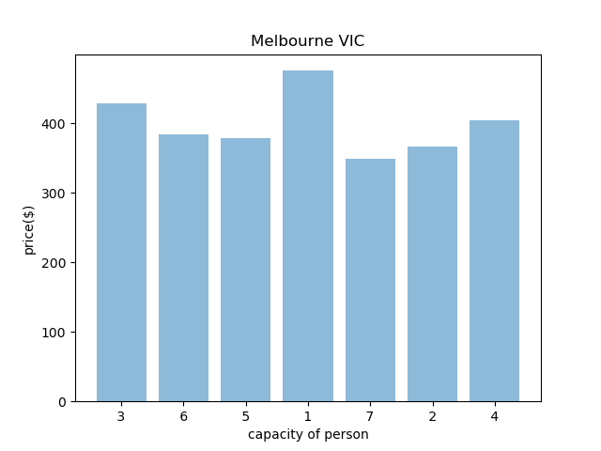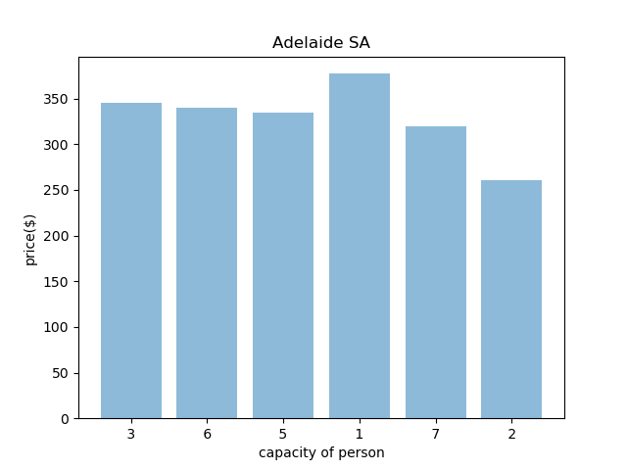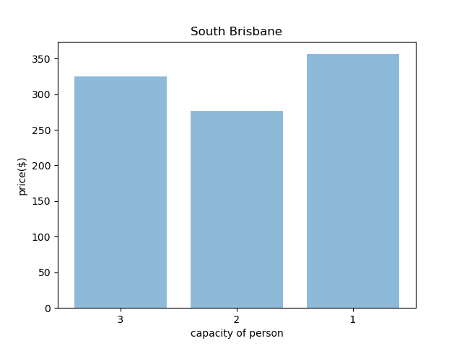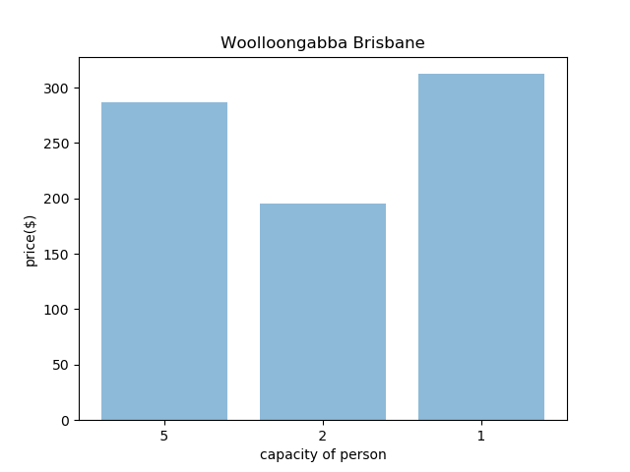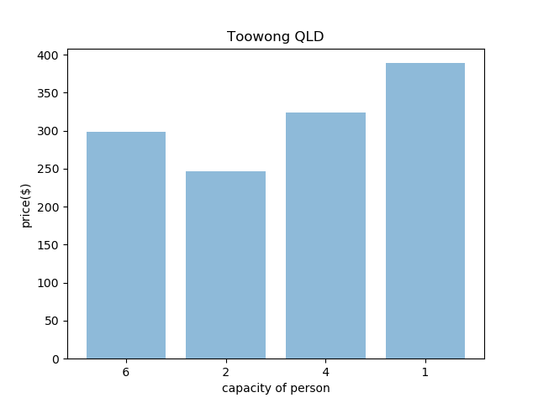

**Technology Stack:**

* I have used python 3.7.6 version to develop this python program. Because it is one of the latest version. Although, 3.8.1 is already released. But I deliberately used this. Because I want to make sure that the version I am using is compatible with commonly used third party packages.
* I used **pip** because it makes package installation easier.

Hours to Complete Task:

* It took my four days to complete this assignment

On Day 1: (6 Hours)

* Read Assignment and instruction carefully
* Learned virtual environment in python
* Python Syntax
* Python best practices
* Environment Setup

On Day 2: (8 Hours)

* Write some code for practice and understanding.
* Explore network requests and file handling in python
* Write code for assignment just to get an idea and for practice

On Day 3: (8 Hours)

* planed the structure of project
* implemented first task complete and second partially

On Day 4: (10 Hours)

* Completed task 2
* Completed bonus task
* Completed Document for assignment
* Submit Assignment

Total Hours Approximately: 32 Hours

Improvement Can Be made:

* I would add logs in my code and save them in a separate file. So that it keeps track of my program and I can inspect it. Currently, I removed all the print statements I used while development to make sure I am getting right data.
* I would use multithread to improve its performance. Because there are many network requests and I have added 3 second delay as per suggestion to avoid getting blocked by server.