大数据人工智能大作业

林灿源

**一、作业要求：**

1、在Kaggle网站上下载一份数据到本地，网址<https://www.kaggle.com/datasets>；

2、针对下载的数据，选择一个sklearn提供的回归算法进行回归模型训练和评估

3、使用模型对数据进行回归预测

4、将预测结果保存成csv文件，结果文件要同时提交到github上。

1. 在Kaggle网站上下载一份数据到本地，

名称：(Bike Sharing Demand)

源文件：test.csv与train.csv

结果生成文件：submission.csv

相关代码：select_model.py与result.py

1. 针对下载的数据，选择一个sklearn提供的回归算法进行回归模型训练和评估；

代码：select_model.py

导入包：

*import* numpy *as* np  
*import* pandas *as* pd  
*import* matplotlib.pyplot *as* plt  
*import* seaborn *as* sns  
*from* sklearn *import* model_selection  
*from* sklearn *import* svm  
*from* sklearn.ensemble *import* RandomForestRegressor

导入数据，划分数据集，处理数据：

f_train = pd.read_csv('C:/Users/lincanyuan/Downloads/Big-Data-Competition-Project/02_共享单车(Bike Sharing Demand)/input/train.csv',header = 0)  
  
df_train['month'] = pd.DatetimeIndex(df_train.datetime).month  
df_train['day'] = pd.DatetimeIndex(df_train.datetime).dayofweek  
df_train['hour'] = pd.DatetimeIndex(df_train.datetime).hour  
  
df_train = df_train.drop(['datetime','casual','registered'], axis = 1)  
df_train_target = df_train['count'].values  
df_train_data = df_train.drop(['count'],axis = 1).values

模型比较："支持向量回归与随机森林回归，最后选择随机森林回归

spliter = model_selection.ShuffleSplit(n_splits=3, test_size=0.2, random_state=0)  
  
  
print("支持向量回归/SVR(kernel='rbf',C=10,gamma=.001)")  
cv = spliter.split(df_train_data)  
*for* train, test *in* cv:  
 svc = svm.SVR(kernel='rbf', C=10, gamma=.001).fit(df_train_data[train], df_train_target[train])  
 print("train score: {0:.3f}, test score: {1:.3f}\n".format(  
 svc.score(df_train_data[train], df_train_target[train]), svc.score(df_train_data[test], df_train_target[test])))  
  
print("随机森林回归/Random Forest(n_estimators = 100)")  
cv = spliter.split(df_train_data)  
*for* train, test *in* cv:  
 svc = RandomForestRegressor(n_estimators=100).fit(df_train_data[train], df_train_target[train])  
 print("train score: {0:.3f}, test score: {1:.3f}\n".format(  
 svc.score(df_train_data[train], df_train_target[train]), svc.score(df_train_data[test], df_train_target[test])))

比较结果：最后选择随机森林回归

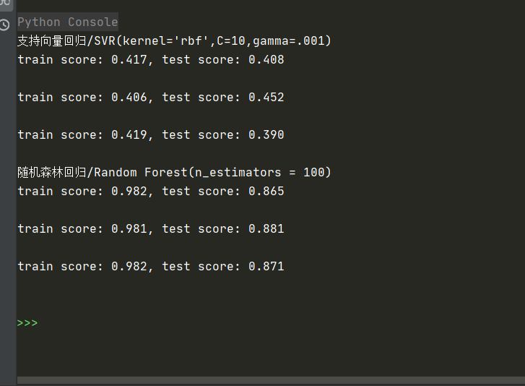

1. 使用模型对数据进行回归预测

代码：result.py

# 特征值处理

X_train_df['month'] = pd.DatetimeIndex(X_train_df.datetime).month

X_train_df['day'] = pd.DatetimeIndex(X_train_df.datetime).dayofweek

X_train_df['hour'] = pd.DatetimeIndex(X_train_df.datetime).hour

X_train_df = X_train_df.drop(['datetime'], axis=1) # axis=1意思为每行执行，axis=0表示每列执行

X_test_df['month'] = pd.DatetimeIndex(X_test_df.datetime).month

X_test_df['day'] = pd.DatetimeIndex(X_test_df.datetime).dayofweek

X_test_df['hour'] = pd.DatetimeIndex(X_test_df.datetime).hour

X_test_df = X_test_df.drop(['datetime'], axis=1)

# 采用DictVectorizer进行特征向量化

from sklearn.feature_extraction import DictVectorizer

dict_vec = DictVectorizer(sparse=False)

X_train_df = dict_vec.fit_transform(X_train_df.to_dict(orient='record'))

X_test_df = dict_vec.transform(X_test_df.to_dict(orient='record'))

# 使用RandomForestRegressor进行回归预测

# from sklearn.ensemble import GradientBoostingRegressor

from sklearn.ensemble import RandomForestRegressor

gbr = RandomForestRegressor()

gbr.fit(X_train_df, y_train_df)

gbr_y_predict = gbr.predict(X_test_df)

# 输出结果

gbr_submission = pd.DataFrame({'datetime': test_df['datetime'], 'count': gbr_y_predict})

gbr_submission.to_csv('submission.csv', index=False)

4、将预测结果保存成csv文件，结果文件要同时提交到github上。

生成结果：

