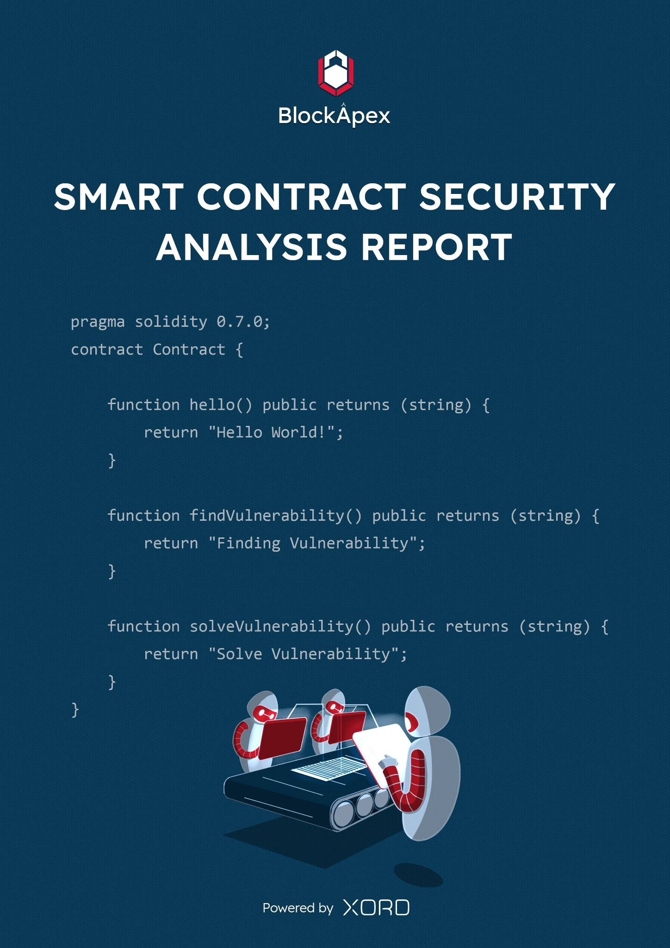

# PREFACE

## Objectives

The purpose of this document is to highlight the identified bugs/issues in the provided codebase. This audit has been conducted in a closed and secure environment, free from influence or bias of any sort. This document may contain confidential information about IT systems/architecture and intellectual property of the client. It also contains information about potential risks and the processes involved in mitigating/exploiting the risks mentioned below.

The usage of information provided in this report is limited, internally, to the client. However, this report can be disclosed publicly with the intention to aid our growing blockchain community; under the discretion of the client.

## Key Understandings

TABLE OF CONTENTS

**PREFACE** **2**

Objectives 2

Key understandings 2

**INTRODUCTION** **3**

Scope 4

Project Overview 5

System Architecture 6

Methodology & Scope 6

**AUDIT REPORT** **7**

Executive Summary 7

Findings 8

Critical-risk issues 9

High-risk issues 11

Medium-risk issues 14

Low-risk issues 14

Informatory issues and Optimization 14

**DISCLAIMER** **16**

# 

# 

# 

# INTRODUCTION

BlockApex (Auditor) was contracted by KaliCo LLC_ (Client) for the purpose of conducting a Smart Contract Audit/Code Review. This document presents the findings of our analysis which took place from 20th of December 2021 .

| Name |
| --- |
| LexDAO/KaliDAO |
| Auditor |
| Moazzam Arif | Kaif Ahmed |
| Platform |
| Ethereum/Solidity |
| Type of review |
| Manual code review / Behavioral testing |
| Methods |
| Architecture Review, Functional Testing, Computer-Aided Verification, Manual Review |
| Git repository |
| <https://github.com/lexDAO/Kali/tree/299a23a084b8f826f591b30725a3d8b512520ec7> |
| White paper/ Documentation |
| <https://github.com/lexDAO/Kali> |
| Document log |
| Initial Audit: 30th December 2021 *(complete)* |
| Final Audit: (*pending*) |

## Scope

The git-repository shared was checked for common code violations along with vulnerability-specific probing to detect[**major issues/vulnerabilities**](https://docs.google.com/document/d/1sEXMfjXRiqiEvnGKMUUoNvJ0pUMafy-7XsDEpP5_DJY/edit?usp=sharing). Some specific checks are as follows:

| **Code review** |  | **Functional review** |
| --- | --- | --- |
| Reentrancy | Unchecked external call | Business Logics Review |
| Ownership Takeover | ERC20 API violation | Functionality Checks |
| Timestamp Dependence | Unchecked math | Access Control & Authorization |
| Gas Limit and Loops | Unsafe type inference | Escrow manipulation |
| DoS with (Unexpected) Throw | Implicit visibility level | Token Supply manipulation |
| DoS with Block Gas Limit | Deployment Consistency | Asset’s integrity |
| Transaction-Ordering Dependence | Repository Consistency | User Balances manipulation |
| Style guide violation | Data Consistency | Kill-Switch Mechanism |
| Costly Loop | Complexity of code | Operation Trails & Event Generation |

## 

## Project Overview

Kali is a protocol for on-chain organizations inspired by [Compound](https://compound.finance/) and [Moloch DAO](https://www.molochdao.com/) Governance. Kali *proposals* are broken into a variety of types, such that each variance can have their own Governance settings, such as simple/super majority and Quorum requirements.

## System Architecture

**KaliDAO.sol**

KaliDAO is a Comp-style governance into a single contract, it supports extensions to add contracts as apps, for example *crowdsale* and *redemption* contracts.

Kali supports hashing and amending docs from deployment and through proposals, providing a hook to wrap organizations into legal templates to rationalize membership rules and liabilities.

**KaliDAOtoken.sol**

KaliDAOtoken represent voting stakes, and can be launched as transferable or non-transferable, with such settings being updateable via PAUSE proposal. Voting weight can also be delegated, and such weight automatically updates upon token transfers from delegators, incorporating functionality from Comp-style tokens.

## Methodology & Scope

**Audit log**

In the first two days, we developed a deeper understanding of the DAO and its workings. We started by reviewing the two main contracts against common solidity flaws. After the reconnaissance phase we wrote unit-test cases to ensure that the functions are performing their intended behavior. Then we began with the line-by-line manual code review.

# AUDIT REPORT

## Executive Summary

The analysis indicates that some of the functionalities in the contracts audited are **working properly.**

Our team performed a technique called “Filtered Audit”, where the contract was separately audited by two individuals. After their thorough and rigorous process of manual testing, an automated review was carried out using Mythril, MythX and Slither. All the flags raised were manually reviewed and re-tested.

**Our team found:** 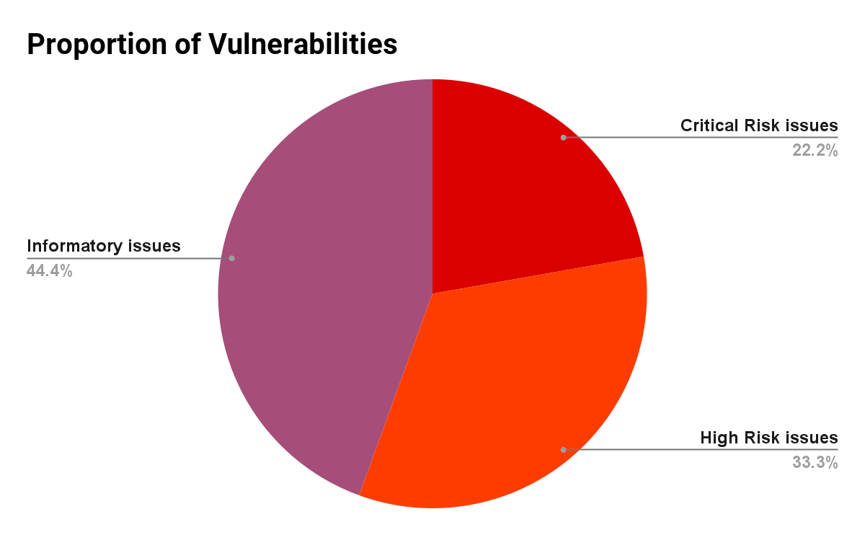

| # of issues | Severity of the risk |
| --- | --- |
| 2 | Critical Risk issue(s) |
| 3 | High Risk issue(s) |
| 0 | Medium Risk issue(s) |
| 0 | Low Risk issue(s) |
| 4 | Informatory issue(s) |

## 

## Findings

|  | Findings | Risk | Status |
| --- | --- | --- | --- |
| 1. | “Arbitrary call” proposals can lead to unauthorized transfers | **Critical-risk** | **Acknowledged** |
| 2. | New “Proposals” should not be processed before processing previous “Proposals” | **Critical-risk** | **Resolved** |
| 3. | A “SUPERMAJORITY” proposal can be triggered without casting any votes | **High-risk** | **Resolved** |
| 4. | Whitelisting can be bypassed in extension | **High-risk** | **Acknowledged** |
| 5. | Any malicious user can withdraw “purchaseTokens” and drain the whole contract | **High-risk** | **Resolved** |
| 6. | Upper and lower bound on Governance params. | Informatory issues | **Acknowledged** |
| 7. | “Pause” proposal should escape previous proposals | Informatory issues | **Acknowledged** |
| 8. | Bad error on proposal: “PROCESSED” for non-existent proposals | Informatory issues | **Acknowledged** |
| 9. | Bad error on voting: “VOTING_ENDED” for non-existent proposals. | Informatory issues | **Acknowledged** |

## 

### 

### Critical-risk issues

1. **“Arbitrary call” proposals can lead to unauthorized transfers**

Contract : [KaliDAO.sol](https://github.com/lexDAO/Kali/blob/main/contracts/KaliDAO.sol)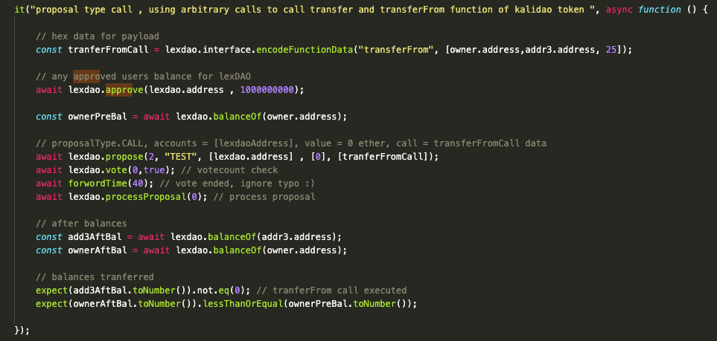

**Exploit Scenario:**

Any malicious user can submit the *proposal type* call, vote type simple *majority* and payload has a *transferFrom* transactions as we created payload on above test. Attackers can transfer any amount from any user if the user has approved his funds to the LexDao contract.

**Remedy:**

1. BlackList specific account addresses and calls.
2. Implement validation of transaction data. (this might create centralization)

**Developer's Response:**

“We believe this issue is avoided by discouraging users from approving token pulls to the `KaliDAO.sol` contract. Instead, payments to DAOs will be through direct transfers or by the use of extension contracts which are authorized to make such token pulls. It is our preference to avoid limiting the kinds of calls that can be made through these kinds of proposals or adding centralization factors”

**Auditor's Response:**

Status : Acknowledged.

1. **New “Proposals” should not be processed before processing previous Proposals**

Contract : [KaliDAO.sol](https://github.com/lexDAO/Kali/blob/main/contracts/KaliDAO.sol)  
Function : *processProposal()*

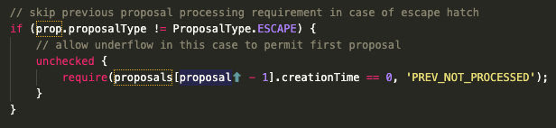

**Exploit Scenario:**   
As stated in the piece of code mentioned above, it is very clear that if any previous *proposal* is pending*,* no new proposal will be processed. However, this check can be easily by-passed if a non-member adds a *proposal* and then *sponsorProposal* is called after that. This way, a new proposal will be processed.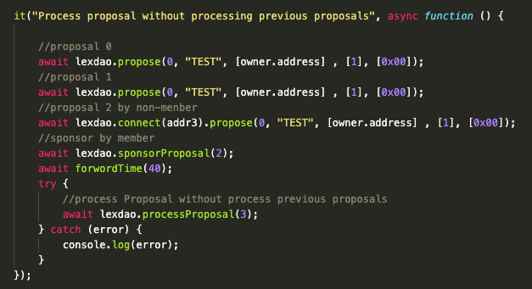

**Remedy:**   
 Do not create a “new” proposal when *sponsorProposal()* is called.

**Developer's Response:**

“We have made a fix by tracking a new global state variable, *currentSponsoredProposal* and updating it upon every sponsored proposal. This value gets appended to the *Proposal* struct and is checked on processing, like so:

*if (proposals[prop.prevProposal].creationTime != 0) revert PrevNotProcessed();*

**Auditor's Response:**

​​Status : Resolved.

### 

### High-risk issues

1. **A “SUPERMAJORITY” proposal can be triggered without casting any votes**

Contract : [KaliDAO.sol](https://github.com/lexDAO/Kali/blob/main/contracts/KaliDAO.sol)

Function : *_countVotes()***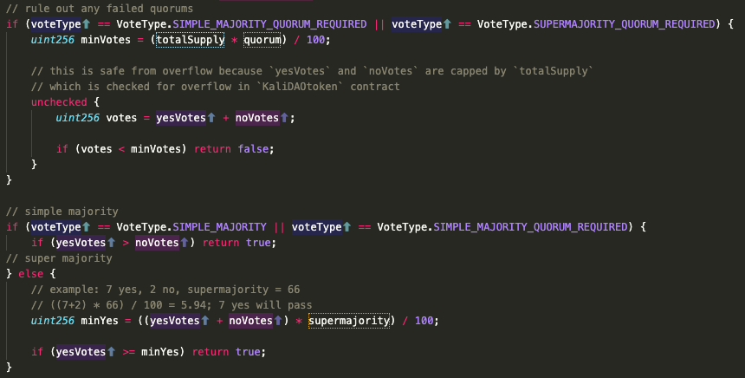Exploit Scenario:**   
Let's consider the code above; The *else()* statement : if *yesVotes* and *noVotes* are zero and *supermajority* is set to 66, the resulting *minYes* will ultimately be zero as well. Now let’s see the last *if()*  inside the *else( )* condition. Both yesVotes and minYes are zero, so the condition will return *true*. If any malicious user adds a proposal of **mint/burn,** they just have to wait to process the proposal because that proposal does not need any votes.

**Remedy:**   
Remove the equality sign and ensure that the voting period is long enough so that the users are able to vote on every proposal. This will make sure that the *yesVotes* required to process a proposal is greater than 0 and can get votes from other users as well.

**Developer's Response:**

We have a made a fix to this issue by putting in a return check at the top of the “_countVotes” internal function that fails a proposal if nobody participated, like so:

“if (yesVotes == 0 && noVotes == 0)”

return false;

**Auditor's Response:**

Status : ​​Resolved.

1. **Whitelisting can be bypassed in extension**

Contract : [KaliDAOcrowdsale.sol](https://github.com/lexDAO/Kali/blob/main/contracts/extensions/crowdsale/KaliDAOcrowdsale.sol)

**Exploit Scenario:**

User can bypass the whitelisting check by providing *listId* “0”.  
(*Note: This might be a false assumption because we didn't properly recon the latest codebase at this point)*

**Remedy:**

A contract should have proper checks that restrict users to set extension with “0” *listId*.

**Developer's Response:**

In the crowdsale extension contract, we purposefully allow users to set a null value for whitelist ID in order to allow for unrestricted token sales.

**Auditor's Response:**

Status : Acknowledged.

1. **Any malicious user can withdraw “purchaseToken” and drain the whole contract**

Contract : [KaliDAOcrowdsale.sol](https://github.com/lexDAO/Kali/blob/main/contracts/extensions/crowdsale/KaliDAOcrowdsale.sol)

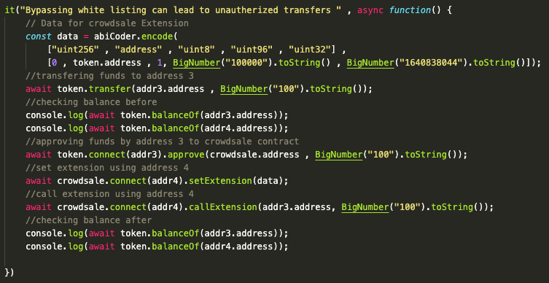

**Exploit Scenario:**

Consider that a user can set an extension using the *listId* “0” (the check which can be easily bypassed). Now if any user has approved their funds to the crowdsale contract, any malicious user can simply call the *setExtension()* using the token address in his data and then call *callExtension()* using address 3 (used in the example above) in the parameters which will ultimately withdraw all the funds user have approved to the crowdsale contract.

**Remedy:**   
Whitelisting should be handled properly like funds should be transferred to a whitelisted address instead of *msg.sender*.

**Developer's Response:**

Resolved the issue by limiting users to call the extension directly from crowdsale and deducting amounts form *msg.sender* instead of any address.

**Auditor's Response:**

Status : Resolved.

### 

### Medium-risk issues

No medium-risk issues were found.

### Low-risk issues

No low-risk issues were found.

### Informatory issues and Optimization

1. **Upper and lower bound on Governance params**

Contract : [KaliDAO.sol](https://github.com/lexDAO/Kali/blob/main/contracts/KaliDAO.sol)

**Description :***init* function has proper upper and lower bounds but if the user set values by Governance, it has no lower and upper bound check. Unchecked math assumes these bounds.

**Remedy:**   
A proper upper and lower bounds check should be placed while changing values by Governance.

**Developer's Response:**

We provide reversion checks on governance params in the “propose()” function to ensure that proposals to amend “votingPeriod”, “quorum”, “supermajority” and proposal types are kept within expected bounds.

**Auditor's Response:**

Status : Acknowledged.

1. **“Pause” proposal should escape previous proposals**

Contract : [KaliDAO.sol](https://github.com/lexDAO/Kali/blob/main/contracts/KaliDAO.sol)

**Description :**To pause the contract, a proposal is submitted. Most of the time a *pause* is needed in emergencies. To timely execute a *pause* proposal it should not wait for previous proposals. (We have seen mishaps with $COMP in the past, where their proposal to fallback takes days).

**Remedy:**There should be a check in *processProposal()* that if the proposal type is “*pause*” it can execute right away.

**Developer's Response:**

It is our preference to maintain a voting period for PAUSE proposal types in order to accommodate the use case of gradual decentralization by some DAOs. For example, there are non-emergency situations where a DAO might deploy with a closed founder group, grow its membership through proposals, but then want to vote and reach consensus on making membership tokens transferable, and therefore, open to the public.

**Auditor's Response:**

​​Fair point! If there are any emergency checks, that should not wait for voting.

1. **Bad error on proposal: “PROCESSED” for non-existent proposals**

Contract : [KaliDAO.sol](https://github.com/lexDAO/Kali/blob/main/contracts/KaliDAO.sol)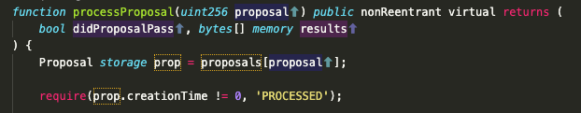

**Description:**If a user tries to process a non-existent proposal, the above code won’t let him process because proposal creation time is 0 but the user will get the “*PROCESSED*” error. This should be handled properly by separately checking if the proposal actually exists or not.

**Remedy:** “Proposal does not exist” should be displayed by adding a check using *require*.

**Developer's Response:**

* We have provided a clarified reversion message, “Processed()” -> “NotCurrentProposal()”.
* We otherwise would like to avoid additional checks to optimize for gas efficiency.

**Auditor's Response:**

Status : Acknowledged.

1. **Bad error on voting: “VOTING_ENDED” for non-existent proposals**

Contract : [KaliDAO.sol](https://github.com/lexDAO/Kali/blob/main/contracts/KaliDAO.sol)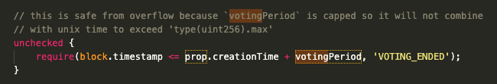

**Description:**If a user tries to vote on a non-existent proposal, the above code won't let him vote because proposal *creationTime* + *votingPeriod* will be less than *block.timestamp* but the user will get “*VOTING_ENDED*” error. This should be handled properly by separately checking if the proposal actually exists or not.

**Remedy:**“Proposal does not exist” should be displayed by adding a check using *require*.

**Developer's Response:**

* We have provided a clarified reversion message, “VotingEnded()” -> “NotVoteable()”.
* We otherwise would like to avoid additional checks to optimize for gas efficiency.

**Auditor's Response:**

Status : Acknowledged.

# DISCLAIMER

The smart contracts provided by the client for audit purposes have been thoroughly analyzed in compliance with the global best practices till date w.r.t cybersecurity vulnerabilities and issues in smart contract code, the details of which are enclosed in this report.

This report is not an endorsement or indictment of the project or team, and they do not in any way guarantee the security of the particular object in context. This report is not considered, and should not be interpreted as an influence, on the potential economics of the token, its sale or any other aspect of the project.

Crypto assets/tokens are results of the emerging blockchain technology in the domain of decentralized finance and they carry with them high levels of technical risk and uncertainty. No report provides any warranty or representation to any third-Party in any respect, including regarding the bug-free nature of code, the business model or proprietors of any such business model, and the legal compliance of any such business. No third-party should rely on the reports in any way, including for the purpose of making any decisions to buy or sell any token, product, service or other asset. Specifically, for the avoidance of doubt, this report does not constitute investment advice, is not intended to be relied upon as investment advice, is not an endorsement of this project or team, and it is not a guarantee as to the absolute security of the project.

Smart contracts are deployed and executed on a blockchain. The platform, its programming language, and other software related to the smart contract can have its vulnerabilities that can lead to hacks. The scope of our review is limited to a review of the Solidity code and only the Solidity code we note as being within the scope of our review within this report. The Solidity language itself remains under development and is subject to unknown risks and flaws. The review does not extend to the compiler layer, or any other areas beyond Solidity that could present security risks.

This audit cannot be considered as a sufficient assessment regarding the utility and safety of the code, bug-free status or any other statements of the contract. While we have done our best in conducting the analysis and producing this report, it is important to note that you should not rely on this report only - we recommend proceeding with several independent audits and a public bug bounty program to ensure security of smart contracts.