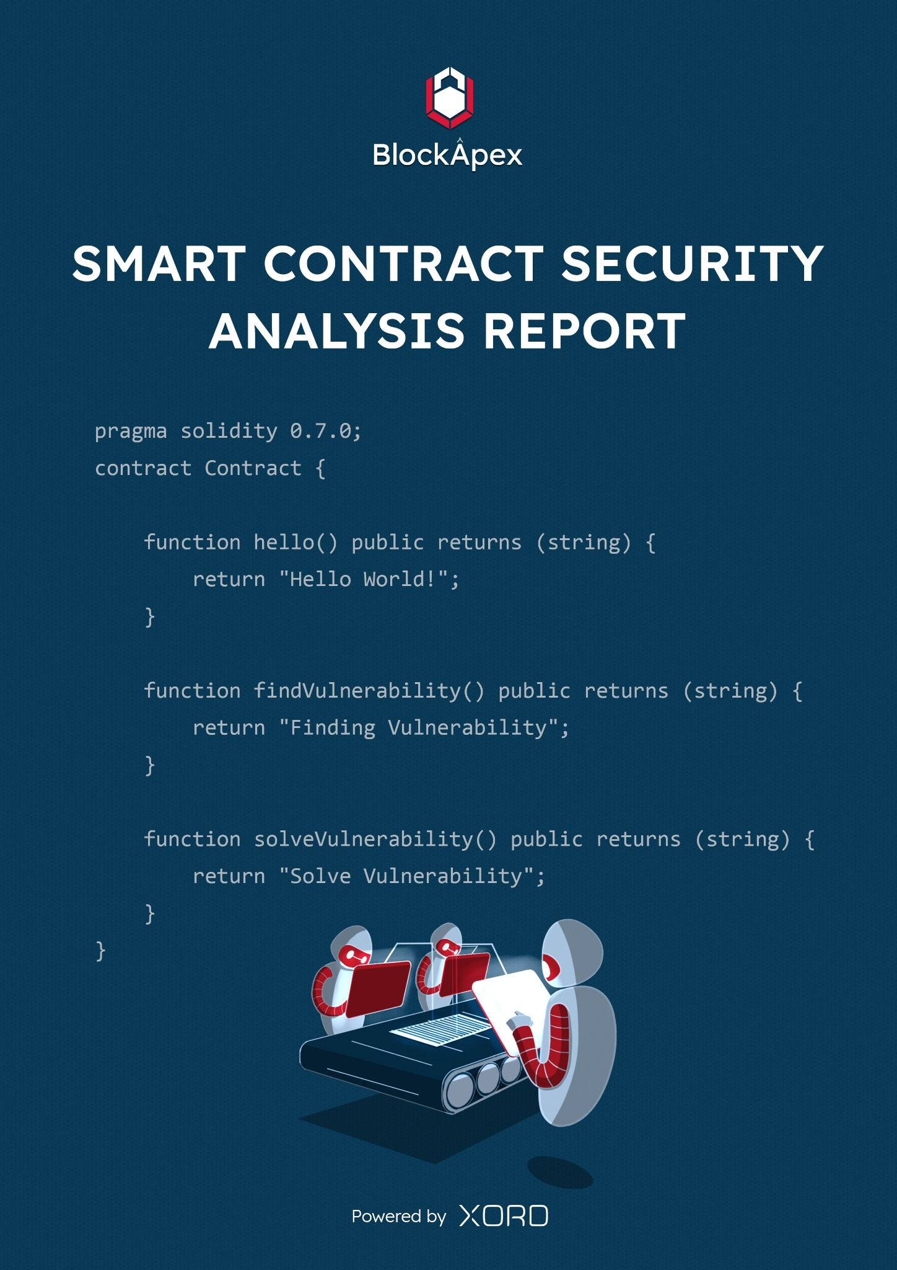

# PREFACE

## Objectives

The purpose of this document is to highlight the identified bugs/issues in the provided codebase. This audit has been conducted in a closed and secure environment, free from influence or bias of any sort. This document may contain confidential information about IT systems/architecture and intellectual property of the client. It also contains information about potential risks and the processes involved in mitigating/exploiting the risks mentioned below.

The usage of information provided in this report is limited, internally, to the client. However, this report can be disclosed publicly with the intention to aid our growing blockchain community; under the discretion of the client.

## Key understandings

# 

**Table of Contents**

**PREFACE** **2**

Objectives 2

Key understandings 2

**INTRODUCTION** **4**

Scope 5

Project Overview 6

System Architecture 6

Manual Review 7

Test Cases 7

**AUDIT REPORT** **8**

Executive Summary 8

Findings 9

Critical-risk issues 9

Issue #1 9

Issue #2 10

High-risk issues 11

Medium-risk issues 12

Issue #1 12

Low-risk issues 13

Informatory issues 13

**DISCLAIMER** **14**

# 

# INTRODUCTION

BlockApex (Auditor) was contracted by Unipilot (Client) for the purpose of conducting a Smart Contract Audit/Code Review. This document presents the findings of our analysis which took place on __13th August 2021_.

| Name |
| --- |
| Unipilot Index Fund |
| Auditor |
| Moazzam Arif | Kaif Ahmed |
| Platform |
| Ethereum/Solidity |
| Type of review |
| Index Fund |
| Methods |
| Architecture Review, Functional Testing, Computer-Aided Verification, Manual Review |
| Git repository |
| <https://github.com/VoirStudio/unipilot-index-fund-contract/tree/66a3655c152c2c3f2cbab1aa35712972ee086453> |
| White paper/ Documentation |
| No white paper was provided |
| Document log |
| Initial Audit: 12-08-2021 |
| Final Audit: 13-08-2021 |

## Scope

The git-repository shared was checked for common code violations along with vulnerability-specific probing to detect major issues/vulnerabilities. Some specific checks are as follows:

| **Code review** |  | **Functional review** |
| --- | --- | --- |
| Reentrancy | Unchecked external call | Business Logics Review |
| Ownership Takeover | ERC20 API violation | Functionality Checks |
| Timestamp Dependence | Unchecked math | Access Control & Authorization |
| Gas Limit and Loops | Unsafe type inference | Escrow manipulation |
| DoS with (Unexpected) Throw | Implicit visibility level | Token Supply manipulation |
| DoS with Block Gas Limit | Deployment Consistency | Asset’s integrity |
| Transaction-Ordering Dependence | Repository Consistency | User Balances manipulation |
| Style guide violation | Data Consistency | Kill-Switch Mechanism |
| Costly Loop |  | Operation Trails & Event Generation |

## Project Overview

Index Fund serves as a repository for the fees earned by the Unipilot protocol, its primary purpose is to underpin the value of the $PILOT token.

## System Architecture

* No System Architecture Diagram was provided *

There is a single smart contract for managing Index Fund. The main functionality of this smart contract is to enable withdrawal of different tokens by burning $PILOT.

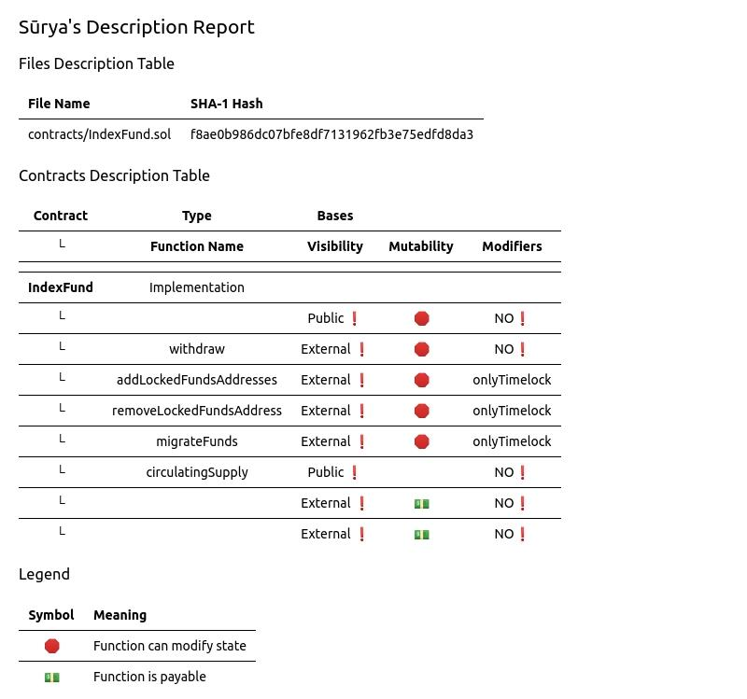

## Manual Review

The smart contract code is very straightforward. The errors reported by slither were verified manually. We also found some coding style issues and gas optimization suggestions, given in the description below.

## Test Cases

The test cases provided by the Unipilot’s dev team were too basic to adequately verify the functionality of the index fund code. The test cases can be found [here](https://github.com/VoirStudio/unipilot-index-fund-contract/tree/66a3655c152c2c3f2cbab1aa35712972ee086453/test).  
We have written our own [test cases](https://github.com/BlockApex/bqa/blob/master/unipilot-index-fund-contract/test/PilotTest.js) to verify the intended behaviour. Following are the [results](https://docs.google.com/spreadsheets/d/196ebGyGalGFQXmfUqlRU2pMIneMfVnN2MqimzJZWkhQ/edit) of the test cases.

## 

# AUDIT REPORT

## Executive Summary

The analysis indicates that the contracts audited are **well-secured.**

Our team performed a technique called “Filtered Audit”, where the contract was separately audited by two individuals. After their thorough and rigorous process of manual testing, an automated review was carried out using Mythril, MythX and Slither. All the flags raised were manually reviewed and re-tested.

**Our team found:** 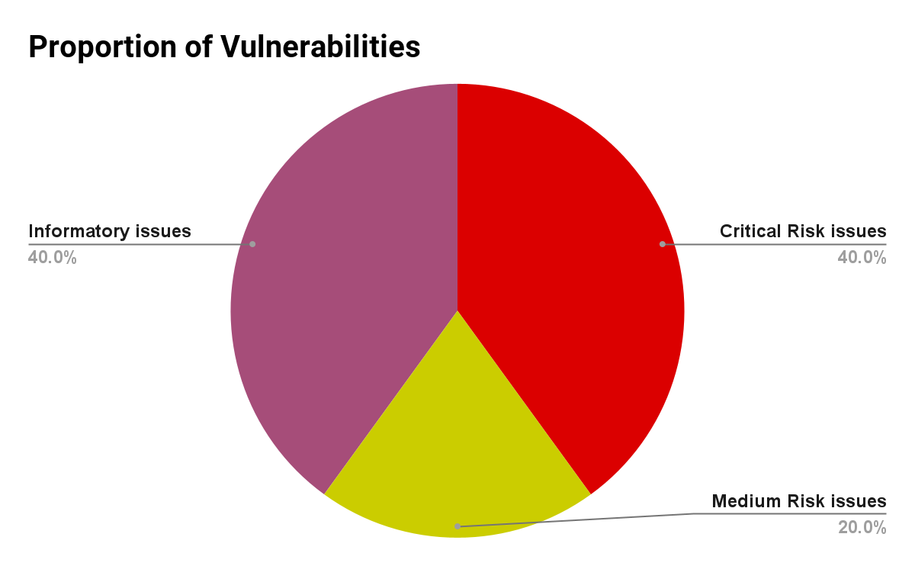

| # of issues | Severity of the risk |
| --- | --- |
| 2 | Critical Risk issue(s) |
| 0 | High Risk issue(s) |
| 1 | Medium Risk issue(s) |
| 0 | Low Risk issue(s) |
| 2 | Informatory issue(s) |

## Findings

### Critical-risk issues

#### Issue #1

The withdraw function accepts an array of token addresses and an amount of $PILOT. The function will loop on tokens array and transfer the tokens proportionally(amonut_of_$PILOT/circulating_supply_$PILOT * token_balance_of_index_fund). In essence, if **index_fund** has 1000 $USDT and 1000 $USDC and the user holds 10% of $PILOT supply he/she will be entitled to 10% of both tokens(USDT and USDC). But this function can be exploited to deplete all the funds from **index_fund**.  
**Attack Scenario:**User XXX holds 20% of $PILOT and calls the withdraw function by passing the same token address multiple times. The user will be able to get more than 20%.

1. const test = await IndexFundContract.withdraw( [contractUsdt.address,contractUsdt.address,contractUsdt.address,contractUsdt.address,contractUni.address],web3.utils.toWei('2000000'))

**Remedy:**Duplicate addresses shouldn’t be allowed in token arrays or If token[i] is already transferred, do not transfer if you encounter the token[i] has already been transferred.  
**Dev Response:**They acknowledged it and have implemented the correct logic. The new logic has been verified in the [latest commit](https://github.com/VoirStudio/unipilot-index-fund-contract/blob/dc3e5bea300204548702a61d77188a8b90883e01/contracts/IndexFund.sol#L46).

#### Issue #2

The migrateFunds function is supposed to migrate funds to the new version of the contract. This function is protected by timeLock, but this function fails on transferring the funds. It uses the safeTransferFrom function while transferring the funds to the new version. safeTransferFrom needs approval before transferring the function even if the sender is the owner of tokens. We tested that with some major tokens like $USDT and $LINK (it fails).  
**Remedy:**Use safeTransfer of SafeERC20 instead of safeTransferFrom.

**Dev Response:**They have acknowledged it and applied the [fix](https://github.com/VoirStudio/unipilot-index-fund-contract/blob/dc3e5bea300204548702a61d77188a8b90883e01/contracts/IndexFund.sol#L79).

### 

### High-risk issues

No High-Risk issues were found.

### 

### Medium-risk issues

#### Issue #1

We raised a concern related to user Experience that if the **index_fund** has no balance of any token passed in the token addresses array while calling the withdraw function. The **index_fund** simply burns $PILOT.   
**Dev Response:**They appreciated the suggestion and added a [check](https://github.com/VoirStudio/unipilot-index-fund-contract/blob/dc3e5bea300204548702a61d77188a8b90883e01/contracts/IndexFund.sol#L104), if the token balance of the contract is zero, then revert the transaction.

### 

### Low-risk issues

No Low-Risk issues were found.

### 

### Informatory issues

1. **Gas cost Optimization**:  
   Use calldata instead of memory while passing the args to withdraw, migrateFunds addLockedFundsAddresses
2. Cross check the **PILOT_ADDRESS** value, as it's hardcoded.

# DISCLAIMER

The smart contracts provided by the client for audit purposes have been thoroughly analyzed in compliance with the global best practices till date w.r.t cybersecurity vulnerabilities and issues in smart contract code, the details of which are enclosed in this report.

This report is not an endorsement or indictment of the project or team, and they do not in any way guarantee the security of the particular object in context. This report is not considered, and should not be interpreted as an influence, on the potential economics of the token, its sale or any other aspect of the project.

Crypto assets/tokens are results of the emerging blockchain technology in the domain of decentralized finance and they carry with them high levels of technical risk and uncertainty. No report provides any warranty or representation to any third-Party in any respect, including regarding the bug-free nature of code, the business model or proprietors of any such business model, and the legal compliance of any such business. No third-party should rely on the reports in any way, including for the purpose of making any decisions to buy or sell any token, product, service or other asset. Specifically, for the avoidance of doubt, this report does not constitute investment advice, is not intended to be relied upon as investment advice, is not an endorsement of this project or team, and it is not a guarantee as to the absolute security of the project.

Smart contracts are deployed and executed on a blockchain. The platform, its programming language, and other software related to the smart contract can have its vulnerabilities that can lead to hacks. The scope of our review is limited to a review of the Solidity code and only the Solidity code we note as being within the scope of our review within this report. The Solidity language itself remains under development and is subject to unknown risks and flaws. The review does not extend to the compiler layer, or any other areas beyond Solidity that could present security risks.

This audit cannot be considered as a sufficient assessment regarding the utility and safety of the code, bug-free status or any other statements of the contract. While we have done our best in conducting the analysis and producing this report, it is important to note that you should not rely on this report only - we recommend proceeding with several independent audits and a public bug bounty program to ensure security of smart contracts.