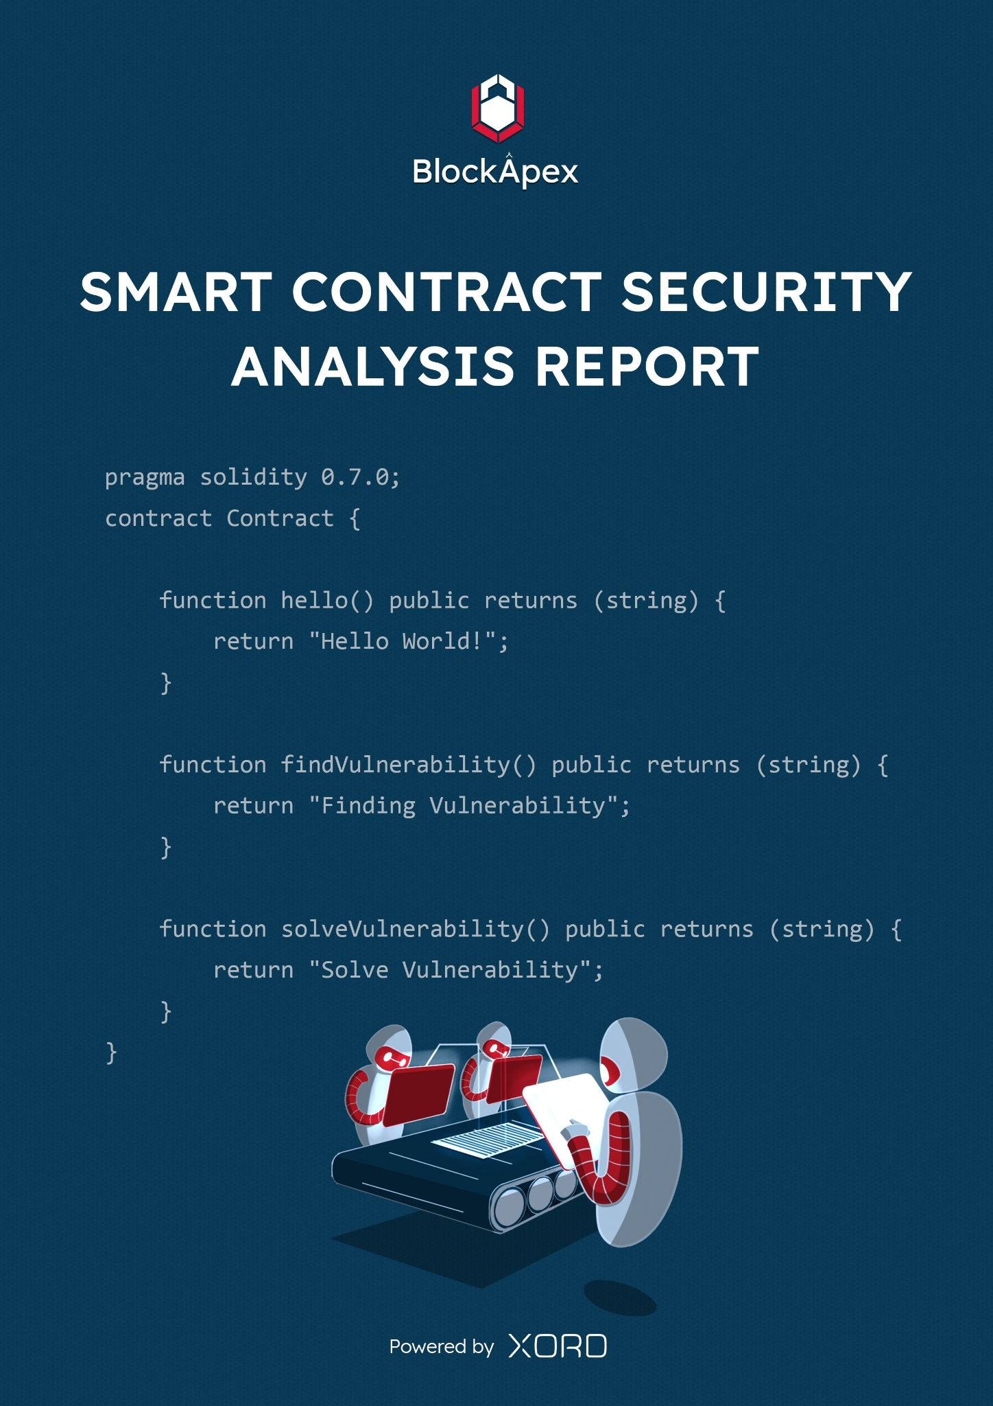

# PREFACE

## Objectives

The purpose of this document is to highlight the identified bugs/issues in the provided codebase. This audit has been conducted in a closed and secure environment, free from influence or bias of any sort. This document may contain confidential information about IT systems/architecture and intellectual property of the client. It also contains information about potential risks and the processes involved in mitigating/exploiting the risks mentioned below.

The usage of information provided in this report is limited, internally, to the client. However, this report can be disclosed publicly with the intention to aid our growing blockchain community; under the discretion of the client.

## Key Understandings

# 

# TABLE OF CONTENTS

# 

**PREFACE** **2**

Objectives 2

Key understandings 2

**TABLE OF CONTENTS** **3**

**INTRODUCTION** **4**

Audit log 4

Project details 6

Scope 7

Project Overview 8

System Architecture 8

**AUDIT REPORT** **10**

Executive Summary 10

Findings 11

Critical-risk issues 11

High-risk issues 11

Medium-risk issues 12

Low-risk issues 15

Informatory issues and Suggestions 15

**DISCLAIMER** **16**

# 

# INTRODUCTION

BlockApex (Auditor) was contracted by _Voirstudio__ (Client) for the purpose of conducting a Smart Contract Audit/Code Review. This document presents the findings of our analysis which took place from _19th August 2021__ .

## Audit Log

Entry #1  
Date: 11th October 2021  
In the first week, we developed a deeper understanding of the protocol and its workings. We started by reviewing the five main contracts against common solidity flaws and did a static analysis using *Slither*. In the second week, we wrote unit-test cases to ensure that the functions are performing their intended behaviour. In the 3rd week, we began with the line-by-line manual code review.

Note: We haven’t fuzzed the end-to-end smart contracts behaviour in this auditing round. So this is the version of the report with the issues that were found in all the steps we performed before the above mentioned date. We are now engaged again by Unipilot to further test and fuzz properties. A detailed analysis will be shared later in an updated version of the report which will be published later.

Entry #2  
Date: 1st November 2021  
We were tasked with an additional review of the protocol by Voirstudio to verify the mathematics and economics of Unipilot. We fuzzed the smart contracts to test properties of the protocol and found some issues which are reported below. We have tested and discussed a few bullets in the grey area regarding the economics of the protocol and worked out contingency plans around it.   
  
Note: We worked closely with the developers and the fixes were incrementally applied. The team was very supportive and was open to suggestions and discussion. They even provided a few pointers as to where we would find potential vulnerabilities.

## 

## Project Details

| Name |
| --- |
| Unipilot |
| Auditor |
| Moazzam Arif | Kaif Ahmed | Muhammad Jarir uddinn |
| Platform |
| Ethereum/Solidity |
| Type of review |
| Mathematics, Tokenomics, Liquidity Management, Index Fund |
| Methods |
| Architecture Review, Functional Testing, Computer-Aided Verification, Manual Review |
| Git repository |
| First review:  <https://github.com/VoirStudio/unipilot-protocol-contract-v2/tree/update-structure> |
| Second review: <https://github.com/VoirStudio/unipilot-protocol-contract-v2/tree/update-getSharesAndAmounts> |
| White paper/ Documentation |
| <https://unipilot.medium.com/> |
| Document log |
| [First review](https://drive.google.com/file/d/1RzyTORCM5xa2VRcYezu2pASj7URpVWOT/view?usp=sharing): Initial Audit (19th August 2021) | Final Audit (11th October 2021) |
| Second review: Initial Audit (20th October 2021) | Final Audit (26th October 2021) |

## Scope

The git-repository shared was checked for common code violations along with vulnerability-specific probing to detect[**major issues/vulnerabilities**](https://docs.google.com/document/d/1sEXMfjXRiqiEvnGKMUUoNvJ0pUMafy-7XsDEpP5_DJY/edit?usp=sharing). Some specific checks are as follows:

| **Code review** |  | **Functional review** |
| --- | --- | --- |
| Reentrancy | Unchecked external call | Business Logics Review |
| Ownership Takeover | ERC20 API violation | Functionality Checks |
| Timestamp Dependence | Unchecked math | Access Control & Authorization |
| Gas Limit and Loops | Unsafe type inference | Escrow manipulation |
| DoS with (Unexpected) Throw | Implicit visibility level | Token Supply manipulation |
| DoS with Block Gas Limit | Deployment Consistency | Asset’s integrity |
| Transaction-Ordering Dependence | Repository Consistency | User Balances manipulation |
| Style guide violation | Data Consistency | Kill-Switch Mechanism |
| Costly Loop |  | Operation Trails & Event Generation |

## 

## Project Overview

Unipilot is an auto-liquidity management protocol built on top of Uniswap v3. It simplifies the liquidity management by rebasing the liquidity of the pool, when prices get out of range.

To readjust the liquidity of the pool, *Captains* (independent nodes) are compensated for the gas fee plus some bonus in $PILOT.

It also has a governing token i.e., $PILOT. When a protocol earns a fee from Uniswap v3, users have the option to claim a fee in equivalent $PILOT (price is fetched from $FEE_TOKEN/$WETH -> $PILOT/$WETH price oracles).

## System Architecture

The protocol is built to support multiple dexes (decentralized exchanges) for liquidity management. Currently it supports only Uniswap v3’s liquidity. In future, the protocol will support other decentralized exchanges like Sushiswap (Trident). So the architecture is designed to keep in mind the future releases.

The protocol has ***5*** main smart contracts and their dependent libraries.

**Unipilot.sol:** The smart contact is the entry point in the protocol. It allows users to deposit, withdraw and collect fees on liquidity. It mints an NFT to it’s users representing their individual shares.

**V3Oracle.sol:** It is a wrapper around Uniswap oracles. It also has helper functions to calculate TWAP (time-weighted average price) and other prices relevant data.

**UniswapLiquidityManager.sol:** The heart of the protocol that allows users to add, withdraw, collectFee and readjust the liquidity on Uniswap v3. This smart contract interacts with Uniswap v3Pool and v3Factory to add and remove liquidity. It maintains 2 positions on Uniswap i.e., base position and range position (leftover tokens are added as range orders).

**UniStrategy.sol:** The smart contract to fetch and process ticks’ data from Uniswap. It also decides the bandwidth of the ticks to supply liquidity (on the basis of governance).

**ULMState.sol:** This smart contract fetches the updated prices and tick ranges from Uniswap’s v3 pools.

***Steps to Add Liquidity:***

1. User will give approval of both tokens to **Unipilot.sol**
2. User will call the deposit method of **Unipilot.sol**
3. **Unipilot.sol’s deposit** method will call the deposit method of **UniswapLiquidityManager.sol** and transfer both the tokens to **UniswapLiquidityManager.sol**
4. **UniswapLiquditymanager.sol** will add the liquidity on Uniswap. This will:
   1. Mint an NFT denoting the user’s shares in the liquidity provided
   2. Alter the existing liquidity by increasing the user’s share

## 

# AUDIT REPORT

## Executive Summary

In our first iteration, we found **1** critical-risk issue, **4** high-risk issues, **1** medium-risk, **1** low-risk issue and 1 informatory issue. All these issues were refactored and fixes have been made. A detailed report on the first review can be found [here](https://drive.google.com/file/d/1RzyTORCM5xa2VRcYezu2pASj7URpVWOT/view?usp=sharing).

The second iteration was performed recently, with the updated codebase. We found a few more issues that were promptly fixed by the team. Our analysis indicates that the contracts are now **secure**.

**Our team found:** 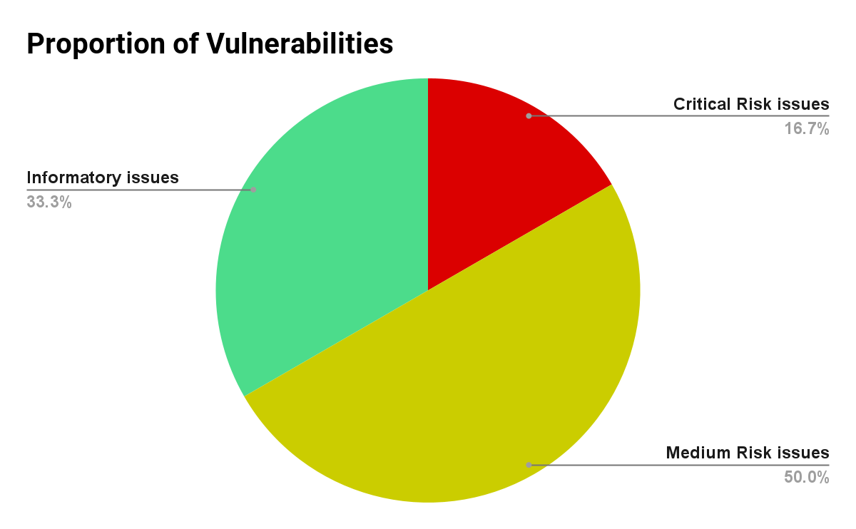

| # of issues | Severity of the risk |
| --- | --- |
| 1 | Critical Risk issue(s) |
| 0 | High Risk issue(s) |
| 3 | Medium Risk issue(s) |
| 0 | Low Risk issue(s) |
| 2 | Informatory issue(s) |

## Findings

### Critical-risk issues

**1. Ether balance of contract can be withdrawn**

**File:** PeripheryPayments.sol

**Description:**Unipilot conducted a testnet bug bounty. In that some users reported they were unable to collect their fees. By investigating that with the dev team, they founded that ERC20/WETH pool was misbehaving due to the following code snippet:

if (balanceWETH9 > 0) {

IWETH9(WETH).withdraw(balanceWETH9); // contract balance is transferred

TransferHelper.safeTransferETH(recipient, balanceWETH9);}

**Remedy:**The dev team suggested to remove this method and pass proper amount to be withdrawn

**Status:**   
 Fixed

### High-risk issues

No high-risk issues were found.

### Medium-risk issues

1. **Math Precision issues**

**File:** UniswapLiquidityManger.sol & ULMState.sol

**Description:**Unipilot uses 1e18 precision for calculating the Liquidity shares and feeGrowth when adding liquidity and fees. This causes some small amounts to be locked forever in the UniswapLiquiditymanager.  
  
See the following code snippet:

position.feeGrowthGlobal0 += FullMath.mulDiv(

collect0Base + collect0Range,

1e18, // precision

position.totalLiquidity

);

**Remedy:**We suggest using FixedPoint128.Q128 from Uniswap. We fuzzed against this precision and we got more precise results

**Status:**   
Fixed

1. **Safe cast and Safe Math**

**Description**

There are many instances in the contract which use unsafe math operations. This might lead to overflow/underflow. The contract also uses unsafe type casting.  
See the following code snippet of unsafe cast:

(**int256** amount0Delta, **int256** amount1Delta) = IUniswapV3Pool(b.poolAddress).swap(  
 **address**(this),  
 b.zeroForOne,  
 **int256**(b.amountIn), // unsafe casting, use safeCast  
 b.sqrtPriceLimitX96,  
 abi.encode((SwapCallbackData({ token0: token0, token1: token1, fee: fee })));

**Remedy:**We suggest to use safe math and safe cast libraries  
**Status:**  
Fixes in progress

1. **Economic Attacks**
2. **Price Oracle manipulation  
   File:** UniswapLiquidityManger.sol  
   Unipilot relies on TWAP when minting new $PILOT tokens, either in fees or in readjustment of the pool. Tokens are priced w.r.t to ether and then from *etherAmount* the *pilotAmount* is calculated.

**Attack Scenario:**Consider users who want to get $PILOT in fees instead of underlying tokens. Users can create a pool with $WETH, do some swaps, and inflate the tokens against $WETH. Unipilot will get the etherAmount of tokens from the pool and convert ethers to pilot. Hence the user gets the $PILOT at a manipulated price.

**Note:   
*To mitigate this attack, devs already have implemented whitelisting of pools when distributing fees. But they had not implemented whitelisting during readjustments.*  
  
Remedy:**Add whitelisting to readjustment  
  
**Status:**   
Fixed

1. **Put a limit on tx.gasPrice**

**File:** UniswapLiquidityManger.sol

**Description:** When a user readjust the pool, his transaction fees is compensated plus a   
 *Premium* is given to the user in $PILOT.

b.gasUsed = tx.gasprice.mul(initialGas.sub(gasleft()));

// tx.gasprice can be adjusted high enough to mint more $PILOT

b.pilotAmount = IOracle(_oracle).ethToAsset(PILOT, 3000,b.gasUsed);

**Remedy:** Add a limit to tx.gasprice

**Status:**   
 Fixed

1. **Probable Slippage Attacks**While readjusting the pool, the Unipilot swaps X amount of tokens to make the pool in range. The swap percent (how much should be swapped) and the slippage is hardcoded. This incentivizes sandwich attacks.

**Remedy:** The swap amount and slippage should be configurable according to favorable conditions

**Status:**   
Fixed

### 

### Low-risk issues

No low-risk issues were found.

### Informatory issues and Suggestions

1. Contracts should be made pausable in case of a mishap.
2. Contracts should have rescue funds methods.

# 

# DISCLAIMER

# 

The smart contracts provided by the client for audit purposes have been thoroughly analyzed in compliance with the global best practices till date w.r.t cybersecurity vulnerabilities and issues in smart contract code, the details of which are enclosed in this report.

This report is not an endorsement or indictment of the project or team, and they do not in any way guarantee the security of the particular object in context. This report is not considered, and should not be interpreted as an influence, on the potential economics of the token, its sale or any other aspect of the project.

Crypto assets/tokens are results of the emerging blockchain technology in the domain of decentralized finance and they carry with them high levels of technical risk and uncertainty. No report provides any warranty or representation to any third-Party in any respect, including regarding the bug-free nature of code, the business model or proprietors of any such business model, and the legal compliance of any such business. No third-party should rely on the reports in any way, including for the purpose of making any decisions to buy or sell any token, product, service or other asset. Specifically, for the avoidance of doubt, this report does not constitute investment advice, is not intended to be relied upon as investment advice, is not an endorsement of this project or team, and it is not a guarantee as to the absolute security of the project.

Smart contracts are deployed and executed on a blockchain. The platform, its programming language, and other software related to the smart contract can have its vulnerabilities that can lead to hacks. The scope of our review is limited to a review of the Solidity code and only the Solidity code we note as being within the scope of our review within this report. The Solidity language itself remains under development and is subject to unknown risks and flaws. The review does not extend to the compiler layer, or any other areas beyond Solidity that could present security risks.

This audit cannot be considered as a sufficient assessment regarding the utility and safety of the code, bug-free status or any other statements of the contract. While we have done our best in conducting the analysis and producing this report, it is important to note that you should not rely on this report only - we recommend proceeding with several independent audits and a public bug bounty program to ensure security of smart contracts.