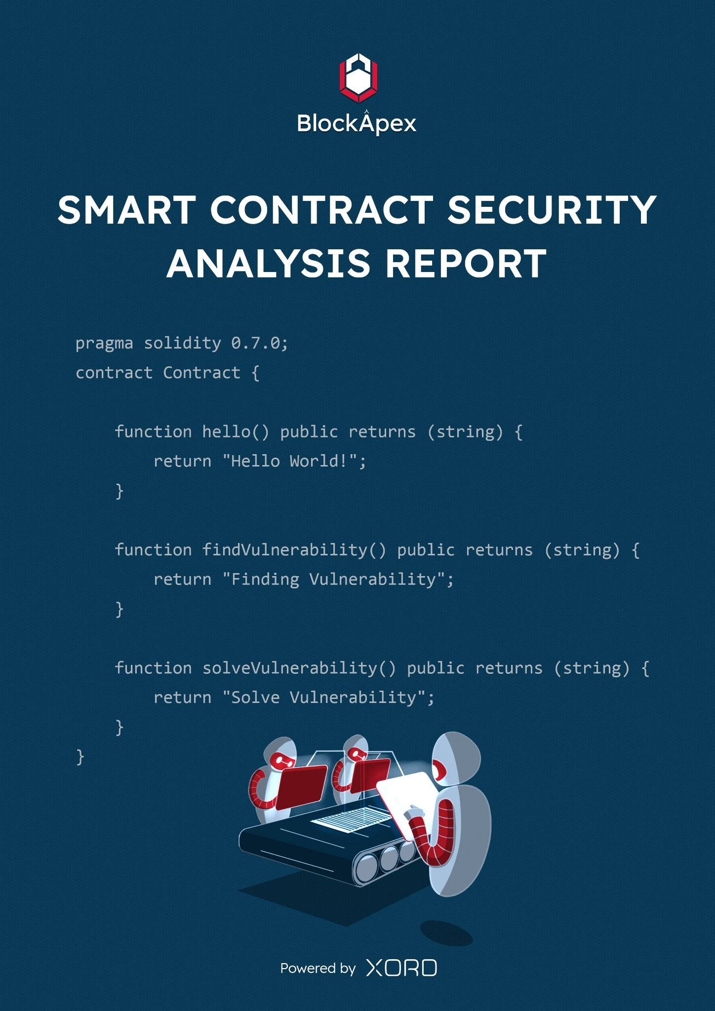

# PREFACE

## Objectives

The purpose of this document is to highlight the identified bugs/issues in the provided codebase. This audit has been conducted in a closed and secure environment, free from influence or bias of any sort. This document may contain confidential information about IT systems/architecture and intellectual property of the client. It also contains information about potential risks and the processes involved in mitigating/exploiting the risks mentioned below.

The usage of information provided in this report is limited, internally, to the client. However, this report can be disclosed publicly with the intention to aid our growing blockchain community; under the discretion of the client.

## Key understandings

# 

**Table of Contents**

**PREFACE** **2**

Objectives 2

Key understandings 2

**INTRODUCTION** **4**

Scope 5

Project Overview 6

System Design 6

Test Cases 6

**AUDIT REPORT** **7**

Executive Summary 7

Findings 8

Critical-risk issues 8

High-risk issues 8

Medium-risk issues 9

Low-risk issues 10

Informatory issues 10

**DISCLAIMER** **11**

# 

# INTRODUCTION

BlockApex (Auditor) was contracted by Sonar (Client) for the purpose of conducting a Smart Contract Audit/Code Review. This document presents the findings of our analysis which took place on 8th September 2021 .

| Name |
| --- |
| Sonar BSC-ETH bridge |
| Auditor |
| Moazzam Arif | Kaif Ahmed |
| Platform |
| Ethereum/Solidity |
| Type of review |
| Bridge |
| Methods |
| Architecture Review, Functional Testing, Manual Review |
| Git repository |
| <https://github.com/sonarplatform/eth_bridge/tree/4c086d33fb5cb7a04a2192d6566c7905ea3b1074> |
| White paper/ Documentation |
| Not provided |
| Document log |
| Initial Audit (08-09-2021) |
| Final Audit (pending) |

## Scope

The git-repository shared was checked for common code violations along with vulnerability-specific probing to detect major issues/vulnerabilities. Some specific checks are as follows:

| **Code review** |  | **Functional review** |
| --- | --- | --- |
| Reentrancy | Unchecked external call | Business Logics Review |
| Ownership Takeover | ERC20 API violation | Functionality Checks |
| Timestamp Dependence | Unchecked math | Access Control & Authorization |
| Gas Limit and Loops | Unsafe type inference | Escrow manipulation |
| DoS with (Unexpected) Throw | Implicit visibility level | Token Supply manipulation |
| DoS with Block Gas Limit | Deployment Consistency | Asset’s integrity |
| Transaction-Ordering Dependence | Repository Consistency | User Balances manipulation |
| Style guide violation | Data Consistency | Kill-Switch Mechanism |
| Costly Loop |  | Operation Trails & Event Generation |

## Project Overview

This is a POA bridge application that provides eth to bsc and bsc to eth bridging. It allows its native tokens to be accessed on both ETH and BSC blockchains.

## System Design

Steps to burn and mint (BSC => ETH):

1. User calls the burn method on BSC bridge (BSC blockchain)
2. With the burn method, tokens are transferred to the admin account
3. Transfer event is emitted on successful burn
4. Relayer listens the event and call the mint method on ETH bridge
5. With the mint method, the tokens are transferred to the user on the ethereum blockchain

For ETH => BSC similar steps are followed.

## Test Cases

No test cases were provided, we did our own simulations.

# 

# AUDIT REPORT

## Executive Summary

The analysis indicates that the contracts audited are **insecure.**

Our team performed a technique called “Filtered Audit”, where the contract was separately audited by two individuals. After a thorough and rigorous process of manual testing, all the flags raised were iteratively reviewed and tested.

**Our team found:** 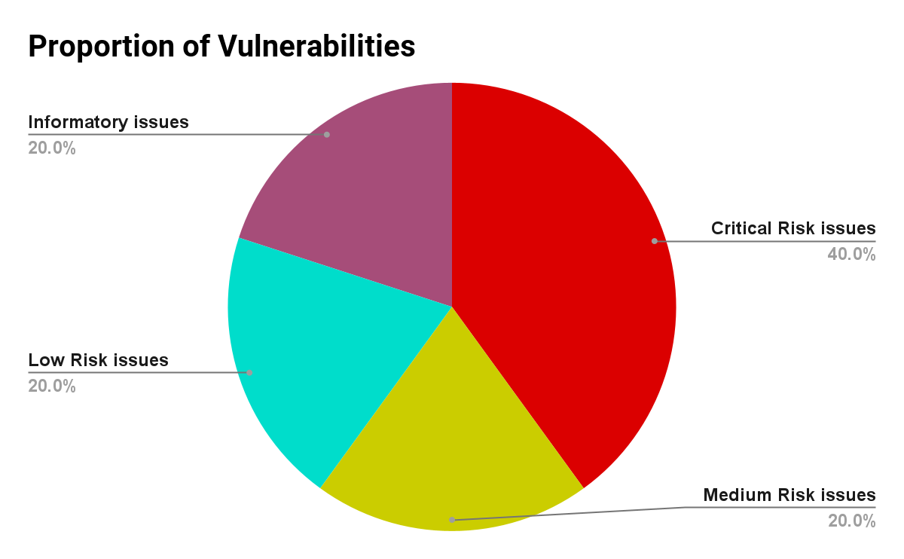

| # of issues | Severity of the risk |
| --- | --- |
| 2 | Critical Risk issue(s) |
| 0 | High Risk issue(s) |
| 1 | Medium Risk issue(s) |
| 1 | Low Risk issue(s) |
| 1 | Informatory issue(s) |

## Findings

### Critical-risk issues

1. **Anyone can lock funds of other users**

If user1 wants to transfer tokens from BSC to ETH, user1 will first approve funds to the BSC bridge. Now that the user has approved his funds to the bridge contract, anyone else can call the burn method passing the address of user1, the funds of user1 have been locked by someone else.

**Remedy:** Burn function contains following logic

token.transferFrom(to, *address*(this), AmountwithFees);

The parameter contains “to” but should contain “msg.sender”

1. **Server API to mint the tokens**

There is an api written in the server to mint tokens. It does not verify that the burn has been called or not. The users can mint without burning using that api.

**Remedy:** User should submit proof of burn before calling the minting API

### High-risk issues

No high-risk issues were found.

### Medium-risk issues

1. **Locking/Unlocking both side**The contract has locking and unlocking functionality on both sides. For minting it is assumed that the admin wallet should have enough token balance.

**Attack scenario:**

* 1. User 1 locks 1000 tokens on BSC bridge
  2. There is not enough token balance equivalent to be given to user1 on ETH bridge

require( adminBal > amount, "insuffient funds in admin account.");

* 1. Now user1 can not unlock on ETH bridge
     1. He will have to unlock his token again to get his funds back from BSC bridge (extra gas, because the function is not performing the intended behavior)
     2. Unlocking of tokens on the same bridge is inconvenient from user’s perspective

**Remedy**:  
Usually the lock/unlock strategy is used on one bridge and mint/burn strategy is used on the other bridge.

### Low-risk issues

1. **Centralization Risk**Admin wallet is a single wallet and there is high risk of centralization if the private key gets compromised.

require(admin == msg.sender, "only admin can call this");

**Remedy:**Assignment of privileged roles to multi-signature wallets to prevent single point of failure due to the private key.

### Informatory issues

1. **Lock pragma versions**

Contracts should be deployed with the same compiler version and flags that they have been tested with thoroughly. Locking the pragma helps to ensure that contracts do not accidentally get deployed using, for example, an outdated compiler version that might introduce bugs that affect the contract system negatively.  
**Remedy**:

Lock the pragma version and also consider known bugs (<https://github.com/ethereum/solidity/releases>) for the compiler version that is chosen. Please refer to this doc for more details.

# DISCLAIMER

The smart contracts provided by the client for audit purposes have been thoroughly analyzed in compliance with the global best practices till date w.r.t cybersecurity vulnerabilities and issues in smart contract code, the details of which are enclosed in this report.

This report is not an endorsement or indictment of the project or team, and they do not in any way guarantee the security of the particular object in context. This report is not considered, and should not be interpreted as an influence, on the potential economics of the token, its sale or any other aspect of the project.

Crypto assets/tokens are results of the emerging blockchain technology in the domain of decentralized finance and they carry with them high levels of technical risk and uncertainty. No report provides any warranty or representation to any third-Party in any respect, including regarding the bug-free nature of code, the business model or proprietors of any such business model, and the legal compliance of any such business. No third-party should rely on the reports in any way, including for the purpose of making any decisions to buy or sell any token, product, service or other asset. Specifically, for the avoidance of doubt, this report does not constitute investment advice, is not intended to be relied upon as investment advice, is not an endorsement of this project or team, and it is not a guarantee as to the absolute security of the project.

Smart contracts are deployed and executed on a blockchain. The platform, its programming language, and other software related to the smart contract can have its vulnerabilities that can lead to hacks. The scope of our review is limited to a review of the Solidity code and only the Solidity code we note as being within the scope of our review within this report. The Solidity language itself remains under development and is subject to unknown risks and flaws. The review does not extend to the compiler layer, or any other areas beyond Solidity that could present security risks.

This audit cannot be considered as a sufficient assessment regarding the utility and safety of the code, bug-free status or any other statements of the contract. While we have done our best in conducting the analysis and producing this report, it is important to note that you should not rely on this report only - we recommend proceeding with several independent audits and a public bug bounty program to ensure security of smart contracts.