Proceeding Paper
Finger-Count Gesture Control for Omnidirectional Mobile Robot with Edge-Host Decoupled Architecture and Dependable Failsafe Design †
Yan-Ming Lin ^{1,a} and Tse-Chuan Hsu ^{1,b,*}
Academic Editor: Firstname Lastname
Published: date
Copyright: © 2026 by the authors. Submitted for possible open access publication under the terms and conditions of the Creative Commons Attribution (CC BY) license.
¹ Soochow University, Taipei, Taiwan
ª imyanming@gmail.com
^{b} tchsu@scu.edu.tw
* Correspondence: tchsu@scu.edu.tw
† Presented at the 2026 International Conference on Knowledge and Intellectual Improvement (ICKII 2026), August 14–16, 2026, Sendai, Japan.
Abstract
Remote telepresence control of mobile robots in constrained environments demands low-latency command pipelines, intuitive human-machine interfaces, and dependable failsafe mechanisms. However, existing systems either rely on resource-intensive onboard AI or physically taxing gesture modalities that induce upper limb fatigue in operators. This ergonomic fatigue, caused by holding an arm outstretched without support for extended periods, is a well-documented barrier to sustained gesture interface adoption. This paper presents an Edge-Host Decoupled architecture for a six-directional omnidirectional vehicle based on omniwheels, deployed on an extremely resource-constrained Raspberry Pi 1 Model B+ (700 MHz, 512 MB RAM). All AI inference is offloaded to a host machine running Google MediaPipe, which maps single-hand finger-count micro-gestures — performed with the arm resting flat on a surface — to holonomic motion commands (forward, backward, left, right, clockwise, counter-clockwise). A latch-state machine locks each command after three consecutive confirmation frames, allowing the operator to remove their hand entirely while the vehicle continues executing the manoeuvre. Dependability is enforced by a UDP watchdog that autonomously halts the vehicle within 533 ms of communication loss. Experimental evaluation demonstrates a gesture recognition accuracy of 98.1% across eight gesture classes and an end-to-end command latency of 1260 ms. The proposed system proves that dependable, zero-fatigue telepresence control is achievable even on decade-old edge hardware. The mobile base is designed as the locomotion layer for integration with robotic arm systems, targeting industrial logistics and inspection applications.
Keywords: Telepresence Robotics; Hand Gesture Recognition; Edge Computing; Omniwheel Robot; Dependable Systems

1. Introduction
Teleoperation of mobile robots is increasingly relevant in industrial inspection, logistics, and search-and-rescue scenarios where direct human presence is hazardous or impractical. In such settings, the quality of the human-machine interface directly determines operational safety and throughput: an interface that is slow to learn, physically demanding, or unreliable under network disturbance can negate the benefits of remote operation altogether. Intuitive control interfaces that require minimal training are therefore essential for rapid deployment, particularly in field conditions where operators cannot be assumed to have prior exposure to specialised control hardware such as joysticks or haptic gloves. Bare-hand gesture recognition has attracted sustained interest as an interaction modality because it requires no wearable instrumentation and maps naturally to human intent, allowing an operator to convey directional commands using the same vocabulary of hand poses employed in everyday human-human communication. A recent comprehensive review by Qi et al. [6] surveys the rapid maturation of vision-based hand gesture recognition for human-robot interaction, noting that the field has shifted from marker-based and glove-based sensing toward markerless, camera-only pipelines as deep-learning-based landmark detectors have become sufficiently accurate and fast for real-time use.
However, two challenges impede adoption on legacy or cost-constrained embedded platforms. First, modern hand-tracking pipelines such as MediaPipe Hands [1] demand real-time neural-network inference that exceeds the computational budget of resource-constrained embedded platforms. A Raspberry Pi 1 Model B+ operates at 700 MHz with 512 MB RAM — insufficient to sustain MediaPipe inference at interactive frame rates, let alone to run inference concurrently with motor control, video encoding, and network I/O on a single core. Offloading computationally intensive perception tasks to a nearby host or cloud node is consequently a recurring strategy for extending the useful lifetime of resource-constrained robot platforms, provided that the added network latency is bounded and that the robot retains the ability to fail safe if the link is lost. Second, mid-air gesture interfaces require operators to hold an arm outstretched for extended periods, inducing Gorilla Arm Syndrome — a condition in which sustained isometric shoulder and arm muscle activation produces fatigue, tremor, and eventually pain. Hansberger et al. [2] demonstrated empirically that supported gestures performed with the arm resting on a surface induce fatigue comparable to keyboard input, whereas mid-air gestures significantly increase perceived exertion and form a primary barrier to sustained adoption of gestural interfaces.
Existing systems do not resolve both challenges simultaneously, and none of them incorporate an explicit dependability or failsafe layer comparable to the one proposed here. Zick et al. [4] demonstrate MediaPipe-based multi-robot teleoperation but co-locate inference hardware with the robot, requiring capable on-board computing resources comparable to a modern single-board computer or laptop-class processor. Similarly, Wameed et al. [7] implement MediaPipe-based hand-gesture control of a tracked robot using a Raspberry Pi 4 as the on-board inference engine, which — while markedly more capable than the Pi 1 Model B+ targeted in this work — still performs perception and actuation on the same compute node, assumes a free-standing mid-air gesture posture, and reports no mechanism for detecting or recovering from communication loss. Ivačko et al. [8] similarly combine an edge-deployed perception pipeline with gesture-based human-robot interaction, running MediaPipe hand tracking alongside object detection on a Jetson Orin Nano or a Raspberry Pi 5 with a Hailo accelerator to control a stationary collaborative manipulator; like Wameed et al. [7], their system targets a fixed-base arm rather than a mobile platform and does not describe a watchdog or safe-transition mechanism for handling link loss or abrupt actuator reversal. Zarkasi et al. [9] apply a closely related finger-counting gesture vocabulary on a comparably constrained embedded platform — a Raspberry Pi paired with an STM32 Nucleo microcontroller — to drive a medicine-delivery robot, confirming that MediaPipe-based finger gestures remain viable on low-cost hardware, although the reported system again omits any explicit fault-tolerance treatment. Beyond ground robots, Hu et al. [10] extend the gesture-to-command paradigm to a structurally different platform, mapping hand gestures to coordinated commands for multiple unmanned aerial vehicles, which demonstrates that gestural control generalises across robot types but leaves the dependability question similarly unaddressed. Taken together, no prior work, to the authors' knowledge, combines host-offloaded AI inference, a supported-arm gesture vocabulary, and an explicit three-layer dependability stack on hardware as constrained as the Pi 1 Model B+.
This paper presents an Edge-Host Decoupled (EHD) architecture in which all MediaPipe inference is offloaded to the operator's laptop, while the Raspberry Pi 1 B+ handles only motor actuation and video streaming, leaving its modest 700 MHz ARM11 core free to service real-time PWM control and HTTP video serving without contention from neural-network inference. The operator controls a four-Mecanum-wheel holonomic robot [5] using single-hand finger-count micro-gestures performed with the forearm resting flat on a desk, so that no joint is held against gravity for any sustained interval. A latch-state machine eliminates the need to sustain any gesture, enabling gesture-and-release control with zero arm fatigue: once a command is recognised and confirmed, the operator's hand may return to a relaxed position while the robot continues to execute the manoeuvre.
The contributions of this work are threefold. First, we present an Edge-Host Decoupled architecture that enables machine-learning-driven teleoperation on decade-old embedded hardware without any hardware modification, by relocating all perception workload to a commodity host machine while the edge node retains only deterministic, low-compute actuation and streaming duties. Second, we introduce a zero-fatigue eight-pose finger-count gesture vocabulary mapped to six holonomic drive commands, paired with a latch-state machine that allows the operator to remove their hand entirely after each gesture is confirmed, removing sustained muscular effort from the control loop. Third, we design and validate a three-layer dependability stack — comprising a UDP watchdog, a motor safe-transition guard, and a gesture confirmation gate — that together achieve 98.1% gesture recognition accuracy across eight pose classes and a measured watchdog halt response of 533 ms following communication loss.
Section 2 describes the system architecture. Section 3 details gesture recognition. Section 4 presents dependability mechanisms. Section 5 reports experimental results. Section 6 concludes.

2. System Architecture
The system comprises two computational nodes connected over a local Wi-Fi network: a Host Node (MacBook laptop) responsible for AI inference and command generation, and an Edge Node (Raspberry Pi 1 Model B+) responsible for actuation and video streaming, as illustrated in Figure 1. This division of labour follows directly from the edge-offloading principle discussed in Section 1: the Host Node absorbs all workload that scales with model complexity, while the Edge Node is reduced to a thin, near-constant-time actuation layer whose computational demands do not grow as the gesture vocabulary or recognition model is refined. The two nodes communicate exclusively over the local network, with no requirement for internet connectivity, cloud infrastructure, or external compute services.
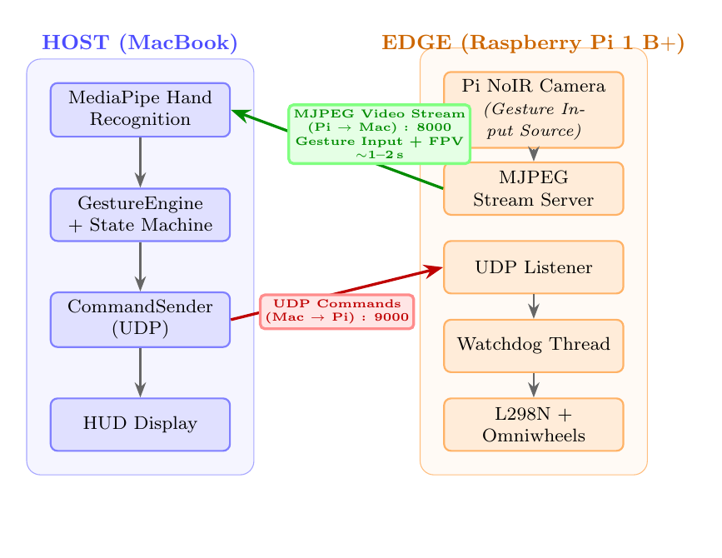
[INSERT FIGURE 1: architecture_v2.png]
Figure 1. Edge-Host Decoupled system architecture. Commands flow Host → Edge via UDP; MJPEG video streams Edge → Host via HTTP.

2.1. Host Node
The Host Node runs telepresence_controller.py with three concurrent roles, implemented as cooperating threads sharing a small set of synchronised state variables. The Perception module captures frames at 30 fps from the built-in webcam, applies a horizontal flip so that the displayed image is mirror-consistent with the operator's own movements, and feeds the resulting RGB frames to MediaPipe Hands [1] with a minimum detection confidence of 0.7 and a minimum tracking confidence of 0.6 — thresholds chosen empirically to suppress spurious detections under the fluorescent lighting used in evaluation while still tracking the hand reliably frame-to-frame. The Cognition module passes the resulting 21-landmark set to GestureEngine, which classifies the hand pose using the heuristics described in Section 3 and maintains a locked command state that persists independently of momentary tracking dropouts. The Communication module transmits the currently locked command via UDP at a fixed 100 ms interval; this interval is deliberately decoupled from the 30 fps display and inference rate, so that the command stream remains constant and predictable for the watchdog logic on the Edge Node regardless of fluctuations in host-side processing load. A secondary thread independently receives and renders the robot's MJPEG video feed, compositing it with a picture-in-picture inset of the gesture camera so that the operator can simultaneously monitor the robot's first-person view and verify that their own gesture is being tracked correctly.

2.2. Edge Node
The Edge Node runs two independent operating-system processes rather than a single monolithic program. pi_fast_stream.py captures 320×240 px video via the V4L2 kernel interface and serves each JPEG-encoded frame as an HTTP multipart MJPEG stream on port 8000, allowing any standard HTTP client to display the feed without a dedicated video codec. pi_udp_omni.py binds a UDP socket on port 9000, parses incoming single-character ASCII command strings, and drives the four Mecanum wheels through two L298N dual H-bridge motor controllers using the gpiozero [3] PWM Motor abstraction, which provides a hardware-agnostic interface to the Pi's GPIO-driven PWM channels. The two processes are deliberately isolated at the operating-system level: should the streaming process crash, hang, or be starved of CPU time by an unrelated system task, the motor-control process continues to run independently and remains responsive to the watchdog logic described in Section 4.1, so that a failure in the non-safety-critical video path can never compromise the robot's ability to stop safely.
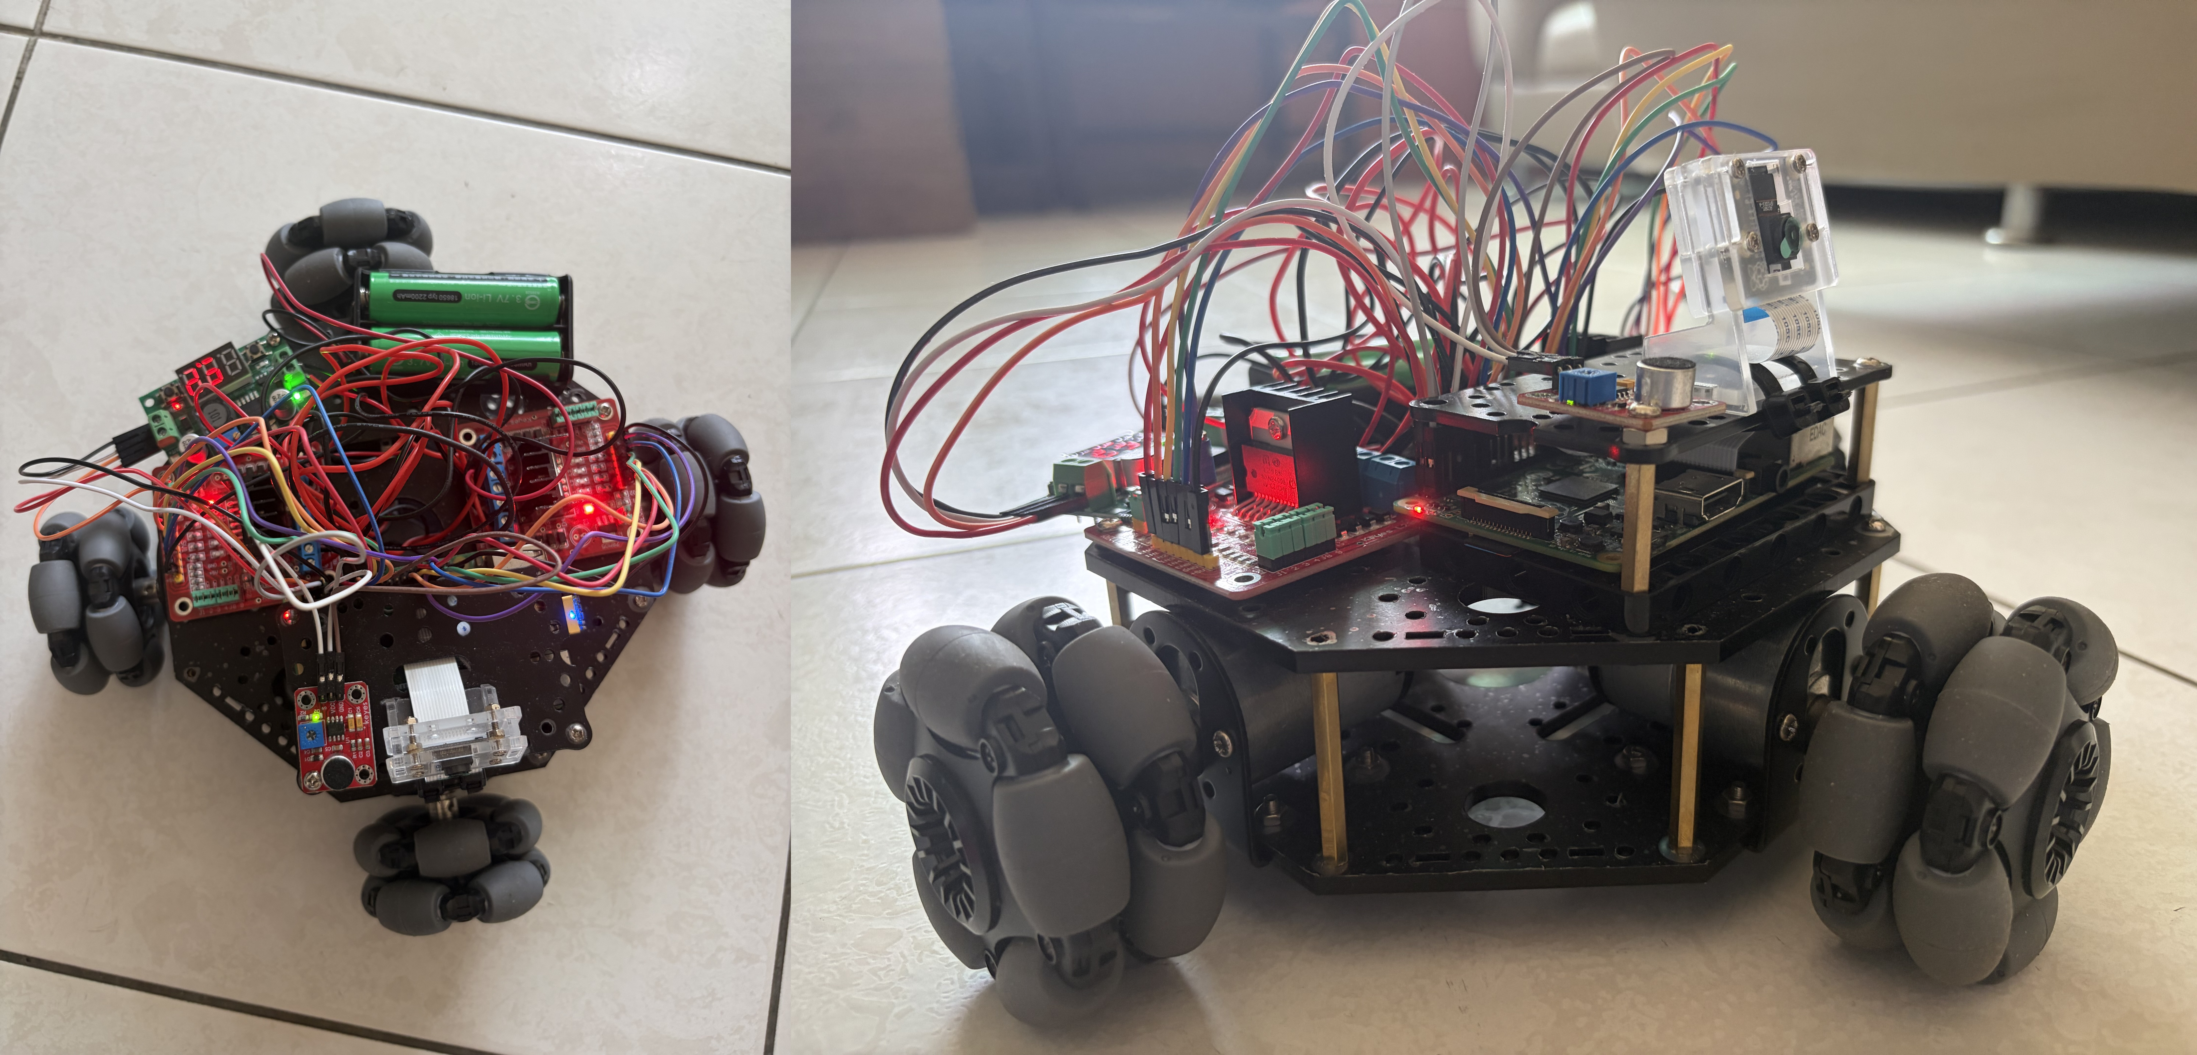
Figure 4. Prototype omnidirectional mobile robot with Raspberry Pi 1 Model B+, four Mecanum wheels, and dual L298N motor drivers.

2.3. Communication Protocol
Commands travel from the Host Node to the Edge Node as single-character ASCII payloads carried over UDP. UDP is preferred over TCP for this channel because its connectionless, low-overhead delivery avoids the head-of-line blocking and retransmission delays that a lossy or congested Wi-Fi link can impose on a stream-oriented protocol; the cost of this choice — namely, that UDP offers no delivery guarantee — is explicitly compensated for by delegating communication-loss safety to the watchdog mechanism described in Section 4.1 rather than relying on the transport layer itself. Video travels in the opposite direction, from the Edge Node to the Host Node, as MJPEG encapsulated in chunked HTTP, a format compatible with any HTTP-capable client and requiring no specialised decoder on the receiving side. Because MJPEG over HTTP provides no inherent mechanism to discard stale frames under load, a buffer anti-accumulation mechanism on the Host Node monitors the size of the incoming byte buffer and discards all but the most recent JPEG frame whenever the buffer exceeds 65,536 bytes, preventing the display latency from accumulating unbounded during transient CPU contention.

3. Gesture Recognition Design

3.1. Landmark-Based Finger Extension
MediaPipe Hands [1] returns 21 normalised 3D landmarks per detected hand, from which finger extension is determined using two lightweight geometric heuristics rather than a learned classifier, in keeping with the broader trend identified by Qi et al. [6] toward landmark-based rule systems that trade a small amount of classification flexibility for substantially lower computational cost and easier interpretability. For fingers two through five — index through pinky — a finger is considered extended when the y-coordinate of its tip landmark is smaller than the y-coordinate of its proximal interphalangeal (PIP) joint, that is, when the tip lies above the PIP joint in screen coordinates. The thumb is treated separately because its principal axis of motion is approximately horizontal rather than vertical: it is considered extended when the horizontal distance between the tip landmark and the wrist landmark exceeds 1.1 times the horizontal distance between the interphalangeal (IP) joint and the wrist, that is, when the tip lies substantially further from the wrist than the IP joint along the horizontal axis. Both heuristics are scale-invariant and robust to moderate wrist rotation, requiring no per-user calibration.

3.2. Gesture Vocabulary
Table 1 lists the eight recognised poses that constitute the gesture vocabulary. The mapping follows an incremental finger-extension sequence, in which each additional extended finger — counted from the thumb through the pinky — changes the active command; this monotonic ordering was chosen deliberately so that the geometric distance between adjacent poses in finger-count space is always exactly one finger, minimising the likelihood of an accidental transition between two semantically distant commands (for example, between Forward and Strafe Right) during the brief instant in which the operator's hand passes through an intermediate pose while forming a gesture. The Open-Palm pose, mapped to BOOST, is the only exception to the strict directional mapping: rather than selecting a new direction, it inherits whichever direction is currently locked and raises the motor duty cycle to 100%, enabling a momentary burst of speed without disturbing the active command.
Table 1. Eight-pose finger-count gesture vocabulary.
Extended Fingers | Pose | Command | Function
None | Fist | SPACE | Emergency stop / clear lock
Thumb only | — | Q | Clockwise rotation
Thumb + Index | L-shape | E | Counter-clockwise rotation
Index only | — | W | Forward
Index + Middle | — | S | Backward
Index + Middle + Ring | — | A | Strafe left
Index + Middle + Ring + Pinky | — | D | Strafe right
All five fingers | Open palm | BOOST | Max speed (inherit direction)
[INSERT FIGURE 2: gesture_diagram.png]
Figure 2. Eight-pose finger-count gesture vocabulary. Each gesture maps to a unique holonomic drive command.

3.3. Latch-State Machine
GestureEngine maintains three states: TRACKING, in which a hand is present in the frame but no command has yet been confirmed; LOCKED, in which a command has been confirmed and is the one actively transmitted to the Edge Node; and LOST, in which the hand has been absent for five or more consecutive frames, during which the previously locked command continues to be transmitted unchanged. Before any classification is allowed to transition the state machine into LOCKED, a temporal confirmation gate requires that the same pose classification be produced in three consecutive frames, corresponding to approximately 100 ms at the system's 30 fps capture rate. This short debounce window is sufficient to suppress the transient misclassifications that arise from motion blur during a gesture transition or from brief partial occlusion of a finger, without introducing a perceptible delay from the operator's perspective.
Once the LOCKED state is reached, the operator may remove their hand from the camera's field of view entirely; the robot continues executing the confirmed command until either a new gesture is classified and confirmed, or the fist pose is shown to reset the lock to SPACE and bring the robot to a stop. This gesture-and-release design is the core enabler of zero-fatigue operation: because no pose must be sustained for longer than the ≈100 ms confirmation window, the operator's arm spends the overwhelming majority of any control session in a fully relaxed, supported position, eliminating the isometric muscular load that characterises conventional held-gesture interfaces.

4. Dependability Mechanisms

4.1. UDP Watchdog
Because the command channel uses UDP and therefore offers no transport-layer guarantee that a dropped link will be detected, dependability against communication loss is enforced entirely at the application layer through a dedicated watchdog mechanism on the Edge Node. The Edge Node maintains a last_recv_time timestamp that is updated on every UDP packet received from the Host Node, regardless of the command it carries. A dedicated background thread, running independently of the socket-receive loop, wakes at a fixed polling interval of T_poll = 100 ms and evaluates the elapsed silence duration since the last received packet. If the elapsed time (t_now − last_recv_time) exceeds a threshold T_wd = 500 ms, the watchdog concludes that the communication link has been lost and immediately invokes the function all_stop(), which halts all four motors and clears the last_cmd register to the empty string so that no stale command can be misinterpreted as still active. The worst-case time from the moment communication is actually lost to the moment the motors are fully halted is therefore bounded above by the sum of the watchdog threshold and one full polling interval, since the loss may occur immediately after a poll has just completed:
t_stop ≤ T_wd + T_poll = 500 + 100 = 600 ms
This theoretical bound was verified experimentally across six independently induced Wi-Fi dropout events, yielding a mean measured halt time of 533 ms and a maximum of 570 ms, both comfortably within the 600 ms analytical bound (full results are reported in Section 5.3). To avoid flooding the system log during a prolonged outage, the watchdog employs edge-triggered logging: an internal flag, _watchdog_fired, ensures that only the first polling cycle in which the triggered condition is detected writes a log entry, with all subsequent cycles during the same sustained outage suppressed until the link recovers and the flag is reset. On reconnection, the fact that last_cmd was cleared at the moment of triggering prevents the Edge Node from inheriting and silently resuming any command that happened to be active immediately before the dropout, which ensures that the robot always resumes operation from a known, explicitly safe state rather than from whatever direction it happened to be moving in when the link failed.

4.2. Motor Safe-Transition Guard
A second dependability concern arises not from communication failure but from the electromechanical behaviour of the drivetrain itself. Abrupt reversal of a brushed DC motor while it is still spinning under inertial load draws a transient surge current substantially larger than its steady-state operating current, because the motor's back-electromotive force (back-EMF) briefly opposes the newly applied voltage in the direction the motor was already rotating; this surge can exceed the continuous current rating of the L298N dual H-bridge driver, accelerating component degradation or, in the worst case, causing immediate thermal failure. The safe_transition() function mitigates this risk by first executing all_stop() — setting all PWM duty cycles to zero so that no drive voltage is applied to any motor — and then blocking for a fixed dwell period of 80 ms before applying the new direction and speed values. This 80 ms interval was chosen to allow the back-EMF generated by the still-spinning rotors to decay below the supply voltage before current is re-applied in the new direction, so that the H-bridge never has to source current against an opposing back-EMF spike.
Critically, safe_transition() is invoked only when the incoming command differs from the previously executed command, that is, only when cmd ≠ last_cmd. Repeated transmissions of an identical command — which occur regularly given the 100 ms UDP send interval described in Section 2.3 — bypass the safe-transition logic entirely, allowing sustained motion in a single direction to continue uninterrupted rather than being punctuated by an 80 ms pause on every received packet. This conditional design was adopted after an early implementation applied the safe-transition guard indiscriminately to every incoming packet, which produced a visible stuttering artefact as the motors repeatedly stopped and restarted even while the operator's commanded direction had not changed; restricting the guard to genuine direction changes eliminated this artefact while preserving the surge-current protection it was designed to provide.

4.3. Stream Anti-Accumulation Buffer
A third, independent dependability concern affects the video path rather than the command path. The MJPEG receiver on the Host Node accumulates raw HTTP chunks in a byte buffer as they arrive from the Edge Node, and under transient CPU load on the Host — for instance while MediaPipe inference and gesture classification are competing for the same processor core — JPEG decoding may fall behind the rate at which new chunks arrive over the network. Left unchecked, this would cause the buffer to grow without bound and the rendered video to display progressively older frames, effectively decoupling the operator's situational awareness from the robot's true current state. To prevent this, the receiver monitors the buffer size on every chunk append and, whenever the buffer length exceeds 65,536 bytes, locates the most recent JPEG start-of-image marker (the two-byte sequence 0xFF 0xD8) using a reverse string search (rfind()) and discards all buffered data preceding that position. This guarantees that the frame rendered to the operator is always the newest one available in the buffer, bounding display latency independently of transient processing load and preventing unbounded memory growth during extended operating sessions.

4.4. Differentiated Speed Profiles
A final dependability-adjacent design decision concerns the perceptual consistency of robot motion rather than fault tolerance per se, but is included in this section because it directly affects operator confidence and predictability of control. Holonomic platforms built on Mecanum or omniwheels require different motor gains for translation and rotation in order to produce perceptually uniform apparent velocities from the operator's viewpoint, since a given PWM duty cycle does not translate into the same apparent angular and linear speed at the robot's centre of mass. A translation speed of TRANS_SPEED = 0.65 (of maximum PWM duty cycle) is applied to the forward, backward, and strafe commands, while a lower rotation speed of ROT_SPEED = 0.30 is applied to the clockwise and counter-clockwise commands, reflecting the fact that rotational motion is perceived as more disorienting at a given angular velocity than translational motion is at the equivalent linear velocity. These values were determined empirically through iterative operator testing, with the criterion that a single finger-extension increment in the gesture vocabulary should produce a visually consistent, comparably-sized change in robot velocity regardless of which of the six motion directions is selected.

5. Experimental Evaluation

5.1. Setup
All experiments were conducted indoors under standard fluorescent office lighting, without any additional illumination or background control, in order to evaluate the system under realistic rather than idealised conditions. The operator was seated approximately 0.6 m from the laptop camera with the forearm resting flat on the desk surface throughout all trials, consistent with the supported-arm posture that the gesture vocabulary was designed around. Tables 2 and 3 summarise, respectively, the hardware and software configurations used across all experiments reported in this section.
Table 2. Hardware configuration.
Component | Specification
Edge compute | Raspberry Pi 1 Model B+, ARM11 @ 700 MHz, 512 MB RAM
Edge motor driver | L298N dual H-bridge × 2 (PWM mode)
Edge chassis | 4-wheel Mecanum omnidirectional platform
Edge camera | USB camera, 320×240 px, 30 fps (V4L2)
Host compute | MacBook, Apple M-series SoC
Host camera | Built-in FaceTime HD webcam
Network | 802.11n Wi-Fi, same LAN subnet

Table 3. Software configuration.
Component | Version / Setting
OS (Edge) | Raspberry Pi OS Bookworm
OS (Host) | macOS Sequoia
Python | 3.11 (venv)
MediaPipe Hands | 0.10.x
OpenCV | 4.x
gpiozero | 2.x
UDP send interval | 100 ms
Watchdog timeout | 500 ms
Confirmation gate | 3 consecutive frames (≈100 ms @ 30 fps)
[hud_screenshot] 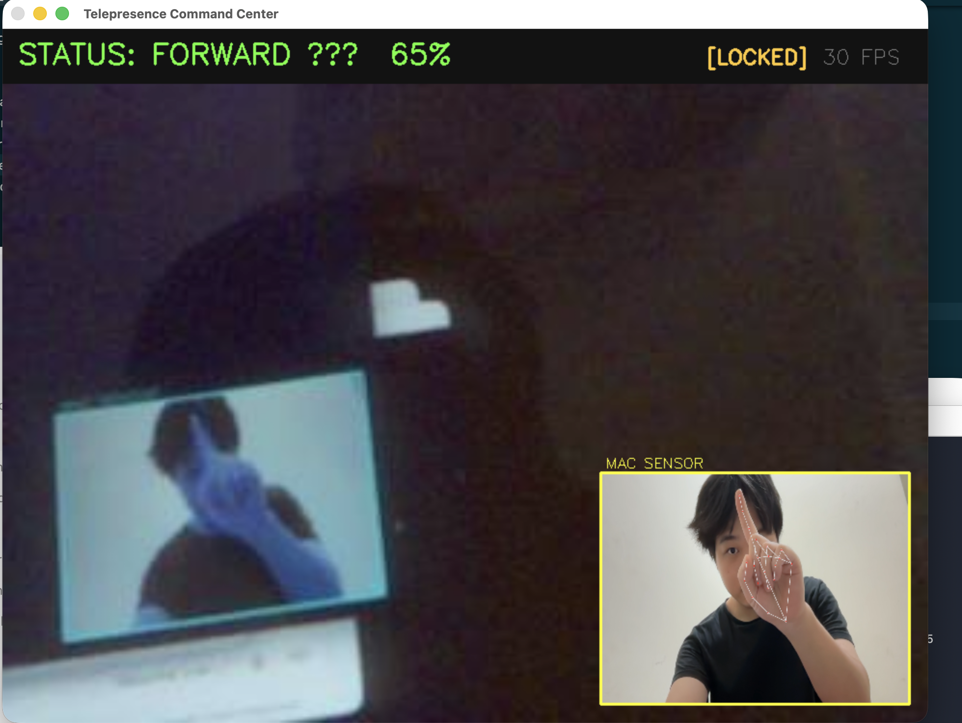
Figure 3. Host-side HUD showing FPV background stream, MediaPipe hand tracking overlay (PIP inset), locked command status, and real-time FPS counter.

5.2. Gesture Recognition Accuracy
Gesture recognition accuracy was evaluated using the built-in GestureAccuracyTest module. For each of the eight gesture classes, twenty independent trials were conducted, in which the operator held the target pose for up to two seconds and a trial was marked correct if GestureEngine confirmed the corresponding classification within that window; a trial was marked incorrect if the window elapsed without confirmation, or if a different class was confirmed instead. Table 4 reports the per-class results obtained from this protocol.

Table 4. Per-class gesture recognition accuracy (20 trials per class).
Gesture | Command | Correct / Total | Accuracy (%)
STOP (Fist) | SPACE | 20 / 20 | 100
ROTATE CW (Thumb) | Q | 20 / 20 | 100
ROTATE CCW (Thumb + Index) | E | 20 / 20 | 100
FORWARD (Index) | W | 20 / 20 | 100
BACKWARD (Index + Middle) | S | 20 / 20 | 100
STRAFE LEFT (3 fingers) | A | 17 / 20 | 85
STRAFE RIGHT (4 fingers) | D | 20 / 20 | 100
BOOST (Open palm) | BOOST | 20 / 20 | 100
Overall | — | 157 / 160 | 98.1
Overall accuracy across all eight classes and 160 trials was 98.1% (157/160). The only class that underperformed the otherwise uniform 100% ceiling was Strafe Left (mapped to the A command) at 85% (17/20), which is attributed to the ring finger partially curling inward whenever the pinky is folded into a fist-adjacent position, occasionally pushing its tip landmark below the extension threshold used by the index-through-pinky heuristic described in Section 3.1. Notably, the thumb-based rotation gestures (Q and E) — a pose category identified as problematic in at least one prior MediaPipe-based teleoperation system [4] — achieved 100% accuracy in this evaluation, a result that suggests the supported-arm posture used throughout this work stabilises the wrist relative to a free-standing or mid-air posture and thereby reduces inter-frame landmark variance, in addition to its already-established ergonomic benefit.
Table 7. Comparison with related gesture-controlled robot systems.
System | Hardware | Accuracy | Watchdog | Zero-Fatigue
Wameed 2023 [7] | Pi 4 | 95% | No | No
Zick 2024 [4] | PC + ROS2 | N/A | No | No
Ivačko 2026 [8] | Jetson Orin | N/A | No | No
Zarkasi 2026 [9] | Pi + STM32 | N/A | No | No
Ours | Pi 1 B+ | 98.1% | 533 ms | Yes

5.3. Watchdog Response Time
Six independent communication-loss events were induced by manually disabling the Host Node's Wi-Fi adapter while the robot was actively executing a non-stop command, simulating an abrupt and total loss of the wireless link rather than a gradual degradation. Table 5 reports the measured halt times observed for each of the six trials.
Table 5. Watchdog halt response times (six trials).
Trial | Response (ms) | Result
1 | 543 | PASS
2 | 570 | PASS
3 | 504 | PASS
4 | 510 | PASS
5 | 518 | PASS
6 | 554 | PASS
Mean | 533 | —
All six trials halted within the 600 ms analytical bound derived in Section 4.1, with a mean halt time of 533 ms and a range of 504–570 ms across trials, indicating that the measured behaviour is both consistent with the theoretical worst case and consistently well within it. This satisfies the design requirement that the robot reach a safe, fully stationary state within roughly one operator decision cycle — that is, within the timescale at which a human operator would notice the loss of video feed and could otherwise attempt a corrective action — after any communication failure, without relying on the operator to intervene.

5.4. End-to-End Command Latency
End-to-end latency, measured from the instant a gesture is confirmed by GestureEngine on the Host Node to the instant the corresponding motor activation takes effect on the Edge Node, was found to be approximately 1260 ms; Table 6 decomposes this total into its constituent stages.
Table 6. End-to-end command latency breakdown.
Stage | Latency
MJPEG stream buffering (Pi 1 B+ encoding limit) | ≈ 900 ms
Gesture confirmation gate (3 frames @ 30 fps) | ≈ 100 ms
UDP transmission (LAN) | < 5 ms
Motor safe-transition guard (command change only) | 80 ms
Total | ≈ 1260 ms
The dominant contributor to this total is MJPEG stream buffering, at approximately 900 ms, which arises directly from the limited JPEG encoding throughput of the Pi 1 B+'s 700 MHz ARM11 core rather than from any inefficiency in the command path itself — the UDP command transmission contributes less than 5 ms, and even the deliberately conservative 80 ms motor safe-transition dwell is a small fraction of the total. Despite this, the latch-state machine substantially mitigates the practical impact of the raw pipeline delay: because a locked command continues to be executed autonomously once confirmed, the operator is free to remove their hand and the robot continues executing the manoeuvre throughout the latency window, which decouples the operator's perceived responsiveness from the raw end-to-end pipeline delay measured in Table 6. The 900 ms video latency thus affects the freshness of the operator's situational awareness rather than the responsiveness of command execution.

6. Conclusions
This paper presented an Edge-Host Decoupled architecture for dependable, zero-fatigue gesture teleoperation of an omnidirectional mobile robot built on a Raspberry Pi 1 Model B+. By offloading all MediaPipe inference to the operator's laptop and adopting a supported-arm finger-count gesture vocabulary confirmed by a latch-state machine, the EHD architecture simultaneously addresses the computational constraints of legacy edge hardware and the ergonomic barriers of mid-air gesture interfaces established by Hansberger et al. [2], two challenges that prior MediaPipe-based teleoperation systems [4,7,8] have so far addressed only separately. The three-layer dependability stack — comprising the UDP watchdog, the motor safe-transition guard, and the gesture confirmation gate — ensures safe operation under both gesture ambiguity and communication failure, the two principal failure modes inherent to any vision-based, wirelessly-networked control scheme. Experimental results demonstrate 98.1% gesture recognition accuracy across eight pose classes and a watchdog halt response of 533 ms, achieved on severely resource-constrained hardware without any hardware upgrade, hardware modification, or increase in the platform's bill of materials.
Building on the contributions and limitations identified above, several directions remain for future work, including the following: (1) upgrading to Raspberry Pi 4 or 5 to enable on-device MediaPipe inference and eliminate Wi-Fi command latency; (2) replacing MJPEG with WebRTC to reduce stream latency from ≈900 ms to below 100 ms; (3) extending the gesture vocabulary to include dynamic gestures for continuous speed modulation; and (4) integrating a robotic arm on the mobile base for industrial logistics and inspection tasks. Future work will also migrate the gesture input source from the host webcam to the Pi NoIR camera, enabling face-to-face operator interaction. The Pi camera stream will serve dual purposes as both FPV display and gesture recognition input, eliminating the need for a secondary host camera. This architecture change also opens the path to autonomous person-following behaviour using MediaPipe pose estimation. These directions are broadly consistent with trends identified by recent surveys of vision-based hand gesture recognition for human-robot interaction [6], which point toward richer multimodal and continuous gesture vocabularies as a natural extension of discrete pose-based control such as the one presented here.
Author Contributions: Conceptualization, Y.-M.L. and T.-C.H.; methodology, Y.-M.L.; software, Y.-M.L.; validation, Y.-M.L.; formal analysis, Y.-M.L.; investigation, Y.-M.L.; writing—original draft preparation, Y.-M.L.; writing—review and editing, T.-C.H.; supervision, T.-C.H.; project administration, T.-C.H. All authors have read and agreed to the published version of the manuscript.
Funding: This research received no external funding.
Institutional Review Board Statement: Not applicable. This study involved no human subjects in a clinical or psychological research context; the operator interaction described constitutes engineering system evaluation.
Informed Consent Statement: Not applicable.
Data Availability Statement: Source code and experimental logs supporting this study are available at https://github.com/imyanming/RobotAI_Project.
Conflicts of Interest: The authors declare no conflicts of interest.

References
1. Zhang, F.; Bazarevsky, V.; Vakunov, A.; Tkachenka, A.; Sung, G.; Chang, C.-L.; Grundmann, M. MediaPipe Hands: On-device Real-time Hand Tracking. In Proceedings of the ECCV Workshop on Computer Vision for Augmented and Virtual Reality, Online, 2020; arXiv:2006.10214.
2. Hansberger, J.T.; Peng, C.; Mathis, S.L.; Areyur Shanthakumar, V.; Meacham, S.C.; Cao, L.; Batterman, H.R. Dispelling the Gorilla Arm Syndrome: The Viability of Prolonged Gesture Interactions. In Virtual, Augmented and Mixed Reality; Lackey, S., Chen, J., Eds.; Lecture Notes in Computer Science, vol. 10280; Springer: Cham, Switzerland, 2017; pp. 505–520. https://doi.org/10.1007/978-3-319-57987-0_41.
3. gpiozero Development Team. gpiozero: A Simple Interface to GPIO Devices with Raspberry Pi, Version 2.0. Available online: https://gpiozero.readthedocs.io (accessed on June 2026).
4. Zick, L.A.; Martinelli, D.; de Oliveira, A.S.; Kalempa, V.C. Teleoperation system for multiple robots with intuitive hand recognition interface. Sci. Rep. 2024, 14, 29760. https://doi.org/10.1038/s41598-024-80898-x.
5. Deepak, B.B.V.L.; Parhi, D.R.; Jha, A.K. Kinematic Model of Wheeled Mobile Robots. Int. J. Recent Trends Eng. Technol. 2011, 5, 5–10. DOI: 01.IJRTET.05.04.128.
6. Qi, J.; Ma, L.; Cui, Z.; Yu, Y. Computer vision-based hand gesture recognition for human-robot interaction: a review. Complex Intell. Syst. 2024, 10, 1581–1606. https://doi.org/10.1007/s40747-023-01173-6.
7. Wameed, M.; Alkamachi, A.M.; Erçelebi, E. Tracked Robot Control with Hand Gesture Based on MediaPipe. Al-Khwarizmi Eng. J. 2023, 19, 56–71. https://doi.org/10.22153/kej.2023.04.004.
8. Ivačko, N.; Ćirić, I.; Simonović, M. Edge Computing Approach to AI-Based Gesture for Human–Robot Interaction and Control. Computers 2026, 15, 241. https://doi.org/10.3390/computers15040241.
9. Zarkasi, A.; Pradnyananda, G.; Sembiring, S.; Prasetyo, A.P.P.; Firnando, R.; Abdurahman, A. Implementation of Finger Gesture-Based Medicine Delivery Robot Control System with MediaPipe. J. Electr. Electron. Inf. Commun. Technol. 2026, 8, 108142. https://doi.org/10.20961/jeeict.8.1.108142.
10. Hu, M.; Li, J.; Jin, R.; Shi, C.; Xu, L.; Liu, R. HGIC: A Hand Gesture Based Interactive Control System for Efficient and Scalable Multi-UAV Operations. arXiv 2024, arXiv:2403.05478.
Disclaimer/Publisher’s Note: The statements, opinions and data contained in all publications are solely those of the individual author(s) and contributor(s) and not of MDPI and/or the editor(s). MDPI and/or the editor(s) disclaim responsibility for any injury to people or property resulting from any ideas, methods, instructions or products referred to in the content.

