Splay Trees
A few points:
A Splay Tree is a self-adjusting Binary Search Tree (BST).
Whenever a node is accessed, move that node to the root.
This operation is called splaying.
There is no concept of balance factor.
Features:
- No Extra Metadata: They require no balance accounting data (like color bits in red-black trees or height numbers in AVL trees), saving memory.
- Locality of Reference: If we access a piece of data once, it moves to the top, making subsequent lookups of the same data instantaneous.
- Efficiency: While a single worst-case operation can take time proportional to the number of elements, a sequence of m operations is guaranteed to run in time proportional to m * log(n, 2).
- Dynamic Adaptation: The tree structure continuously morphs to fit the actual access pattern of the workload rather than enforcing a rigid shape.
Uses:
- Caches and Memory Allocation: Great for systems where a small subset of data is requested repeatedly.
- Network Routers: Used to quickly look up frequently matched IP addresses.
- Data Compression: Ideal for algorithms that exploit recurring patterns in data streams.

The first diagram in the next page illustrate the three basic operations : Zig-Zig, Zig-zag and Zig. We shall discuss them in detail.
The second diagram illustrates what happens when the key 2 is searched. This key will move to the root.
Frequently accessed elements move to the root. The principle of the splat tree is that the key accessed recently is likely to be accessed again in the near future.
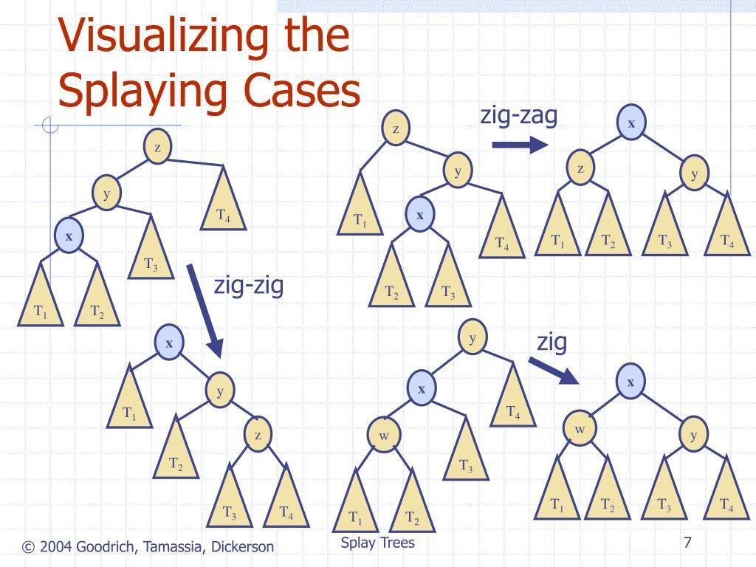
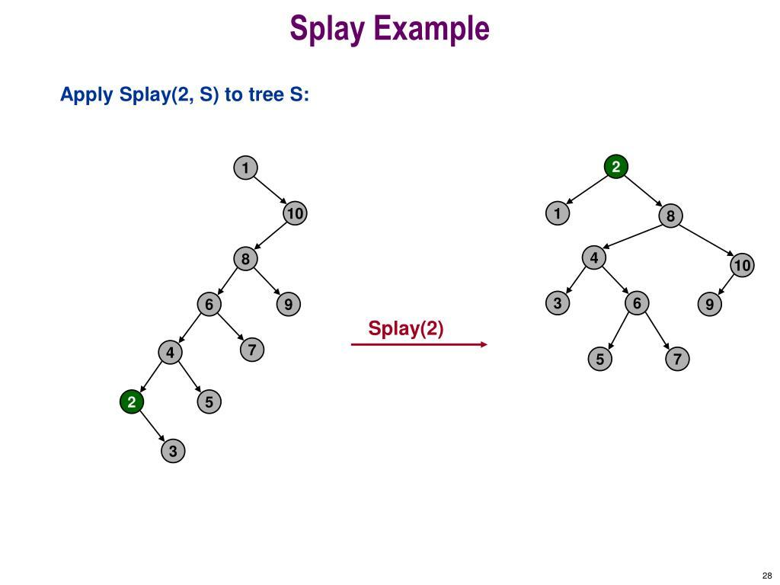

How is a node moved to the root?
Splaying is performed using rotations.
There are three basic cases:
- Zig
- Zig-Zig
- Zig-Zag

- Case 1 : Zig:
This occurs when the node being accessed is a child of the root.
Suppose we access 30:
50
/
30
Perform a right rotation:
30
\
50
So 30 becomes the root.
Suppose we access 70
50
\
70
perform a left rotation:
70
/
50

Zig rule
Node is child of root
↓
Perform one rotation
↓
Node becomes root
Case 2 — Zig-Zig
This occurs when the node and its parent are both on the same side.
For example:
50
/
30
/
20
We want to access 20.
Here:
- 20 is the left child of 30
- 30 is the left child of 50
So this is Left-Left (LL).
First rotation
Rotate 50 right:
30
/ \
20 50

Second rotation
Rotate 30 right:
20
\
30
\
50
So:
50 20
/ \
30 → 30
/ \
20 50
This is Zig-Zig.

5. Another Zig-Zig: Right-Right
Consider:
20
\
30
\
50
Access 50.
Both links are to the right.

Therefore, it is a Right-Right (RR) case.
After two left rotations:
50
/
30
/
20
So:
LL → two right rotations

RR → two left rotations

Case 3 — Zig-Zag
Here the node and its parent are on opposite sides.
Consider:
50
/
20
\
30
We want to access 30.
Here:
- 30 is the right child of 20
- 20 is the left child of 50
Therefore:
Left-Right (LR) configuration.
First rotation
Rotate 20 left:
50
/
30
/
20
Second rotation
Rotate 50 right:
30
/ \
20 50
So 30 becomes the root.
The four rotation patterns
Configuration | Splay operation
Node is child of root | Zig
Left-Left | Zig-Zig
Right-Right | Zig-Zig
Left-Right | Zig-Zag
Right-Left | Zig-Zag
A useful way to remember it:
Same direction → Zig-Zig
Opposite direction → Zig-Zag
One level from root → Zig

Example 1: search for 20
50
/ \
30 70
/ \ / \
20 40 60 80
50
/
30
/
20
The path is:
50 → 30 → 20
Since:
20 is left child of 30
30 is left child of 50
we have Zig-Zig.
After splaying:
20
\
30
/ \
? 50

Including the remaining nodes, the resulting tree is:
20
\
30
\
50
/ \
40 70
/ \
60 80
The important point is not that the tree remains perfectly balanced.
The important point is:
20, which was just accessed, is now at the root.

Example 2:
What happens if we now access 60?
Current tree:
20
\
30
\
50
/ \
40 70
/ \
60 80
The path to 60 is:
20 → 30 → 50 → 70 → 60
The node 60 is:
60 is left child of 70
70 is right child of 50
This is a Zig-Zag configuration.
After appropriate rotations, 60 moves upward.
Eventually:
60
/ \
20 70
\ \
30 80
\
50
/
40.
and 60 becomes the root.
Thus, every access modifies the tree.

