Theme: Personal Expense Tracker DB
Section A: Concept Application
- Explain how relational databases help maintain accuracy in expense records.
- Relational databases keep expense record accurate by organizing data into connected tables and applying rules.
They use keys to link data correctly, so every expense matches a valid user or category.
Constraints stops the wrong entries.
Normalizations avoid duplicate or inconsistent data.
Also transaction ensures all changes are saved properly or not at all.
This structures helps prevent errors and keeps data inconsistent.

- Why are constraints important in personal finance data?
- Constraints are important in personal financial data because they prevent incorrect or invalid entries.
They make sure things like:
The amount are not negative
Data are valid
Required fields (like category) are not empty

This keeps the data are accurate, consistent and reliable , which is essential for tracking expenses correctly and making good financial decisions.

- How does GROUP BY help analyze spending patterns?
- GROUP BY helps you summarize expenses by grouping similar data.
How it helps analyze spending:
- Category-wise Spending:-
you can group expenses by category
Query:- SELECT category, SUM(amount) FROM expenses GROUP BY category;

- Monthly spending spends:-
Query:- SELECT Month(date), SUM(amount) FROM expenses GROUP BY Month(date);

- Frequent expense types:-
You can count how often you spend in each category.
Query:- SELECT category, COUNT(*) FROM expenses GROUP BY category;

- Average Spending behavior:-
Query:- SELECT category, AVG(amount) FROM expenses GROUP BY category;

- Explain a scenario where rollback is required during expense entry.
- A rollback is needed when something goes wrong while entering an expense and you don’t want partial or incorrect data saved.

Example scenario:-
Suppose you are adding new expenses :-
Amount: 500
Category: Food
Payment Method : card

The system start saving the data,
But the category is invalid or
The payment update fails.

What Rollback Does:-
Rollback cancels the entire transactions and restore the database to it’s previous state, so no partial or wrong data is saved.

- How do views help users track monthly expenses efficiently?
- View helps users track monthly expenses by saving ready-made query that shows only the needed data.

A view can show expenses grouped by month.
It hides complex SQL, so user just query the view.
It always shows updated data automatically.
Query:- SELECT Month(date) AS month, SUM(amount) total FRey OM expenses GROUP BY Month(date);

- Why use triggers for automatic category or balance updates?
- Triggers are used to automatically updated data when an expenses added, updated and deleted.

Why they are useful:-
Auto Category Handling :- Assign or adjust categories without manual input.
Auto Balance Update :- Deduct amount from balance as soon as an expense is entered.
Data Consistency :- ensures related data is always correct.
Less Manual Work:- no need to write extra queries every time.

Section B: SQL Hands-On
- Create a Database on ExpenseDB;
- Create database ExpenseDB;
Screenshot:-

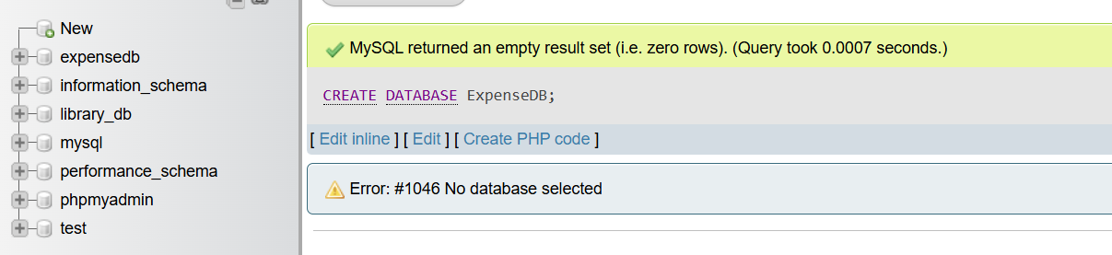

- Create a Table for users, categories and expenses.
- Below the table are created.
- Table 1:- Users

CREATE TABLE users(user_id int PRIMARY KEY AUTO_INCREMENT, name varchar(50),email varchar(100) UNIQUE, created_at DATE);

Screenshot:-

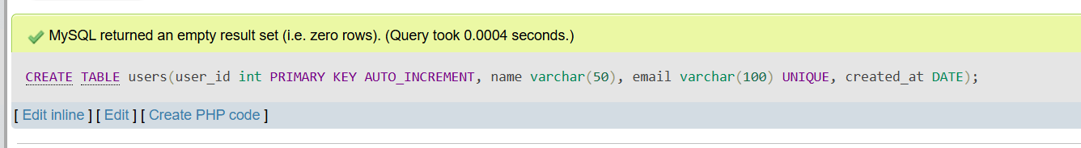
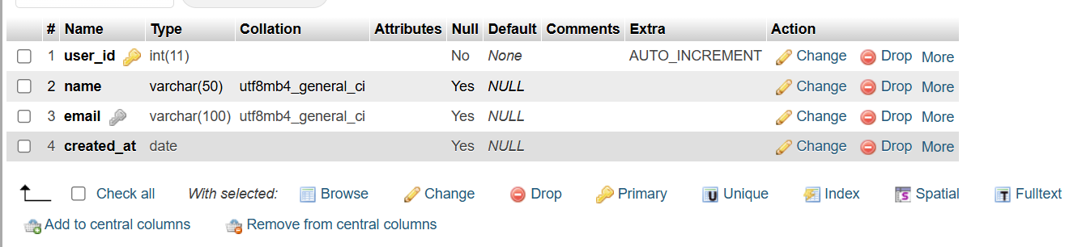

- Table 2:- Categories

CREATE TABLE categories(category_id int PRIMARY KEY AUTO_INCREMENT, category_name varchar(50));

Screenshot:-

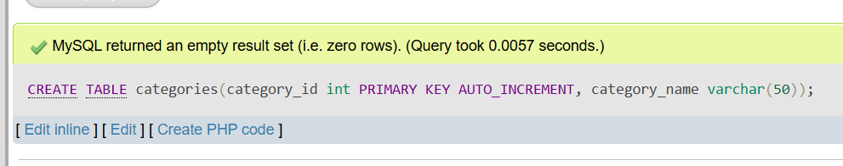
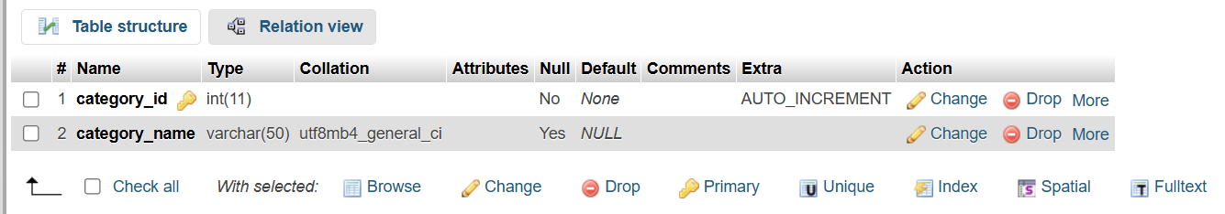

- Table 3:- Expenses

CREATE TABLE expenses(expense_id int PRIMARY KEY AUTO_INCREMENT, user_id int, category_id int, amount DECIMAL(10,2), expense_date DATE, FOREIGN KEY(user_id) REFERENCES users(user_id), FOREIGN KEY(category_id) REFERENCES categories(category_id));

Screenshot:-

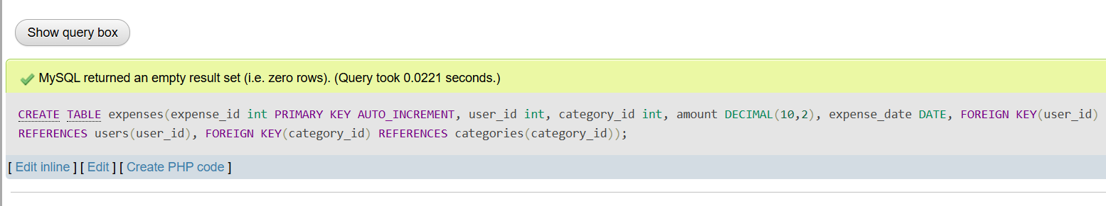
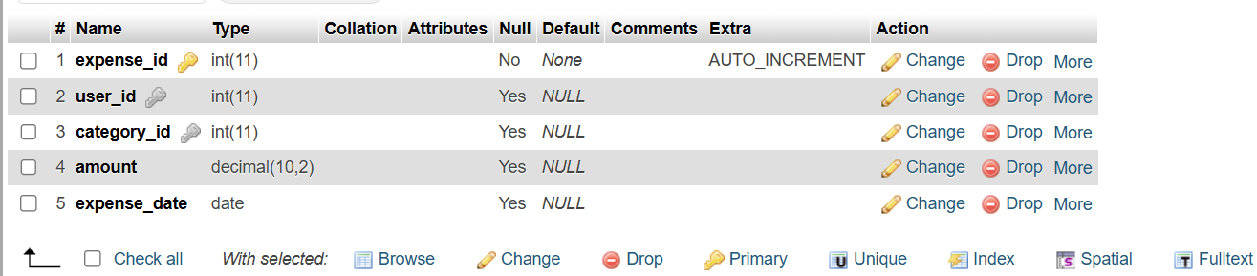

- DDL Understanding :-

- Explain why foreign keys are used: Specifically, why must user_id in the expenses table correspond to a real ID in the users table?
- Foreign keys are used to enforce relationships and maintain data integrity between tables and database.
In your personal expense tracker example,
The users table store valid users.
The expense table records transactions and includes a user_id columns.

Why must user_id in expenses correspond to a real ID in users?
Because of referential integrity – a core concept in relational database.
- Prevent Invalid data
- Ensures meaningful relationships
- Maintain consistency
- Improves query reliability.

- Mention one issue that would occur if foreign keys were removed: Describe the risk of "Orphaned Records" (e.g., an expense existing for a user who has been deleted).
- In foreign keys are removed, one major issue is orphaned records.
This happens when expense remains in the expense table even though its’s related user has been deleted from the users table

Risk:
- The expense has a user_id that no longer exists.
- It becomes unclear who expense belongs to
- Reports and query may show incorrect or confusing data.

- DML Operations:-
Write SQL queries to:
● Insert 5 users into the users table with unique names and emails.
INSERT INTO users(name,email,created_at)VALUES('YashTailor','yash165@gmail.com','2026-04-24');
INSERT INTO users(name,email,created_at)VALUES('Raj Patel','raj15@gmail.com','2026-02-18');
INSERT INTO users(name,email,created_at)VALUES('Sahil Patel','sahil56@gmail.com','2025-01-12');
INSERT INTO users(name,email,created_at)VALUES('KrunalRathod','krunal12@gmail.com','2024-04-22');
INSERT INTO users(name,email,created_at)VALUES('ParthPatel','parth23@gmail.com','2023-02-07');
Screenshot:-
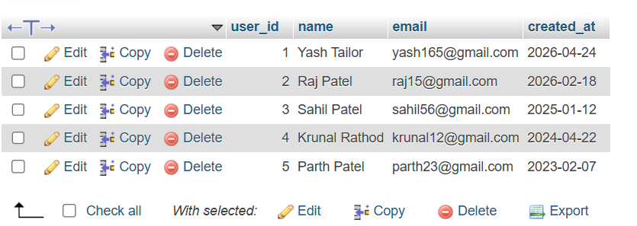

- Insert 3 categories (e.g., 'Food', 'Rent', 'Entertainment').
INSERT INTO categories(category_name)VALUES('Food');
INSERT INTO categories(category_name)VALUES('Rent');
INSERT INTO categories(category_name)VALUES('Entertainment');
Screenshot:-
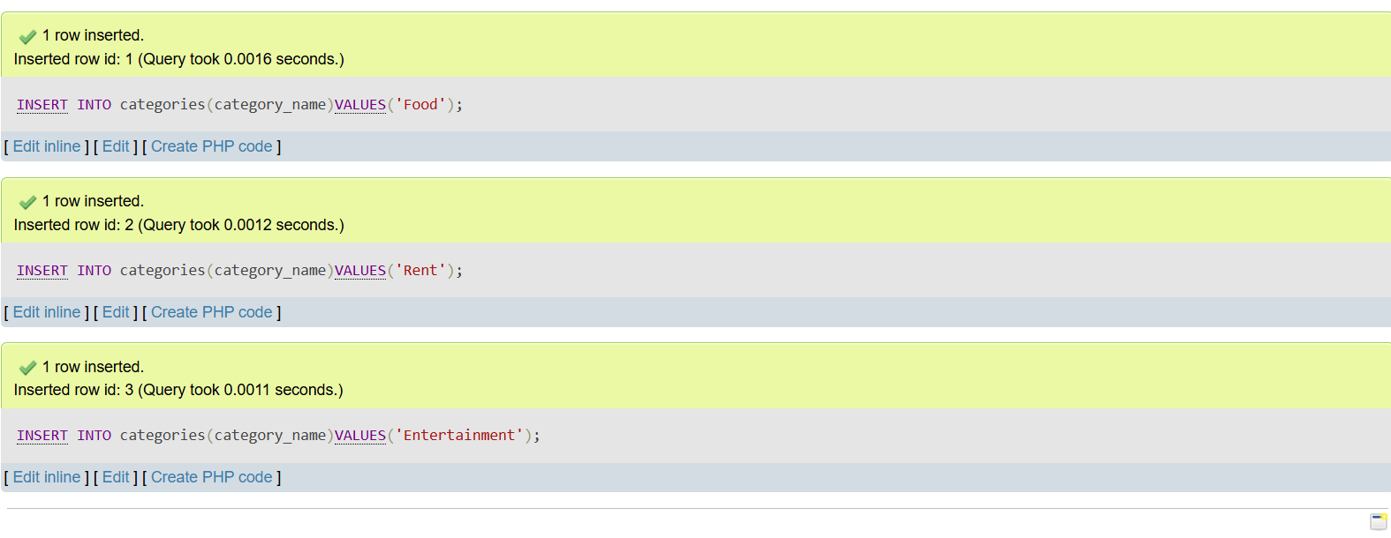
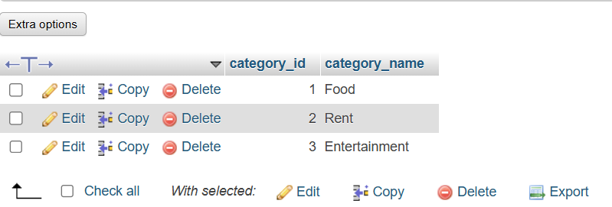

- Insert 10 expense records distributed across different users and categories.
INSERT INTO expenses (expense_id, user_id, category_id, amount, expense_date) VALUES
(1, 1, 1, 250.50, '2024-06-01'),
(2, 1, 2, 8000.00, '2024-06-02'),
(3, 2, 1, 300.00, '2024-06-03'),
(4, 2, 3, 1200.00, '2024-06-04'),
(5, 3, 2, 7500.00, '2024-06-05'),
(6, 3, 1, 150.75, '2024-06-06'),
(7, 4, 3, 500.00, '2024-06-07'),
(8, 4, 1, 220.00, '2024-06-08'),
(9, 5, 2, 9000.00, '2024-06-09'),
(10, 5, 3, 650.00, '2024-06-10');
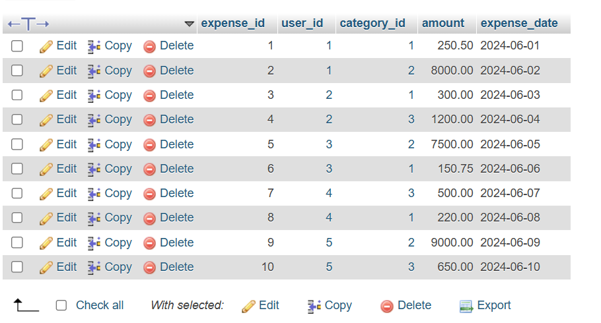

- Update one incorrect expense: Use the UPDATE command to change the amount of a specific expense_id.
UPDATE expenses SET amount = 200.75 WHERE expense_id=6;
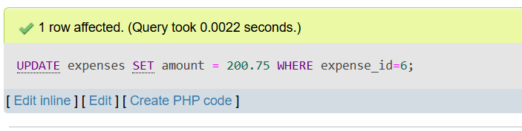

- Delete one expense: Remove a record where the amount is less than a specific value.

DELETE FROM expenses WHERE amount < 500;

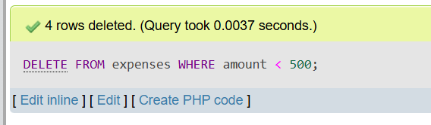
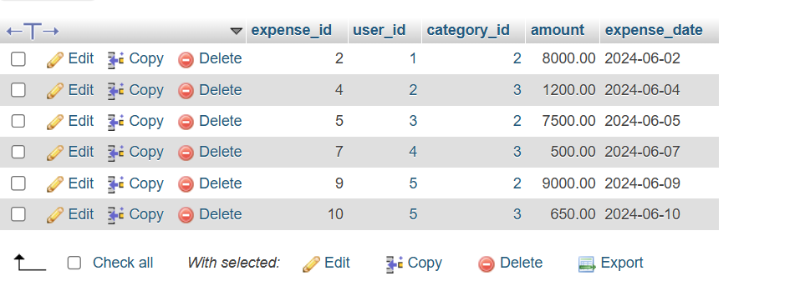

- Data Retrieval:-
- Display all expenses with details: Show the expense_date, amount, name (from users), and category_name (from categories) using INNER JOIN.
Query:-
SELECT expenses.expense_date, expenses.amount, users.name, categories.category_name FROM expenses INNER JOIN users ON expenses.user_id = users.user_id INNER JOIN categories ON expenses.category_id = categories.category_id;
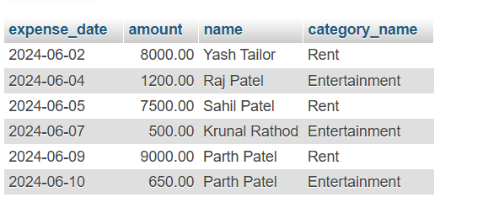

- Show total expense amount per category: Use SUM(amount) and GROUP BY category_name.

Query:-

SELECT categories.category_name, SUM(expenses.amount) AS total_expense FROM expenses INNER JOIN categories ON expenses.category_id = categories.category_id GROUP BY categories.category_name;

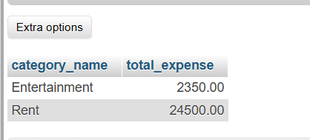

- Display users sorted by total spending: List user names and their total sum of expenses, ordered from highest to lowest.

Query:-

SELECT users.name, SUM(expenses.amount) AS total_spending FROM expenses INNER JOIN users ON users.user_id = expenses.user_id GROUP BY users.name ORDER BY total_spending DESC;

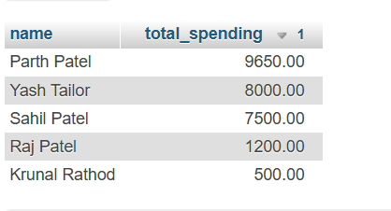

- Views :-

- Create a view named ActiveUsersView: This view should list the name and email of any user who has logged more than 5 individual expense records.

Query:-

CREATE VIEW ActiveUsersView AS SELECT users.name, users.email FROM users INNER JOIN expenses ON users.user_id = expenses.user_id GROUP BY users.user_id, users.name, users.email HAVING COUNT(expenses.expense_id) > 5;

SELECT *FROM ActiveUsersView;

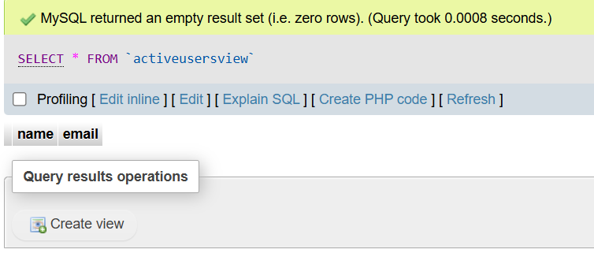

Section C: Mini Project
Mini Project: Expense Tracker DB
Using the same schema:
- Write CRUD queries
- Insert :- (Create)

Query:-

INSERT INTO expenses(expense_id, user_id, category_id, amount, expense_date)values(11, 1, 1, 450.00, ‘'2024-06-11'’);

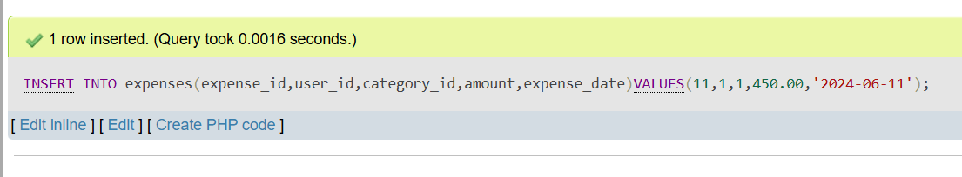
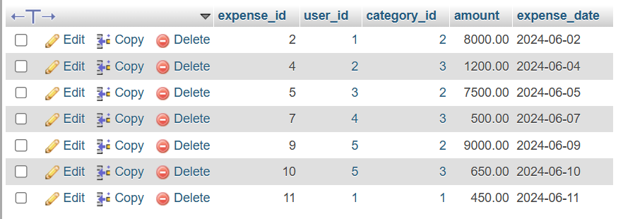

- Select(Read):-

Query:-

SELECT *FROM expenses;


- Update :-
Query:-

UPDATE expenses SET amount = 800.65 WHERE expense_id = 10;

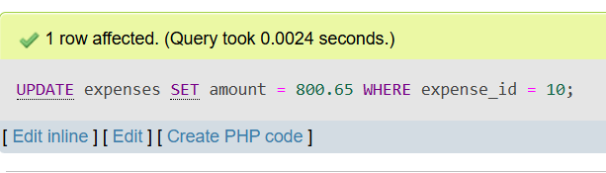

- Delete :-
Query:-
DELETE FROM expenses WHERE expense_id = 11;

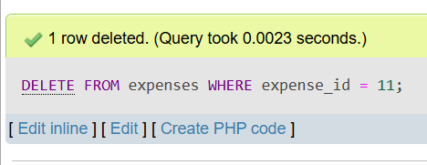
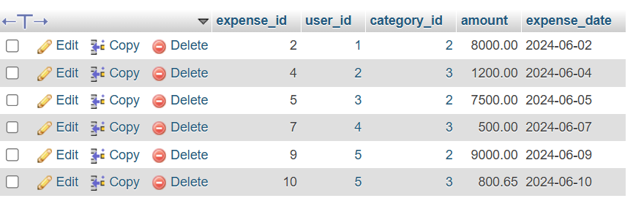

- Write a stored procedure to calculate monthly user expense

Query:-

DELIMITER //
CREATE PROCEDURE GetMonthlyExpense(
IN p_user_id int,
IN p_month int,
IN p_year int
)
BEGIN
SELECT users.name, SUM(expenses.amount) AS total_monthly_expense FROM expenses JOIN users ON expenses.user_id = users.user_id WHERE expenses.user_id = p_user_id AND MONTH(expenses.expense_date) = p_month AND YEAR(expenses.expense_date) = p_year GROUP BY users.name
END //

DELIMITER ;

Execute Query:- CALL GetMonthlyExpense(1, 6, 2024);

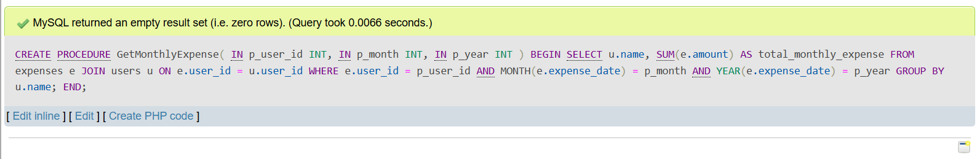

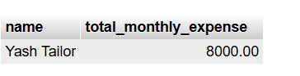

- Demonstrate COMMIT and ROLLBACK with example queries

ROLLBACK :-

Query:-

START TRANSACTION;

INSERT INTO expenses(expense_id,user_id,category_id,amount,expense_date)VALUES(12,2,1,600.00,'2024-06-12');

SELECT *FROM expenses WHERE expense_id = 12;

ROLLBACK;

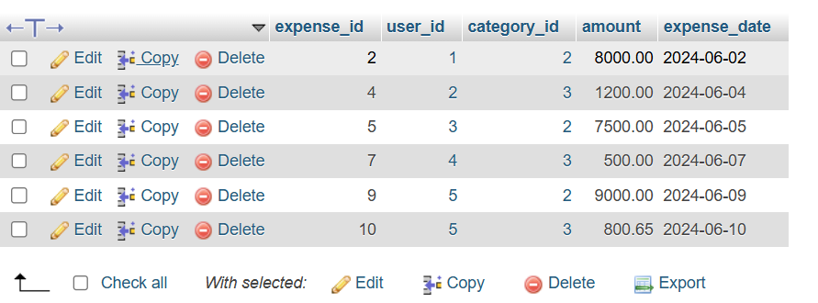

COMMIT :-
Query :-
START TRANSACTION;
INSERT INTO expenses(user_id,category_id,amount,expense_date)VALUES(3,2,700.00,'2024-06-13');
COMMIT;

