Assignment - 1
Module 1 – Overview of IT Industry
- What is a Program?
- Program is a set of instructions for a computer to execute a specific tasks.
- Write a simple "Hello World" program in two different programming languages of your choice. Compare the structure and syntax ? - LAB EXERCISE
- Input :-

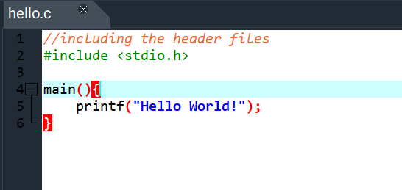

Output:-
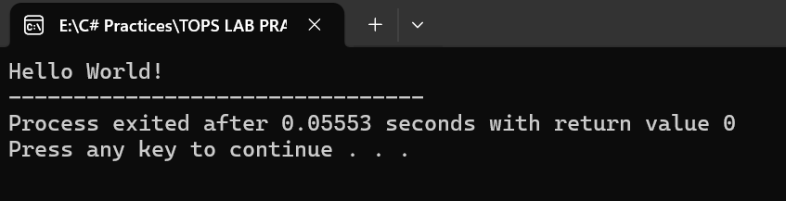
Compare Structure and Syntax between C language and python programming language
C Language | Python Language
Compiled Programming Language | Interpreted Programming Language
High Speed | Low Speed
Complex Syntax | Simple Syntax
Limited set of Built-in Functions | Extensive library of Built-in Functions
Manual Memory Management | Automatic Memory Management

- Explain in your own words what a program is and how it functions.
- Program is a set of instructions for a computer to execute a specific tasks.
How Program Functions Work :-
- Written in Code :- A Programmer writes the instructions using specific programming languages such as python, c etc..
- This source code is designed to be clear and logical.
- Compilation or Interpretation:- Source code is converted into machine code through the process called compilation , or read and executed line-by-line by an interpreter.
- Execution:- The computer’s CPU carries out instructions sequentially, from start to finish.
- This might involve processing input, performing calculations, making decisions based on conditions, managing data and producing output.
- Interaction:- The program interacts with computer’s hardware, such as memory(RAM)
Storage drives, screen, keyboard and network connections to complete it’s task and produce to desired result or user experience.

- What is Programming?
- Programming is the process of writing step-by-step instructions called code in a specific language that tells computer how to perform task or solve the problem.

- What are the key steps involved in the programming process?
- Here’s some key steps of programming process:-
Step 1 : Analysis/Problem Definition:-
- Understand the problem, user needs, goals, inputs, and expected outputs.
Step 2 : Design :-
- Develop a solution strategy (algorithm) using pseudocode or flowcharts.
Step 3 : Coding/Implementation :-
- Translate the design into actual code using a chosen programming language, adhering to syntax.
Step 4 : Testing & Debugging :-
- Run the program to find and fix errors (bugs).
Step 5 : Documentation :-
- Create comments, user manuals, and technical guides for clarity and future maintenance.
Step 6 : Deployment & Maintenance :-
- Release the program to users.
- Ongoing updates, bug fixes, and feature additions.
- Types of Programming Languages?
- There are basically five types of programming languages.
- Procedural- oriented Programming Language (such as C, C++, Java)
- Object-oriented Programming Language (Such as Java, Python, PHP)
- Logical Programming Language (such as prolog)
- Functional Programming Language (such as Scala, Erlang)
- Scripting Language (PHP, Ruby)

- What are the main differences between high-level and low-level programming languages?
- Here’s the main differences between high-level and low-level programming languages
Low-Level Languages | High-Level Languages
Easy to Understand for machine, but less human-readable. | Human readable and easier to understand and use.
Not Portable | Portable
Higher Execution Speed | Comparatively Lower Execution Speed
Uses Binary code and mnemonics | Uses Syntax and semantics
Example:- Assembly Language, Machine Language | Example:- Java, Python, C++

- World Wide Web & How Internet Works ?
- It is a collection of websites or web pages stored in web servers.
- Connected to local computers through the internet.
How Internet Works :-
- The Internet works by connecting networks together through a series of routers and switches.

- Research and create a diagram of how data is transmitted from a client to a server over the internet. -- LAB EXERCISE

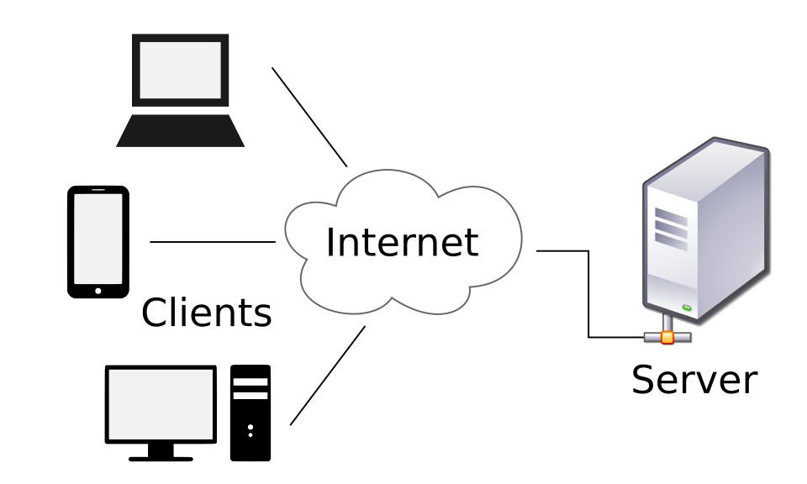

- Describe the roles of the client and server in web communication.
- Client sent a Request :- The client start the conversation by a sending a request.
- Server Processes Request :- The server does necessary work – this might involve querying a database, running a computation, or reading a file.
- Server Sends a Response :- The server sends back the requested information, or an error message if something goes wrong.
- Network Layers on Client and Server ?
- There are basically 7 layers on Client and Server.
- Physical Layer :- Deals with the physical connection between devices.
- Data-Link Layer :- Handle communication between adjacent network nodes.
- Network Layer :- Manages data transfer between different networks.
- Transport Layer :- Ensures reliable transmission of data.
- Session Layer :- Manages sessions and connections between applications.
- Presentation Layer :- Translate the data between application layer and the network.
- Application Layer :- Interfaces directly with the end-user or application.
- Design a simple HTTP client-server communication in any language. - LAB EXERCISE:

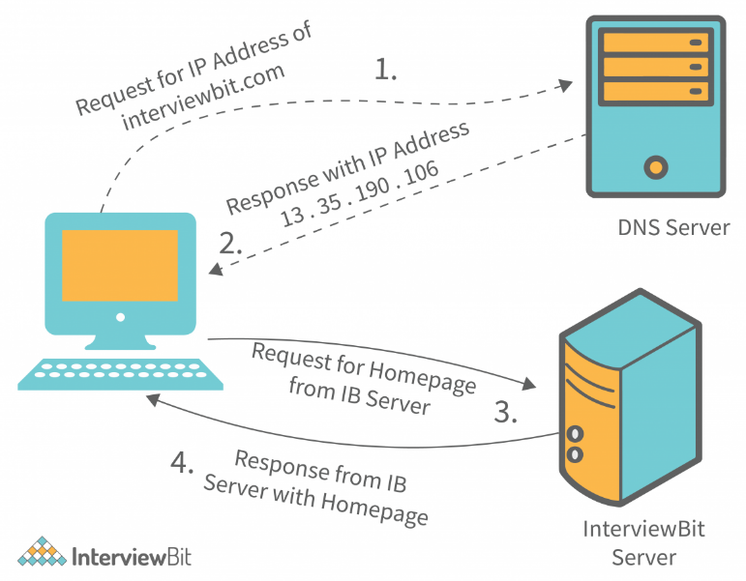
- Explain the function of the TCP/IP model and its layers ?
- TCP/IP Working :- Breaks data into segments and ensures reliable (TCP) or Fast (UDP) delivery.
- Layers of TCP/IP Model :-
- Application Layer :- This layer is used by users and application, it include protocols like HTTP, FTP, SMTP. It manages how the data is presented, formatted and secured.
- Transport Layer :- Ensures reliable transmission of data.
- Network Layer :- Manages data transfer between different networks.
- Network Access Layer:- Handles how data is sent on the local network using hardware, cables, Wi-Fi, Ethernet, etc.
- Explain Client Server Communication ?
- Client sent a Request :- The client start the conversation by a sending a request.
- Server Processes Request :- The server does necessary work – this might involve querying a database, running a computation, or reading a file.
- Server Sends a Response :- The server sends back the requested information, or an error message if something goes wrong.
- Types of Internet Connections ?
- There are 8 types of Internet Connections:
- Dial-Up Connection
- Broadband Connection
- DSL(Digital Subscriber Line)
- Cabel
- Satellite Connection
- Wireless Connection
- Cellular
- ISDN (Integrated Service Digital Network).
- Research different types of internet connections (e.g., broadband, fiber, satellite) and list their pros and cons. - LAB EXERCISE
- Here’s are the different types of internet connections
- Dial-Up Connection :-
Pros :- Low Cost.
Cons :- Very Slow speed.
- Broadband Connection :-
Pros :- High-Speed Internet, Always Connected.
Cons :- More expensive than dial-up connection.
- DSL(Digital Subscriber Line) :-
Pros :- Uses existing telephone lines, Faster than Dial-Up
Cons :- Speed decreases with distance
- Cabel :-
Pros :- Fast Internet Speed, Goof for Streaming.
Cons :- Speed may slow during peak hours.
- Satellite Connection :-
Pros :- Available in Remote Areas.
Cons :- Affected by weather.
- Wireless Connection :-
Pros :- No Cable Required, Easy to use.
Cons :- Limited Range
- Cellular Connection :-
Pros :- Portable and mobile access
Cons :- Limited data Plans.
- ISDN(Integrated Service Digital Network) :-
Pros :- More reliable than dial-up.
Cons :- Outdated and expensive.
- How does broadband differ from fiber-optic internet?
- Here’s a difference from broadband and fiber-optic
Broadband Internet | Fiber-Optic Internet
Medium to High Speed | Very High Speed
Uses Copper Cables (DSL/Cable) | Uses Fiber-Optic Cables
Can slow during peak hours | Very reliable
Widely available | Limited availability
Less Expensive | More Expensive
Best for home use | Best for gaming, streaming, heavy usages.
- Protocols ?
- Protocol is a set of rules accomplished by network.
- Protocols identifies the rules, syntax, semantics and synchronization of communication and error managing methods.
- There are five types of protocols
- HTTP or HTTPS
- FTP (File Transfer Protocol)
- Email (POP3, SMTP)
- TCP (Transmission Control Protocol)
- UDP (User Datagram Protocol)
- Simulate HTTP and FTP requests using command line tools (e.g., curl) - LAB EXERCISE ?
- HTTP Request using curl :-
Curl https : //google.com
- Sends an http GET request and show the web page content.
- HTTP POST Request :-
Curl – X POST – d “name=yash” https://google.com/form
- Sends data to a server.
- FTP Request using curl :-
Curl ftp://ftp.google.com
- Lists files on a FTP Server.
- FTP Download :-
curl -u username : password ftp://ftp.google.com/file.txt

- What are the differences between HTTP and HTTPS protocols?
- Here’s the difference of HTTP and HTTPS Protocols
HTTP | HTTPs
HTTP stands for Hyper Text Transfer Protocol. | HTTPs stands for Hyper Text Transfer Protocol Secure.
HTTP is less secure. | HTTPs is more secure.
HTTP works in application layer of OSI model. | HTTPs works in transport layer of OSI model.
HTTP does not use certificate. | HTTPs uses SSL certificate.
There is no encryption and decryption. | There is encryption and decryption.
- What is Application Security ?
- It refers to security precautions used at the application level to prevent the theft to hijacking of data or code within the Application.
- It include security concerns made during application development and design etc. once they have been deployed.
- Identify and explain three common application security vulnerabilities. Suggest possible solutions. - LAB EXERCISE
- Here’s a three common application security vulnerabilities :-
- SQL Injection :-
- Attackers insert malicious SQL code into input fields to access or modify database.
Solutions :-
- Use Prepared Statement / Parameterized queries.
- Validate and sanitize user input.
- Use ORM Frameworks.
- Cross-Site Scripting (XSS) :-
- Attackers inject malicious scripts into web pages viewed by other users.
Solutions :-
- Escape and encode output.
- Use Content Security Policy (CSP).
- Validate and sanitize user input.
- Broken Authentication :-
- Weak authentication allows attackers to take over user accounts.
Solutions :-
- Enforce strong passwords policy.
- Use Multi-Factor Authentication (MFA).
- Secure Session Management (HTTPs, secure cookies).
- What is the role of encryption in securing applications?
- Encryption ensures no one can read communications or data except the intended recipient or data owner.
- This prevents attackers from intercepting and accessing sensitive data.
- Software Applications and Its Types ?
- Software applications are programs designs to help users perform specific tasks on a computer or mobile device.
- Types of Software Applications :-
- Application Software
- System Software
- Driver Software
- Middleware
- Programming Software
- Identify and classify 5 applications you use daily as either system software or application software ? - LAB EXERCISE
- Here’s the five applications I daily use either system software or application software.
- Google Chrome (Web Browser) :- Classification :- Application Software
- WhatsApp (Messaging) :- Classification :- Application Software
- Spotify (music streaming) :- Classification :- Application Software
- Google Maps (Navigation) :- Classification :- Application Software
- Android/IOS (Operating System) :- Classification :- System Software.
- What is the difference between system software and application software?
- Here’s the difference between system software and application software.
System Software | Application Software
Manages and controls Computer Hardware. | Helps user perform specific tasks.
Acts as an interface between hardware and user. | Acts as an interface between user and system software.
Runs in the background. | Runs when user starts it.
Required for system to operate. | Not Required for basic system operation.
Installed during system setup. | Installed as per user needs.
Examples :- Operating Systems, Device Drivers. | Examples :- MS Word, Excel, Browser.

- Design a basic three-tier software architecture diagram for a web application. – LAB EXERCISE
- Here’s below the diagram
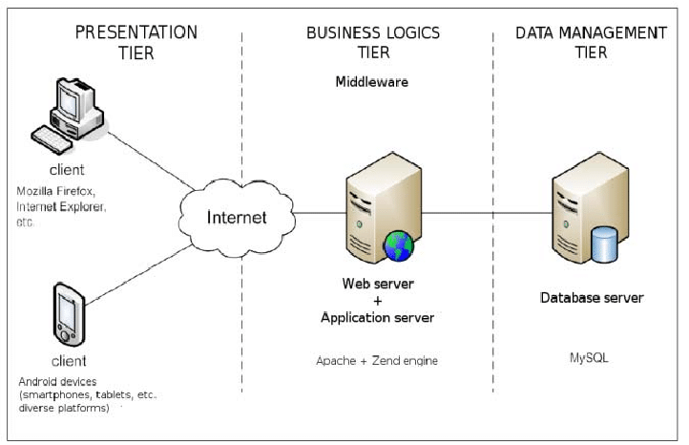
- What is the significance of modularity in software architecture?
- Here’s the below significance of modularity
- Improves Maintainability :-
- Makes the system easier to understand.
- Allow changes and bug fixes without affecting other parts.
- Enhances Reusability :-
- Modules can be reused in different projects.
- Saves development time and efforts.
- Supports Scalability :-
- Individual modules can be optimized, replaced or scaled independently.
- New functionality can be added without redesigning the entire system.
- Enables Parallel Development :-
- Different teams can work separate modules at the same time.
- Reduce development time.
- Improves Testability :-
- Unit Testing of individual modules.
- Make it easier to identify and fix errors.
- Promotes Flexibility and Adaptability :-
- Modules can be updated or swapped with minimal impact
- The systems adapts more easily to new technologies or platforms.
- Encourages Better design practice :-
- Support separation of concerns.
- Ensure low coupling and high cohesion.
- Reduces Risk and Cost :-
- Limits the impacts of changes.
- Lowers long-term maintenance costs.
- Layers in Software Architecture ?
- There are basically five types of layer in software architecture:-
- Presentation Layer :-
- It is also called UI layer.
- It handles everything related to the user interface , displaying data to users and collecting input from them.
- This tire is most accessible
- Application Layer :-
- It handles main programs of architecture.
- It include code definitions and most basic functionality.
- This is the layer that programs spend most of the time when working on software.
- Business Layer :-
- It is also called domain layer.
- This layer is contain a business logic – the core rules defines how the system behaves and process the data.
- Persistence Layer :-
- It is also called data-access layer.
- It manages data access, such as querying databases , mapping objects to relational data (ORM).
- Database Layer :-
- It stores and retrieve the application data, typically in database like SQL or NoSQL.
- Create a case study on the functionality of the presentation, business logic, and data access layers of a given software system ? - LAB EXERCISE
- Here’s the layers functionality :-
- Presentation Layer :-
- It is also called UI layer.
- It handles everything related to the user interface , displaying data to users and collecting input from them.
- This tire is most accessible
- Business Layer :-
- It is also called domain layer.
- This layer is contain a business logic – the core rules defines how the system behaves and process the data.
- Persistence Layer :-
- It is also called data-access layer.
- It manages data access, such as querying databases , mapping objects to relational data (ORM).
- Why are layers important in software architecture?
- There are several key reasons that are layers are very important in software architecture :-
- Separation of Concerns
- Improved Maintainability
- Better Reusability
- Enhanced Scalability
- Improved Testability
- Flexibility and Adaptability
- Supports Team Collaboration
- Improves Security
- this above reasons that’s layer are very important.
- Explore different types of software environments (development, testing, production). Set up a basic environment in a virtual machine. - LAB EXERCISE
- Here’s a below types of software environments :-
- Development Environment :-
- Where Developers write and modify the code. - purpose
- Frequent code changes.
- Debugging data enabled.
- Uses test/dummy data.
- Testing Environment :-
- To verify that software works correctly before release. - purpose
- More stable than Development Environment.
- Uses test data.
- Production Environment :-
- The Live system used by real users. – purpose
- Very stable and secure.
- Uses Real data.
- Setup a basic environment of Virtual Machine :-
Here’s a below steps :-
Step 1 :- Install Virtualization Software
- Choose One :- Virtual Box or VMware Workstation Player.
Step 2 :- Download Linux ISO
- Ubuntu 22.04 LTS --- Recommended
Step 3 :- Create a Virtual Machine
- Open Virtual Box
- Click New
- Name : Dev-Environment
- Type : Linux
- Version : Ubuntu (64 bit)
- Memory : 2-4 GB RAM
- CPU : 2 cores
- Disk : 20-30 GB (VDI, dynamically allocated)
Step 4 :- Install Ubuntu in VM(Virtual Machine)
- Attach the ubuntu ISO file to the VM
- Start VM
- Choose Install Ubuntu
- Follow on-screen instructions
- Create a username and password
- Complete Installation and then Reboot the system.
Step 5 :- Update the System
- Open terminal inside the VM and run :
sudo apt update && sudo apt upgrade -y
Step 6 :- Install basic development tools
- sudo apt install -y git curl build-essential.
- Explain the importance of a development environment in software production.
- Here’s below importance of development environment in software production
- Safe experimentation :- Developers can write and test the code without affecting the live server.

- Early bug detection :- Errors are found and fixed it early, reducing cost issue later.
- Faster Development :- Tools like IDs, Debuggers and libraries speed up coding.
- Consistency:- Ensures all developers work with the same tools and configuration.
- Better Quality Software :- Continuous testing and improvements lead to more stable and reliable products.
- What is the difference between source code and machine code?
- Here’s the basic difference of source code and machine code
Source code | Machine code
Human Readable instructions written by programmers. | Binary Instructions directly understood by the computer.
High Level Language | Low Level Language
Easy for humans to read and understand | Very difficult for humans to read
It represents uses words, symbol and syntax. | It represents Binary digits
Easier to detect and fix errors | Errors are hard to detect and debug.
Example :- print("Hello World") | Example :- 10101010 00001010
- Why is version control important in software development?
- Here’s are some reasons when version control are very important
- Track Changes :- keeps a full record of who change the code , what was changed and when?
- Enables team collaboration :- Allow many developers to work on the same project at the same time without conflicts.
- Prevents data loss :- Old version of file can be restored if something is deleted or goes wrong.
- Support experimentation :- Developers can test new features separately without affecting the main code.
- Improves code quality :- code can be reviewed , compared and tested before final approval.
- Helps find and fixed bugs :- Makes it easier to see when and where an error was introduced.
- Maintains project history :- store the complete development history for reference and learning.
- Support CI/CD :- Works well with automated testing and deployment systems.
- What are the benefits of using GitHub for students?
- There are many benefits of using GitHub below :-
- Free access to professional version control tools (such as github copilot, jetbrains IDEs.).
- Easy collaborations on group projects.
- Track and manage code changes safely.
- Build a public portfolio for employers.
- Learn industry-standard workflow(git).
- Access to GitHub student Developer Pack.
- Practice code review and teamwork.
- Showcase and share project easily.
- Create a list of software you use regularly and classify them into the following categories: system, application, and utility software. - LAB EXERCISE
- Here’s I daily use software and below the classification :-
- System Software :- Operating System (such as like Windows, Android).
- Application Software :-
  - Web Browsers :- Google chrome, Firefox, Microsoft Edge etc..
  - Productivity :- Microsoft Word, Excel, Google docs.
  - Communication :- Zoom , Google Meet, WhatsApp.
  - Entertainment :- Netflix, Spotify, Amazon Prime, Jio Hotstar etc..
- Utility Software :-
  - Antivirus :- Windows Defender, Quick heal, Avast etc.
  - File Compression :- WinZip, 7Zip.
  - Disk Cleanup
  - Backup Software
- What are the differences between open-source and proprietary software?
- Here’s below a basic difference of open-source and proprietary software
Open-source software | Proprietary software
Developed Collectively | Owned by a specific company or individual.
Source code made by public. | Source code not made by public.
Users can access, modify the source code. | Access to software is restricted.
Example :- Linux Operating System, Mozilla Firefox Browser | Example :- Microsoft office , Adobe Photoshop
- How does GIT improve collaboration in a software development team?
- Here’s below some key aspects to improve collaboration in software development team:-
- Version Control :- Track all changes, so nothing is lost.
- Parallel Work :- Multiple developers can work on same projects at once.
- Branching :- Create separate branches to develop features safely.
- Merging :- Combine work from different team members smoothly.
- Change history :- See who changed what and when.
- Rollback Support :- Easily revert to previous versions if something breaks.
- Code review :- Helps review and discuss changes before merging.
- Write a report on the various types of application software and how they improve productivity. - LAB EXERCISE
- There are several types of application software
- Word Processing Software :- (ex :- MS Word)
- Used for writing and editing documents.
- Save time with formatting and spell check.
- Productivity Improvement :- Faster document creation and reduced errors.
- Spreadsheet Software :- (ex :- MS Excel)
- Used for calculation and data analysis.
- Generates charts and reports quickly.
- Productivity Improvement :- Improve accuracy and speeds up data processing.
- Presentation Software :- (ex:- MS Power point)
- Used to create slides and presentations.
- Makes information clear and attractive.
- Productivity Improvement :- Saves time and enhance communication of ideas.
- Database Software :- (ex:- MS Access)
- Stores and manages large data.
- Allow Quick data search and updates.
- Productivity Improvement :- Improve data organization and retrieval speed.
- Communication Software :- (ex:- Zoom, MS Teams)
- Helps people communicates quickly.
- Supports remote work and virtual meetings.
- Productivity Improvement :- Reduced delays and improve teamwork.
- What is the role of application software in businesses?
- Application software helps businesses do everyday tasks like accounting, communication, data management and customer services, making work faster and more efficient.
- Create a flowchart representing the Software Development Life Cycle (SDLC). - LAB EXERCISE
- Here’s the below flowchart that representing the software development life cycle
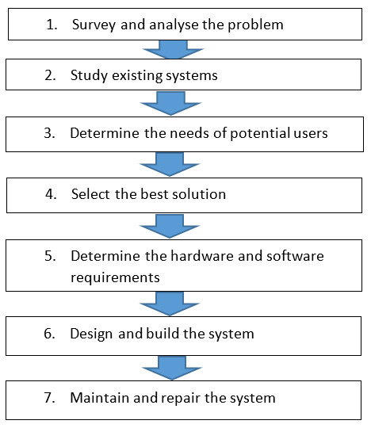
- What are the main stages of the software development process?
- There are basically 6 main stages of the software development process :-
- Requirement Gathering
- Analysis
- Designing
- Implementation
- Testing
- Maintenance
- Write a requirement specification for a simple library management system. - LAB EXERCISE
- Here’s a requirement specification for a simple library management system.
- Purpose :- The system is design to help manage activities such as adding books, issuing books, returning books and keeping record efficiently.
- Users :-
  - Librarian(Admin)
  - Librarian members (Student/staff)
- Functional Requirements :-
  - The system shall allow the librarian to add, update and delete books record.
  - The system shall allow the librarian to register and manage members.
  - The system shall allow issuing and returning books.
  - The system shall track available and issued books.
  - The system shall generate basic reports.
- Non-Functional Requirements :-
  - The system shall easy to use.
  - The system shall responds quickly to user actions.
  - The system shall store data securely.
- Constraints :-
- The system will be used on single computer or local network.
- The system will use a simple database for storage.
- Why is the requirement analysis phase critical in software development?
- The requirement analysis phase is critical because it clearly defines what users needs, helps avoid misunderstandings, reduces errors and ensures the software built correctly form start.
- Perform a functional analysis for an online shopping system. - LAB EXERCISE
- Here’s below functional analysis for an online shopping system
- User Registration and login
- Browse and search for products
- View product details and prices
- Add and remove item form shopping cart
- Place orders and make online payments
- Track order status
- Manage products and orders(Admin).
- What is the role of software analysis in the development process?
- The role of software analysis is to understand user needs, clearly define system requirements and ensure software is planned correctly before design and development begin.
- Design a basic system architecture for a food delivery app. - LAB EXERCISE
- Here’s the basic system architecture for a food delivery app
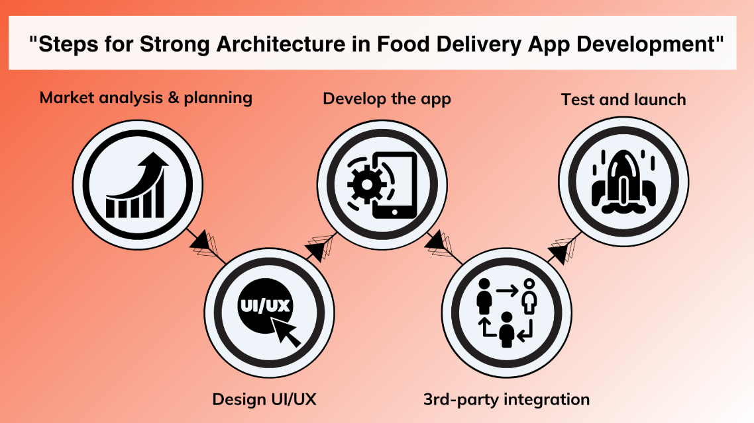
- What are the key elements of system design?
- There are several key elements of system design
- Architecture
- Database Design
- APIs and Communication
- Caching
- Load Balancing
- Security
- Scalability and Performance
- Redundancy and Fault tolerance
- Monitoring and logging
- User Experience
- Develop test cases for a simple calculator program. - LAB EXERCISE
- Here’s a simple calculator test cases scenario in table format
- Basic Arithmetic Operation Test cases :-
TC ID | Scenario | Input | Expected Output
TC 01 | Addition | 10 + 5 | 15
TC 02 | Subtraction | 10 – 5 | 5
TC 03 | Subtraction (Negative Result) | 5 – 10 | -5
TC 04 | Multiplication | 10 * 5 | 50
TC 05 | Division | 10 / 2 | 5
TC 06 | Multiplication By Zero | 10 * 0 | 0
TC 07 | Decimal Calculation | 3.5 + 2.5 | 6.0
TC 08 | Negative Numbers | -5 + -3 | -8
- Edge Case and Boundary Test Cases :-
TC ID | Scenario | Input | Expected Output
TC 09 | Division By Zero | 5 / 0 | Error (or cannot divided by zero)
TC 10 | Large Number Calculation | 999999999 + 1 | Correct result and scientific notation
TC 11 | Multiple Consecutive Operations | 2 + 3 * 4 | 14 (Operator Precedence)
TC 12 | Decimal Precision | 0.1 + 0.2 | 0.3 (check floating point errors)
TC 13 | Maximum/Minimum Input | Maximum digits allowed. | Proper display without truncation.
- Functional/Control Test Cases :-
TC ID | Scenario | Input/Action | Expected Output
TC 14 | Clear Function (C/AC) | 5 + 5 ‘then press C’ | Display resets to 0
TC 15 | Backspace / Delete | Input 123, press backspace | Display shows 12
TC 16 | Re-Calculation | 5 + 5 = 10, then 2 | 2 (new input starts fresh)
TC 17 | Equal Button Functionality | 5 + 5 | Pressing ‘=’ results in 10
- Negative Test Cases :-
TC ID | Scenario | Input/Action | Expected Output
TC 18 | Invalid Input | Enter letters/Symbols | Error message or ignore input
TC 19 | Empty Calculation | Press ‘=’ without input | 0 or error, no crash
TC 20 | Invalid Operator Sequence | 5 + + 5 or 5 + / * 5 | Error or display first valid operator.
- UI/Usability Test Cases (For GUI Calculators) :-
- Maximize/Minimize :- Ensure the window maximize and minimize properly.
- Button Responsiveness :- All digits and operators buttons responds to click.
- Display Formatting :- Large results are displayed without breaking the UI.
- Command-Line Specific Test Cases :-
- Exit Command :- Ensures the application closes when a specific command is entered.
- Invalid menu selection :- If a menu(1,2,3,4) is shown, entering 5 should result in an invalid selection error.
- Why is software testing important?
- Here’s a importance of software testing :-
- Ensures Software works correctly
- Finds Bugs early
- Improves Product Quality
- Enhances user satisfaction
- Increases Security
- Ensures reliability and performance
- Reduces Business risks
- Saves time and cost
- Verify user requirements
- Improves maintainability.
- Document a real-world case where a software application required critical maintenance. - LAB EXERCISE
- Real- world case :- Equifax Data Breach (2017)
- Organization :- Equifax (Credit Reporting Company)
- Software Used :- Apache Struts Web Application Framework
- Critical Maintenance Issue :-
- Security Patch for Apache Struts was released in March 2017
- Equifax failed to update the affected application.
- The system continued running outdated, vulnerable software.
- What Happened :-
- Hackers exploited the unpatched vulnerability.
- Unauthorized access occurred for several months.
- The breach was not detected immediately.
- Impact :-
- Personal data of 147 million people was exposed.
- Included social security numbers and other sensitive data.
- Equifax faced huge financial losses legal penalties.
- Lesson Learned :-
- Critical software updates must be applied on time.
- Regular Maintenance is essential for security and vulnerability.
- What types of software maintenance are there?
- There are basically four types of software maintenance
- Corrective Maintenance :- To fix defects, error and bugs discovered after deployment.
- Adaptive Maintenance :- To modify the software to remain compatible with changes in it’s external environment
- Perfective Maintenance :- To improve the software’s performance, maintainability, and user-friendliness.
- Preventative Maintenance :- To proactively prevent future problems, reduce complexity and improve system robustness.
- What are the key differences between web and desktop applications?
- Here’s below the basic difference between web and desktop applications.
Desktop Application | Web Application
App runs locally | App runs in the cloud
Offline access | Internet access required
Security | Cyberattack risks
Manual updates | Automated updates
High speed | Speed depends on the lot of factors
- What role does UI/UX design play in application development?
- Here’s below roles of UI/UX :-
- Roles of UX(User Experience) :-
- Makes the app easy and intuitive to use.
- Focuses on user needs through research.
- Creates positive emotions and satisfaction.
- Improve engagement and reduces user drop-off.
- Roles of UI (User Interface) :-
- Focuses on visual looks (color, fonts, layout)
- Create a first strong impression.
- Maintain brand consistency and identity.
- What are the differences between native and hybrid mobile apps?
- Here’s a below difference between native and hybrid mobiles apps

Native Apps | Hybrid Apps
Platform specific functionality | Multiple Functionality
Operating speed Fast | Operating speed Medium
High-End Graphics Available | High-End Graphics Not Available
UI/UX High | UI/UX Moderate
Access to API Full | Restricted
App store Availability Available | App store Availability Available
- Create a DFD for a hospital management system. - LAB EXERCISE
- Below the DFD of a hospital management system:-
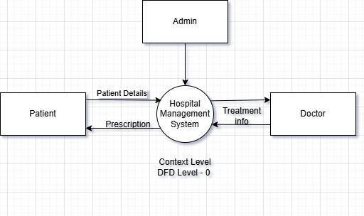
DFD Level – 0 of Hospital Management System
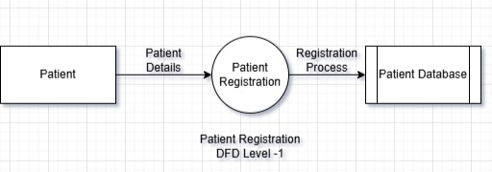
DFD Level – 1 Patient Registration

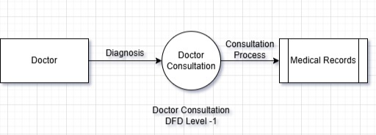
DFD Level – 1 Doctor Consultation
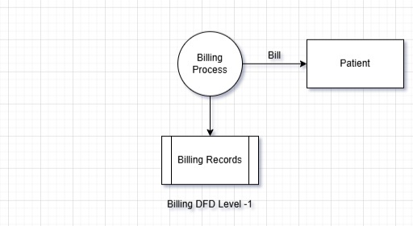
DFD Level – 1 Billing Generate

- What is the significance of DFDs in system analysis?
- Significance of DFDs :-
- Shows data flow clearly and simply.
- Helps understand how system works.
- Identifies errors, delays and inefficiencies.
- Improves communication among team members.
- Support system design and documentation.
- Breaks complex systems into smaller levels.
- Helps locate sensitive data for security.
- Build a simple desktop calculator application using a GUI library. - LAB EXERCISE
- Here’s below code :-
- Input :-
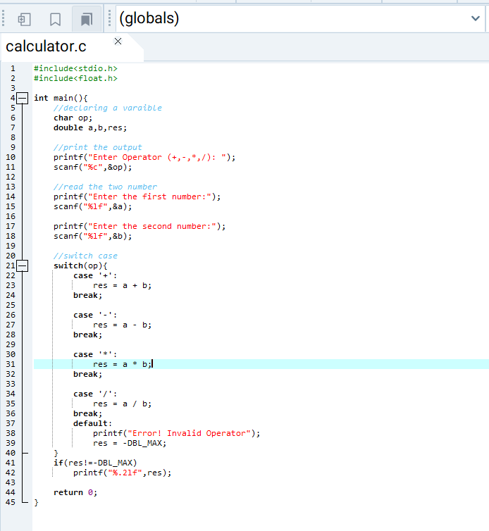
- Output :-
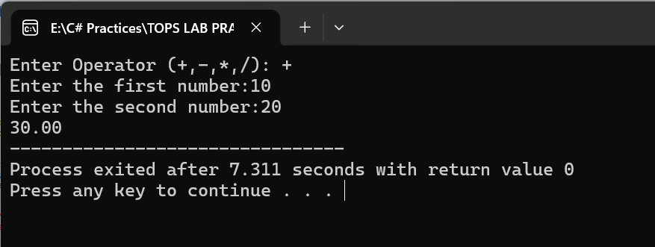

- What are the pros and cons of desktop applications compared to web applications?
- Pros and cons of desktop applications and web applications
- Desktop Applications – Pros
- Faster Performance
- Can work offline
- Better access to system hardware (e.g. printer, camara, files)
- More secure for sensitive local data.
- Desktop Applications – Cons
- Must be installed on each device.
- Platform – dependent (Windows, macOS).
- Updates require manual and separate installation.
- Not easily accessible from anywhere.
- Web Application – Pros
- No Installation require
- Accessible form anywhere with internet.
- Platform-Independent.
- Easy to Update.
- Web Application – Cons
- Requires internet connection.
- Slower compared to desktop apps.
- Limited access to device hardware.
- Security depends heavily on server and browser protection.
- Draw a flowchart representing the logic of a basic online registration system.
- Here’s below represent a flowchart :-
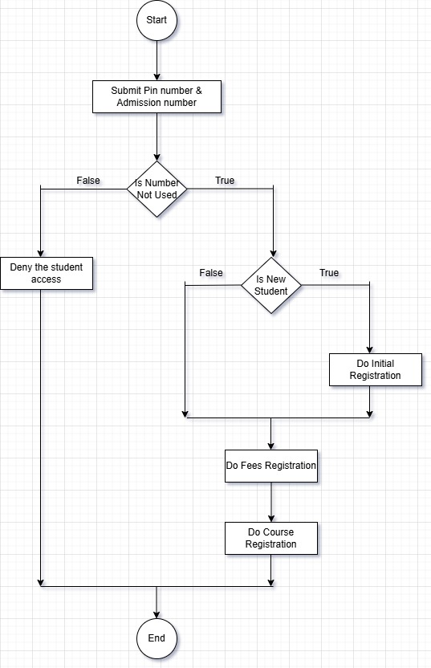
- How do flowcharts help in programming and system design?
- There are key aspects that flowchart help in programming and system design.
- In Programming :-
- Planning & Logic
- Debugging & Troubleshooting
- Modular design
- Documentation
- In System Design :-
- Process Mapping
- Communication Bridge
- Efficiency & Optimization
- Collaboration

