

**Title of the Project: TRENDY TREASURES**

_______________________________________________________________________________________________________________________________

**Objective : Social Relevance:**

1. **This provides access to fashion and clothing for individuals who might face challenges accessing physical stores due to disabilities or other limitations.**

**Our objective is to make the shopping easy to the students with the 2. Online stores often incorporate social elements like customer**

**Boundary of VIT CHENNAI.The students can get the Latest trends reviews,forums,or social media platforms,fostering a sense of community community among shoppers who can share their experiences**

**To their door step.It will also increase the employment and helps ,tips,and style advice.**

**The students to not waste the time. 3. People can engage with fashion and styles from around the world,promoting world.**

**Block Diagram: 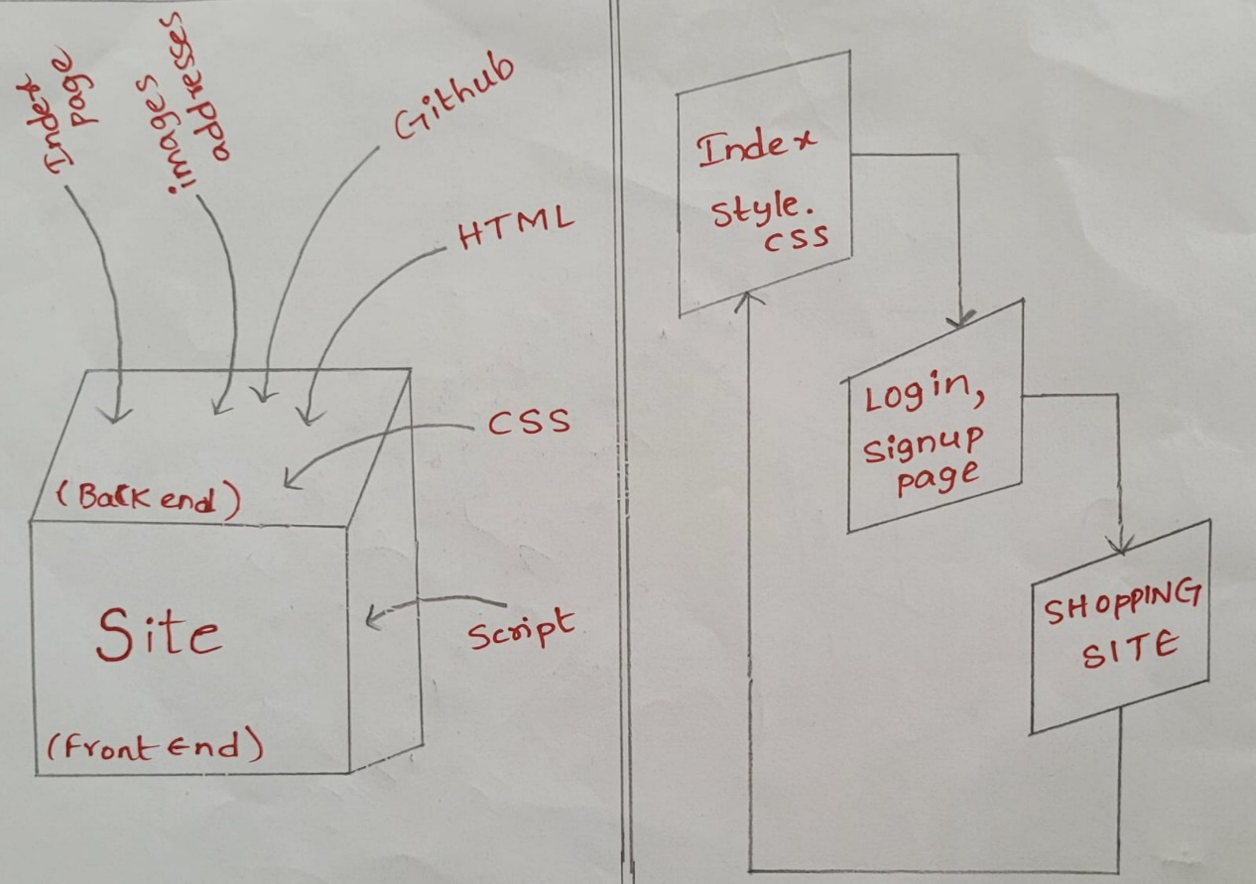 Mentor Name: Dr.Benil.T**

**Team Members Reg. No. & Name:**

1. **23MIS1112 – Pinupolu Gokul 6. 23MIS1113 – Pathi Gnanith**
2. 23MIS1105 – Sodanapalli Yashwanth Reddy 7. 23MIS1136 – Chithirala Lokesh
3. 23MIS1127 – Tanguturi Uma Maheswari 8. 23MIS1102 – Kakarla Prasad
4. 23MIS1154 – Papara Deepthi 9. 23BEE1059 – Mummadi Nikitha
5. 23BEC1186 – Aitha Sai Srijan