What is SFDR Article classification | 1. Article 6: The "Neutral" Category  Definition: Funds that do not have a specific sustainability objective.  The Focus: Sustainability Risks.  Requirements: Even if a fund doesn't claim to be "green," it must disclose how it handles sustainability risks (like climate change or labor strikes) that could hurt the fund's financial performance.  If it's not relevant: The manager must explain why they believe sustainability risks aren't applicable to that specific fund.  2. Article 8: The "Light Green" Category  Definition: Funds that promote environmental or social characteristics.  The Focus: Promoting ESG (Environmental, Social, and Governance) values alongside financial returns.  Requirements: * The companies invested in must follow good governance practices.  The fund must disclose how it meets these environmental/social characteristics.  Example: A fund that avoids investing in tobacco or firearms, or one that prefers companies with a high percentage of female board members.  3. Article 9: The "Dark Green" Category  Definition: Funds that have sustainable investment as their core objective.  The Focus: Making a measurable positive impact.  Requirements: * The fund must have a non-financial objective at its heart (e.g., reducing carbon emissions by a specific amount).  It must use a "reference benchmark" (an index) to prove it is reaching that sustainable goal.  Key Difference: While Article 8 promotes ESG, Article 9 targets a specific sustainable outcome.
What is SFDR 2.0 | 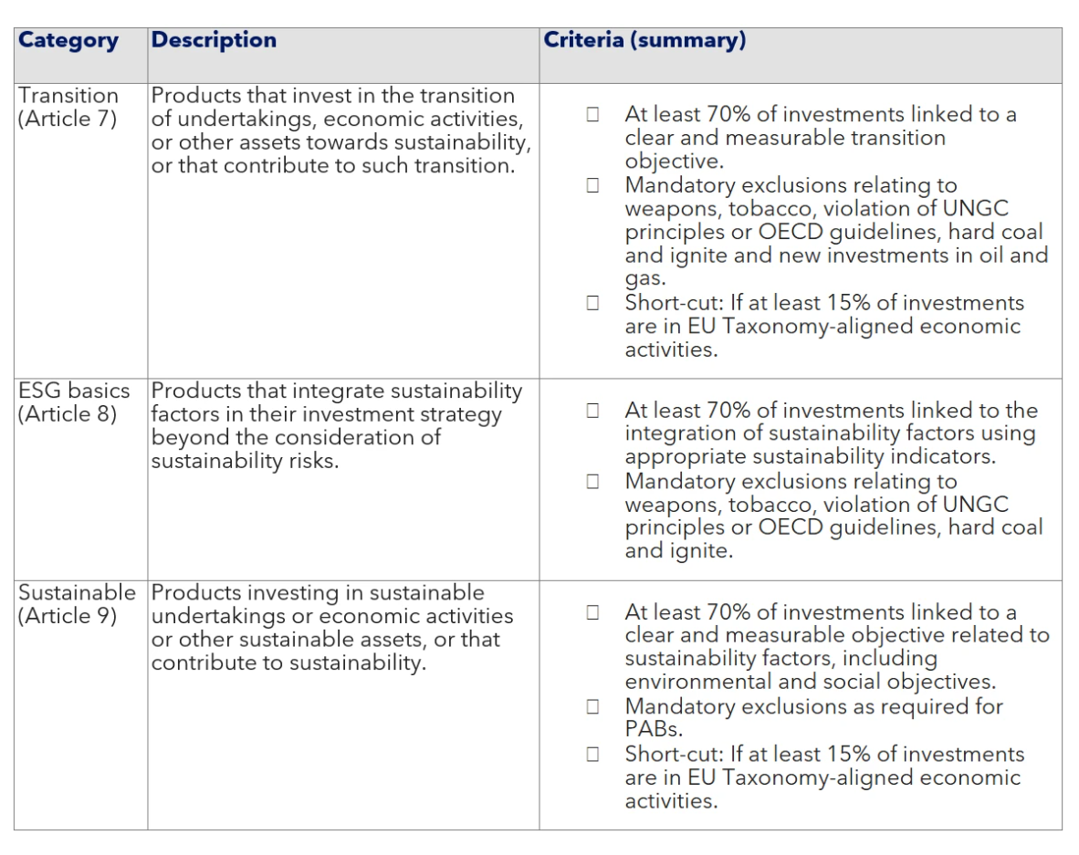  Three Clear Buckets  Instead of the confusing Article 8 and 9, funds must now fit into:  Sustainable: High-standard, "pure green" investments.  Transition: Investments in companies that are currently "brown" but have a credible, science-based plan to improve (crucial for markets like Malaysia).  ESG Basics: Funds that simply integrate basic environmental and social factors (like excluding tobacco).  The "70% Guardrail"  To stop greenwashing, SFDR 2.0 introduces a minimum threshold. At least 70% of a fund's assets must strictly align with its chosen category. You can no longer call a fund "Sustainable" if only a small fraction of its holdings are actually green.
What is the reason they change from SFDR 1.0 to 2.0 on November 2025 | • Accidental Labeling: Articles 8 and 9 were meant to be disclosure categories (rules for paperwork), but the market turned them into marketing labels. This led to "green-labeling" without strict standards.  • The "Dark Green" Struggle: Article 9 (the strictest category) was so difficult to maintain that many funds "downgraded" themselves to Article 8, causing massive market confusion.  • Greenwashing Risks: Article 8 became a massive, $17.7 trillion "catch-all" bucket. It was impossible for investors to distinguish between a fund that was truly doing good and one that was just doing the bare minimum.  https://www.bloomberg.com/professional/insights/sustainable-finance/sfdr-2-0-why-data-becomes-the-new-competitive-edge/#:~:text=One%20of%20the%20biggest%20changes,measurable%20social%20or%20environmental%20impact.  improve coherence across the EU’s sustainable finance rules, such as MiFID II (Markets in Financial Instruments Directive), PRIIPS (Packaged Retail and Insurance-based Investment Products), and CSRD (Corporate Sustainability Reporting Directive).  https://www.sustainalytics.com/esg-research/resource/investors-esg-blog/sfdr-2.0-in-figures--impact-analysis

New framework how our system will tackle
Our system:
• Audit Data Providers: Don't just trust a data feed; check their "governance" (how they verify their Malaysian data, for example).
• Focus on PAI Indicators: "Principal Adverse Impacts" (PAI) are specific "red flags" (like high carbon output or human rights violations). You need data that catches these early.
• Document Everything: Reliability and "auditability" are now just as important as the actual ESG score.
https://www.ey.com/en_lu/insights/sustainability/preparing-for-sfdr-2-0-a-practical-roadmap-for-fund-managers
Report:
Be ready to redesign pre-contractual and periodic reporting early | •Prepare for shorter, more focused disclosures (~2 pages) by:  •Prioritizing material sustainability information  •Eliminating narrative-heavy explanations  •Align disclosures with PRIIPs-style framing, particularly the new section: “How sustainable is this product?”
Embed category criteria into portfolio construction | •Translate SFDR 2.0 category requirements directly into:  •Investment guidelines  •Portfolio management systems  •Pre-trade and post-trade controls  •Ensure portfolio managers can demonstrate ongoing compliance, not just point-in-time alignment
Re-map the product range against the new SFDR categories | •Conduct a gap analysis of all existing funds against the three SFDR 2.0 categories (Sustainable, Transition, ESG Basics)  •Identify which products can realistically meet the 70% minimum threshold and mandatory exclusion criteria  •Decide early which products should remain non-categorized to avoid forced re-positioning and greenwashing exposure
Reassess Article 8 and Article 9 products as a priority | •Treat current Article 8 and Article 9 funds as high-risk for misalignment under SFDR 2.0  •Stress-test investment strategies against:  •New eligibility thresholds  •Common exclusion lists  •Taxonomy alignment shortcut (15%)  •Prepare contingency plans for downgrading or merging products that fail to qualify

Report 2 pages long
product-level PAIs
implementation timeline
Reclassification required: Existing Article 8 and 9 funds will need to requalify under the new regime — there is no grandfathering.
Data strategy shift: ESG data needs will move from volume to quality and credibility, with emphasis on exclusions, EU Taxonomy alignment, transition plans, and engagement metrics.
Investor communication: Shorter, clearer disclosures aim to improve retail usability and comparability, but managers must prepare for scrutiny on category criteria.
References
SFDR statistic | https://www.sustainalytics.com/esg-research/resource/investors-esg-blog/sfdr-2.0-in-figures--impact-analysis

