Lens Design HW #7

1) Take the prescription below for a Petzval Portrait lens and flatten the field with a negative lens near the image. The final lens must have f=100 mm, f/# = 3.7, field of +/- 14 deg. and operate in the visible. Optimize for best performance (rms spot size) and correct for distortion. Select appropriate glasses. Set 20% and 50% vignetting factors for the 7/10 field and full field. 7 points

2) Design a paraxial diffractive landscape lens @f/15 and f/100 mm at 587 nm. Use the two-point construction model, the phase model, and the Sweatt model. Compare the three models. The stop must be located at the front focal point. Read the paper on the design of a diffractive landscape lens by Buralli and Morris, Applied Optics 28 18 p-3950. Do your analyses at 486, 587, and 656 nm. 8 points

3) Add to a landscape lens that is free of astigmatism (previous HW plano-convex solution) a plano-concave lens at the stop to correct for field curvature. The concave surface of this hybrid lens must have a diffractive surface to make it afocal. Design at 587 nm. Discuss the performance. 5 points

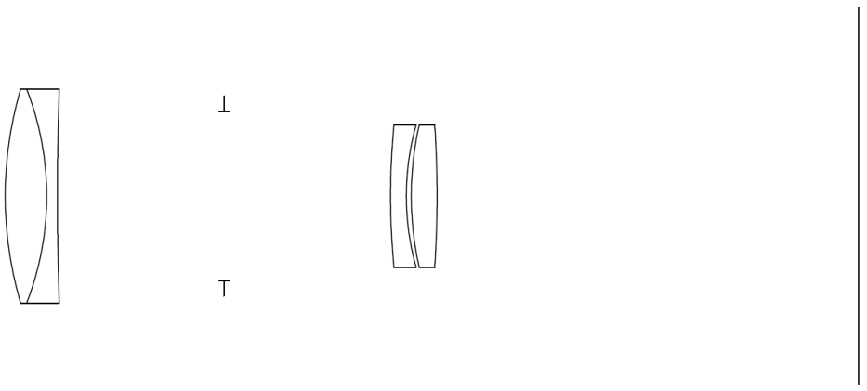

R +52.9 -41.4 +436.2 +104.8 +36.8 45.5 -149.5
N-crown=1.517; N-flint=1.576
T 5.8 1.5 23.3/23.3 2.2 0.7 3.6
F=100 mm

