Lysosomal Storage Disorder Newborn Screening in Mainland China
  - Market analysis and entry strategy for U.S. biotechnology companies
This report evaluates the mainland Chinese market for lysosomal storage disorder (LSD) newborn screening, from population size and patient identification to diagnosis, treatment, payment, competition, and entry strategy. The recommended direction is a registered IVD business supported by local validation, clinical partnerships, and a workable route from screening to treatment.
English edition • September 2026. Amounts are in Chinese yuan (CNY or RMB). Definitions explain unfamiliar terms. Source notes identify numerical inconsistencies and unfinished points.

1 Population and the Healthcare Payment Environment

Mainland China and its population base
China’s administrative framework includes 34 provincial-level jurisdictions. For commercial planning, mainland China is generally treated separately from Hong Kong, Macao, and Taiwan because they operate under different regulatory and administrative systems. This report focuses on mainland China.
Mainland China comprises 31 provincial-level regions, including provinces, autonomous regions, and centrally administered municipalities. These are the most useful units for regional market analysis, broadly comparable to the state level in a U.S. market assessment. At the end of 2025, mainland China had a population of 1.405 billion, the second largest in the world. The report records 7.92 million births during the year and a crude birth rate of 5.63 per 1,000 people. Births have continued to decline, although the annual total remains more than twice that of the United States; the source also ranks China second globally by annual births. The government is introducing measures to encourage childbearing.
Figure 1 Births and crude birth rates in China and the United States
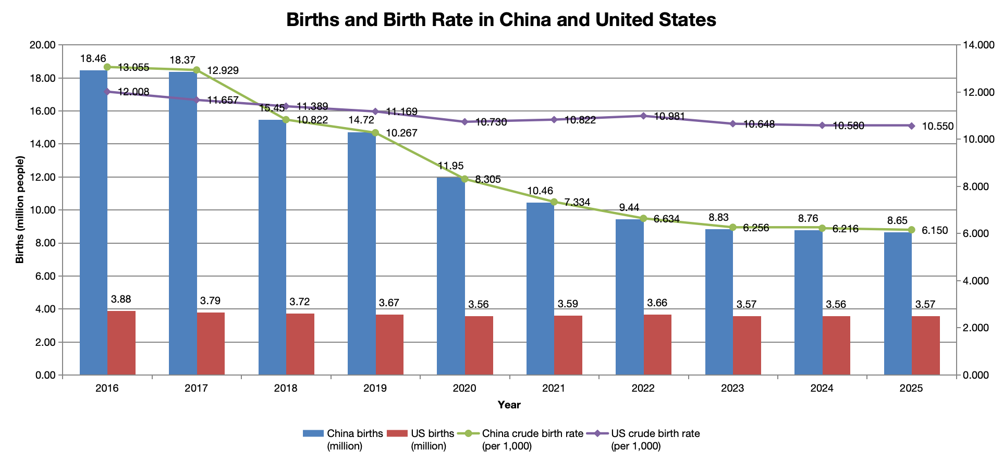
Source data note. The embedded chart reports 8.65 million Chinese births and 6.150 births per 1,000 people for 2025, whereas the narrative uses 7.92 million and 5.63 per 1,000. The source also describes a decline fluctuating around −1%, without specifying a consistent measure or period. Both sets of figures are retained; the national scenario later in the report uses 7.92 million.

A government led healthcare payment system
The United States has a multipayer system built around employer-sponsored coverage, Medicare, Medicaid, and other private plans. China’s system is organized around public basic medical insurance, a second layer of catastrophic medical expense coverage, and means-tested medical assistance, with commercial health insurance providing supplemental coverage. The first three layers are government led; commercial insurance is a supplementary market product.
A complete pathway from screening to diagnosis and treatment requires payment arrangements at each stage. Screening is often supported by public health budgets or local government funding. Repeat testing and diagnostic confirmation must fall within payable medical services. Treatment requires an accessible drug and a workable reimbursement route, including national formulary coverage where available and actual supply through hospitals. Long-term follow-up also requires outpatient benefits. A funding gap at any stage can interrupt the patient pathway. For companies entering China, clinical value is therefore only one part of the scale-up equation: national reimbursement policy, the scope of covered services, and government priorities also shape adoption.

Public medical coverage
Public programs primarily pay for listed drugs, tests, and medical services that meet the applicable coverage conditions. Patients remain responsible for deductibles, coinsurance, amounts above benefit caps, and noncovered expenses. At the end of 2025, approximately 1.331 billion people were enrolled in basic medical insurance, maintaining coverage at about 95% of the population.

Basic medical insurance
The two main programs are Employee Basic Medical Insurance, which covers employed people, and Urban–Rural Resident Basic Medical Insurance, which covers children, students, and other residents outside the employee program. In 2025, the funds paid 84.1% and 66.0%, respectively, of eligible inpatient expenses. Children generally enroll in the resident program, so the latter is the more relevant benchmark for pediatric care. These percentages apply to eligible expenses, rather than to the entire hospital bill.

Catastrophic medical expense coverage
This second layer, commonly translated as “critical illness insurance,” reimburses a further share of eligible out-of-pocket expenses after basic insurance has paid. It is expense-based protection, unlike the lump-sum critical illness products familiar to many U.S. readers. The source describes an annual trigger linked to the prior year’s local per capita disposable income. Once the applicable local threshold is exceeded, further reimbursement is typically around 60%–70% or more, depending on the local rules.

Medical assistance
Medical assistance supports low-income households, people in extreme hardship, and households impoverished by illness. It works in two ways. First, it fully or partially subsidizes the resident insurance premium for eligible people. Second, after basic insurance and catastrophic coverage have paid, it covers a specified share of remaining eligible inpatient and designated chronic or serious outpatient expenses at contracted providers. Where direct settlement is available, that assistance is deducted at the hospital payment counter.
Figure 2 An illustrative public reimbursement pathway
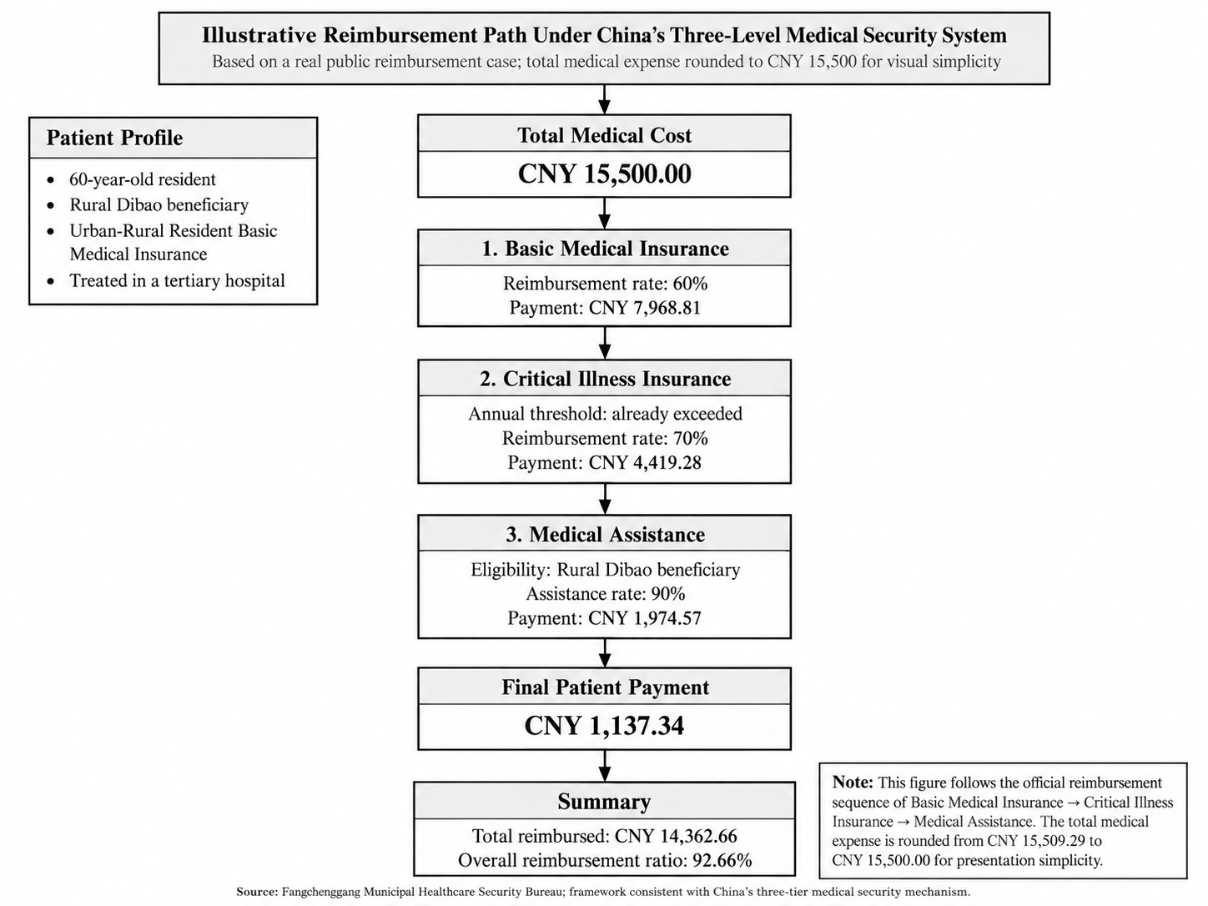
Reading the example. Dibao is China’s minimum-living-standard assistance program. “Tertiary hospital” refers to the highest hospital service tier. Each payment layer applies to its own eligible expense base, so the displayed percentages should not be applied sequentially to the full bill. The figure rounds the original CNY 15,509.29 expense to CNY 15,500; that changes its arithmetic by CNY 9.29.

Commercial health insurance
Individuals or employers can purchase commercial health insurance to supplement public coverage for drugs, services, and major expenses. It does not provide the main foundation of population-wide coverage. Plans may offer substantial reimbursement for drugs included in the national Commercial Health Insurance Innovative Drug List. Depending on the policy, eligible expenses under midrange and high-end plans purchased before a diagnosis may be reimbursed up to 100%. People with an existing diagnosis may instead have access to government-supported city insurance plans, often called Huiminbao, for which reimbursement of covered pre-existing conditions may be around 30%. Actual benefits depend on the plan and its eligibility rules.

How products and services become payable
Public insurance pays for drugs, medical services, and medical consumables through different processes for coverage, pricing, and payment. The source’s overall market observation is that patients may face higher post-reimbursement costs for imported products than for domestic alternatives [original NHSA reference 1]. This is a price and benefit-design observation, rather than a single reimbursement rule applied to every imported product.

Drugs
Unlike the United States, where individual health plans determine formulary coverage, China negotiates drug prices and national coverage through the National Reimbursement Drug List, or NRDL. In 2024, drugs successfully added through negotiation or competitive bidding received an average price reduction of 63%. Patients then receive reimbursement under the rules of their insurance jurisdiction, combining a lower negotiated price with insurance payment [original NHSA reference 2]. For example, a drug costing CNY 100,000 a year would cost CNY 37,000 after a 63% reduction. If local insurance then paid 70%, the patient’s theoretical annual share would be CNY 11,100. This example illustrates the mechanism; actual expenses also depend on the covered indication, deductible, benefit cap, and local policy.

Medical services
Examinations, laboratory tests, procedures, and treatments are generally billed as medical service items. The National Healthcare Security Administration, or NHSA, publishes guidelines that standardize service names and pricing rules. Provincial authorities then establish actual charges and determine local insurance coverage. A new test’s registration with the National Medical Products Administration, or NMPA, therefore does not by itself establish a hospital billing code or insurance reimbursement.
The 2026 laboratory service pricing guidelines also apply tiered discounts to qualifying combined tests: up to five analytes are charged at 80% of the sum of the individual prices; six to ten at 70%; and more than ten at 60%. A panel of more than ten analytes with individual charges totaling CNY 1,000 would therefore be billed at CNY 600, a 40% reduction.

Medical consumables
Prices for consumables are controlled through provincial procurement platform listings, centralized volume-based procurement, and insurance payment standards. Some basic consumables are already included in the medical service fee and cannot be billed separately. Certain consumables or diagnostic reagents may be charged separately, generally at the actual acquisition price.
In national centralized procurement of high-value medical consumables, selected products have achieved average price reductions of 70%. Earlier national procurement rounds covering eight categories, including coronary stents and artificial joints, achieved average reductions of more than 80%.

Rare disease policy and expansion of newborn screening
China has an estimated 20 million people living with rare diseases, and publicly reported estimates suggest that more than 200,000 affected children are born each year. The first and second national Rare Disease Lists, issued in 2018 and 2023, cover 207 conditions in total. These lists help define the policy scope for diagnosis, treatment, drug review, and medical coverage. The number of rare disease drugs in the NRDL increased from 39 in 2018 to 121 in 2025, approximately 3.1 times the earlier total. This reflects growing support for rare disease care as economic capacity improves and policy places greater emphasis on healthy births and children’s long-term health.
In 2025, China also introduced the Commercial Health Insurance Innovative Drug List. Its first edition included 19 drugs with substantial clinical value whose cost was beyond the basic public insurance benefit package. This provides an additional market access and payment route for certain high-cost rare disease therapies.
Alongside improved treatment coverage, child health policy is moving earlier in the care pathway, toward prevention of birth defects and early detection. The National Program for Child Development 2021–2030 covers premarital, preconception, prenatal, and postnatal care and calls for a broader newborn screening panel. Coverage now exceeds 98% for both the core inherited and metabolic newborn screening program, centered on phenylketonuria (PKU) and congenital hypothyroidism (CH), and newborn hearing screening. These established programs provide a mature national service network. The Plan to Improve Birth Defect Prevention and Treatment Capacity 2023–2027 further encourages regions with sufficient resources to add screening conditions. Beijing, Shanghai, and Zhejiang have expanded their publicly funded panels to 12, 15, and 29 conditions, respectively.
Two connected developments are taking shape. Public and commercial insurance are improving access to treatment after diagnosis, while broader newborn screening is moving identification before symptoms appear. With basic screening coverage approaching saturation, further growth is more likely to come from additional conditions, upgrades to regional programs, and better connections among screening, diagnosis, payment, and treatment.

2 The LSD Patient Population in China
Mainland China does not yet have a nationwide LSD newborn screening program or a nationally coordinated population database published by an authoritative institution. The source cites an overall newborn LSD incidence estimate of approximately 1 in 7,000–8,000, including Gaucher disease at about 1 in 50,000, Pompe disease at about 1 in 20,000, and Niemann–Pick disease types A/B at about 1 in 10,000. Comparative evidence also suggests higher detected frequencies of Fabry and Pompe disease in some Asian populations than in Western populations.
Table 1 Population differences in the six principal LSDs
Disease and gene | Population with higher reported frequency | Incidence or prevalence comparison in the source | Genetic or clinical context
Fabry disease  GLA | East Asian populations | East Asia: approximately 1 in 1,250–1,600 male births.  Western populations: approximately 1 in 22,000–40,000 male births. | High frequencies in some East Asian cohorts are associated with the founder variant IVS4+919G>A and late-onset cardiac Fabry disease.
Pompe disease  GAA | East Asian populations | East Asia: approximately 1 in 16,000–20,000 live births.  Western populations: approximately 1 in 40,000. | Severe infantile-onset Pompe disease (IOPD) is particularly prominent in southern China and Taiwan, associated with specific genetic variants.
Gaucher disease  GBA | Western populations, especially Ashkenazi Jewish populations | Western populations: approximately 1 in 40,000–60,000; about 1 in 800 among Ashkenazi Jewish people.  Asia–Pacific: fewer than 1 in 100,000. | Non-neuronopathic type 1 is particularly associated with Western and Ashkenazi Jewish populations. Among Asian patients, neuronopathic type 3 accounts for a larger proportion of the disease mix.
Krabbe disease  GALC | Western populations | Western populations: approximately 1 in 100,000 live births.  East Asia: clinically recognized cases are very uncommon. | A common 30 kb deletion in people of European ancestry contributes to the higher frequency of severe infantile disease in Western populations.
Niemann–Pick A/B  SMPD1 | Some Western and Middle Eastern populations | Western populations: approximately 1 in 100,000–250,000 live births.  East Asia: a consistently low background frequency. | Type A carrier frequency is higher in Ashkenazi Jewish populations. Both types remain rare in Asia.
MPS I  IDUA | Western populations | Western populations: approximately 1 in 100,000 live births.  East Asia: approximately 3.7% of reported MPS cases. | MPS I is more prominent in Europe and the United States. MPS II (Hunter syndrome) predominates in the Asian MPS disease mix cited in the source, accounting for more than 50% of cases.
Comparison note. These estimates use different populations and denominators, including male births, all live births, and the share of MPS cases. They are not directly interchangeable. The disease-specific estimates in the preceding narrative also differ from this comparative table and should not be added to derive an overall incidence.

Results from regional newborn screening programs
LSD newborn screening in China currently follows two main technical approaches. The first is enzyme activity testing by tandem mass spectrometry (MS/MS), typically a four-condition panel for Gaucher, Fabry, Pompe, and mucopolysaccharidosis type I (MPS I), or a six-condition panel that adds acid sphingomyelinase deficiency (ASMD, historically Niemann–Pick A/B) and Krabbe disease. The second incorporates LSD genes into broader genetic newborn screening panels.
Most available evidence comes from a limited number of regional studies and pilot programs in places such as Shanghai, Shandong, Fujian, and Nanjing. These programs are concentrated in areas with stronger finances, screening infrastructure, and specialist diagnostic resources.
Across mainland six-condition enzyme screening cohorts, reported study-endpoint identification rates are approximately 2.82–5.39 per 10,000 newborns. The narrative synthesis of genetic screening cohorts reports presymptomatic confirmation or symptomatic diagnoses during follow-up at approximately 3.38–6.61 per 10,000. Both approaches suggest that several LSD-related individuals can be identified for every 10,000 newborns screened. Differences depend on assay cutoffs, repeat testing, genetic confirmation criteria, classification of variants of uncertain significance (VUS), and completion of follow-up. The higher yields relative to consensus incidence estimates may partly reflect enrichment for newborns with clinical findings in research cohorts; this is an interpretation, rather than an established explanation across all studies. Such cohorts may nevertheless be relevant to an initial market entry built around research partnerships.
Table 2 Regional LSD newborn screening and high-risk screening evidence
Evidence type | Program and institution | Panel | Reported yield per 10,000 | Disease-specific findings | Method Instrument and kit
Mainland  Enzyme NBS | Shanghai six-condition screening; Shanghai Institute for Pediatric Research; specimens from 41 maternity hospitals | Gaucher, ASMD, Krabbe, MPS I, Fabry, Pompe | 5.39  1 in 1,856 | Gaucher 2 (1 in 25,054); ASMD 5 (1 in 10,022); Krabbe 9 (1 in 5,568); MPS I 0; Fabry 8 (1 in 6,264); Pompe 3 (1 in 16,702) | MS/MS; PerkinElmer NeoLSD MSMS Kit; QSight 210 MD
Mainland  Enzyme NBS | Six-city Shandong six-condition program; Shandong Newborn Screening Center | Gaucher, ASMD, Krabbe, MPS I, Fabry, Pompe | 2.82  1 in 3,540 | Krabbe 5; Fabry 3; Pompe 3 | MS/MS; Waters Xevo TQD; PerkinElmer NeoLSD MSMS Kit
Mainland  Enzyme NBS  Overlapping subset | Jinan cohort of 26,689; Jinan Maternal and Child Health Hospital and Newborn Screening Center | Gaucher, ASMD, Krabbe, MPS I, Fabry, Pompe | 3.00  1 in 3,336 | Pompe 3; Krabbe 3; Fabry 2 | MS/MS; Waters Xevo TQD; PerkinElmer NeoLSD MSMS Kit
Mainland  Enzyme NBS | Fujian cohort of 3,000; Medical Genetics Center of Fujian Maternity and Child Health Hospital and Fujian CDC | Gaucher, ASMD, Krabbe, MPS I, Fabry, Pompe | 3.33  1 in 3,000 | Pompe 1 | MS/MS; instrument and kit not reported in the abstract
Mainland  Genetic NBS | Nanjing 15-LSD genetic screening; Nanjing Maternity and Child Health Care Hospital | 15 LSDs and 18 genes, including Fabry, Krabbe, Pompe, Niemann–Pick, and MPS II | 6.61  1 in 1,512 | Fabry 5; Krabbe 8; Pompe 1; Niemann–Pick 1 | Target-capture NGS within a 94-disease/164-gene panel; enzyme confirmation of positive results; NeoLSD MSMS Kit in a 900-sample subset
Mainland  Genetic NBS | Yunnan cohort of 3,001; First People’s Hospital of Yunnan Province | Full project: 156 diseases/159 genes; explicit LSD-specific findings limited to Niemann–Pick A/B | 10.00  1 in 1,000 | Niemann–Pick A/B 3 | Traditional biochemical NBS (tNBS) plus targeted genetic NBS (gNBS); instrument and kit NR
Mainland  Genetic NBS | Eight-center first-tier genetic screening: Shanghai, Guangzhou, Shijiazhuang, Yunnan, Chongqing, Inner Mongolia, Jinan, and Hainan | 128 diseases/142 genes; LSD-specific reporting for Niemann–Pick A/B, Krabbe, and Fabry | 4.39  1 in 2,277 | Niemann–Pick A/B 6; Krabbe 4; Fabry 3 | Targeted DBS gene panel, at least 100× coverage, MGI sequencing; concurrent biochemical NBS
Mainland  Genetic NBS | Retrospective Zhejiang cohort of 4,986; Children’s Hospital of Zhejiang University School of Medicine; Zhejiang Newborn Screening Center; Biosan laboratory | 74 inherited diseases/134 genes | NR | No verifiable disease-specific confirmed LSD outcomes extracted | Multiplex PCR plus NGS, compared with routine biochemical NBS
Mainland  High-risk screening | Sanofi and Beijing Dayi Public Welfare Foundation multicenter LSD program | Gaucher, Pompe, Fabry, MPS I | NR | Submitted sample volumes only; disease-specific positive, confirmed, and lost-to-follow-up counts unavailable | Materials did not specify a uniform instrument, kit, or confirmation algorithm
External reference  Taiwan | Taiwan 8-plex screening cohort of 73,743; newborn screening network | Pompe, Fabry, Gaucher, MPS I, II, IIIB, IVA, VI, and mucolipidosis (ML) | 31.19 as printed*  1 in 3,206 | Pompe 4; Fabry 4; Gaucher 1; MPS I 1; MPS II 3; MPS IIIB 3; MPS IVA 6; MPS VI 0; ML 1; total 23 | MS/MS; Waters Xevo TQD; PerkinElmer 8-plex MS/MS kit
NBS = newborn screening; NR = not reported or not available in the reviewed material. Study-defined identification, presymptomatic confirmation, and symptomatic diagnosis are distinct endpoints. The Jinan row overlaps the Shandong evidence and should not be counted as an independent population.
* The Taiwan row prints 31.19 per 10,000, but 23 of 73,743 equals approximately 3.12 per 10,000, or 31.19 per 100,000. The source’s printed value and 1-in-3,206 ratio are preserved. The narrative genetic-cohort range also does not include the Yunnan table value of 10.00 per 10,000.

Figure 3 Provincial distribution in a four-condition high-risk screening program
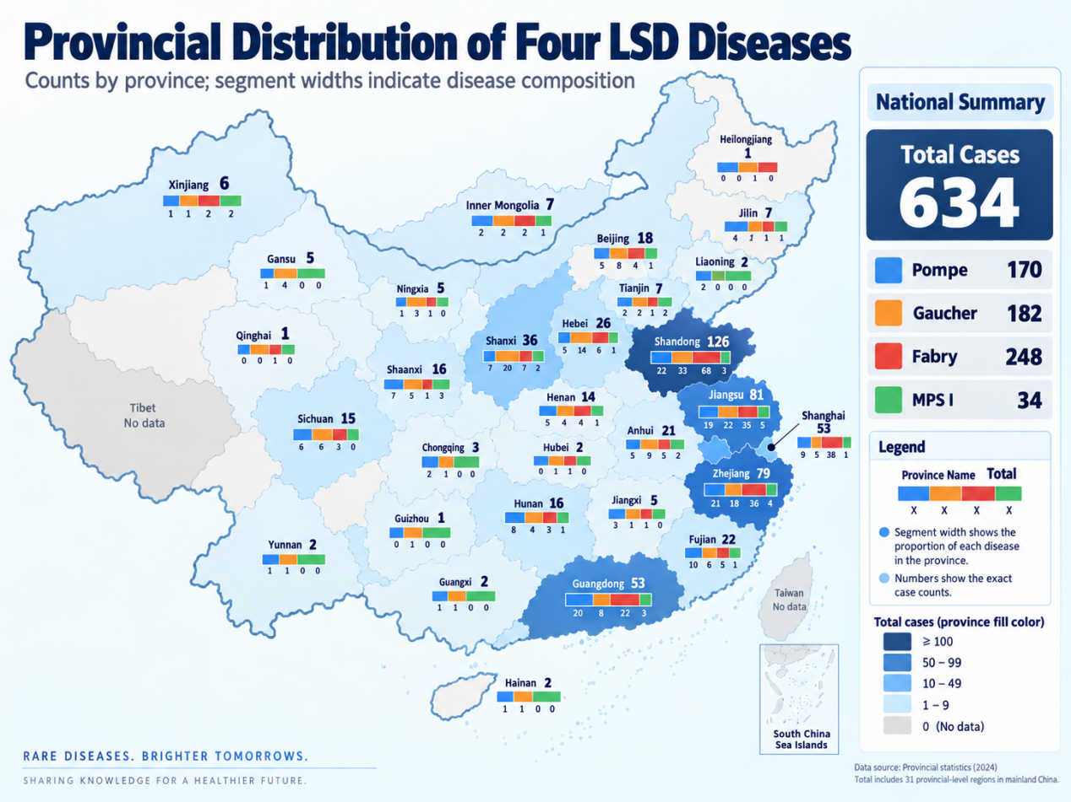
Program context. The map is reproduced from the source’s four-condition high-risk screening dataset. Geographic counts reflect participation and diagnosis within that program, not newborn incidence or the total number of people living with LSDs.

Disease mix and geographic distribution
A Takeda China high-risk diagnostic screening program conducted over approximately one year across 30 provinces recorded 634 LSD-related individuals across four conditions. Fabry disease represented the largest share, at 39.1%. Gaucher and Pompe disease accounted for similar shares, while MPS I was least frequent, at 5.4%. The program provides a useful view of the disease mix among people reaching an established diagnostic pathway.
Shandong, Jiangsu, Zhejiang, Guangdong, and Shanghai accounted for 392 individuals, or 61.8% of the total. This concentration along the coast is consistent with stronger referral networks, specialist care, and testing capacity. It supports entering through cities where diagnostic demand is already being identified. These program counts describe the population reached by high-risk screening; they are not population-based provincial prevalence estimates.

Theoretical annual identification under nationwide screening
After comparing cohort size, disease coverage, screening procedures, and completeness of outcomes, the Shanghai cohort was selected as the reference for a national scenario. Applying its six-condition panel, screening thresholds, confirmation criteria, and follow-up performance to the report’s 2025 birth base of 7.92 million, with 100% screening coverage, gives approximately 4,268 LSD-related individuals identified annually. The source’s count-based interval is approximately 2,813–6,208. This is a full-coverage scenario, not a forecast of realized testing demand or confirmed symptomatic disease.
Table 3 Provincial identification scenario under full newborn screening coverage
All counts are theoretical annual identifications at 100% coverage. Disease columns use the Shanghai cohort’s disease mix.
Province or region | Birth share | 2025 birth base | Total identified | Lower count | Upper count | Gaucher | ASMD | Krabbe | MPS I | Fabry | Pompe
Tibet | 0.5% | 42,316 | 23 | 15 | 33 | 2 | 4 | 8 | — | 7 | 3
Qinghai | 0.6% | 49,813 | 27 | 18 | 39 | 2 | 5 | 9 | — | 8 | 3
Tianjin | 0.7% | 56,505 | 30 | 20 | 44 | 2 | 6 | 10 | — | 9 | 3
Ningxia | 0.8% | 66,390 | 36 | 24 | 52 | 3 | 7 | 12 | — | 11 | 4
Jilin | 1.0% | 80,592 | 43 | 29 | 63 | 3 | 8 | 14 | — | 13 | 5
Hainan | 1.0% | 81,327 | 44 | 29 | 64 | 3 | 8 | 15 | — | 13 | 5
Heilongjiang | 1.1% | 84,698 | 46 | 30 | 66 | 3 | 8 | 15 | — | 14 | 5
Shanghai | 1.2% | 97,933 | 53 | 35 | 77 | 4 | 10 | 18 | — | 16 | 6
Inner Mongolia | 1.4% | 109,615 | 59 | 39 | 86 | 4 | 11 | 20 | — | 18 | 7
Beijing | 1.4% | 110,443 | 60 | 39 | 87 | 4 | 11 | 20 | — | 18 | 7
Liaoning | 1.9% | 149,498 | 81 | 53 | 117 | 6 | 15 | 27 | — | 24 | 9
Chongqing | 2.0% | 158,656 | 85 | 56 | 124 | 6 | 16 | 28 | — | 25 | 9
Gansu | 2.1% | 163,478 | 88 | 58 | 128 | 7 | 16 | 29 | — | 26 | 10
Shanxi | 2.5% | 199,115 | 107 | 71 | 156 | 8 | 20 | 36 | — | 32 | 12
Xinjiang | 2.6% | 204,148 | 110 | 72 | 160 | 8 | 20 | 37 | — | 33 | 12
Shaanxi | 3.0% | 241,502 | 130 | 86 | 189 | 10 | 24 | 43 | — | 39 | 14
Fujian | 3.1% | 241,636 | 130 | 86 | 189 | 10 | 24 | 43 | — | 39 | 14
Jiangxi | 3.1% | 248,900 | 134 | 88 | 195 | 10 | 25 | 45 | — | 40 | 15
Hubei | 3.3% | 260,656 | 140 | 93 | 204 | 10 | 26 | 47 | — | 42 | 16
Anhui | 4.0% | 313,581 | 169 | 111 | 246 | 13 | 31 | 56 | — | 50 | 19
Hunan | 4.0% | 320,449 | 173 | 114 | 251 | 13 | 32 | 58 | — | 51 | 19
Yunnan | 4.2% | 333,762 | 180 | 119 | 262 | 13 | 33 | 60 | — | 53 | 20
Zhejiang | 4.3% | 340,549 | 184 | 121 | 267 | 14 | 34 | 61 | — | 54 | 20
Guizhou | 4.3% | 344,384 | 186 | 122 | 270 | 14 | 34 | 62 | — | 55 | 21
Guangxi | 4.4% | 348,819 | 188 | 124 | 273 | 14 | 35 | 63 | — | 56 | 21
Jiangsu | 4.5% | 352,489 | 190 | 125 | 276 | 14 | 35 | 63 | — | 56 | 21
Hebei | 4.6% | 361,745 | 195 | 128 | 284 | 14 | 36 | 65 | — | 58 | 22
Sichuan | 5.6% | 445,191 | 240 | 158 | 349 | 18 | 44 | 80 | — | 71 | 27
Shandong | 6.8% | 538,383 | 290 | 191 | 422 | 21 | 54 | 97 | — | 86 | 32
Henan | 8.0% | 632,960 | 341 | 225 | 496 | 25 | 63 | 114 | — | 101 | 38
Guangdong | 11.9% | 940,468 | 507 | 334 | 737 | 38 | 94 | 169 | — | 150 | 56
Total | 100.0% | 7,920,000 | 4,268 | 2,813 | 6,208 | 316 | 790 | 1,423 | — | 1,264 | 474
Model note. The birth column is the source’s allocated 2025 national birth base, using the displayed provincial weights; it should not be read as a separately verified set of provincial vital statistics. All identification counts are scenario outputs based on the Shanghai cohort. A dash for MPS I reflects zero identified cases in that reference cohort, rather than absence of MPS I in China. Independent rounding means totals may differ by one from the sum of displayed disease columns.

Diagnostic delay and the undiagnosed population
Published Chinese patient cohorts show a recurring pattern of nonspecific symptoms, consultations across multiple specialties, and repeated misdiagnosis, although the length of delay differs by disorder.
For Fabry disease, the mean interval from first symptoms to diagnosis was 14.48 ± 11.85 years. In late-onset Pompe disease, the median delay was five years, and 33 of 34 patients, or 97.1%, had previously been misdiagnosed. Gaucher patients had a shorter mean delay of 1.2 ± 1.7 years, but experienced an average of 5.0 misdiagnoses and attended 3.9 hospitals before diagnosis. Across MPS patients, the mean time from the first visit for relevant symptoms to diagnosis was 9.42 months, with an average of 6.31 consultations and 4.56 misdiagnoses. Among patients with MPS II, 83 of 145, or 57.2%, reported prior misdiagnosis.
Slow onset and symptoms distributed across several organs can leave Fabry and late-onset Pompe disease unrecognized for years. Gaucher disease and MPS may be diagnosed sooner, but patients still pass through multiple hospitals and incorrect diagnoses.
Patients often reach enzyme and genetic testing only after clear symptoms have developed and several specialties have been consulted. China therefore has two distinct identification needs: newborn screening to identify a subset of patients at birth or before symptoms, and high-risk screening to shorten the diagnostic journey for people who already have clinical findings.

3 Diagnosis and Treatment in China
China has progressed from recognizing isolated LSD cases to establishing a basic framework for diagnosis and treatment. An initial division of responsibilities is now in place: screening centers identify potential cases; disease-specific centers confirm and classify them; leading tertiary hospitals provide treatment and follow-up; and independent medical laboratories supply testing services. Coverage and referral connections remain uneven. At this stage, the more substantial bottleneck is the capacity for clinical classification, treatment decisions, and long-term follow-up after diagnosis.

Development of the clinical framework
Between 1999 and 2009, Gaucher treatment evolved from charitable access to medication toward commercial availability of enzyme replacement therapy. Molecular classification began to appear in studies of Chinese Gaucher patients in 2005. In 2018, Fabry disease, Gaucher disease, glycogen storage disease type II (Pompe disease), mucopolysaccharidoses, Niemann–Pick disease, and lysosomal acid lipase deficiency were included in China’s First National Rare Disease List, bringing them explicitly into the national policy framework. The China LSD Newborn Screening Collaborative Group was established in 2020. In 2026, the first expert consensus dedicated to newborn screening for common LSDs further formalized screening, diagnosis, treatment, and follow-up.
Taken together, these developments mark the transition from isolated case recognition to an initial system of standardized care.

Diagnostic pathway
The recommended pathway begins with newborn dried blood spot (DBS) screening, followed by repeat testing of the original specimen and recall, confirmatory enzyme testing, disease-specific biomarkers and genetic analysis, clinical classification, and a treatment and follow-up plan. Initial screening may use a multiplex MS/MS enzyme assay or genetic testing. Final diagnosis requires concordance among enzyme activity, biomarkers, genotype, and clinical findings to distinguish affected individuals from carriers, pseudodeficiency, and variants of uncertain significance. Pseudodeficiency refers to low measured enzyme activity that does not itself indicate the disease.
Figure 4 LSD newborn screening workflow
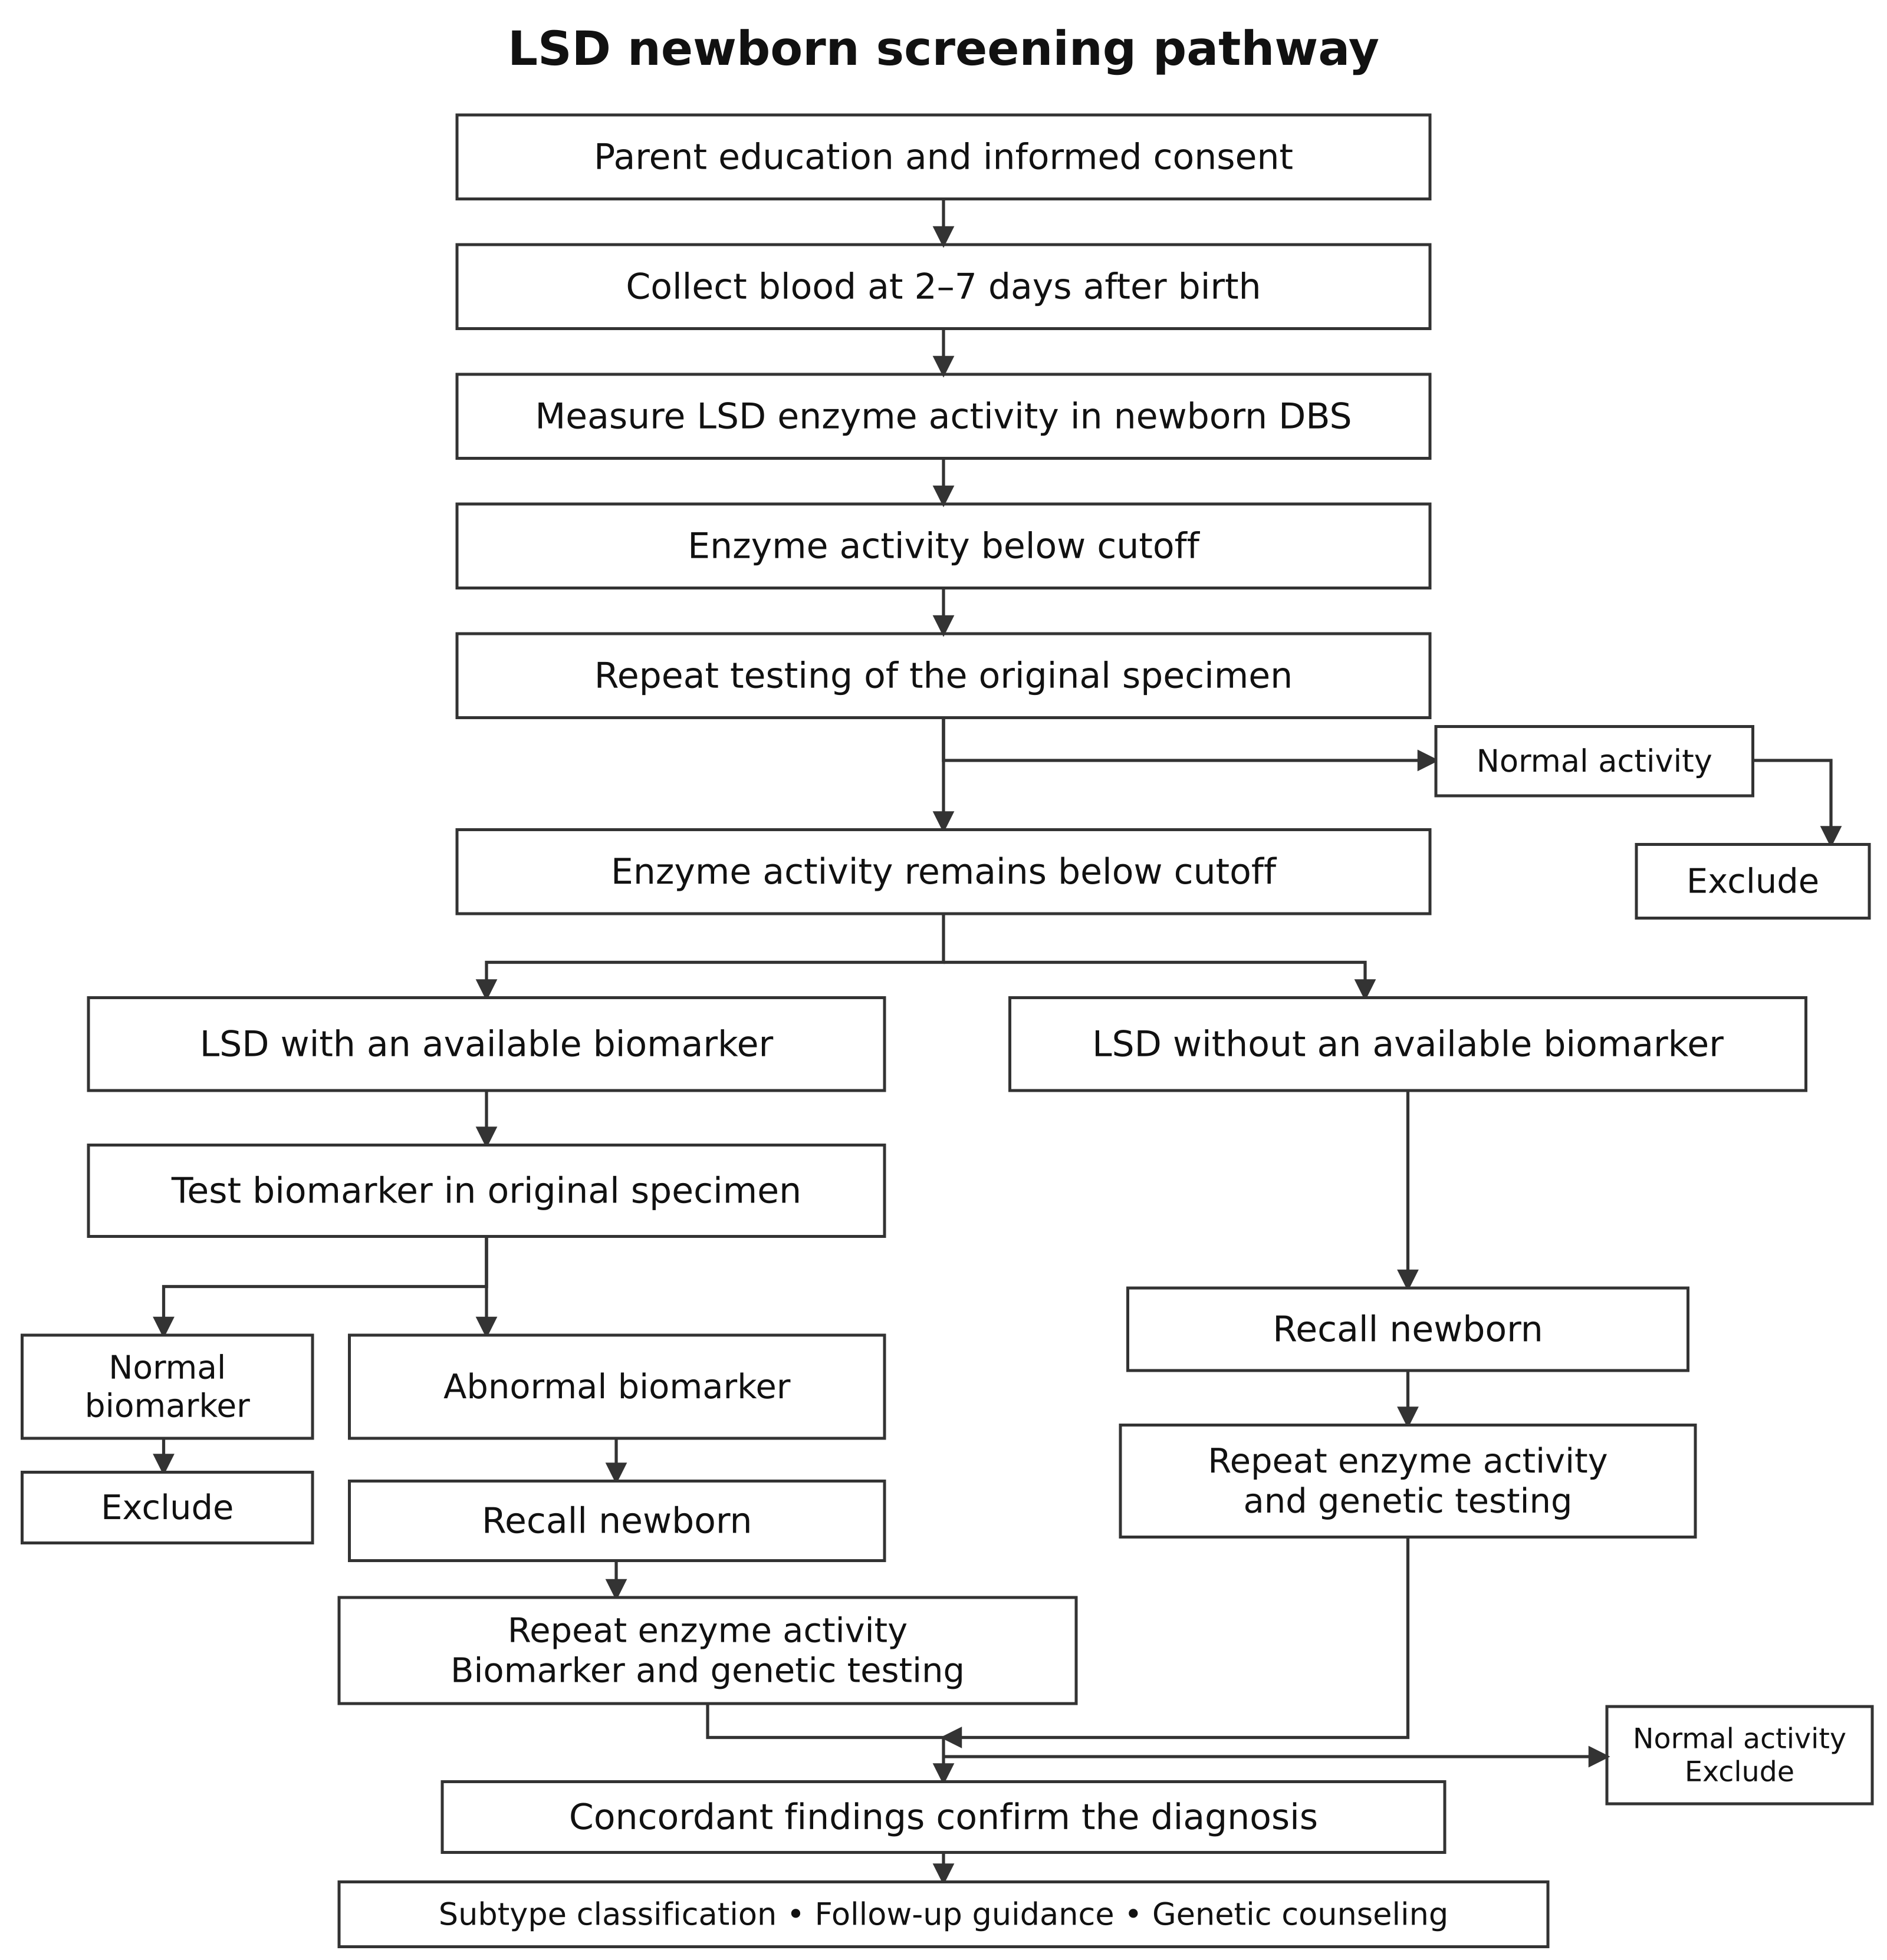

Available treatments
Treatment combines medication or hematopoietic stem cell transplantation (HSCT) with rehabilitation and other supportive care. Drug therapy remains the principal approach. HSCT is used less often because its role depends on the disorder, the timing of treatment, procedural risks, and cost. Several leading pediatric centers offer transplantation. For example, the hematology service at the Capital Institute of Pediatrics in Beijing began treating children with MPS using this approach in 2015 and reported 138 successfully treated children by March 2025, placing it among China’s more experienced specialist teams.
Table 4 Principal treatment approaches
Treatment | Principal applications | Main limitations or role
Enzyme replacement therapy (ERT) | Gaucher types I/III; Pompe; Fabry; MPS I | Most intravenous ERT does not cross the blood–brain barrier; regular long-term infusions are required.
Small-molecule therapies | Gaucher type I; selected Fabry patients; ambroxol and other approaches remain largely exploratory | Eligibility depends on age, genotype, or phenotype; availability in China differs by product.
HSCT | Asymptomatic or presymptomatic early-infantile Krabbe disease; severe MPS I | A narrow treatment window and transplant-related risk; limited improvement of established neurologic injury.
Symptom management and rehabilitation | All LSDs | Cardiopulmonary support, nutrition, pain control, renal replacement therapy, and motor, respiratory, hearing, and vision rehabilitation.

Drugs available in China
There are 11 drugs identified in this review as available in China for Gaucher, Fabry, Pompe, MPS types I, II, and IVA, and Niemann–Pick type C. Three are listed as receiving nationwide NRDL coverage beginning in 2024, with separate-payment management. This arrangement provides a designated reimbursement route for specified drugs, with implementation determined locally.
For separately paid drugs, nationally negotiated reimbursement prices may not be publicly disclosed. Most provinces supply them through designated hospitals or pharmacies and may require enrollment, review of the covered indication, or an annual payment limit. Actual reimbursement and patient spending caps vary by province.
Most LSD enzyme replacement therapies remain outside the national basic insurance formulary. Patients rely on local supplemental benefits, special catastrophic insurance arrangements, commercial insurance, charitable assistance, or self-payment. The first Commercial Health Insurance Innovative Drug List, released in late 2025 and implemented in 2026, includes velaglucerase beta as a supplemental commercial insurance option.
Table 5 LSD drugs and payment routes in China
Drug | Disease and treatment type | National or supplemental payment status | Public price entry in the source
Imiglucerase injection | Gaucher; ERT | Local supplemental coverage, charity, or self-payment | NR
Velaglucerase alfa for injection | Gaucher; ERT | Local supplemental coverage, charity, or self-payment | 84 mg: CNY 381/capsule*
Velaglucerase beta for injection | Gaucher types I/III; ERT | Listed as the only LSD drug in the first Commercial Health Insurance Innovative Drug List; outside the NRDL | NR
Eliglustat tartrate capsules | Gaucher type I; oral substrate reduction therapy for adults with eligible CYP2D6 metabolizer status | 2024 and 2025 NRDL editions; separate-payment management | 5 mg: CNY 9,650/vial*
Agalsidase alfa concentrate for infusion | Fabry; ERT | 2024 and 2025 NRDL editions; separate-payment management | 50 mg: CNY 5,306.3/unit*
Agalsidase beta for injection | Fabry; ERT | Local supplemental coverage, charity, or self-payment | NR
Alglucosidase alfa | Pompe; ERT | Local supplemental coverage, charity, or self-payment | NR
Laronidase | MPS I; ERT | Local supplemental coverage, charity, or self-payment | 5 mg/5 mL: CNY 7,960/vial
Idursulfase beta | MPS II; ERT | Local supplemental coverage, charity, or self-payment | NR
Elosulfase alfa | MPS IVA; ERT | Local supplemental coverage, charity, or self-payment | NR
Miglustat capsules | Niemann–Pick type C; oral substrate reduction therapy | 2024 and 2025 NRDL editions; separate-payment management | 84 mg: CNY 381/capsule*
* Source data note. The drug–strength–price pairings marked with an asterisk appear misaligned, including a capsule price attached to an injectable enzyme and an injectable presentation attached to oral eliglustat. The entries are reproduced as supplied rather than reassigned. They are not a usable drug-specific cost schedule without reconciliation. NR means that no public price is reported in the source table.

Where care is delivered

Institutional roles
Table 6 Institutions involved in LSD screening and care
Institution | Responsibilities
Provincial and municipal newborn screening centers | First-tier DBS screening, quality control, repeat testing, recall of screen-positive infants, and regional data management.
Maternal and child health hospitals and maternity hospitals | Specimen collection, informed consent and parent education, recall, and referral; first-tier testing where capacity permits.
Rare disease and inherited metabolic disease centers | Confirmatory enzyme, biomarker, and genetic testing; clinical classification; genetic counseling; treatment decisions.
Children’s hospitals and leading tertiary hospitals | Multiorgan assessment, ERT, supportive treatment, and long-term follow-up. Transplant centers provide HSCT for selected Krabbe and MPS I cases.
Independent medical laboratories | Enzyme, metabolite, and genetic testing services; clinical classification and treatment decisions remain with the treating institution.
Institutional terminology. Maternal and child health hospitals are dedicated providers in China’s maternal and pediatric care network. The source’s “Grade III Class A” hospitals are leading tertiary institutions; the designation is not a U.S. hospital accreditation category.

4 Health Economics and Payment for LSD Care
LSDs are not included in the mandatory or publicly funded newborn screening lists verified in this report for Beijing, Shanghai, Zhejiang, and Guangdong. LSD screening has therefore not been fully incorporated into the national program, and access varies by region. Lysosomal enzyme activity testing is the main screening approach. Voluntary programs have been introduced in locations including Shanghai [original reference 10], Beijing [12], and Shandong [13]. Because national insurance coverage for LSD treatment remains limited, local government policy and commercial support programs play a substantial role.

Diagnostic costs

Dried blood spot screening
Current DBS screening primarily uses mass spectrometry-based enzyme assays. There is no single publicly quoted national price for LSD DBS screening. Based on comparable rare genetic disease tests, the report estimates testing costs of CNY 80–120, with customer charges commonly around CNY 100–250 per target, depending on the panel. Our market assessment is that research-supported, no-charge enzyme screening is available to nearly all high-risk patients who can be connected to a suitable program. Pharmaceutical sponsors with active rare disease franchises support these diagnostic pathways; the examples below include both enzyme-based screening and other disease-specific tests.
Table 7 Examples of sponsor-supported diagnostic programs
Sponsor | Conditions covered | Testing and no-charge service scope
Sanofi China; testing performed by providers including PerkinElmer medical laboratories in China | Gaucher, Pompe, Fabry, MPS I | Three-tier approach: dried blood spot enzyme testing, biomarkers, and genetic testing.
Takeda China | Fabry | Dried blood spot testing.
CANbridge Pharmaceuticals | MPS II | Urine glycosaminoglycan (GAG) testing.

Genetic testing
Single-gene testing generally costs CNY 300–800 per person, multigene panels CNY 2,000–5,000, and whole-exome sequencing (WES) CNY 6,000–10,000. Family segregation analysis or Sanger confirmation is typically charged separately for each additional person or test. Genetic screening for LSDs generally uses a multigene panel.

Treatment costs

Transplantation and supporting care
Allogeneic HSCT, using donor stem cells, may be the preferred option for selected subtypes with neurologic involvement. In China, the report estimates a total cost of CNY 300,000–800,000, including the potential burden of post-transplant complications. After resident basic insurance and a second payment from catastrophic coverage, estimated patient costs are CNY 150,000–400,000. Additional provincial arrangements can reduce this further. Regions with such support substantially overlap with areas where LSD screening is more established.
Patients receiving medication also incur infusion and outpatient charges. Motor, swallowing, respiratory, or renal complications may add rehabilitation and supportive care, while long-term management requires repeated assessment of multiple organs. Many of the listed outpatient, infusion, rehabilitation, and routine test charges are below CNY 100 per service; hemodialysis is approximately CNY 300 per session and MRI approximately CNY 300–600. Our assessment is that many routine service charges are modest relative to medication or transplantation and can be manageable for families. The source leaves the intended quantitative affordability benchmark unfinished; total annual burden still depends on visit frequency and the services required.
Table 8 Example charges for treatment support and follow-up
Service and common clinical use | Example publicly posted charge in CNY
Outpatient intravenous infusion for ERT | 11.80 per session, including the infusion set
Motor function training for mobility limitations | 84 per 30 minutes
Speech training for speech impairment | 45 per 30 minutes
Swallowing training for dysphagia | 39 per 30 minutes
Noninvasive assisted ventilation | 3 per hour
Hemodialysis for end-stage kidney disease | 300 per session
Hematopoietic stem cell transplantation for selected indications | Based on the transplant center’s full inpatient bill
Laboratory or imaging test | Hospital posted charge in CNY
Complete blood count; urinalysis | 15 per test; 18 per test
Routine liver function; renal function | 31 per test; 12 per test
Quantitative urine protein; urine microalbumin | 8 per item; 9 per item
Routine electrocardiogram | 20 per examination
Routine color Doppler ultrasound, such as abdominal ultrasound | 70 per anatomic region
Echocardiography | 65 per examination
Bone mineral density | 86 per examination
Pulmonary ventilation function test | 40 per examination
Magnetic resonance imaging | 495 per examination; anatomic region requires confirmation
These are individual posted charge examples, not national tariffs or all-inclusive treatment costs. The infusion administration fee does not include the ERT drug. Repeated sessions, local pricing, and disease severity determine annual spending.

Public financing and additional provincial support
The household’s direct medical burden is the total cost of diagnosis, drugs, infusions, hospitalization, rehabilitation, complication management, and follow-up, less the amounts actually paid by basic insurance, catastrophic coverage, provincial or municipal programs, commercial policies already in force, charities, and company-supported programs.
Additional channels now include provincial rare disease funds, special-drug benefits under catastrophic coverage, medical assistance, and city-based supplemental commercial insurance. We use imiglucerase, at a cited payment standard of CNY 20,700 per 400-unit vial, as a high-cost example. At 60 U/kg every two weeks, or 26 infusions per year, a 20 kg child requires CNY 1,614,600 of medication annually. The source compares this with 39.1 times national per capita disposable income. It estimates that nearly one-third of provinces have arrangements capable of bringing this burden below ten times a two-person income benchmark. More developed local reimbursement arrangements can reduce household costs beyond what national coverage alone achieves.
Table 9 Provincial and local supplemental coverage examples
Region and payment channel | Covered LSD drugs or populations | Reimbursement mechanism | Effective payment share in source example | Remaining annual cost as a multiple of income
Zhejiang | Listed drugs including imiglucerase, alglucosidase alfa, and agalsidase beta; Gaucher, Pompe, and Fabry | Eligible annual drug expenses: 80% of the first CNY 300,000; 90% of the CNY 300,000–700,000 band; 100% above CNY 700,000. | 93.81% | 0.71×  Per capita income: CNY 70,240
Jiangsu | Approved Gaucher, Pompe, Fabry, and MPS IVA drugs under the special program | Tiered special coverage: 80% up to CNY 300,000; 85% for CNY 300,000–700,000; 90% above CNY 700,000. | 86.90% | 1.82×  Per capita income: CNY 57,971
Shandong | Specified drugs including imiglucerase, alglucosidase alfa, and agalsidase beta | CNY 20,000 deductible; 80% for the CNY 20,000–400,000 band; 85% above CNY 400,000; annual payment cap CNY 900,000. | 55.74% | 8.09×  Per capita income: CNY 44,180
Shanxi | Historical policy names imiglucerase and alglucosidase alfa for Gaucher and Pompe | Catastrophic coverage pays 50%, subject to its annual cap; government funds then subsidize 60% of the remaining eligible expenses. | Up to 80.00% | At least 4.76×  Per capita income: CNY 33,923
Shaanxi | Imiglucerase and alglucosidase alfa | After basic and catastrophic coverage, medical assistance pays 70% of the remaining eligible expenses for qualifying people, or 80% for ages 0–14. | Up to 90% | At least 2.25×  Per capita income: CNY 35,790
Shanghai | Children’s fund: disease-specific drugs for Gaucher, Pompe, Fabry, and MPS | After resident insurance, the children’s fund pays up to 50% of disease-specific drug costs, capped at CNY 100,000 per school year. Huhuibao domestic special-drug branches pay 70% or 30%; two MPS drugs each have a CNY 200,000 cap. Benefits were not stacked in the source. | 12.5% | 4.08×  Per capita income: CNY 91,987
Beijing | Velaglucerase beta and idursulfase beta | 65% for people without the specified pre-existing conditions; 35% for specified pre-existing conditions; annual coverage limit CNY 500,000. | 35% | 5.62×  Per capita income: CNY 89,090
Guangdong | Rare disease benefit includes imiglucerase, velaglucerase alfa/beta, alglucosidase alfa, and selected MPS drugs. Eliglustat first uses basic insurance and does not fall under this self-paid-drug benefit. | At least 3 continuous years enrolled: 70% above CNY 10,000, cap CNY 600,000; 2 years: 60% above CNY 10,000, cap CNY 550,000; first year: 50% above CNY 11,000, cap CNY 500,000. | 37.16% | 9.45×  Per capita income: CNY 53,669
Comparability note. These are different provincial or local programs with different drug lists, eligibility rules, deductibles, and caps. The Shanghai and Beijing income multiples do not reconcile with the common annual-cost assumption and displayed payment percentages. Figures are preserved from the source rather than recalculated using unstated assumptions.

* The source table footnote labels the CNY 1,614,600 annual example as eliglustat, while the preceding dose and vial calculation is for imiglucerase. The numeric results below are preserved from the source and should be read with that mismatch in mind.
** Income multiple = remaining annual drug cost after reimbursement ÷ (2025 provincial per capita disposable income × 2). This is the report’s two-person income proxy, not a measured household income or wage estimate.

5 The Chinese Diagnostics Market
Population aging, chronic disease management, early cancer detection, birth defect prevention, and precision medicine continue to generate substantial demand for testing in mainland China. The domestic IVD reagent market is estimated at approximately CNY 130 billion in 2025.
The market is also undergoing a major change in direction. National policies and healthcare reforms are shifting attention from adding billable services and expanding treatment volume toward clinical value, cost control, and testing efficiency. This disruption is reshaping competition across the IVD industry.

Laboratory departments are moving from revenue centers to cost centers
China began national pilots of diagnosis-related group (DRG) and diagnosis-intervention packet (DIP) payment in 2019 and expanded implementation nationwide during 2022–2024. Both move hospital payment toward a case-based budget, although their grouping and payment calculations differ. Under these arrangements, a laboratory test becomes part of the cost of an inpatient episode, rather than simply an additional source of fee-for-service revenue. Hospitals therefore scrutinize whether a new test is necessary. Tests retain clear value when they reduce misdiagnosis or repeat testing, enable an earlier treatment decision, shorten a hospital stay, or avoid ineffective medication.
Figure 5 Hospital payment reform and its implications
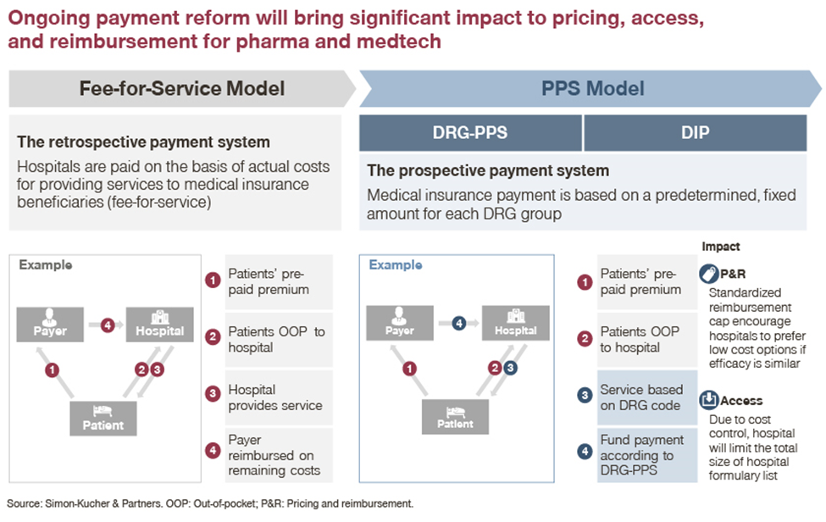
PPS = prospective payment system; OOP = out-of-pocket; P&R = pricing and reimbursement. The source illustration groups DRG and DIP under prospective payment. DIP uses a diagnosis-and-intervention points framework within a regional budget and is not identical to a fixed DRG rate.

Laboratory services face pressure to lower costs and improve efficiency
In 2026, the NHSA issued the Guidelines for Establishing Laboratory Medical Service Price Items, directly affecting billing and hospital technology choices. The guidelines standardize test names, service content, billing units, and billing codes nationwide, consolidating more than 2,000 laboratory service items into 662. In principle, the same test is no longer priced differently solely because a different method is used, although add-on charges may reflect the actual costs of methods such as mass spectrometry, quantitative testing, and confirmatory testing. The intended effects are more consistent billing, wider acceptance of test results across institutions, fewer irregular charges, and less room for opaque margins associated with outside testing.
The same-method-neutral pricing approach is accompanied by discounts for combined testing: 80% of individual charges for panels of up to five analytes, 70% for six to ten, and 60% for more than ten.
Hospitals will consequently place more weight on cost per test, staff time, and actual clinical output when adopting a technology. Companies will have less room to justify a premium solely on the basis of technical complexity.

Implications for diagnostic reagent companies
These policies reduce the scope for premium pricing based only on differences in routine testing technology. Routine chemistry and immunoassay reagents will compete increasingly on cost, consistency, instrument compatibility, and reliable supply. Genetic, oncology, and rare disease tests must demonstrate clinical value while also securing product registration, a billable service item, hospital adoption, and a payment source.
For qualifying products with substantial clinical value, NMPA has established a Special Review Procedure for Innovative Medical Devices and published registration review guidance for devices used in rare disease prevention and treatment. These mechanisms can support earlier regulatory communication and a more tailored review. Where patient numbers are small and enrollment is difficult, conditional approval with additional postmarketing clinical evidence may be explored if the available evidence supports a favorable benefit–risk assessment.

Figure 6 The Chinese IVD company base and reported financial risk indicators
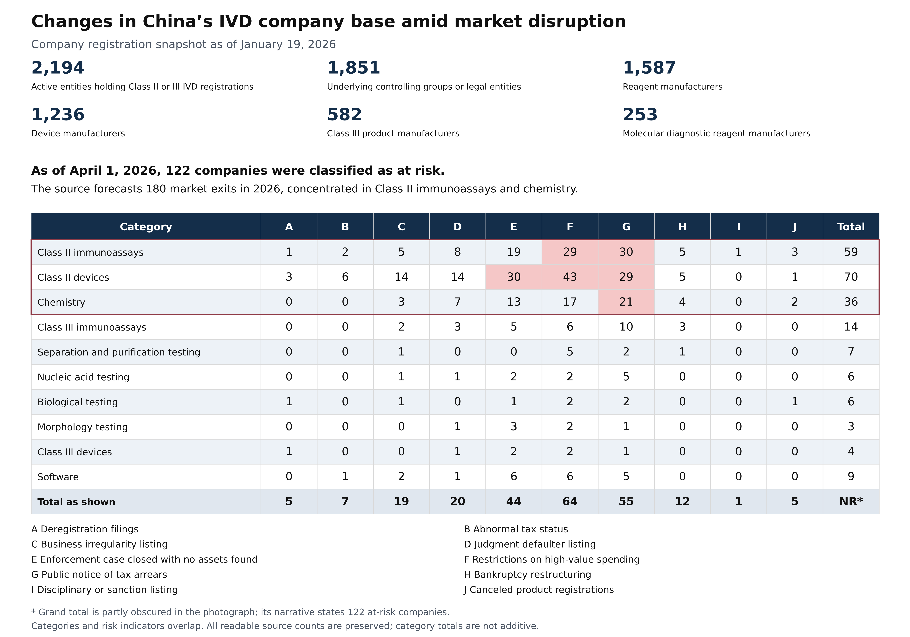
Figure source. English reconstruction of the industry presentation photograph supplied in the report. Its market-exit figure is the presenter’s forecast. No speaker, event, or underlying database is identified in the photograph.

6 Commercial Feasibility of LSD Screening in China

Market size
Market expansion must account for the tension between short-term government and insurance budget pressure and the long-term burden of untreated disease.
Because LSDs are inherited conditions, effective market education could extend testing beyond newborns to parents and families. We estimate a potential market two to three times the newborn-only population. Broader adoption would depend on national policy support and would take time. Family or carrier testing also requires an appropriate assay and intended use; this is an expansion opportunity rather than an automatic multiplier for a newborn enzyme screening kit.

The role of expert consensus
Expert consensus statements are influential practice-setting documents in China. They help clinicians determine which tests to use, how to interpret results, and how to manage patients. Companies often collaborate with the specialists who develop these statements through clinical research, assay validation, and evidence generation. Such work can create an opportunity to contribute data and technical expertise to the development of practice standards.
The Expert Consensus on Newborn Screening for Common Lysosomal Storage Disorders 2026 (PubMed ID 41986260) is reported in the source as published on September 20, 2026. Relevant specialists in several provinces are actively seeking partnerships with diagnostic companies.
The previous absence of a dedicated LSD newborn screening consensus may have been one reason domestic companies had not pursued product registration. This is our interpretation of the market, rather than an established causal finding.

Broader policy direction
The source reports that the National Health Commission (NHC) and the National Administration of Traditional Chinese Medicine issued a notice on September 20 calling for stronger rare disease prevention and treatment. Its stated targets include rare disease clinics and quality control centers in every province by the end of 2026, together with standardized clinical use of genetic testing.

Policy support and commercial prospects
- Clinical value in regulatory review. China’s device review process emphasizes clinical value. Support from clinical experts and recognition in guidelines can strengthen the evidence supporting an application.
- Potential benefits for innovative products. The market interviews identify opportunities to seek a separate medical service price item and special payment treatment outside standard DRG arrangements. Innovative-device review can support the regulatory strategy, but separate pricing and payer decisions must be obtained; it should not be understood as an automatic exemption from billing rules or hospital payment limits. [E3]
- Compatibility with local sourcing priorities. Foreign ownership does not in itself prevent an application. Manufacturing in China may allow a foreign company to localize its product and better fit procurement preferences for domestic supply. In this context, “domestic substitution” refers to a policy and purchasing preference for locally supplied products. The source’s reference to equivalent local production is not a claim of FDA-style substantial equivalence.

Requirements for special review mechanisms
- Innovative-device review. Four main considerations apply: an invention patent in China, or a published application supported by the required novelty assessment; a substantially finalized product design; a technology that is novel in China; and meaningful clinical value demonstrated with data. Exact eligibility must be established for the proposed product.
- Rare disease review guidance. Because the LSD panel covers rare diseases, the company should request early confirmation that the relevant rare disease guidance applies and use that discussion to define the clinical evidence required. “Rare disease pathway” here refers to this tailored review framework, rather than a separate blanket approval for any LSD kit. [E2]
- Coordinating the two mechanisms. Pursuing innovative-device review alongside the rare disease framework may reduce unnecessary development spending and clarify the scale of the clinical study before major commitments are made.

The value of early diagnosis
Within China’s first Rare Disease List of 121 conditions, LSDs include several of the relatively few disorders for which an actionable diagnostic and treatment pathway is available.

LDT pilot programs and commercial limitations
The industry participants consulted for this report consistently expected hospital-based laboratory-developed test (LDT) projects to become part of the hospital’s own service offering. In their assessment, this can leave limited returns for the company that helped establish the test. Formal LDT pilots are also limited to a small number of hospitals. Given the economics, the institutional constraints, and the risk that a hospital internalizes the service after a company’s initial investment, we do not recommend LDTs as the principal model for a scalable China business.

Products and services currently in the market
The report’s search did not identify an NMPA-registered commercial kit for either multiplex lysosomal enzyme activity testing or an LSD-specific genetic panel. Existing newborn screening activity is largely organized as hospital- or research-led cohorts, or charitable high-risk screening. Testing is delivered through hospital and independent laboratory in-house methods, described in the source as LDTs, or through research services. Use of that label does not establish that every service belongs to a formally authorized LDT pilot. Broad commercial deployment remains limited.
The principal enzyme assay products identified are Biotree’s LSD enzyme activity kit and NeoLSD, associated in the China market with Xinbo Biotechnology, part of Revvity’s business following its earlier PerkinElmer ownership. Both six-condition kits cover Gaucher, Niemann–Pick A/B, Krabbe, MPS I, Fabry, and Pompe disease. The source attributes approximately 70% of China’s overall newborn screening business to Xinbo and describes cooperation with 610 hospitals across all 31 mainland provincial-level regions. This is an overall newborn screening footprint, not a measured NeoLSD or LSD-specific market share. Xinbo lists PerkinElmer Shanghai among its partners. International authorization is version-specific: the original NeoLSD and the later 7plex product must be distinguished, as shown below. In 2024, NeoLSD entered the pediatric service at Ruijin Hospital Hainan, affiliated with Shanghai Jiao Tong University School of Medicine and also known as the Boao Research Hospital, through Hainan’s special import mechanism for urgently needed medical devices. According to our September 2026 market discussions, Xinbo was speaking with a contract research organization (CRO) about an NMPA application, with its final decision expected the following month.
Beyond enzyme assays, Biotree offers a Lyso-GL1/GL3 biomarker kit for Gaucher and Fabry disease, and several companies provide genetic testing services. Regional providers with an established local presence, such as Zhejiang Biosan Biotech, may bring in NeoLSD kits from Revvity and perform testing on platforms already installed in hospitals or on their own laboratory platforms.
Table 10 Products Services and other competitors
Company | Product or version | Type of competitor | Panel or scope | Access evidence recorded in the source
Xinbo / Revvity* | NeoLSD MSMS Kit  3093-001U | DBS enzyme assay kit; MS/MS six-plex | Gaucher, Niemann–Pick A/B, Krabbe, MPS I, Fabry, Pompe | U.S. FDA 510(k) K173829
Xinbo / Revvity | NeoLSD 7plex  3256-0010 | DBS enzyme assay kit; LC-MS/MS seven-plex | Original six conditions plus MPS II, using iduronate-2-sulfatase (IDS) | CE marking under the EU IVDR
Biotree | LSD enzyme activity kit | DBS enzyme assay kit; MS/MS six-plex | Gaucher, Niemann–Pick A/B, Krabbe, MPS I, Fabry, Pompe | No Chinese product registration identified
Biotree | LSD biomarker / Lyso-GL1 and GL3 kit | DBS biomarker assay; LC-MS/MS | Gaucher and Fabry | No Chinese product registration identified
BGI | Integrated newborn LSD screening service | DBS enzyme activity service; LC-MS/MS | Gaucher, Niemann–Pick A/B, Krabbe, MPS I, Fabry, Pompe | No product registration identified for the described service
BGI | Anxinke genetic screening | Broad NGS screening service | 112 diseases, including pathogenic genes associated with ten LSDs | No product registration identified for the described service
Cipher Gene | Newborn inherited disease genetic screening | Multiplex PCR capture plus NGS | Gaucher, Niemann–Pick A/B, Krabbe, Fabry, Pompe, MPS I, II, III, IV, VI, and VII | No product registration identified for the described service
Biosan Biotech | MSSMA / AMTSPre and screening solutions | Instrument and system channel | Platforms support multiple metabolic tests; exact LSD offering requires confirmation | No Chinese registration identified for the described LSD offering
KingMed Diagnostics | LSD enzyme and genetic diagnostic services | Referral testing and confirmation | Disease-specific menu and example reports still to be obtained | No product registration identified for the described service
Jiangsu Haosi Muke* | Substrate and internal-standard technology associated with CN111269280B | Reagent raw materials | Public patent covers compounds used in several LSD enzyme assays | Patent granted
* Company names describe the source’s commercial mapping and do not necessarily identify the legal manufacturer or registration holder. “Jiangsu Haosi Muke” is a romanized rendering of the supplied Chinese name. International FDA or CE status does not constitute Chinese registration. A service offering and an assay kit also have different regulatory identities.

Xinbo can be understood commercially as part of the localization of Revvity’s technology in China. Michael H. Gelb previously served as a technical adviser to PerkinElmer, and we note substantial similarity between its products and our own. Potential technical overlap and conflicts of interest should therefore be considered when evaluating competitors or partners.

7 Market Entry Strategy for Mainland China
We recommend building the China business around IVD registration and recurring reagent sales. Local partnerships should support validation in Chinese populations, registration studies, and the first customers, while work on billing, procurement, and referral into diagnosis and treatment proceeds in parallel. The first product should focus on six to eight conditions to control investment, with expansion guided by clinical value and market demand. Early research services and qualifying hospital co-development projects can have commercial value, but contracts must specify how revenue will be earned and how the company will retain its technology rights.

Regulatory and commercial approach
- For an eligible imported product, the innovative IVD procedure can waive the usual requirement to submit evidence of prior marketing authorization in the applicant’s home jurisdiction or the manufacturing jurisdiction. This can permit an application in China before U.S. commercialization. [E1]
- The operating assumption should be that Chinese population validation and a local clinical study will be needed. Overseas data can inform the package, but the business plan should not depend on U.S. data alone being sufficient.
- Using innovative-device review together with the rare disease framework may lower avoidable development costs and clarify the expected clinical study size.
- A separate service price item and appropriate treatment under hospital payment rules should be pursued alongside registration. These are separate access decisions, even if the product qualifies as innovative. [E3]
- The standard imported-product route generally requires evidence that the product may be marketed in the relevant overseas jurisdiction. The innovative-product exception provides an alternative when its conditions are met. [E1]
Given the current commercial limitations of LDTs in China, we recommend the registered IVD route. With no registered product identified in this review, early communication with NMPA should focus on eligibility for innovative-device review, the application of rare disease guidance, the evidence plan, and the parallel route to a separate billable service. For innovative review, the central arguments are novelty in China, substantial clinical value, and the required Chinese patent or published patent application and novelty assessment.
For the rare disease framework, the initial discussion should establish which panel conditions qualify and what clinical evidence is proportionate to the intended use and the limited availability of positive cases.
A severe combined immunodeficiency (SCID) screening project provides a recent comparator. The reported comparator received a national medical device registration certificate on September 24, 2026, becoming the first approved immunologic newborn screening kit in China. For a condition with a cited incidence of approximately 1 in 100,000, the reported project cycle was 15–16 months: approximately three to four months for startup, agreements, and data analysis, plus 12 months for baseline work and follow-up. This is a project example, rather than a guaranteed LSD review timeline.
The proposed LSD product is expected to require Class III IVD registration in China and supporting clinical evidence. This is China’s device classification and registration framework; it is not equivalent to an FDA “Class III De Novo” pathway. FDA De Novo classification is used to place eligible novel devices into Class I or II. [E4] China can accept overseas clinical data, but differences in populations, assay cutoffs, and Good Clinical Practice (GCP) implementation may require additional local evidence. The practical recommendation remains to plan for clinical work in China and agree on sample requirements with the reviewing authority. The source cites a SCID precedent in which one affected individual was identified among 30,000 samples; that figure is a study-specific reference, not a general regulatory rule for LSDs.
Cost scope. The latest source draft does not provide a total registration or market-entry budget. The 15–16 month comparator should therefore not be read as a complete LSD budget or a forecast of time to commercial revenue.
A limited early-use option is Hainan’s special import mechanism for products addressing urgent clinical need. The Tongze Hangzhou interview cited in the draft clarifies that this is a geographically restricted opportunity, potentially involving a local entity, an approved clinical partner, and special-import or real-world study requirements. It does not establish nationwide access, and data acceptance, hospital participation, procurement, and local implementation can still present obstacles. This option should be evaluated as a separate pilot opportunity rather than a substitute for national registration.
Early patent filing in China is important because local manufacturers can reproduce isotope-labeled materials and related assay technologies quickly. The company should identify and protect the elements that are central to its competitive position before broad technical disclosure.
China’s stringent controls on genetic information and human genetic resources make the local operating structure a central entry decision. The recommended model is technology licensing or transfer to an appropriate Chinese entity, or establishment of a local company, with Chinese partners handling the local activities required for validation and commercialization. The ownership and compliance structure must fit the proposed research and data flows.

Commercial preparation before entry
- Map the purchasers and decision makers. These include health commissions, screening centers, maternal and child health hospitals, laboratory departments, pediatric genetics teams, independent medical laboratories, and the public insurance or special-purpose funds that may pay for testing.
- Assess the dependencies. Priority factors are clinical key opinion leaders (KOLs), sample volume, access to MS/MS platforms, confirmatory testing and referral capacity, a payment source, the procurement route, and the strength of incumbent supplier relationships.
- Score potential entry cities. Compare birth volume, how concentrated screening is within a small number of centers, LSD specialist capacity, local payment support, willingness to pilot, existing competitors, and procurement difficulty.
- Build a shortlist of three to five candidate cities and then select the first entry point. The initial plan should allow a comparison of realistic partners and pilot designs before committing to one location.

Definitions for American Readers

Chinese healthcare and market access terms
Term | Meaning in this report
Basic medical insurance | China’s core public medical coverage, delivered through employee and resident programs. Local benefit rules determine what the fund pays.
Catastrophic coverage | A second public layer for high eligible out-of-pocket expenses. It is often translated as critical illness insurance and is not a lump-sum diagnosis benefit.
Medical assistance and Dibao | Means-tested support for vulnerable households. Dibao is the minimum-living-standard assistance program; qualifying people may receive additional medical support.
Huiminbao | Government-supported, city-based supplemental commercial health insurance. Products and pre-existing-condition benefits differ locally.
NRDL | National Reimbursement Drug List, the national formulary used by basic medical insurance. A drug’s listing does not establish an identical patient copayment everywhere.
NMPA and NHSA | NMPA regulates medical products. NHSA oversees public medical insurance and healthcare pricing policy. Product authorization and payment access are separate decisions.
NHC and health commissions | The National Health Commission and its local counterparts oversee health services and public health programs, including screening policy and provider networks.
Medical service price item | An officially defined billable service with a pricing framework. A registered assay still needs an applicable billing and payment route.
Procurement platform listing | Admission to a government or regional purchasing platform, often required before routine public hospital procurement. Listing is separate from winning a tender or hospital adoption.
Volume-based procurement | Centralized purchasing that uses committed demand to negotiate lower prices.
Expert consensus and KOL | A clinical practice statement developed by specialists; a KOL is a key opinion leader. These can influence adoption but do not replace a regulatory authorization.
DRG and DIP | Two case-based hospital payment approaches. DRG groups similar inpatient cases; DIP assigns points to diagnosis-and-intervention combinations within a budget.
Separate-payment management | A designated reimbursement arrangement for specified drugs. Local eligibility, dispensing sites, and payment limits still apply.
IVD and LDT | An IVD is an in vitro diagnostic product, such as an assay kit. An LDT is developed within a laboratory. China’s product registration and hospital pilot arrangements differ from U.S. laboratory practice.

Clinical and technical abbreviations
Abbreviation | Definition
LSD; NBS; DBS | Lysosomal storage disorder; newborn screening; dried blood spot.
ASMD; MPS; ML | Acid sphingomyelinase deficiency, historically Niemann–Pick A/B; mucopolysaccharidosis; mucolipidosis. Niemann–Pick type C is a different disorder from ASMD.
PKU; CH; SCID | Phenylketonuria; congenital hypothyroidism; severe combined immunodeficiency.
MS/MS; LC-MS/MS | Tandem mass spectrometry; liquid chromatography coupled to tandem mass spectrometry.
NGS; WES; PCR | Next-generation sequencing; whole-exome sequencing; polymerase chain reaction.
gNBS or NBGS; tNBS | Genetic or genomic newborn screening; traditional biochemical newborn screening.
ERT; HSCT; allo-HSCT | Enzyme replacement therapy; hematopoietic stem cell transplantation; allogeneic transplantation using donor cells.
IOPD; VUS; GAG | Infantile-onset Pompe disease; variant of uncertain significance; glycosaminoglycan.
CRO; GCP; IVDR | Contract research organization; Good Clinical Practice; the European Union In Vitro Diagnostic Medical Devices Regulation.
Screening yield versus incidence | Yield is the number meeting a study’s endpoint among those screened. Incidence refers to new disease cases in a defined population and period. A screen-positive result is not a confirmed diagnosis.
NR; CNY; U | Not reported or unavailable; Chinese yuan; units of enzyme activity in the treatment-dose example.

Editorial Clarifications and Source References
The English edition preserves the report’s argument, sequence, tables, and figures. Technical terminology and selected U.S. comparisons have been clarified. Source figures with conflicting labels, units, or assumptions remain visible with notes next to the affected material.

Specific source issues
- The population narrative and Figure 1 use different 2025 birth totals and birth rates. The source’s −1% trend description has no defined time series, and its global birth ranking is retained as a source claim.
- The Taiwan rate in Table 2 has a per-10,000 versus per-100,000 discrepancy. Table 3 is a modeled national allocation and includes rounding differences.
- Table 5 contains apparent drug–strength–price misalignment. Table 9’s example is labeled eliglustat in its original footnote but is calculated from an imiglucerase regimen; some reimbursement and income ratios do not reconcile.
- The source leaves a quantitative affordability benchmark unfinished and does not state a complete registration cost estimate. It also ends a sentence on provincial coverage mid-thought; the completed discussion preserves only the meaning recoverable from the surrounding text.
- The draft’s “Class III De Novo” analogy has been clarified using FDA terminology. Potential pricing exceptions are distinguished from innovative-device review because payer approval is a separate process.
- The urgent-clinical-need import paragraph incorporates the clarification requested in the source draft, using the supplied Tongze Hangzhou interview summary. The mechanism is described as a regional pilot opportunity rather than nationwide authorization.
- The source includes NHSA reference markers 1 and 2, and screening reference markers 10, 12, and 13, without a complete corresponding bibliography. These are retained as original reference markers; missing URLs or article details have not been invented.

References for English terminology and limited regulatory clarifications
E1 Measures for the Registration and Filing of In Vitro Diagnostic Reagents, SAMR Order 48, Article 19
NMPA Information Center. Supports the prior-marketing-document exception for qualifying innovative IVDs.
E2 Questions and answers on registration review guidance for rare disease medical devices
Beijing Medical Products Administration, April 9, 2021. Explains applicability to IVDs and early communication on clinical evidence.
E3 Case-by-case special review under DRG and DIP payment
NHSA, August 6, 2026. Describes separate payer review of qualifying high-cost or innovative-technology cases.
E4 De Novo Classification Request
U.S. Food and Drug Administration. De Novo classification places qualifying devices into Class I or II.
The original four English figures are retained. The Chinese screening algorithm and photographed IVD industry slide are reconstructed in English, preserving their readable content. The obscured grand total in the photograph is identified rather than guessed.

