**Assignment 3: How can cubes in general be calculated efficiently? What is an Iceberg Cube?**

**Efficient Calculation of Cubes**

Cubes in data warehousing represent multidimensional aggregations of data. To calculate cubes efficiently, the following strategies are used:

1. **Pre-computation & Materialization**
   * Some frequently used cube aggregations can be precomputed and stored to speed up query responses.
   * Partial materialization is used to store only essential aggregates instead of the full cube.
2. **Optimization Techniques**
   * **ROLAP (Relational OLAP)**: Uses SQL optimizations, indexing, and caching to enhance cube calculations.
   * **MOLAP (Multidimensional OLAP)**: Stores precomputed cube values in specialized storage structures for fast retrieval.
   * **HOLAP (Hybrid OLAP)**: Combines ROLAP and MOLAP for efficient query performance.
3. **Efficient Query Execution**
   * **CUBE and ROLLUP Operators**: SQL provides built-in operators to compute multiple levels of aggregation efficiently.
   * **Grouping Sets**: Allows selection of specific aggregate combinations, reducing computational overhead.
4. **Parallel Processing**
   * Utilizing distributed databases and parallel computation helps in handling large datasets.
5. **Pruning Techniques**
   * Only computing necessary aggregates instead of full cube calculations helps in reducing complexity.

**Iceberg Cube**

An **Iceberg Cube** is an optimized form of a data cube where only significant aggregations are calculated and stored. It is based on the principle of **minimal support**, meaning only groupings that meet a certain threshold are computed.

**Concept**

* Regular cube computation leads to exponential growth in data, making storage and computation costly.
* An Iceberg Cube reduces this by pruning out low-importance aggregations using a **HAVING** clause.

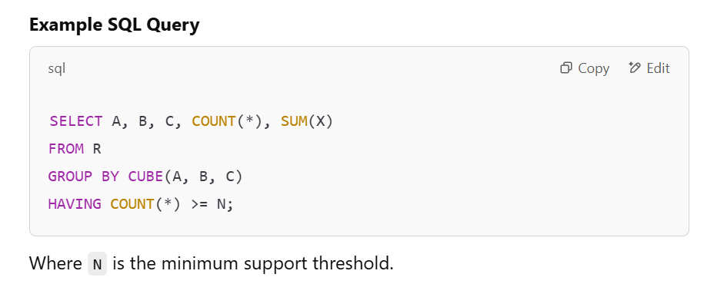

**Benefits**

* Reduces storage and computation overhead.
* Faster query performance by avoiding unnecessary aggregations.
* Used in data mining and OLAP for discovering meaningful patterns.