**[S-Function实现simulink仿真与VC通信](http://www.cnblogs.com/xpvincent/archive/2013/02/05/2892978.html)**

  在使用simulink仿真和其他语言编写的仿真模块合作时，总存在两种语言模块的数据交互的问题，本文考虑使用S-Function构建一个单独的通信模块，将该模块添加到simulink模型中，实现仿真数据的交互。Matlab的simulink仿真有提供一个用户自定义模块，该模块可以用多种编程语言来实现，本文介绍：使用C++的Socket通信来编写代码，实现和Vc的交互。

**1. VC++用户自定义模块的实现方法**

a. 在模型中添加S-Function, 编写模块对应的函数代码

b、编译C++代码，在matlab中编译，需要先通过matlab命令行设置matlab的mex编译器，方法如下:

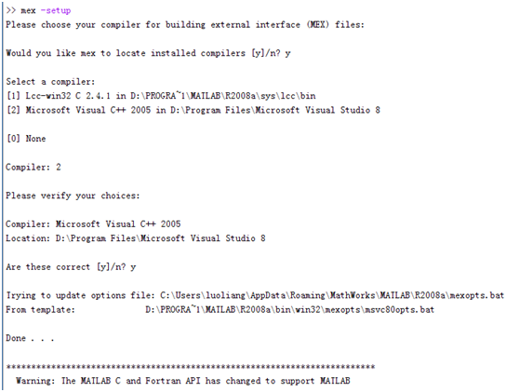

选择VS2005编译器，然后使用mex 命令来编译代码，命令格式：mex cppfile（模块对应的代码的文件名），编译成功会有相应的提示

c. 编译成功会产生一个后缀为mexw32的mex程序，有了这个程序，用户自定义模块就可以工作了

**2. 例子**

Demo说明：两个正弦输入信号经过mux模块集束成一个输入数组，经过自定义模块，最后到达Scope模块显示。在自定义模块(UseFunc)中，通过Socket采用UDP将输入数据发送到某个端口。

**2.1 Simulink模型**

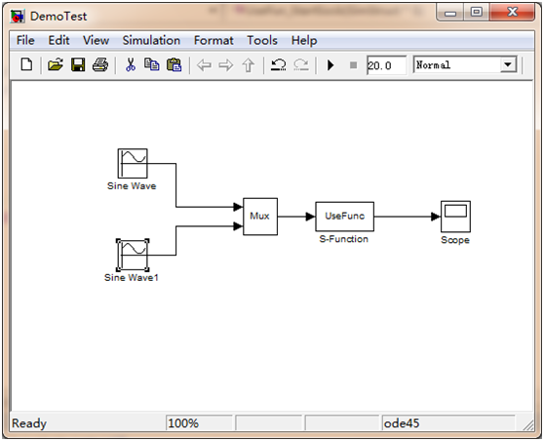

S-Function代码：

**UseFunc.h**

/* Copyright 2003-2004 The MathWorks, Inc. */

#ifndef _SFUN_CPP_USER_DEFINE_CPP_

#define _SFUN_CPP_USER_DEFINE_CPP_

// Define a generic template that can accumulate

// values of any numeric data type

template <class DataType> class GenericAdder {

private:

DataType Peak;

public:

GenericAdder()

{

Peak = 0;

}

DataType AddTo(DataType Val) {

Peak += Val;

return Peak;

}

DataType GetPeak()

{

return Peak;

}

};

// Specialize the generic adder to a 'double'

// data type adder

class DoubleAdder : public GenericAdder<double> {};

#endif

**UseFunc.cpp**

/* Copyright 2003-2004 The MathWorks, Inc. */

// *******************************************************************

// **** To build this mex function use: mex sfun_cppcount_cpp.cpp ****

// *******************************************************************

#include "UseFunc.h"

#define S_FUNCTION_LEVEL 2

#define S_FUNCTION_NAME UseFunc

// Need to include simstruc.h for the definition of the SimStruct and

// its associated macro definitions.

#include "simstruc.h"

#include "mex.h"

#ifndef WIN32_LEAN_AND_MEAN

#define WIN32_LEAN_AND_MEAN

#endif

#include <winsock2.h>

#include <Ws2tcpip.h>

#include <stdio.h>

// Link with ws2_32.lib

#pragma comment(lib, "Ws2_32.lib")

void UseFun_StartSock(SimStruct *S);

void UseFun_SentData(SimStruct *S, const real_T *data, int DataNum);

void UseFun_CloseSock(SimStruct *S);

#define IS_PARAM_DOUBLE(pVal) (mxIsNumeric(pVal) && !mxIsLogical(pVal) &&\

!mxIsEmpty(pVal) && !mxIsSparse(pVal) && !mxIsComplex(pVal) && mxIsDouble(pVal))

// Function: mdlInitializeSizes ===============================================

// Abstract:

// The sizes information is used by Simulink to determine the S-function

// block's characteristics (number of inputs, outputs, states, etc.).

static void mdlInitializeSizes(SimStruct *S)

{

// No expected parameters

ssSetNumSFcnParams(S, 0);

// Parameter mismatch will be reported by Simulink

if (ssGetNumSFcnParams(S) != ssGetSFcnParamsCount(S))

{

return;

}

// Specify I/O

if (!ssSetNumInputPorts(S, 1)) return;

ssSetInputPortWidth(S, 0, DYNAMICALLY_SIZED);

ssSetInputPortDirectFeedThrough(S, 0, 1);

if (!ssSetNumOutputPorts(S,1)) return;

ssSetOutputPortWidth(S, 0, DYNAMICALLY_SIZED);

ssSetNumSampleTimes(S, 1);

// Reserve place for C++ object

ssSetNumPWork(S, 3);

ssSetOptions(S,

SS_OPTION_WORKS_WITH_CODE_REUSE |

SS_OPTION_EXCEPTION_FREE_CODE);

}

// Function: mdlInitializeSampleTimes =========================================

// Abstract:

// This function is used to specify the sample time(s) for your

// S-function. You must register the same number of sample times as

// specified in ssSetNumSampleTimes.

static void mdlInitializeSampleTimes(SimStruct *S)

{

ssSetSampleTime(S, 0, INHERITED_SAMPLE_TIME);

ssSetOffsetTime(S, 0, 0.0);

ssSetModelReferenceSampleTimeDefaultInheritance(S);

}

// Function: mdlStart =======================================================

// Abstract:

// This function is called once at start of model execution. If you

// have states that should be initialized once, this is the place

// to do it.

#define MDL_START

static void mdlStart(SimStruct *S)

{

// Store new C++ object in the pointers vector

DoubleAdder *da = new DoubleAdder();

ssGetPWork(S)[0] = da;

UseFun_StartSock(S);

}

// Function: mdlOutputs =======================================================

// Abstract:

// In this function, you compute the outputs of your S-function

// block.

static void mdlOutputs(SimStruct *S, int_T tid)

{

// Retrieve C++ object from the pointers vector

DoubleAdder *da = static_cast<DoubleAdder *>(ssGetPWork(S)[0]);

// Get data addresses of I/O

InputRealPtrsType u = ssGetInputPortRealSignalPtrs(S,0);

real_T *y = ssGetOutputPortRealSignal(S, 0);

int InputNum = ssGetInputPortWidth(S, 0);

for(int i=0;i<InputNum;i++)

{

y[i] = *u[i];

}

UseFun_SentData(S, y, InputNum);

}

// Function: mdlTerminate =====================================================

// Abstract:

// In this function, you should perform any actions that are necessary

// at the termination of a simulation. For example, if memory was

// allocated in mdlStart, this is the place to free it.

static void mdlTerminate(SimStruct *S)

{

// Retrieve and destroy C++ object

DoubleAdder *da = static_cast<DoubleAdder *>(ssGetPWork(S)[0]);

delete da;

UseFun_CloseSock(S);

}

void UseFun_StartSock(SimStruct *S)

{

int iResult;

WSADATA wsaData;

SOCKET *pSendSocket = new SOCKET;

*pSendSocket = INVALID_SOCKET;

sockaddr_in *pRecvAddr = new sockaddr_in;

unsigned short Port = 27015;

printf("Start socket communication, please wait...\n");

//----------------------

// Initialize Winsock

iResult = WSAStartup(MAKEWORD(2, 2), &wsaData);

if (iResult != NO_ERROR)

{

printf("WSAStartup failed with error: %d\n", iResult);

return ;

}

//---------------------------------------------

// Create a socket for sending data

*pSendSocket = socket(AF_INET, SOCK_DGRAM, IPPROTO_UDP);

if (*pSendSocket == INVALID_SOCKET)

{

printf("socket failed with error: %ld\n", WSAGetLastError());

WSACleanup();

return ;

}

//---------------------------------------------

// Set up the RecvAddr structure with the IP address of

// the receiver (in this example case "192.168.1.1")

// and the specified port number.

pRecvAddr->sin_family = AF_INET;

pRecvAddr->sin_port = htons(Port);

pRecvAddr->sin_addr.s_addr = inet_addr("127.0.0.1");

ssGetPWork(S)[1] = pSendSocket;

ssGetPWork(S)[2] = pRecvAddr;

}

void UseFun_SentData(SimStruct *S, const real_T *data, int DataNum)

{

int iResult;

char SendBuf[1024]={'\0'};

int BufLen = 1024;

SOCKET *pSendSocket = static_cast<SOCKET *>(ssGetPWork(S)[1]);

sockaddr_in *pRecvAddr = static_cast<sockaddr_in *>(ssGetPWork(S)[2]);

if (*pSendSocket == SOCKET_ERROR)

{

printf("SOCKET_ERROR error: %d\n", WSAGetLastError());

closesocket(*pSendSocket);

WSACleanup();

return ;

}

//---------------------------------------------

// Send a datagram to the receiver

//printf("Sending a datagram to the receiver...\n");

int ValidateBufLen = 0;

for(int i=0;i<DataNum;i++)

{

ValidateBufLen = strlen(SendBuf);

sprintf(SendBuf+ValidateBufLen, "%g;", data[i]);

}

iResult = sendto(*pSendSocket,

SendBuf, BufLen, 0, (SOCKADDR *)pRecvAddr, sizeof(sockaddr_in));

}

void UseFun_CloseSock(SimStruct *S)

{

SOCKET *pSendSocket = static_cast<SOCKET *>(ssGetPWork(S)[1]);

sockaddr_in *pRecvAddr = static_cast<sockaddr_in *>(ssGetPWork(S)[2]);

//---------------------------------------------

// When the application is finished sending, close the socket.

printf("Finished socket communication, Closing socket.\n");

if (closesocket(*pSendSocket) == SOCKET_ERROR)

{

printf("closesocket failed with error: %d\n", WSAGetLastError());

}

//---------------------------------------------

// Clean up and quit.

WSACleanup();

delete pSendSocket;

pSendSocket = NULL;

delete pRecvAddr;

pRecvAddr = NULL;

}

// Required S-function trailer

#ifdef MATLAB_MEX_FILE /* Is this file being compiled as a MEX-file? */

#include "simulink.c" /* MEX-file interface mechanism */

#else

#include "cg_sfun.h" /* Code generation registration function */

#endif

运行效果图：

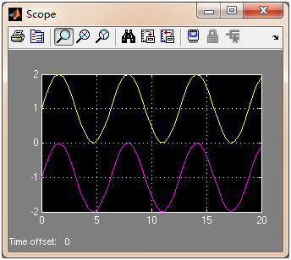

**2.2  数据接收**

通过辅助程序，收到上面自定义模型发出来的数据如下

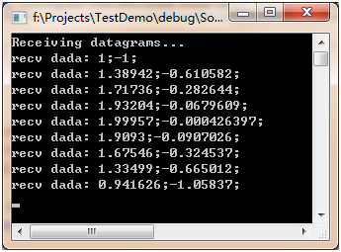

说明:分号前为第一个正弦输入信号的数据，分号后为第二个正弦输入信号的数据。

VC2005 控制台程序代码如下：

**SocketServer.cpp**

// SocketServer.cpp : 定义控制台应用程序的入口点。

#include "stdafx.h"

#ifndef UNICODE

#define UNICODE

#endif

#define WIN32_LEAN_AND_MEAN

#include <winsock2.h>

#include <stdio.h>

// Link with ws2_32.lib

#pragma comment(lib, "Ws2_32.lib")

int _tmain(int argc, _TCHAR* argv[])

{

int iResult = 0;

WSADATA wsaData;

SOCKET RecvSocket;

sockaddr_in RecvAddr;

unsigned short Port = 27015;

char RecvBuf[1024];

int BufLen = 1024;

sockaddr_in SenderAddr;

int SenderAddrSize = sizeof (SenderAddr);

//-----------------------------------------------

// Initialize Winsock

iResult = WSAStartup(MAKEWORD(2, 2), &wsaData);

if (iResult != NO_ERROR)

{

wprintf(L"WSAStartup failed with error %d\n", iResult);

return 1;

}

//-----------------------------------------------

// Create a receiver socket to receive datagrams

RecvSocket = socket(AF_INET, SOCK_DGRAM, IPPROTO_UDP);

if (RecvSocket == INVALID_SOCKET)

{

wprintf(L"socket failed with error %d\n", WSAGetLastError());

return 1;

}

//-----------------------------------------------

// Bind the socket to any address and the specified port.

RecvAddr.sin_family = AF_INET;

RecvAddr.sin_port = htons(Port);

RecvAddr.sin_addr.s_addr = htonl(INADDR_ANY);

iResult = bind(RecvSocket, (SOCKADDR *) & RecvAddr, sizeof (RecvAddr));

if (iResult != 0)

{

wprintf(L"bind failed with error %d\n", WSAGetLastError());

return 1;

}

//-----------------------------------------------

// Call the recvfrom function to receive datagrams

// on the bound socket.

wprintf(L"Receiving datagrams...\n");

iResult = 0;

int RecvNum = 0;

while(RecvNum < 100)

{

memset(RecvBuf,0,BufLen);

iResult = recvfrom(RecvSocket,

RecvBuf, BufLen, 0, (SOCKADDR *) & SenderAddr, &SenderAddrSize);

if (iResult == SOCKET_ERROR)

{

wprintf(L"recvfrom failed with error %d\n", WSAGetLastError());

break;

}

printf("recv dada: %s \n", RecvBuf);

RecvNum++;

}

//-----------------------------------------------

// Close the socket when finished receiving datagrams

wprintf(L"Finished receiving. Closing socket.\n");

iResult = closesocket(RecvSocket);

if (iResult == SOCKET_ERROR)

{

wprintf(L"closesocket failed with error %d\n", WSAGetLastError());

return 1;

}

//-----------------------------------------------

// Clean up and exit.

wprintf(L"Exiting.\n");

WSACleanup();

return 0;

}