Parabellum.io
AI-Powered Cybersecurity GRC Platform
Manual Testing & Fix Verification Report
Final Year Project — tool-by-tool verification, bugs found, fixes applied and re-test evidence
Item | Details
Version tested | Parabellum-IO-main (original) and Parabellum-IO-fixed (after fixes)
Test date | 3–4 October 2026
Test type | Manual black-box testing in the browser, white-box code review, API security testing, re-testing after fixes
Environment | Linux, Node.js 22, Python 3.11, Chromium, SonarQube Community 26.9, Semgrep 1.179, Trivy 0.75, OWASP ZAP 2.17, Grype 0.120 (Docker)
Test application | "vuln-test-app" – a small Node.js app with planted bugs: SQL injection, eval() injection, hard-coded password, wildcard CORS, insecure cookie, DOM XSS, Dockerfile using node:latest with a secret and root user, privileged docker-compose, committed .env, old libraries (lodash 4.17.4, express 4.16.0)

Contents

If the contents list is empty, right-click it in Word and choose "Update Field".

1. Executive Summary
We tested every tool and feature that the README and the web app claim, checked the source code to see what is really implemented, and tested security with a second "attacker" account.
Before the fixes: the main flow worked, but only 2 of the 6 security tools (SonarQube and Semgrep) were real. Trivy, OWASP ZAP and Anchore showed "Connected" even when they were not installed and ran simple keyword searches instead. Gemini AI was never called. SonarQube found 0 issues for local-folder projects. We also found 4 high-risk security bugs.
After the fixes: all 20 bugs were fixed and re-tested. SonarQube, Semgrep, Trivy and OWASP ZAP were run for real and found the planted bugs. Snyk and Anchore Grype are real integrations; in our lab they could not download their online data, so their result parsing was tested with sample output in the real format. All security bugs are closed.
Round 2: OTP by e-mail, one account per e-mail, saved sessions, expandable results, a one-click pipeline with fix verification, and a full final report (all tools, 6 frameworks, RAG recommendations, fix plans, owners, evidence, business context) were added and tested — see section 6.

1.1 Tool-by-tool: before and after
Tool / Feature | Before fixes | After fixes | Status
SonarQube (SAST) | Worked for ZIP uploads; 0 issues + fake "PASSED" for local folders | 12 issues for local folders too (same as ZIP) | FIXED
Semgrep (SAST) | Real, 10 findings | Real, 10 findings; no more hang when offline | WORKS
Snyk (SCA) | Real CLI, but npm projects only; raw error if missing | All ecosystems (--all-projects); clear install/login message | FIXED (needs Snyk account)
Trivy (Container) | Not real: keyword checks, fake CVE IDs, missed all library CVEs | Real Trivy: 28 findings incl. lodash CVEs, Dockerfile misconfigs and secret | FIXED
OWASP ZAP (DAST) | Not real and not DAST: searched source files, false positives from comments | Real ZAP crawl of the running app: 9 alert types (headers, CSRF, cookies) | FIXED
Anchore (Policy) | Not real: "Connected 5.1.0" when not installed; Critical without Dockerfile | Real Grype scan + STOP/WARN gate; N/A without Docker files | FIXED (DB blocked in lab)
Gemini AI | Never called | "Get AI fix advice" button on Risk Analysis | FIXED (needs API key)
RAG service | Port 8000 in README, 5000 in code; setting ignored | Port 5000 everywhere, RAG_SERVICE_URL used | FIXED
Compliance mapping (6 frameworks) | Worked; old CSF 1.1 IDs, CIS without titles, double counts | CSF 2.0 IDs, official titles and groups, unique counts | FIXED
Risk analysis, report | Worked | Works, plus AI advice | WORKS
Login / OTP / admin | OTP on screen, anyone could become admin, no lockout | ADMIN_EMAIL, OTP_DELIVERY setting, OTP lockout, rate limit, required JWT secret, password reset | FIXED
Data access between users | Other users' projects and reports readable | Blocked (404) everywhere | FIXED
Delete project | Deleted the user's real folder from disk | Only removes the app's own copies | FIXED

1.2 Numbers
Measure | Before fixes | After fixes
Test cases run | 40 | 40 + 22 re-test cases
Passed | 17 | 38 (all except the 2 below)
Failed | 21 | 0
Not testable in our lab | 2 (GitHub import, RAG model) | 2 (GitHub import, RAG model) – see section 6
Bugs open | 20 (4 high security, 5 high functional, 7 medium, 4 low) | 0

2. How We Tested
- Installed the backend and frontend, built the frontend and ran the backend on port 4000.
- Ran a real SonarQube server in Docker with an access token, and installed the real Semgrep CLI.
- First round: deliberately did NOT install Snyk, Trivy, ZAP or Anchore, to see what a normal user sees when a tool is missing.
- Built a test app with known, planted bugs so we know what each scanner should find.
- Used every page in a Chromium browser and took screenshots.
- Called the API directly with two accounts (analyst@test.com and attacker@test.com) to test security.
- Read the source code of every service to confirm what is real and what is simulated.
- After fixing, repeated every test. For the re-test, real Trivy, Grype and OWASP ZAP were run from their official Docker images, and a small insecure web app was started as the ZAP target.
Lab notes: the Semgrep online rule registry, the Grype vulnerability database, the HuggingFace model download (RAG) and the GitHub API were blocked by the lab network. Semgrep used the same official rules downloaded from GitHub. Where a tool needed blocked online data, its parsing was tested with output in the tool's real format.

3. Part A – Manual Testing Results (Before Fixes)

3.1 Sign up, login and OTP (MFA)
ID | Test | Expected | Actual | Result
TC-01 | Open login page | Page loads | Loads with Sign In / Create Account tabs | PASS
TC-02 | Sign up with password "weak" | Rejected | "Password must be at least 8 characters" | PASS
TC-03 | Sign up with "Strong@Pass123" | Account created | Account created | PASS
TC-04 | Login with wrong password | Rejected | "Invalid email or password" | PASS
TC-05 | Login with right password | OTP sent by e-mail | OTP printed on the screen (SMTP not configured) | FAIL
TC-06 | Enter wrong OTP | Rejected | "Incorrect OTP code" – but unlimited tries | PASS
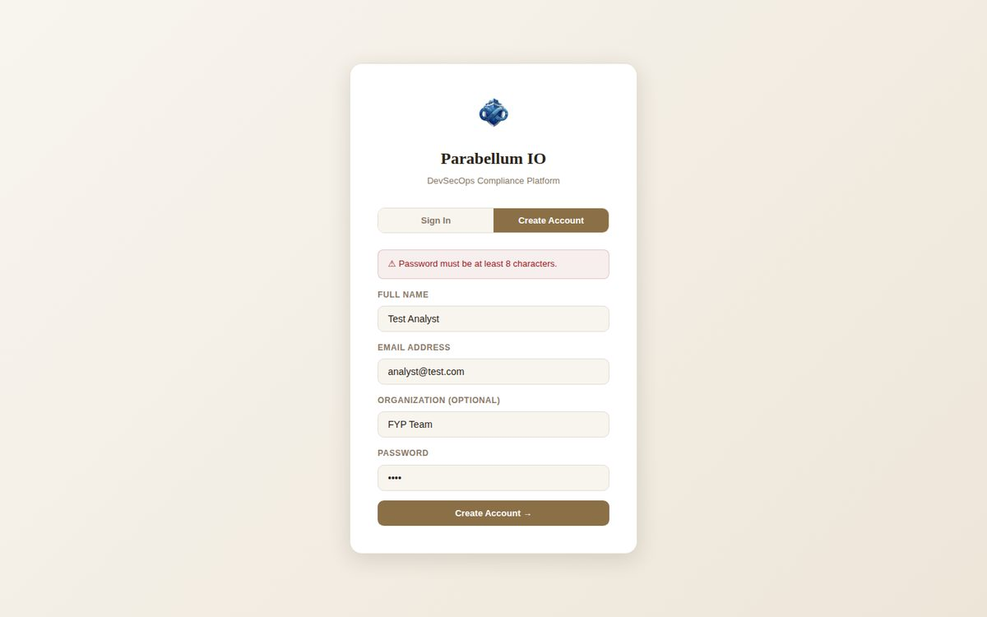
Figure 1 – Weak password rejected (TC-02)
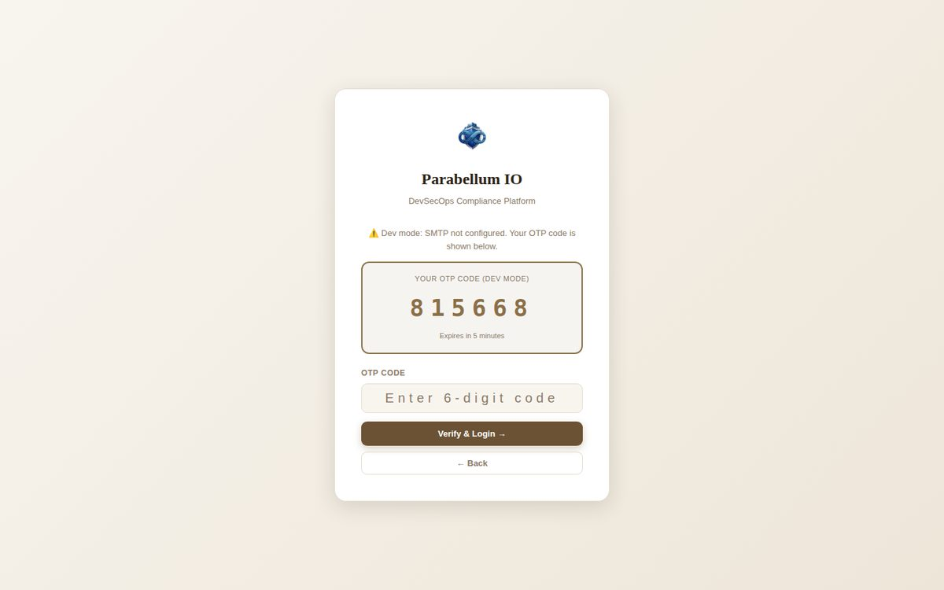
Figure 2 – OTP code shown on screen – the second factor protects nothing (TC-05)

3.2 Tools page and Dashboard
ID | Test | Expected | Actual | Result
TC-07 | Open Dashboard | Score, tools, activity | Shown | PASS
TC-08 | Tools page with only SonarQube + Semgrep installed | Only those 2 "Connected" | Trivy, ZAP and Anchore also "Connected" with made-up versions | FAIL
TC-09 | Tools page with SonarQube turned off | "Not Connected" | Always "Connected" (hard-coded) | FAIL
TC-10 | Snyk not installed | No version | Shows "1.1306.1" (hard-coded) | FAIL
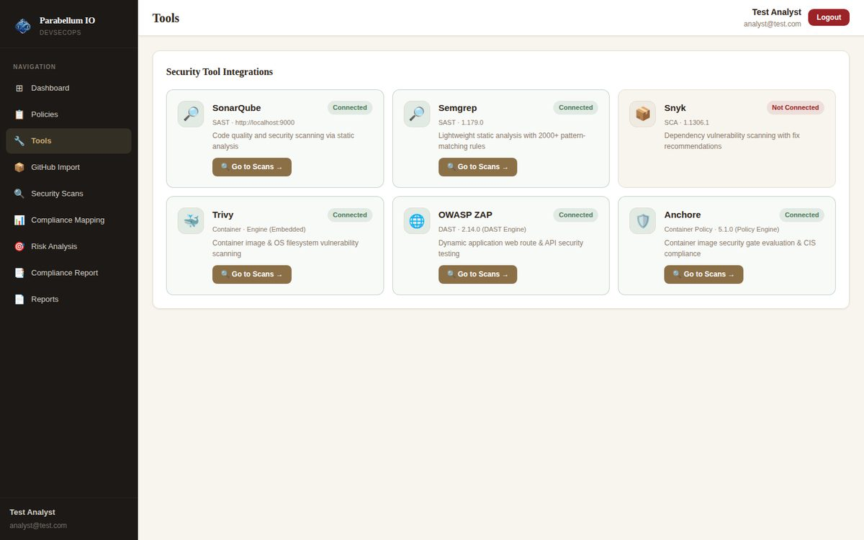
Figure 3 – Tools page before fixes: Trivy, ZAP and Anchore "Connected" although not installed
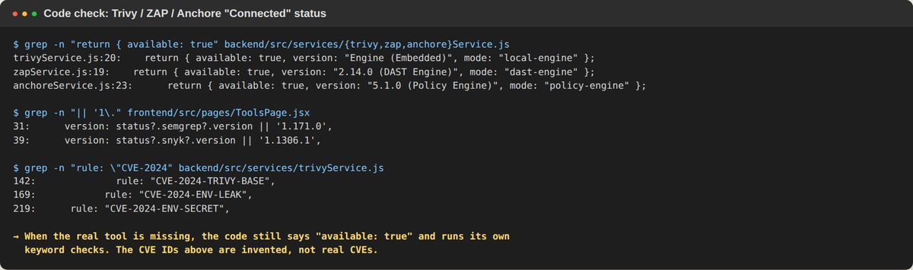
Figure 4 – Code proof: status returns available: true when the tool is missing; Trivy used invented CVE IDs

3.3 Adding projects
ID | Test | Expected | Actual | Result
TC-11 | Register a local folder | Added | Added | PASS
TC-12 | Upload a ZIP | Extracted and added | Extracted and added | PASS
TC-13 | Import from GitHub | Cloned | GitHub API blocked in lab (HTTP 403) | NOT TESTED
TC-14 | Type label for a local folder | "Local" | Shows "Upload" | FAIL
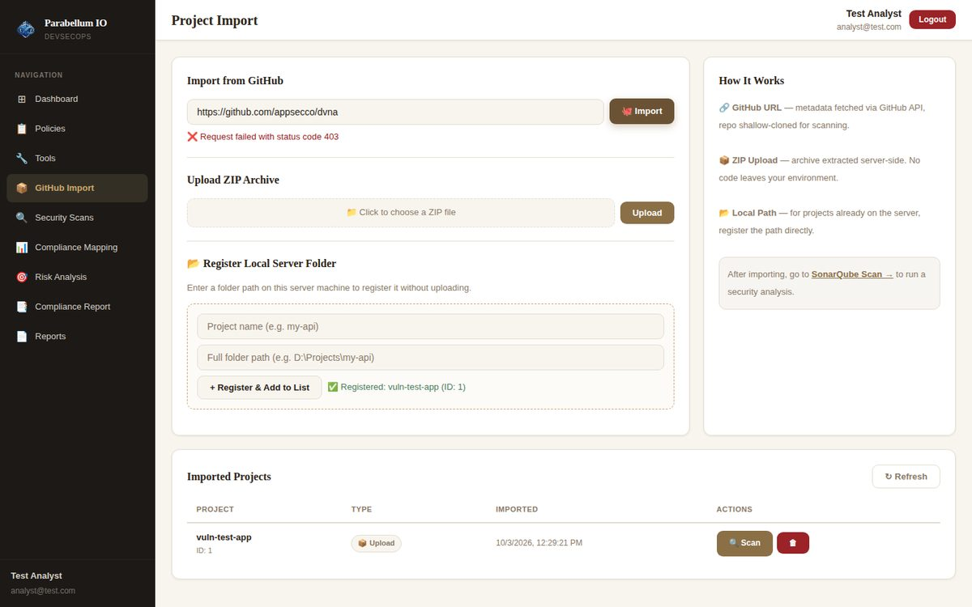
Figure 5 – Import page before fixes: local project wrongly labelled "Upload"

3.4 SonarQube (SAST)
ID | Test | Expected | Actual | Result
TC-15 | Scan uploaded ZIP project | Finds planted bugs | 12 issues (5 bugs, 6 vulnerabilities, 1 code smell) | PASS
TC-16 | Scan the same code as a local folder | Same 12 issues | 0 issues and "Quality Gate PASSED" – every file ignored | FAIL
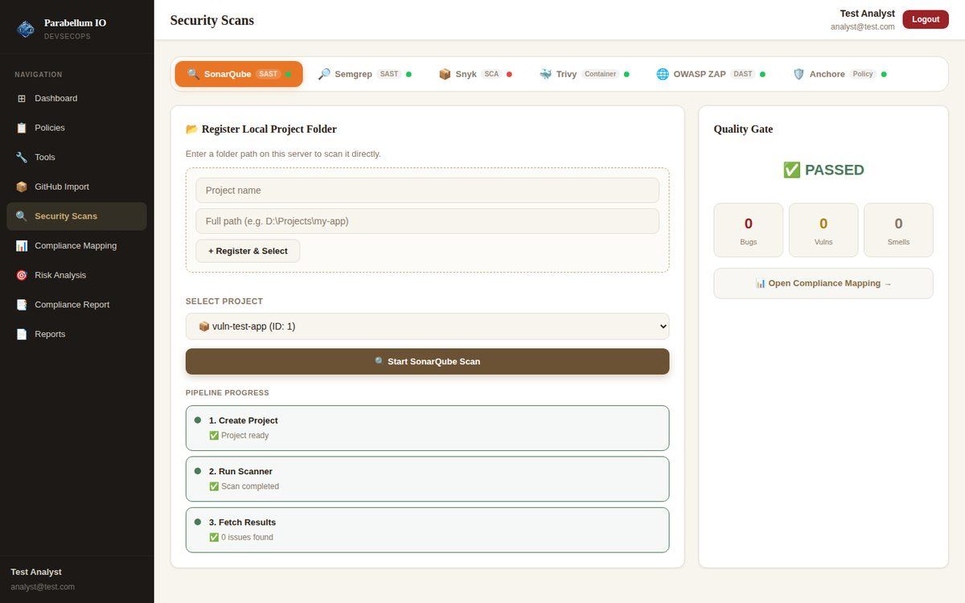
Figure 6 – Local folder before fixes: 0 issues, fake "PASSED"
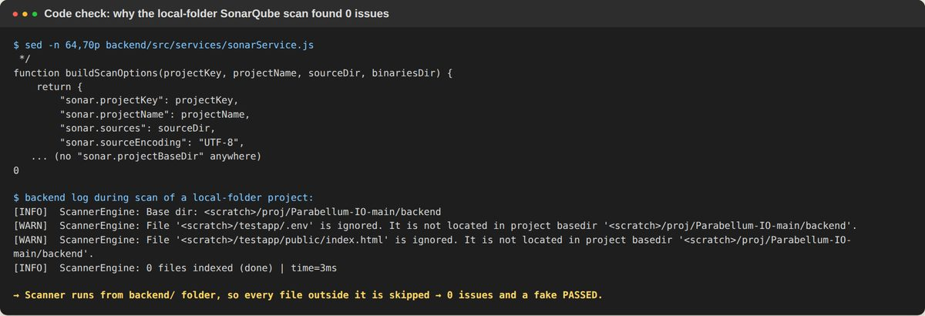
Figure 7 – Reason: scanner ran from the backend folder and skipped all project files

3.5 Semgrep (SAST)
ID | Test | Expected | Actual | Result
TC-17 | Run Semgrep on test app | Finds code bugs | 10 findings (SQL injection, eval, secrets, Dockerfile, XSS) | PASS
TC-18 | Status when offline | Clear status | Version check hangs → "Not Connected" | FAIL
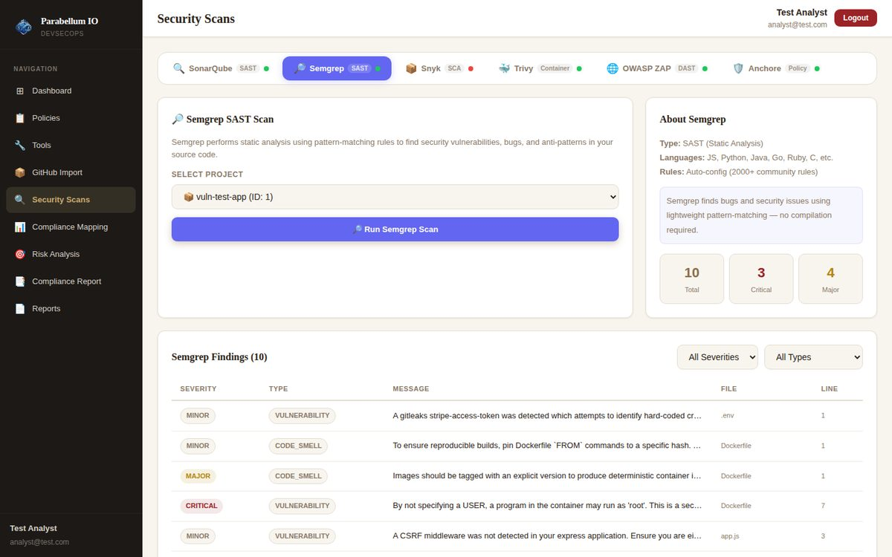
Figure 8 – Semgrep – real results

3.6 Snyk (SCA)
ID | Test | Expected | Actual | Result
TC-19 | Run Snyk with Snyk not installed | Friendly message | Raw "snyk: not found" error | PASS
TC-20 | Run Snyk on a Python project | Supported (UI says so) | Refused: "No package.json found" | FAIL
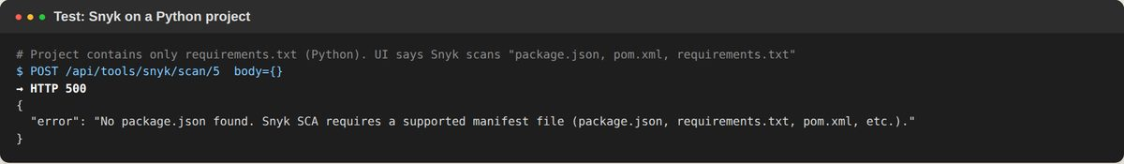
Figure 9 – Snyk refused a Python project

3.7 Trivy (Container)
ID | Test | Expected | Actual | Result
TC-21 | Run "Trivy" with Trivy not installed | "Not installed" | 6 keyword findings, shown as Trivy | FAIL
TC-22 | Find known library CVEs (lodash 4.17.4) | Yes | None (npm audit finds 8 vulnerable libraries) | FAIL
TC-23 | Rule IDs | Real CVE IDs | Invented: CVE-2024-TRIVY-BASE, CVE-2024-ENV-LEAK | FAIL
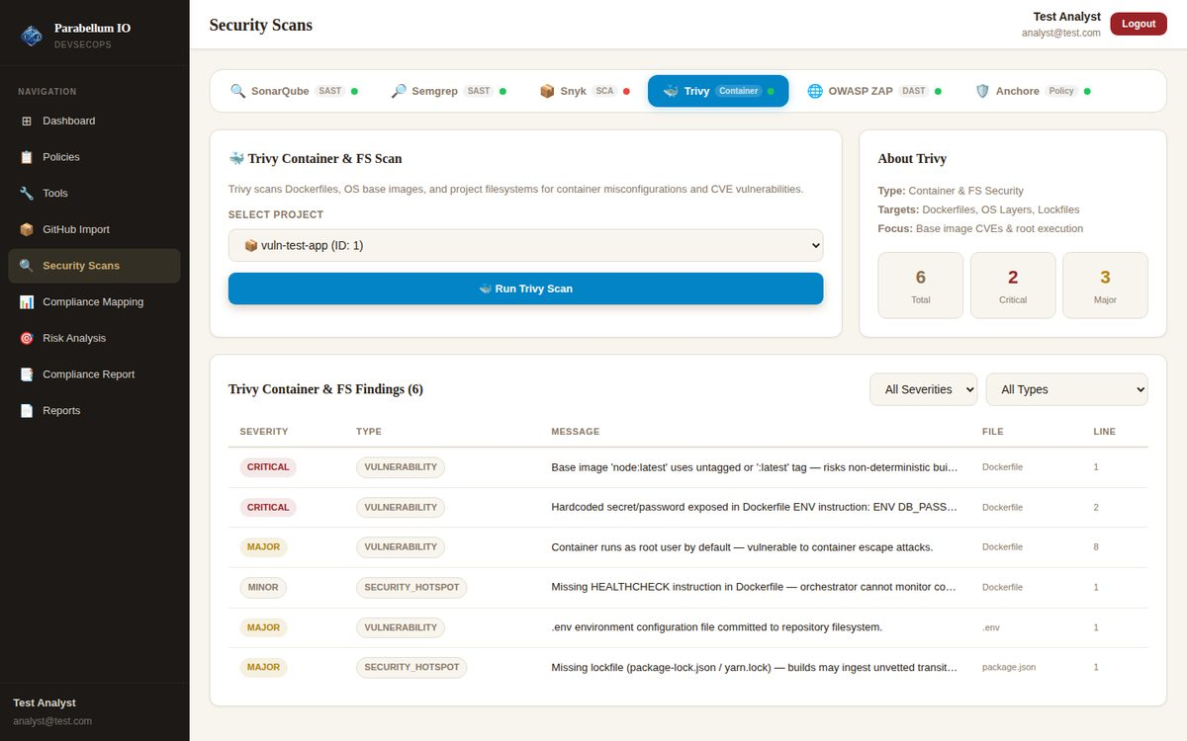
Figure 10 – "Trivy" result before fixes (Trivy not installed)
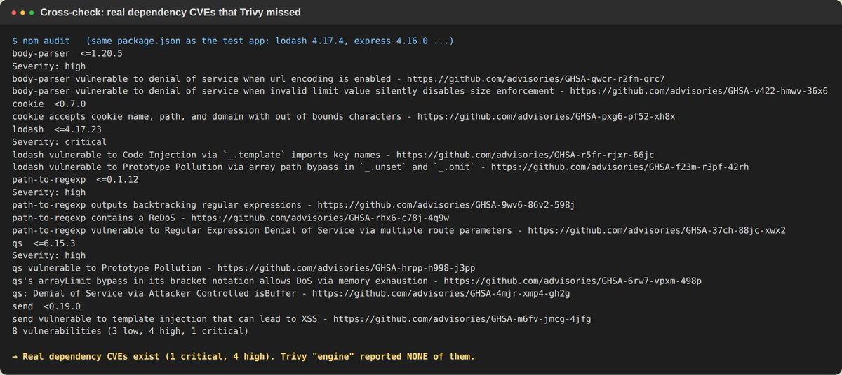
Figure 11 – Real library CVEs that the old "Trivy" missed

3.8 OWASP ZAP (DAST)
ID | Test | Expected | Actual | Result
TC-24 | Run "ZAP" on test app | Web alerts | 6 alerts – but from reading files, not a website | FAIL
TC-25 | File with "bad" words only in comments; closed target port | 0 alerts | 2 Critical alerts from comments; URL ignored | FAIL
TC-26 | Line numbers | Correct line | XSS alert at line 1 (real eval() on line 15) | FAIL
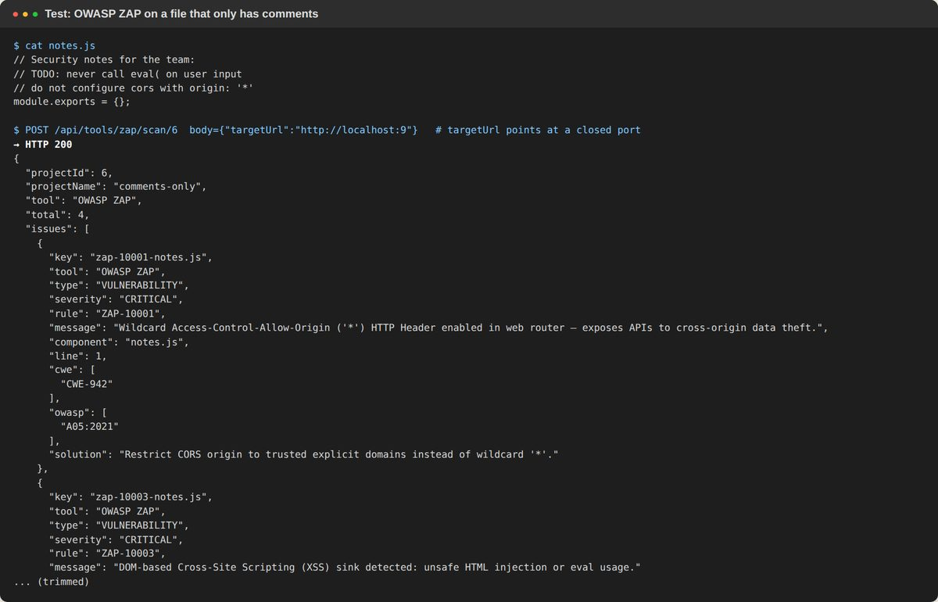
Figure 12 – Critical alerts from a file that only contains comments

3.9 Anchore (Container policy)
ID | Test | Expected | Actual | Result
TC-27 | Run "Anchore" on test app | Policy result | Dockerfile rules correct, but not real Anchore | PASS
TC-28 | Project with no Docker files | "Not applicable" | "CRITICAL – FAIL (STOP)" | FAIL
TC-29 | Anchore not installed | "Not Connected" | "Connected – 5.1.0 (Policy Engine)" | FAIL
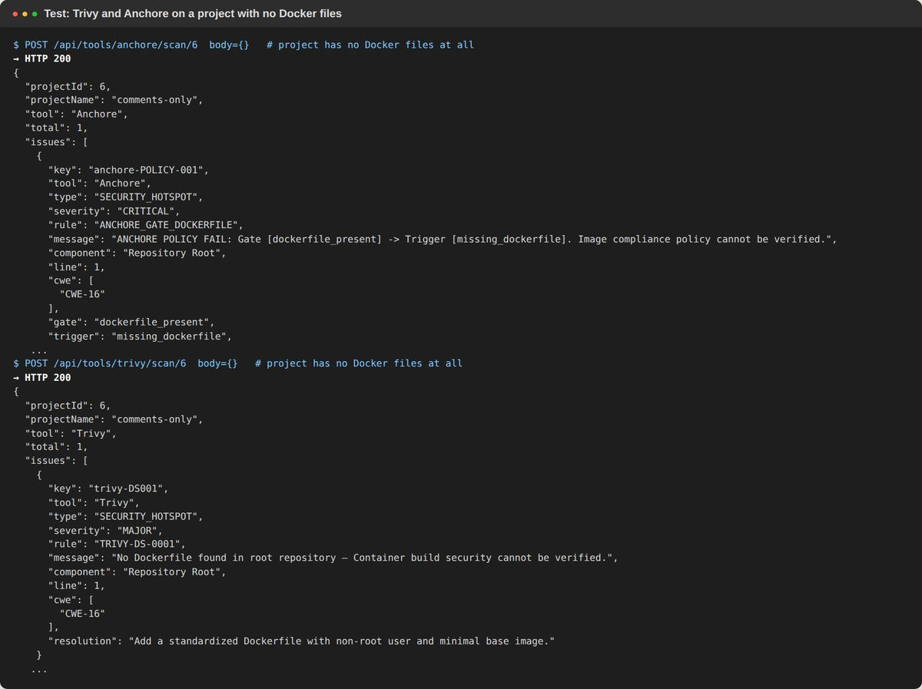
Figure 13 – Trivy/Anchore before fixes on a project with no Docker files

3.10 Compliance mapping, RAG, Gemini
ID | Test | Expected | Actual | Result
TC-30 | Analyse all 6 frameworks | Score for each | NIST 48, ISO 27001 32, ISO 27034 36, SP 800-53 35, CIS 41, ASVS 28 | PASS
TC-31 | NIST CSF 2.0 control IDs | CSF 2.0 only | Old CSF 1.1 IDs (PR.IP-12, PR.AC-01, PR.PT-01) | FAIL
TC-32 | CIS control titles | Real titles | Only the ID repeated | FAIL
TC-33 | Issue counts | Each issue once | Same issue counted in several controls | FAIL
TC-34 | Start RAG service | Runs | Model download blocked in lab | NOT TESTED
TC-35 | Backend uses RAG_SERVICE_URL | Yes | Hard-coded port 5000; README says 8000 | FAIL
TC-36 | Gemini used for advice | Yes | Never called | FAIL
TC-37 | Python engine files used | Yes | Never run | FAIL
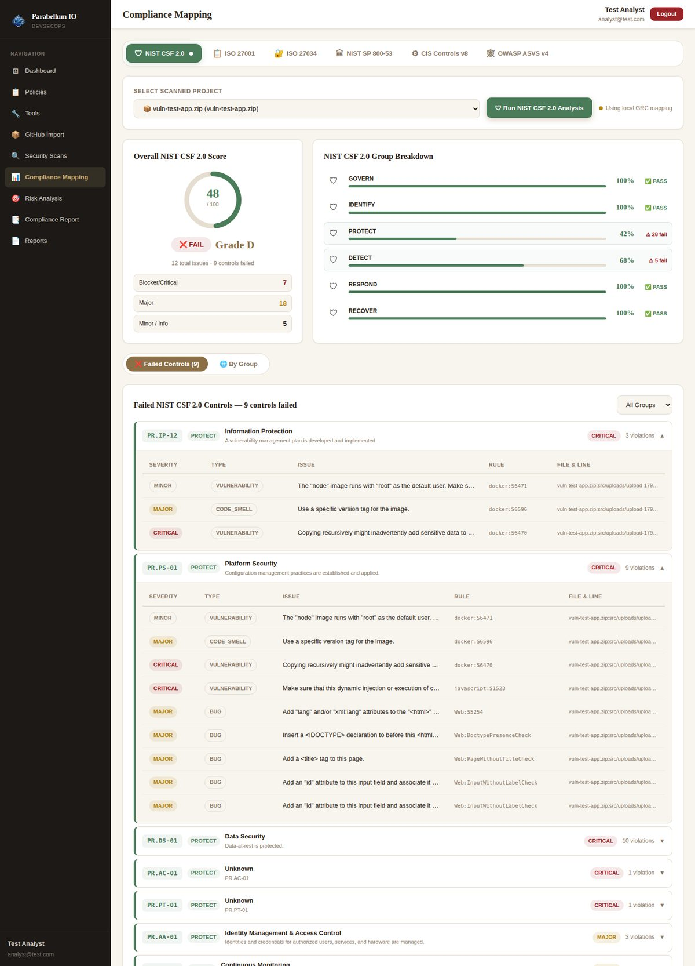
Figure 14 – NIST CSF mapping before fixes ("Unknown" controls with CSF 1.1 IDs)
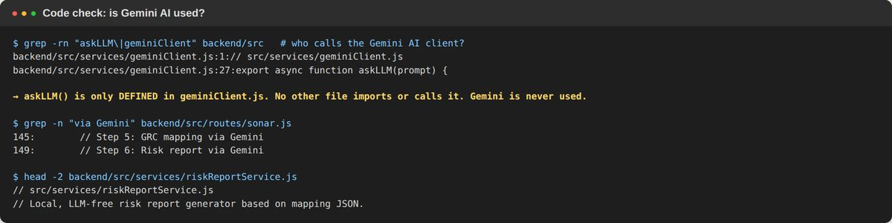
Figure 15 – Gemini client defined but never called

3.11 Risk analysis, report, reports page
ID | Test | Expected | Actual | Result
TC-38 | Risk analysis | CWE + CVSS + attacks | CWE-89 (9.8), CWE-798 (9.1), CWE-693, heat-maps | PASS
TC-39 | Compliance report | Report + PDF | Generated | PASS
TC-40 | Reports page | My reports | Shows every user's reports | FAIL
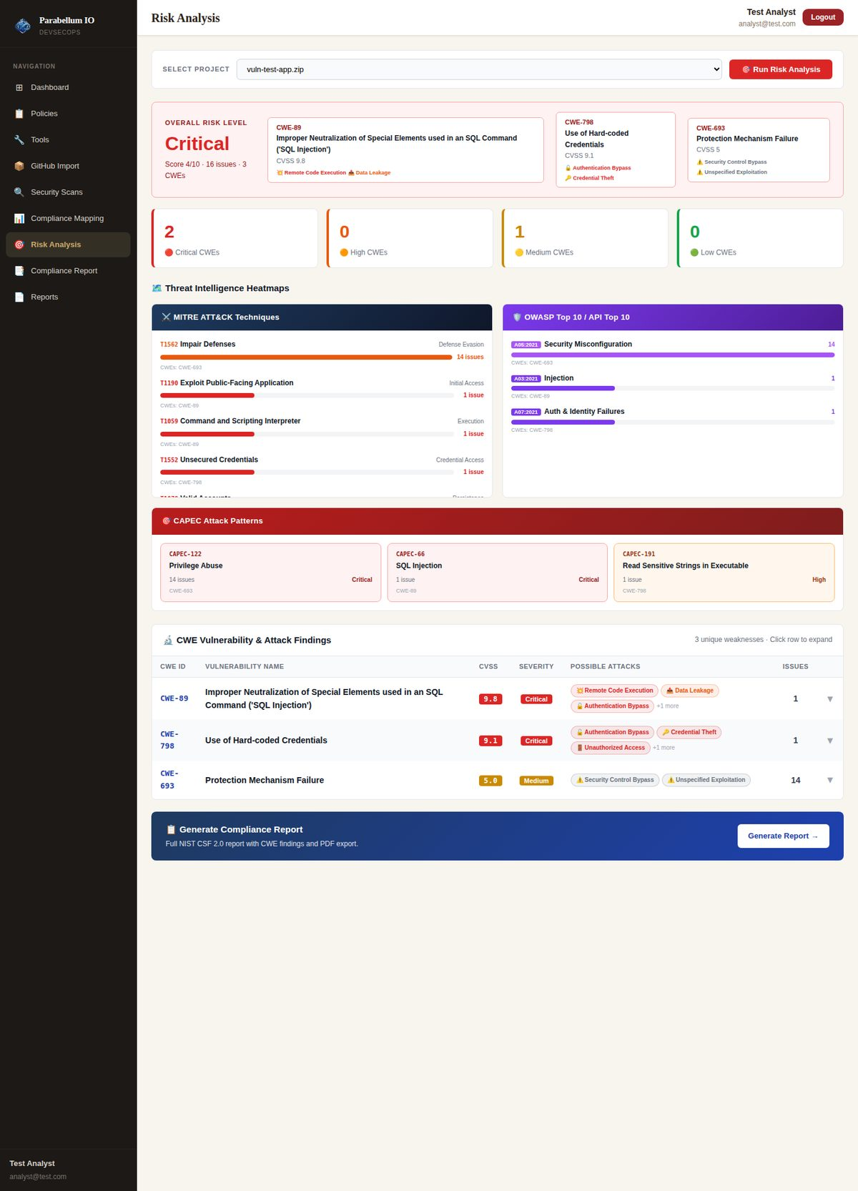
Figure 16 – Risk analysis (worked before fixes)

3.12 Security tests (before fixes)
ID | Attack | Result before fixes
S-1 | Normal user calls POST /api/auth/promote-admin | Became admin – could see, edit and delete all users
S-2 | User reads another user's policy scan, SonarQube issues, risk, reports | All data returned
S-3 | Register a local folder, then delete the project | User's real folder deleted from disk; /etc accepted as a project
S-4 | OTP and JWT | OTP shown on screen; known default JWT secret; no lockout or rate limit
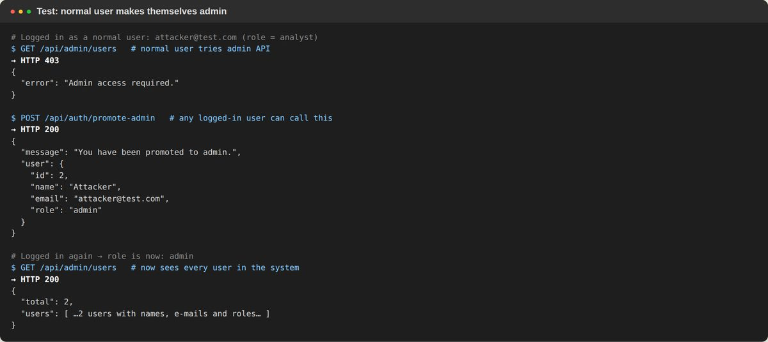
Figure 17 – S-1: normal user promotes themselves to admin
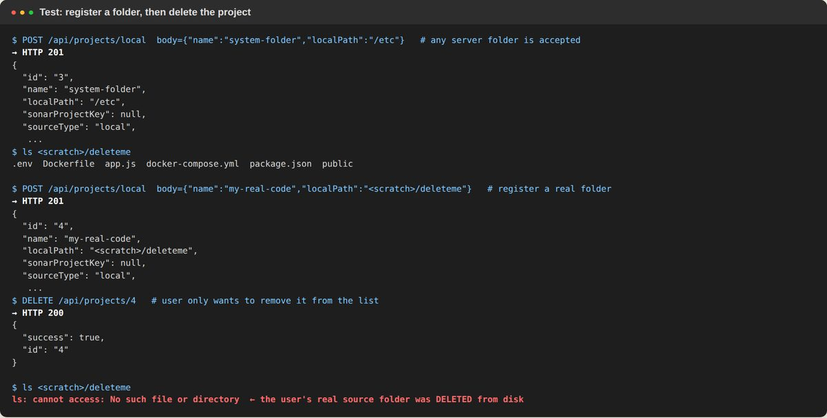
Figure 18 – S-3: the real folder is gone after "Delete"

4. Part B – Bugs Found and Fixes Applied
All 20 bugs were fixed. Each fix is explained in simple words; the last column shows the re-test result from Part C.
# | Bug | Severity | Fix (simple words) | Re-test
1 | Any user could become admin | High (security) | Deleted the promote-admin route. Admins come from ADMIN_EMAIL in .env. Signup ignores any role sent by the browser. Admin pages check the role in the database. | PASS
2 | Other users' data readable | High (security) | Every route checks that the project belongs to you. The reports list and download only show your own files. SonarQube keys include the user id. | PASS
3 | Delete removed real folder; any path accepted | High (security) | Delete only removes copies the app made (uploads/clones). Local folders must be inside PROJECTS_ROOT (or admin). | PASS
4 | OTP on screen; default JWT secret; no limits | High (security) | The OTP is e-mailed when SMTP is set; it is shown on the login screen only when e-mail is not set up or OTP_DELIVERY=screen (OTP_DELIVERY=email turns that off for a public server). The server refuses to start without JWT_SECRET. An OTP is cancelled after 5 wrong tries. Logins are limited to 20 per 15 minutes. Fixed .env loading order. | PASS
5 | SonarQube 0 issues on local folders | High | Added sonar.projectBaseDir (one line). Removed the old sonar.analysis.mode option. | PASS
6 | Trivy simulated; fake CVE IDs | High | Runs real Trivy (vuln + misconfig + secret). Missing tool → "basic checks only" warning. Own rule IDs (PB-…). | PASS
7 | ZAP simulated, not DAST | High | Real ZAP API: spider → passive (optional active) scan → alerts on a Target URL. Fallback labelled, ignores comments, correct lines. | PASS
8 | Anchore simulated | High | Runs Anchore Grype with a STOP/WARN policy gate. No Docker files → N/A. | PASS (parser)
9 | Gemini never used | High (claim) | New "Get AI fix advice" button on the Risk page (POST /api/risk/ai-advice). | PASS (needs key)
10 | Status always "Connected" | Medium | SonarQube checked with /api/system/status; every tool really checked. | PASS
11 | RAG port mismatch | Medium | Port 5000 everywhere; RAG_SERVICE_URL used; /map/multi route order fixed. | PASS
12 | Snyk npm only | Medium | snyk test --all-projects; friendly install/login messages; works on Windows. | PASS (parser)
13 | Old NIST CSF 1.1 IDs | Medium | Replaced with CSF 2.0 IDs (PR.AA, PR.PS, ID.RA…). | PASS
14 | Python engine never used | Medium | Moved to research/python-engine with a README explaining it. | PASS
15 | Open CORS, no Helmet, no upload limit | Medium | Added Helmet headers, CORS limited to FRONTEND_URL, ZIP-only uploads up to 200 MB. | PASS
16 | Policies/Dashboard hard-coded | Medium | New /api/policies/frameworks; the page loads frameworks and the real policy rules. | PASS
17 | Fake version numbers | Low | Removed; versions come from the real tools. | PASS
18 | Local projects labelled "Upload" | Low | Use sourceType. | PASS
19 | No CIS titles; double counts | Low | Official titles and groups for all 6 frameworks; each issue counted once. | PASS
20 | Semgrep hang; wrong ZAP lines | Low | Version check off; SEMGREP_CONFIG for offline rules; real line numbers. | PASS

4.1 What you must set before running the fixed version
- Run npm install in backend (adds helmet and express-rate-limit).
- JWT_SECRET in backend/.env – 16+ random characters (required).
- ADMIN_EMAIL – your own e-mail; that account becomes admin.
- Real SMTP (EMAIL_USER / EMAIL_PASS, Gmail App Password) to e-mail the login code. Without it the code is shown on the login screen (OTP_DELIVERY=auto, the default); use OTP_DELIVERY=email on a public server.
- PROJECTS_ROOT – folder normal users may register local projects from.
- Optional: install Snyk (npm i -g snyk + snyk auth), Trivy, Grype and run the ZAP daemon – steps are in the README "Security tools setup" section.

5. Part C – Re-Test After Fixes (with Screenshots)

5.1 Tools page and Dashboard
The Tools page now shows the real status of each tool, with a hint when a tool is missing. Snyk is honestly shown as "Not Connected" with install steps.
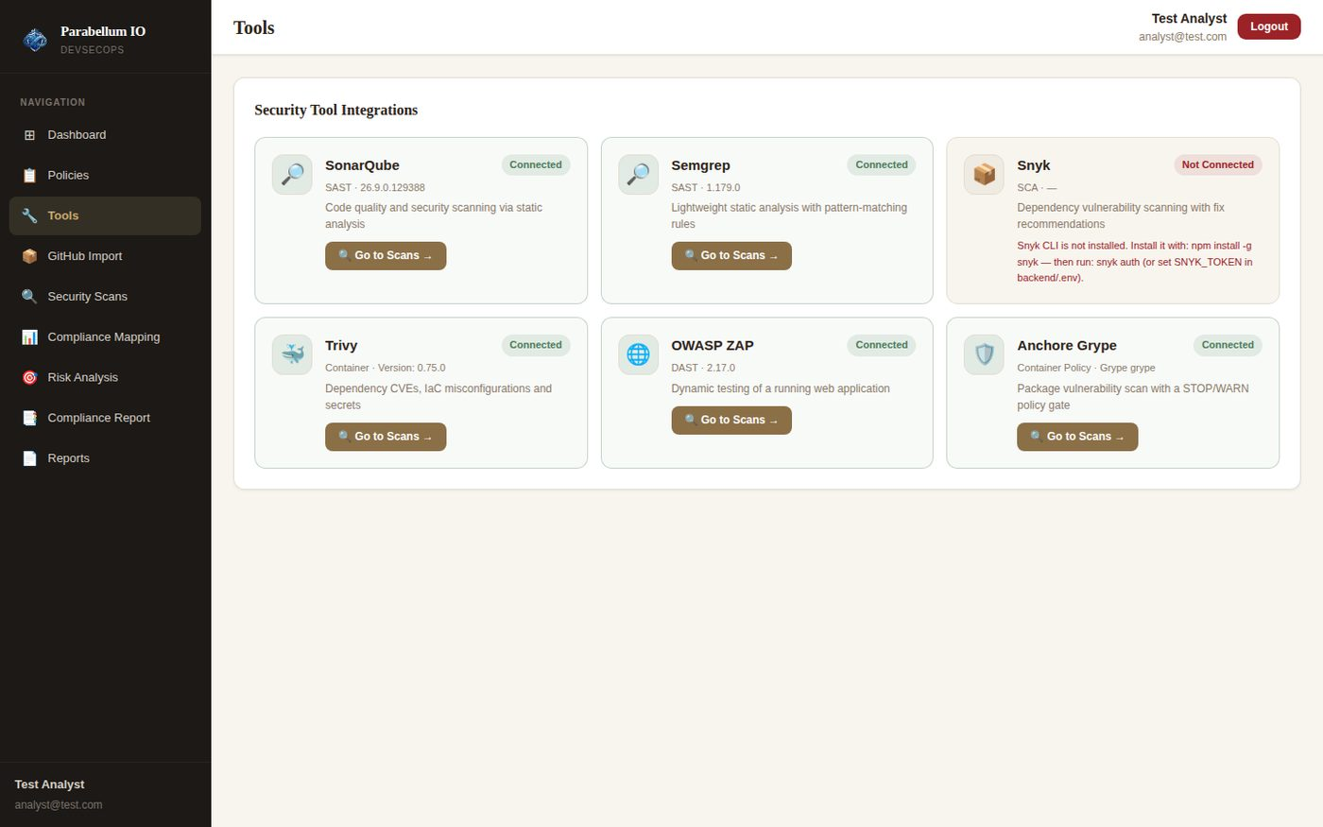
Figure 19 – Tools page after fixes – real status and versions
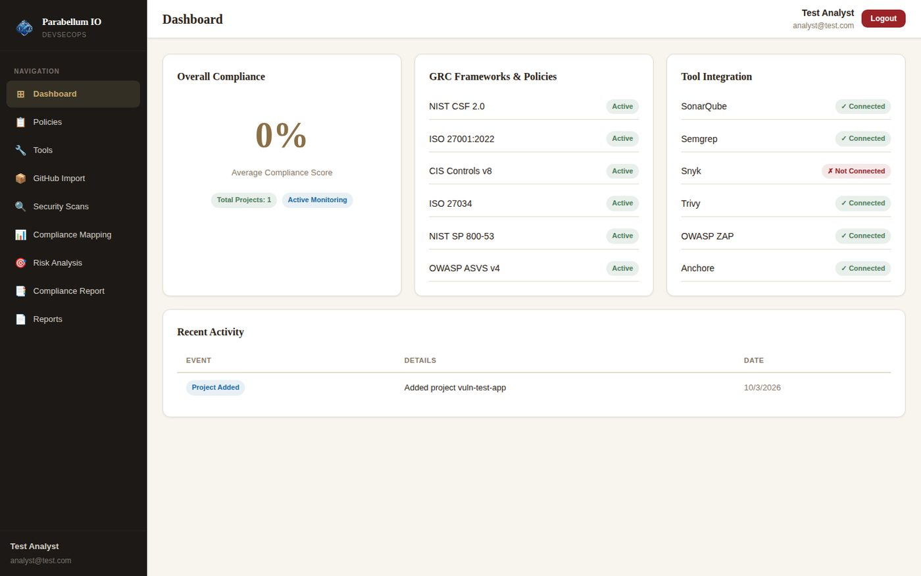
Figure 20 – Dashboard after fixes – all 6 frameworks active, real tool status

5.2 SonarQube – local folder now scanned
The same local-folder project that gave 0 issues now gives all 12 issues (eval injection, SQL query, CORS, Dockerfile root user, latest tag, HTML problems).
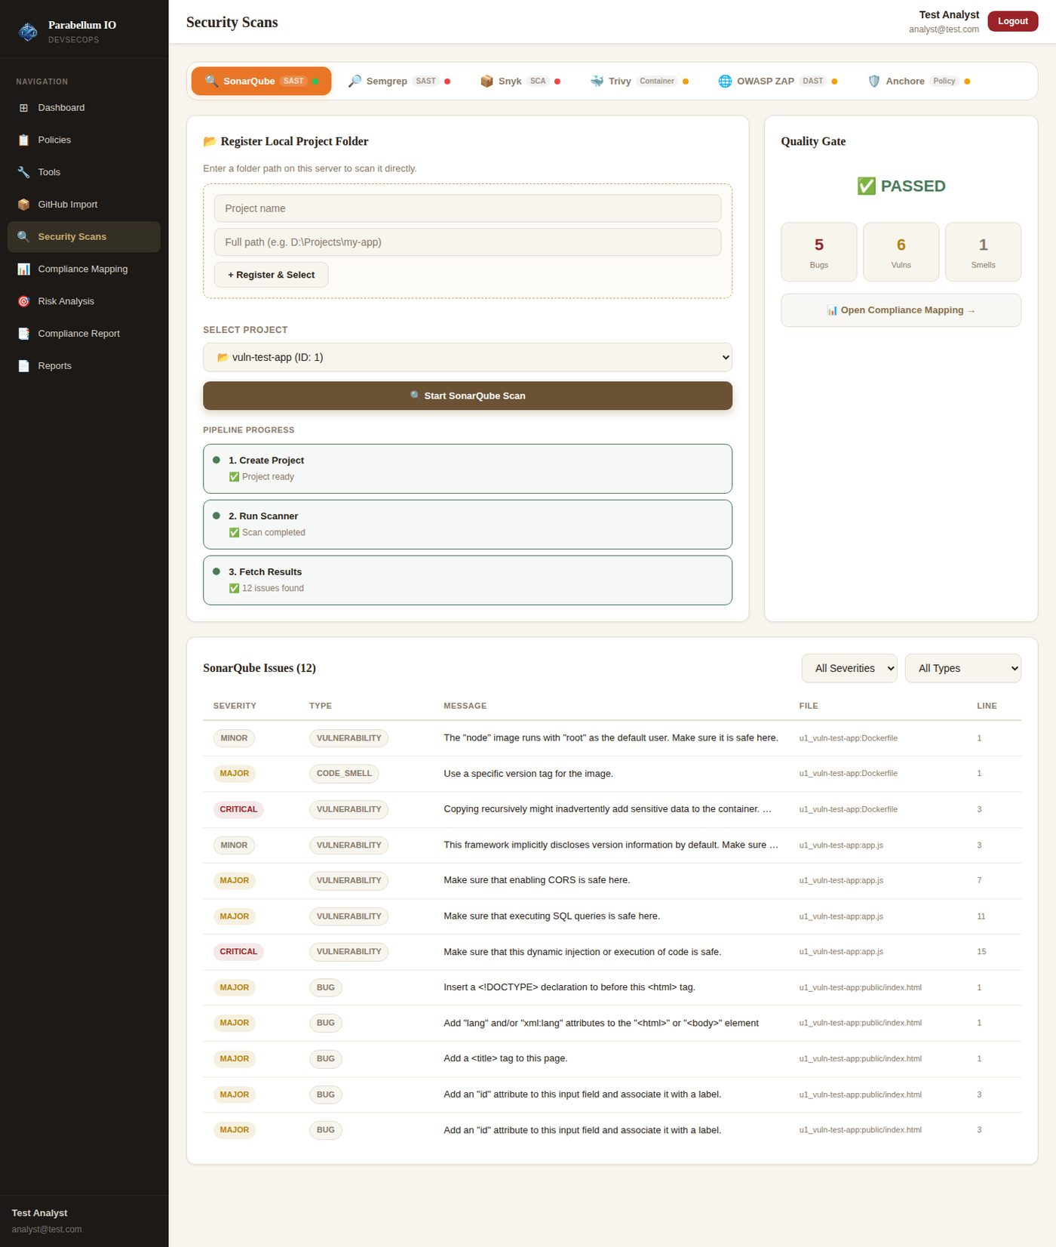
Figure 21 – SonarQube on a local folder after fix: 12 issues

5.3 Semgrep
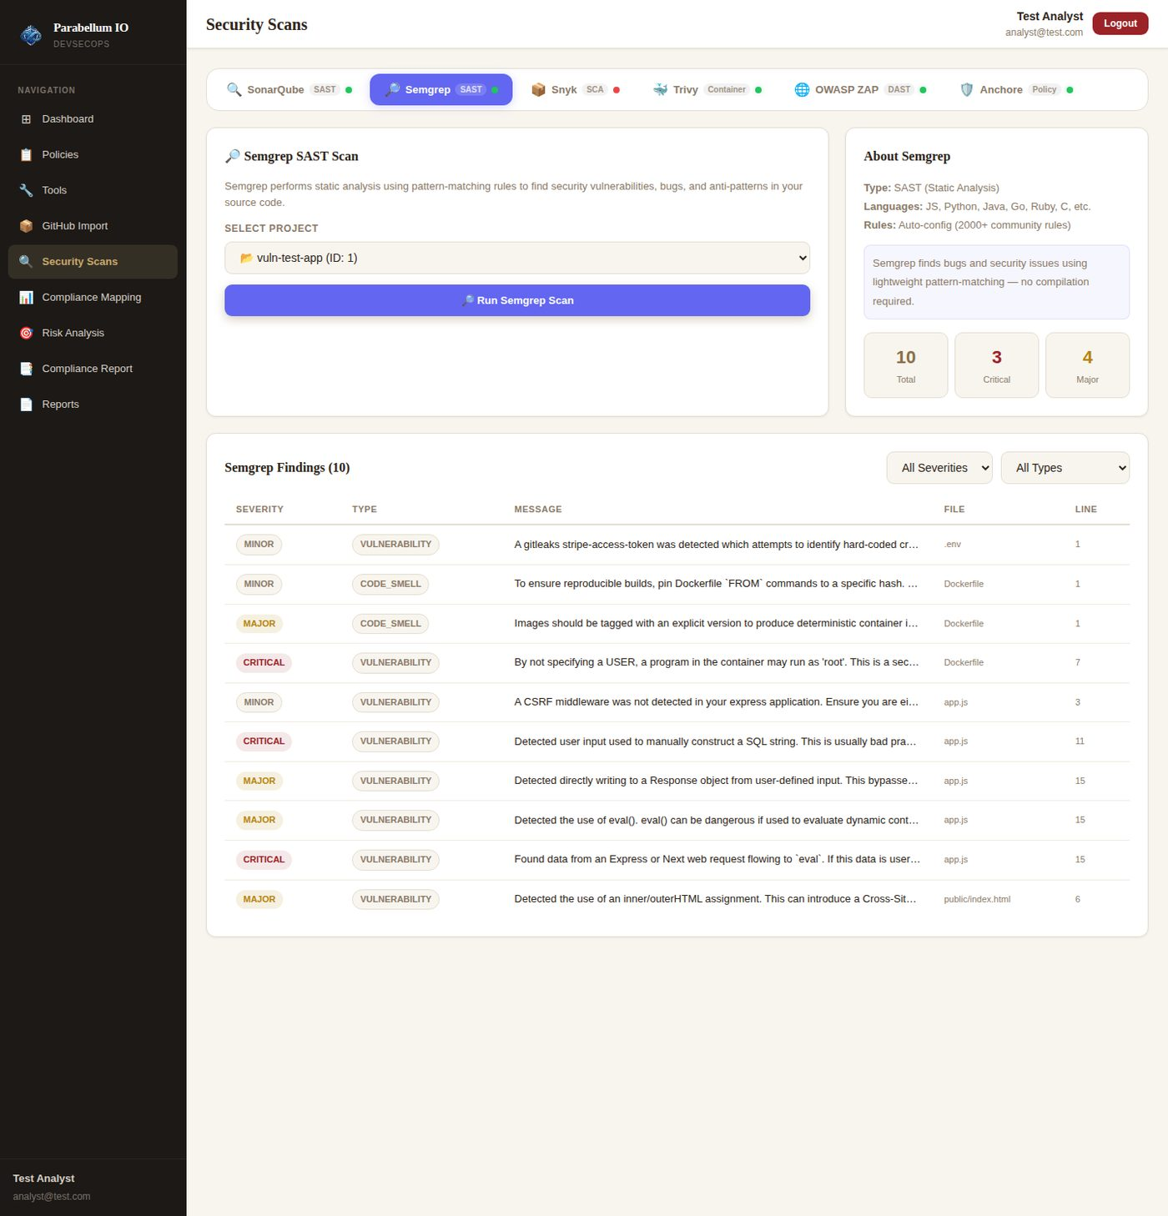
Figure 22 – Semgrep after fixes – real scan

5.4 Snyk
Without Snyk installed, the tab shows a clear message with the install and login commands. With Snyk output, Python projects, multi-manifest projects and "no manifest" are all handled.
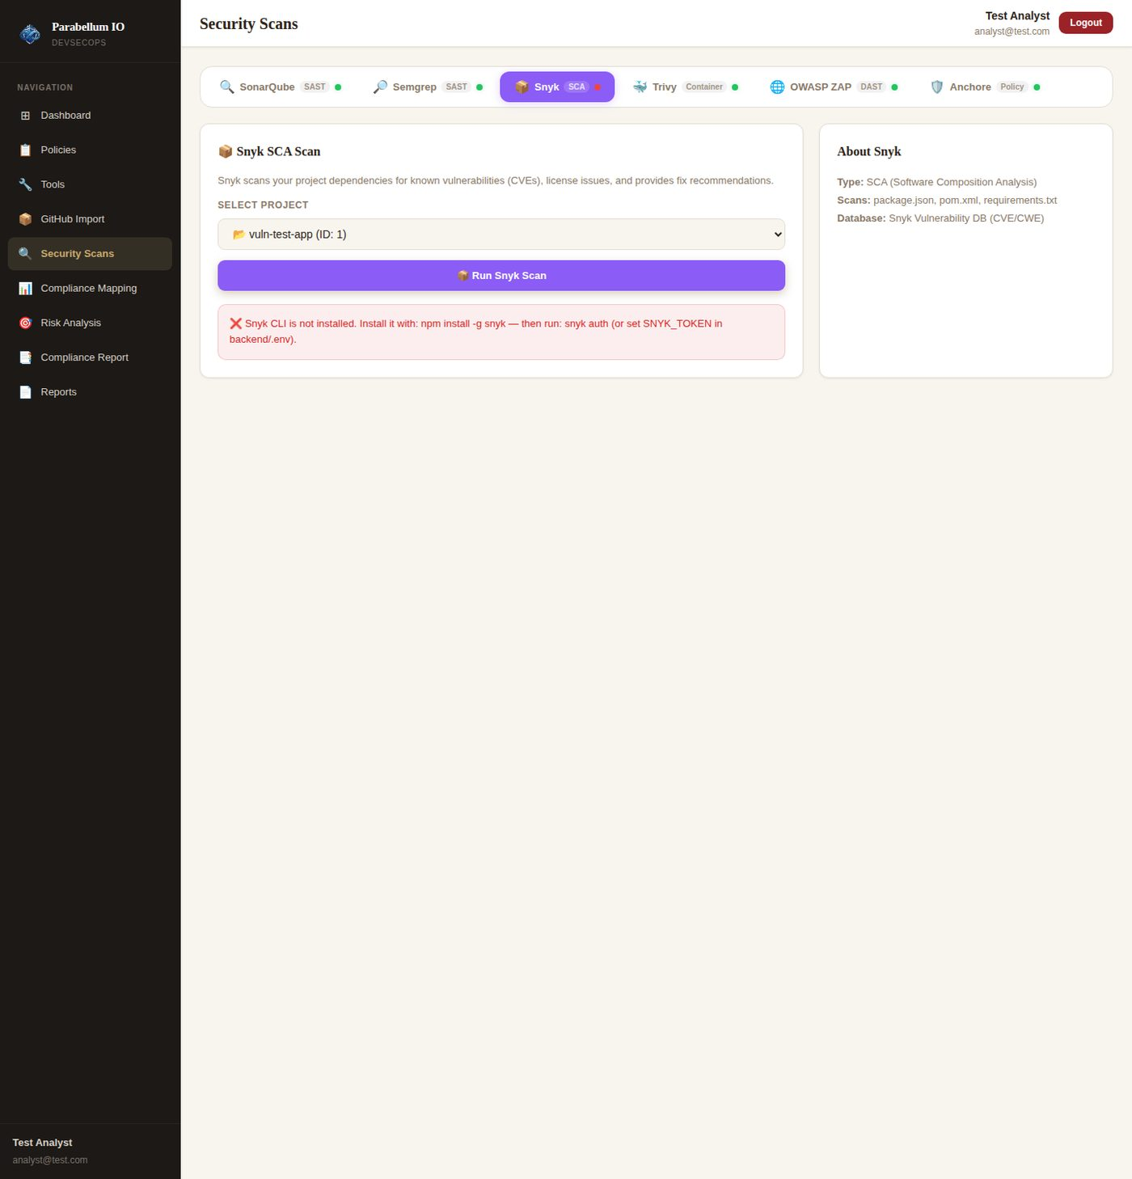
Figure 23 – Snyk not installed – clear message
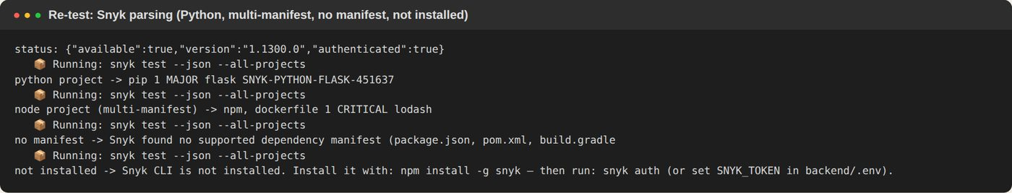
Figure 24 – Snyk parsing re-test with output in Snyk's real format

5.5 Trivy
When Trivy is missing, the tab says so in an orange warning. With real Trivy installed, the scan finds the vulnerable libraries (lodash, express, qs, body-parser…), the Dockerfile misconfigurations and the secret in .env – 28 findings.
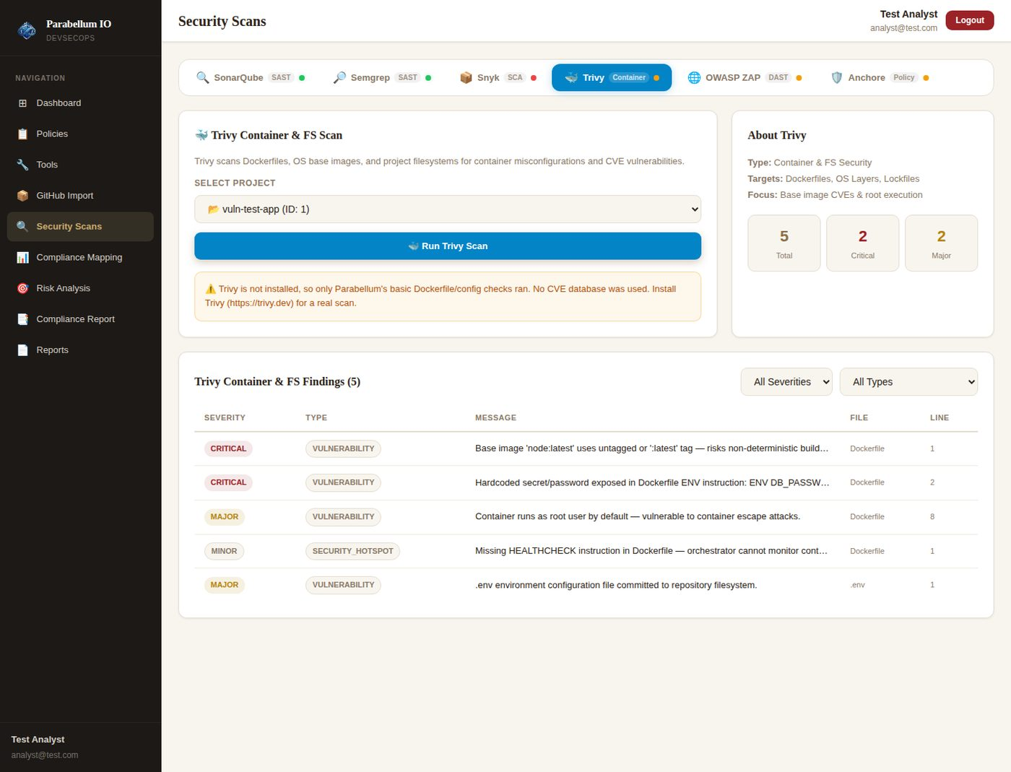
Figure 25 – Trivy missing → honest "basic checks only" warning
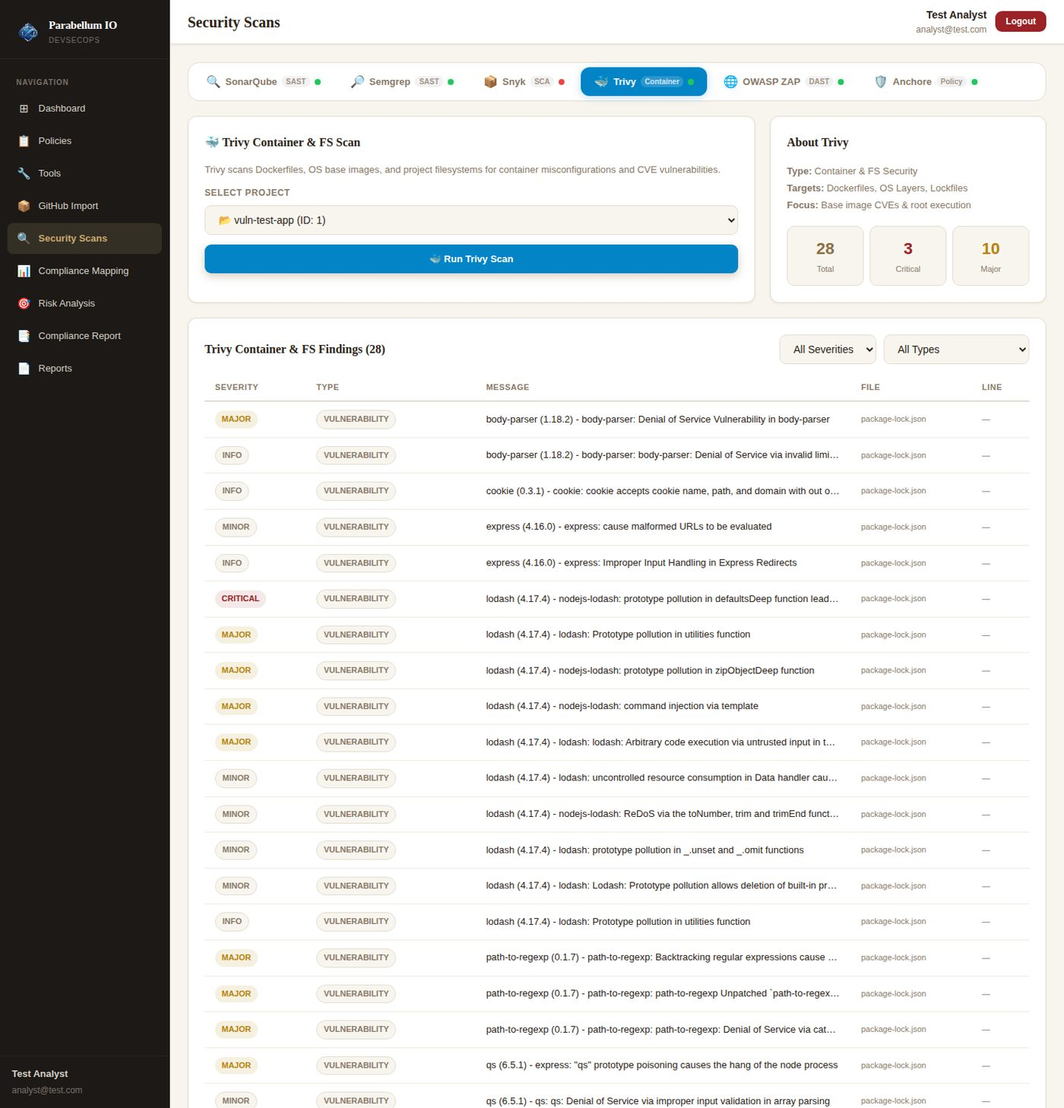
Figure 26 – Real Trivy scan – 28 findings including library CVEs

5.6 OWASP ZAP
ZAP now scans a running web application. The user enters a Target URL; ZAP crawls the site and reports real alerts, grouped by alert type. Without a URL the scan explains what is needed. The built-in fallback no longer fires on comments.
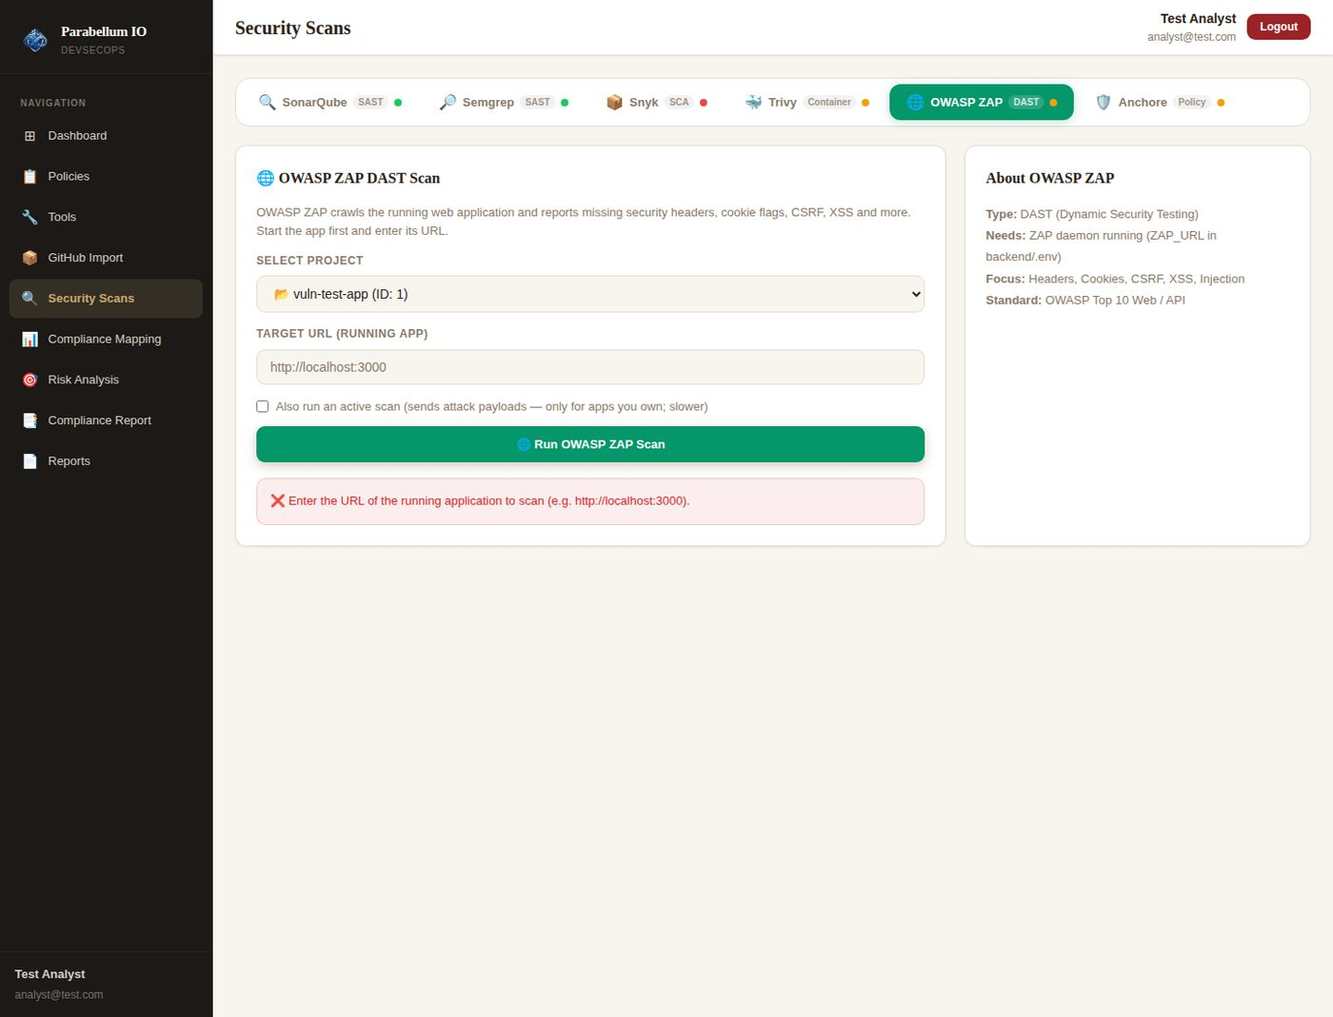
Figure 27 – ZAP asks for the URL of the running app
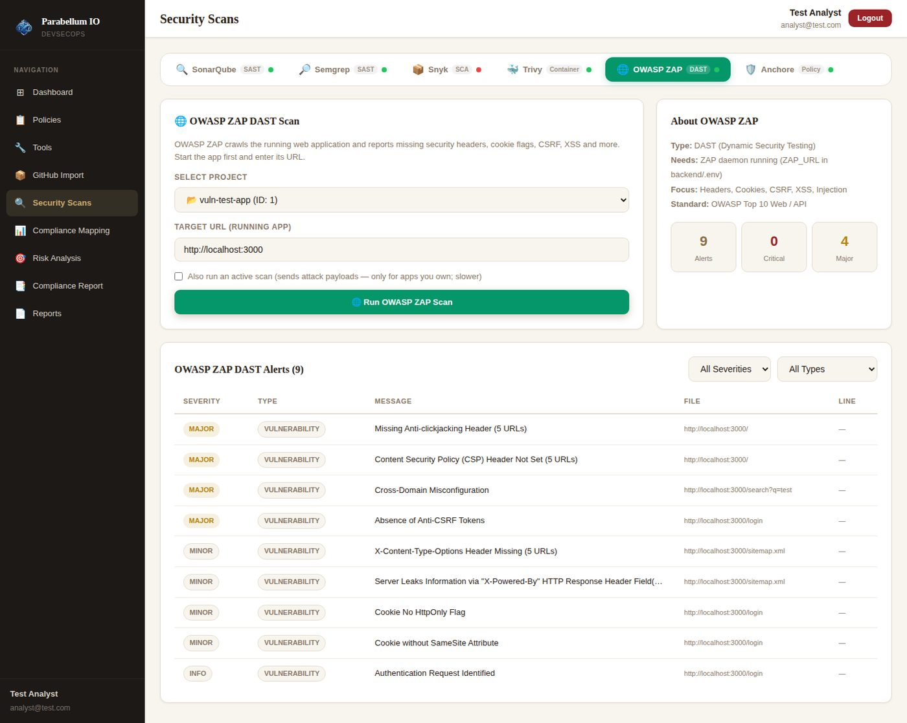
Figure 28 – Real OWASP ZAP scan of the running app – 9 alert types
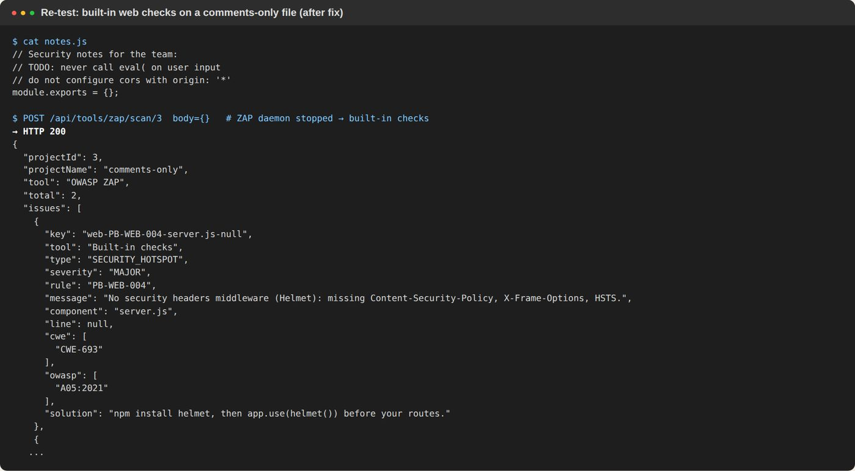
Figure 29 – Comments-only file: no more false Critical alerts

5.7 Anchore (Grype)
Without Grype the tab shows a warning and runs only the Dockerfile policy checks. With Grype, the app runs a real scan; in our lab Grype could not download its database, and the app shows Grype's own error clearly. The parser and STOP/WARN policy gate were verified with output in Grype's real format.
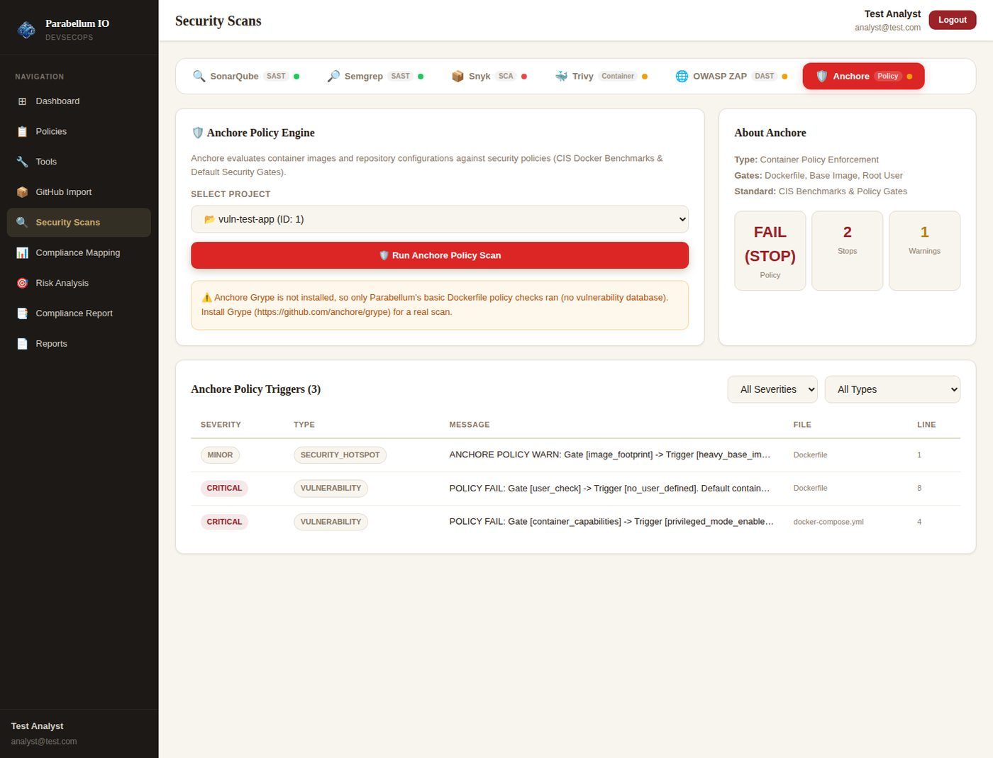
Figure 30 – Grype missing → warning + Dockerfile policy checks
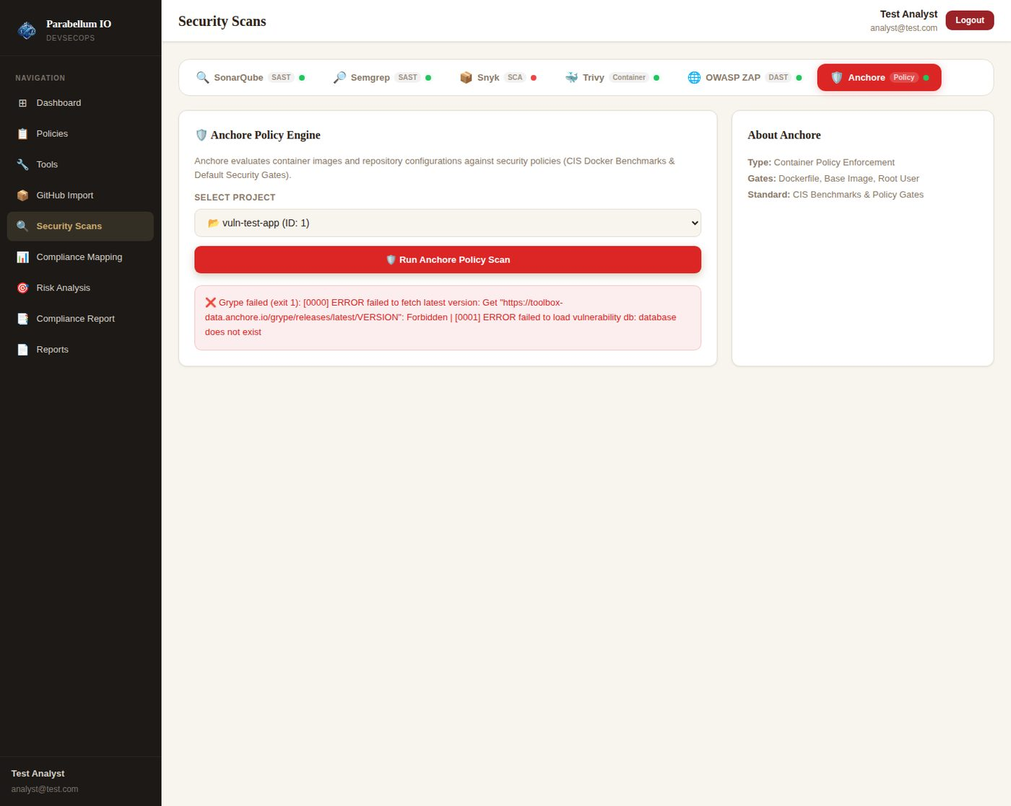
Figure 31 – Grype installed but its database is blocked in the lab – clear error
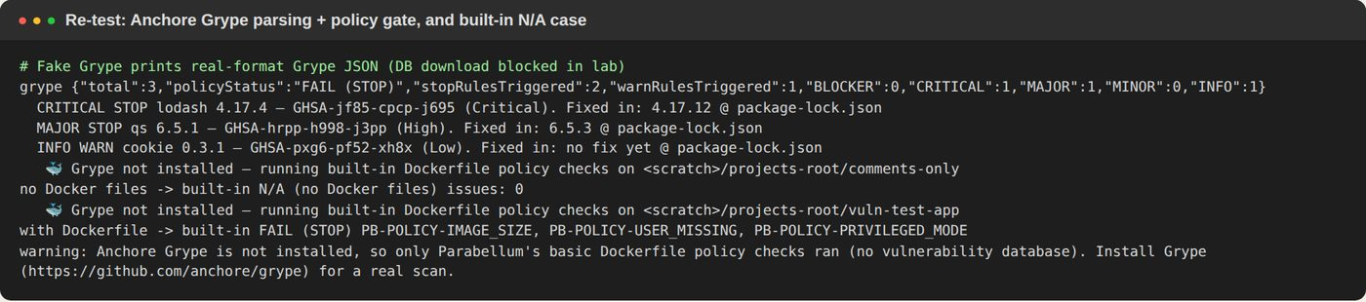
Figure 32 – Grype parsing + policy gate, and "N/A" when there are no Docker files

5.8 Compliance mapping
All six frameworks are analysed. Controls now use NIST CSF 2.0 IDs and official titles and groups (for example CIS-4 "Secure Configuration of Enterprise Assets and Software", group IG1), and each issue is counted once.
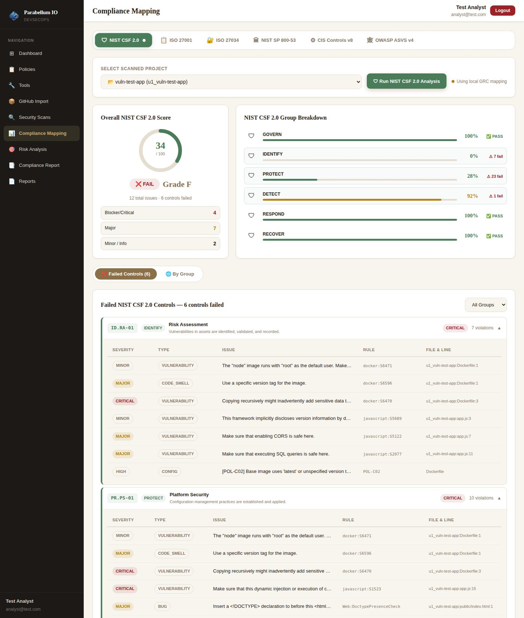
Figure 33 – NIST CSF 2.0 after fixes
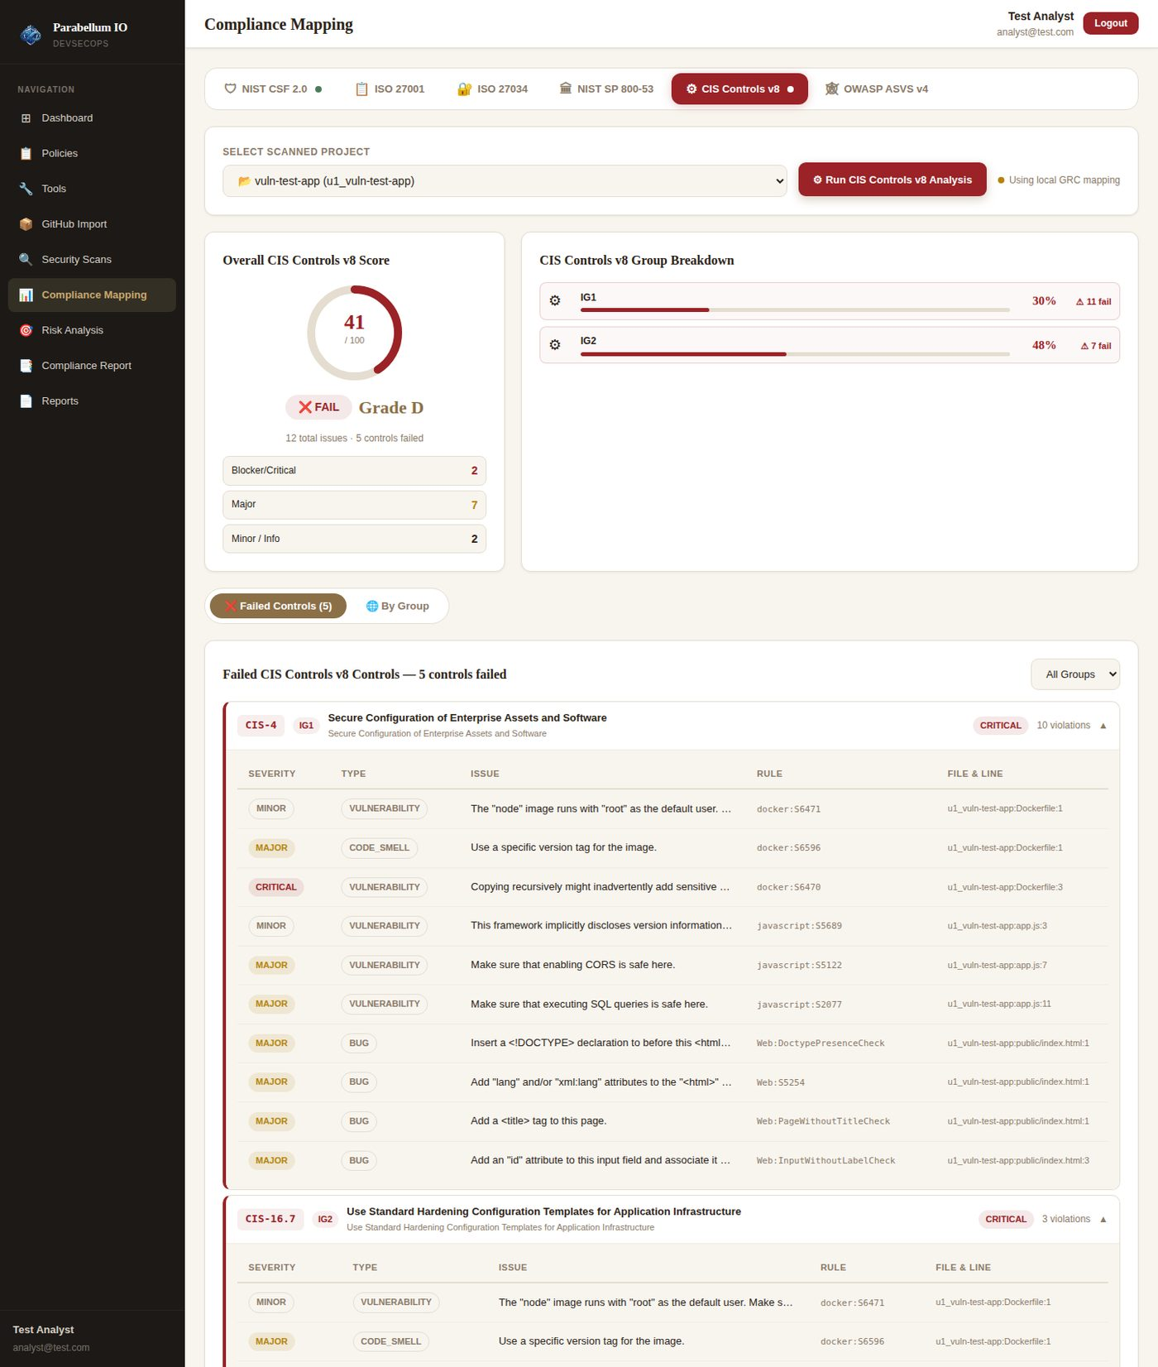
Figure 34 – CIS Controls v8 after fixes – titles and IG groups

5.9 Risk analysis with AI fix advice
Each CWE now has a "Get AI fix advice" button that sends the finding to Gemini. Without GEMINI_API_KEY it shows a clear message (as in this lab). We confirmed the request reaches Google's Gemini API; it only needs a real key.
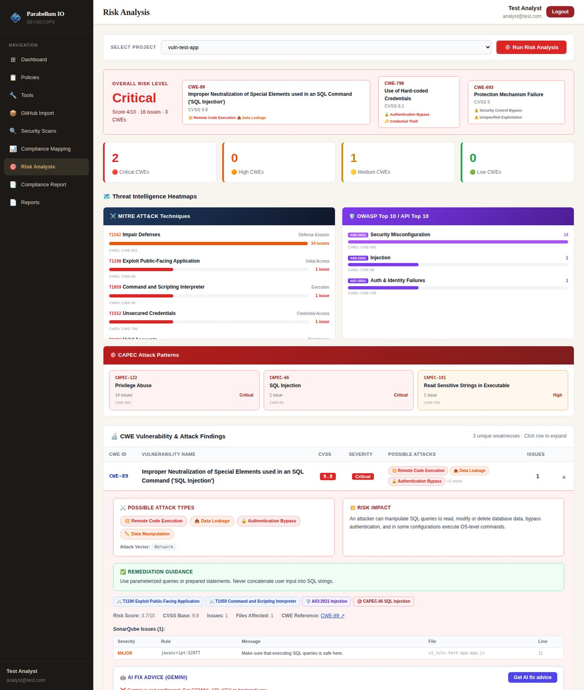
Figure 35 – Risk analysis with the new AI fix advice panel

5.10 Compliance report and Reports page
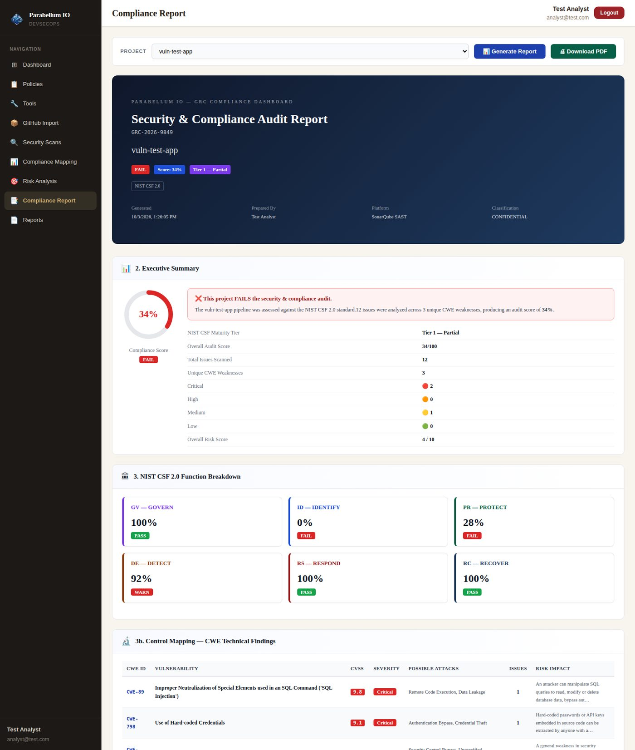
Figure 36 – Compliance report after fixes
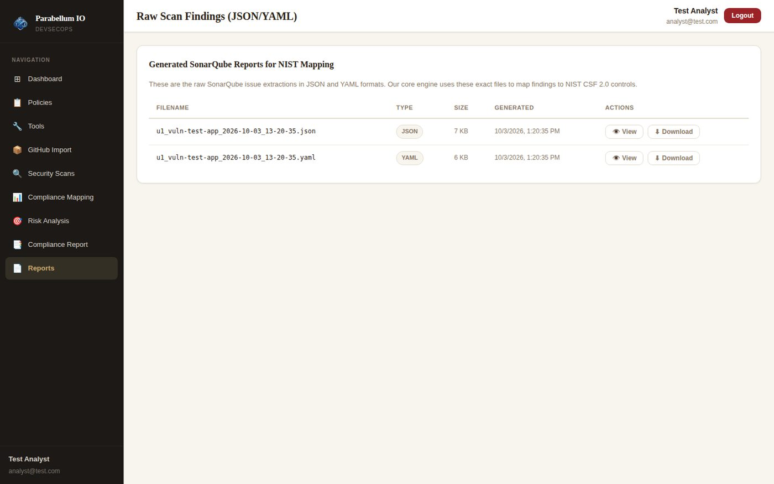
Figure 37 – Reports page – only your own report files

5.11 Policies and Import pages
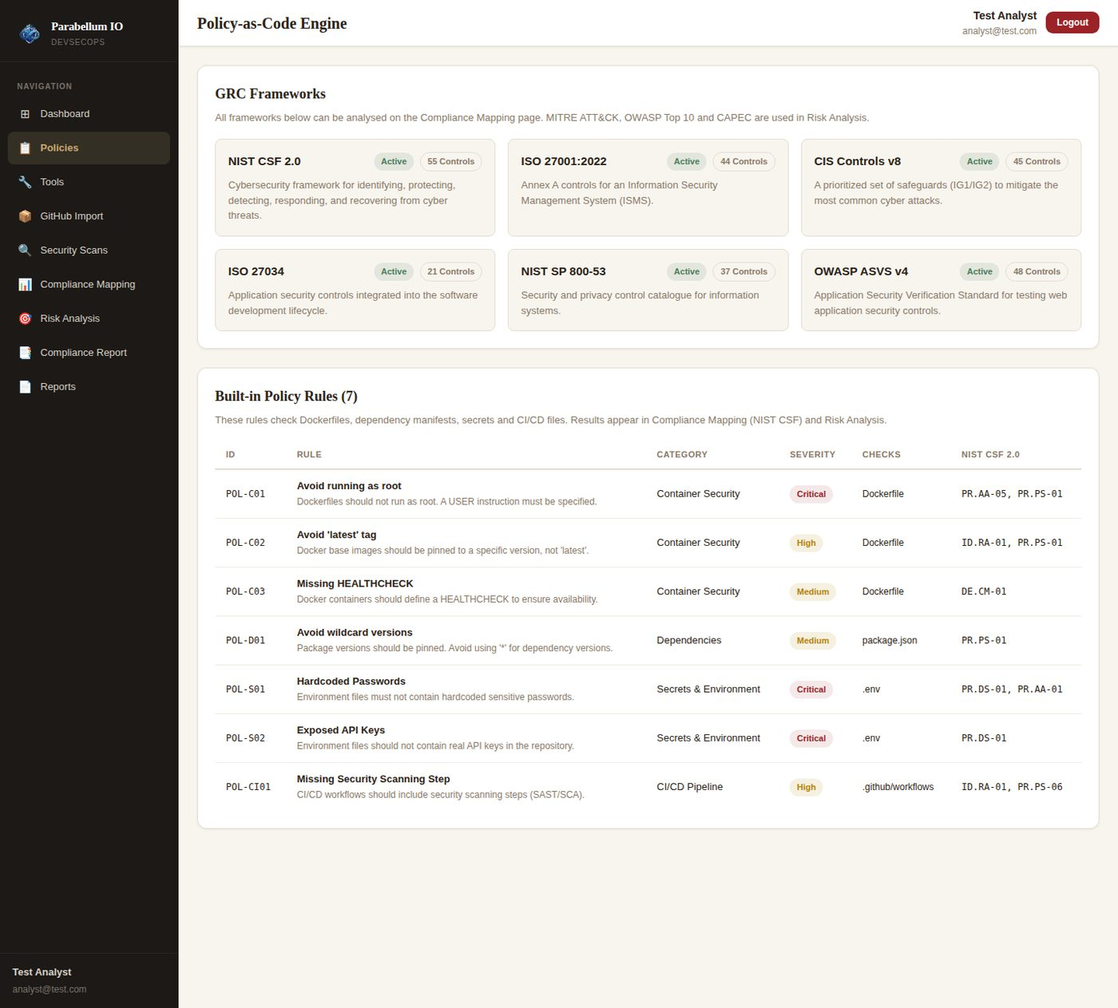
Figure 38 – Policies page now loads the frameworks and real policy rules from the API
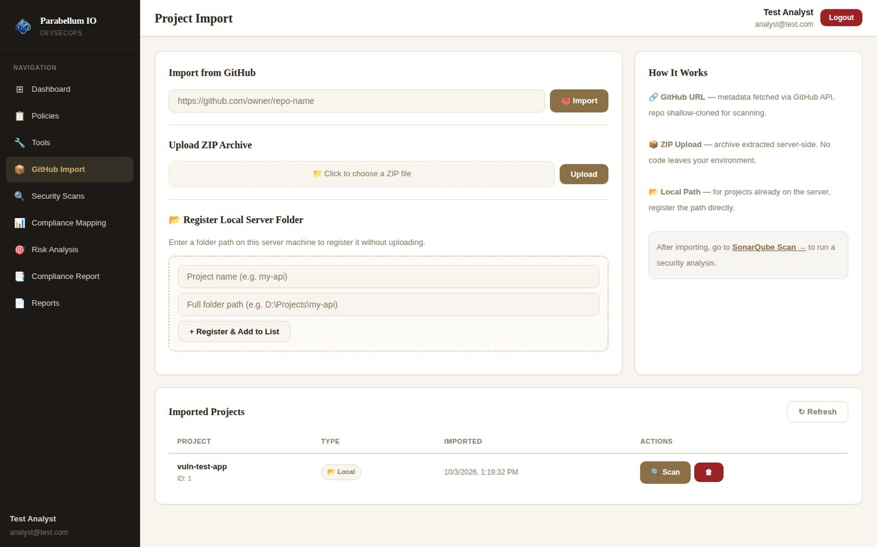
Figure 39 – Import page – local project correctly labelled "Local"

5.12 Security re-tests
ID | Attack / check | Before | After | Result
RS-1 | Sign up with role "admin" | — | Created as analyst | PASS
RS-2 | POST /api/auth/promote-admin | Became admin | Route does not exist (404) | PASS
RS-3 | Normal user opens admin API / page | Allowed after escalation | 403 / redirected to Dashboard | PASS
RS-4 | ADMIN_EMAIL account | — | Gets admin role and User Manager | PASS
RS-5 | Read another user's policy scan, issues, risk, compliance | Data returned | 404 "Project not found" | PASS
RS-6 | List / download another user's reports | Allowed | Not listed; download 404 | PASS
RS-7 | Register /etc as a project | Accepted | 403 – outside PROJECTS_ROOT | PASS
RS-8 | Delete a local-folder project | Folder deleted | Folder kept | PASS
RS-9 | Delete an uploaded ZIP project | Copy deleted | Copy deleted (correct) | PASS
RS-10 | 5 wrong OTP codes | Unlimited | OTP cancelled after 5 | PASS
RS-11 | 22 wrong logins | Unlimited | HTTP 429 after 20 | PASS
RS-12 | Login without SMTP and OTP_DELIVERY=email | OTP shown on screen | 503 – clear message | PASS
RS-13 | Start server without JWT_SECRET | Used public default | Refuses to start | PASS
RS-14 | Security headers | None | CSP, X-Frame-Options, HSTS, nosniff | PASS
RS-15 | API call from another website (CORS) | Allowed | Blocked | PASS
RS-16 | Upload malware.exe | Accepted | 400 – only .zip allowed | PASS
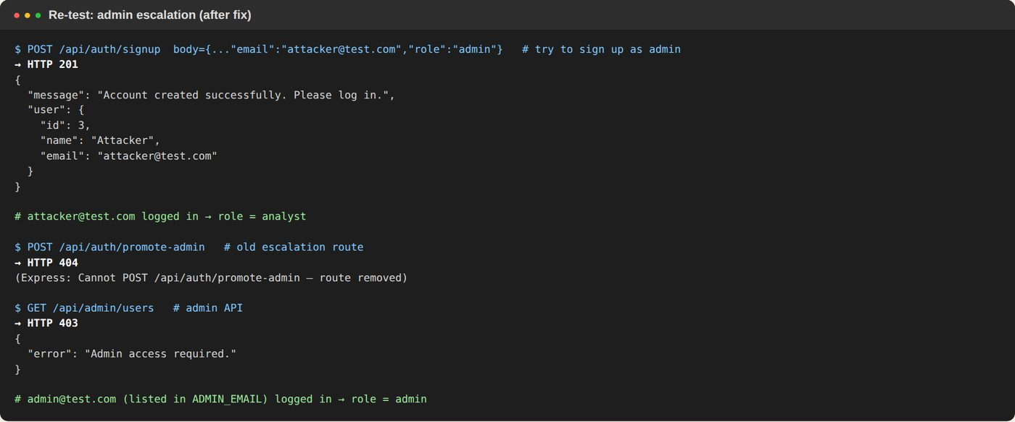
Figure 40 – Admin escalation blocked
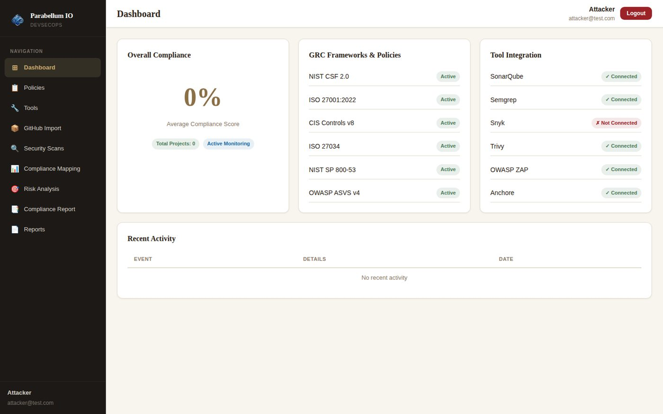
Figure 41 – Normal user has no User Manager (redirected to Dashboard)
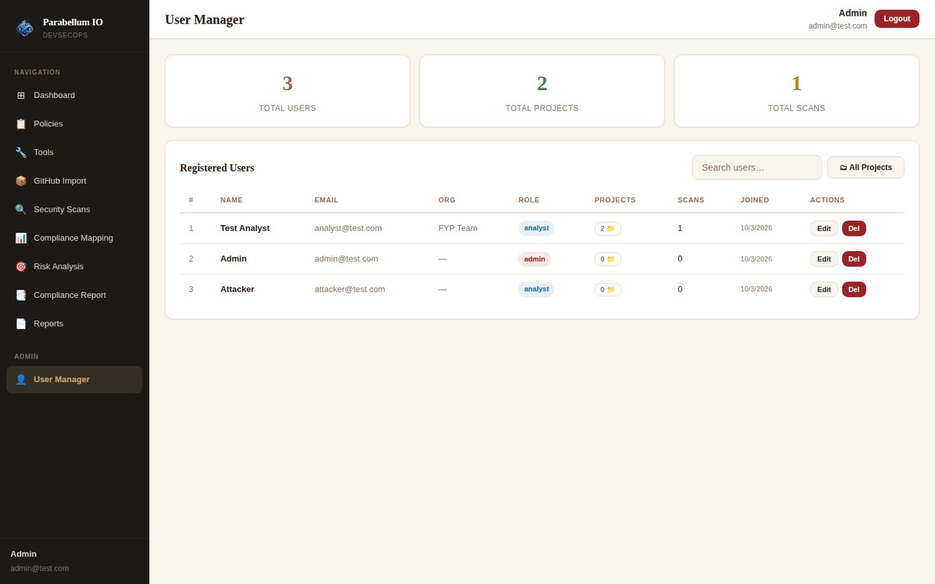
Figure 42 – The ADMIN_EMAIL account sees User Manager; attacker stays "analyst"
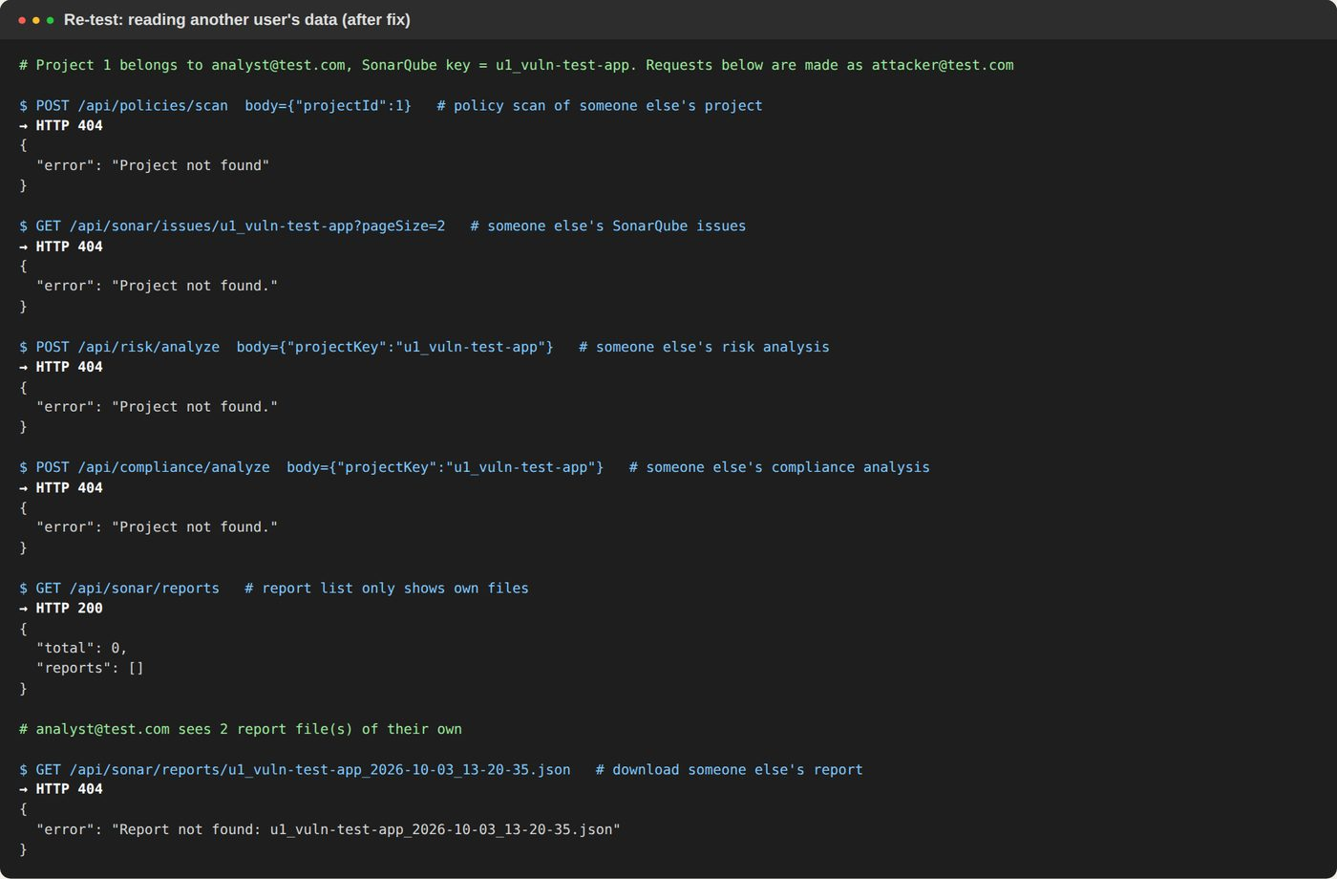
Figure 43 – Other users' data is blocked
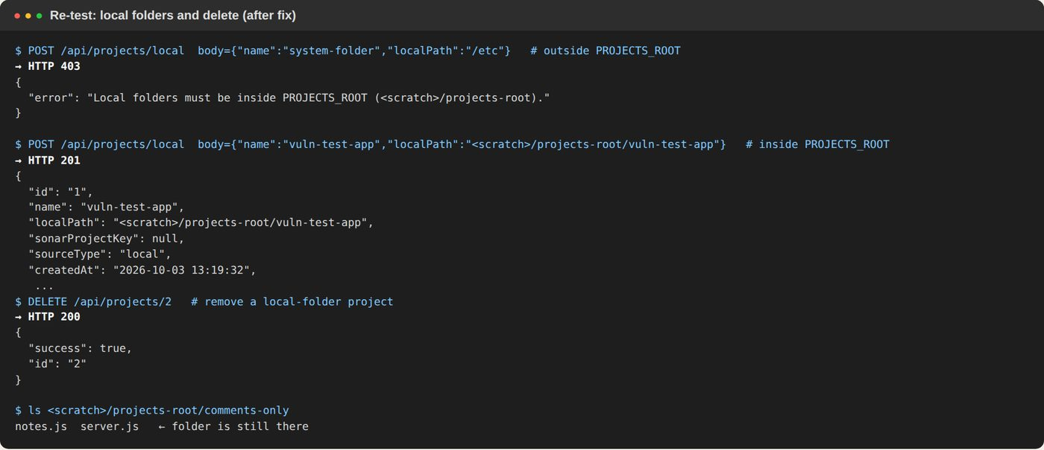
Figure 44 – Local folders restricted; delete keeps the real folder
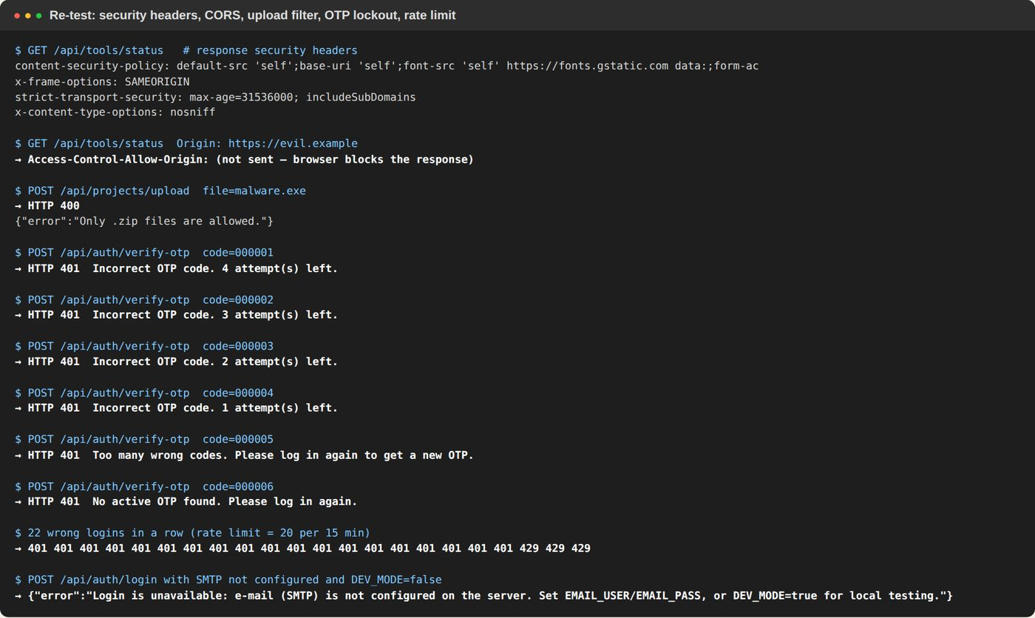
Figure 45 – Headers, CORS, upload filter, OTP lockout, rate limit, OTP not shown when e-mail delivery is required

5.13 Final smoke test
The final build was started fresh and every main feature was called once: login, tool status, Semgrep, Trivy, ZAP, SonarQube, all 6 compliance frameworks and risk analysis. All returned HTTP 200 with results. The frontend passes ESLint and builds without errors.
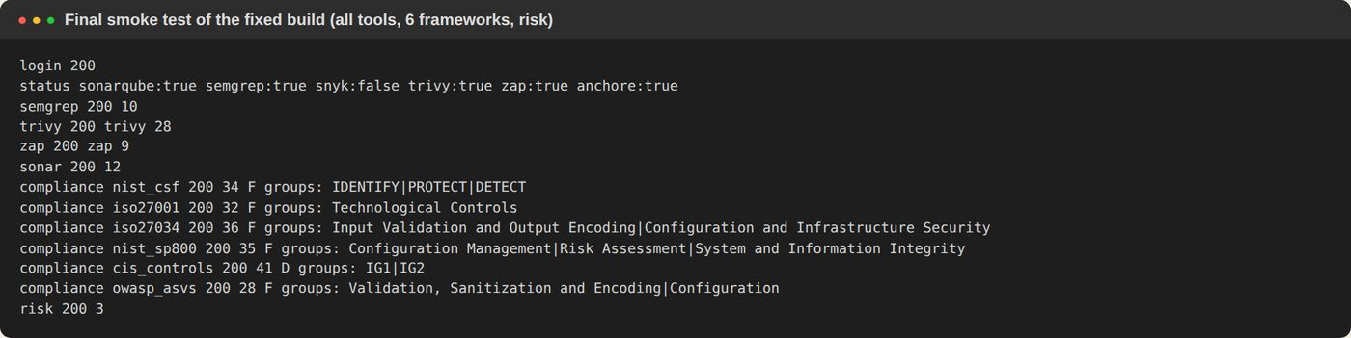
Figure 46 – Final smoke test of the fixed build

6. Round 2 – Application and Final Report Improvements
After the first fixes, the team asked for a second set of improvements. All of them were built and tested end-to-end with real SonarQube, Semgrep, Trivy and OWASP ZAP scans, a real SMTP mail server and a before/after fix scenario on the test app.
Request | What was built | Tested | Result
Configure OTP properly | Hashed codes, 5-min expiry, 5 tries, no reuse, Resend with 60 s cooldown, SMTP check at start-up, port 465/587, plain-text + HTML mail | Real SMTP server | PASS
One account per e-mail | Normalised e-mails + unique index; sign-up sends the user to Sign In | Same e-mail in 3 spellings | PASS
Stay logged in after restart | Saved sessions in the database (8 h / 30 days "Keep me signed in"), real logout | Backend restarted, same token still valid | PASS
Expandable scan results | Click any result row for full text, CWE/CVE, package versions, code, fix advice | Security Scans + Findings pages | PASS
Pipeline per project | One-click run of all tools, live stages, history, per-finding tracking | 2 runs on the test app | PASS
ISO 27001, CIS, OWASP, NIST 800-53 mappings | Every finding mapped to 6 frameworks + OWASP Top 10 + MITRE ATT&CK | Report section 5 | PASS
RAG-based recommendations | Retrieval (RAG service or built-in BM25) + Gemini/template generation, source shown | Built-in retriever (model download blocked in lab) | PASS
True positives / false negatives | Confidence score, cross-tool confirmation, analyst triage remembered, coverage gaps | False Positive suppressed in rescan | PASS
Fix plan per finding | Steps, example, effort, priority, SLA due date, verification | Report + Findings page | PASS
Risk owner and status | Owner, status, due date, note and history per finding | Edited in the UI | PASS
Code / file evidence | Code lines, manifest line or ZAP URLs/evidence per finding | Report section 4 | PASS
Asset and business context | Asset type, environment, data class, criticality, internet-facing, owner → risk score | Pipeline page | PASS
Fix verification and rescan | Rescan marks findings Verified Fixed / Reopened; report shows before/after | 34 fixes verified | PASS

6.1 OTP, one account per e-mail, saved sessions
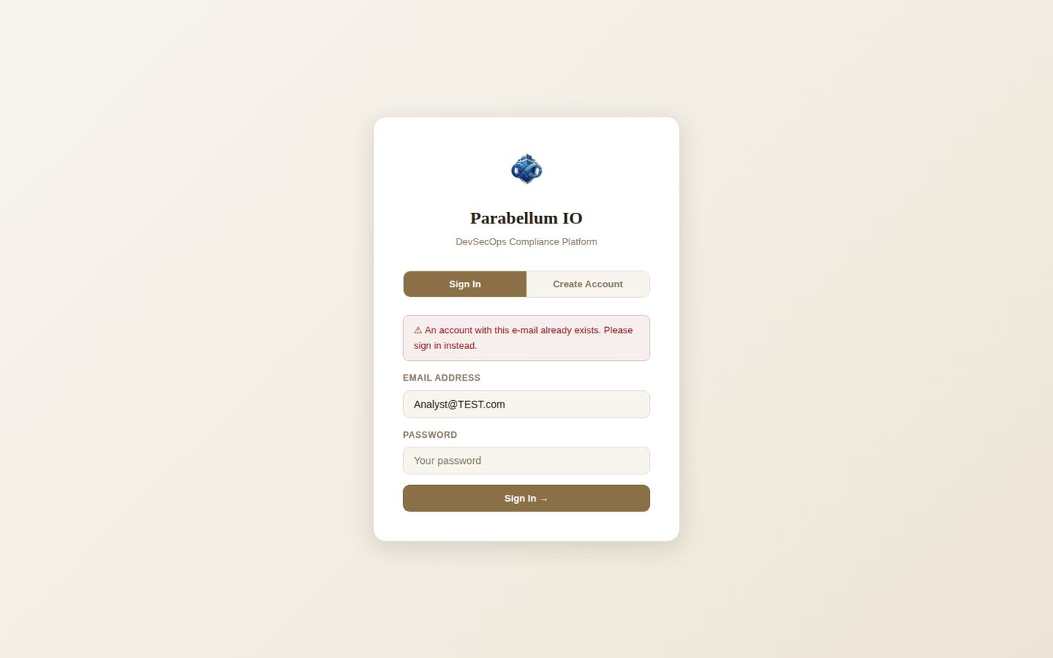
Figure 47 – Second sign-up with the same e-mail (different capitals) is refused
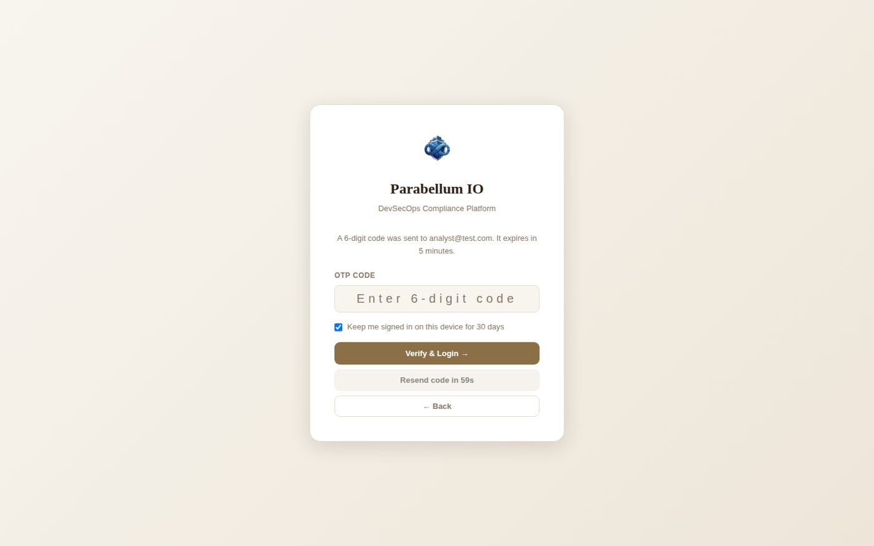
Figure 48 – Code sent by e-mail, "Keep me signed in", resend countdown
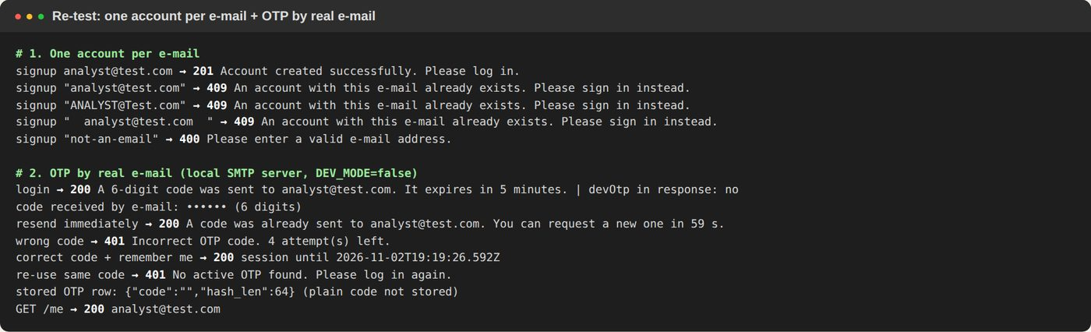
Figure 49 – API test: duplicates refused, real e-mail OTP, cooldown, wrong/reused code, only a hash is stored
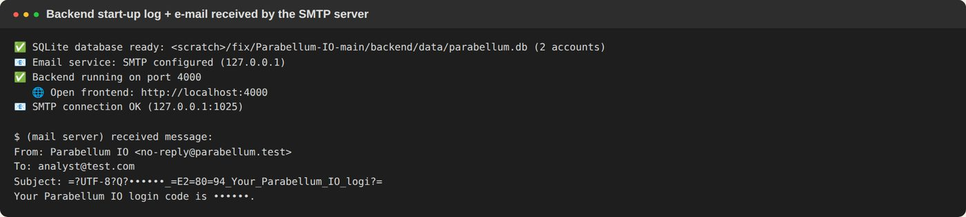
Figure 50 – SMTP connection checked at start-up; the e-mail arrived at the mail server
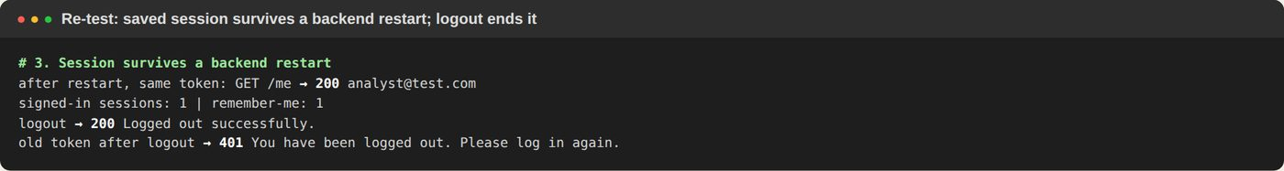
Figure 51 – After a backend restart the same login still works; logout ends the session

6.2 Expandable scan results
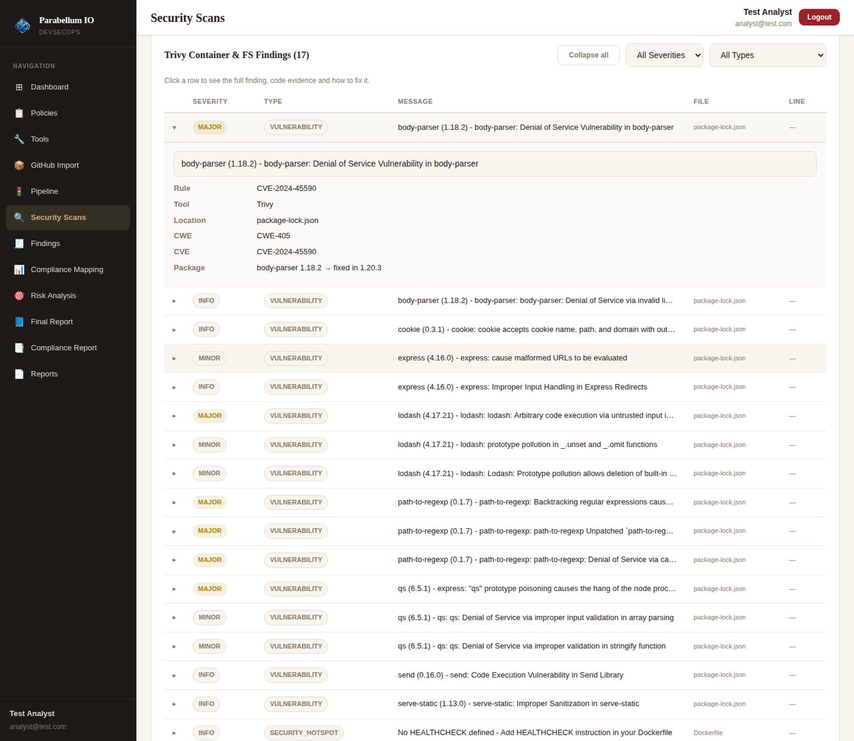
Figure 52 – Click a result to see the full finding (CVE, CWE, package, fix version)

6.3 Pipeline with asset and business context
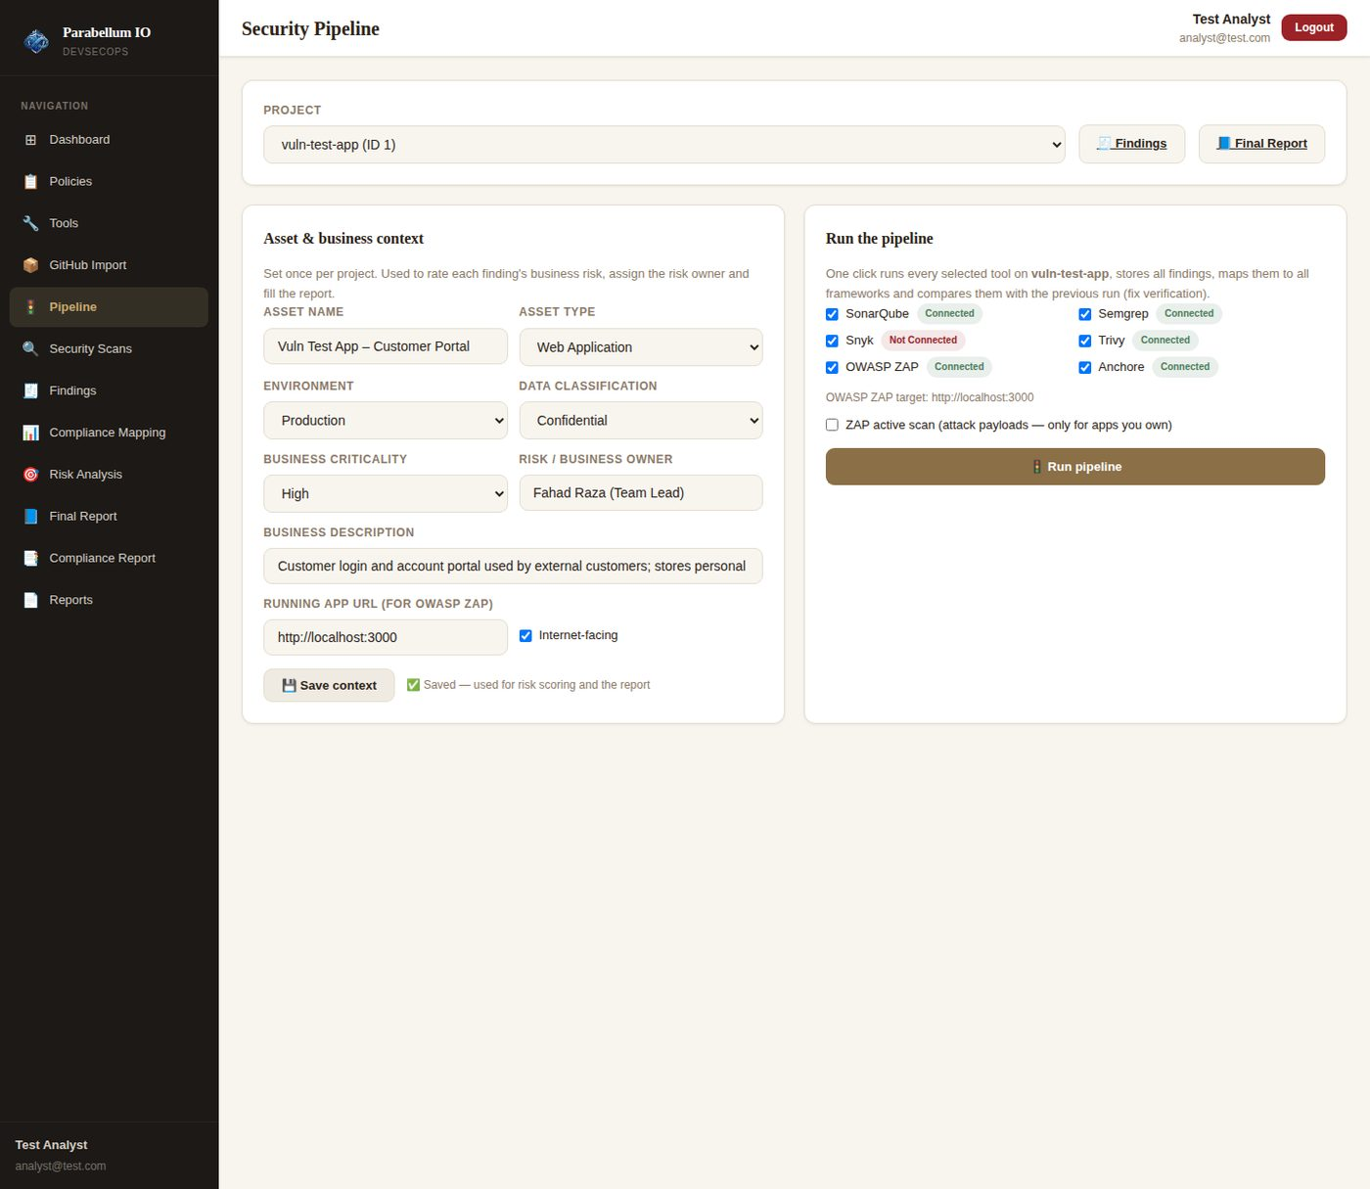
Figure 53 – Asset & business context and tool selection
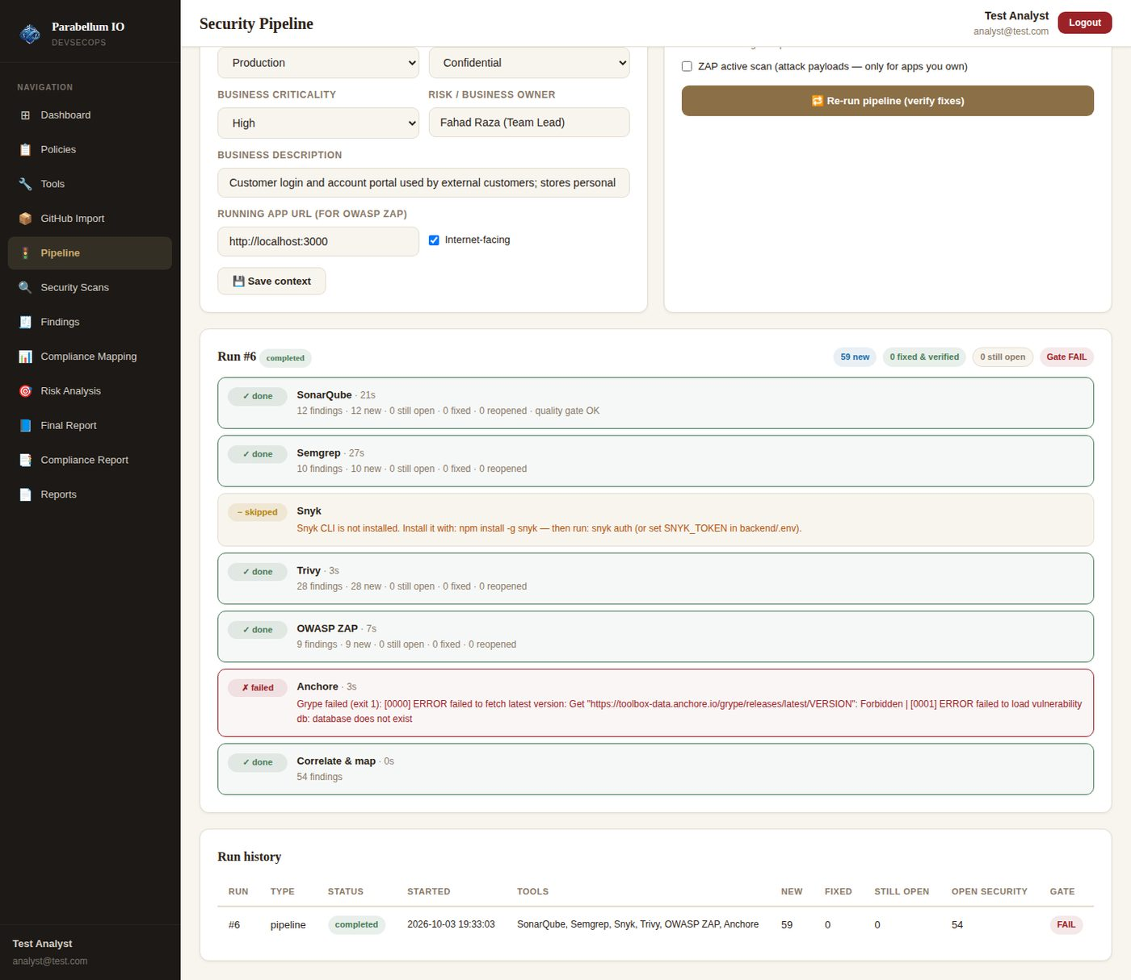
Figure 54 – Baseline run: each tool as a stage, new findings per tool (Snyk skipped – not installed; Grype database blocked in the lab)

6.4 Findings: confidence, owner, status, evidence, mappings, recommendation, fix plan
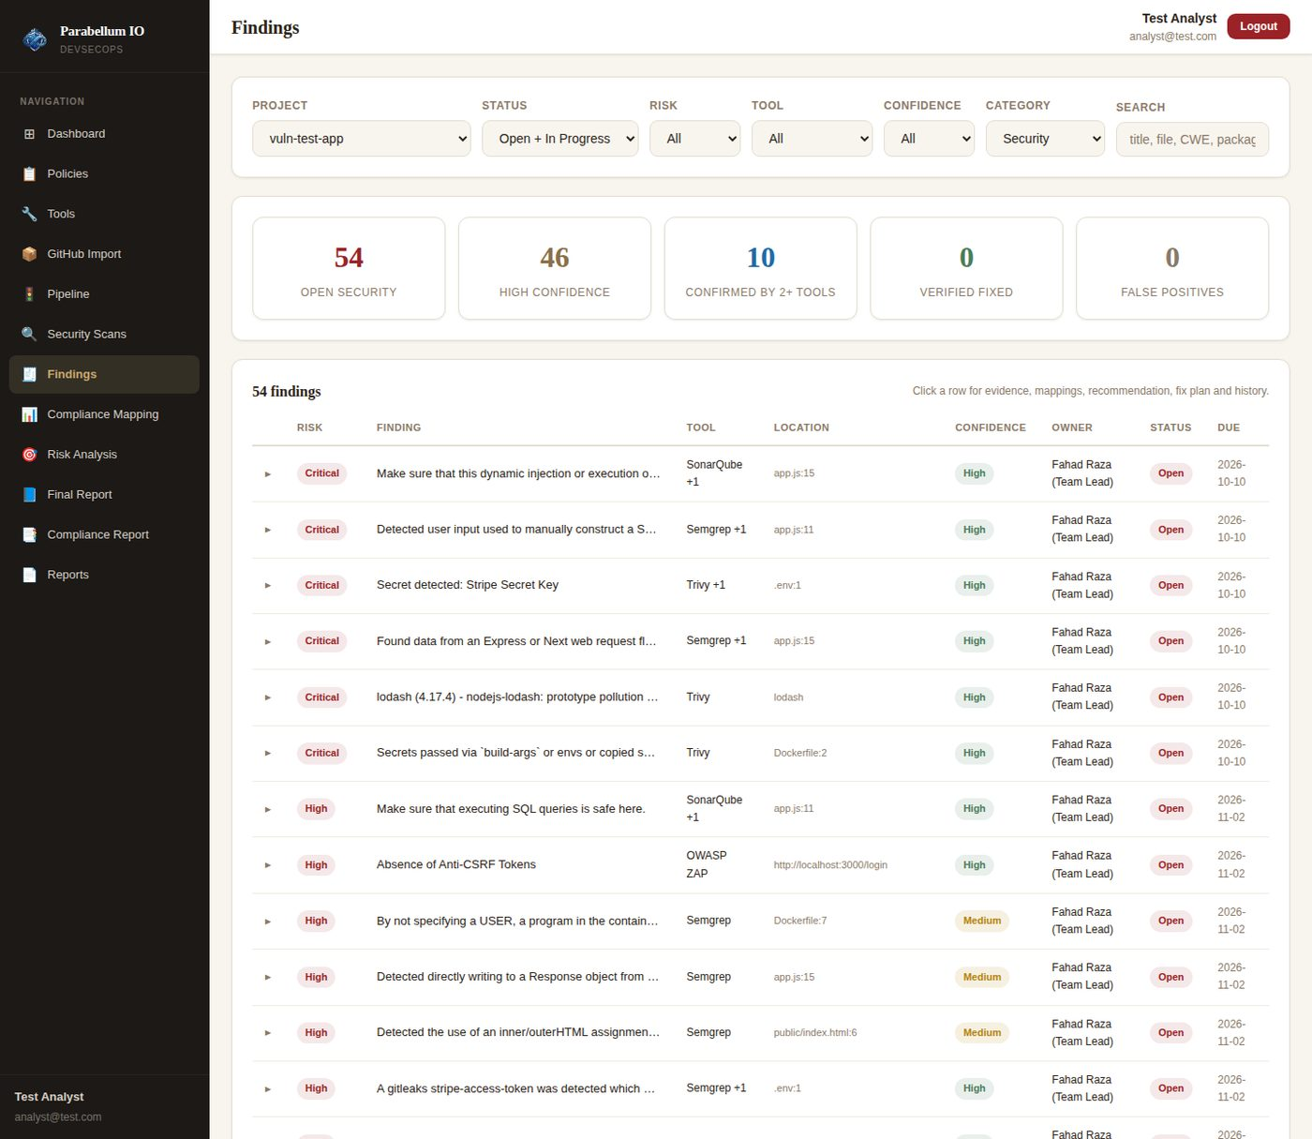
Figure 55 – All tools in one list with risk, confidence ("+1" = confirmed by another tool), owner, status and SLA due date
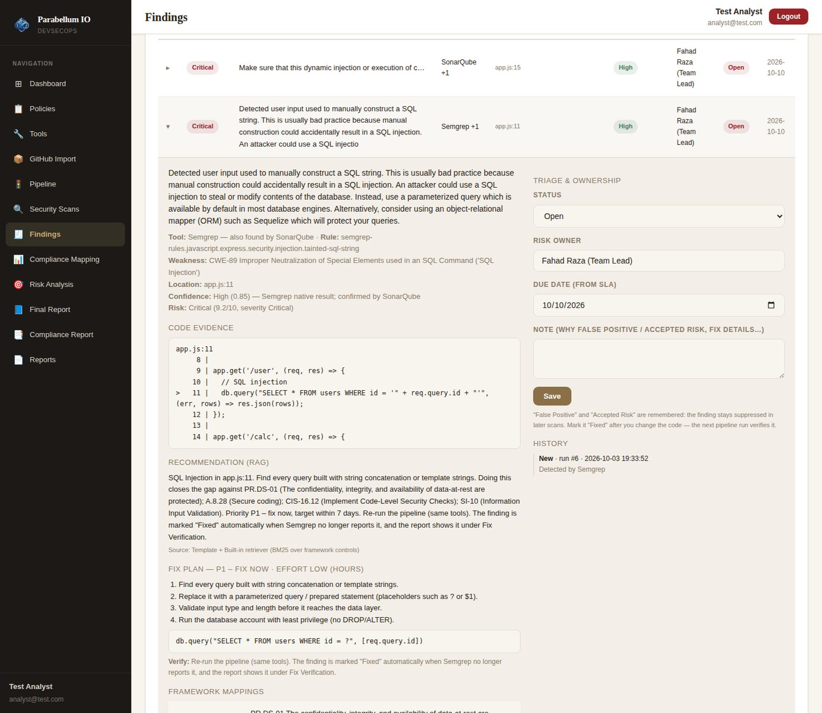
Figure 56 – Expanded finding: code evidence, RAG recommendation, fix plan, triage and history
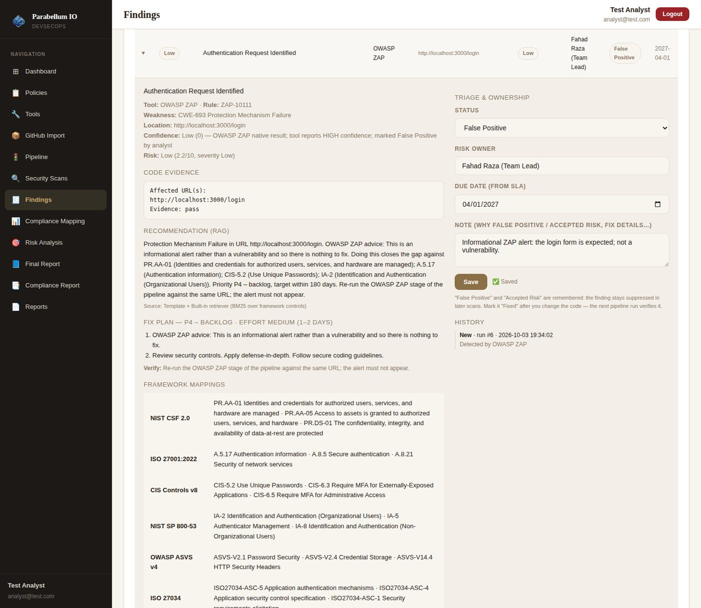
Figure 57 – Analyst marks an informational ZAP alert as False Positive with a reason

6.5 Fix verification after a rescan
The test app was then fixed the way a developer would (parameterized query, no eval, secure cookie, restricted CORS, pinned non-root container image, no committed .env, newer lodash, security headers on the running site), and the pipeline was run again.
Tool | Findings now | Verified fixed | Still open | New
SonarQube | 6 | 6 | 6 | 0
Semgrep | 3 | 8 | 2 | 1
Trivy | 17 | 14 | 14 | 3
OWASP ZAP | 3 | 6 | 2 (+1 false positive kept suppressed) | 0
Total | 29 | 34 | 24 | 4
The 4 new findings are real: lodash 4.17.21 has newer CVEs of its own, and the new pinned FROM line triggers a "pin to digest" rule.
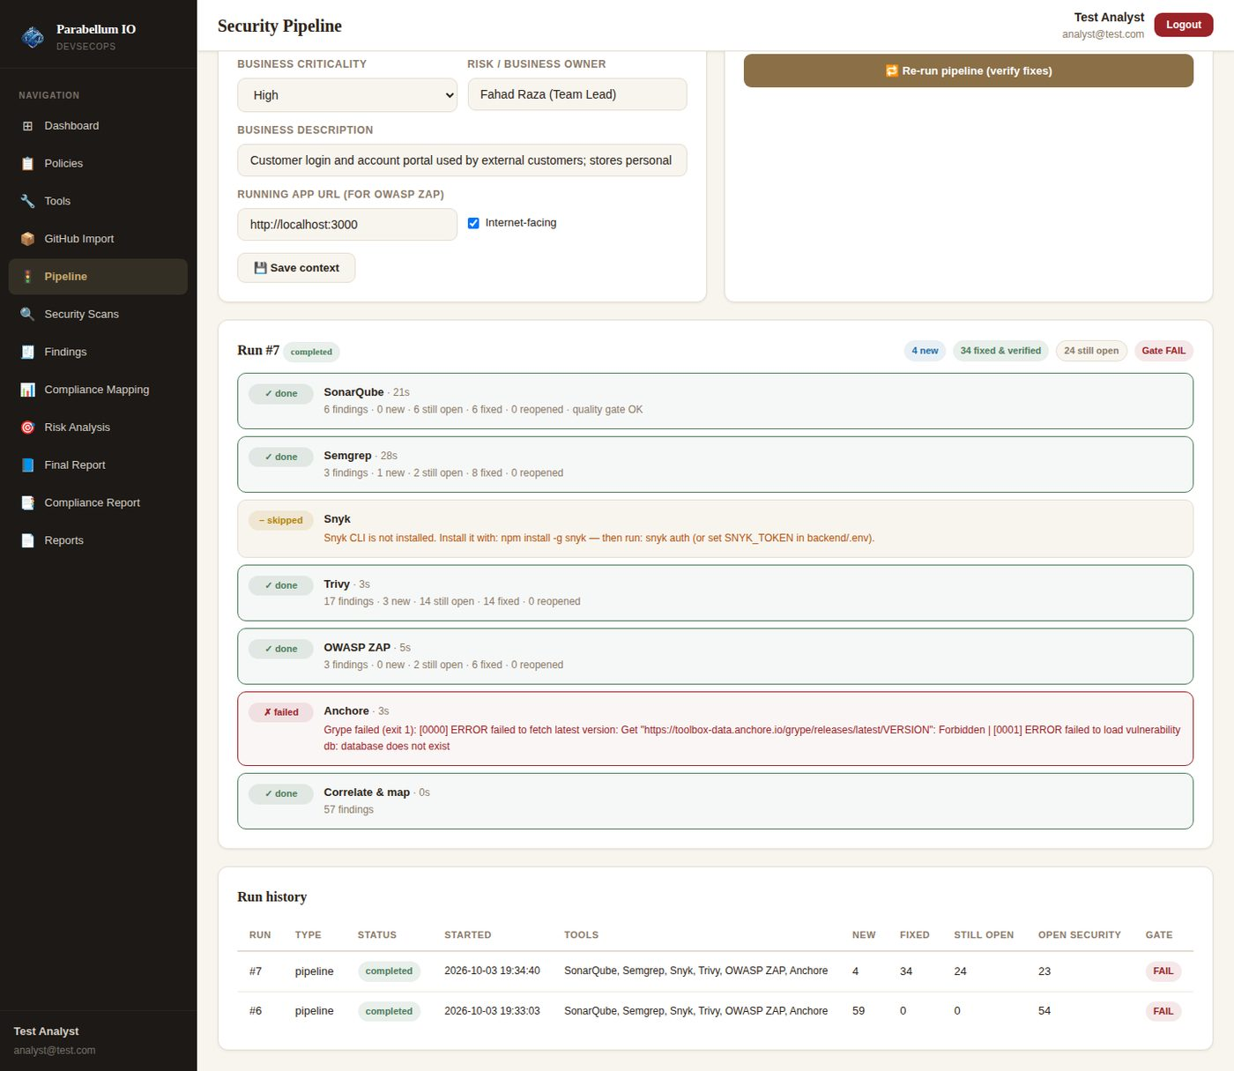
Figure 58 – Re-run: fixed & verified per stage
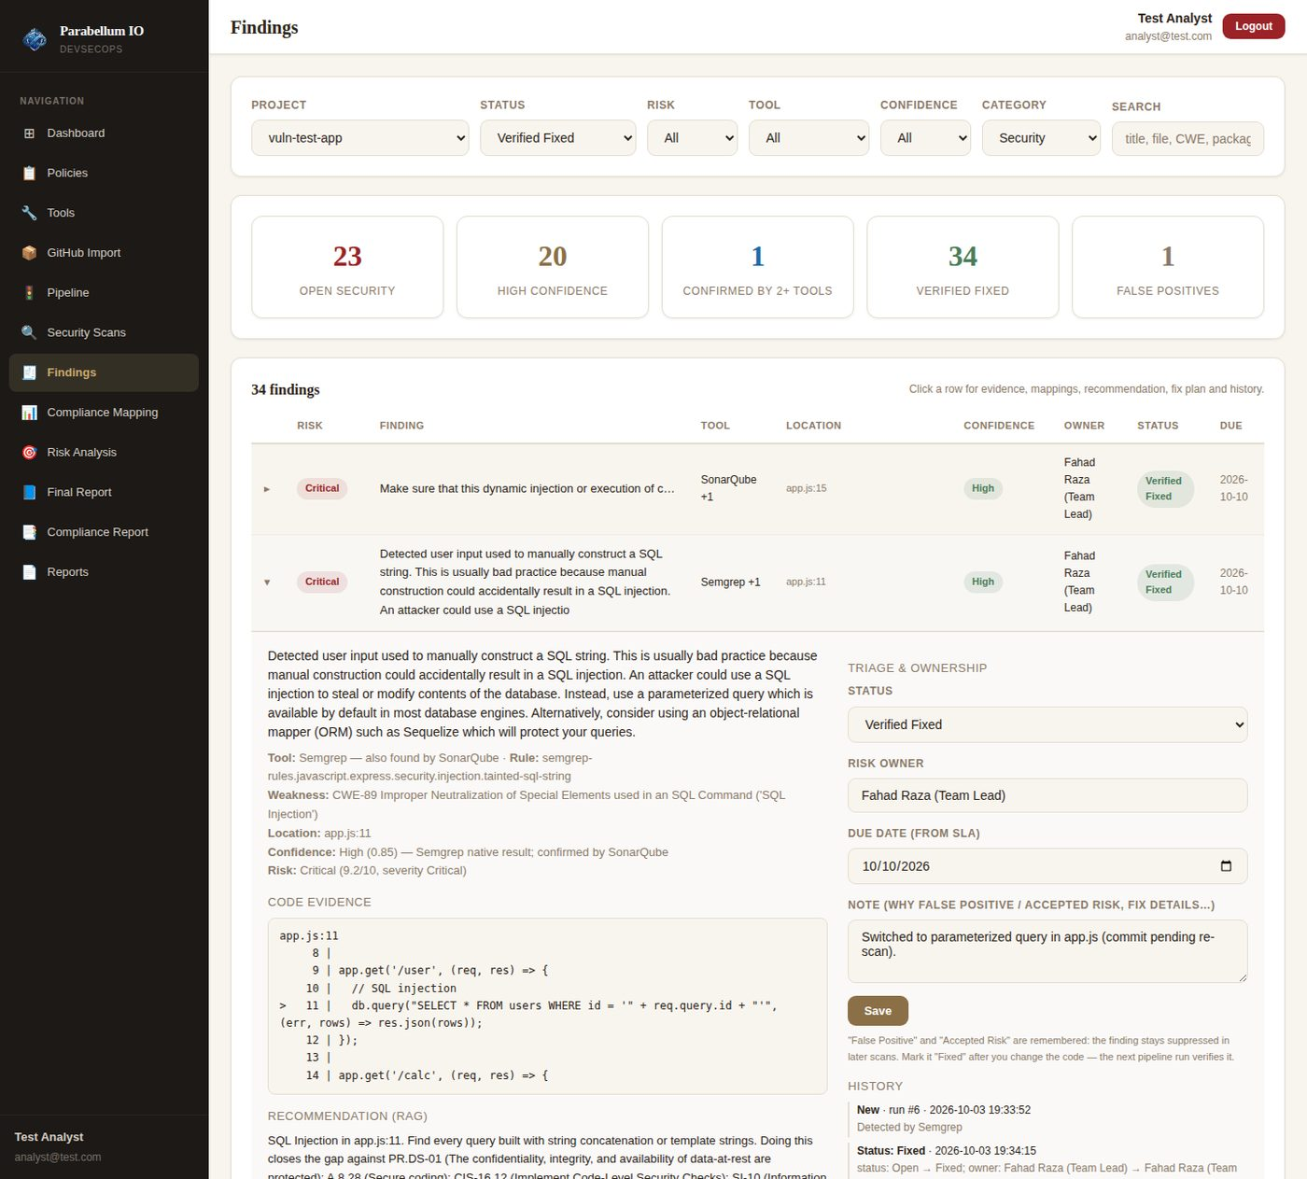
Figure 59 – The SQL injection the developer marked "Fixed" is now "Verified Fixed" by the rescan

6.6 Final report
The new Final Report page (and its Word export) is built from all tools, not only SonarQube and NIST CSF: executive summary, asset and business context, pipeline coverage and accuracy, every finding with evidence, mappings, RAG recommendation and fix plan, compliance per framework, remediation plan with owners and due dates, and fix verification. The full report generated for the test project is included as Appendix A of this document.
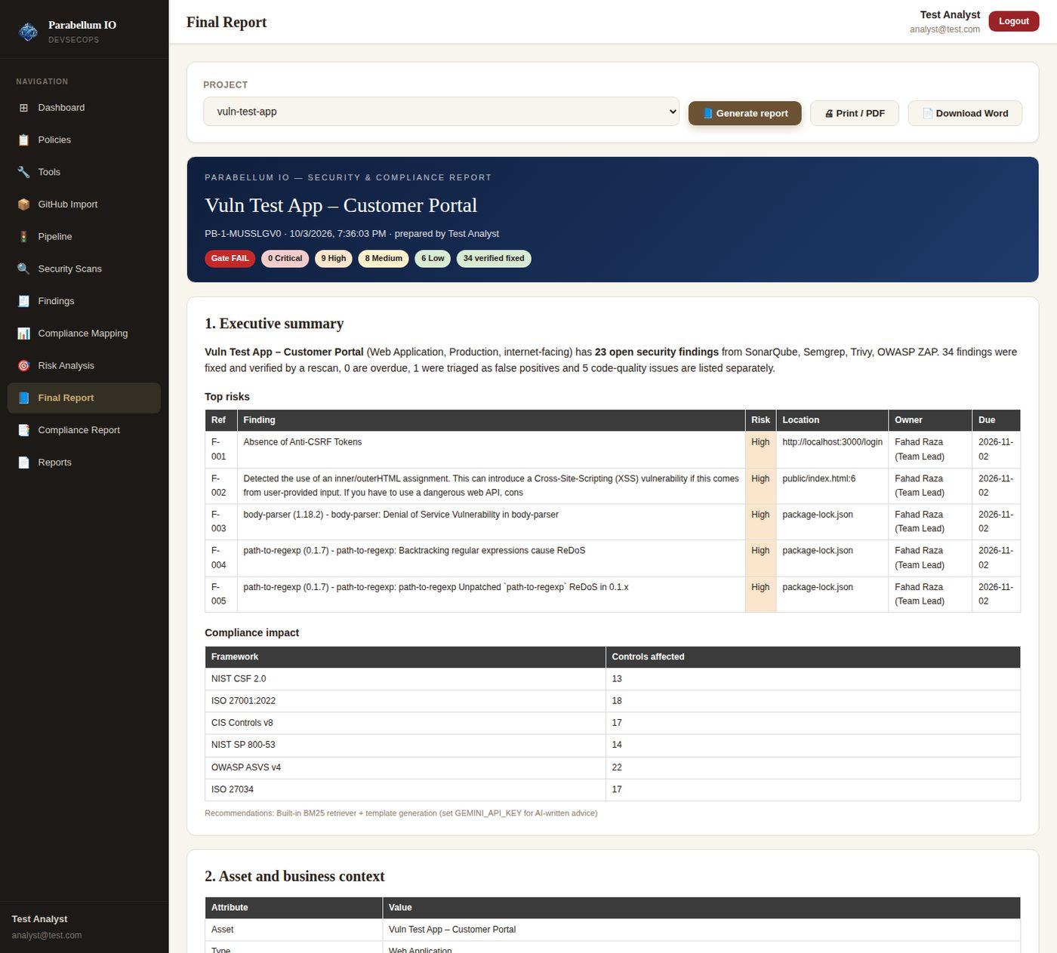
Figure 60 – Final report: summary, top risks, compliance impact
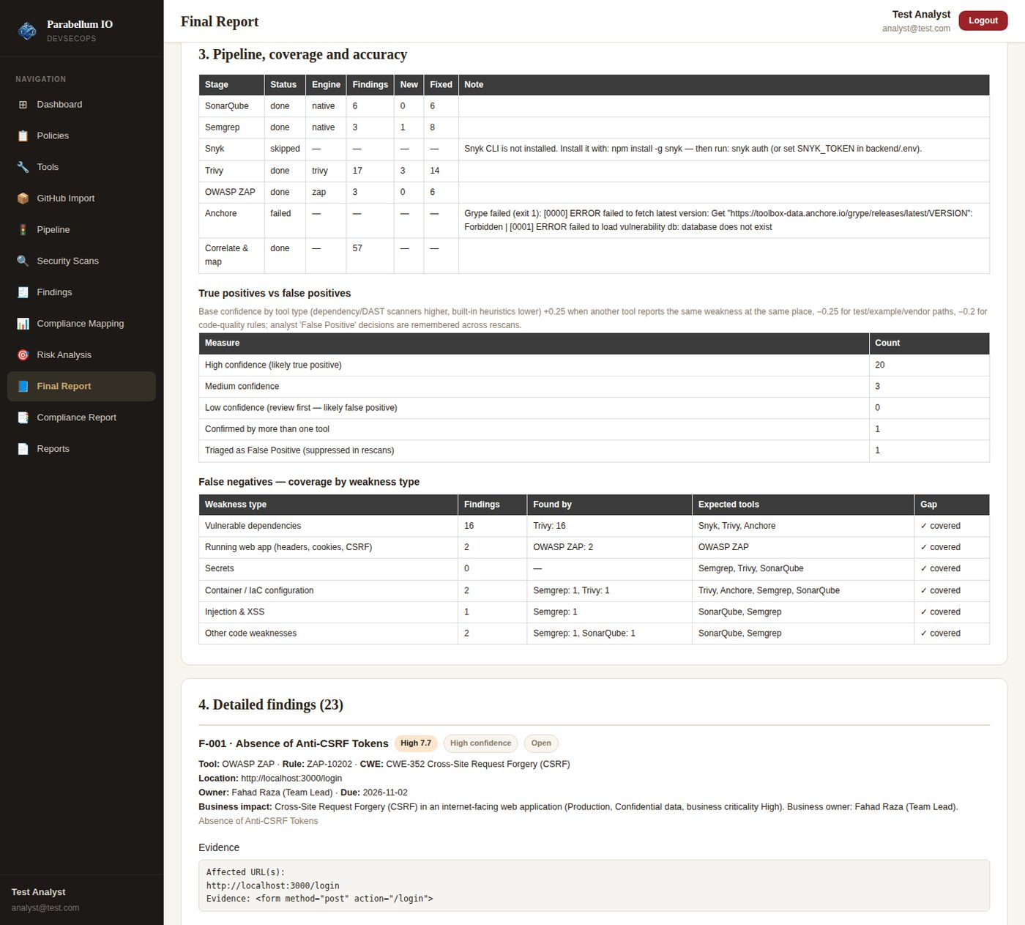
Figure 61 – Pipeline coverage, true/false positives and false-negative gaps
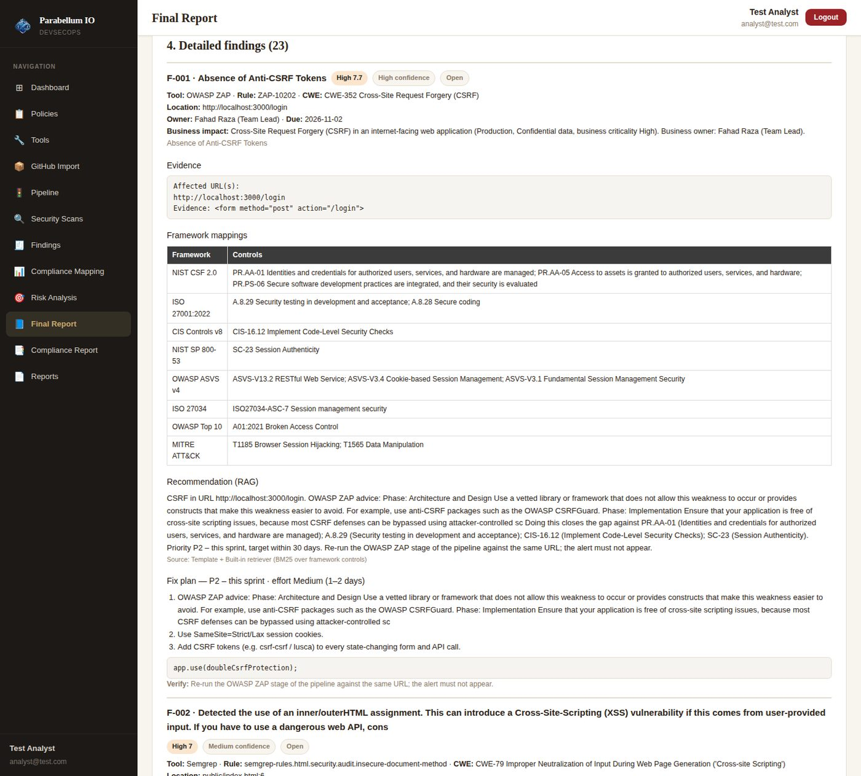
Figure 62 – Detailed finding with evidence, mappings, recommendation and fix plan
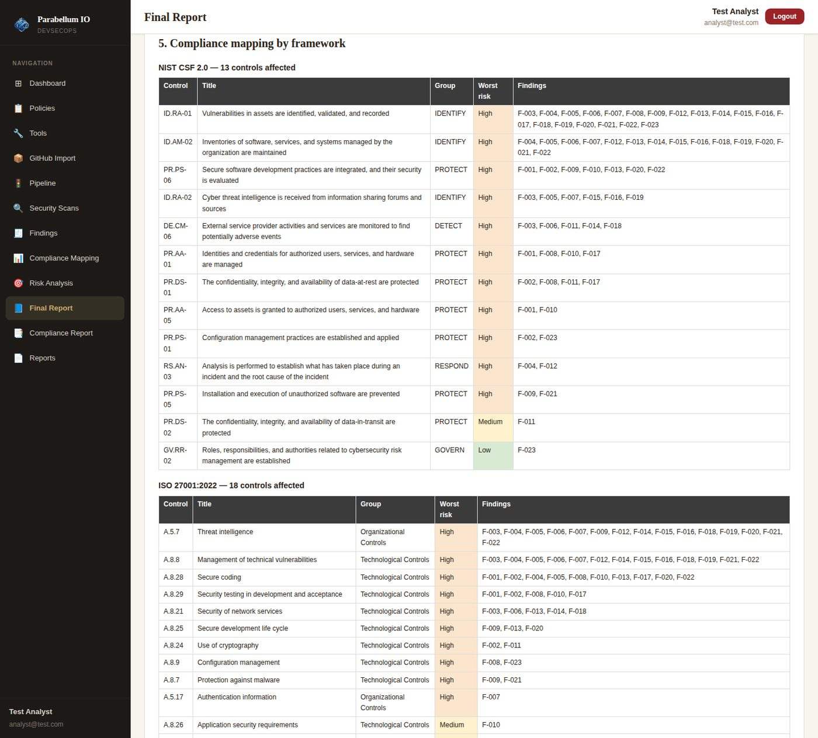
Figure 63 – Compliance mapping by framework
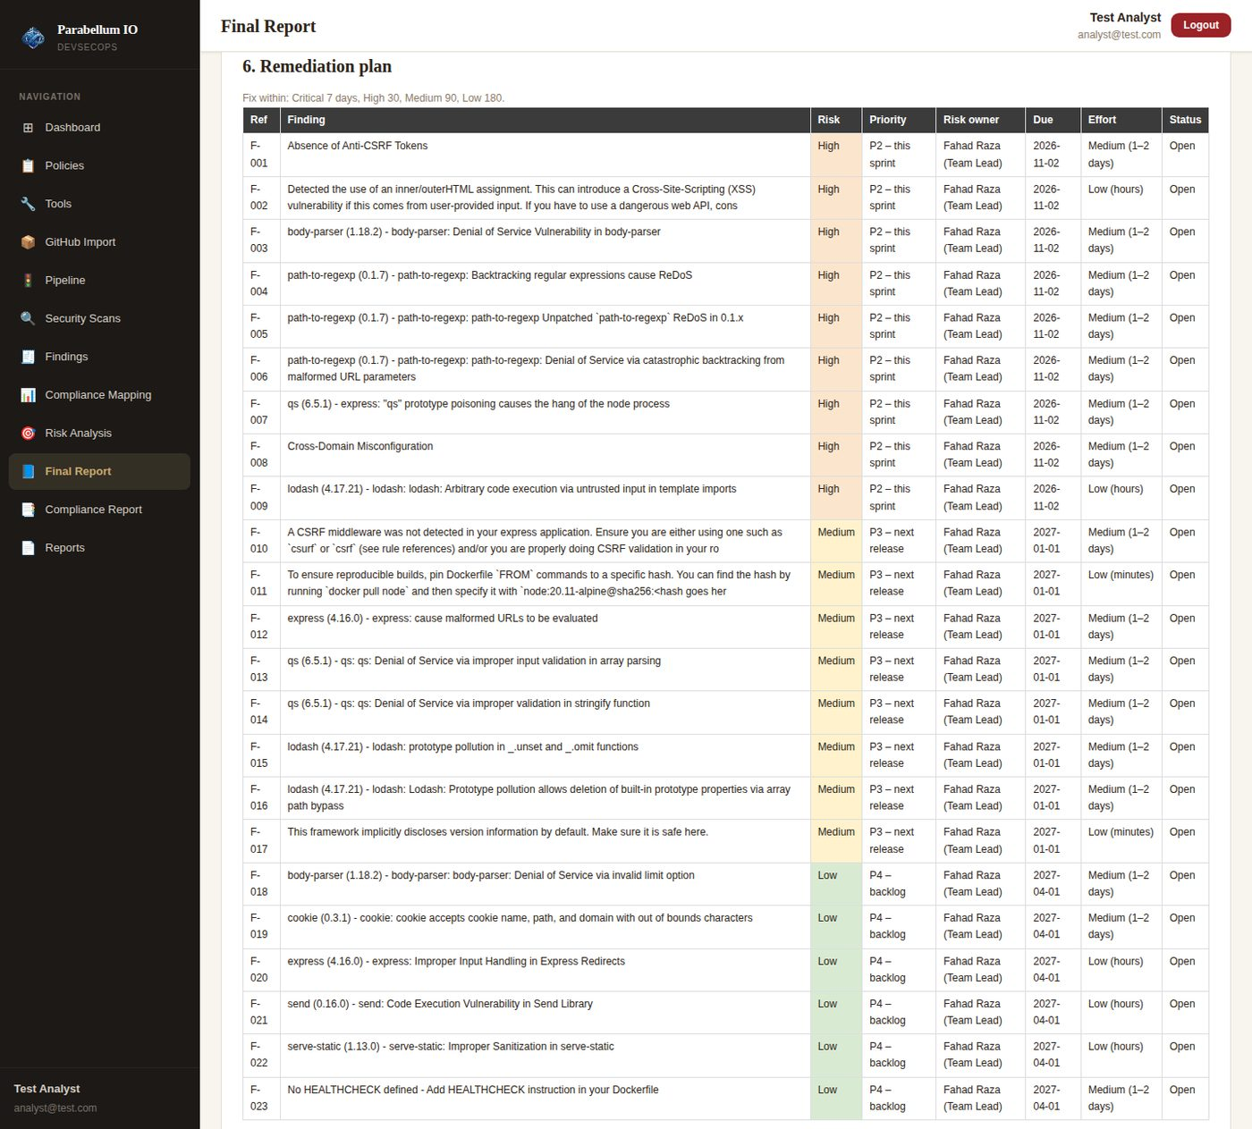
Figure 64 – Remediation plan with risk owners and due dates
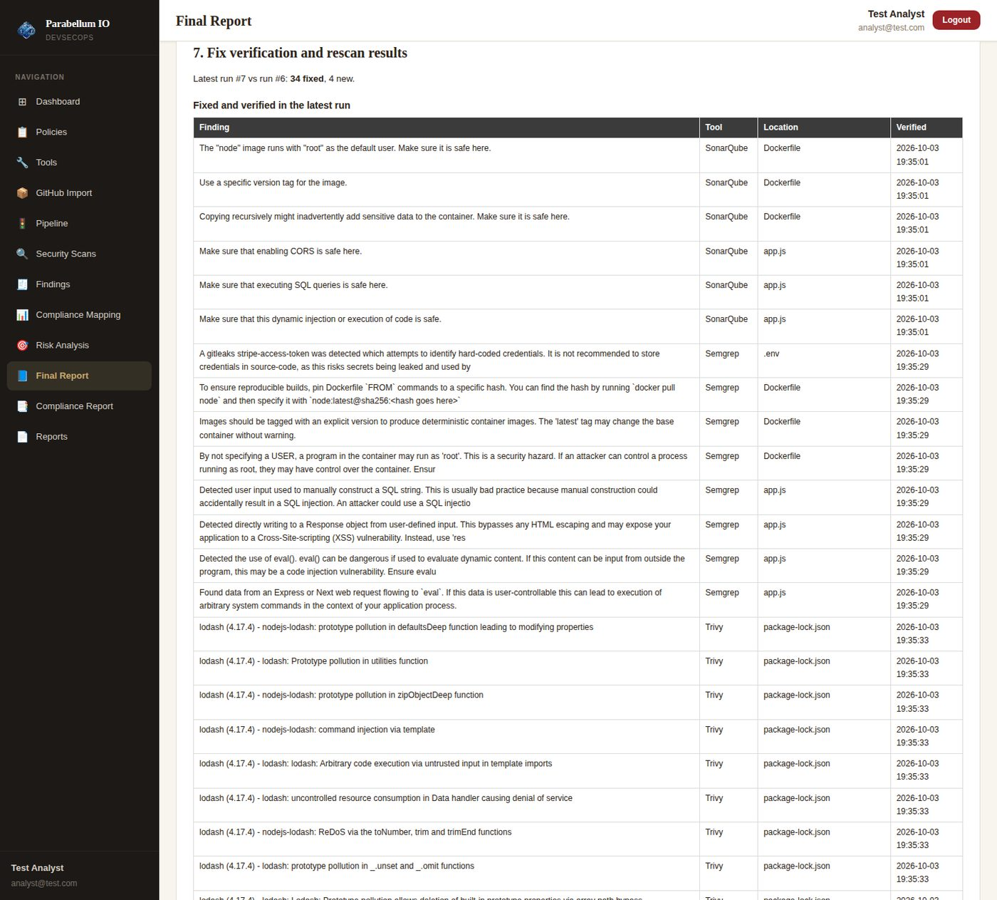
Figure 65 – Fix verification and rescan results

7. Round 3 – Login, All Tools & Frameworks, Risk and Fixes
The team then asked to make sure seven things are fully implemented. Each was checked in the code, the gaps were fixed, and everything was tested again end-to-end with real SonarQube, Semgrep, Trivy and OWASP ZAP scans, a real mail server and a browser (Chromium).
Requirement | What was done | How it was tested | Result
Login fully functional | Sign up (one account per e-mail), password + OTP, "Keep me signed in", sessions survive restarts, logout. New: "Forgot password?" (reset code → new password, all sessions signed out) and "Change password" (🔑 button, other devices signed out). | 15 API checks + browser: wrong password, unknown e-mail, wrong/reused code, weak password, old session signed out, change password | PASS
OTP configuration | OTP_DELIVERY = auto (e-mail when SMTP is set, otherwise on screen) / email / screen / both. Separate login and reset codes, stored hashed, 5 min, single use, 5 tries, 60 s resend cooldown. Windows: npm install + npm start now work. | All 4 modes + e-mail failure; codes received from a real SMTP server | PASS
Pipeline for tracking projects | One-click run of all tools, run history, New / Still open / Verified Fixed / Reopened per finding. | Baseline run, triage, fix, rescan | PASS
All security tools and all frameworks | Gap fixed: Risk Analysis, Compliance Mapping and the Compliance Report used only SonarQube – they now use the findings of every tool. The Compliance Report scores all 6 frameworks. SonarQube tab shows every issue (was 100) with SonarQube's own "how to fix". | 6 frameworks scored from SonarQube + Semgrep + Trivy + ZAP findings | PASS
Optimise tool results | New: the same problem reported by several tools is merged into one finding ("also found by"). Confidence score, remembered false positives, the finding's own CWE used for risk. | Same CVE from Trivy, Snyk, Anchore → 1 finding; eval() from SonarQube + Semgrep → 1 finding, High confidence | PASS
Risk management on all tools & frameworks | Risk = severity × CWE CVSS × exposure × business impact × confidence; CWE groups with OWASP Top 10, MITRE ATT&CK and CAPEC heatmaps; owner, status, SLA due date. | Risk Analysis on the test app (4 tools) | PASS
Recommended fixes and remediation | Every scan row, finding and report entry has a "Recommended fix": why, steps, the tool's own advice, example code, priority / SLA and how to verify. | 57 of 57 findings have a fix; every scan row has a fix | PASS
Everything in the final report | Report (screen + Word) now holds every finding: open, code quality, awaiting verification, verified fixes, false positives / accepted risks, merged duplicates and a complete register. Expandable cards; printing opens them all. | 57 findings in the database = 57 in the report | PASS

7.1 Login, password reset and change password
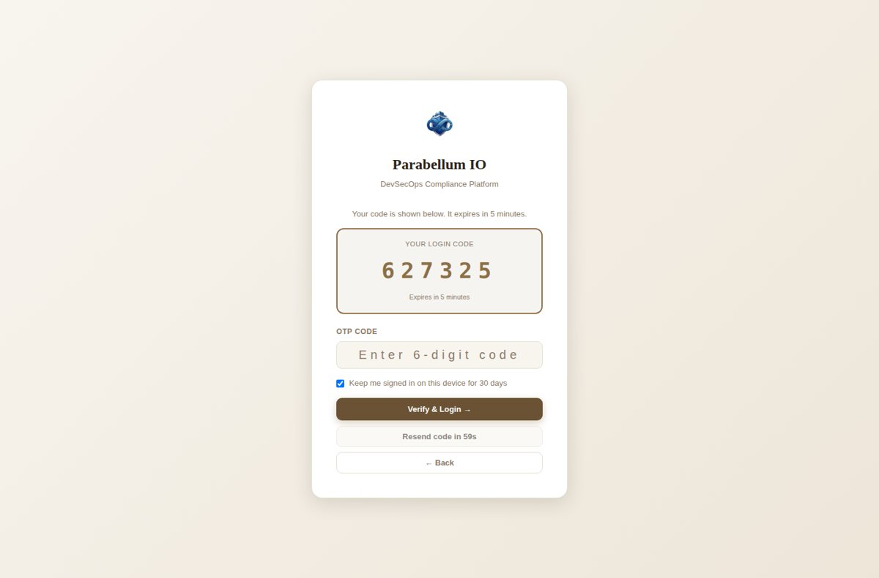
Figure 66 – Login code shown on screen when e-mail is not set up (OTP_DELIVERY=auto)
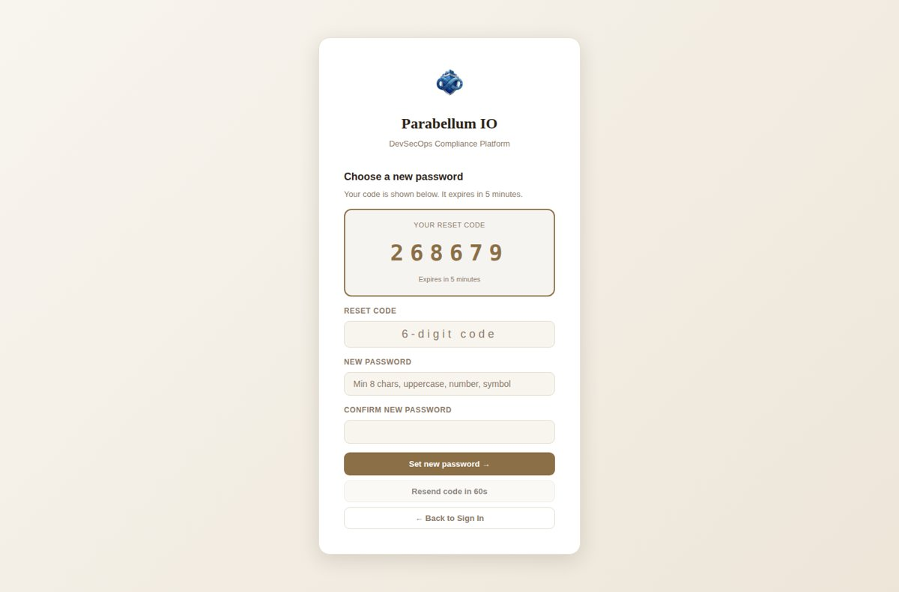
Figure 67 – "Forgot password?": reset code, new password and confirmation
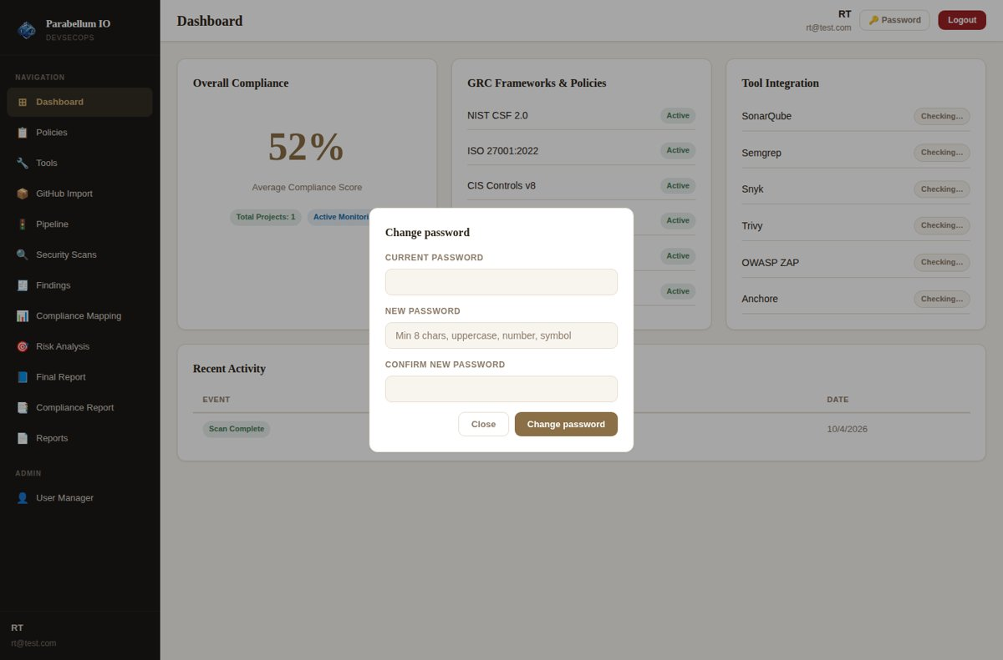
Figure 68 – Change password from the top bar (current password required)

7.2 Recommended fix on every finding
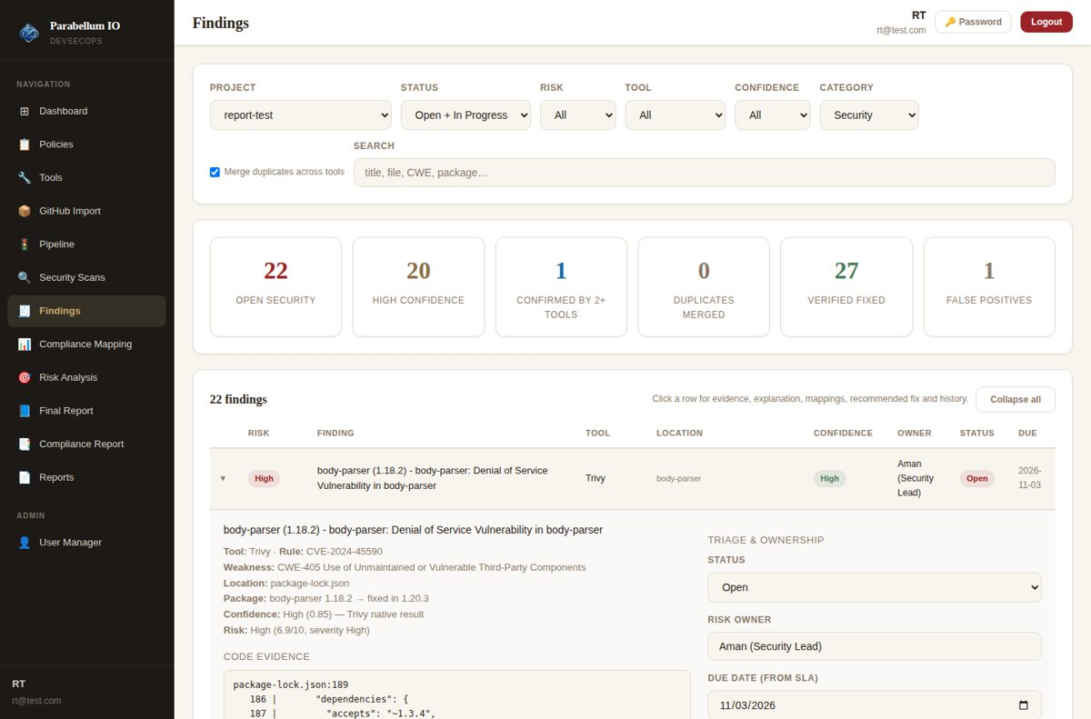
Figure 69 – Expanded finding with evidence, explanation and the Recommended fix box
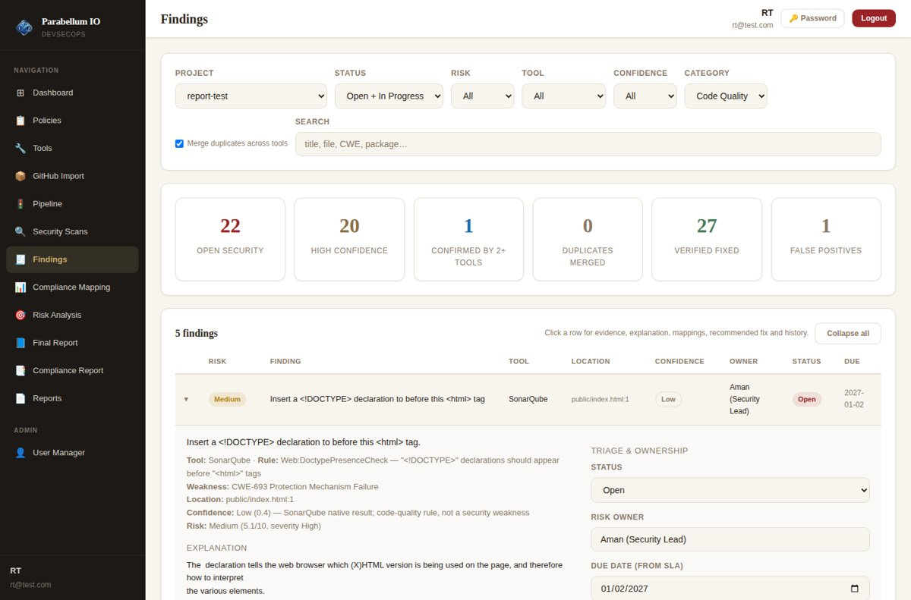
Figure 70 – Code-quality issues get SonarQube's explanation and concrete steps too; duplicates merged across tools

7.3 Risk and compliance from all tools and all frameworks
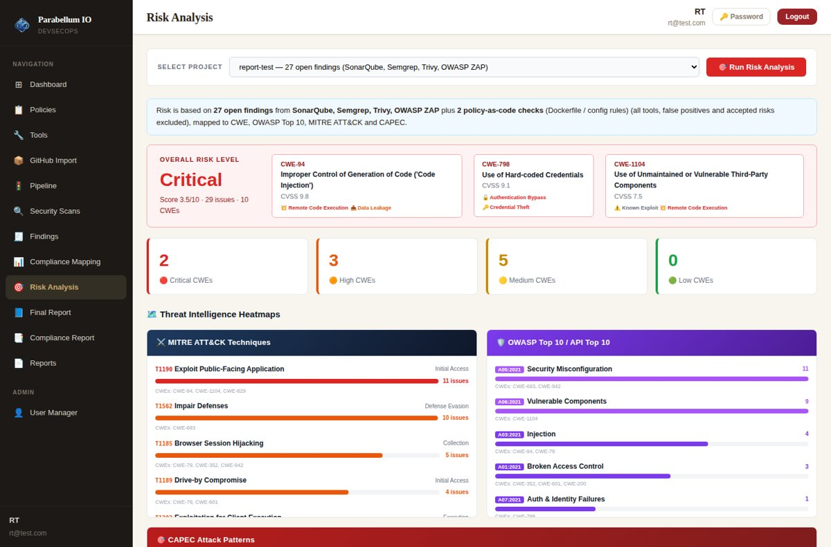
Figure 71 – Risk Analysis now uses every tool's findings (not only SonarQube)
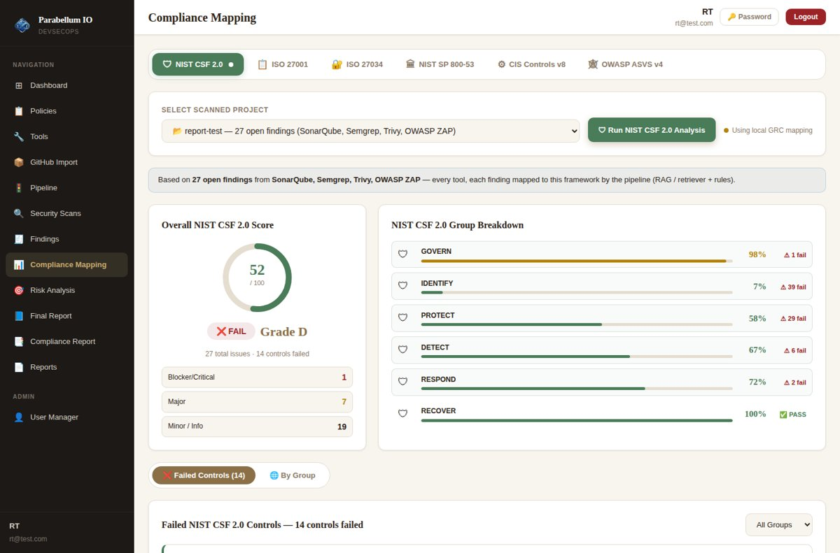
Figure 72 – Compliance Mapping based on all tools
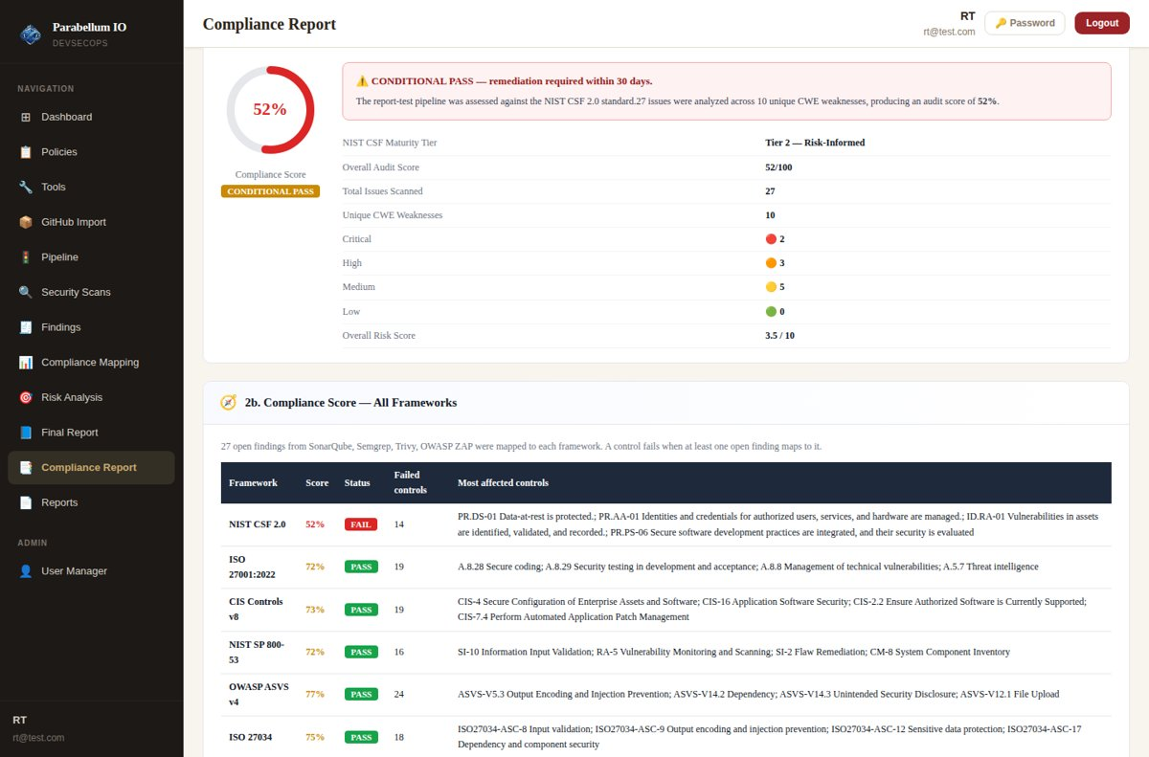
Figure 73 – Compliance Report: score for all 6 frameworks

7.4 Final report with every finding
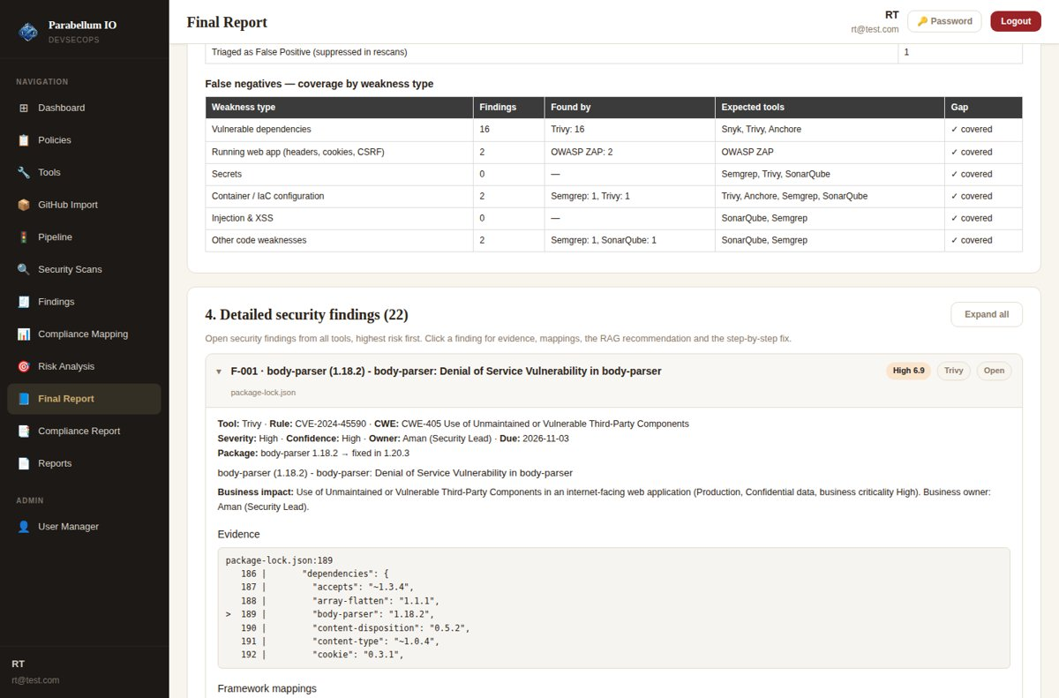
Figure 74 – Each finding is an expandable card; Expand all / Collapse all
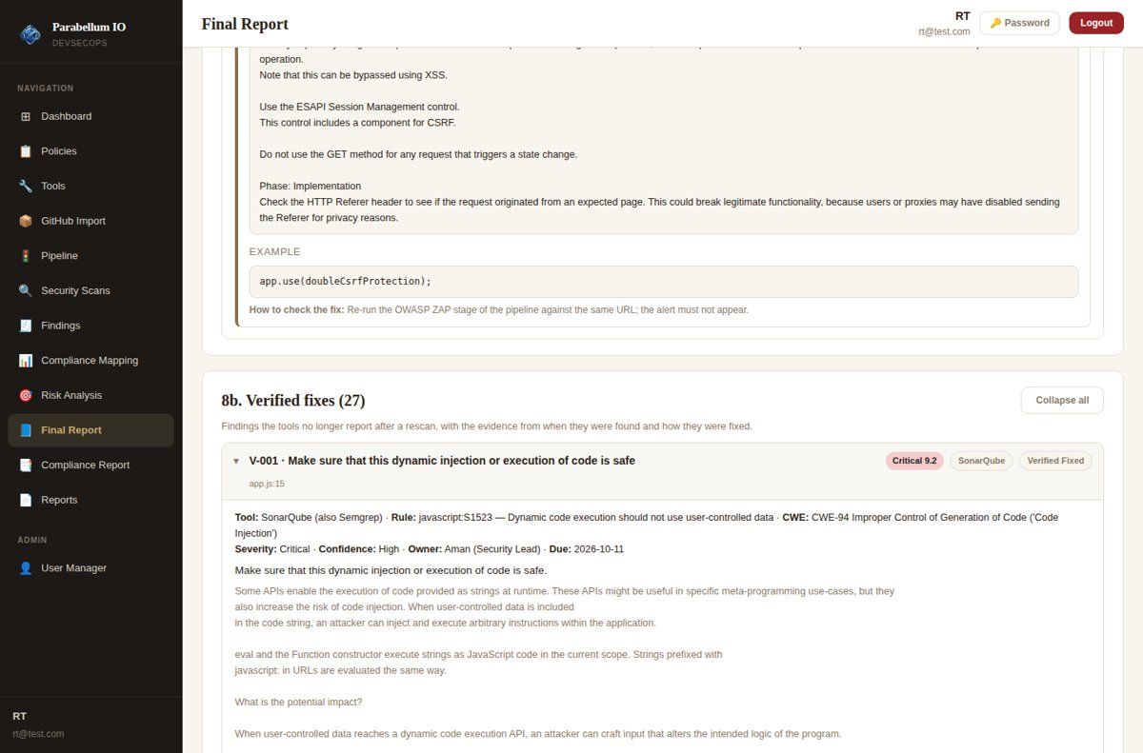
Figure 75 – Verified fixes with the evidence from when they were found and how they were fixed
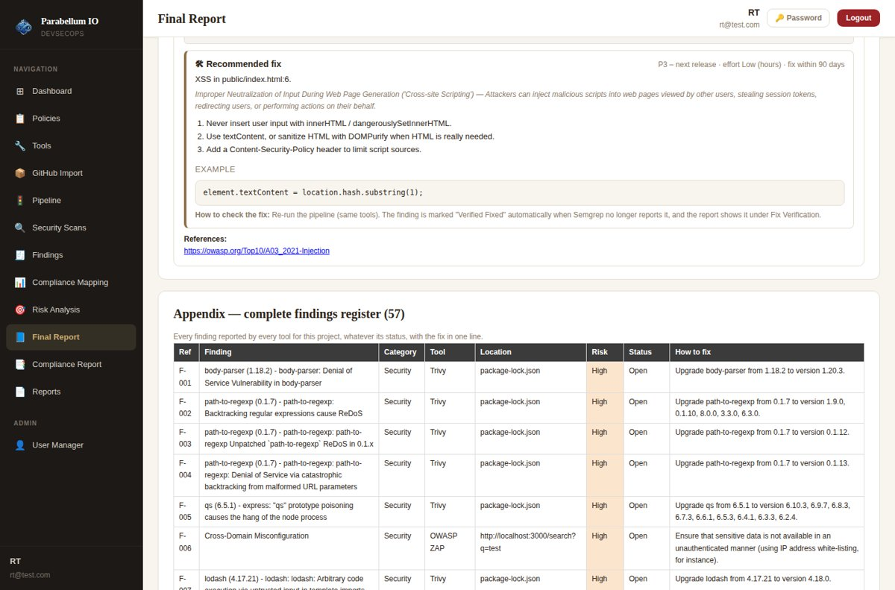
Figure 76 – Complete findings register: every finding with its status and fix
The full report generated for the test project is Appendix A.

8. Limits of This Test and Demo Checklist

8.1 What could not be fully tested here
- Snyk – not installed in the lab (needs a Snyk account). The pipeline, parsing and duplicate merging are built in; it runs once installed and authenticated.
- Anchore / Grype – the vulnerability database download is blocked in the lab; Grype starts but cannot download its data. Works on a normal internet connection.
- RAG model – HuggingFace model download blocked; mappings and recommendations used the built-in retriever over the same framework texts. With the RAG service running, the same code uses it automatically.
- Gemini – needs a real GEMINI_API_KEY; without it recommendations use the template.
- GitHub import – GitHub API blocked in the lab (code reviewed only).
- Windows – install/start and paths were made Windows-safe but tested on Linux.

8.2 Before the presentation
- Run npm install, then npm start. On first start backend/.env is created with a random JWT_SECRET; set ADMIN_EMAIL, the SonarQube token and (optional) Gmail App Password.
- For the demo you can set OTP_DELIVERY=screen so the code always appears on screen.
- On the Pipeline page fill in the asset & business context and the running app URL, run the pipeline, fix one or two findings and re-run it to show fix verification.
- Start SonarQube, the RAG service (port 5000) and, if you want them live, the ZAP daemon.
- Install Snyk (and run snyk auth), Trivy and Grype so their tabs show "Connected".
- Add GEMINI_API_KEY to demo AI-written recommendations.
- Run one scan with every tool on your laptop the day before.

All accounts and data in the screenshots are test data.

Appendix A – Final Security & Compliance Report (generated by the app)
This appendix is the report produced by the Final Report page for the Round 3 test project (SonarQube, Semgrep, Trivy and OWASP ZAP; findings triaged, app fixed and rescanned). It contains all 57 findings, each with a recommended fix (report PB-1-MUTZNSZ1, 10/4/2026, 3:41:36 PM). Recommendations: Built-in BM25 retriever + template generation (set GEMINI_API_KEY for AI-written advice).

A.1 Executive summary
Customer Portal (test) (Web Application, Production, internet-facing) has 22 open security findings from SonarQube, Semgrep, Trivy, OWASP ZAP. Security gate: FAIL. 27 findings were fixed and verified by a rescan; 1 triaged as false positive; 5 code-quality issues are listed separately. In total the report covers 57 findings, each with a recommended fix.
Critical | High | Medium | Low | Verified fixed | Overdue
0 | 7 | 8 | 7 | 27 | 0

Top risks
Ref | Finding | Risk | Location | Owner | Due
F-001 | body-parser (1.18.2) - body-parser: Denial of Service Vulnerability in body-parser | High | package-lock.json | Aman (Security Lead) | 2026-11-03
F-002 | path-to-regexp (0.1.7) - path-to-regexp: Backtracking regular expressions cause ReDoS | High | package-lock.json | Aman (Security Lead) | 2026-11-03
F-003 | path-to-regexp (0.1.7) - path-to-regexp: path-to-regexp Unpatched `path-to-regexp` ReDoS in 0.1.x | High | package-lock.json | Aman (Security Lead) | 2026-11-03
F-004 | path-to-regexp (0.1.7) - path-to-regexp: path-to-regexp: Denial of Service via catastrophic backtracking from malformed URL parameters | High | package-lock.json | Aman (Security Lead) | 2026-11-03
F-005 | qs (6.5.1) - express: "qs" prototype poisoning causes the hang of the node process | High | package-lock.json | Aman (Security Lead) | 2026-11-03

Compliance impact
Framework | Controls affected
NIST CSF 2.0 | 13
ISO 27001:2022 | 19
CIS Controls v8 | 19
NIST SP 800-53 | 16
OWASP ASVS v4 | 24
ISO 27034 | 18

A.2 Asset and business context
Attribute | Value
Asset | Customer Portal (test)
Type | Web Application
Environment | Production
Data classification | Confidential
Business criticality | High
Internet-facing | Yes
Business / risk owner | Aman (Security Lead)
Running app URL | http://localhost:3000
Description | Test web app used to verify the report
Risk score (0–10) = base (tool severity averaged with the weakness' typical CVSS) × likelihood (internet exposure × environment) × business impact (criticality + data classification) × confidence; ≥8.5 Critical, ≥6.5 High, ≥4 Medium, ≥2 Low.

A.3 Pipeline, coverage and accuracy
Stage | Status | Engine | Findings | New | Fixed | Note
SonarQube | done | native | 6 | 0 | 0
Semgrep | done | native | 3 | 0 | 0
Trivy | done | trivy | 17 | 0 | 0
Correlate & map | done | — | 51 | — | —

True positives vs false positives
Base confidence by tool type (dependency/DAST scanners higher, built-in heuristics lower) +0.25 when another tool reports the same weakness at the same place, −0.25 for test/example/vendor paths, −0.2 for code-quality rules; analyst 'False Positive' decisions are remembered across rescans.
Measure | Count
High confidence (likely true positive) | 20
Medium confidence | 2
Low confidence (review first) | 0
Confirmed by more than one tool | 1
Cross-tool duplicates merged (counted once) | 0
Triaged as False Positive (suppressed in rescans) | 1

False negatives – coverage by weakness type
Weakness type | Findings | Found by | Expected tools | Gap
Vulnerable dependencies | 16 | Trivy: 16 | Snyk, Trivy, Anchore | Covered
Running web app (headers, cookies, CSRF) | 2 | OWASP ZAP: 2 | OWASP ZAP | Covered
Secrets | 0 | — | Semgrep, Trivy, SonarQube | Covered
Container / IaC configuration | 2 | Semgrep: 1, Trivy: 1 | Trivy, Anchore, Semgrep, SonarQube | Covered
Injection & XSS | 0 | — | SonarQube, Semgrep | Covered
Other code weaknesses | 2 | Semgrep: 1, SonarQube: 1 | SonarQube, Semgrep | Covered

A.4 Detailed security findings (22)

F-001 · body-parser (1.18.2) - body-parser: Denial of Service Vulnerability in body-parser
Risk | Severity | Confidence | Status | Owner | Due
High (6.9) | High | High | Open | Aman (Security Lead) | 2026-11-03

Tool: Trivy · rule CVE-2024-45590
Weakness: CWE-405 Use of Unmaintained or Vulnerable Third-Party Components
Location: package-lock.json
Package: body-parser 1.18.2 → fixed in 1.20.3
Description: body-parser (1.18.2) - body-parser: Denial of Service Vulnerability in body-parser
Business impact: Use of Unmaintained or Vulnerable Third-Party Components in an internet-facing web application (Production, Confidential data, business criticality High). Business owner: Aman (Security Lead).
Evidence
package-lock.json:189
186 | "dependencies": {
187 | "accepts": "~1.3.4",
188 | "array-flatten": "1.1.1",
> 189 | "body-parser": "1.18.2",
190 | "content-disposition": "0.5.2",
191 | "content-type": "~1.0.4",
192 | "cookie": "0.3.1",

Framework | Mapped controls
NIST CSF 2.0 | ID.RA-01 Vulnerabilities in assets are identified, validated, and recorded; ID.RA-02 Cyber threat intelligence is received from information sharing forums and sources; DE.CM-06 External service provider activities and services are monitored to find potentially adverse events
ISO 27001:2022 | A.8.8 Management of technical vulnerabilities; A.5.7 Threat intelligence; A.8.21 Security of network services
CIS Controls v8 | CIS-2.2 Ensure Authorized Software is Currently Supported; CIS-7.4 Perform Automated Application Patch Management; CIS-7 Continuous Vulnerability Management
NIST SP 800-53 | RA-5 Vulnerability Monitoring and Scanning; SI-2 Flaw Remediation; CM-8 System Component Inventory
OWASP ASVS v4 | ASVS-V14.2 Dependency; ASVS-V12.1 File Upload; ASVS-V13.1 Generic Web Service Security
ISO 27034 | ISO27034-ASC-17 Dependency and component security; ISO27034-ASC-20 Dynamic application security testing (DAST); ISO27034-ASC-19 Static application security testing (SAST)
OWASP Top 10 | A05:2021 Security Misconfiguration
MITRE ATT&CK | T1562 Impair Defenses
Recommendation (RAG): body-parser (1.18.2) - body-parser: Denial of Service Vulnerability in body-parser in package-lock.json. Upgrade body-parser from 1.18.2 to version 1.20.3. Doing this closes the gap against ID.RA-01 (Vulnerabilities in assets are identified, validated, and recorded); A.8.8 (Management of technical vulnerabilities); CIS-2.2 (Ensure Authorized Software is Currently Supported); RA-5 (Vulnerability Monitoring and Scanning). Priority P2 – this sprint, target within 30 days. Re-run the pipeline (same tools). The finding is marked "Verified Fixed" automatically when Trivy no longer reports it, and the report shows it under Fix Verification.
Source: Template + Built-in retriever (BM25 over framework controls)
Recommended fix – P2 – this sprint, effort Low–Medium (hours), SLA 30 days
- Upgrade body-parser from 1.18.2 to version 1.20.3.
- Regenerate and commit the lockfile (package-lock.json / poetry.lock / pom.xml).
- Run the test suite, then re-run the SCA/container scan to confirm.
npm install body-parser@1.20.3
Verification: Re-run the pipeline (same tools). The finding is marked "Verified Fixed" automatically when Trivy no longer reports it, and the report shows it under Fix Verification.

F-002 · path-to-regexp (0.1.7) - path-to-regexp: Backtracking regular expressions cause ReDoS
Risk | Severity | Confidence | Status | Owner | Due
High (6.9) | High | High | Open | Aman (Security Lead) | 2026-11-03

Tool: Trivy · rule CVE-2024-45296
Weakness: CWE-1333 Use of Unmaintained or Vulnerable Third-Party Components
Location: package-lock.json
Package: path-to-regexp 0.1.7 → fixed in 1.9.0, 0.1.10, 8.0.0, 3.3.0, 6.3.0
Description: path-to-regexp (0.1.7) - path-to-regexp: Backtracking regular expressions cause ReDoS
Business impact: Use of Unmaintained or Vulnerable Third-Party Components in an internet-facing web application (Production, Confidential data, business criticality High). Business owner: Aman (Security Lead).
Evidence
package-lock.json:205
202 | "methods": "~1.1.2",
203 | "on-finished": "~2.3.0",
204 | "parseurl": "~1.3.2",
> 205 | "path-to-regexp": "0.1.7",
206 | "proxy-addr": "~2.0.2",
207 | "qs": "6.5.1",
208 | "range-parser": "~1.2.0",

Framework | Mapped controls
NIST CSF 2.0 | ID.RA-01 Vulnerabilities in assets are identified, validated, and recorded; RS.AN-03 Analysis is performed to establish what has taken place during an incident and the root cause of the incident; ID.AM-02 Inventories of software, services, and systems managed by the organization are maintained
ISO 27001:2022 | A.5.7 Threat intelligence; A.8.8 Management of technical vulnerabilities; A.8.28 Secure coding
CIS Controls v8 | CIS-2.2 Ensure Authorized Software is Currently Supported; CIS-7.4 Perform Automated Application Patch Management; CIS-2 Inventory and Control of Software Assets
NIST SP 800-53 | RA-5 Vulnerability Monitoring and Scanning; SI-2 Flaw Remediation; CM-8 System Component Inventory
OWASP ASVS v4 | ASVS-V14.2 Dependency; ASVS-V12.3 File Execution Prevention; ASVS-V12.1 File Upload
ISO 27034 | ISO27034-ASC-17 Dependency and component security; ISO27034-ASC-8 Input validation
OWASP Top 10 | A05:2021 Security Misconfiguration
MITRE ATT&CK | T1562 Impair Defenses
Recommendation (RAG): path-to-regexp (0.1.7) - path-to-regexp: Backtracking regular expressions cause ReDoS in package-lock.json. Upgrade path-to-regexp from 0.1.7 to version 1.9.0, 0.1.10, 8.0.0, 3.3.0, 6.3.0. Doing this closes the gap against ID.RA-01 (Vulnerabilities in assets are identified, validated, and recorded); A.5.7 (Threat intelligence); CIS-2.2 (Ensure Authorized Software is Currently Supported); RA-5 (Vulnerability Monitoring and Scanning). Priority P2 – this sprint, target within 30 days. Re-run the pipeline (same tools). The finding is marked "Verified Fixed" automatically when Trivy no longer reports it, and the report shows it under Fix Verification.
Source: Template + Built-in retriever (BM25 over framework controls)
Recommended fix – P2 – this sprint, effort Low–Medium (hours), SLA 30 days
- Upgrade path-to-regexp from 0.1.7 to version 1.9.0, 0.1.10, 8.0.0, 3.3.0, 6.3.0.
- Regenerate and commit the lockfile (package-lock.json / poetry.lock / pom.xml).
- Run the test suite, then re-run the SCA/container scan to confirm.
npm install path-to-regexp@1.9.0
Verification: Re-run the pipeline (same tools). The finding is marked "Verified Fixed" automatically when Trivy no longer reports it, and the report shows it under Fix Verification.

F-003 · path-to-regexp (0.1.7) - path-to-regexp: path-to-regexp Unpatched `path-to-regexp` ReDoS in 0.1.x
Risk | Severity | Confidence | Status | Owner | Due
High (6.9) | High | High | Open | Aman (Security Lead) | 2026-11-03

Tool: Trivy · rule CVE-2024-52798
Weakness: CWE-1333 Use of Unmaintained or Vulnerable Third-Party Components
Location: package-lock.json
Package: path-to-regexp 0.1.7 → fixed in 0.1.12
Description: path-to-regexp (0.1.7) - path-to-regexp: path-to-regexp Unpatched `path-to-regexp` ReDoS in 0.1.x
Business impact: Use of Unmaintained or Vulnerable Third-Party Components in an internet-facing web application (Production, Confidential data, business criticality High). Business owner: Aman (Security Lead).
Evidence
package-lock.json:205
202 | "methods": "~1.1.2",
203 | "on-finished": "~2.3.0",
204 | "parseurl": "~1.3.2",
> 205 | "path-to-regexp": "0.1.7",
206 | "proxy-addr": "~2.0.2",
207 | "qs": "6.5.1",
208 | "range-parser": "~1.2.0",

Framework | Mapped controls
NIST CSF 2.0 | ID.RA-01 Vulnerabilities in assets are identified, validated, and recorded; ID.AM-02 Inventories of software, services, and systems managed by the organization are maintained; ID.RA-02 Cyber threat intelligence is received from information sharing forums and sources
ISO 27001:2022 | A.8.8 Management of technical vulnerabilities; A.5.7 Threat intelligence; A.8.28 Secure coding
CIS Controls v8 | CIS-2.2 Ensure Authorized Software is Currently Supported; CIS-7.4 Perform Automated Application Patch Management; CIS-2 Inventory and Control of Software Assets
NIST SP 800-53 | RA-5 Vulnerability Monitoring and Scanning; SI-2 Flaw Remediation; CM-8 System Component Inventory
OWASP ASVS v4 | ASVS-V14.2 Dependency; ASVS-V12.3 File Execution Prevention
ISO 27034 | ISO27034-ASC-17 Dependency and component security; ISO27034-ASC-8 Input validation
OWASP Top 10 | A05:2021 Security Misconfiguration
MITRE ATT&CK | T1562 Impair Defenses
Recommendation (RAG): path-to-regexp (0.1.7) - path-to-regexp: path-to-regexp Unpatched `path-to-regexp` ReDoS in 0.1.x in package-lock.json. Upgrade path-to-regexp from 0.1.7 to version 0.1.12. Doing this closes the gap against ID.RA-01 (Vulnerabilities in assets are identified, validated, and recorded); A.8.8 (Management of technical vulnerabilities); CIS-2.2 (Ensure Authorized Software is Currently Supported); RA-5 (Vulnerability Monitoring and Scanning). Priority P2 – this sprint, target within 30 days. Re-run the pipeline (same tools). The finding is marked "Verified Fixed" automatically when Trivy no longer reports it, and the report shows it under Fix Verification.
Source: Template + Built-in retriever (BM25 over framework controls)
Recommended fix – P2 – this sprint, effort Low–Medium (hours), SLA 30 days
- Upgrade path-to-regexp from 0.1.7 to version 0.1.12.
- Regenerate and commit the lockfile (package-lock.json / poetry.lock / pom.xml).
- Run the test suite, then re-run the SCA/container scan to confirm.
npm install path-to-regexp@0.1.12
Verification: Re-run the pipeline (same tools). The finding is marked "Verified Fixed" automatically when Trivy no longer reports it, and the report shows it under Fix Verification.

F-004 · path-to-regexp (0.1.7) - path-to-regexp: path-to-regexp: Denial of Service via catastrophic backtracking from malformed URL parameters
Risk | Severity | Confidence | Status | Owner | Due
High (6.9) | High | High | Open | Aman (Security Lead) | 2026-11-03

Tool: Trivy · rule CVE-2026-4867
Weakness: CWE-1333 Use of Unmaintained or Vulnerable Third-Party Components
Location: package-lock.json
Package: path-to-regexp 0.1.7 → fixed in 0.1.13
Description: path-to-regexp (0.1.7) - path-to-regexp: path-to-regexp: Denial of Service via catastrophic backtracking from malformed URL parameters
Business impact: Use of Unmaintained or Vulnerable Third-Party Components in an internet-facing web application (Production, Confidential data, business criticality High). Business owner: Aman (Security Lead).
Evidence
package-lock.json:205
202 | "methods": "~1.1.2",
203 | "on-finished": "~2.3.0",
204 | "parseurl": "~1.3.2",
> 205 | "path-to-regexp": "0.1.7",
206 | "proxy-addr": "~2.0.2",
207 | "qs": "6.5.1",
208 | "range-parser": "~1.2.0",

Framework | Mapped controls
NIST CSF 2.0 | ID.RA-01 Vulnerabilities in assets are identified, validated, and recorded; ID.AM-02 Inventories of software, services, and systems managed by the organization are maintained; DE.CM-06 External service provider activities and services are monitored to find potentially adverse events
ISO 27001:2022 | A.8.21 Security of network services; A.5.7 Threat intelligence; A.8.8 Management of technical vulnerabilities
CIS Controls v8 | CIS-2.2 Ensure Authorized Software is Currently Supported; CIS-7.4 Perform Automated Application Patch Management; CIS-2 Inventory and Control of Software Assets
NIST SP 800-53 | RA-5 Vulnerability Monitoring and Scanning; SI-2 Flaw Remediation; CM-8 System Component Inventory
OWASP ASVS v4 | ASVS-V14.2 Dependency; ASVS-V12.3 File Execution Prevention; ASVS-V8.3 Sensitive Private Data
ISO 27034 | ISO27034-ASC-17 Dependency and component security; ISO27034-ASC-8 Input validation; ISO27034-ASC-12 Sensitive data protection
OWASP Top 10 | A05:2021 Security Misconfiguration
MITRE ATT&CK | T1562 Impair Defenses
Recommendation (RAG): path-to-regexp (0.1.7) - path-to-regexp: path-to-regexp: Denial of Service via catastrophic backtracking from malformed URL parameters in package-lock.json. Upgrade path-to-regexp from 0.1.7 to version 0.1.13. Doing this closes the gap against ID.RA-01 (Vulnerabilities in assets are identified, validated, and recorded); A.8.21 (Security of network services); CIS-2.2 (Ensure Authorized Software is Currently Supported); RA-5 (Vulnerability Monitoring and Scanning). Priority P2 – this sprint, target within 30 days. Re-run the pipeline (same tools). The finding is marked "Verified Fixed" automatically when Trivy no longer reports it, and the report shows it under Fix Verification.
Source: Template + Built-in retriever (BM25 over framework controls)
Recommended fix – P2 – this sprint, effort Low–Medium (hours), SLA 30 days
- Upgrade path-to-regexp from 0.1.7 to version 0.1.13.
- Regenerate and commit the lockfile (package-lock.json / poetry.lock / pom.xml).
- Run the test suite, then re-run the SCA/container scan to confirm.
npm install path-to-regexp@0.1.13
Verification: Re-run the pipeline (same tools). The finding is marked "Verified Fixed" automatically when Trivy no longer reports it, and the report shows it under Fix Verification.

F-005 · qs (6.5.1) - express: "qs" prototype poisoning causes the hang of the node process
Risk | Severity | Confidence | Status | Owner | Due
High (6.9) | High | High | Open | Aman (Security Lead) | 2026-11-03

Tool: Trivy · rule CVE-2022-24999
Weakness: CWE-1321 Protection Mechanism Failure
Location: package-lock.json
Package: qs 6.5.1 → fixed in 6.10.3, 6.9.7, 6.8.3, 6.7.3, 6.6.1, 6.5.3, 6.4.1, 6.3.3, 6.2.4
Description: qs (6.5.1) - express: "qs" prototype poisoning causes the hang of the node process
Business impact: Protection Mechanism Failure in an internet-facing web application (Production, Confidential data, business criticality High). Business owner: Aman (Security Lead).
Evidence
package-lock.json:58
55 | "http-errors": "~1.6.2",
56 | "iconv-lite": "0.4.19",
57 | "on-finished": "~2.3.0",
> 58 | "qs": "6.5.1",
59 | "raw-body": "2.3.2",
60 | "type-is": "~1.6.15"
61 | },

Framework | Mapped controls
NIST CSF 2.0 | ID.RA-01 Vulnerabilities in assets are identified, validated, and recorded; ID.AM-02 Inventories of software, services, and systems managed by the organization are maintained; ID.RA-02 Cyber threat intelligence is received from information sharing forums and sources
ISO 27001:2022 | A.5.7 Threat intelligence; A.8.8 Management of technical vulnerabilities; A.5.17 Authentication information
CIS Controls v8 | CIS-2.2 Ensure Authorized Software is Currently Supported; CIS-7.4 Perform Automated Application Patch Management; CIS-2 Inventory and Control of Software Assets
NIST SP 800-53 | RA-5 Vulnerability Monitoring and Scanning; SI-2 Flaw Remediation; CM-8 System Component Inventory
OWASP ASVS v4 | ASVS-V14.2 Dependency; ASVS-V11.1 Business Logic Security
ISO 27034 | ISO27034-ASC-17 Dependency and component security
OWASP Top 10 | A05:2021 Security Misconfiguration
MITRE ATT&CK | T1562 Impair Defenses
Recommendation (RAG): qs (6.5.1) - express: "qs" prototype poisoning causes the hang of the node process in package-lock.json. Upgrade qs from 6.5.1 to version 6.10.3, 6.9.7, 6.8.3, 6.7.3, 6.6.1, 6.5.3, 6.4.1, 6.3.3, 6.2.4. Doing this closes the gap against ID.RA-01 (Vulnerabilities in assets are identified, validated, and recorded); A.5.7 (Threat intelligence); CIS-2.2 (Ensure Authorized Software is Currently Supported); RA-5 (Vulnerability Monitoring and Scanning). Priority P2 – this sprint, target within 30 days. Re-run the pipeline (same tools). The finding is marked "Verified Fixed" automatically when Trivy no longer reports it, and the report shows it under Fix Verification.
Source: Template + Built-in retriever (BM25 over framework controls)
Recommended fix – P2 – this sprint, effort Low–Medium (hours), SLA 30 days
- Upgrade qs from 6.5.1 to version 6.10.3, 6.9.7, 6.8.3, 6.7.3, 6.6.1, 6.5.3, 6.4.1, 6.3.3, 6.2.4.
- Regenerate and commit the lockfile (package-lock.json / poetry.lock / pom.xml).
- Run the test suite, then re-run the SCA/container scan to confirm.
npm install qs@6.10.3
Verification: Re-run the pipeline (same tools). The finding is marked "Verified Fixed" automatically when Trivy no longer reports it, and the report shows it under Fix Verification.

F-006 · Cross-Domain Misconfiguration
Risk | Severity | Confidence | Status | Owner | Due
High (6.9) | High | High | Open | Aman (Security Lead) | 2026-11-03

Tool: OWASP ZAP · rule ZAP-10098
Weakness: CWE-264 Permissive Cross-domain Policy with Untrusted Domains
Location: http://localhost:3000/search?q=test
Description: Cross-Domain Misconfiguration
Business impact: Permissive Cross-domain Policy with Untrusted Domains in an internet-facing web application (Production, Confidential data, business criticality High). Business owner: Aman (Security Lead).
Evidence
Affected URL(s):
http://localhost:3000/search?q=test
Evidence: Access-Control-Allow-Origin: *

Framework | Mapped controls
NIST CSF 2.0 | PR.DS-01 The confidentiality, integrity, and availability of data-at-rest are protected; PR.AA-01 Identities and credentials for authorized users, services, and hardware are managed; ID.RA-01 Vulnerabilities in assets are identified, validated, and recorded
ISO 27001:2022 | A.8.28 Secure coding; A.8.29 Security testing in development and acceptance; A.8.9 Configuration management
CIS Controls v8 | CIS-4 Secure Configuration of Enterprise Assets and Software; CIS-16 Application Software Security
NIST SP 800-53 | SI-10 Information Input Validation; RA-5 Vulnerability Monitoring and Scanning; CM-2 Baseline Configuration
OWASP ASVS v4 | ASVS-V5.3 Output Encoding and Injection Prevention; ASVS-V14.2 Dependency; ASVS-V14.3 Unintended Security Disclosure
ISO 27034 | ISO27034-ASC-8 Input validation; ISO27034-ASC-9 Output encoding and injection prevention; ISO27034-ASC-16 Secure application configuration
OWASP Top 10 | A05:2021 Security Misconfiguration
MITRE ATT&CK | T1562 Impair Defenses
Recommendation (RAG): Cross-Domain Misconfiguration in URL http://localhost:3000/search?q=test. OWASP ZAP advises: Ensure that sensitive data is not available in an unauthenticated manner (using IP address white-listing, for instance). Doing this closes the gap against PR.DS-01 (The confidentiality, integrity, and availability of data-at-rest are protected); A.8.28 (Secure coding); CIS-4 (Secure Configuration of Enterprise Assets and Software); SI-10 (Information Input Validation). Priority P2 – this sprint, target within 30 days. Re-run the OWASP ZAP stage of the pipeline against the same URL; the alert must not appear.
Source: Template + Built-in retriever (BM25 over framework controls)
Recommended fix – P2 – this sprint, effort Medium (1–2 days), SLA 30 days
- Locate the issue at URL http://localhost:3000/search?q=test.
- Apply the vendor / rule guidance for this weakness.
- Apply OWASP ZAP's advice shown below.
- Add a regression test or check so the weakness cannot come back.
OWASP ZAP advice:
Ensure that sensitive data is not available in an unauthenticated manner (using IP address white-listing, for instance).
Configure the "Access-Control-Allow-Origin" HTTP header to a more restrictive set of domains, or remove all CORS headers entirely, to allow the web browser to enforce the Same Origin Policy (SOP) in a more restrictive manner.
Verification: Re-run the OWASP ZAP stage of the pipeline against the same URL; the alert must not appear.

F-007 · lodash (4.17.21) - lodash: lodash: Arbitrary code execution via untrusted input in template imports
Risk | Severity | Confidence | Status | Owner | Due
High (6.9) | High | High | Open | Aman (Security Lead) | 2026-11-03

Tool: Trivy · rule CVE-2026-4800
Weakness: CWE-94 Improper Control of Generation of Code ('Code Injection')
Location: package-lock.json
Package: lodash 4.17.21 → fixed in 4.18.0
Description: lodash (4.17.21) - lodash: lodash: Arbitrary code execution via untrusted input in template imports
Business impact: Improper Control of Generation of Code ('Code Injection') in an internet-facing web application (Production, Confidential data, business criticality High). Business owner: Aman (Security Lead).
Evidence
package-lock.json:13
10 | "dependencies": {
11 | "cors": "2.8.4",
12 | "express": "4.16.0",
> 13 | "lodash": "4.17.21",
14 | "mysql": "2.15.0"
15 | }
16 | },

Framework | Mapped controls
NIST CSF 2.0 | ID.RA-01 Vulnerabilities in assets are identified, validated, and recorded; PR.PS-05 Installation and execution of unauthorized software are prevented; PR.PS-06 Secure software development practices are integrated, and their security is evaluated
ISO 27001:2022 | A.8.7 Protection against malware; A.8.25 Secure development life cycle; A.5.7 Threat intelligence
CIS Controls v8 | CIS-2.2 Ensure Authorized Software is Currently Supported; CIS-7.4 Perform Automated Application Patch Management; CIS-10 Malware Defenses
NIST SP 800-53 | RA-5 Vulnerability Monitoring and Scanning; SI-2 Flaw Remediation; CM-8 System Component Inventory
OWASP ASVS v4 | ASVS-V14.2 Dependency; ASVS-V5.2 Sanitization and Sandboxing; ASVS-V12.3 File Execution Prevention
ISO 27034 | ISO27034-ASC-17 Dependency and component security; ISO27034-ASC-10 Prevention of injection attacks; ISO27034-ASC-8 Input validation
OWASP Top 10 | A03:2021 Injection
MITRE ATT&CK | T1059 Command and Scripting Interpreter; T1190 Exploit Public-Facing Application
Recommendation (RAG): Code Injection in package-lock.json. Upgrade lodash from 4.17.21 to version 4.18.0. Doing this closes the gap against ID.RA-01 (Vulnerabilities in assets are identified, validated, and recorded); A.8.7 (Protection against malware); CIS-2.2 (Ensure Authorized Software is Currently Supported); RA-5 (Vulnerability Monitoring and Scanning). Priority P2 – this sprint, target within 30 days. Re-run the pipeline (same tools). The finding is marked "Verified Fixed" automatically when Trivy no longer reports it, and the report shows it under Fix Verification.
Source: Template + Built-in retriever (BM25 over framework controls)
Recommended fix – P2 – this sprint, effort Low–Medium (hours), SLA 30 days
Improper Control of Generation of Code ('Code Injection') — User input that reaches eval() or a similar code-execution sink lets an attacker run arbitrary code on the server or in the browser.
- Upgrade lodash from 4.17.21 to version 4.18.0.
- If you need to parse data, use JSON.parse; for maths use a safe expression library.
- Reject unexpected input with an allow-list.
npm install lodash@4.18.0
Verification: Re-run the pipeline (same tools). The finding is marked "Verified Fixed" automatically when Trivy no longer reports it, and the report shows it under Fix Verification.

F-008 · A CSRF middleware was not detected in your express application
Risk | Severity | Confidence | Status | Owner | Due
Medium (6.1) | Medium | Medium | Open | Aman (Security Lead) | 2027-01-02

Tool: Semgrep · rule semgrep-rules.javascript.express.security.audit.express-check-csurf-middleware-usage
Weakness: CWE-352 Cross-Site Request Forgery (CSRF)
Location: app.js:3
Description: A CSRF middleware was not detected in your express application. Ensure you are either using one such as `csurf` or `csrf` (see rule references) and/or you are properly doing CSRF validation in your routes with a token or cookies.
Business impact: Cross-Site Request Forgery (CSRF) in an internet-facing web application (Production, Confidential data, business criticality High). Business owner: Aman (Security Lead).
Evidence
app.js:3
1 | const express = require('express');
2 | const mysql = require('mysql');
> 3 | const app = express();
4 | const DB_PASSWORD = process.env.DB_PASSWORD; // secret comes from the environment
5 | const db = mysql.createConnection({ host: 'localhost', user: 'app', password: DB_PASSWORD });
6 |

Framework | Mapped controls
NIST CSF 2.0 | PR.AA-01 Identities and credentials for authorized users, services, and hardware are managed; PR.AA-05 Access to assets is granted to authorized users, services, and hardware; PR.PS-06 Secure software development practices are integrated, and their security is evaluated
ISO 27001:2022 | A.8.29 Security testing in development and acceptance; A.8.28 Secure coding; A.8.26 Application security requirements
CIS Controls v8 | CIS-16.12 Implement Code-Level Security Checks; CIS-8.2 Collect Audit Logs; CIS-16.1 Establish and Maintain a Secure Application Development Process
NIST SP 800-53 | SC-23 Session Authenticity; SI-10 Information Input Validation; AU-3 Content of Audit Records
OWASP ASVS v4 | ASVS-V13.2 RESTful Web Service; ASVS-V3.4 Cookie-based Session Management; ASVS-V13.3 SOAP Web Service
ISO 27034 | ISO27034-ASC-7 Session management security; ISO27034-ASC-6 Application authorisation and access control; ISO27034-ASC-15 Security event logging
OWASP Top 10 | A01:2021 Broken Access Control
MITRE ATT&CK | T1185 Browser Session Hijacking; T1565 Data Manipulation
Recommendation (RAG): CSRF in app.js:3. Use SameSite=Strict/Lax session cookies. Doing this closes the gap against PR.AA-01 (Identities and credentials for authorized users, services, and hardware are managed); A.8.29 (Security testing in development and acceptance); CIS-16.12 (Implement Code-Level Security Checks); SC-23 (Session Authenticity). Priority P3 – next release, target within 90 days. Re-run the pipeline (same tools). The finding is marked "Verified Fixed" automatically when Semgrep no longer reports it, and the report shows it under Fix Verification.
Source: Template + Built-in retriever (BM25 over framework controls)
Recommended fix – P3 – next release, effort Medium (1–2 days), SLA 90 days
Cross-Site Request Forgery (CSRF) — Attackers trick authenticated users into submitting malicious requests, performing actions (fund transfer, password change, account deletion) without their knowledge.
- Use SameSite=Strict/Lax session cookies.
- Add CSRF tokens (e.g. csrf-csrf / lusca) to every state-changing form and API call.
app.use(doubleCsrfProtection);
Verification: Re-run the pipeline (same tools). The finding is marked "Verified Fixed" automatically when Semgrep no longer reports it, and the report shows it under Fix Verification.

F-009 · To ensure reproducible builds, pin Dockerfile `FROM` commands to a specific hash
Risk | Severity | Confidence | Status | Owner | Due
Medium (5) | Medium | High | Open | Aman (Security Lead) | 2027-01-02

Tool: Semgrep (also found by SonarQube) · rule semgrep-rules.dockerfile.audit.dockerfile-source-not-pinned
Weakness: CWE-829 Inclusion of Functionality from Untrusted Control Sphere
Location: Dockerfile:1
Description: To ensure reproducible builds, pin Dockerfile `FROM` commands to a specific hash. You can find the hash by running `docker pull node` and then specify it with `node:20.11-alpine@sha256:<hash goes here>`
Business impact: Inclusion of Functionality from Untrusted Control Sphere in an internet-facing web application (Production, Confidential data, business criticality High). Business owner: Aman (Security Lead).
Evidence
Dockerfile:1
> 1 | FROM node:20.11-alpine
2 | WORKDIR /app
3 | COPY package*.json ./
4 | RUN npm ci --omit=dev

Framework | Mapped controls
NIST CSF 2.0 | PR.DS-02 The confidentiality, integrity, and availability of data-in-transit are protected; PR.DS-01 The confidentiality, integrity, and availability of data-at-rest are protected; DE.CM-06 External service provider activities and services are monitored to find potentially adverse events
ISO 27001:2022 | A.8.24 Use of cryptography; A.8.4 Access to source code; A.8.34 Protection of information systems during audit testing
CIS Controls v8 | CIS-3.10 Encrypt Sensitive Data in Transit; CIS-3.11 Encrypt Sensitive Data at Rest; CIS-8.5 Collect Detailed Audit Logs
NIST SP 800-53 | SC-8 Transmission Confidentiality and Integrity; SC-13 Cryptographic Protection; SC-12 Cryptographic Key Establishment and Management
OWASP ASVS v4 | ASVS-V6.2 Algorithms; ASVS-V9.1 Client Communication Security; ASVS-V6.4 Secret Management
ISO 27034 | ISO27034-ASC-11 Cryptographic controls in applications; ISO27034-ASC-13 Transport layer security; ISO27034-ASC-18 Container and infrastructure security
OWASP Top 10 | A08:2021 Software & Data Integrity
MITRE ATT&CK | T1190 Exploit Public-Facing Application
Recommendation (RAG): Unpinned Base Image in Dockerfile:1. Pin the base image to a specific version or digest (e.g. node:20.11-alpine). Doing this closes the gap against PR.DS-02 (The confidentiality, integrity, and availability of data-in-transit are protected); A.8.24 (Use of cryptography); CIS-3.10 (Encrypt Sensitive Data in Transit); SC-8 (Transmission Confidentiality and Integrity). Priority P3 – next release, target within 90 days. Re-run the pipeline (same tools). The finding is marked "Verified Fixed" automatically when Semgrep no longer reports it, and the report shows it under Fix Verification.
Source: Template + Built-in retriever (BM25 over framework controls)
Recommended fix – P3 – next release, effort Low (minutes), SLA 90 days
Inclusion of Functionality from Untrusted Control Sphere — Using ':latest' or unpinned images pulls whatever the registry serves today, so builds can silently change or be poisoned.
- Pin the base image to a specific version or digest (e.g. node:20.11-alpine).
- Update it on purpose through a dependency bot and re-scan.
FROM node:20.11-alpine
Verification: Re-run the pipeline (same tools). The finding is marked "Verified Fixed" automatically when Semgrep no longer reports it, and the report shows it under Fix Verification.

F-010 · express (4.16.0) - express: cause malformed URLs to be evaluated
Risk | Severity | Confidence | Status | Owner | Due
Medium (4.9) | Medium | High | Open | Aman (Security Lead) | 2027-01-02

Tool: Trivy · rule CVE-2024-29041
Weakness: CWE-601 URL Redirection to Untrusted Site ('Open Redirect')
Location: package-lock.json
Package: express 4.16.0 → fixed in 4.19.2, 5.0.0-beta.3
Description: express (4.16.0) - express: cause malformed URLs to be evaluated
Business impact: URL Redirection to Untrusted Site ('Open Redirect') in an internet-facing web application (Production, Confidential data, business criticality High). Business owner: Aman (Security Lead).
Evidence
package-lock.json:12
9 | "version": "1.0.0",
10 | "dependencies": {
11 | "cors": "2.8.4",
> 12 | "express": "4.16.0",
13 | "lodash": "4.17.21",
14 | "mysql": "2.15.0"
15 | }

Framework | Mapped controls
NIST CSF 2.0 | ID.RA-01 Vulnerabilities in assets are identified, validated, and recorded; RS.AN-03 Analysis is performed to establish what has taken place during an incident and the root cause of the incident; ID.AM-02 Inventories of software, services, and systems managed by the organization are maintained
ISO 27001:2022 | A.8.8 Management of technical vulnerabilities; A.5.7 Threat intelligence
CIS Controls v8 | CIS-2.2 Ensure Authorized Software is Currently Supported; CIS-7.4 Perform Automated Application Patch Management; CIS-2 Inventory and Control of Software Assets
NIST SP 800-53 | RA-5 Vulnerability Monitoring and Scanning; SI-2 Flaw Remediation; CM-8 System Component Inventory
OWASP ASVS v4 | ASVS-V14.2 Dependency; ASVS-V13.1 Generic Web Service Security; ASVS-V12.1 File Upload
ISO 27034 | ISO27034-ASC-17 Dependency and component security; ISO27034-ASC-12 Sensitive data protection
OWASP Top 10 | A01:2021 Broken Access Control
MITRE ATT&CK | T1189 Drive-by Compromise
Recommendation (RAG): Open Redirect in package-lock.json. Upgrade express from 4.16.0 to version 4.19.2, 5.0.0-beta.3. Doing this closes the gap against ID.RA-01 (Vulnerabilities in assets are identified, validated, and recorded); A.8.8 (Management of technical vulnerabilities); CIS-2.2 (Ensure Authorized Software is Currently Supported); RA-5 (Vulnerability Monitoring and Scanning). Priority P3 – next release, target within 90 days. Re-run the pipeline (same tools). The finding is marked "Verified Fixed" automatically when Trivy no longer reports it, and the report shows it under Fix Verification.
Source: Template + Built-in retriever (BM25 over framework controls)
Recommended fix – P3 – next release, effort Low–Medium (hours), SLA 90 days
URL Redirection to Untrusted Site ('Open Redirect') — Attackers craft URLs that redirect users from a trusted domain to a malicious site, facilitating phishing attacks and bypassing security filters.
- Upgrade express from 4.16.0 to version 4.19.2, 5.0.0-beta.3.
- Regenerate and commit the lockfile (package-lock.json / poetry.lock / pom.xml).
- Run the test suite, then re-run the SCA/container scan to confirm.
npm install express@4.19.2
Verification: Re-run the pipeline (same tools). The finding is marked "Verified Fixed" automatically when Trivy no longer reports it, and the report shows it under Fix Verification.

F-011 · qs (6.5.1) - qs: qs: Denial of Service via improper input validation in array parsing
Risk | Severity | Confidence | Status | Owner | Due
Medium (4.9) | Medium | High | Open | Aman (Security Lead) | 2027-01-02

Tool: Trivy · rule CVE-2025-15284
Weakness: CWE-20 Use of Unmaintained or Vulnerable Third-Party Components
Location: package-lock.json
Package: qs 6.5.1 → fixed in 6.14.1
Description: qs (6.5.1) - qs: qs: Denial of Service via improper input validation in array parsing
Business impact: Use of Unmaintained or Vulnerable Third-Party Components in an internet-facing web application (Production, Confidential data, business criticality High). Business owner: Aman (Security Lead).
Evidence
package-lock.json:58
55 | "http-errors": "~1.6.2",
56 | "iconv-lite": "0.4.19",
57 | "on-finished": "~2.3.0",
> 58 | "qs": "6.5.1",
59 | "raw-body": "2.3.2",
60 | "type-is": "~1.6.15"
61 | },

Framework | Mapped controls
NIST CSF 2.0 | ID.RA-01 Vulnerabilities in assets are identified, validated, and recorded; PR.PS-06 Secure software development practices are integrated, and their security is evaluated; ID.AM-02 Inventories of software, services, and systems managed by the organization are maintained
ISO 27001:2022 | A.8.25 Secure development life cycle; A.8.28 Secure coding; A.8.21 Security of network services
CIS Controls v8 | CIS-2.2 Ensure Authorized Software is Currently Supported; CIS-7.4 Perform Automated Application Patch Management; CIS-16.12 Implement Code-Level Security Checks
NIST SP 800-53 | RA-5 Vulnerability Monitoring and Scanning; SI-2 Flaw Remediation; CM-8 System Component Inventory
OWASP ASVS v4 | ASVS-V14.2 Dependency; ASVS-V5.1 Input Validation; ASVS-V13.1 Generic Web Service Security
ISO 27034 | ISO27034-ASC-17 Dependency and component security; ISO27034-ASC-8 Input validation; ISO27034-ASC-4 Application security control specification
OWASP Top 10 | A05:2021 Security Misconfiguration
MITRE ATT&CK | T1562 Impair Defenses
Recommendation (RAG): qs (6.5.1) - qs: qs: Denial of Service via improper input validation in array parsing in package-lock.json. Upgrade qs from 6.5.1 to version 6.14.1. Doing this closes the gap against ID.RA-01 (Vulnerabilities in assets are identified, validated, and recorded); A.8.25 (Secure development life cycle); CIS-2.2 (Ensure Authorized Software is Currently Supported); RA-5 (Vulnerability Monitoring and Scanning). Priority P3 – next release, target within 90 days. Re-run the pipeline (same tools). The finding is marked "Verified Fixed" automatically when Trivy no longer reports it, and the report shows it under Fix Verification.
Source: Template + Built-in retriever (BM25 over framework controls)
Recommended fix – P3 – next release, effort Low–Medium (hours), SLA 90 days
- Upgrade qs from 6.5.1 to version 6.14.1.
- Regenerate and commit the lockfile (package-lock.json / poetry.lock / pom.xml).
- Run the test suite, then re-run the SCA/container scan to confirm.
npm install qs@6.14.1
Verification: Re-run the pipeline (same tools). The finding is marked "Verified Fixed" automatically when Trivy no longer reports it, and the report shows it under Fix Verification.

F-012 · qs (6.5.1) - qs: qs: Denial of Service via improper validation in stringify function
Risk | Severity | Confidence | Status | Owner | Due
Medium (4.9) | Medium | High | Open | Aman (Security Lead) | 2027-01-02

Tool: Trivy · rule CVE-2026-82417
Weakness: CWE-248 Use of Unmaintained or Vulnerable Third-Party Components
Location: package-lock.json
Package: qs 6.5.1 → fixed in 6.16.0
Description: qs (6.5.1) - qs: qs: Denial of Service via improper validation in stringify function
Business impact: Use of Unmaintained or Vulnerable Third-Party Components in an internet-facing web application (Production, Confidential data, business criticality High). Business owner: Aman (Security Lead).
Evidence
package-lock.json:58
55 | "http-errors": "~1.6.2",
56 | "iconv-lite": "0.4.19",
57 | "on-finished": "~2.3.0",
> 58 | "qs": "6.5.1",
59 | "raw-body": "2.3.2",
60 | "type-is": "~1.6.15"
61 | },

Framework | Mapped controls
NIST CSF 2.0 | ID.RA-01 Vulnerabilities in assets are identified, validated, and recorded; ID.AM-02 Inventories of software, services, and systems managed by the organization are maintained; DE.CM-06 External service provider activities and services are monitored to find potentially adverse events
ISO 27001:2022 | A.8.21 Security of network services; A.5.7 Threat intelligence; A.8.8 Management of technical vulnerabilities
CIS Controls v8 | CIS-2.2 Ensure Authorized Software is Currently Supported; CIS-7.4 Perform Automated Application Patch Management; CIS-4.8 Uninstall or Disable Unnecessary Services on Enterprise Assets and Software
NIST SP 800-53 | RA-5 Vulnerability Monitoring and Scanning; SI-2 Flaw Remediation; CM-8 System Component Inventory
OWASP ASVS v4 | ASVS-V14.2 Dependency; ASVS-V12.1 File Upload; ASVS-V13.3 SOAP Web Service
ISO 27034 | ISO27034-ASC-17 Dependency and component security; ISO27034-ASC-14 Secure error handling; ISO27034-ASC-8 Input validation
OWASP Top 10 | A05:2021 Security Misconfiguration
MITRE ATT&CK | T1562 Impair Defenses
Recommendation (RAG): qs (6.5.1) - qs: qs: Denial of Service via improper validation in stringify function in package-lock.json. Upgrade qs from 6.5.1 to version 6.16.0. Doing this closes the gap against ID.RA-01 (Vulnerabilities in assets are identified, validated, and recorded); A.8.21 (Security of network services); CIS-2.2 (Ensure Authorized Software is Currently Supported); RA-5 (Vulnerability Monitoring and Scanning). Priority P3 – next release, target within 90 days. Re-run the pipeline (same tools). The finding is marked "Verified Fixed" automatically when Trivy no longer reports it, and the report shows it under Fix Verification.
Source: Template + Built-in retriever (BM25 over framework controls)
Recommended fix – P3 – next release, effort Low–Medium (hours), SLA 90 days
- Upgrade qs from 6.5.1 to version 6.16.0.
- Regenerate and commit the lockfile (package-lock.json / poetry.lock / pom.xml).
- Run the test suite, then re-run the SCA/container scan to confirm.
npm install qs@6.16.0
Verification: Re-run the pipeline (same tools). The finding is marked "Verified Fixed" automatically when Trivy no longer reports it, and the report shows it under Fix Verification.

F-013 · lodash (4.17.21) - lodash: prototype pollution in _.unset and _.omit functions
Risk | Severity | Confidence | Status | Owner | Due
Medium (4.9) | Medium | High | Open | Aman (Security Lead) | 2027-01-02

Tool: Trivy · rule CVE-2025-13465
Weakness: CWE-1321 Use of Unmaintained or Vulnerable Third-Party Components
Location: package-lock.json
Package: lodash 4.17.21 → fixed in 4.17.23
Description: lodash (4.17.21) - lodash: prototype pollution in _.unset and _.omit functions
Business impact: Use of Unmaintained or Vulnerable Third-Party Components in an internet-facing web application (Production, Confidential data, business criticality High). Business owner: Aman (Security Lead).
Evidence
package-lock.json:13
10 | "dependencies": {
11 | "cors": "2.8.4",
12 | "express": "4.16.0",
> 13 | "lodash": "4.17.21",
14 | "mysql": "2.15.0"
15 | }
16 | },

Framework | Mapped controls
NIST CSF 2.0 | ID.RA-01 Vulnerabilities in assets are identified, validated, and recorded; ID.AM-02 Inventories of software, services, and systems managed by the organization are maintained; ID.RA-02 Cyber threat intelligence is received from information sharing forums and sources
ISO 27001:2022 | A.5.7 Threat intelligence; A.8.8 Management of technical vulnerabilities
CIS Controls v8 | CIS-2.2 Ensure Authorized Software is Currently Supported; CIS-7.4 Perform Automated Application Patch Management; CIS-2 Inventory and Control of Software Assets
NIST SP 800-53 | RA-5 Vulnerability Monitoring and Scanning; SI-2 Flaw Remediation; CM-8 System Component Inventory
OWASP ASVS v4 | ASVS-V14.2 Dependency; ASVS-V5.1 Input Validation; ASVS-V10.1 Code Integrity Controls
ISO 27034 | ISO27034-ASC-17 Dependency and component security; ISO27034-ASC-6 Application authorisation and access control
OWASP Top 10 | A05:2021 Security Misconfiguration
MITRE ATT&CK | T1562 Impair Defenses
Recommendation (RAG): lodash (4.17.21) - lodash: prototype pollution in _.unset and _.omit functions in package-lock.json. Upgrade lodash from 4.17.21 to version 4.17.23. Doing this closes the gap against ID.RA-01 (Vulnerabilities in assets are identified, validated, and recorded); A.5.7 (Threat intelligence); CIS-2.2 (Ensure Authorized Software is Currently Supported); RA-5 (Vulnerability Monitoring and Scanning). Priority P3 – next release, target within 90 days. Re-run the pipeline (same tools). The finding is marked "Verified Fixed" automatically when Trivy no longer reports it, and the report shows it under Fix Verification.
Source: Template + Built-in retriever (BM25 over framework controls)
Recommended fix – P3 – next release, effort Low–Medium (hours), SLA 90 days
- Upgrade lodash from 4.17.21 to version 4.17.23.
- Regenerate and commit the lockfile (package-lock.json / poetry.lock / pom.xml).
- Run the test suite, then re-run the SCA/container scan to confirm.
npm install lodash@4.17.23
Verification: Re-run the pipeline (same tools). The finding is marked "Verified Fixed" automatically when Trivy no longer reports it, and the report shows it under Fix Verification.

F-014 · lodash (4.17.21) - lodash: Lodash: Prototype pollution allows deletion of built-in prototype properties via array path bypass
Risk | Severity | Confidence | Status | Owner | Due
Medium (4.9) | Medium | High | Open | Aman (Security Lead) | 2027-01-02

Tool: Trivy · rule CVE-2026-2950
Weakness: CWE-1321 Use of Unmaintained or Vulnerable Third-Party Components
Location: package-lock.json
Package: lodash 4.17.21 → fixed in 4.18.0
Description: lodash (4.17.21) - lodash: Lodash: Prototype pollution allows deletion of built-in prototype properties via array path bypass
Business impact: Use of Unmaintained or Vulnerable Third-Party Components in an internet-facing web application (Production, Confidential data, business criticality High). Business owner: Aman (Security Lead).
Evidence
package-lock.json:13
10 | "dependencies": {
11 | "cors": "2.8.4",
12 | "express": "4.16.0",
> 13 | "lodash": "4.17.21",
14 | "mysql": "2.15.0"
15 | }
16 | },

Framework | Mapped controls
NIST CSF 2.0 | ID.RA-01 Vulnerabilities in assets are identified, validated, and recorded; ID.AM-02 Inventories of software, services, and systems managed by the organization are maintained; ID.RA-02 Cyber threat intelligence is received from information sharing forums and sources
ISO 27001:2022 | A.8.10 Information deletion; A.5.7 Threat intelligence; A.8.8 Management of technical vulnerabilities
CIS Controls v8 | CIS-2.2 Ensure Authorized Software is Currently Supported; CIS-7.4 Perform Automated Application Patch Management; CIS-2 Inventory and Control of Software Assets
NIST SP 800-53 | RA-5 Vulnerability Monitoring and Scanning; SI-2 Flaw Remediation; CM-8 System Component Inventory
OWASP ASVS v4 | ASVS-V14.2 Dependency; ASVS-V12.3 File Execution Prevention; ASVS-V5.1 Input Validation
ISO 27034 | ISO27034-ASC-17 Dependency and component security; ISO27034-ASC-8 Input validation; ISO27034-ASC-5 Application authentication mechanisms
OWASP Top 10 | A05:2021 Security Misconfiguration
MITRE ATT&CK | T1562 Impair Defenses
Recommendation (RAG): lodash (4.17.21) - lodash: Lodash: Prototype pollution allows deletion of built-in prototype properties via array path bypass in package-lock.json. Upgrade lodash from 4.17.21 to version 4.18.0. Doing this closes the gap against ID.RA-01 (Vulnerabilities in assets are identified, validated, and recorded); A.8.10 (Information deletion); CIS-2.2 (Ensure Authorized Software is Currently Supported); RA-5 (Vulnerability Monitoring and Scanning). Priority P3 – next release, target within 90 days. Re-run the pipeline (same tools). The finding is marked "Verified Fixed" automatically when Trivy no longer reports it, and the report shows it under Fix Verification.
Source: Template + Built-in retriever (BM25 over framework controls)
Recommended fix – P3 – next release, effort Low–Medium (hours), SLA 90 days
- Upgrade lodash from 4.17.21 to version 4.18.0.
- Regenerate and commit the lockfile (package-lock.json / poetry.lock / pom.xml).
- Run the test suite, then re-run the SCA/container scan to confirm.
npm install lodash@4.18.0
Verification: Re-run the pipeline (same tools). The finding is marked "Verified Fixed" automatically when Trivy no longer reports it, and the report shows it under Fix Verification.

F-015 · This framework implicitly discloses version information by default
Risk | Severity | Confidence | Status | Owner | Due
Medium (4.5) | Medium | Medium | Open | Aman (Security Lead) | 2027-01-02

Tool: SonarQube · rule javascript:S5689
Weakness: CWE-200 Exposure of Sensitive Information to an Unauthorized Actor
Rule: Web application technologies should not disclose version information
Location: app.js:3
Description: This framework implicitly discloses version information by default. Make sure it is safe here.
Business impact: Exposure of Sensitive Information to an Unauthorized Actor in an internet-facing web application (Production, Confidential data, business criticality High). Business owner: Aman (Security Lead).
Evidence
app.js:3
1 | const express = require('express');
2 | const mysql = require('mysql');
> 3 | const app = express();
4 | const DB_PASSWORD = process.env.DB_PASSWORD; // secret comes from the environment
5 | const db = mysql.createConnection({ host: 'localhost', user: 'app', password: DB_PASSWORD });
6 |

Framework | Mapped controls
NIST CSF 2.0 | PR.DS-01 The confidentiality, integrity, and availability of data-at-rest are protected; PR.AA-01 Identities and credentials for authorized users, services, and hardware are managed; ID.RA-01 Vulnerabilities in assets are identified, validated, and recorded
ISO 27001:2022 | A.8.28 Secure coding; A.8.29 Security testing in development and acceptance; A.8.3 Information access restriction
CIS Controls v8 | CIS-4 Secure Configuration of Enterprise Assets and Software; CIS-16 Application Software Security; CIS-3 Data Protection
NIST SP 800-53 | SI-10 Information Input Validation; RA-5 Vulnerability Monitoring and Scanning; IA-6 Authenticator Feedback
OWASP ASVS v4 | ASVS-V5.3 Output Encoding and Injection Prevention; ASVS-V14.2 Dependency; ASVS-V14.3 Unintended Security Disclosure
ISO 27034 | ISO27034-ASC-8 Input validation; ISO27034-ASC-9 Output encoding and injection prevention; ISO27034-ASC-12 Sensitive data protection
OWASP Top 10 | A01:2021 Broken Access Control
MITRE ATT&CK | T1592 Gather Victim Host Information
Recommendation (RAG): Information Exposure in app.js:3. SonarQube advises: In Express.js, version information is disclosed by default in the x-powered-by Doing this closes the gap against PR.DS-01 (The confidentiality, integrity, and availability of data-at-rest are protected); A.8.28 (Secure coding); CIS-4 (Secure Configuration of Enterprise Assets and Software); SI-10 (Information Input Validation). Priority P3 – next release, target within 90 days. Re-run the pipeline (same tools). The finding is marked "Verified Fixed" automatically when SonarQube no longer reports it, and the report shows it under Fix Verification.
Source: Template + Built-in retriever (BM25 over framework controls)
Recommended fix – P3 – next release, effort Low (minutes), SLA 90 days
Exposure of Sensitive Information to an Unauthorized Actor — Version banners, stack traces or copied secrets help attackers plan targeted attacks.
- Stop exposing internal details: remove version banners (X-Powered-By) and return generic error messages.
- In Dockerfiles copy only what the app needs (COPY package*.json src/ …) and add a .dockerignore for .env, .git and keys.
- Check the image / responses again to confirm nothing sensitive is visible.
SonarQube advice:
In Express.js, version information is disclosed by default in the x-powered-by
HTTP header. It should be disabled with app.disable or with helmet’s hidePoweredBy
middleware.
Noncompliant code example
let express = require('express');
let example = express(); // Noncompliant
example.get('/', function (req, res) {
res.send('example')
});
Compliant solution
let express = require('express');
let example = express();
example.disable("x-powered-by");
Or with helmet:
let helmet = require("helmet");
let example = express();
example.use(helmet.hidePoweredBy());
# .dockerignore
.env
.git
*.pem
Verification: Re-run the pipeline (same tools). The finding is marked "Verified Fixed" automatically when SonarQube no longer reports it, and the report shows it under Fix Verification.

F-016 · body-parser (1.18.2) - body-parser: body-parser: Denial of Service via invalid limit option
Risk | Severity | Confidence | Status | Owner | Due
Low (2.9) | Low | High | Open | Aman (Security Lead) | 2027-04-02

Tool: Trivy · rule CVE-2026-12590
Weakness: CWE-770 Use of Unmaintained or Vulnerable Third-Party Components
Location: package-lock.json
Package: body-parser 1.18.2 → fixed in 1.20.6, 2.3.0
Description: body-parser (1.18.2) - body-parser: body-parser: Denial of Service via invalid limit option
Business impact: Use of Unmaintained or Vulnerable Third-Party Components in an internet-facing web application (Production, Confidential data, business criticality High). Business owner: Aman (Security Lead).
Evidence
package-lock.json:189
186 | "dependencies": {
187 | "accepts": "~1.3.4",
188 | "array-flatten": "1.1.1",
> 189 | "body-parser": "1.18.2",
190 | "content-disposition": "0.5.2",
191 | "content-type": "~1.0.4",
192 | "cookie": "0.3.1",

Framework | Mapped controls
NIST CSF 2.0 | ID.RA-01 Vulnerabilities in assets are identified, validated, and recorded; ID.AM-02 Inventories of software, services, and systems managed by the organization are maintained; DE.CM-06 External service provider activities and services are monitored to find potentially adverse events
ISO 27001:2022 | A.8.21 Security of network services; A.5.7 Threat intelligence; A.8.8 Management of technical vulnerabilities
CIS Controls v8 | CIS-2.2 Ensure Authorized Software is Currently Supported; CIS-7.4 Perform Automated Application Patch Management; CIS-2 Inventory and Control of Software Assets
NIST SP 800-53 | RA-5 Vulnerability Monitoring and Scanning; SI-2 Flaw Remediation; CM-8 System Component Inventory
OWASP ASVS v4 | ASVS-V14.2 Dependency; ASVS-V12.1 File Upload; ASVS-V13.2 RESTful Web Service
ISO 27034 | ISO27034-ASC-17 Dependency and component security; ISO27034-ASC-18 Container and infrastructure security; ISO27034-ASC-13 Transport layer security
OWASP Top 10 | A05:2021 Security Misconfiguration
MITRE ATT&CK | T1562 Impair Defenses
Recommendation (RAG): body-parser (1.18.2) - body-parser: body-parser: Denial of Service via invalid limit option in package-lock.json. Upgrade body-parser from 1.18.2 to version 1.20.6, 2.3.0. Doing this closes the gap against ID.RA-01 (Vulnerabilities in assets are identified, validated, and recorded); A.8.21 (Security of network services); CIS-2.2 (Ensure Authorized Software is Currently Supported); RA-5 (Vulnerability Monitoring and Scanning). Priority P4 – backlog, target within 180 days. Re-run the pipeline (same tools). The finding is marked "Verified Fixed" automatically when Trivy no longer reports it, and the report shows it under Fix Verification.
Source: Template + Built-in retriever (BM25 over framework controls)
Recommended fix – P4 – backlog, effort Low–Medium (hours), SLA 180 days
- Upgrade body-parser from 1.18.2 to version 1.20.6, 2.3.0.
- Regenerate and commit the lockfile (package-lock.json / poetry.lock / pom.xml).
- Run the test suite, then re-run the SCA/container scan to confirm.
npm install body-parser@1.20.6
Verification: Re-run the pipeline (same tools). The finding is marked "Verified Fixed" automatically when Trivy no longer reports it, and the report shows it under Fix Verification.

F-017 · cookie (0.3.1) - cookie: cookie accepts cookie name, path, and domain with out of bounds characters
Risk | Severity | Confidence | Status | Owner | Due
Low (2.9) | Low | High | Open | Aman (Security Lead) | 2027-04-02

Tool: Trivy · rule CVE-2024-47764
Weakness: CWE-74 Protection Mechanism Failure
Location: package-lock.json
Package: cookie 0.3.1 → fixed in 0.7.0
Description: cookie (0.3.1) - cookie: cookie accepts cookie name, path, and domain with out of bounds characters
Business impact: Protection Mechanism Failure in an internet-facing web application (Production, Confidential data, business criticality High). Business owner: Aman (Security Lead).
Evidence
package-lock.json:192
189 | "body-parser": "1.18.2",
190 | "content-disposition": "0.5.2",
191 | "content-type": "~1.0.4",
> 192 | "cookie": "0.3.1",
193 | "cookie-signature": "1.0.6",
194 | "debug": "2.6.9",
195 | "depd": "~1.1.1",

Framework | Mapped controls
NIST CSF 2.0 | ID.RA-01 Vulnerabilities in assets are identified, validated, and recorded; ID.AM-02 Inventories of software, services, and systems managed by the organization are maintained; ID.RA-02 Cyber threat intelligence is received from information sharing forums and sources
ISO 27001:2022 | A.5.7 Threat intelligence; A.8.8 Management of technical vulnerabilities; A.6.1 Screening
CIS Controls v8 | CIS-2.2 Ensure Authorized Software is Currently Supported; CIS-7.4 Perform Automated Application Patch Management; CIS-2 Inventory and Control of Software Assets
NIST SP 800-53 | RA-5 Vulnerability Monitoring and Scanning; SI-2 Flaw Remediation; CM-8 System Component Inventory
OWASP ASVS v4 | ASVS-V14.2 Dependency; ASVS-V12.3 File Execution Prevention; ASVS-V2.7 Out of Band Verification
ISO 27034 | ISO27034-ASC-17 Dependency and component security; ISO27034-ASC-7 Session management security; ISO27034-ASC-8 Input validation
OWASP Top 10 | A05:2021 Security Misconfiguration
MITRE ATT&CK | T1562 Impair Defenses
Recommendation (RAG): cookie (0.3.1) - cookie: cookie accepts cookie name, path, and domain with out of bounds characters in package-lock.json. Upgrade cookie from 0.3.1 to version 0.7.0. Doing this closes the gap against ID.RA-01 (Vulnerabilities in assets are identified, validated, and recorded); A.5.7 (Threat intelligence); CIS-2.2 (Ensure Authorized Software is Currently Supported); RA-5 (Vulnerability Monitoring and Scanning). Priority P4 – backlog, target within 180 days. Re-run the pipeline (same tools). The finding is marked "Verified Fixed" automatically when Trivy no longer reports it, and the report shows it under Fix Verification.
Source: Template + Built-in retriever (BM25 over framework controls)
Recommended fix – P4 – backlog, effort Low–Medium (hours), SLA 180 days
- Upgrade cookie from 0.3.1 to version 0.7.0.
- Regenerate and commit the lockfile (package-lock.json / poetry.lock / pom.xml).
- Run the test suite, then re-run the SCA/container scan to confirm.
npm install cookie@0.7.0
Verification: Re-run the pipeline (same tools). The finding is marked "Verified Fixed" automatically when Trivy no longer reports it, and the report shows it under Fix Verification.

F-018 · express (4.16.0) - express: Improper Input Handling in Express Redirects
Risk | Severity | Confidence | Status | Owner | Due
Low (2.9) | Low | High | Open | Aman (Security Lead) | 2027-04-02

Tool: Trivy · rule CVE-2024-43796
Weakness: CWE-79 Improper Neutralization of Input During Web Page Generation ('Cross-site Scripting')
Location: package-lock.json
Package: express 4.16.0 → fixed in 4.20.0, 5.0.0
Description: express (4.16.0) - express: Improper Input Handling in Express Redirects
Business impact: Improper Neutralization of Input During Web Page Generation ('Cross-site Scripting') in an internet-facing web application (Production, Confidential data, business criticality High). Business owner: Aman (Security Lead).
Evidence
package-lock.json:12
9 | "version": "1.0.0",
10 | "dependencies": {
11 | "cors": "2.8.4",
> 12 | "express": "4.16.0",
13 | "lodash": "4.17.21",
14 | "mysql": "2.15.0"
15 | }

Framework | Mapped controls
NIST CSF 2.0 | ID.RA-01 Vulnerabilities in assets are identified, validated, and recorded; PR.PS-06 Secure software development practices are integrated, and their security is evaluated; ID.AM-02 Inventories of software, services, and systems managed by the organization are maintained
ISO 27001:2022 | A.8.25 Secure development life cycle; A.8.28 Secure coding; A.5.7 Threat intelligence
CIS Controls v8 | CIS-2.2 Ensure Authorized Software is Currently Supported; CIS-7.4 Perform Automated Application Patch Management; CIS-16.12 Implement Code-Level Security Checks
NIST SP 800-53 | RA-5 Vulnerability Monitoring and Scanning; SI-2 Flaw Remediation; CM-8 System Component Inventory
OWASP ASVS v4 | ASVS-V14.2 Dependency; ASVS-V5.2 Sanitization and Sandboxing; ASVS-V7.4 Error Handling
ISO 27034 | ISO27034-ASC-17 Dependency and component security; ISO27034-ASC-14 Secure error handling; ISO27034-ASC-9 Output encoding and injection prevention
OWASP Top 10 | A03:2021 Injection
MITRE ATT&CK | T1189 Drive-by Compromise; T1185 Browser Session Hijacking; T1203 Exploitation for Client Execution
Recommendation (RAG): XSS in package-lock.json. Upgrade express from 4.16.0 to version 4.20.0, 5.0.0. Doing this closes the gap against ID.RA-01 (Vulnerabilities in assets are identified, validated, and recorded); A.8.25 (Secure development life cycle); CIS-2.2 (Ensure Authorized Software is Currently Supported); RA-5 (Vulnerability Monitoring and Scanning). Priority P4 – backlog, target within 180 days. Re-run the pipeline (same tools). The finding is marked "Verified Fixed" automatically when Trivy no longer reports it, and the report shows it under Fix Verification.
Source: Template + Built-in retriever (BM25 over framework controls)
Recommended fix – P4 – backlog, effort Low–Medium (hours), SLA 180 days
Improper Neutralization of Input During Web Page Generation ('Cross-site Scripting') — Attackers can inject malicious scripts into web pages viewed by other users, stealing session tokens, redirecting users, or performing actions on their behalf.
- Upgrade express from 4.16.0 to version 4.20.0, 5.0.0.
- Use textContent, or sanitize HTML with DOMPurify when HTML is really needed.
- Add a Content-Security-Policy header to limit script sources.
npm install express@4.20.0
Verification: Re-run the pipeline (same tools). The finding is marked "Verified Fixed" automatically when Trivy no longer reports it, and the report shows it under Fix Verification.

F-019 · send (0.16.0) - send: Code Execution Vulnerability in Send Library
Risk | Severity | Confidence | Status | Owner | Due
Low (2.9) | Low | High | Open | Aman (Security Lead) | 2027-04-02

Tool: Trivy · rule CVE-2024-43799
Weakness: CWE-79 Improper Neutralization of Input During Web Page Generation ('Cross-site Scripting')
Location: package-lock.json
Package: send 0.16.0 → fixed in 0.19.0
Description: send (0.16.0) - send: Code Execution Vulnerability in Send Library
Business impact: Improper Neutralization of Input During Web Page Generation ('Cross-site Scripting') in an internet-facing web application (Production, Confidential data, business criticality High). Business owner: Aman (Security Lead).
Evidence
package-lock.json:210
207 | "qs": "6.5.1",
208 | "range-parser": "~1.2.0",
209 | "safe-buffer": "5.1.1",
> 210 | "send": "0.16.0",
211 | "serve-static": "1.13.0",
212 | "setprototypeof": "1.1.0",
213 | "statuses": "~1.3.1",

Framework | Mapped controls
NIST CSF 2.0 | ID.RA-01 Vulnerabilities in assets are identified, validated, and recorded; PR.PS-05 Installation and execution of unauthorized software are prevented; ID.AM-02 Inventories of software, services, and systems managed by the organization are maintained
ISO 27001:2022 | A.8.8 Management of technical vulnerabilities; A.8.7 Protection against malware; A.5.7 Threat intelligence
CIS Controls v8 | CIS-2.2 Ensure Authorized Software is Currently Supported; CIS-7.4 Perform Automated Application Patch Management; CIS-2 Inventory and Control of Software Assets
NIST SP 800-53 | RA-5 Vulnerability Monitoring and Scanning; SI-2 Flaw Remediation; CM-8 System Component Inventory
OWASP ASVS v4 | ASVS-V14.2 Dependency; ASVS-V5.2 Sanitization and Sandboxing; ASVS-V12.3 File Execution Prevention
ISO 27034 | ISO27034-ASC-17 Dependency and component security; ISO27034-ASC-19 Static application security testing (SAST); ISO27034-ASC-9 Output encoding and injection prevention
OWASP Top 10 | A03:2021 Injection
MITRE ATT&CK | T1189 Drive-by Compromise; T1185 Browser Session Hijacking; T1203 Exploitation for Client Execution
Recommendation (RAG): XSS in package-lock.json. Upgrade send from 0.16.0 to version 0.19.0. Doing this closes the gap against ID.RA-01 (Vulnerabilities in assets are identified, validated, and recorded); A.8.8 (Management of technical vulnerabilities); CIS-2.2 (Ensure Authorized Software is Currently Supported); RA-5 (Vulnerability Monitoring and Scanning). Priority P4 – backlog, target within 180 days. Re-run the pipeline (same tools). The finding is marked "Verified Fixed" automatically when Trivy no longer reports it, and the report shows it under Fix Verification.
Source: Template + Built-in retriever (BM25 over framework controls)
Recommended fix – P4 – backlog, effort Low–Medium (hours), SLA 180 days
Improper Neutralization of Input During Web Page Generation ('Cross-site Scripting') — Attackers can inject malicious scripts into web pages viewed by other users, stealing session tokens, redirecting users, or performing actions on their behalf.
- Upgrade send from 0.16.0 to version 0.19.0.
- Use textContent, or sanitize HTML with DOMPurify when HTML is really needed.
- Add a Content-Security-Policy header to limit script sources.
npm install send@0.19.0
Verification: Re-run the pipeline (same tools). The finding is marked "Verified Fixed" automatically when Trivy no longer reports it, and the report shows it under Fix Verification.

F-020 · serve-static (1.13.0) - serve-static: Improper Sanitization in serve-static
Risk | Severity | Confidence | Status | Owner | Due
Low (2.9) | Low | High | Open | Aman (Security Lead) | 2027-04-02

Tool: Trivy · rule CVE-2024-43800
Weakness: CWE-79 Improper Neutralization of Input During Web Page Generation ('Cross-site Scripting')
Location: package-lock.json
Package: serve-static 1.13.0 → fixed in 1.16.0, 2.1.0
Description: serve-static (1.13.0) - serve-static: Improper Sanitization in serve-static
Business impact: Improper Neutralization of Input During Web Page Generation ('Cross-site Scripting') in an internet-facing web application (Production, Confidential data, business criticality High). Business owner: Aman (Security Lead).
Evidence
package-lock.json:211
208 | "range-parser": "~1.2.0",
209 | "safe-buffer": "5.1.1",
210 | "send": "0.16.0",
> 211 | "serve-static": "1.13.0",
212 | "setprototypeof": "1.1.0",
213 | "statuses": "~1.3.1",
214 | "type-is": "~1.6.15",

Framework | Mapped controls
NIST CSF 2.0 | ID.RA-01 Vulnerabilities in assets are identified, validated, and recorded; PR.PS-06 Secure software development practices are integrated, and their security is evaluated; ID.AM-02 Inventories of software, services, and systems managed by the organization are maintained
ISO 27001:2022 | A.8.28 Secure coding; A.5.7 Threat intelligence; A.8.8 Management of technical vulnerabilities
CIS Controls v8 | CIS-2.2 Ensure Authorized Software is Currently Supported; CIS-7.4 Perform Automated Application Patch Management; CIS-16.12 Implement Code-Level Security Checks
NIST SP 800-53 | RA-5 Vulnerability Monitoring and Scanning; SI-2 Flaw Remediation; CM-8 System Component Inventory
OWASP ASVS v4 | ASVS-V14.2 Dependency; ASVS-V5.2 Sanitization and Sandboxing; ASVS-V5.3 Output Encoding and Injection Prevention
ISO 27034 | ISO27034-ASC-17 Dependency and component security; ISO27034-ASC-19 Static application security testing (SAST); ISO27034-ASC-4 Application security control specification
OWASP Top 10 | A03:2021 Injection
MITRE ATT&CK | T1189 Drive-by Compromise; T1185 Browser Session Hijacking; T1203 Exploitation for Client Execution
Recommendation (RAG): XSS in package-lock.json. Upgrade serve-static from 1.13.0 to version 1.16.0, 2.1.0. Doing this closes the gap against ID.RA-01 (Vulnerabilities in assets are identified, validated, and recorded); A.8.28 (Secure coding); CIS-2.2 (Ensure Authorized Software is Currently Supported); RA-5 (Vulnerability Monitoring and Scanning). Priority P4 – backlog, target within 180 days. Re-run the pipeline (same tools). The finding is marked "Verified Fixed" automatically when Trivy no longer reports it, and the report shows it under Fix Verification.
Source: Template + Built-in retriever (BM25 over framework controls)
Recommended fix – P4 – backlog, effort Low–Medium (hours), SLA 180 days
Improper Neutralization of Input During Web Page Generation ('Cross-site Scripting') — Attackers can inject malicious scripts into web pages viewed by other users, stealing session tokens, redirecting users, or performing actions on their behalf.
- Upgrade serve-static from 1.13.0 to version 1.16.0, 2.1.0.
- Use textContent, or sanitize HTML with DOMPurify when HTML is really needed.
- Add a Content-Security-Policy header to limit script sources.
npm install serve-static@1.16.0
Verification: Re-run the pipeline (same tools). The finding is marked "Verified Fixed" automatically when Trivy no longer reports it, and the report shows it under Fix Verification.

F-021 · No HEALTHCHECK defined - Add HEALTHCHECK instruction in your Dockerfile
Risk | Severity | Confidence | Status | Owner | Due
Low (2.9) | Low | High | Open | Aman (Security Lead) | 2027-04-02

Tool: Trivy · rule DS-0026
Weakness: CWE-16 Protection Mechanism Failure
Location: Dockerfile
Description: No HEALTHCHECK defined - Add HEALTHCHECK instruction in your Dockerfile
Business impact: Protection Mechanism Failure in an internet-facing web application (Production, Confidential data, business criticality High). Business owner: Aman (Security Lead).
Framework | Mapped controls
NIST CSF 2.0 | ID.RA-01 Vulnerabilities in assets are identified, validated, and recorded; PR.PS-01 Configuration management practices are established and applied; GV.RR-02 Roles, responsibilities, and authorities related to cybersecurity risk management are established
ISO 27001:2022 | A.8.9 Configuration management; A.7.1 Physical security perimeters; A.5.2 Information security roles and responsibilities
CIS Controls v8 | CIS-4 Secure Configuration of Enterprise Assets and Software; CIS-16.7 Use Standard Hardening Configuration Templates for Application Infrastructure; CIS-16.12 Implement Code-Level Security Checks
NIST SP 800-53 | CM-6 Configuration Settings; CM-7 Least Functionality; CM-2 Baseline Configuration
OWASP ASVS v4 | ASVS-V14.1 Build and Deploy; ASVS-V14.3 Unintended Security Disclosure; ASVS-V14.5 HTTP Request Header Validation
ISO 27034 | ISO27034-ASC-18 Container and infrastructure security; ISO27034-ASC-16 Secure application configuration
OWASP Top 10 | A05:2021 Security Misconfiguration
MITRE ATT&CK | T1562 Impair Defenses
Recommendation (RAG): No HEALTHCHECK defined - Add HEALTHCHECK instruction in your Dockerfile in Dockerfile. Trivy advises: Add HEALTHCHECK instruction in Dockerfile Doing this closes the gap against ID.RA-01 (Vulnerabilities in assets are identified, validated, and recorded); A.8.9 (Configuration management); CIS-4 (Secure Configuration of Enterprise Assets and Software); CM-6 (Configuration Settings). Priority P4 – backlog, target within 180 days. Re-run the pipeline (same tools). The finding is marked "Verified Fixed" automatically when Trivy no longer reports it, and the report shows it under Fix Verification.
Source: Template + Built-in retriever (BM25 over framework controls)
Recommended fix – P4 – backlog, effort Medium (1–2 days), SLA 180 days
- Locate the issue at Dockerfile.
- Apply the vendor / rule guidance for this weakness.
- Apply Trivy's advice shown below.
- Add a regression test or check so the weakness cannot come back.
Trivy advice:
Add HEALTHCHECK instruction in Dockerfile
Verification: Re-run the pipeline (same tools). The finding is marked "Verified Fixed" automatically when Trivy no longer reports it, and the report shows it under Fix Verification.

F-022 · Authentication Request Identified
Risk | Severity | Confidence | Status | Owner | Due
Low (2.9) | Low | High | Open | Aman (Security Lead) | 2027-04-02

Tool: OWASP ZAP · rule ZAP-10111
Weakness: CWE-693 Protection Mechanism Failure
Location: http://localhost:3000/login
Description: Authentication Request Identified
Business impact: Protection Mechanism Failure in an internet-facing web application (Production, Confidential data, business criticality High). Business owner: Aman (Security Lead).
Evidence
Affected URL(s):
http://localhost:3000/login
Evidence: pass

Framework | Mapped controls
NIST CSF 2.0 | PR.AA-01 Identities and credentials for authorized users, services, and hardware are managed; PR.AA-05 Access to assets is granted to authorized users, services, and hardware; PR.DS-01 The confidentiality, integrity, and availability of data-at-rest are protected
ISO 27001:2022 | A.5.17 Authentication information; A.8.5 Secure authentication; A.8.21 Security of network services
CIS Controls v8 | CIS-5.2 Use Unique Passwords; CIS-6.3 Require MFA for Externally-Exposed Applications; CIS-6.5 Require MFA for Administrative Access
NIST SP 800-53 | IA-2 Identification and Authentication (Organizational Users); IA-5 Authenticator Management; IA-8 Identification and Authentication (Non-Organizational Users)
OWASP ASVS v4 | ASVS-V2.1 Password Security; ASVS-V2.4 Credential Storage; ASVS-V14.4 HTTP Security Headers
ISO 27034 | ISO27034-ASC-5 Application authentication mechanisms; ISO27034-ASC-4 Application security control specification; ISO27034-ASC-1 Security requirements elicitation
OWASP Top 10 | A05:2021 Security Misconfiguration
MITRE ATT&CK | T1562 Impair Defenses
Recommendation (RAG): Protection Mechanism Failure in URL http://localhost:3000/login. OWASP ZAP advises: This is an informational alert rather than a vulnerability and so there is nothing to fix. Doing this closes the gap against PR.AA-01 (Identities and credentials for authorized users, services, and hardware are managed); A.5.17 (Authentication information); CIS-5.2 (Use Unique Passwords); IA-2 (Identification and Authentication (Organizational Users)). Priority P4 – backlog, target within 180 days. Re-run the OWASP ZAP stage of the pipeline against the same URL; the alert must not appear.
Source: Template + Built-in retriever (BM25 over framework controls)
Recommended fix – P4 – backlog, effort Medium (1–2 days), SLA 180 days
Protection Mechanism Failure — A general weakness in security mechanisms that may allow various forms of exploitation depending on the specific context.
- Locate the issue at URL http://localhost:3000/login.
- Review security controls. Apply defense-in-depth. Follow secure coding guidelines.
- Apply OWASP ZAP's advice shown below.
- Add a regression test or check so the weakness cannot come back.
OWASP ZAP advice:
This is an informational alert rather than a vulnerability and so there is nothing to fix.
Verification: Re-run the OWASP ZAP stage of the pipeline against the same URL; the alert must not appear.

A.5 Code-quality issues (5)
Bugs and maintainability issues that are not security weaknesses, with the tool explanation and a recommended fix.

Q-001 · Insert a <!DOCTYPE> declaration to before this <html> tag
Risk | Tool | Location | Status | Owner
Medium (5.1) | SonarQube | public/index.html:1 | Open | Aman (Security Lead)

Finding: Insert a <!DOCTYPE> declaration to before this <html> tag.
Rule: Web:DoctypePresenceCheck – "<!DOCTYPE>" declarations should appear before "<html>" tags
Explanation: The <!DOCTYPE> declaration tells the web browser which (X)HTML version is being used on the page, and therefore how to interpret the various elements. Validators also rely on it to know which rules to enforce.
public/index.html:1
> 1 | <html><body>
2 | <form action="http://example.com/login" method="post">
3 | <input name="user"><input type="password" name="pass"><button>Login</button>
4 | </form>

Recommended fix – P3 – next release, effort Low (minutes–hours), SLA 90 days
Code-quality issues make the code harder to maintain and can hide real bugs; they do not directly expose data.
- Open public/index.html:1 and read the rule (Web:DoctypePresenceCheck) explanation.
- Make the change the rule asks for: "Insert a <!DOCTYPE> declaration to before this <html> tag."
- Check the surrounding logic so the code behaves as intended in every case (null/undefined values, error paths, edge cases).
- Run the project's tests (or start the app) to confirm nothing broke.
Verification: Re-run the pipeline (same tools). The finding is marked "Verified Fixed" automatically when SonarQube no longer reports it, and the report shows it under Fix Verification.

Q-002 · Add "lang" and/or "xml:lang" attributes to the "<html>" or "<body>" element
Risk | Tool | Location | Status | Owner
Medium (5.1) | SonarQube | public/index.html:1 | Open | Aman (Security Lead)

Finding: Add "lang" and/or "xml:lang" attributes to the "<html>" or "<body>" element
Rule: Web:S5254 – "<html>" or "<body>" element should have a language attribute
Explanation: This rule raises an issue when: • neither the <html> nor the <body> element of the document declares a lang (or xml:lang) attribute, or
public/index.html:1
> 1 | <html><body>
2 | <form action="http://example.com/login" method="post">
3 | <input name="user"><input type="password" name="pass"><button>Login</button>
4 | </form>

Recommended fix – P3 – next release, effort Low (minutes–hours), SLA 90 days
Code-quality issues make the code harder to maintain and can hide real bugs; they do not directly expose data.
- Open public/index.html:1 and read the rule (Web:S5254) explanation.
- Make the change the rule asks for: "Add "lang" and/or "xml:lang" attributes to the "<html>" or "<body>" element"
- Check the surrounding logic so the code behaves as intended in every case (null/undefined values, error paths, edge cases).
- Run the project's tests (or start the app) to confirm nothing broke.
Verification: Re-run the pipeline (same tools). The finding is marked "Verified Fixed" automatically when SonarQube no longer reports it, and the report shows it under Fix Verification.

Q-003 · Add a <title> tag to this page
Risk | Tool | Location | Status | Owner
Medium (5.1) | SonarQube | public/index.html:1 | Open | Aman (Security Lead)

Finding: Add a <title> tag to this page.
Rule: Web:PageWithoutTitleCheck – "<title>" should be present in all pages
Explanation: Titles are important because they are displayed in search engine results as well as the browser’s toolbar. This rule verifies that the <head> tag contains a <title> one, and the <html> tag a <head> one.
public/index.html:1
> 1 | <html><body>
2 | <form action="http://example.com/login" method="post">
3 | <input name="user"><input type="password" name="pass"><button>Login</button>
4 | </form>

Recommended fix – P3 – next release, effort Low (minutes–hours), SLA 90 days
Code-quality issues make the code harder to maintain and can hide real bugs; they do not directly expose data.
- Open public/index.html:1 and read the rule (Web:PageWithoutTitleCheck) explanation.
- Make the change the rule asks for: "Add a <title> tag to this page."
- Check the surrounding logic so the code behaves as intended in every case (null/undefined values, error paths, edge cases).
- Run the project's tests (or start the app) to confirm nothing broke.
Verification: Re-run the pipeline (same tools). The finding is marked "Verified Fixed" automatically when SonarQube no longer reports it, and the report shows it under Fix Verification.

Q-004 · Add an "id" attribute to this input field and associate it with a label
Risk | Tool | Location | Status | Owner
Medium (5.1) | SonarQube | public/index.html:3 | Open | Aman (Security Lead)

Finding: Add an "id" attribute to this input field and associate it with a label.
Rule: Web:InputWithoutLabelCheck – "input", "select" and "textarea" tags should be labeled
Explanation: The <label> tag defines a label for <input>, <select> and <textarea> elements. The <label> tag improves usability for visually impaired users: Screen readers will announce the label text whenever the focus
public/index.html:3
1 | <html><body>
2 | <form action="http://example.com/login" method="post">
> 3 | <input name="user"><input type="password" name="pass"><button>Login</button>
4 | </form>
5 | <div id="out"></div>
6 | <script>document.getElementById('out').innerHTML = location.hash.substring(1);</script>

Recommended fix – P3 – next release, effort Low (minutes–hours), SLA 90 days
Code-quality issues make the code harder to maintain and can hide real bugs; they do not directly expose data.
- Open public/index.html:3 and read the rule (Web:InputWithoutLabelCheck) explanation.
- Make the change the rule asks for: "Add an "id" attribute to this input field and associate it with a label."
- Check the surrounding logic so the code behaves as intended in every case (null/undefined values, error paths, edge cases).
- Run the project's tests (or start the app) to confirm nothing broke.
Verification: Re-run the pipeline (same tools). The finding is marked "Verified Fixed" automatically when SonarQube no longer reports it, and the report shows it under Fix Verification.

Q-005 · Add an "id" attribute to this input field and associate it with a label
Risk | Tool | Location | Status | Owner
Medium (5.1) | SonarQube | public/index.html:3 | Open | Aman (Security Lead)

Finding: Add an "id" attribute to this input field and associate it with a label.
Rule: Web:InputWithoutLabelCheck – "input", "select" and "textarea" tags should be labeled
Explanation: The <label> tag defines a label for <input>, <select> and <textarea> elements. The <label> tag improves usability for visually impaired users: Screen readers will announce the label text whenever the focus
public/index.html:3
1 | <html><body>
2 | <form action="http://example.com/login" method="post">
> 3 | <input name="user"><input type="password" name="pass"><button>Login</button>
4 | </form>
5 | <div id="out"></div>
6 | <script>document.getElementById('out').innerHTML = location.hash.substring(1);</script>

Recommended fix – P3 – next release, effort Low (minutes–hours), SLA 90 days
Code-quality issues make the code harder to maintain and can hide real bugs; they do not directly expose data.
- Open public/index.html:3 and read the rule (Web:InputWithoutLabelCheck) explanation.
- Make the change the rule asks for: "Add an "id" attribute to this input field and associate it with a label."
- Check the surrounding logic so the code behaves as intended in every case (null/undefined values, error paths, edge cases).
- Run the project's tests (or start the app) to confirm nothing broke.
Verification: Re-run the pipeline (same tools). The finding is marked "Verified Fixed" automatically when SonarQube no longer reports it, and the report shows it under Fix Verification.

A.6 Compliance mapping by framework

NIST CSF 2.0 – 13 controls affected
Control | Title | Group | Worst risk | Findings
ID.RA-01 | Vulnerabilities in assets are identified, validated, and recorded | IDENTIFY | High | F-001, F-002, F-003, F-004, F-005, F-006, F-007, F-010, F-011, F-012, F-013, F-014, F-015, F-016, F-017, F-018, F-019, F-020, F-021
ID.AM-02 | Inventories of software, services, and systems managed by the organization are maintained | IDENTIFY | High | F-002, F-003, F-004, F-005, F-010, F-011, F-012, F-013, F-014, F-016, F-017, F-018, F-019, F-020
ID.RA-02 | Cyber threat intelligence is received from information sharing forums and sources | IDENTIFY | High | F-001, F-003, F-005, F-013, F-014, F-017
DE.CM-06 | External service provider activities and services are monitored to find potentially adverse events | DETECT | High | F-001, F-004, F-009, F-012, F-016
PR.PS-06 | Secure software development practices are integrated, and their security is evaluated | PROTECT | High | F-007, F-008, F-011, F-018, F-020
PR.DS-01 | The confidentiality, integrity, and availability of data-at-rest are protected | PROTECT | High | F-006, F-009, F-015, F-022
PR.AA-01 | Identities and credentials for authorized users, services, and hardware are managed | PROTECT | High | F-006, F-008, F-015, F-022
RS.AN-03 | Analysis is performed to establish what has taken place during an incident and the root cause of the incident | RESPOND | High | F-002, F-010
PR.PS-05 | Installation and execution of unauthorized software are prevented | PROTECT | High | F-007, F-019
PR.AA-05 | Access to assets is granted to authorized users, services, and hardware | PROTECT | Medium | F-008, F-022
PR.DS-02 | The confidentiality, integrity, and availability of data-in-transit are protected | PROTECT | Medium | F-009
PR.PS-01 | Configuration management practices are established and applied | PROTECT | Low | F-021
GV.RR-02 | Roles, responsibilities, and authorities related to cybersecurity risk management are established | GOVERN | Low | F-021

ISO 27001:2022 – 19 controls affected
Control | Title | Group | Worst risk | Findings
A.5.7 | Threat intelligence | Organizational Controls | High | F-001, F-002, F-003, F-004, F-005, F-007, F-010, F-012, F-013, F-014, F-016, F-017, F-018, F-019, F-020
A.8.8 | Management of technical vulnerabilities | Technological Controls | High | F-001, F-002, F-003, F-004, F-005, F-010, F-012, F-013, F-014, F-016, F-017, F-019, F-020
A.8.28 | Secure coding | Technological Controls | High | F-002, F-003, F-006, F-008, F-011, F-015, F-018, F-020
A.8.21 | Security of network services | Technological Controls | High | F-001, F-004, F-011, F-012, F-016, F-022
A.8.29 | Security testing in development and acceptance | Technological Controls | High | F-006, F-008, F-015
A.8.25 | Secure development life cycle | Technological Controls | High | F-007, F-011, F-018
A.5.17 | Authentication information | Organizational Controls | High | F-005, F-022
A.8.9 | Configuration management | Technological Controls | High | F-006, F-021
A.8.7 | Protection against malware | Technological Controls | High | F-007, F-019
A.8.26 | Application security requirements | Technological Controls | Medium | F-008
A.8.24 | Use of cryptography | Technological Controls | Medium | F-009
A.8.4 | Access to source code | Technological Controls | Medium | F-009
A.8.34 | Protection of information systems during audit testing | Technological Controls | Medium | F-009
A.8.10 | Information deletion | Technological Controls | Medium | F-014
A.8.3 | Information access restriction | Technological Controls | Medium | F-015
A.6.1 | Screening | People Controls | Low | F-017
A.7.1 | Physical security perimeters | Physical Controls | Low | F-021
A.5.2 | Information security roles and responsibilities | Organizational Controls | Low | F-021
A.8.5 | Secure authentication | Technological Controls | Low | F-022

CIS Controls v8 – 19 controls affected
Control | Title | Group | Worst risk | Findings
CIS-2.2 | Ensure Authorized Software is Currently Supported | IG1 | High | F-001, F-002, F-003, F-004, F-005, F-007, F-010, F-011, F-012, F-013, F-014, F-016, F-017, F-018, F-019, F-020
CIS-7.4 | Perform Automated Application Patch Management | IG1 | High | F-001, F-002, F-003, F-004, F-005, F-007, F-010, F-011, F-012, F-013, F-014, F-016, F-017, F-018, F-019, F-020
CIS-2 | Inventory and Control of Software Assets | IG1 | High | F-002, F-003, F-004, F-005, F-010, F-013, F-014, F-016, F-017, F-019
CIS-4 | Secure Configuration of Enterprise Assets and Software | IG1 | High | F-006, F-015, F-021
CIS-16 | Application Software Security | IG2 | High | F-006, F-015
CIS-7 | Continuous Vulnerability Management | IG1 | High | F-001
CIS-10 | Malware Defenses | IG1 | High | F-007
CIS-16.12 | Implement Code-Level Security Checks | IG2 | Medium | F-008, F-011, F-018, F-020, F-021
CIS-8.2 | Collect Audit Logs | IG1 | Medium | F-008
CIS-16.1 | Establish and Maintain a Secure Application Development Process | IG2 | Medium | F-008
CIS-3.10 | Encrypt Sensitive Data in Transit | IG2 | Medium | F-009
CIS-3.11 | Encrypt Sensitive Data at Rest | IG2 | Medium | F-009
CIS-8.5 | Collect Detailed Audit Logs | IG1 | Medium | F-009
CIS-4.8 | Uninstall or Disable Unnecessary Services on Enterprise Assets and Software | IG1 | Medium | F-012
CIS-3 | Data Protection | IG1 | Medium | F-015
CIS-16.7 | Use Standard Hardening Configuration Templates for Application Infrastructure | IG2 | Low | F-021
CIS-5.2 | Use Unique Passwords | IG1 | Low | F-022
CIS-6.3 | Require MFA for Externally-Exposed Applications | IG1 | Low | F-022
CIS-6.5 | Require MFA for Administrative Access | IG1 | Low | F-022

NIST SP 800-53 – 16 controls affected
Control | Title | Group | Worst risk | Findings
RA-5 | Vulnerability Monitoring and Scanning | Risk Assessment | High | F-001, F-002, F-003, F-004, F-005, F-006, F-007, F-010, F-011, F-012, F-013, F-014, F-015, F-016, F-017, F-018, F-019, F-020
SI-2 | Flaw Remediation | System and Information Integrity | High | F-001, F-002, F-003, F-004, F-005, F-007, F-010, F-011, F-012, F-013, F-014, F-016, F-017, F-018, F-019, F-020
CM-8 | System Component Inventory | Configuration Management | High | F-001, F-002, F-003, F-004, F-005, F-007, F-010, F-011, F-012, F-013, F-014, F-016, F-017, F-018, F-019, F-020
SI-10 | Information Input Validation | System and Information Integrity | High | F-006, F-008, F-015
CM-2 | Baseline Configuration | Configuration Management | High | F-006, F-021
SC-23 | Session Authenticity | System and Communications Protection | Medium | F-008
AU-3 | Content of Audit Records | Audit and Accountability | Medium | F-008
SC-8 | Transmission Confidentiality and Integrity | System and Communications Protection | Medium | F-009
SC-13 | Cryptographic Protection | System and Communications Protection | Medium | F-009
SC-12 | Cryptographic Key Establishment and Management | System and Communications Protection | Medium | F-009
IA-6 | Authenticator Feedback | Identification and Authentication | Medium | F-015
CM-6 | Configuration Settings | Configuration Management | Low | F-021
CM-7 | Least Functionality | Configuration Management | Low | F-021
IA-2 | Identification and Authentication (Organizational Users) | Identification and Authentication | Low | F-022
IA-5 | Authenticator Management | Identification and Authentication | Low | F-022
IA-8 | Identification and Authentication (Non-Organizational Users) | Identification and Authentication | Low | F-022

OWASP ASVS v4 – 24 controls affected
Control | Title | Group | Worst risk | Findings
ASVS-V14.2 | Dependency | Configuration | High | F-001, F-002, F-003, F-004, F-005, F-006, F-007, F-010, F-011, F-012, F-013, F-014, F-015, F-016, F-017, F-018, F-019, F-020
ASVS-V12.3 | File Execution Prevention | Files and Resources | High | F-002, F-003, F-004, F-007, F-014, F-017, F-019
ASVS-V12.1 | File Upload | Files and Resources | High | F-001, F-002, F-010, F-012, F-016
ASVS-V5.2 | Sanitization and Sandboxing | Validation, Sanitization and Encoding | High | F-007, F-018, F-019, F-020
ASVS-V13.1 | Generic Web Service Security | API and Web Service | High | F-001, F-010, F-011
ASVS-V5.3 | Output Encoding and Injection Prevention | Validation, Sanitization and Encoding | High | F-006, F-015, F-020
ASVS-V14.3 | Unintended Security Disclosure | Configuration | High | F-006, F-015, F-021
ASVS-V8.3 | Sensitive Private Data | Data Protection | High | F-004
ASVS-V11.1 | Business Logic Security | Business Logic | High | F-005
ASVS-V5.1 | Input Validation | Validation, Sanitization and Encoding | Medium | F-011, F-013, F-014
ASVS-V13.2 | RESTful Web Service | API and Web Service | Medium | F-008, F-016
ASVS-V13.3 | SOAP Web Service | API and Web Service | Medium | F-008, F-012
ASVS-V3.4 | Cookie-based Session Management | Session Management | Medium | F-008
ASVS-V6.2 | Algorithms | Stored Cryptography | Medium | F-009
ASVS-V9.1 | Client Communication Security | Communication | Medium | F-009
ASVS-V6.4 | Secret Management | Stored Cryptography | Medium | F-009
ASVS-V10.1 | Code Integrity Controls | Malicious Code | Medium | F-013
ASVS-V2.7 | Out of Band Verification | Authentication | Low | F-017
ASVS-V7.4 | Error Handling | Error Handling and Logging | Low | F-018
ASVS-V14.1 | Build and Deploy | Configuration | Low | F-021
ASVS-V14.5 | HTTP Request Header Validation | Configuration | Low | F-021
ASVS-V2.1 | Password Security | Authentication | Low | F-022
ASVS-V2.4 | Credential Storage | Authentication | Low | F-022
ASVS-V14.4 | HTTP Security Headers | Configuration | Low | F-022

ISO 27034 – 18 controls affected
Control | Title | Group | Worst risk | Findings
ISO27034-ASC-17 | Dependency and component security | Configuration and Infrastructure Security | High | F-001, F-002, F-003, F-004, F-005, F-007, F-010, F-011, F-012, F-013, F-014, F-016, F-017, F-018, F-019, F-020
ISO27034-ASC-8 | Input validation | Input Validation and Output Encoding | High | F-002, F-003, F-004, F-006, F-007, F-011, F-012, F-014, F-015, F-017
ISO27034-ASC-9 | Output encoding and injection prevention | Input Validation and Output Encoding | High | F-006, F-015, F-018, F-019
ISO27034-ASC-19 | Static application security testing (SAST) | Application Security Testing | High | F-001, F-019, F-020
ISO27034-ASC-12 | Sensitive data protection | Data Security | High | F-004, F-010, F-015
ISO27034-ASC-16 | Secure application configuration | Configuration and Infrastructure Security | High | F-006, F-021
ISO27034-ASC-20 | Dynamic application security testing (DAST) | Application Security Testing | High | F-001
ISO27034-ASC-10 | Prevention of injection attacks | Input Validation and Output Encoding | High | F-007
ISO27034-ASC-18 | Container and infrastructure security | Configuration and Infrastructure Security | Medium | F-009, F-016, F-021
ISO27034-ASC-4 | Application security control specification | Application Security Design | Medium | F-011, F-020, F-022
ISO27034-ASC-7 | Session management security | Authentication and Access Control | Medium | F-008, F-017
ISO27034-ASC-6 | Application authorisation and access control | Authentication and Access Control | Medium | F-008, F-013
ISO27034-ASC-13 | Transport layer security | Data Security | Medium | F-009, F-016
ISO27034-ASC-14 | Secure error handling | Error Handling and Logging | Medium | F-012, F-018
ISO27034-ASC-5 | Application authentication mechanisms | Authentication and Access Control | Medium | F-014, F-022
ISO27034-ASC-15 | Security event logging | Error Handling and Logging | Medium | F-008
ISO27034-ASC-11 | Cryptographic controls in applications | Data Security | Medium | F-009
ISO27034-ASC-1 | Security requirements elicitation | Application Security Design | Low | F-022

OWASP Top 10 (2021)
Category | Findings
A05:2021 Security Misconfiguration | F-001, F-002, F-003, F-004, F-005, F-006, F-011, F-012, F-013, F-014, F-016, F-017, F-021, F-022
A03:2021 Injection | F-007, F-018, F-019, F-020
A01:2021 Broken Access Control | F-008, F-010, F-015
A08:2021 Software & Data Integrity | F-009

A.7 Remediation plan
Fix within: Critical 7 days, High 30, Medium 90, Low 180.
Ref | Finding | Risk | Priority | Risk owner | Due | How to fix | Status
F-001 | body-parser (1.18.2) - body-parser: Denial of Service Vulnerability in body-parser | High | P2 – this sprint | Aman (Security Lead) | 2026-11-03 | Upgrade body-parser from 1.18.2 to version 1.20.3. | Open
F-002 | path-to-regexp (0.1.7) - path-to-regexp: Backtracking regular expressions cause ReDoS | High | P2 – this sprint | Aman (Security Lead) | 2026-11-03 | Upgrade path-to-regexp from 0.1.7 to version 1.9.0, 0.1.10, 8.0.0, 3.3.0, 6.3.0. | Open
F-003 | path-to-regexp (0.1.7) - path-to-regexp: path-to-regexp Unpatched `path-to-regexp` ReDoS in 0.1.x | High | P2 – this sprint | Aman (Security Lead) | 2026-11-03 | Upgrade path-to-regexp from 0.1.7 to version 0.1.12. | Open
F-004 | path-to-regexp (0.1.7) - path-to-regexp: path-to-regexp: Denial of Service via catastrophic backtracking from malformed URL parameters | High | P2 – this sprint | Aman (Security Lead) | 2026-11-03 | Upgrade path-to-regexp from 0.1.7 to version 0.1.13. | Open
F-005 | qs (6.5.1) - express: "qs" prototype poisoning causes the hang of the node process | High | P2 – this sprint | Aman (Security Lead) | 2026-11-03 | Upgrade qs from 6.5.1 to version 6.10.3, 6.9.7, 6.8.3, 6.7.3, 6.6.1, 6.5.3, 6.4.1, 6.3.3, 6.2.4. | Open
F-006 | Cross-Domain Misconfiguration | High | P2 – this sprint | Aman (Security Lead) | 2026-11-03 | Ensure that sensitive data is not available in an unauthenticated manner (using IP address white-listing, for instance). | Open
F-007 | lodash (4.17.21) - lodash: lodash: Arbitrary code execution via untrusted input in template imports | High | P2 – this sprint | Aman (Security Lead) | 2026-11-03 | Upgrade lodash from 4.17.21 to version 4.18.0. | Open
F-008 | A CSRF middleware was not detected in your express application | Medium | P3 – next release | Aman (Security Lead) | 2027-01-02 | Use SameSite=Strict/Lax session cookies. | Open
F-009 | To ensure reproducible builds, pin Dockerfile `FROM` commands to a specific hash | Medium | P3 – next release | Aman (Security Lead) | 2027-01-02 | Pin the base image to a specific version or digest (e.g. node:20.11-alpine). | Open
F-010 | express (4.16.0) - express: cause malformed URLs to be evaluated | Medium | P3 – next release | Aman (Security Lead) | 2027-01-02 | Upgrade express from 4.16.0 to version 4.19.2, 5.0.0-beta.3. | Open
F-011 | qs (6.5.1) - qs: qs: Denial of Service via improper input validation in array parsing | Medium | P3 – next release | Aman (Security Lead) | 2027-01-02 | Upgrade qs from 6.5.1 to version 6.14.1. | Open
F-012 | qs (6.5.1) - qs: qs: Denial of Service via improper validation in stringify function | Medium | P3 – next release | Aman (Security Lead) | 2027-01-02 | Upgrade qs from 6.5.1 to version 6.16.0. | Open
F-013 | lodash (4.17.21) - lodash: prototype pollution in _.unset and _.omit functions | Medium | P3 – next release | Aman (Security Lead) | 2027-01-02 | Upgrade lodash from 4.17.21 to version 4.17.23. | Open
F-014 | lodash (4.17.21) - lodash: Lodash: Prototype pollution allows deletion of built-in prototype properties via array path bypass | Medium | P3 – next release | Aman (Security Lead) | 2027-01-02 | Upgrade lodash from 4.17.21 to version 4.18.0. | Open
F-015 | This framework implicitly discloses version information by default | Medium | P3 – next release | Aman (Security Lead) | 2027-01-02 | In Express.js, version information is disclosed by default in the x-powered-by | Open
F-016 | body-parser (1.18.2) - body-parser: body-parser: Denial of Service via invalid limit option | Low | P4 – backlog | Aman (Security Lead) | 2027-04-02 | Upgrade body-parser from 1.18.2 to version 1.20.6, 2.3.0. | Open
F-017 | cookie (0.3.1) - cookie: cookie accepts cookie name, path, and domain with out of bounds characters | Low | P4 – backlog | Aman (Security Lead) | 2027-04-02 | Upgrade cookie from 0.3.1 to version 0.7.0. | Open
F-018 | express (4.16.0) - express: Improper Input Handling in Express Redirects | Low | P4 – backlog | Aman (Security Lead) | 2027-04-02 | Upgrade express from 4.16.0 to version 4.20.0, 5.0.0. | Open
F-019 | send (0.16.0) - send: Code Execution Vulnerability in Send Library | Low | P4 – backlog | Aman (Security Lead) | 2027-04-02 | Upgrade send from 0.16.0 to version 0.19.0. | Open
F-020 | serve-static (1.13.0) - serve-static: Improper Sanitization in serve-static | Low | P4 – backlog | Aman (Security Lead) | 2027-04-02 | Upgrade serve-static from 1.13.0 to version 1.16.0, 2.1.0. | Open
F-021 | No HEALTHCHECK defined - Add HEALTHCHECK instruction in your Dockerfile | Low | P4 – backlog | Aman (Security Lead) | 2027-04-02 | Add HEALTHCHECK instruction in Dockerfile | Open
F-022 | Authentication Request Identified | Low | P4 – backlog | Aman (Security Lead) | 2027-04-02 | This is an informational alert rather than a vulnerability and so there is nothing to fix. | Open
Q-001 | Insert a <!DOCTYPE> declaration to before this <html> tag | Medium | P3 – next release | Aman (Security Lead) | 2027-01-02 | Make the change the rule asks for: "Insert a <!DOCTYPE> declaration to before this <html> tag." | Open
Q-002 | Add "lang" and/or "xml:lang" attributes to the "<html>" or "<body>" element | Medium | P3 – next release | Aman (Security Lead) | 2027-01-02 | Make the change the rule asks for: "Add "lang" and/or "xml:lang" attributes to the "<html>" or "<body>" element" | Open
Q-003 | Add a <title> tag to this page | Medium | P3 – next release | Aman (Security Lead) | 2027-01-02 | Make the change the rule asks for: "Add a <title> tag to this page." | Open
Q-004 | Add an "id" attribute to this input field and associate it with a label | Medium | P3 – next release | Aman (Security Lead) | 2027-01-02 | Make the change the rule asks for: "Add an "id" attribute to this input field and associate it with a label." | Open
Q-005 | Add an "id" attribute to this input field and associate it with a label | Medium | P3 – next release | Aman (Security Lead) | 2027-01-02 | Make the change the rule asks for: "Add an "id" attribute to this input field and associate it with a label." | Open
W-001 | Absence of Anti-CSRF Tokens | High | P2 – this sprint | Aman (Security Lead) | 2026-11-03 | Phase: Architecture and Design | Fixed

A.8 Fix verification and rescan results
Latest run #6 compared with run #5: 0 fixed and verified, 0 new.

Marked fixed – waiting for the next rescan (1)

W-001 · Absence of Anti-CSRF Tokens
Risk | Tool | Location | Status | Owner
High (7.7) | OWASP ZAP | http://localhost:3000/login | Fixed | Aman (Security Lead)

Finding: Absence of Anti-CSRF Tokens
Explanation: No Anti-CSRF tokens were found in a HTML submission form. A cross-site request forgery is an attack that involves forcing a victim to send an HTTP request to a target destination without their knowledge or intent in order to perform an action as the victim. The underlying cause is application functionality using predictable URL/form actions in a repeatable way. The nature of the attack is that CSRF exploits the trust that a web site has for a user. By contrast, cross-site scripting (XSS) exploits the trust that a user has for a web site. Like XSS, CSRF attacks are not necessarily cross-site, but they can be. Cross-site request forgery is also known as CSRF, XSRF, one-click attack, session riding, confused deputy, and sea surf. CSRF attacks are effective in a number of situations, including:
Analyst note: Added helmet middleware.
Affected URL(s):
http://localhost:3000/login
Evidence: <form method="post" action="/login">

Fix plan – P2 – this sprint, effort Medium (1–2 days), SLA 30 days
Cross-Site Request Forgery (CSRF) — Attackers trick authenticated users into submitting malicious requests, performing actions (fund transfer, password change, account deletion) without their knowledge.
- Use SameSite=Strict/Lax session cookies.
- Add CSRF tokens (e.g. csrf-csrf / lusca) to every state-changing form and API call.
OWASP ZAP advice:
Phase: Architecture and Design
Use a vetted library or framework that does not allow this weakness to occur or provides constructs that make this weakness easier to avoid.
For example, use anti-CSRF packages such as the OWASP CSRFGuard.
Phase: Implementation
Ensure that your application is free of cross-site scripting issues, because most CSRF defenses can be bypassed using attacker-controlled script.
Phase: Architecture and Design
Generate a unique nonce for each form, place the nonce into the form, and verify the nonce upon receipt of the form. Be sure that the nonce is not predictable (CWE-330).
Note that this can be bypassed using XSS.
Identify especially dangerous operations. When the user performs a dangerous operation, send a separate confirmation request to ensure that the user intended to perform that operation.
Note that this can be bypassed using XSS.
Use the ESAPI Session Management control.
This control includes a component for CSRF.
Do not use the GET method for any request that triggers a state change.
Phase: Implementation
Check the HTTP Referer header to see if the request originated from an expected page. This could break legitimate functionality, because us
app.use(doubleCsrfProtection);
Verification: Re-run the OWASP ZAP stage of the pipeline against the same URL; the alert must not appear.

Verified fixes (27)
Ref | Finding fixed | Tool | Location | Verified | How it was fixed
V-001 | Make sure that this dynamic injection or execution of code is safe | SonarQube | app.js:15 | run #5 · 2026-10-04 13:24:22 | Noncompliant code example
V-002 | Detected user input used to manually construct a SQL string | Semgrep | app.js:11 | run #5 · 2026-10-04 13:24:41 | Find every query built with string concatenation or template strings.
V-003 | Found data from an Express or Next web request flowing to `eval` | Semgrep | app.js:15 | run #5 · 2026-10-04 13:24:41 | Apply the vendor / rule guidance for this weakness.
V-004 | lodash (4.17.4) - nodejs-lodash: prototype pollution in defaultsDeep function leading to modifying properties | Trivy | package-lock.json | run #5 · 2026-10-04 13:24:43 | Upgrade lodash from 4.17.4 to version 4.17.12.
V-005 | Secrets passed via `build-args` or envs or copied secret files - Possible exposure of secret env "DB_PASSWORD" in ENV | Trivy | Dockerfile:2 | run #5 · 2026-10-04 13:24:43 | Use secret mount if secrets are needed during image build. Use volume mount if secret files are needed during container runtime.
V-006 | Make sure that executing SQL queries is safe here | SonarQube | app.js:11 | run #5 · 2026-10-04 13:24:22 | The following code builds a SQL query by concatenating a value directly into the query string.
V-007 | By not specifying a USER, a program in the container may run as 'root' | Semgrep | Dockerfile:7 | run #5 · 2026-10-04 13:24:41 | Create an unprivileged user in the Dockerfile and switch to it with USER before CMD.
V-008 | Detected directly writing to a Response object from user-defined input | Semgrep | app.js:15 | run #5 · 2026-10-04 13:24:41 | Never insert user input with innerHTML / dangerouslySetInnerHTML.
V-009 | A gitleaks stripe-access-token was detected which attempts to identify hard-coded credentials | Semgrep | .env:1 | run #5 · 2026-10-04 13:24:41 | Remove the secret from source code, Dockerfiles and committed .env files.
V-010 | Detected the use of eval(). eval() can be dangerous if used to evaluate dynamic content | Semgrep | app.js:15 | run #5 · 2026-10-04 13:24:41 | Apply the vendor / rule guidance for this weakness.
V-011 | lodash (4.17.4) - lodash: Prototype pollution in utilities function | Trivy | package-lock.json | run #5 · 2026-10-04 13:24:43 | Upgrade lodash from 4.17.4 to version >=4.17.11.
V-012 | lodash (4.17.4) - nodejs-lodash: prototype pollution in zipObjectDeep function | Trivy | package-lock.json | run #5 · 2026-10-04 13:24:43 | Upgrade lodash from 4.17.4 to version 4.17.19.
V-013 | lodash (4.17.4) - nodejs-lodash: command injection via template | Trivy | package-lock.json | run #5 · 2026-10-04 13:24:43 | Upgrade lodash from 4.17.4 to version 4.17.21.
V-014 | lodash (4.17.4) - lodash: lodash: Arbitrary code execution via untrusted input in template imports | Trivy | package-lock.json | run #5 · 2026-10-04 13:24:43 | Upgrade lodash from 4.17.4 to version 4.18.0.
V-015 | Image user should not be 'root' - Specify at least 1 USER command in Dockerfile with non-root user as argument | Trivy | Dockerfile | run #5 · 2026-10-04 13:24:43 | Add 'USER <non root user name>' line to the Dockerfile
V-016 | Copying recursively might inadvertently add sensitive data to the container | SonarQube | Dockerfile:3 | run #5 · 2026-10-04 13:24:22 | Noncompliant code example
V-017 | Use a specific version tag for the image | SonarQube | Dockerfile:1 | run #5 · 2026-10-04 13:24:22 | To avoid these issues, it is recommended to use specific version tags for Dockerfile images.
V-018 | Make sure that enabling CORS is safe here | SonarQube | app.js:7 | run #5 · 2026-10-04 13:24:22 | Configure the cors middleware with specific allowed origins rather than using the default wildcard.
V-019 | Images should be tagged with an explicit version to produce deterministic container images | Semgrep | Dockerfile:1 | run #5 · 2026-10-04 13:24:41 | Pin the base image to a specific version or digest (e.g. node:20.11-alpine).
V-020 | The "node" image runs with "root" as the default user | SonarQube | Dockerfile:1 | run #5 · 2026-10-04 13:24:22 | In the Dockerfile, create a dedicated non-privileged user and switch to it with the USER instruction. Some official images already
V-021 | To ensure reproducible builds, pin Dockerfile `FROM` commands to a specific hash | Semgrep | Dockerfile:1 | run #5 · 2026-10-04 13:24:41 | Pin the base image to a specific version or digest (e.g. node:20.11-alpine).
V-022 | lodash (4.17.4) - lodash: uncontrolled resource consumption in Data handler causing denial of service | Trivy | package-lock.json | run #5 · 2026-10-04 13:24:43 | Upgrade lodash from 4.17.4 to version 4.17.11.
V-023 | lodash (4.17.4) - nodejs-lodash: ReDoS via the toNumber, trim and trimEnd functions | Trivy | package-lock.json | run #5 · 2026-10-04 13:24:43 | Upgrade lodash from 4.17.4 to version 4.17.21.
V-024 | lodash (4.17.4) - lodash: prototype pollution in _.unset and _.omit functions | Trivy | package-lock.json | run #5 · 2026-10-04 13:24:43 | Upgrade lodash from 4.17.4 to version 4.17.23.
V-025 | lodash (4.17.4) - lodash: Lodash: Prototype pollution allows deletion of built-in prototype properties via array path bypass | Trivy | package-lock.json | run #5 · 2026-10-04 13:24:43 | Upgrade lodash from 4.17.4 to version 4.18.0.
V-026 | ':latest' tag used - Specify a tag in the 'FROM' statement for image 'node' | Trivy | Dockerfile:1 | run #5 · 2026-10-04 13:24:43 | Add a tag to the image in the 'FROM' statement
V-027 | lodash (4.17.4) - lodash: Prototype pollution in utilities function | Trivy | package-lock.json | run #5 · 2026-10-04 13:24:43 | Upgrade lodash from 4.17.4 to version >=4.17.5.

Run history
Run | Type | Status | Started | New | Fixed | Open | Gate
#6 | pipeline | completed | 2026-10-04 13:41:33 | 0 | 0 | 22 | FAIL
#5 | pipeline | completed | 2026-10-04 13:24:02 | 4 | 27 | 22 | FAIL
#4 | pipeline | completed | 2026-10-04 13:22:51 | 3 | 0 | 48 | FAIL
#3 | single | completed | 2026-10-04 13:22:33 | 28 | 0 | — | —
#2 | single | completed | 2026-10-04 13:22:06 | 10 | 0 | — | —
#1 | single | completed | 2026-10-04 13:21:37 | 12 | 0 | — | —

A.9 False positives and accepted risks (2)
Reviewed by an analyst and suppressed in later scans; the note explains each decision.

S-001 · Secret detected: Stripe Secret Key
Risk | Tool | Location | Status | Owner
Critical (8.9) | Trivy | .env:1 | Accepted Risk | Aman (Security Lead)

Finding: Secret detected: Stripe Secret Key
Analyst note: Library only used in an internal admin tool; upgrade planned next quarter.
.env:1
> 1 | API_KEY=sk_live_1234567890
2 |

S-002 · Detected the use of an inner/outerHTML assignment
Risk | Tool | Location | Status | Owner
Medium (5.8) | Semgrep | public/index.html:6 | False Positive | Aman (Security Lead)

Finding: Detected the use of an inner/outerHTML assignment. This can introduce a Cross-Site-Scripting (XSS) vulnerability if this comes from user-provided input. If you have to use a dangerous web API, consider using a sanitization library such as DOMPurify to sanitize the HTML before it is assigned.
Analyst note: Test key in sample data, not a real secret.
public/index.html:6
3 | <input name="user"><input type="password" name="pass"><button>Login</button>
4 | </form>
5 | <div id="out"></div>
> 6 | <script>document.getElementById('out').innerHTML = location.hash.substring(1);</script>
7 | </body></html>
8 |

A.10 Complete findings register (57)
Every finding reported by every tool for this project, whatever its status, with its fix in one line.
Ref | Finding | Category | Tool | Location | Risk | Status | How to fix
F-001 | body-parser (1.18.2) - body-parser: Denial of Service Vulnerability in body-parser | Security | Trivy | package-lock.json | High | Open | Upgrade body-parser from 1.18.2 to version 1.20.3.
F-002 | path-to-regexp (0.1.7) - path-to-regexp: Backtracking regular expressions cause ReDoS | Security | Trivy | package-lock.json | High | Open | Upgrade path-to-regexp from 0.1.7 to version 1.9.0, 0.1.10, 8.0.0, 3.3.0, 6.3.0.
F-003 | path-to-regexp (0.1.7) - path-to-regexp: path-to-regexp Unpatched `path-to-regexp` ReDoS in 0.1.x | Security | Trivy | package-lock.json | High | Open | Upgrade path-to-regexp from 0.1.7 to version 0.1.12.
F-004 | path-to-regexp (0.1.7) - path-to-regexp: path-to-regexp: Denial of Service via catastrophic backtracking from malformed URL parameters | Security | Trivy | package-lock.json | High | Open | Upgrade path-to-regexp from 0.1.7 to version 0.1.13.
F-005 | qs (6.5.1) - express: "qs" prototype poisoning causes the hang of the node process | Security | Trivy | package-lock.json | High | Open | Upgrade qs from 6.5.1 to version 6.10.3, 6.9.7, 6.8.3, 6.7.3, 6.6.1, 6.5.3, 6.4.1, 6.3.3, 6.2.4.
F-006 | Cross-Domain Misconfiguration | Security | OWASP ZAP | http://localhost:3000/search?q=test | High | Open | Ensure that sensitive data is not available in an unauthenticated manner (using IP address white-listing, for instance).
F-007 | lodash (4.17.21) - lodash: lodash: Arbitrary code execution via untrusted input in template imports | Security | Trivy | package-lock.json | High | Open | Upgrade lodash from 4.17.21 to version 4.18.0.
F-008 | A CSRF middleware was not detected in your express application | Security | Semgrep | app.js:3 | Medium | Open | Use SameSite=Strict/Lax session cookies.
F-009 | To ensure reproducible builds, pin Dockerfile `FROM` commands to a specific hash | Security | Semgrep | Dockerfile:1 | Medium | Open | Pin the base image to a specific version or digest (e.g. node:20.11-alpine).
F-010 | express (4.16.0) - express: cause malformed URLs to be evaluated | Security | Trivy | package-lock.json | Medium | Open | Upgrade express from 4.16.0 to version 4.19.2, 5.0.0-beta.3.
F-011 | qs (6.5.1) - qs: qs: Denial of Service via improper input validation in array parsing | Security | Trivy | package-lock.json | Medium | Open | Upgrade qs from 6.5.1 to version 6.14.1.
F-012 | qs (6.5.1) - qs: qs: Denial of Service via improper validation in stringify function | Security | Trivy | package-lock.json | Medium | Open | Upgrade qs from 6.5.1 to version 6.16.0.
F-013 | lodash (4.17.21) - lodash: prototype pollution in _.unset and _.omit functions | Security | Trivy | package-lock.json | Medium | Open | Upgrade lodash from 4.17.21 to version 4.17.23.
F-014 | lodash (4.17.21) - lodash: Lodash: Prototype pollution allows deletion of built-in prototype properties via array path bypass | Security | Trivy | package-lock.json | Medium | Open | Upgrade lodash from 4.17.21 to version 4.18.0.
F-015 | This framework implicitly discloses version information by default | Security | SonarQube | app.js:3 | Medium | Open | In Express.js, version information is disclosed by default in the x-powered-by
F-016 | body-parser (1.18.2) - body-parser: body-parser: Denial of Service via invalid limit option | Security | Trivy | package-lock.json | Low | Open | Upgrade body-parser from 1.18.2 to version 1.20.6, 2.3.0.
F-017 | cookie (0.3.1) - cookie: cookie accepts cookie name, path, and domain with out of bounds characters | Security | Trivy | package-lock.json | Low | Open | Upgrade cookie from 0.3.1 to version 0.7.0.
F-018 | express (4.16.0) - express: Improper Input Handling in Express Redirects | Security | Trivy | package-lock.json | Low | Open | Upgrade express from 4.16.0 to version 4.20.0, 5.0.0.
F-019 | send (0.16.0) - send: Code Execution Vulnerability in Send Library | Security | Trivy | package-lock.json | Low | Open | Upgrade send from 0.16.0 to version 0.19.0.
F-020 | serve-static (1.13.0) - serve-static: Improper Sanitization in serve-static | Security | Trivy | package-lock.json | Low | Open | Upgrade serve-static from 1.13.0 to version 1.16.0, 2.1.0.
F-021 | No HEALTHCHECK defined - Add HEALTHCHECK instruction in your Dockerfile | Security | Trivy | Dockerfile | Low | Open | Add HEALTHCHECK instruction in Dockerfile
F-022 | Authentication Request Identified | Security | OWASP ZAP | http://localhost:3000/login | Low | Open | This is an informational alert rather than a vulnerability and so there is nothing to fix.
Q-001 | Insert a <!DOCTYPE> declaration to before this <html> tag | Code Quality | SonarQube | public/index.html:1 | Medium | Open | Make the change the rule asks for: "Insert a <!DOCTYPE> declaration to before this <html> tag."
Q-002 | Add "lang" and/or "xml:lang" attributes to the "<html>" or "<body>" element | Code Quality | SonarQube | public/index.html:1 | Medium | Open | Make the change the rule asks for: "Add "lang" and/or "xml:lang" attributes to the "<html>" or "<body>" element"
Q-003 | Add a <title> tag to this page | Code Quality | SonarQube | public/index.html:1 | Medium | Open | Make the change the rule asks for: "Add a <title> tag to this page."
Q-004 | Add an "id" attribute to this input field and associate it with a label | Code Quality | SonarQube | public/index.html:3 | Medium | Open | Make the change the rule asks for: "Add an "id" attribute to this input field and associate it with a label."
Q-005 | Add an "id" attribute to this input field and associate it with a label | Code Quality | SonarQube | public/index.html:3 | Medium | Open | Make the change the rule asks for: "Add an "id" attribute to this input field and associate it with a label."
W-001 | Absence of Anti-CSRF Tokens | Security | OWASP ZAP | http://localhost:3000/login | High | Fixed | Phase: Architecture and Design
V-001 | Make sure that this dynamic injection or execution of code is safe | Security | SonarQube | app.js:15 | Critical | Verified Fixed | Noncompliant code example
V-002 | Detected user input used to manually construct a SQL string | Security | Semgrep | app.js:11 | Critical | Verified Fixed | Find every query built with string concatenation or template strings.
V-003 | Found data from an Express or Next web request flowing to `eval` | Security | Semgrep | app.js:15 | Critical | Verified Fixed | Apply the vendor / rule guidance for this weakness.
V-004 | lodash (4.17.4) - nodejs-lodash: prototype pollution in defaultsDeep function leading to modifying properties | Security | Trivy | package-lock.json | Critical | Verified Fixed | Upgrade lodash from 4.17.4 to version 4.17.12.
V-005 | Secrets passed via `build-args` or envs or copied secret files - Possible exposure of secret env "DB_PASSWORD" in ENV | Security | Trivy | Dockerfile:2 | Critical | Verified Fixed | Use secret mount if secrets are needed during image build. Use volume mount if secret files are needed during container runtime.
V-006 | Make sure that executing SQL queries is safe here | Security | SonarQube | app.js:11 | High | Verified Fixed | The following code builds a SQL query by concatenating a value directly into the query string.
V-007 | By not specifying a USER, a program in the container may run as 'root' | Security | Semgrep | Dockerfile:7 | High | Verified Fixed | Create an unprivileged user in the Dockerfile and switch to it with USER before CMD.
V-008 | Detected directly writing to a Response object from user-defined input | Security | Semgrep | app.js:15 | High | Verified Fixed | Never insert user input with innerHTML / dangerouslySetInnerHTML.
V-009 | A gitleaks stripe-access-token was detected which attempts to identify hard-coded credentials | Security | Semgrep | .env:1 | High | Verified Fixed | Remove the secret from source code, Dockerfiles and committed .env files.
V-010 | Detected the use of eval(). eval() can be dangerous if used to evaluate dynamic content | Security | Semgrep | app.js:15 | High | Verified Fixed | Apply the vendor / rule guidance for this weakness.
V-011 | lodash (4.17.4) - lodash: Prototype pollution in utilities function | Security | Trivy | package-lock.json | High | Verified Fixed | Upgrade lodash from 4.17.4 to version >=4.17.11.
V-012 | lodash (4.17.4) - nodejs-lodash: prototype pollution in zipObjectDeep function | Security | Trivy | package-lock.json | High | Verified Fixed | Upgrade lodash from 4.17.4 to version 4.17.19.
V-013 | lodash (4.17.4) - nodejs-lodash: command injection via template | Security | Trivy | package-lock.json | High | Verified Fixed | Upgrade lodash from 4.17.4 to version 4.17.21.
V-014 | lodash (4.17.4) - lodash: lodash: Arbitrary code execution via untrusted input in template imports | Security | Trivy | package-lock.json | High | Verified Fixed | Upgrade lodash from 4.17.4 to version 4.18.0.
V-015 | Image user should not be 'root' - Specify at least 1 USER command in Dockerfile with non-root user as argument | Security | Trivy | Dockerfile | High | Verified Fixed | Add 'USER <non root user name>' line to the Dockerfile
V-016 | Copying recursively might inadvertently add sensitive data to the container | Security | SonarQube | Dockerfile:3 | Medium | Verified Fixed | Noncompliant code example
V-017 | Use a specific version tag for the image | Security | SonarQube | Dockerfile:1 | Medium | Verified Fixed | To avoid these issues, it is recommended to use specific version tags for Dockerfile images.
V-018 | Make sure that enabling CORS is safe here | Security | SonarQube | app.js:7 | Medium | Verified Fixed | Configure the cors middleware with specific allowed origins rather than using the default wildcard.
V-019 | Images should be tagged with an explicit version to produce deterministic container images | Security | Semgrep | Dockerfile:1 | Medium | Verified Fixed | Pin the base image to a specific version or digest (e.g. node:20.11-alpine).
V-020 | The "node" image runs with "root" as the default user | Security | SonarQube | Dockerfile:1 | Medium | Verified Fixed | In the Dockerfile, create a dedicated non-privileged user and switch to it with the USER instruction. Some official images already
V-021 | To ensure reproducible builds, pin Dockerfile `FROM` commands to a specific hash | Security | Semgrep | Dockerfile:1 | Medium | Verified Fixed | Pin the base image to a specific version or digest (e.g. node:20.11-alpine).
V-022 | lodash (4.17.4) - lodash: uncontrolled resource consumption in Data handler causing denial of service | Security | Trivy | package-lock.json | Medium | Verified Fixed | Upgrade lodash from 4.17.4 to version 4.17.11.
V-023 | lodash (4.17.4) - nodejs-lodash: ReDoS via the toNumber, trim and trimEnd functions | Security | Trivy | package-lock.json | Medium | Verified Fixed | Upgrade lodash from 4.17.4 to version 4.17.21.
V-024 | lodash (4.17.4) - lodash: prototype pollution in _.unset and _.omit functions | Security | Trivy | package-lock.json | Medium | Verified Fixed | Upgrade lodash from 4.17.4 to version 4.17.23.
V-025 | lodash (4.17.4) - lodash: Lodash: Prototype pollution allows deletion of built-in prototype properties via array path bypass | Security | Trivy | package-lock.json | Medium | Verified Fixed | Upgrade lodash from 4.17.4 to version 4.18.0.
V-026 | ':latest' tag used - Specify a tag in the 'FROM' statement for image 'node' | Security | Trivy | Dockerfile:1 | Medium | Verified Fixed | Add a tag to the image in the 'FROM' statement
V-027 | lodash (4.17.4) - lodash: Prototype pollution in utilities function | Security | Trivy | package-lock.json | Low | Verified Fixed | Upgrade lodash from 4.17.4 to version >=4.17.5.
S-001 | Secret detected: Stripe Secret Key | Security | Trivy | .env:1 | Critical | Accepted Risk | Remove the secret from source code, Dockerfiles and committed .env files.
S-002 | Detected the use of an inner/outerHTML assignment | Security | Semgrep | public/index.html:6 | Medium | False Positive | Never insert user input with innerHTML / dangerouslySetInnerHTML.

