# HW-Lecture 3& 4

Name. ___王星达____. Student No. __2352747__ 2024/3/20

1. （1）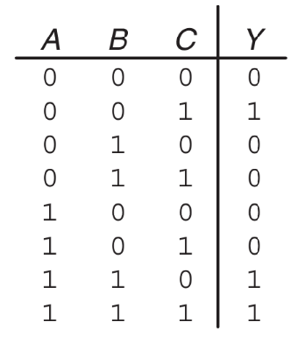Write Boolean equations in (a) sum-of-products and (b) product-of-sums canonical form for the truth table in Figure 1.

Y = A’B’C +ABC+ABC’

Y = (A+B+C)(A+B’+C)(A+B’+C’)(A’+B+C)(A’+B+C’)

（2）Minimize the Boolean equations from (1)

Y = A’B’C +AB

(3) Sketch a reasonably simple combinational circuit implementing the function from (2).

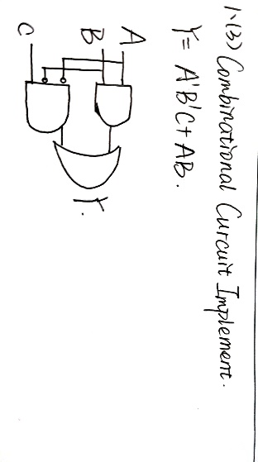

1. Simplify the following Boolean equations using Boolean theorems.

(1) (2) (2) 

(3) (4)

(5) (6)

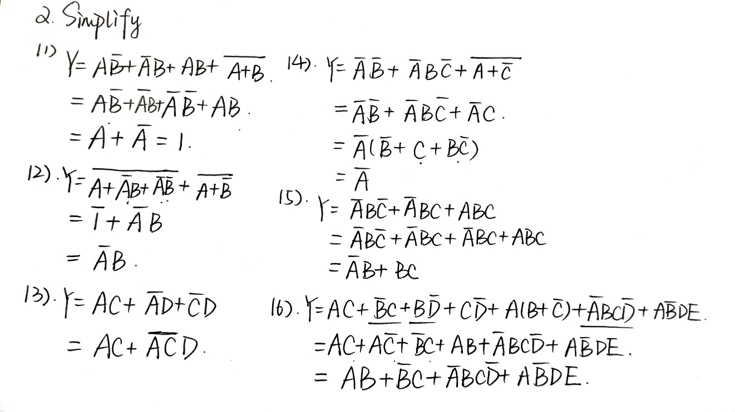



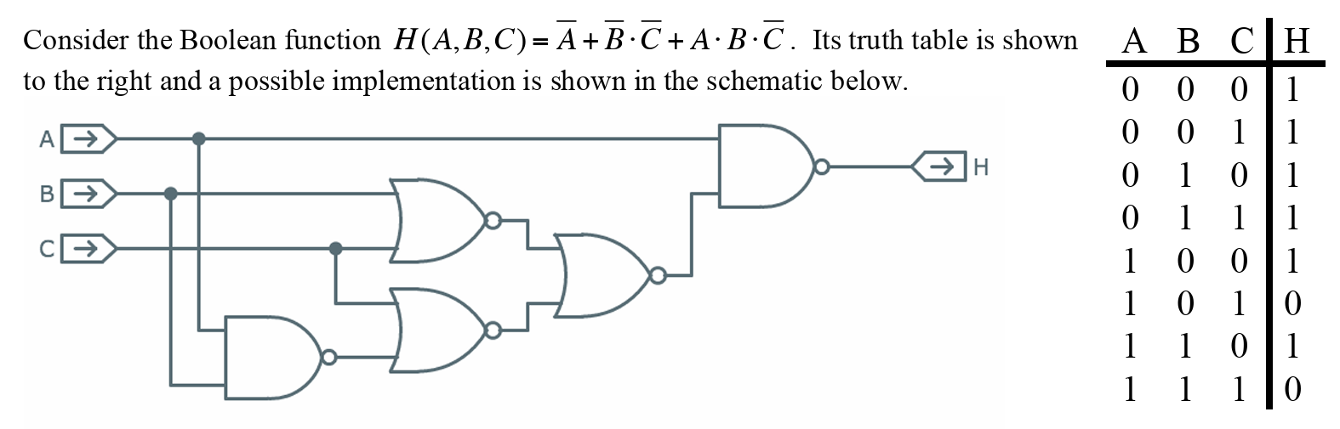

1. Give a minimal sum-of-products expression for H. A couple of scratch 3-input Karnaugh map templates are provided for your convenience.

**minimal sum-of-products expression for H: ___A’+C’___**

|  |  |  |  |  |  |  |  |  |  |  |
| --- | --- | --- | --- | --- | --- | --- | --- | --- | --- | --- |
|  | 00 | 01 | 11 | 10 |  |  | 00 | 01 | 11 | 10 |
| 0 | 1 | 1 | 1 | 1 | 0 | 1 | 1 | 1 | 1 |
| 1 | 1 | 1 | 0 | 0 | 1 | 1 | 1 | 0 | 0 |

1. What is the largest number of product terms possible in a minimal sum-of-products expression for a 3-input, 1-output Boolean function?

**Largest number of product terms possible: ____4____**

|  |  |  |  |  |
| --- | --- | --- | --- | --- |
|  | 00 | 01 | 11 | 10 |
| 0 | 1 | 0 | 1 | 0 |
| 1 | 0 | 1 | 0 | 1 |

1. Find a minimal Boolean equation for the function in Figure blow. Remember to take advantage of the don’t care entries.

 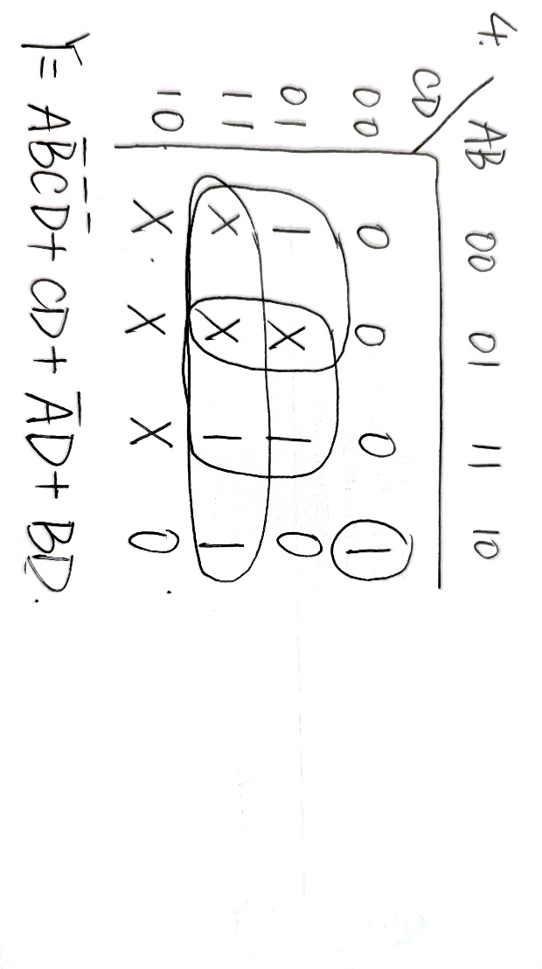

1. A gate or set of gates is universal if it can be used to construct any Boolean function. For example, the set {AND, OR, NOT} is universal.

(1) Is a AND gate by itself universal? Why or why not?

(2) Is a NAND gate by itself universal? Why or why not?

1. AND gates are not universal. Reason: Using AND gates alone cannot get all Boolean functions, especially the logical NOT operation. For example, if the input is A, the output of the AND gate is always A or 0. So, u can never get A’ by only AND. Since NOT is the basis for building other logic gates (such as OR and NAND), its absence means that all possible Boolean functions cannot be combined.
2. NAND gates can implement all basic logic operations (NOT, AND, OR) by combination, thus constructing any Boolean function. NOT: A NAND A. AND: (A NAND B) NAND (A NAND B). OR: (A’B’)’
3. A minority gate has three inputs (call them A, B, C) and one output (call it Y). The output will be 0 if two or more of the inputs are 1, and 1 if two or more of the inputs are 0.

(1). Give a *minimal* **sum-of-products** Boolean expression for the minority gates output Y, in terms of its three inputs A, B, and C.

|  |  |  |  |  |
| --- | --- | --- | --- | --- |
|  | 00 | 01 | 11 | 10 |
| 0 | 1 | 1 | 0 | 1 |
| 1 | 0 | 0 | 0 | 1 |

**Minimal SOP expression: Y = ________AB’+A’C’_________**

(2). Is a minority gate **universal**, in the sense that using only minority gates (along with constants 0 and 1) its possible to implement arbitrary combinational logic functions?

YES. To achieve NOT, we can use input (0,1,A). To achieve AND, we can use input NAND Y0=(A,B,0),and later use NOT(Y0).To achieve OR, we use NAND(NOT(A),NOT(B))

1. Using De Morgan equivalent gates and bubble pushing methods, redraw the circuit in Figure below so that you can find the Boolean equation by inspection. Write the Boolean equation.

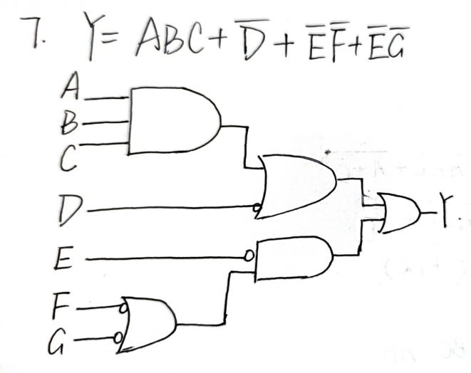

1. Write a minimized Boolean equation for the function performed by the circuit in the Figure.

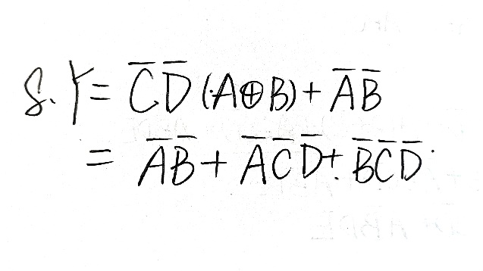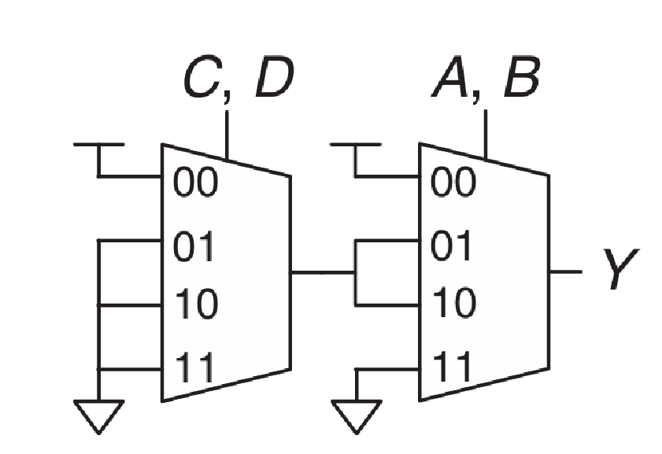

1. **Two level logic**
2. Write Boolean equations for the circuit in Figure blow. You need NOT minimize the equations.
3. Minimize the Boolean equations you get from (1) and sketch an improved circuit with the same function.

 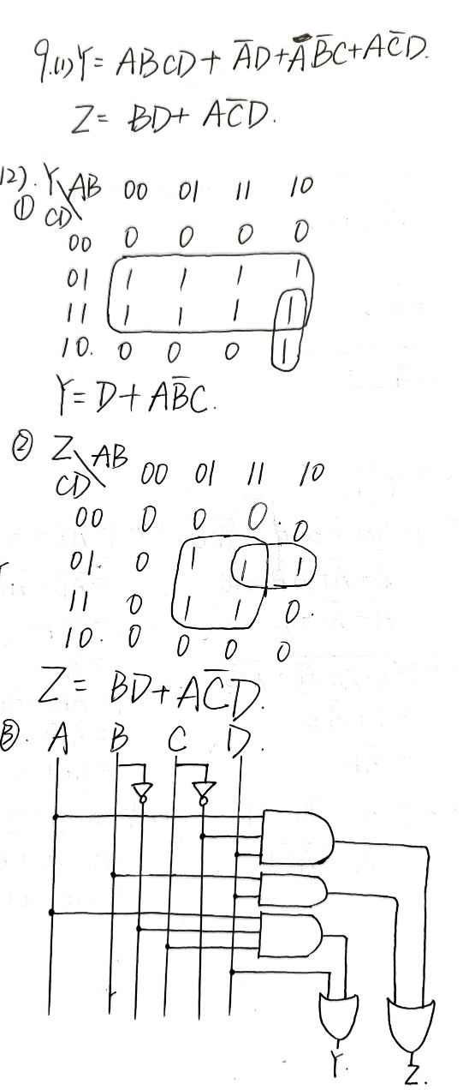 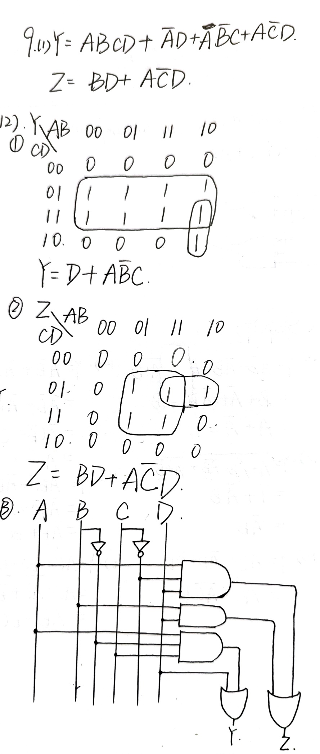

1. Boolean equation simplification

(1) Simplify the Boolean equation: 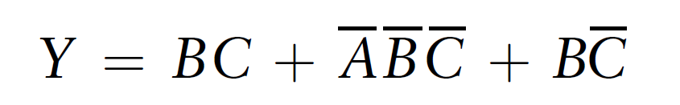

(2) Implement the function using an 8:1 multiplexer

(3) a 4:1 multiplexer and no other gates

(4) a 2:1 multiplexer, one OR gate, and an inverter

