1.Given the input waveforms shown in Figure blow, sketch the output *Q_latch* of a D latch, and output Q_ff of a D flip-flop

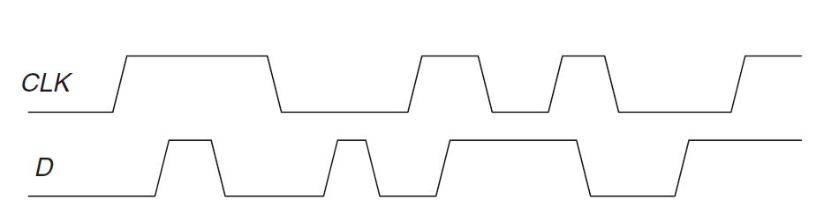

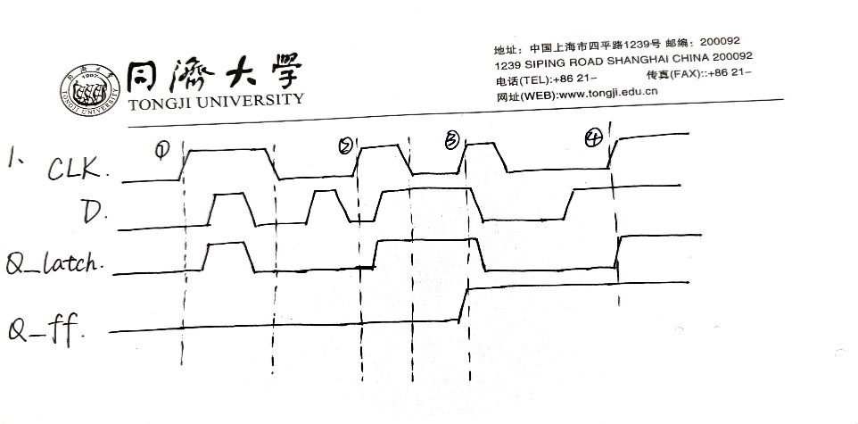

2.The *toggle* (*T*) *flip-flop* has one input, *CLK*, and one output, *Q*. On each rising edge of *CLK*, *Q* toggles to the complement of its previous value.Draw a schematic for a T flip-flop using a D flip-flop and an inverter.

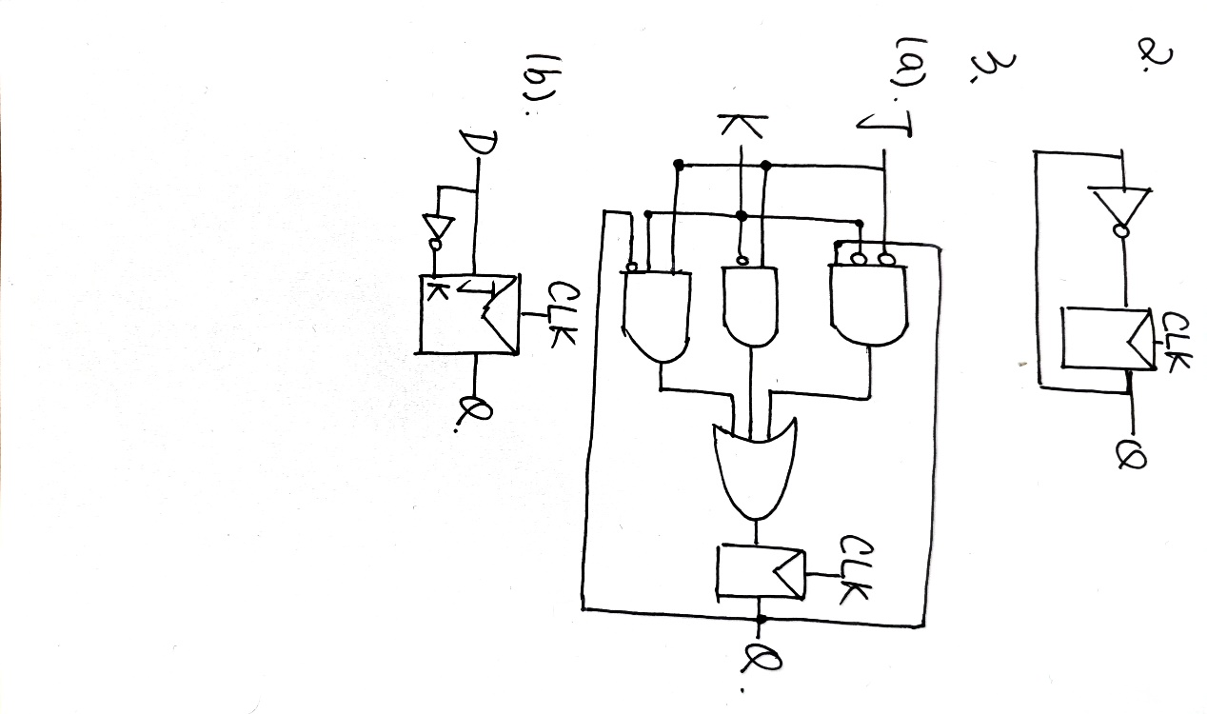

3.A JK flip-flop receives a clock and two inputs, J and K. On the rising edge of the clock, it updates the output, Q. If J and K are both 0, Q retains its old value. If only J is 1, Q becomes 1. If only K is 1, Q becomes 0. If both J and K are 1, Q becomes the opposite of its present state.

(a) Construct a JK flip-flop, using a D flip-flop and some combinational logic.

(b) Construct a D flip-flop, using a JK flip-flop and some combinational logic.

