**FSM-1**

Sketch the state transition diagram for the FSM described by the following HDL code. An FSM of this nature is used in a branch predictor on some microprocessors.

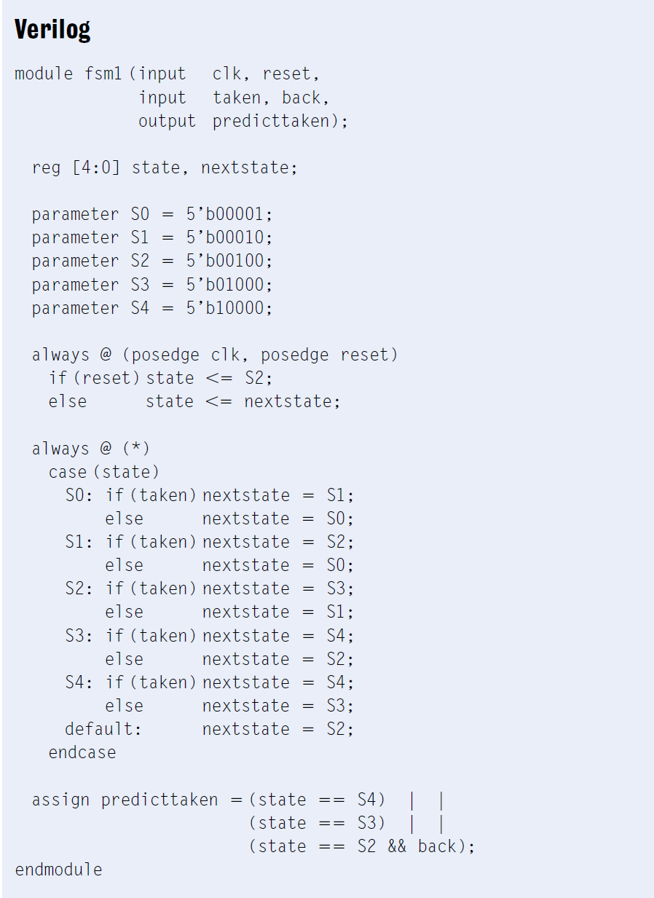

**FSM-2**

Alyssa P. Hacker’s snail has a daughter with a Mealy machine FSM brain. The daughter snail smiles whenever she slides over the pattern 1101 or the pattern 1110. Sketch the state transition diagram for this happy snail using as few states as possible. Write Verilog code(including testbench) for this FSM, run simulation to verify you design.

**FSM-3**

(1). Gray codes have a useful property in that consecutive numbers differ in only a single bit position. Table blow lists a 3-bit Gray code representing the numbers 0 to 7. Design a 3-bit modulo 8 Gray code counter FSM with no data inputs and three outputs. (A modulo *N* counter counts from 0 to *N* − 1, then repeats. For example, a watch uses a modulo 60 counter for the minutes and seconds that counts from 0 to 59.) When reset, the output should be 000. On each clock edge, the output should advance to the next Gray code. After reaching 100, it should repeat with 000. Draw state transition diagram for this FSM.

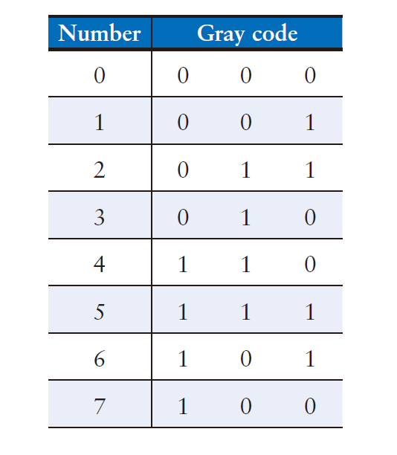

(2). Extend your modulo 8 Gray code counter to be an UP/DOWN counter by adding an UP input. If UP = 1, the counter advances to the next number. If UP = 0, the counter retreats to the previous number. write Verilog code and testbench for this FSM, compile and simulate your design.

4. Timing

A field programmable gate array (FPGA) uses configurable logic blocks (CLBs) rather than logic gates to implement combinational logic. The Xilinx Spartan 3 FPGA has propagation and contamination delays of 0.61 and 0.30 ns, respectively, for each CLB. It also contains flip-flops with propagation and contamination delays of 0.72 and 0.50 ns, and setup and hold times of 0.53 and 0 ns, respectively.

(a) If you are building a system that needs to run at 40 MHz, how many consecutive CLBs can you use between two flip-flops? Assume there is no clock skew and no delay through wires between CLBs.

(b) Suppose that all paths between flip-flops pass through at least one CLB. How much clock skew can the FPGA have without violating the hold time?