OWC Primary Enrollment Data
Manual Business Process Report & Step-by-Step Procedure

The Source
This manual business process report serves as a data source used for updating the enrollment_data table (data source: "primary_school_enrollment.csv") on the OWC dashboards. It contains sources such as county, district, school, race, gender, and grade tracing back to a single source: the Oklahoma State Department of Education's public website, where the state publishes enrollment totals reported by schools each year.
Source: Oklahoma State Department of Education
https://oklahoma.gov/education/services/student-information/state-public-enrollment-totals.html
Business Process Steps:
Step 1. Go visit oklahoma.gov website:
https://oklahoma.gov/education/services/student-information/state-public-enrollment-totals.html
Step 2. Under State Public Enrollments Total, find FY 2024-2025 or any desired year. Select Click here. Once opened, go to File -> Create a copy -> Download a copy. This will download a copy to your computer.
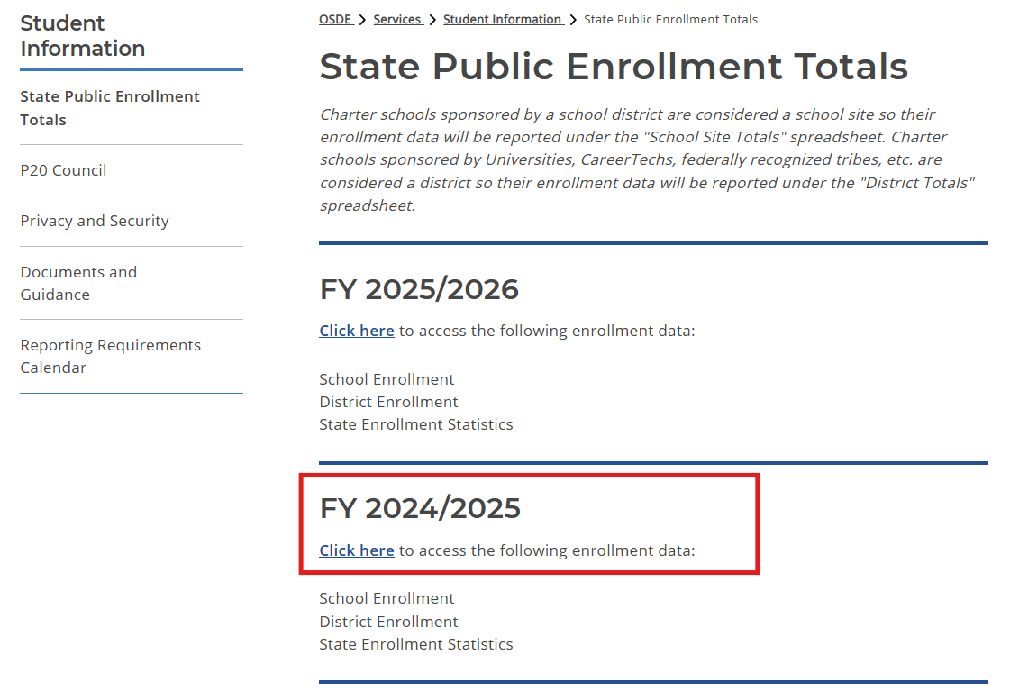

Step 3. Next, in FY 2025-2026. Once opened, go to File -> Create a copy -> Download a copy. This will also download a copy to your computer.
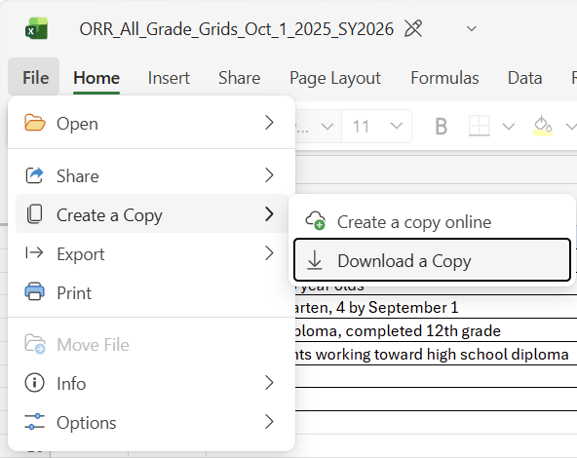
Step 4. Next, open a blank excel spreadsheet or Google spreadsheet. Then also open "ORR ALL Grids Oct 1 2024 SY2025_Format(School Totals by Race).csv". Copy and paste all data from “School Totals by Race” page in "ORR ALL Grids Oct 1 2024 SY2025_Format(School Totals by Race).csv". to the blank spreadsheet.
Step 5. From “School Totals by Race” page, rearranged the columns by SchoolYear, County, District, School, His M, His F, AmInd, AmInd F, Asian M, Asian F, Black M, Black F, Pac Is M, Pac Is F, White M, White F, Multi M, Multi F, Grade.
Step 6. Delete all unused columns that is not listed above.
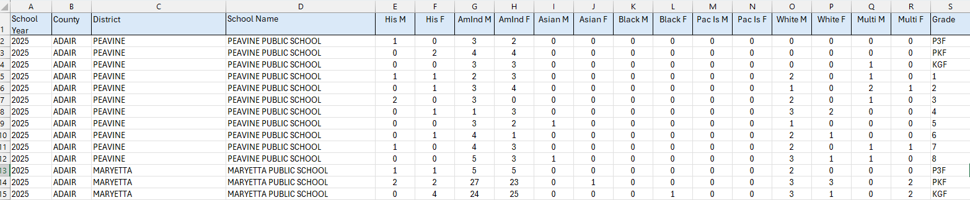
Step 7. Repeat steps 4 to 7 for FY 2025-2026 as well.
Step 8. Next, go ahead merge both blank xlsx files that was rearranged and renamed as "primary_enrollment_data". Save as .csv file. (NOTE: Ensure the last row of the table is deleted. This is the total of race and gender which is not needed.)
Step 9. Next, with an AI agent (I use Claude AI) under add files. Drop "primary_enrollment_data.csv" into the chatbox. Tell the agent to unpivoted the 14 race/gender columns into two new columns called "Race" and "Gender" with counts in a single column called "Total", while keeping School Year, County, District, School Name, and Grade intact.
Step 10. Once completed download that unpivoted .csv file.
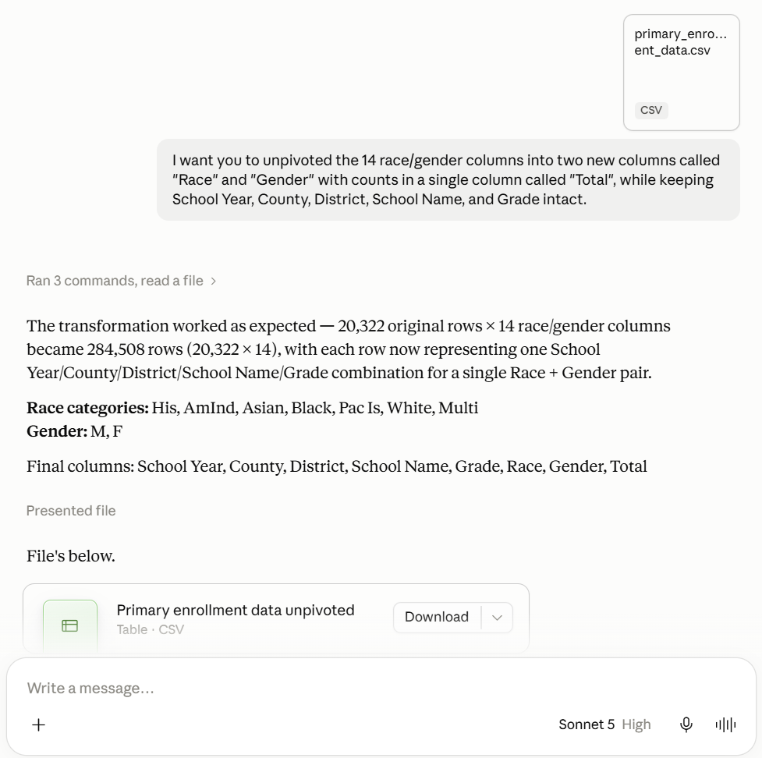
Step 11. Repeat steps 9 and 10 for "primary_enrollment_data.csv". (if needing additional school years.)
Step 12. Once the files are unpivoted, open the unpivoted .csv file(s) you have created.
Step 13. Next, for column School Year renamed the column title "Year". Do the same to column School Name to "School". (NOTE: This aligns the same headers from the original .csv file.)
Step 14. Next click Edit in the top menu, and select Find and replace (or press Ctrl + H on Windows or ⌘ + Shift + H on Mac). Then on "Find" type 2025 for "Replace with" type 2024-2025. For "Search" dropdown click on This sheet. Next check "Match entire cell contents". Once finished, click "Replace All". Then click "Done". Do the same for 2026 to 2025-2026.
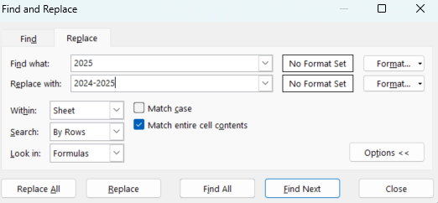
Step 15. Next, go back and highlight column Grade then click Edit in the top menu, and select Find and replace (or press Ctrl + H on Windows or ⌘ + Shift + H on Mac). Then on "Find" type P3F for "Replace with" type Pre-Kindergarten. Do the same for P3H, PKF, and PKH. For "Search" dropdown it should automatically display your highlighted column range. Next check "Match entire cell contents". Once finished, click "Replace All". Repeat the same process and rename all values such as KGF and KGH to Kindergarten, 1 or 01 to 1st Grade, and so on to 12 to 12th Grade. Do the same for Race Column, if race is ‘His’ turn to Hispanic.
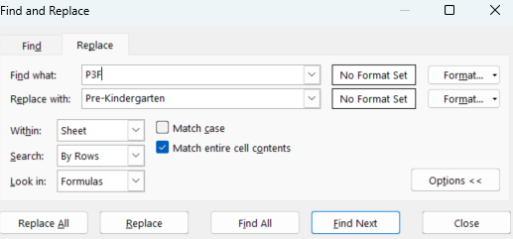
Step 16. If any column rows are not mentioned above, find and replace those values to Others. If row are blank, find and replaced as UNKNOWN.
Step 17. Next, save the unpivoted csv file as "primary_enrollment_data.csv".
Step 18. OPTIONAL: Next, merge and stack the original primary_enrollment_data.csv with new primary_enrollment_data.csv. This will consolidate as one main file.
Step 19. Once completed, export this file into the enrollment data table in OWC dashboard.
Step 20. With that all steps are completed.

