CARBON CREATIONS TOKEN  
  
  
NETWORK\_RPC\_URL=

<https://rpc.ankr.com/polygon/d9c6ea20518db31f4dbaf0bfe06973594398df5b26203fba08a41b5223349d30>

PRIVATE\_KEY= 88dedca51a7dcef7ddadc8d76bf1e218679e667258a21dc576165b2e8bb6eda6

#### Token Contract (WITH **18** Decimals)

[0x6b9358109cc8af590f7df64045bc52ddfb37279d](https://polygonscan.com/address/0x6b9358109cc8af590f7df64045bc52ddfb37279d)

POLYGONSCAN\_API\_KEY= MT6PJTPWFKKQHHXFTGWP9X75GX6TBRQMS5  
  
  
POL\_ADDRESS = 0xEB174c859047580dCb4Bf5043D75E596e0c1975e

USDT\_ADDRESS = 0xEB174c859047580dCb4Bf5043D75E596e0c1975e

USDC\_ADDRESS = 0xEB174c859047580dCb4Bf5043D75E596e0c1975e

TOKEN DETAILS

NEXT\_PUBLIC\_TOKEN\_NAME = CARBON CREATIONS TOKEN  
NEXT\_PUBLIC\_TOKEN\_SYMBOL = CCT  
NEXT\_PUBLIC\_TOKEN\_DECIMAL = 18  
NEXT\_PUBLIC\_TOKEN\_SUPPLY = 1000000000  
NEXT\_PUBLIC\_PER\_TOKEN\_USD\_PRICE = 0.001  
NEXT\_PUBLIC\_NEXT\_PER\_TOKEN\_USD\_PRICE = 0.002  
NEXT\_PUBLIC\_NEXT\_STABLE\_PRICE =

Hostinger LOGIN Information  
  
EMAIL -- [carboncreations5566@gmail.com](mailto:carboncreations5566@gmail.com" \t "https://keep.google.com/u/0/" \l "NOTE/_blank)  
PASSWORD--- @C1c2c3c4c5@  
DOMAINS --- [carboncreations.cloud](http://carboncreations.cloud/" \t "https://keep.google.com/u/0/" \l "NOTE/_blank)  
Hosting --- buy it for as per requirement.

<https://formspree.io/forms>

EMAIL -- [carboncreations5566@gmail.com](mailto:carboncreations5566@gmail.com" \t "https://keep.google.com/u/0/" \l "NOTE/_blank)  
PASSWORD--- @C1c2c3c4c5@  
  
  
[https://polygonscan.com/myaccount](https://polygonscan.com/myaccount" \t "https://keep.google.com/u/0/" \l "NOTE/_blank)   
USER NAME-- carboncreations  
EMAIL -- [carboncreationsorg@gmail.com](mailto:carboncreationsorg@gmail.com" \t "https://keep.google.com/u/0/" \l "NOTE/_blank)  
PASSWORD--- @C1c2c3c4c5@

CARBON CREATIONS TOKEN

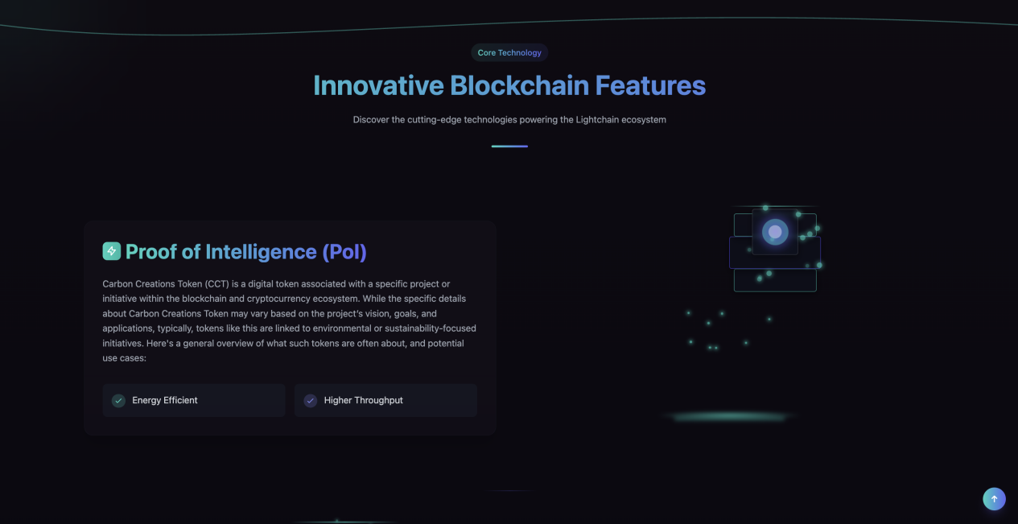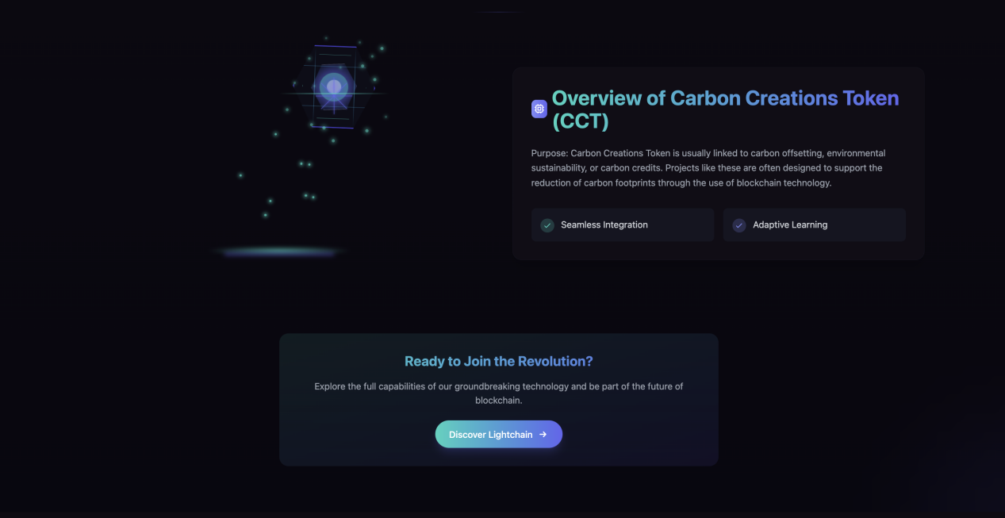  
  
Introduction   
Carbon Creations Token (CCT) is a digital token associated with a specific project or initiative within the blockchain and cryptocurrency ecosystem. While the specific details about Carbon Creations Token may vary based on the project’s vision, goals, and applications, typically, tokens like this are linked to environmental or sustainability-focused initiatives. Here's a general overview of what such tokens are often about, and potential use cases:  
  
Overview of Carbon Creations Token (CCT):  
- Purpose: Carbon Creations Token is usually linked to carbon offsetting, environmental sustainability, or carbon credits. Projects like these are often designed to support the reduction of carbon footprints through the use of blockchain technology.

- Blockchain Integration: Like other utility or security tokens, CCT would likely be built on a popular blockchain like Ethereum or Binance Smart Chain (BSC) for easy integration with decentralized applications (dApps).  
  
- Environmental Focus: The token could serve as a means to participate in carbon credits markets, with an aim to help combat climate change, facilitate the reduction of greenhouse gas emissions, and promote sustainable practices.  
  
Market Impact:  
- Partnerships: Carbon-related tokens like CCT can forge partnerships with carbon offset projects, environmental NGOs, or governments. These partnerships would ensure the token has real-world value in environmental efforts.  
  
- Green Investment Opportunities: CCT might appeal to investors looking for eco-friendly projects and cryptocurrencies that support sustainability, potentially drawing attention to the growing green finance sector.

Possible Advantages of Carbon Creations Token:  
- Environmental Impact: Encourages businesses and individuals to actively contribute to reducing carbon emissions.

- Incentivized Participation: Rewards users for taking sustainable actions, creating a positive feedback loop for green behavior.  
  
- Utility and Staking: If the project allows, staking your CCT tokens may earn rewards in the form of additional tokens or environmental credits.  
  
Conclusion:  
Carbon Creations Token (CCT) could represent a promising intersection between cryptocurrency and sustainability, providing both environmental benefits and investment opportunities. By using blockchain technology to help tackle climate change and make carbon offsetting more accessible, CCT has the potential to drive meaningful environmental impact while offering users a way to participate in the growing green finance sector.  
  
  
  
How to Buy-- [https://linktum.gitbook.io/linktum/linktum-docs/publish-your-docs](https://linktum.gitbook.io/linktum/linktum-docs/publish-your-docs" \t "https://keep.google.com/u/0/" \l "NOTE/_blank) \*\*\* change as per linkum Ai to CCT   
  
  
Import Token-- [https://linktum.gitbook.io/linktum/import-token](https://linktum.gitbook.io/linktum/import-token" \t "https://keep.google.com/u/0/" \l "NOTE/_blank) \*\*\* change as per linkum Ai to CCT

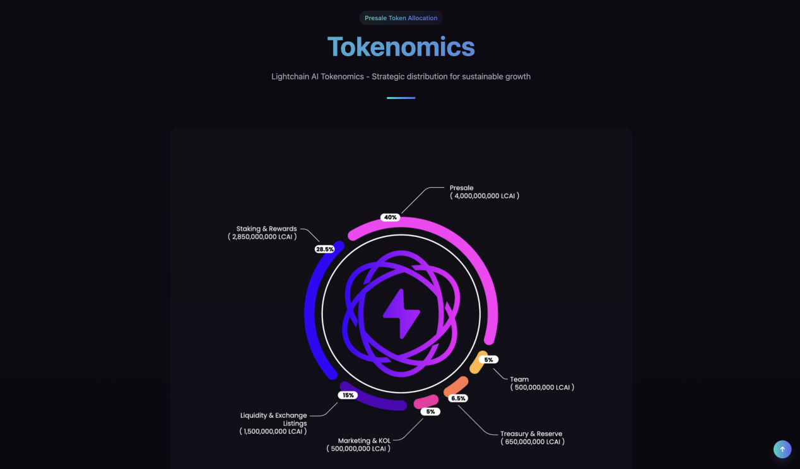Tokenomics CARBON CREATIONS TOKEN  
  
Crypto Tokenomics Distribution help provide a clear structure for how tokens will be distributed and allocated within a cryptocurrency project. Tokenomics is critical in ensuring the long-term success of a project by properly managing the distribution and usage of tokens.  
  
Crypto Tokenomics Distribution  
  
1. Total Token Supply: 1,000,000,000 CCT Token   
2. Token Allocation   
(Allocate the tokens into different categories based on your project's priorities. These percentages should add up to 100%.)

Category | Percentage (for the total supply)   
  
Founders & Team | 15%   
  
Advisors & Partners | 5%   
  
Public Sale | 40%   
  
Staking/Rewards | 15%   
  
Liquidity Pool (Exchanges) | 10%   
  
Ecosystem / Reserve | 10%   
  
Marketing & Development | 5%   
  
Note: Adjust the numbers as per your specific project needs. Some projects may allocate a larger portion to certain categories like rewards, liquidity, or ecosystem partnerships.…

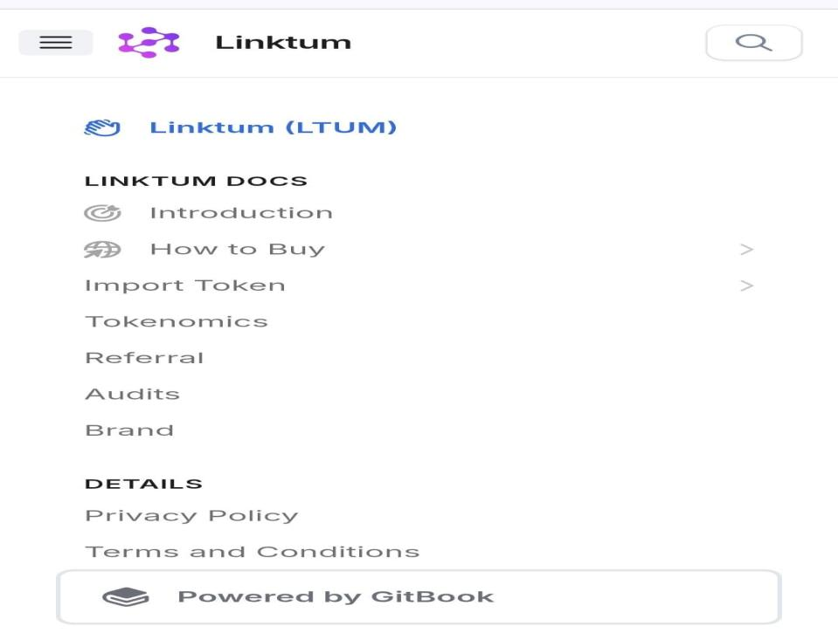

Referral-- [https://linktum.gitbook.io/linktum/referral](https://linktum.gitbook.io/linktum/referral" \t "https://keep.google.com/u/0/" \l "NOTE/_blank) \*\*\* change as per linkum Ai to CCT   
  
Audits -- [https://linktum.gitbook.io/linktum/audits](https://linktum.gitbook.io/linktum/audits" \t "https://keep.google.com/u/0/" \l "NOTE/_blank) \*\*\* change as per linkum Ai to CCT   
  
  
Brand -- [https://linktum.gitbook.io/linktum/brand](https://linktum.gitbook.io/linktum/brand" \t "https://keep.google.com/u/0/" \l "NOTE/_blank) \*\*\* change as per linkum Ai to CCT

Details Privacy Policy --- [https://linktum.gitbook.io/linktum/details/privacy-policy](https://linktum.gitbook.io/linktum/details/privacy-policy" \t "https://keep.google.com/u/0/" \l "NOTE/_blank) \*\*\* change as per linkum Ai to CCT   
  
  
Terms and Conditions [https://linktum.gitbook.io/linktum/details/terms-and-conditions](https://linktum.gitbook.io/linktum/details/terms-and-conditions" \t "https://keep.google.com/u/0/" \l "NOTE/_blank) \*\*\* change as per linkum Ai to CCT

**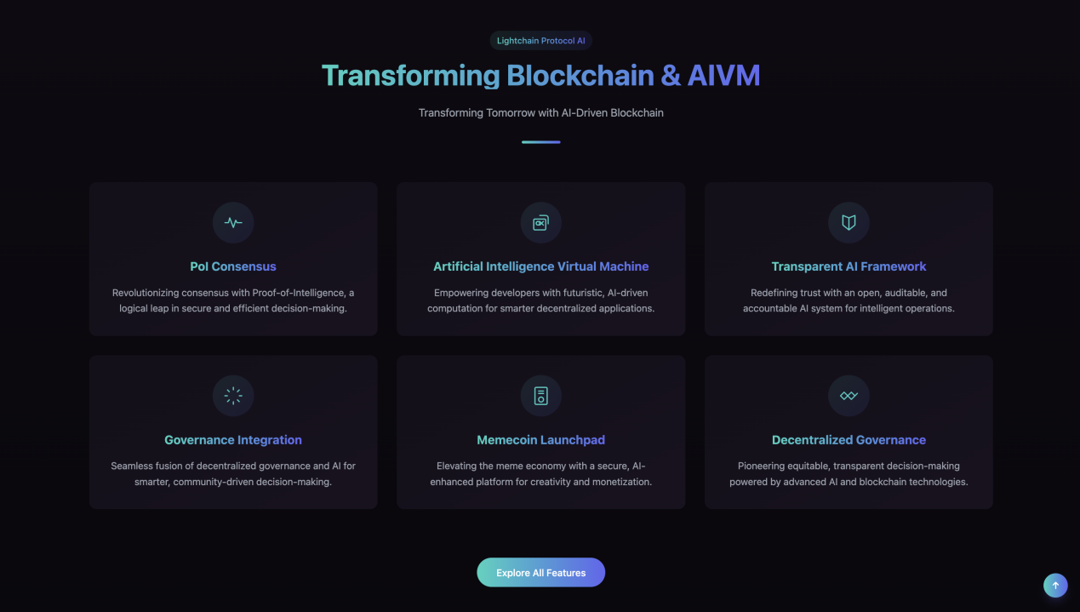  
Blockchain and Carbon Project Transformation**

**1/ Carbon Creations Platform Development**

**Join us in the sustainability revolution with the Carbon Credit Marketplace - where every transaction counts towards a greener future!**

**2/ Carbon Creations Marketplace Key Features**

**This expansive ecosystem is designed to drive positive environmental impact and build a global commitment to sustainability.**

**3/ Scalability and Integration**

**Designed for scalability to accommodate the growth of sustainability initiatives. It integrates seamlessly with other systems.**

**4/ Mobile Compatibility**

**Allows users to participate in the Carbon Creations ecosystem from anywhere.**

**5/ MemeCoin Launchpad**

**Elevating the meme economy through a secure, AI-enhanced platform for creativity and monetization.**

**6/ Decentralized Governance**

**Advancing fair, transparent decision-making powered by advanced carbon ecosystems and blockchain technology.**  
  
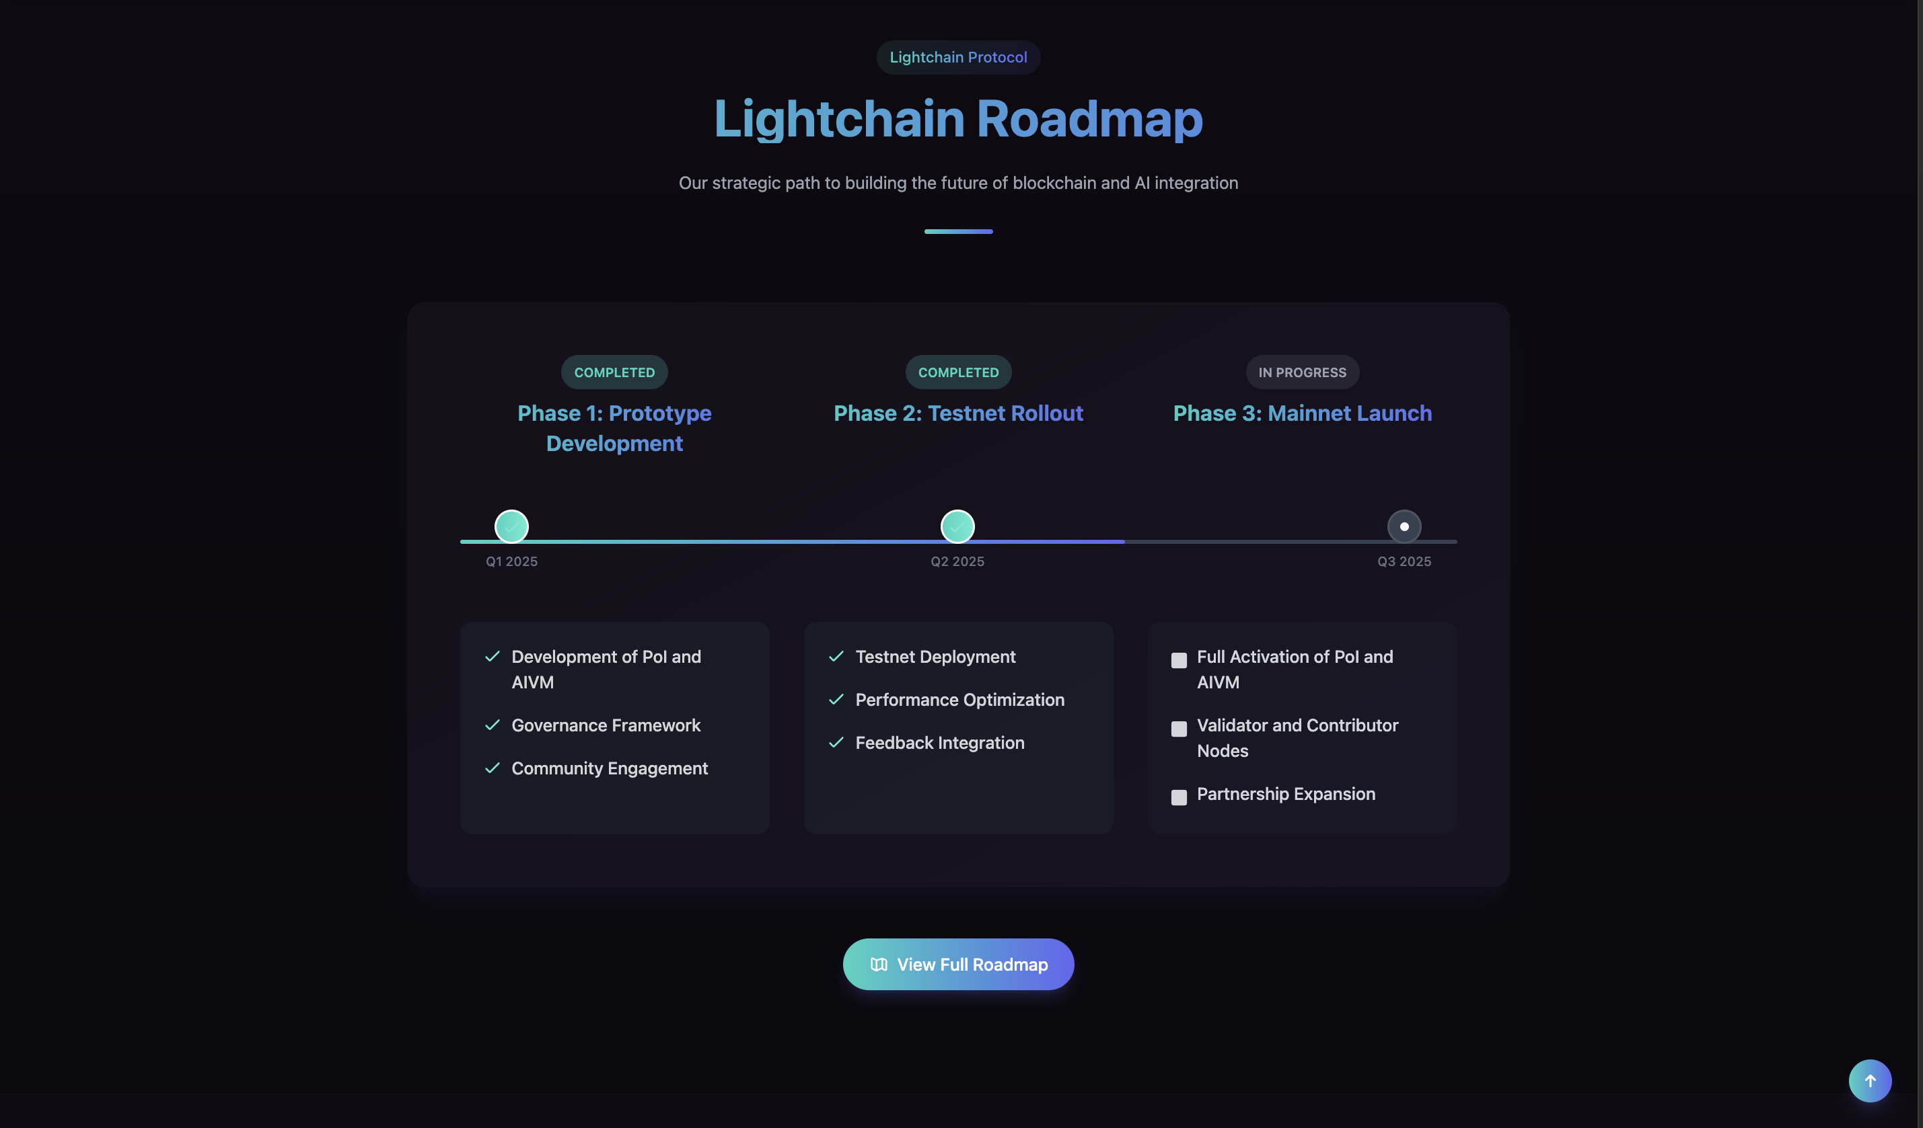

Roadmap\*  
: Roadmap for Carbon Creations Token  
  
🟢 Phase 1: Launch & Setup (Q2 2025)  
- Token smart contract deployment  
- Website & whitepaper live  
- Social media, community, and Telegram group  
  
🌍 Phase 2: Ecosystem Building (Q3 2025)  
- Launch Utility project   
- Staking platform live  
- CCT collection to support green projects  
  
💼 Phase 3: Global Access & Utility (Q4 2025)  
- DAO launch for community governance  
- Begin issuing blockchain verified carbon credits   
- Listings on centralized exchanges (CEX)  
  
🌐 Phase 4: Expansion & Sustainability (Q1 2026)  
- Integrate with climate NGOs and sustainability orgs  
- Launch Carbon Market analytics platform  
- Expand utility (debit card integration, carbon farming)  
- Cross-chain bridge for multi-chain support

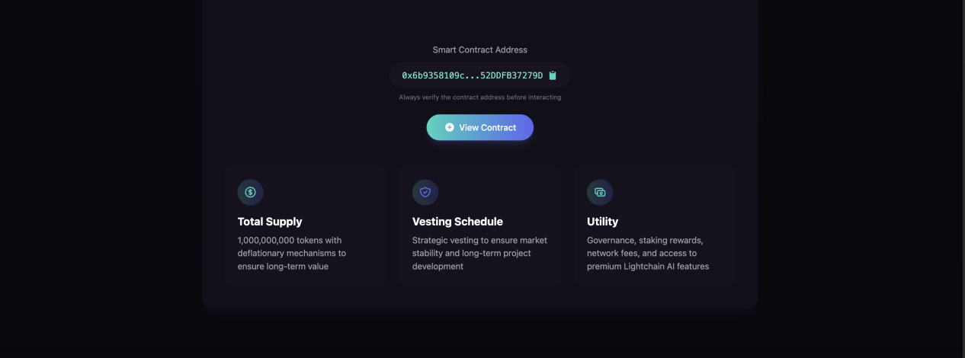  
  
Total Supply  
10,000,000,000 tokens with deflationary mechanisms to ensure long-term value  
  
Utility  
Governance, staking rewards, network fees, and access to premium The Blockchain features

Buy / Staking Information CCT Token  
  
Min Buy Amount: 50 $  
Min Stake Amount: 50000 CCT   
  
APY Boosters / Base APY Started : 10%- 30%  
30 Days Lock Bonus -10%  
90 Days Lock Bonus -15%  
180 Days Lock Bonus -20%  
365 Days Lock Bonus -30%  
  
Staked tokens are locked for the selected period and cannot be withdrawn early. Rewards can be harvested at any time. After the lock period ends, you can unstake your tokens or keep them staked to continue earning rewards at the base APY rate.

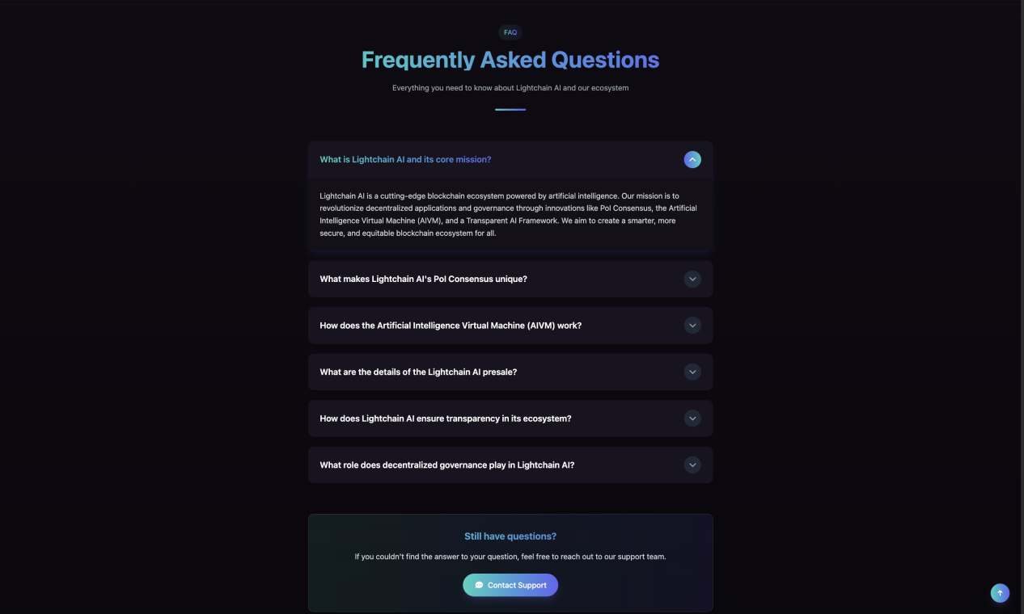

🌿 Carbon Creations Token (CCT) – Frequently Asked Questions

❓ What is Carbon Creations Token (CCT)?

Carbon Creations Token (CCT) is a blockchain-based utility token designed to support verified carbon offset initiatives and sustainable development projects by providing transparent and decentralized funding and tracking.

---

❓ What is the purpose of CCT?

CCT aims to:

- Empower eco-conscious individuals and organizations

- Tokenize and trade verified carbon credits

- Fund real-world renewable energy and sustainability projects

- Build a green economy using blockchain transparency

---

❓ Is CCT backed by real-world carbon credits?

Yes. CCT supports real-world carbon offset projects such as solar power, reforestation, and waste management, aligning with verified carbon standards (e.g., VCS, Gold Standard).

---

❓ On which blockchain is CCT deployed?

Carbon Creations Token is deployed on Polygon , offering fast, low-cost transactions and EVM compatibility.

---

❓ How can I buy CCT?

You can participate in the presale or public launch via: Carbon Creations Presale Page

- Supported with wallets like MetaMask and Trust Wallet

---

❓ Is staking available for CCT?

Yes. CCT holders can stake tokens to earn rewards while supporting long-term project sustainability.

---

❓ How does Carbon Creations fight greenwashing?

By using blockchain-based proof and partnering only with verified and audited carbon offset projects, we ensure transparency, accountability, and traceability.

---

❓ What wallets support CCT?

Any EVM-compatible wallet supports CCT, including:

- MetaMask

- Trust Wallet

---

❓ Where can I find more information?

- Website: [carboncreations.cloud](http://carboncreations.cloud/" \t "https://keep.google.com/u/0/" \l "NOTE/_blank)

- Twitter: https://x.com/CarbonCreation\_

- Support: [carboncreationsorg@gmail.com](mailto:carboncreationsorg@gmail.com" \t "https://keep.google.com/u/0/" \l "NOTE/_blank)

Follow Me:  
  
Facebook: https://www.facebook.com/CarbonCreationsorg  
Twitter: https://x.com/CarbonCreation\_  
Youtube https://www.youtube.com/@CarbonCreationsHelpline  
EMAIL -- [carboncreationsorg@gmail.com](mailto:carboncreationsorg@gmail.com" \t "https://keep.google.com/u/0/" \l "NOTE/_blank)