ENPRESA

# ENPRESA

## IZENA

iPNGames

## KOKAPENA

[Calle Prim, 34-38, 20006 San Sebastián, Guipúzcoa](https://www.google.es/maps/dir/Calle+Prim,+34-38,+20006+San+Sebasti%C3%A1n,+Guip%C3%BAzcoa/@43.3144481,-1.9821944,17z/data=!4m9!4m8!1m0!1m5!1m1!1s0xd51a557a50adea7:0x39cd49b95dca4536!2m2!1d-1.9801279!2d43.3143376!3e4)

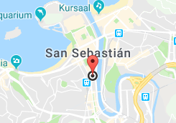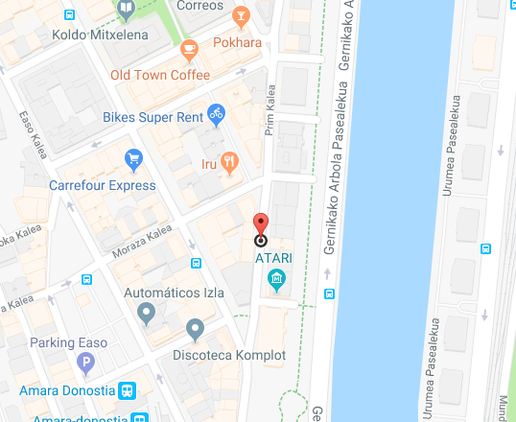

## AKTIBITATEA

# LOGOTIPOA

# LANGILE KOPURUA

# LANTOKIKO PLANOA