**What are the strengths of your company? Feel free to describe market demands that are addressed, any innovative market angles your company has taken, any financial successes or potential, or any areas of team technical expertise that can be leveraged in your product.**

Market demand:

* Companies do want to recycle and they are willing to spend money on it. Why are they drive to recycle? The answer is twofold.
  + Many of them have worldwide ESG goals that are driving them to increase the amount of recycled content in their packaging and products. For example, Unilever has pledged to increase their 11% recycled plastic per product to 25% by 2025.*
  + The other reason is that countries all over the world are beginning to implement laws that levy a tax on companies that do not handle the full lifecycle of their products, from production, to collection, to recycling.
* So what is the reason they don’t recycle as much as they could?
* Currently, recycling trucks, if available in cities, collect all recyclables together, compress it and taking to a sorting center, where people, like we saw before in the pictures, have to separate it manually.
  + This process reduces total volume collected, reduces worker safety, and increases costs.

Financial success metrics:

* Together, we have finalized contracts with 9 companies across Argentina to run a pilot program during the next 18 months in partnership with the Argentinian University of Saint Louis.
* We are partnering with them to collaborate with NGOs and work on accessible material that we can use to increase the public knowledge of how to recycle.
* Our clients for this pilot include leading consumer product conglomerates such as Unilever, Nestle and P&G.
* The total budget for the project, including communication, is more than a million dollars, around $700k of which are for the platform. This is for 18 months, so in terms of annualized returns this would represent just under half a million dollars in ARR for the Recyco Platform.

Regarding the team and expertise:

* My partner Cristian is focused on the operations side of the business, He founded a recycling logistics company two decades ago which he has been operating ever since and has done consulting work for companies such as Coca Cola, Kimberly-Clark and Pepsico in recycling projects.
* I am focused on the platform and the technology development. I am currently studying Computer Science and Statistics at Harvard. Before coming to college I worked as a software engineer at startups such as Satellogic and Rutd designing web-based platforms. In my two gap years before coming to college I worked in the Venture Capital industry as an associate.
* This combination has been specially useful in the past since Cristian’s network has allowed us to get warm introductions to clients, speak to industry experts to validate ideas, and my networks have allowed us to access developer talent that gets behind our company goals and wants to join the company.

**What are the weaknesses of your company?**

I would say that the biggest weakness is that the company is a SaaS business, which means differentiation is hard. Everything is software, which cannot be patented, so with enough money anyone can replicate your product.

**What is the competitive landscape of the market that your product lands in? Are there similar products to your own out there?**

Potential competitors are companies like Greener.Bio, but they have migrated to lower barrier to access markets, like that of online marketplaces for collection services. There are no more current competitors, at least in Argentina, that we could find.

**How would you best describe your revenue potential? Feel free to refer to past sales, new investments, etc.**

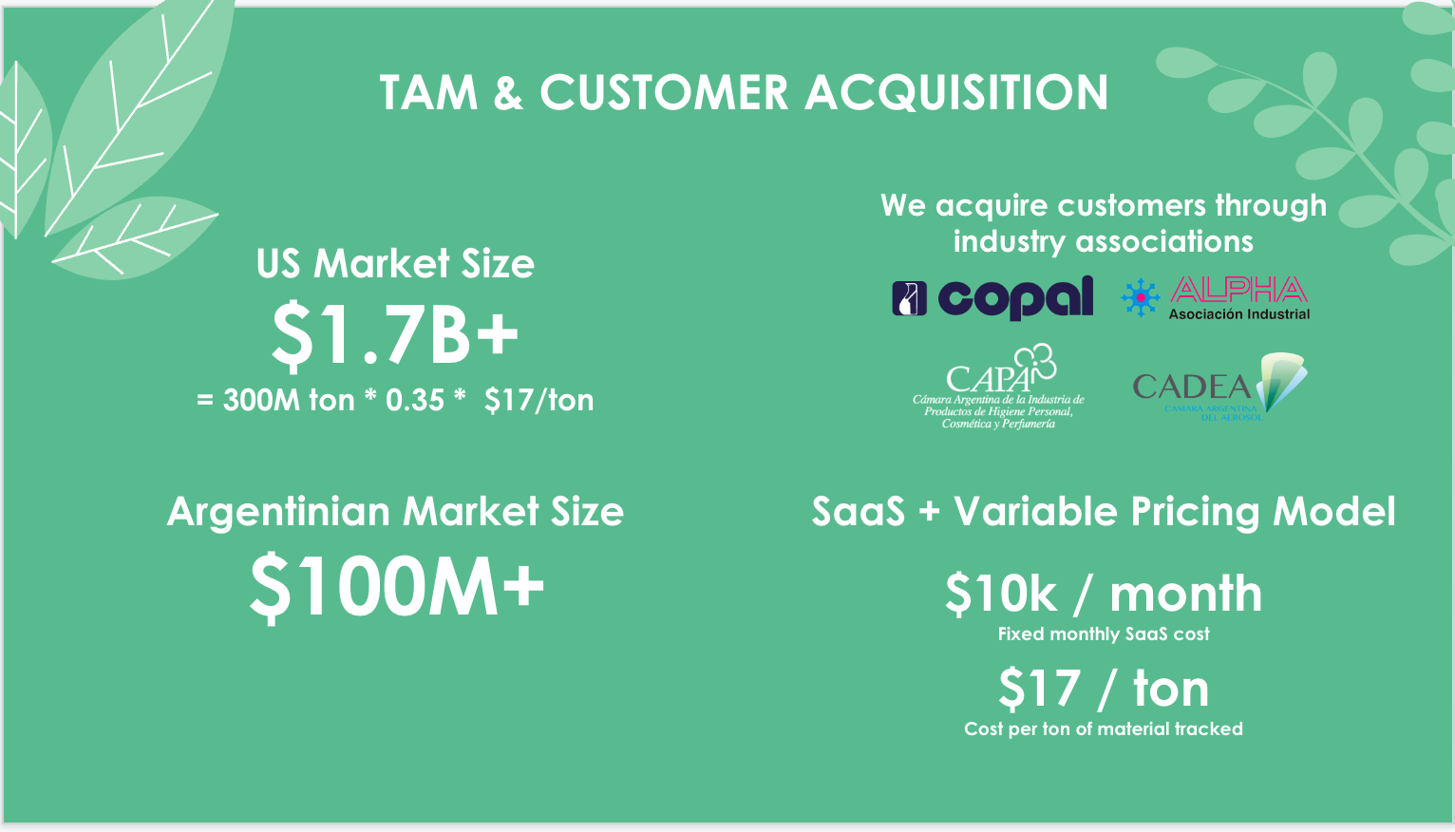

* So what is the total market size of this problem, and how can we grow our customer base within this market?
* We are currently targeting companies that have already allotted part of their budget to find innovative solutions to their PCR problems, but we’ve come to annual market sizes for Argentina and the US by using a bottoms up approach based on the number of tons recycled yearly and the price companies are willing to pay to track these.
* To reach these customers we have found that going through industry associations is the most time and cost effective way of gaining new clients.
  + We are typically referred to someone in the organization by one of our clients, who becomes a champion for our service within the association, and organizes for us to present to all the member companies.
  + In this way we spend very little money and time, and we are able to get warm intros to multiple potential customers which tend to convert most of the time.
  + These are upcoming associations which we may be partnering with, including the one for aerosol producers and the cosmetic industry.
* To these clients we currently price our platform with a mixture of SaaS and variable pricing. We charge a fixed monthly fee and then on top of that we charge per ton of plastic collected. In the future we would like to migrate to a purely variable cost pricing model since having a lower barrier to entry opens up the door for smaller companies that may not afford to pay the monthly SaaS fee to be able to offset their production.

**What are the next milestones / goals you have for the profitability and success of your company?**

Next milestone is to launch publicly in 5 cities. That will happen in April. After that launching out materials marketplace business unit would be the next milestone.

**What questions do you currently have about your own company ––whether financial, in terms of management, or structure, etc. –– that you would personally seek to address before seeking to advance your company to the next step or seek investment?**

I would probably like to validate the UX of the product and the incentives further. I am not sure that people will be willing to ask for their recyclables to be picked up from their doorstep.