Iñaki Arango

Richard T. Lee, M.D.

GENED 1053

07 October 2022

Healthy Living Challenge

I am an international student from Argentina. Having transferred recently from Rice University, my biggest challenge has been able to balance the development of healthy habits with academics and a social life.

# HEALTHY LIVING PROPOSAL

During the healthy living challenge, I focused on eating a good amount of food consistently and tried to sleep at the same time every day. I was not necessarily aiming to sleep early, but to do it at consistent times.

Last year I was extremely busy during the second semester, between transfer applications and trying to keep up with multiple weekly problem sets, so I was usually going to sleep between 4 AM and 7 AM, and waking up in the early afternoon. This “worked” for a while because I was more productive at night, but after a some time my body started asking for more and more hours of sleep, so even though I was going to sleep at the same time, I would wake up later.

Even though by the end I was sleeping the same amount of hours as I did in my first semester, my sleep schedule was completely misaligned with daylight, and I was feeling the physical effects it had on my body.

This semester I decided that the bases for a good social and academic life was to first get my eating and sleeping habits in check. After each meal I would take note of what I ate, the ingredients of the food, and the number of drinks consumed.

Initially I thought my biggest obstacle was going to be having enough time to eat on Monday, Wednesdays and Fridays, since I have class from 12 PM to 3 PM, and the dining hall closes at 2 PM. That means that I would normally not be able to have lunch on those three days, which represent the majority of my weekdays. To get around that, I would plan those three days so that I could be at 11:20 the the dining hall, and as soon as lunch opened at 11:30, I would be the first one inside. After eating for 20 minutes, I would go to class as quickly as I could. It is not optimal to eat that fast, but it was better than not eating.

# SUMMARY OF DATA COLLECTION

To track my progress in Excel, I created two sheets, one that included the food information mentioned in the section above, and one that had the time at which I went to sleep and woke up every day. I analyzed three aspects of my life after the two weeks: meal ingredients, distribution of drink types and how much I slept.

*Common meal ingredients.* Plotting what I ate per meal, weighted by the amount I consumed, it is apparent that I have a somewhat varied diet except for my high chicken consumption. Given that chicken meat is low on fat and high on protein, I do not recognize this as an issue.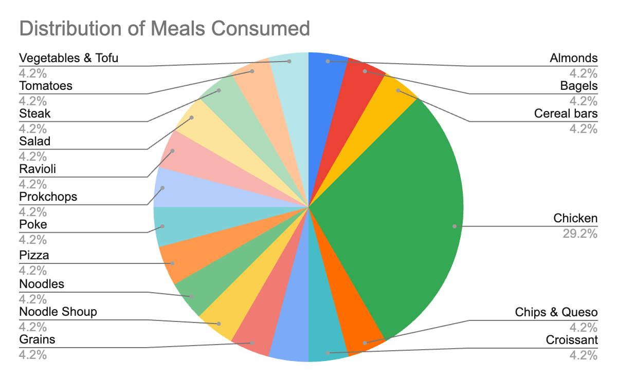

*Drink Types.* Another interesting thing I noticed is that my drinking habits are typically good. I drink at least one cup of a drink per meal, sometimes more, and it is usually water or water alternatives that are not unhealthy. The following shows the percentages of my daily average intake that come from each beverage source.

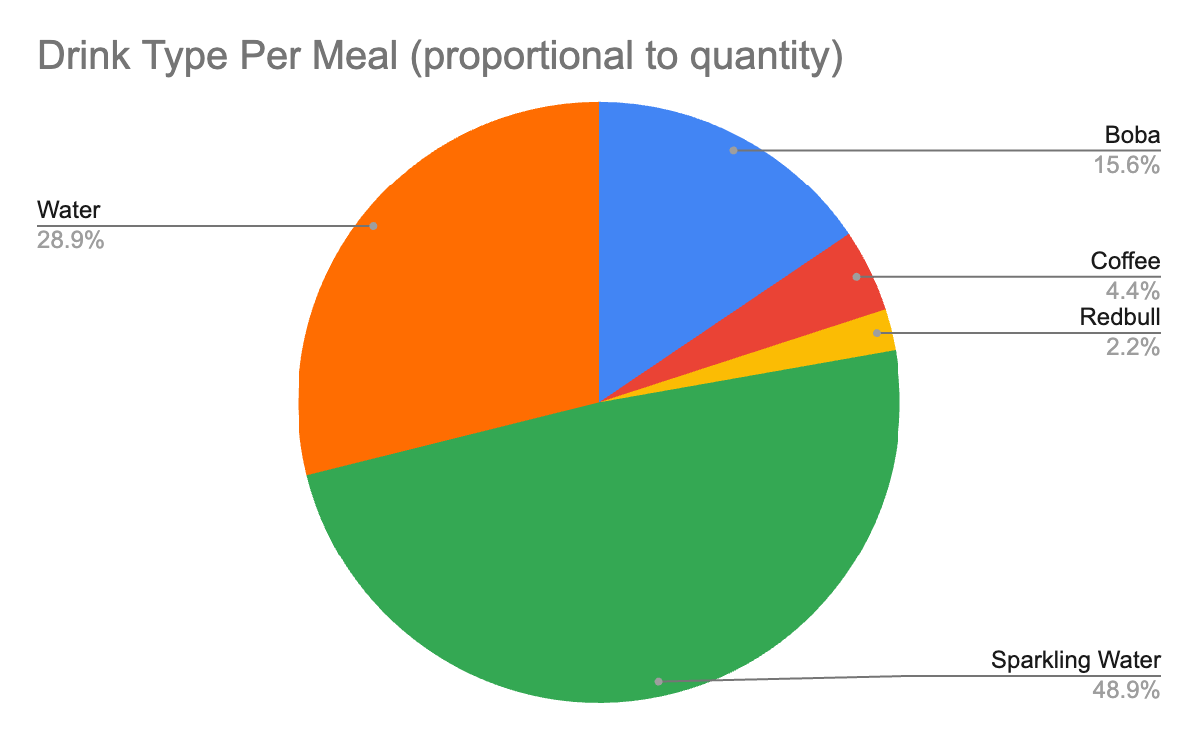

Although it may look like I consume a lot of boba, this is a phenomenon that really developed during the last week. In the first couple of weeks of school, including the first one of the healthy living challenge, I got boba at most two times per week, but during the first week of midterms, I went almost every night. It was probably related to stress and tiredness. This is a habit I need to stop because, while it is not necessarily unhealthy, it is quite expensive.

*Amount of Sleep per Day.* I usually sleep around 7 to 8 hours per night, which is what I am currently targeting. During the second week, unfortunately, this time went down significantly due to having to spend an unexpected amount of time getting prepared for midterms. I did not plan for that beforehand, so it caught me off guard and I was not able to compensate accordingly.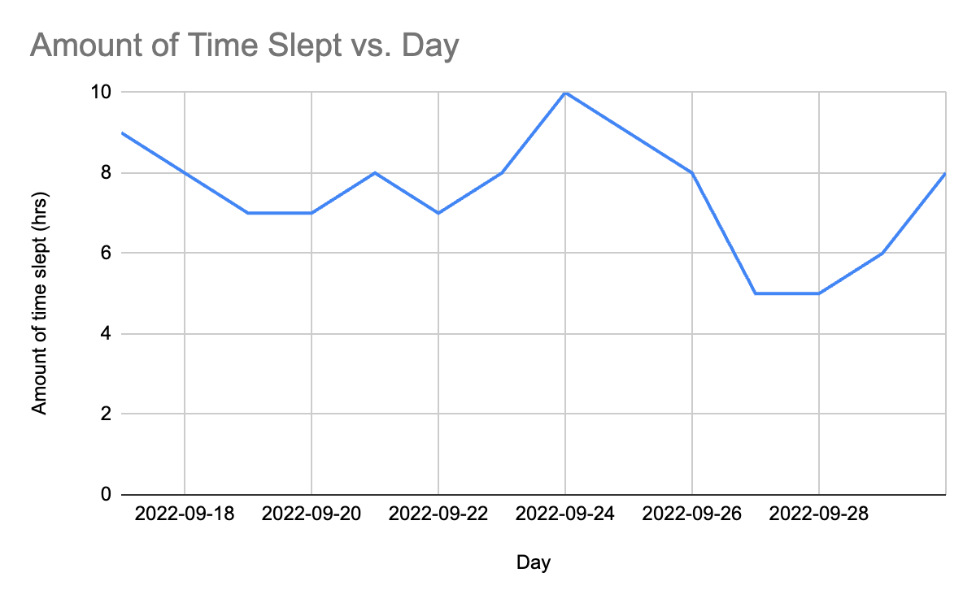

# REFLECTION AND DISCUSSION

The first week of the challenge I noticed increases in energy and productivity, I was able to get distracted less and do work in between classes, which freed up time in the afternoons and nights to get together with friends. The second week however I was not able to keep up with my habits and saw a significant decline energy and happiness.

I expected my main obstacles to be problem sets, but they did not turn out to be much of a struggle. As long as I started them early, which is what I forced myself to do, I would be able to comfortably finish them in time and not have to stay up late the night before the submission date.

The huge obstacle I did face was midterms. Once they got close, I realized that there was considerably more to study than I had initially thought, so that meant skipping classes, meals and sleep to study for them. This is the biggest cause of my decreased mood in the second week.

# CONCLUSION

Completing my healthy challenge made me really appreciate the importance of building sustainable habits. I had become used to lower standards of living because I did not have any way of measuring my habits, but tracking what I ate and how much I slept every day showed me there was a very strong correlation between the eating and sleeping habits of a certain week, and my energy and productivity.

The challenge has showed me how much impact relatively small improvements in daily habits can have in my day to day, and has made me take a closer look at my behaviour and how to improve it.