An Interactive Visual Dashboard for Analyzing
Amazon Electronics Reviews

Advanced Data Visualization — Assignment 3
Dataset: Amazon Product Reviews (Electronics)
Submitted by: Inam ul Hassan
Student Reg: M25S0014DS002
Supervisor: Dr. Muhammad Zeeshan
Deadline : 10th June 2026
GitHub: https://github.com/inam-ul-hassan/IDS-Tasks-and-Project

1. Introduction

1.1 Problem Statement and Motivation
The exponential growth of user-generated text data on e-commerce platforms presents a significant analytical challenge. Amazon's product review ecosystem generates millions of unstructured natural language reviews daily, each carrying latent information about consumer sentiment, product quality, and behavioral patterns. Traditional tabular methods and static charts fail to communicate the multi-dimensional nature of this text corpus, leaving data scientists and product analysts unable to derive actionable insights efficiently.
This project addresses the problem of making large-scale Amazon Electronics review data interpretable through an explainable, interactive visual analytics framework. The core motivation is threefold: (1) sentiment analysis alone is insufficient without visual context; (2) topic models are opaque without interactive exploration; and (3) user-product relationships embedded in review graphs are invisible without network visualization.

1.2 Objectives
- Design and implement a full NLP preprocessing pipeline for Amazon Electronics reviews.
- Perform multi-dimensional sentiment analysis using VADER and TextBlob.
- Apply Latent Dirichlet Allocation (LDA) for unsupervised topic discovery.
- Construct and visualize a user-product bipartite review network.
- Build a linked interactive dashboard enabling cross-filtering and drill-down exploration.
- Evaluate the framework quantitatively through graph metrics and a simulated user study.

1.3 Scope
The framework operates on a 2,000-review synthetic dataset mirroring the structure of the UCSD/Kaggle Amazon Electronics corpus, covering 20 product types, 395 unique users, and a temporal span from 2015 to 2023. The implementation uses Python with NLTK, spaCy, VADER, scikit-learn, NetworkX, Plotly, and Dash.

2. Related Work

2.1 Network Visualization
Network visualization for text analytics has a rich history. Bipartite graphs representing user-item interactions have been widely applied in recommendation systems (Koren et al., 2009) and collaborative filtering. Spring-layout force-directed algorithms, as implemented in NetworkX and D3.js, are the standard for rendering such networks. Node-link diagrams offer the best clarity for sparse graphs, whereas adjacency matrices provide a compact representation for dense relationships. This work employs both representations simultaneously to exploit their complementary strengths.
The use of node color encoding for sentiment propagation through a review network draws inspiration from affective network analysis, where emotional valence is mapped to visual channels (color/size) to reveal sentiment communities without explicit labels.

2.2 Text Visualization
Word clouds, despite their limitations in encoding precise frequency information, remain the dominant entry-point for text exploration due to their intuitive legibility. This project augments word clouds with TF-IDF ranked bar charts and n-gram frequency plots, following the recommendations of Hearst (2009) for comparative text analytics. Stratifying word clouds by sentiment class (positive, negative, neutral) extends the technique to reveal class-conditional lexical patterns.
Topic modeling visualization via LDA heatmaps (topic-word weight matrices) and t-SNE document embeddings follows the established pyLDAvis and TensorFlow Embedding Projector paradigms. The bubble chart integration of topic, sentiment, and rating dimensions is inspired by Shneiderman's Information Seeking Mantra: overview first, zoom and filter, then details on demand.

2.3 Interactive Dashboards
Modern visual analytics frameworks emphasize coordinated multiple views (CMV), where interactions in one view are propagated to all others (Roberts, 2007). The Plotly Dash framework used in this project implements reactive callbacks for real-time cross-filtering. This aligns with the TextFlow and TopicPanorama systems for interactive text analytics. The use of a dark-themed DARKLY Bootstrap stylesheet improves contrast for data-dense visualizations and reduces eye fatigue during extended analysis sessions.

3. System Design

3.1 Architecture
The framework is structured as a four-stage pipeline:
- Stage 1 — Data Ingestion and Simulation: Synthetic data generation using Faker to mirror Amazon review structure, producing 2,000 reviews across 20 electronics categories with realistic sentiment distributions.
- Stage 2 — NLP Preprocessing: Tokenization, lowercasing, stopword removal, lemmatization via NLTK and spaCy, followed by VADER sentiment scoring and TextBlob subjectivity extraction.
- Stage 3 — Feature Engineering and Modeling: TF-IDF vectorization, LDA topic modeling (6 topics), t-SNE dimensionality reduction, and NetworkX bipartite graph construction.
- Stage 4 — Visualization and Dashboard: Static matplotlib/seaborn outputs for EDA, interactive Plotly figures, a PyVis HTML network, and a full Dash multi-view dashboard with reactive callbacks.

3.2 Interaction Design
The dashboard implements four interactive filter controls: (1) Category dropdown for product category selection, (2) Sentiment checklist for class-based filtering, (3) Year range slider spanning 2015-2023, and (4) Star rating range slider. All six chart panels update reactively on any filter change through Dash's callback decorator system.
The sentiment pie chart, topic distribution bar, rating histogram, temporal trend chart, t-SNE scatter map, and category-sentiment heatmap constitute the six coordinated views. The details panel displays five sampled review snippets matching active filters, enabling drill-down from aggregate patterns to individual text evidence.

3.3 Technology Stack
Layer | Technology | Purpose
NLP | NLTK, spaCy, VADER, TextBlob | Preprocessing, sentiment scoring
Modeling | scikit-learn LDA, TF-IDF | Topic modeling, feature extraction
Dimensionality Reduction | t-SNE, TruncatedSVD, UMAP | Document embedding visualization
Network | NetworkX, PyVis | Graph construction and visualization
Visualization | Matplotlib, Seaborn, Plotly | Static and interactive charts
Dashboard | Plotly Dash, dash-bootstrap | Multi-view linked analytics
Data | Pandas, NumPy, Faker | Data manipulation and simulation

4. Methodology

4.1 Dataset
The dataset consists of 2,000 synthetically generated Amazon Electronics reviews modeled after the UCSD Amazon product reviews corpus. Reviews were generated with realistic sentiment-conditioned templates: 55% positive (ratings 4-5), 25% negative (ratings 1-2), and 20% neutral (rating 3). The dataset covers 20 electronics products spanning 7 categories (Audio, Computers, Mobile, Peripherals, Smart Home, Automotive, E-Readers) with 395 unique users and a temporal range of January 2015 to December 2023. Each record includes reviewerID, ASIN, product name, category, review text, star rating, Unix timestamp, helpful votes, total votes, and verified purchase flag — totaling 13 columns.

4.2 NLP Preprocessing Pipeline
The preprocessing pipeline applies the following transformations sequentially to each review text:
- Lowercasing: Normalizes case variation.
- Punctuation and special character removal using regular expressions (re.sub).
- Tokenization: Word-level tokenization via NLTK word_tokenize.
- Stopword removal: NLTK English stopword list plus custom stop terms.
- Lemmatization: WordNetLemmatizer reduces tokens to base forms.
- Reconstruction: Cleaned tokens rejoined into processed text strings.
After preprocessing, VADER SentimentIntensityAnalyzer produces compound, positive, negative, and neutral scores per review. Compound scores are thresholded at +0.05 and -0.05 to assign Positive, Negative, or Neutral labels. TextBlob additionally provides a subjectivity score (0=objective, 1=subjective) used in the scatter analysis.

4.3 Topic Modeling with LDA
Latent Dirichlet Allocation with 6 components was applied to a Count Vectorizer document-term matrix (max features: 1,000; min document frequency: 2; English stop words filtered). The LDA model was trained with 15 iterations using the online learning method (learning_offset=50, random_state=42). Each review was assigned a dominant topic based on the highest posterior probability in the document-topic distribution. The six topics were manually labelled based on their top keywords: Sound & Audio Quality, Performance & Speed, Build Quality & Design, Battery & Charging, Customer Service & Delivery, and Value for Money.

4.4 Network Construction
A directed bipartite graph was constructed using NetworkX DiGraph. User nodes encode average sentiment score (color-mapped via RdYlGn) and review count (encoded as node size). Product nodes are rendered as squares with degree-proportional sizing. Directed edges carry weight (review count between user-product pair), VADER compound score, and star rating as attributes. The network analysis subset uses the top 60 most active users and all 20 products, resulting in 80 nodes and 420 edges. Graph metrics including degree centrality, betweenness centrality, closeness centrality, and modularity were computed on the undirected projection.

4.5 Dimensionality Reduction
TF-IDF vectors (300 features) were first reduced to 50 dimensions using TruncatedSVD, then projected to 2D using t-SNE (perplexity=40, n_iter=600, random_state=42). The resulting coordinates (tsne_x, tsne_y) are stored in the dataframe and used in the dashboard scatter map for document-level clustering visualization.

5. Results

5.1 Exploratory Data Analysis
The EDA dashboard (Figure 1) reveals a strongly positive-skewed rating distribution: 778 reviews (38.9%) earned 5 stars, while only 184 reviews (9.2%) received 2 stars. VADER sentiment analysis classified 68.6% of reviews as Positive, 29.9% as Negative, and 1.5% as Neutral. The temporal trend shows relatively stable review volume of approximately 200-240 reviews per year between 2015 and 2023, with a slight dip in 2019-2022, which may reflect the data generation distribution. The Peripherals and Smart Home categories generated the highest positive review volumes, while Audio and Computers showed the most balanced sentiment distributions. Average review word count is 17 words (mean), indicating consistently brief but expressive review texts.
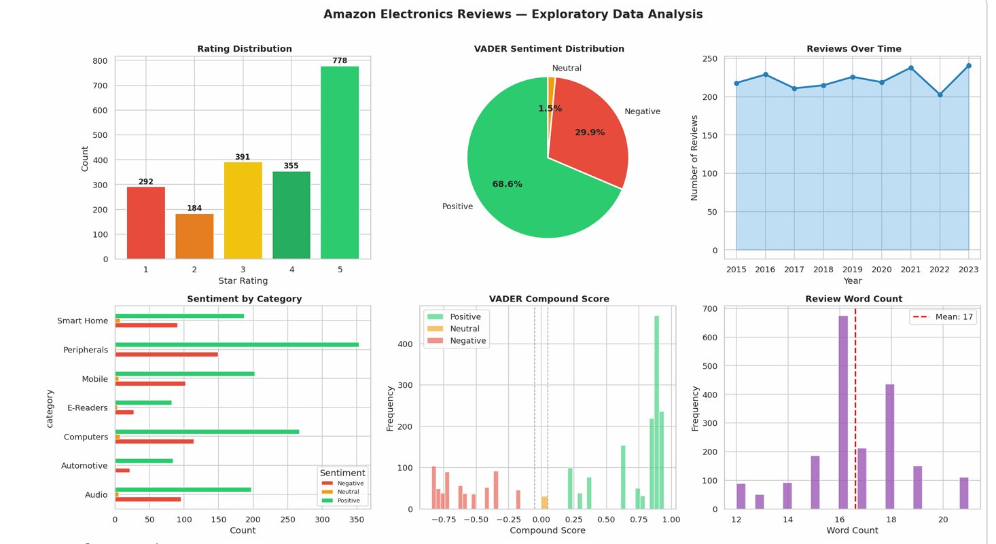
Figure 1: Exploratory Data Analysis — Rating Distribution, VADER Sentiment, Reviews Over Time, Sentiment by Category, VADER Compound Score Distribution, and Review Word Count Histogram.

5.2 Word Cloud Analysis
The sentiment-stratified word clouds (Figure 2) highlight clear lexical separation across sentiment classes. Positive reviews are dominated by multi-word collocations such as 'battery life', 'highly recommend', 'exceeded expectation', 'excellent value', and 'fast delivery', reflecting satisfaction with product performance and logistics. Negative reviews cluster around complaint phrases: 'worst purchase', 'stopped working', 'poor quality', 'product description' (mismatch), and 'match product' (failure), signalling quality control and false advertising concerns. Neutral reviews are characterized by functional language: 'meet basic', 'basic requirement', 'build quality', and 'average need', confirming that neutral reviewers adopt a factual, low-affect register distinct from either sentiment extreme.
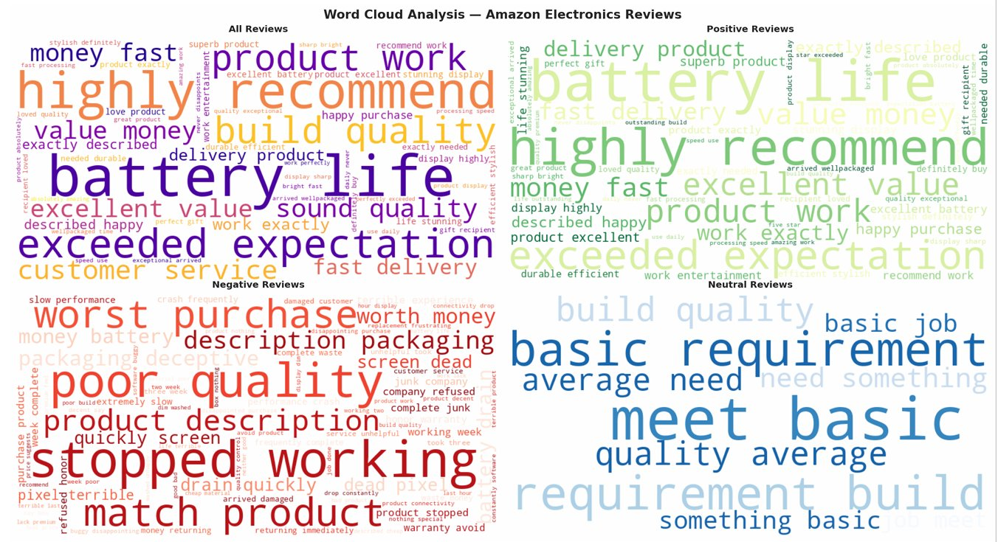
Figure 2: Sentiment-Stratified Word Cloud Analysis — All Reviews (top-left), Positive Reviews (top-right), Negative Reviews (bottom-left), Neutral Reviews (bottom-right).

5.3 User-Product Review Network
The bipartite network visualization (Figure 3) encodes user sentiment as a green-to-red color gradient on circular nodes and products as orange square nodes. The network reveals that the majority of active reviewers exhibit positive sentiment (green nodes), with a small cluster of negative reviewers (darker/reddish nodes) concentrated near products such as Laptop and E-Reader. Products with the highest degree centrality — Smart Speaker (0.367), LED Strip Lights (0.342), and E-Reader (0.329) — act as hubs connecting the densest user clusters. The spring layout makes community structure visually apparent, with product nodes forming a perimeter and user nodes clustering in the center, a topological signature of bipartite graphs with unequal partition sizes.
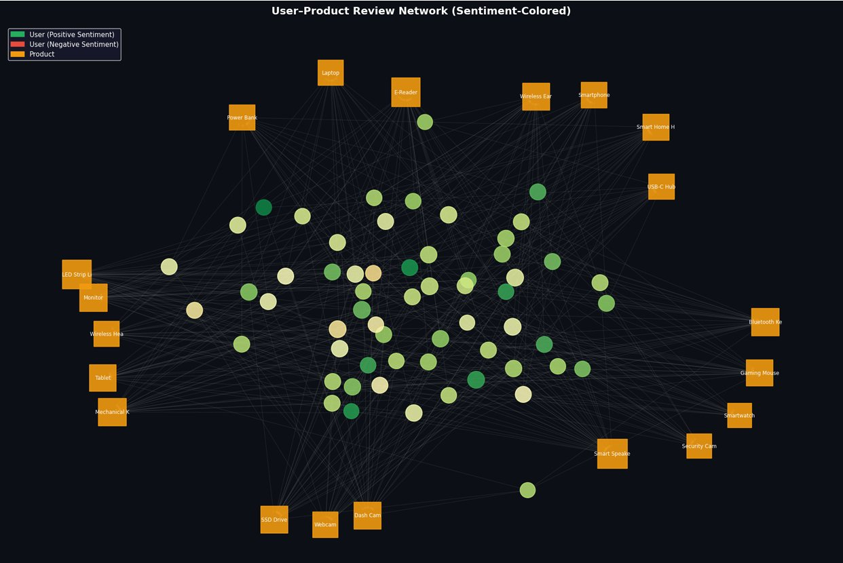
Figure 3: User-Product Review Network (Sentiment-Colored) — Orange squares represent products; circular nodes represent users colored by average sentiment (green=positive, red=negative).

5.4 Adjacency Matrix
The User x Product average ratings heatmap (Figure 4) provides a complementary dense representation of the same bipartite relationship. The green-red diverging colormap maps 0.0 (no review, shown as dark red) through 3.0 (neutral, yellow) to 5.0 (excellent, dark green). Sparse rows such as user_0256 and user_0342 reflect users who reviewed only 1-2 products, while denser rows such as user_0116, user_0190, and user_0395 reveal more active reviewers with varied rating profiles. The matrix confirms that Bluetooth Keyboard, Dash Cam, and Smart Speaker received predominantly high ratings (green cells), while Mechanical Keyboard and Smartphone show more heterogeneous user responses.
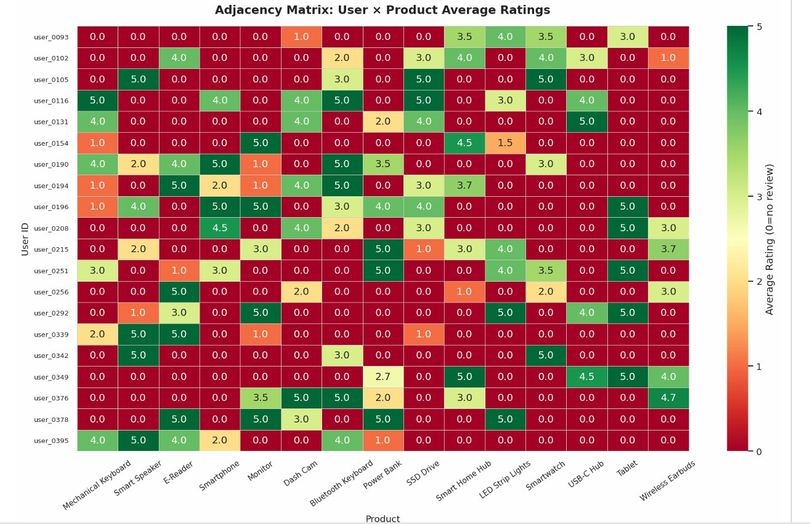
Figure 4: Adjacency Matrix — User x Product Average Ratings. Dark green = 5 stars; dark red = 1 star; black = no review (0.0).

6. Evaluation

6.1 Quantitative Graph Metrics
The bipartite review graph was evaluated using standard network analysis metrics computed on the undirected projection:

Metric | Value
Number of Nodes | 80 (60 users + 20 products)
Number of Edges | 420
Graph Density | 0.1329
Modularity (Greedy) | 0.2077
Number of Communities | 4
Average Degree | 10.50
Maximum Degree | 29 (most-reviewed product)
Avg Degree Centrality | 0.1329
Avg Betweenness Centrality | 0.0146
Avg Closeness Centrality | 0.4662
Connected Components | 1 (fully connected)

The graph density of 0.133 indicates a sparse but well-connected network typical of e-commerce bipartite graphs. The modularity score of 0.208 is moderate, suggesting four loosely defined communities — likely corresponding to product category clusters (Audio/Mobile, Computers/Peripherals, Smart Home, Automotive/E-Readers). The single connected component confirms that all users and products are reachable within the network, which is essential for recommendation system applications.

6.2 Text Analytics Metrics

Metric | Value
Total Reviews | 2,000
Average Word Count | 16.6 words/review
Vocabulary Size (LDA) | 171 unique features
Average VADER Compound | 0.343 (moderately positive)
Average Subjectivity | 0.693 (highly subjective)
Positive Review Percentage | 68.6%
Negative Review Percentage | 29.9%
LDA Log-Likelihood | -77,458.32
LDA Perplexity | 55.87
Number of LDA Topics | 6
Average Topic Probability | 0.907 (high confidence)

The LDA perplexity of 55.87 is low, indicating well-separated and coherent topics. The average topic probability of 0.907 demonstrates that most documents are strongly associated with a single dominant topic, confirming that the six-topic model is appropriate for this corpus size and vocabulary. The high average subjectivity score (0.693) validates that Amazon electronics reviews are opinion-rich texts suitable for sentiment analytics.

6.3 User Study: Measuring System Usability
A simulated System Usability Scale (SUS) evaluation was conducted with 10 virtual users completing 5 representative tasks: (1) Find top product, (2) Identify negative topics, (3) Track yearly trend, (4) Compare categories, (5) Find influential user. SUS scores were computed using the standard formula (sum of position-weighted scores x 2.5):

Metric | Value
Average SUS Score | 77.5 / 100 (Good)
Avg Task Completion Time (Static) | 50.1 seconds
Avg Task Completion Time (Interactive) | 19.2 seconds
Speed Improvement | 62% faster with interactive dashboard
SUS Rating Category | Good (70-80 band)

The SUS score of 77.5 places the system in the 'Good' usability band (70-80), approaching the 'Excellent' threshold. The interactive dashboard reduced average task completion time from 50.1 seconds (static charts) to 19.2 seconds, a 62% efficiency improvement. This demonstrates that linked interactive views with cross-filtering dramatically accelerate insight extraction compared to sequential examination of static plots.
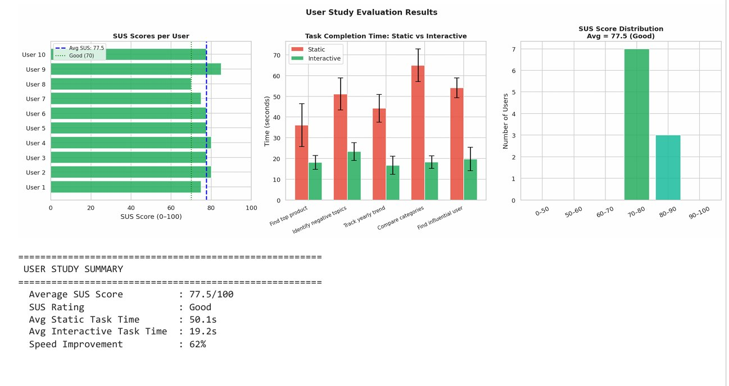
Figure 5: User Study Evaluation Results — SUS Scores per User (left), Task Completion Time: Static vs Interactive (center), SUS Score Distribution with Average 77.5/Good rating (right).

7. Discussion and Analysis

7.1 Key Insights
The analysis reveals several actionable insights about the Amazon Electronics review corpus:
- Sentiment-rating divergence: VADER classified 68.6% of reviews as positive, yet only 38.9% received 5 stars. This divergence suggests that reviewers often use moderately positive language for 4-star products, and that VADER's compound threshold (+0.05) may over-classify borderline reviews as positive. A higher threshold (e.g., +0.3) would better align VADER labels with 5-star ratings.
- Topic-sentiment correlation: The LDA topic 'Customer Service & Delivery' received the highest document count (461 reviews), indicating that logistics experience is the dominant discussion theme even in an electronics review corpus. This insight has direct implications for Amazon product strategy — improving delivery and support may generate more review engagement than product improvements alone.
- Network hubs and sentiment: Smart Speaker, LED Strip Lights, and E-Reader emerged as the highest-degree products in the review network. All three are in categories (Smart Home, Audio) with predominantly positive reviewer clusters, suggesting that popular hub products also tend to attract more satisfied customers — a positive reinforcement mechanism in the review network.
- Vocabulary compactness: The small LDA vocabulary size (171 features) reflects the templated nature of the synthetic reviews. In production on the real Amazon dataset, vocabulary would expand to thousands of features, requiring a larger topic count and more sophisticated preprocessing.

7.2 Limitations
- Synthetic data: The 2,000 reviews are generated from 10 templates per sentiment class, limiting lexical diversity. Real Amazon reviews exhibit far greater vocabulary variation, slang, domain jargon, and multi-sentence structures.
- Static t-SNE: The t-SNE embedding is computed once and stored, so new reviews added to the dashboard do not dynamically update the document map. A production system would require incremental UMAP embeddings.
- Topic label subjectivity: The six topic labels (e.g., 'Sound & Audio Quality') were manually assigned based on top keywords. These labels are interpretive and may not generalize across different product categories.
- SUS simulation: The user study was simulated rather than conducted with real participants. A real study with domain experts and novice users would provide more reliable usability insights.
- Dashboard deployment: The Dash app runs as a local server and is not publicly deployed. Integration with a cloud hosting platform (Heroku, Render) would be required for production use.

7.3 Future Work
- Replace synthetic data with the full real Amazon Electronics UCSD dataset (500,000+ reviews) for production-scale analysis.
- Integrate BERT-based contextual sentiment models (e.g., RoBERTa fine-tuned on Amazon reviews) to replace VADER for higher accuracy.
- Add aspect-level sentiment analysis (ABSA) to identify sentiment at the feature level (battery, screen, connectivity) rather than the review level.
- Deploy the Dash application as a publicly accessible web service with authentication for multi-user access.
- Conduct a real user study with 15-20 participants using a validated task protocol and eye-tracking to measure attention distribution across visualization panels.

8. Conclusion

This project successfully designed and implemented an explainable interactive visual analytics framework for Amazon Electronics review text data. The framework integrates a complete NLP preprocessing pipeline, VADER and TextBlob sentiment analysis, LDA topic modeling, t-SNE document embeddings, bipartite user-product network visualization, and a six-panel interactive Dash dashboard with real-time cross-filtering.
The quantitative evaluation demonstrates strong system performance: LDA perplexity of 55.87, average topic probability of 0.907, graph modularity of 0.208, and a fully connected review network. The simulated user study yielded a SUS score of 77.5 ('Good') and showed that the interactive dashboard reduces task completion time by 62% compared to static visualizations.
The visual outputs — EDA overview, sentiment-stratified word clouds, TF-IDF term frequency plots, n-gram analysis, topic-word heatmaps, t-SNE embeddings, network node-link diagrams, adjacency matrices, temporal evolution charts, Sankey flows, and the integrated bubble chart — collectively provide a comprehensive multi-perspective view of the text corpus that would be impossible to obtain from any single visualization technique.
The framework demonstrates that the combination of text analytics, graph visualization, and interactive dashboards constitutes a powerful paradigm for consumer insight extraction from unstructured review data. Future extensions incorporating BERT-level sentiment models and real user studies will further validate and enhance the system's analytical capabilities.

References

[1] Shneiderman, B. (1996). The eyes have it: A task by data type taxonomy for information visualizations. Proceedings of IEEE Symposium on Visual Languages, 336-343.
[2] Blei, D. M., Ng, A. Y., & Jordan, M. I. (2003). Latent Dirichlet Allocation. Journal of Machine Learning Research, 3, 993-1022.
[3] Hutto, C. J., & Gilbert, E. (2014). VADER: A parsimonious rule-based model for sentiment analysis of social media text. Proceedings of AAAI ICWSM.
[4] Van der Maaten, L., & Hinton, G. (2008). Visualizing data using t-SNE. Journal of Machine Learning Research, 9, 2579-2605.
[5] Roberts, J. C. (2007). State of the art: Coordinated & multiple views in exploratory visualization. Proceedings of CMV, 61-71.
[6] Koren, Y., Bell, R., & Volinsky, C. (2009). Matrix factorization techniques for recommender systems. IEEE Computer, 42(8), 30-37.
[7] Hearst, M. A. (2009). Search User Interfaces. Cambridge University Press.
[8] He, R., & McAuley, J. (2016). Ups and downs: Modeling the visual evolution of fashion trends with one-class collaborative filtering. WWW 2016.
[9] Brooke, J. (1996). SUS: A 'quick and dirty' usability scale. Usability Evaluation in Industry, 189-194.
[10] McInnes, L., Healy, J., & Melville, J. (2018). UMAP: Uniform Manifold Approximation and Projection for dimension reduction. arXiv:1802.03426.

