The Evolution of AI Agents and Modern AI Engineering
Technical Research Report

Large language models (LLMs) have evolved from single-turn text generators into the reasoning core of autonomous software systems. This report traces that evolution — from simple LLM applications, to tool-using agents, to coordinated multi-agent systems — and closes with a look at where AI engineering is heading.

1. LLM Applications
The starting point. Early production use of LLMs followed a request–response pattern: a prompt goes in, text comes out. Chatbots, summarizers, copilots, and retrieval-augmented generation (RAG) systems fall here. These applications are largely stateless — no persistent memory, no independent action. Their limitation is passivity: the system responds but does not pursue a goal. Closing that gap is what defines the shift to agents.

2. AI Agents
Definition. An AI agent combines a foundation model with a control loop, external tools, and (usually) memory, so it can autonomously plan and execute a multi-step task rather than answer a single prompt. The canonical architecture is a loop: perceive the state, decide the next action, optionally call a tool, observe the result, update memory, and repeat until the goal is met. This reframes an agent as a small system — the LLM as planner and executor inside a scaffold of retries and guardrails — not a single model call.
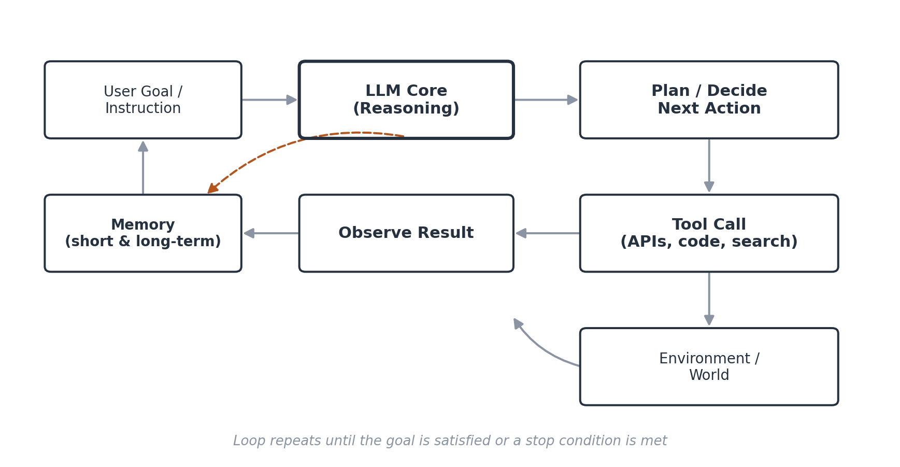
Figure 1 — The core agent control loop: perceive, plan, act via tools, observe, and update memory.
REAL-WORLD EXAMPLE — Claude Code / GitHub Copilot Agent Mode
Coding agents read a repository, plan a multi-file change, edit files, run tests, and iterate on failures — a direct instance of the perceive-plan-act-observe loop applied to software engineering.

3. Tool Calling
How agents act on the world. Tool calling (function calling) lets a model invoke external code — a search API, a database query, a code interpreter — by emitting a structured request that matches a schema the developer defines. The result returns to the model's context, which decides the next step. Anthropic's Model Context Protocol (MCP), released November 2024, standardizes this exchange so any compliant tool can plug into any compliant agent. By 2026 it has been adopted by essentially every major AI provider.
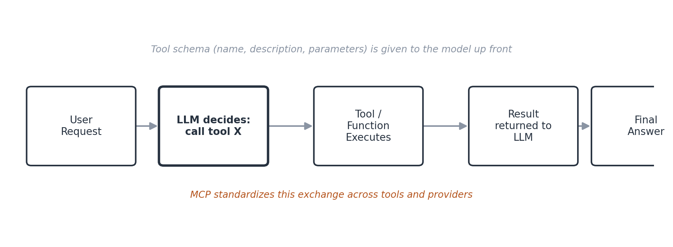
Figure 2 — A single tool-call turn: the model selects a tool, the tool executes, and the result re-enters the model's context.
REAL-WORLD EXAMPLE — Enterprise developer tooling
Teams connect coding assistants to Jira, GitHub, Slack, and Datadog through MCP servers so an assistant can pull sprint data, summarize error logs, and draft a pull request from a diff — with every call logged.

4. Memory
Continuity across time. Memory lets an agent retain information beyond a single context window. Short-term memory covers the current task's intermediate results; long-term memory persists facts and preferences across sessions, typically via vector stores or knowledge graphs, retrieved on demand. Memory is now its own engineering discipline, with dedicated benchmarks and open problems such as cross-session identity and staleness — a stored fact silently becoming wrong over time.

5. Planning
Deciding the sequence of actions. Planning is how an agent decomposes a goal into ordered steps — from reactive, one-step-at-a-time reasoning, to explicit hierarchical planners that produce a task list up front and revise it as information arrives. Reflection, having the model critique or verify its own output before proceeding, is commonly layered on top to reduce compounding errors over long task horizons. Production systems increasingly make plans explicit and machine-readable, so they can be logged and checked for adherence.

6. Multi-Agent Systems
Specialization through teamwork. As tasks grow complex, a single generalist agent becomes harder to prompt and secure. Multi-agent systems instead assign narrower roles — researcher, coder, reviewer, orchestrator — each with its own tools. An orchestrator decomposes the goal and delegates subtasks; individual agents reach tools through MCP, while delegation between agents flows through a peer protocol such as Google's Agent2Agent (A2A).
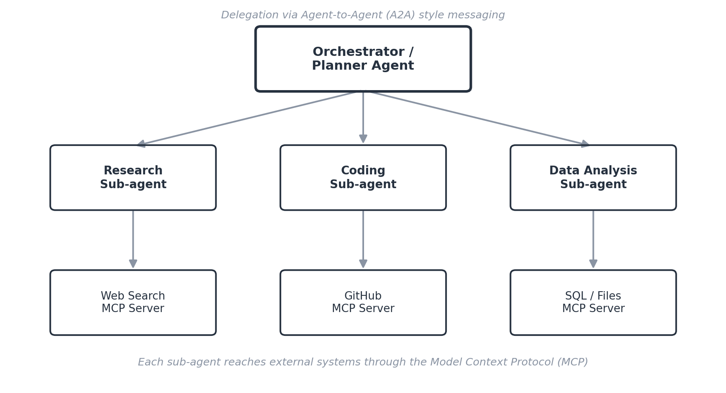
Figure 3 — A hierarchical multi-agent system: an orchestrator delegates to specialist sub-agents, each connected to its own MCP-based tools.
REAL-WORLD EXAMPLE — BMW Agents Framework
BMW has documented a multi-agent framework that automates internal task workflows by coordinating specialized agents for retrieval, reasoning, and execution toward a shared goal.

7. Future of AI Engineering
- Protocol standardization: MCP and A2A consolidate agent-to-tool and agent-to-agent communication into open standards.
- Memory as infrastructure: persistent, queryable memory with privacy and staleness controls is now a first-class system component.
- Evaluation and observability: trace-level logging and CI-integrated evaluation are replacing demo-driven development.
- Security by design: prompt injection and over-privileged tool access are treated as production threats, not edge cases.
- Model routing: systems route subtasks to the smallest capable model, reserving frontier models for what needs them.
The overall trajectory is one of maturation: the differentiator in 2026 is no longer whether a model can respond intelligently, but whether the surrounding system is engineered reliably enough to be trusted with real-world tasks.

References
- Anthropic. “Introducing the Model Context Protocol.” November 2024. modelcontextprotocol.io
- Masterman, T., Besen, S., Sawtell, M., & Chao, A. “The Landscape of Emerging AI Agent Architectures for Reasoning, Planning, and Tool Calling: A Survey.” arXiv:2404.11584, 2024.
- Xi, Z. et al. “The Rise and Potential of Large Language Model Based Agents: A Survey.” arXiv:2309.07864, 2023.
- Casper AI Agent Index Team. “The AI Agent Index.” arXiv:2502.01635, 2025.
- “AI Agent Systems: Architectures, Applications, and Evaluation.” arXiv:2601.01743, 2026.
- Mem0. “State of AI Agent Memory 2026.” mem0.ai/blog/state-of-ai-agent-memory-2026, 2026.
- IBM. “What is Model Context Protocol (MCP)?” ibm.com/think/topics/model-context-protocol, 2026.
- Wikipedia. “Model Context Protocol.” en.wikipedia.org/wiki/Model_Context_Protocol, accessed 2026.
- BMW Group. “BMW Agents — A Framework for Task Automation Through Multi-Agent Collaboration.” arXiv:2406.20041, 2024.
- Google. “Agent2Agent (A2A) Protocol.” a2a-mcp.org / Linux Foundation Agentic AI Foundation, 2025–2026.

