AI Application Architecture
Case study: AI Workspace — a browser chat client backed by a FastAPI server and Google's Gemini API.

Architecture Diagram
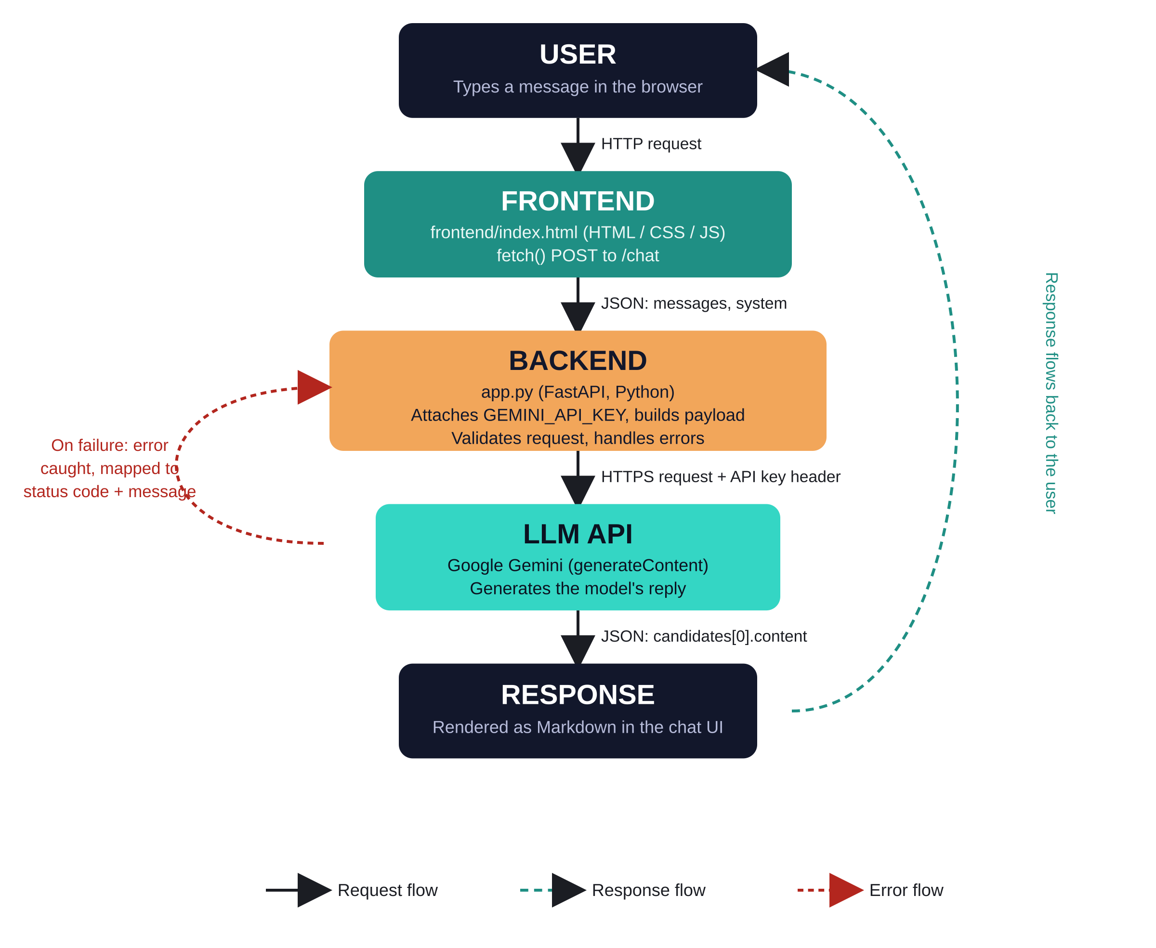
User → Frontend → Backend → LLM API → Response

Request Flow
- User input: The user types a message in the browser UI (frontend/index.html) and presses Send.
- Frontend request: The frontend's JavaScript packages the conversation history and the system prompt into a JSON object, then sends it as an HTTP POST to the backend's /chat endpoint using fetch().
- Backend validation: FastAPI (app.py) receives the request, validates it against a Pydantic schema (ChatRequest), and rejects malformed input immediately with a 400 response.
- API call: The backend attaches the server-side GEMINI_API_KEY (never exposed to the browser) and forwards a reformatted payload to Google's generateContent endpoint over HTTPS.

Response Flow
- LLM response: Gemini generates a reply and returns it as JSON, wrapped in a candidates array containing the generated text.
- Backend parsing: The backend parses that JSON, extracts the reply text, and returns a clean { content, model } object to the frontend.
- Frontend render: The frontend receives the response, converts Markdown (headings, code blocks, lists, tables) to HTML, and appends it to the chat window.
- UI update: The UI updates the status indicator back to “Ready” and re-enables the input box for the next message.

Error Handling
- Backend layer: Network failures (timeout, DNS, offline) are caught in try/except blocks on the backend and returned as 502/504 with a plain-English message rather than a raw stack trace.
- Provider errors: Gemini-specific failures are mapped to meaningful responses: 401 for a bad API key, 429 for rate-limit exhaustion, and a safety-block message if the prompt is filtered.
- Frontend layer: The frontend wraps every fetch() call in try/catch, distinguishes a user-triggered abort (Stop button) from a real failure, and displays failures in a dismissible error banner instead of failing silently.
- Timeouts: A 60-second client-side timeout guarantees the UI never hangs indefinitely waiting on a stalled request.

API Integration
- Frontend ↔ Backend: Frontend to backend: a same-origin REST call (POST /chat) — no API keys touch the browser, avoiding key leakage through dev tools or network tabs.
- Backend ↔ LLM API: Backend to LLM: the Python requests library calls Gemini's REST API (v1beta/models/{model}:generateContent) with the key in a header, keeping credentials server-side and swappable via environment variables.
- Configuration: Configuration such as GEMINI_MODEL and GEMINI_MAX_OUTPUT_TOKENS is read from a .env file, so the integration can be reconfigured or pointed at a different model without touching code.

