Report On

Music Player


Web Development Using Java - CSC3102

Submitted By:-
D.Inamur Rahman
200071601029
CSE – A

Overview

In the last few years, music players have made it possible to take your whole collection with you anywhere. Despite this convenience, we are limited to listening music through headphones. Our implementation does provide the convenience to a Music Player as well as the added benefit of being able to listen to it on a regular stereo anywhere. Basically, in today’s busy life, music is really a very beautiful part of our life. Listening Music is my favourite way to make mind stress free and relaxation. Music player website or app is one of the basic requirement.

Introduction

The music player allows a user to play various media file formats. It can be used to play audio. The music player is a project supporting all known media files and has the ability to play them with ease. Building a music player involves in different types of classes and instances of HTML, CSS and JavaScript to present the songs in a list view and to control over playback functions and to skip forward and back.

Tools Used

- HTML
- CSS
- JavaScript

Features

- User Friendly
- It supports various music formats
- It consists of Pause/Play/Stop feature to control over the song
- User may also add songs to the current play lists.
- It contains a interactive UI which allows user to control the songs.

Code Analysis
- First, we created a container class using <div> to keep whole code in that class for better efficiency.
- And using another <div> classes uploaded songs from local storage.
- Using input type = ‘range’ instance we create an progress_bar for to know how much the song has been played.

- Using font awesome icons I inserted Play/Pause/Stop icons.

- Using CSS I styled the Website into attractive.
- Using <link rel = “stylesheet” href = “style.css”> i have linked the CSS file with HTML file.
- In CSS stylesheet I have used display, font, background, margin, padding, opacity. Transition and cursor tags to look website more attractive.
- Using <script src = “script.js”></script> I have linked the JavaScript file with HTML file
- Basically, JavaScript used for functionality of website.
- In index.js, I have defined new variables for the classes which are defined in HTML file using document.getElementById etc,.
- In JavaScript, I have used functions, ‘eventlisteners’ and media elements for
Play/Pause/Stop and Forward/previous functionality.

Snapshots
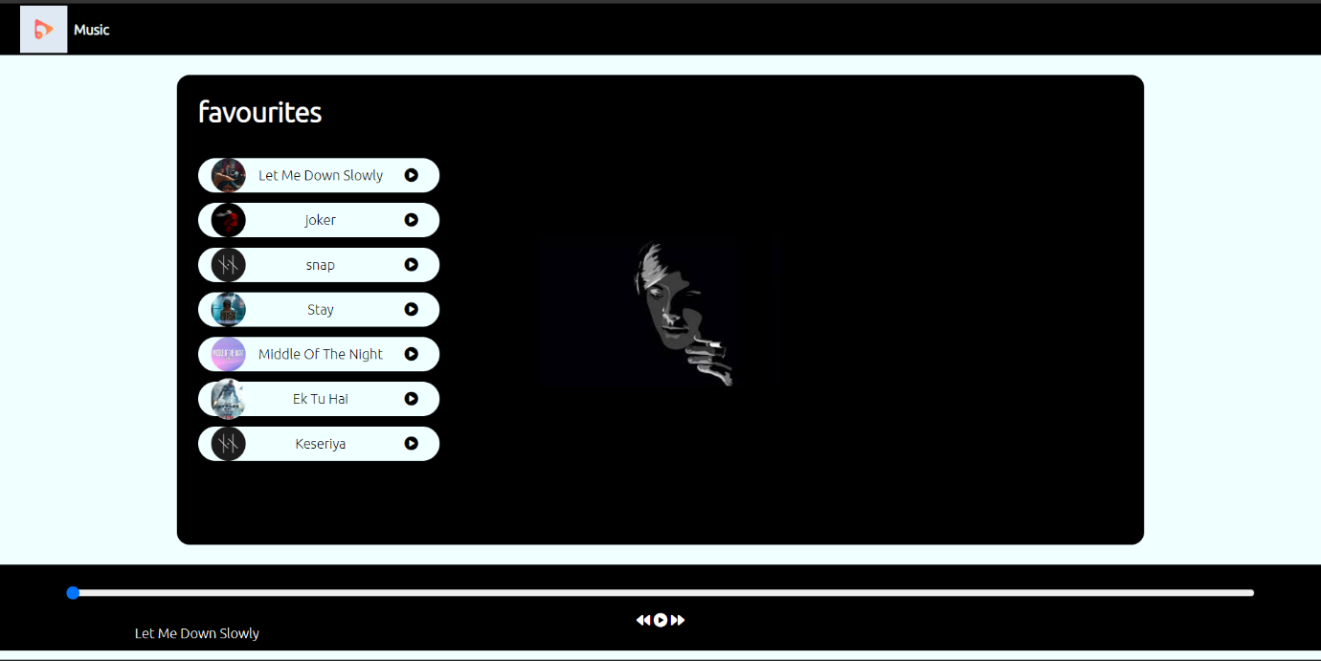

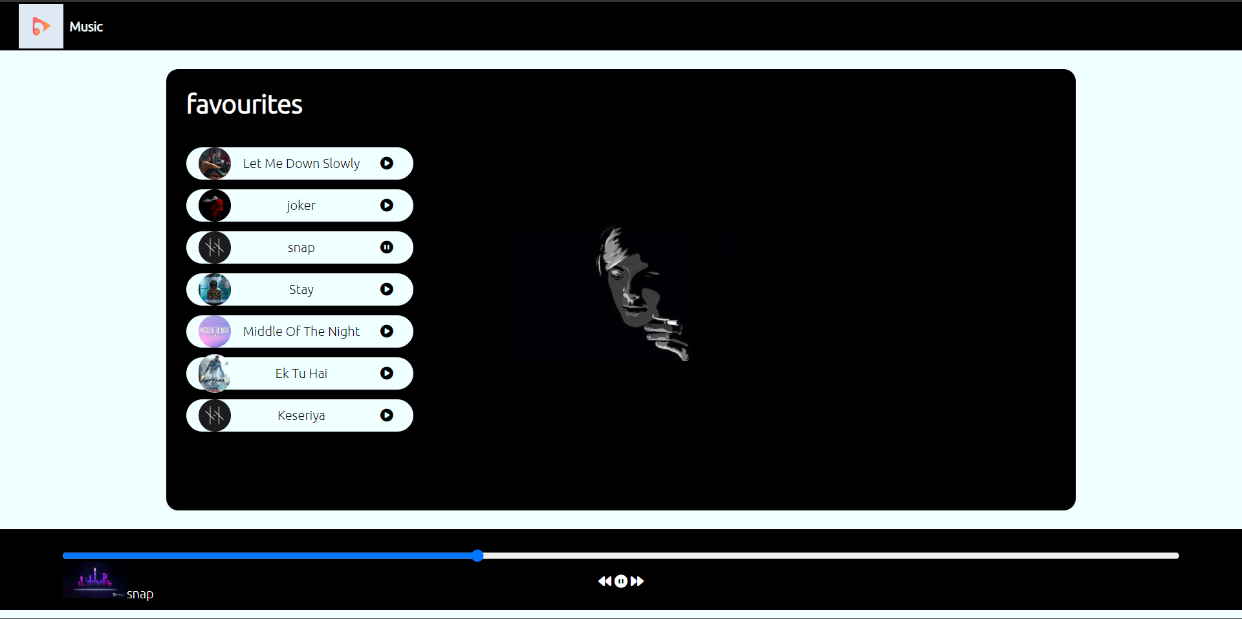
(Songs are been playing)

Conclusion

- opacity. Transition and cursor tags to look website more attractive.
- Using <script src = “script.js”></script> I have linked the JavaScript file with HTML file
- Basically, JavaScript used for functionality of website.
- In index.js, I have defined new variables for the classes which are defined in HTML file using document.getElementById etc,.
In JavaScript, I have used functions, ‘eventlisteners’

