Decoding the answers:

lhs rhs support confidence lift

[1] {rice,

sugar} => {whole milk} 0.0012 1.00 3.9

[2] {canned fish,

hygiene articles} => {whole milk} 0.0011 1.00 3.9

[3] {whipped/sour cream,

house keeping products} => {whole milk} 0.0012 0.92 3.6

[4] {rice,

bottled water} => {whole milk} 0.0012 0.92 3.6

[5] {soups,

bottled beer} => {whole milk} 0.0011 0.92 3.6

We used the Apriori algorithm to understand the how and which products have any relation to its purchase.

In the above Figure, we have created the rule for support=0.001, confidence=0.5, which means that we show a pattern of transactions which have at least 0.001 occurrences. So, the confidence of 1 means items on left also contains items on the right-hand side. Having high confidence is always better.

To explain more, people who buy rice & sugar, have very chances of buying whole milk as they have a very high confidence.

Now, we have changed the situation, we are now trying to find what people genrally buy when they buy Whole milk.

lhs rhs support confidence lift

[1] {whole milk} => {other vegetables} 0.075 0.29 1.5

[2] {whole milk} => {rolls/buns} 0.057 0.22 1.2

[3] {whole milk} => {yogurt} 0.056 0.22 1.6

[4] {whole milk} => {root vegetables} 0.049 0.19 1.8

[5] {whole milk} => {tropical fruit} 0.042 0.17 1.6

We see that buying vegetables have a very high probability.

Now we graph the rules for better clarity:

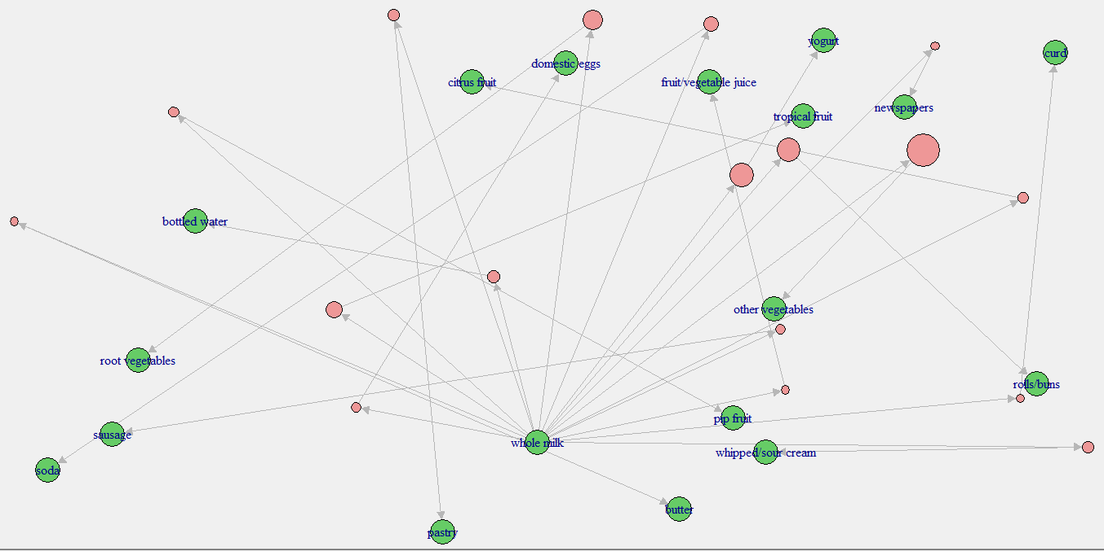

The size of the pink bubble shows the density of confidence level associated with the purchase.