STcorr SHORT USER GUIDE
This guide will shortly introduce how to use the IDL code STcorr. For detailed information on the background of the method and the code, refer the paper named “STcorr: An IDL code for image based normalization of lapse rate and illumination effects on nighttime TIR imagery” by “Ulusoy, İ., Labazuy, P., Aydar, E” presented in Computers and Geosciences.
1. Installation and running STcorr
STcorr is an IDL (version 6.3 for Microsoft Windows© OS) code that can alternatively run standalone with runtime application, with IDL virtual machine or in the IDL environment. Two files named “STcorr.sav” and “STcorr.pro” is referring the same code in two different formats. Neither requires an installation; they can directly run in the IDL environment. STcorr.sav is the standalone version, can be run by double click on the file. To run this code user must have a registered copy of IDL or runtime application of IDL. “IDL virtual machine” is distributed freely and it is possible to run STcorr.sav with this virtual IDL environment. STcorr.pro is the source code. It can only be run under IDL environment. Before running STcorr.pro under IDL, code must be compiled. Please refer the paper when you use the code.
2. Using STcorr
It is very simple to use STcorr. When STcorr is run, the main graphical user interface (GUI) appears (Figure 1). There are sixteen buttons, three drop-lists (Fig. 1: 8, 12 and 16), and a text panel (Fig. 1: 6) on the GUI. Every button and drop-list is released free to use when the conditions to make this operation are met.
Step – 1: Loading input images
When STcorr is opened, three buttons (Fig. 1: buttons 1, 2, 3 and 4) are free to use. User must load the four initial input images to make the calculations STcorr offer. These are Surface Kinetic Temperature image, Digital Elevation Model, Slope Aspect image and Slope image. All four images must be spatially same sized, in same resolution and must cover the same area. When buttons 1, 2, 3, 4 are pressed, a dialog box will open to browse and select the appropriate files. The loaded images will appear in separate windows with appropriate color scales.
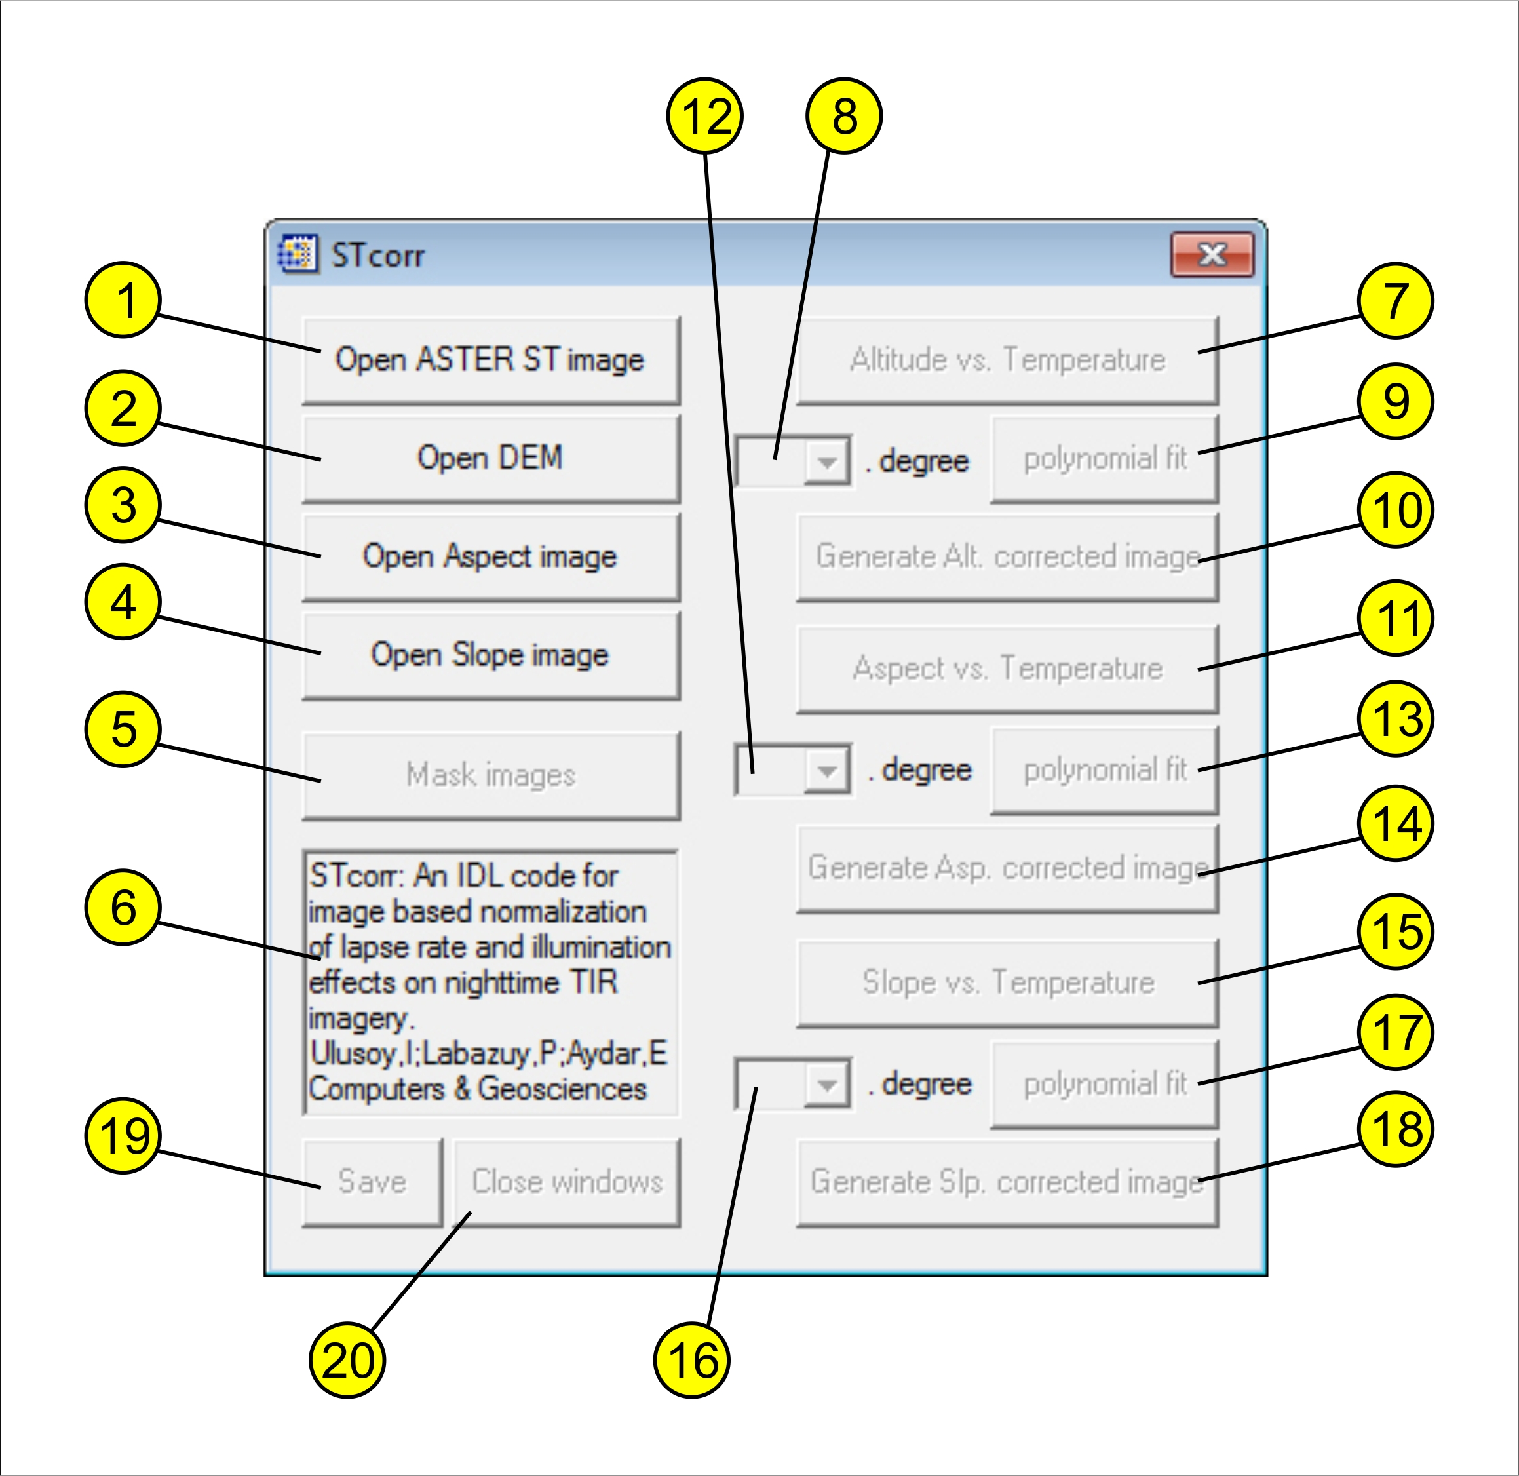
Figure 1. Main window of STcorr.
Step – 2: Masking images
When the input images are loaded, “Mask images” and “Altitude vs. Temperature” buttons (Fig. 1: buttons 5 and 7) are released. Button 5 (Mask images) is used for masking some parts of the images. User can optionally set a mask to apply the input images before the calculation with button 5, or directly start the calculations passing this step. Pressing button 5 will bring forward the “Surface temperature image” window. User can mask the image using mouse buttons. Use left mouse button to select the corner points of the masking polygon and right mouse button to close and finish the masking polygon. When mask polygon is built by the user, three input images are masked and image windows will updated accordingly.
Step – 3: Altitude vs. Temperature graph
Before or after the masking option, using button 7 will draw a graph of Altitude versus Temperature in a new window.

Step – 4: Polynomial fit
The first drop-list (Fig. 1: 8) and “polynomial fit” button (Fig. 1: button 9) are then released. User must choose a polynomial degree to use for the fit equation from the drop-list and press the polynomial fit button to calculate the fit. When the polynomial fit button is pressed, the fit equation with the desired degree will be calculated and will be drawn on the Altitude versus Temperature graph. The chi-square goodness of fit value will appear on the text panel (Fig. 1: 6) of GUI. Polynomial fit image will be shown in a new window. Buttons 10 will then be released.
Step – 5: Generate altitude-corrected image
Using button 10 (Generate altitude-corrected image) will produce the altitude-corrected image. Button 11 to start the aspect correction will be released.
Step – 6: Aspect vs. Altitude corrected Temperature anomaly graph
Button 11 will be used to draw graph of altitude-corrected temperature versus aspect degree. This button will also release second drop-list (Fig. 1: 12) and second polynomial fit button (button 13).
Step – 7: Second Polynomial fit
User chooses a polynomial degree to use for the fit equation from the second drop-list (Fig. 1: 12) and presses the polynomial fit button (button 13) to calculate the second fit. When the polynomial fit button is pressed, the fit equation with the desired degree will be calculated and will be drawn on the Aspect versus Altitude-corrected Temperature graph. The chi-square goodness of fit value will appear on the text panel of GUI. Polynomial fit image will be shown in a new window. Button 14 will be released.
Step – 8: Generate aspect-corrected image
Using button 14 (Generate aspect-corrected image) will produce aspect-corrected image. This action will release button 15
Step – 6: Slope vs. Aspect-corrected Temperature anomaly graph
Button 15 will be used to draw graph of aspect-corrected temperature versus slope degree. This button will also release the third drop-list (Fig. 1: 16) and the third polynomial fit button (button 17).
Step – 7: Third Polynomial fit
User chooses a polynomial degree to use for the fit equation from the third drop-list (Fig. 1: 16) and presses the polynomial fit button (button 17) to calculate the third fit. When the polynomial fit button is pressed, the fit equation with the desired degree will be calculated and will be drawn on the Slope versus Aspect-corrected Temperature graph. The chi-square goodness of fit value will appear on the text panel of GUI. Polynomial fit image will be shown in a new window. Button 18 will be released.
Step – 8: Generate final image
Using button 18 (Generate slope-corrected image) will produce final, slope-corrected image.
Button 19 opens a new window showing the save options. All of the produced images, fit equations and graphs may be saved via this button. Here user may chose the files to be saved.
Using button 20, user may choose to close the image and graph windows produced by the program.

Dr. Inan Ulusoy
Hacettepe University,
Geological Engineering Dept.
Beytepe 06800
Ankara / Turkey

inan@hacettepe.edu.tr

