
MINISTRY OF EDUCATION, CULTURE AND RESEARCH
OF THE REPUBLIC OF MOLDOVA
Technical University of Moldova
Faculty of Computers, Informatics and Microelectronics
Department of Software Engineering and Automation

Ina Pancenco FAF-242

Report
Laboratory Work No.1
Cryptography and Security
Topic: Caesar Cipher

Checked by:
Maia Zaica, university assistant
DISA, FCIM, UTM

Chișinău – 2026
Table of Contents
1 AIM OF THE WORK 3
1.1 Purpose of laboratory work 3
1.2 Problem statement 3
2 THEORETICAL BACKGROUND 4
2.1 The Caesar cipher 4
2.2 The Caesar cipher with a permutation 4
2.3 Key space and security 5
3 IMPLEMENTATION 6
3.1 Tools and project structure 6
3.2 Letter encoding 6
3.3 Input normalization and validation 6
3.4 Building the permuted alphabet 8
3.5 Encryption and decryption 8
3.6 User interface 8
3.7 Verification 9
4 RESULTS 10
4.1 Task 1.1 - Caesar cipher 10
4.2 Task 1.2 - Caesar cipher with a permutation 12
4.3 Invalid input 14
4.4 Brute-force attack on the Caesar cipher 18
CONCLUSION 19
REFERENCES 20

1 AIM OF THE WORK

1.1 Purpose of laboratory work
The purpose of this laboratory work is to understand how the Caesar cipher works, to see why its very small key space makes it insecure, and to strengthen it with a second key - a keyword that permutes the alphabet. Both versions of the algorithm are implemented for the Romanian alphabet of n = 31 letters.
Another objective is to practise careful input handling in a cryptographic program: the letters must be encoded only through the table given in the laboratory guide, the keys must be restricted to their valid ranges, and the user must receive clear messages whenever an invalid value is entered.

1.2 Problem statement
Task 1.1. Implement the Caesar cipher for the Romanian alphabet (A Ă Â B C D E F G H I Î J K L M N O P Q R S Ș T Ț U V W X Y Z) using only the encoding A = 0, Ă = 1, …, Z = 30. The key is an integer from 1 to 30; the text may contain only Romanian letters (upper- or lowercase) and spaces, which are removed. The text is converted to uppercase, the user chooses encryption or decryption, and invalid keys or characters must produce a clear message stating the allowed values, after which the value is requested again.
Task 1.2. Implement the Caesar cipher with two keys under the same conditions: key 1 is the numeric shift (1-30), and key 2 is a keyword of at least 7 Romanian letters, which is used to build a permuted alphabet of all 31 letters. The program must display the permuted alphabet so that the result can be verified by hand.
The implementation was written in Python 3.13. The laboratory guide allows any programming language, so besides a console version a graphical web interface was built with Streamlit for convenient use.

2 THEORETICAL BACKGROUND

2.1 The Caesar cipher
The Caesar cipher is a monoalphabetic substitution cipher in which every letter of the plaintext is replaced by the letter located a fixed number of positions further in the alphabet. The secret key k is this shift value and is the same for encryption and decryption, k ∈ {1, 2, …, n − 1}, where n is the number of letters of the alphabet (k = 0 would leave the text unchanged). If x and y are the numeric codes of a plaintext and a ciphertext letter, encryption and decryption are defined by:
c = eₖ(x) = (x + k) mod n
m = dₖ(y) = (y − k) mod n
The result of the modulo operation must always lie in the range 0 … n − 1. When y − k is negative, n is added to bring the value back into that range; for example, for n = 31, (1 − 3) mod 31 = 29. The method is named after Julius Caesar, who is said to have used it with k = 3.
For the Romanian alphabet n = 31 and the letters are encoded according to Table 2.1. With k = 3, the message “cifrul cezar” becomes CIFRULCEZAR after uppercase conversion and removal of spaces, and is encrypted letter by letter: C (4) → F (7), I (10) → K (13), …, R (20) → T (23), giving FKITXOFHÂBT.
Letter | A | Ă | Â | B | C | D | E | F | G | H | I | Î | J | K | L | M
Code | 0 | 1 | 2 | 3 | 4 | 5 | 6 | 7 | 8 | 9 | 10 | 11 | 12 | 13 | 14 | 15
Letter | N | O | P | Q | R | S | Ș | T | Ț | U | V | W | X | Y | Z
Code | 16 | 17 | 18 | 19 | 20 | 21 | 22 | 23 | 24 | 25 | 26 | 27 | 28 | 29 | 30
Table 2.1 Letter encoding of the Romanian alphabet (n = 31)

2.2 The Caesar cipher with a permutation
To increase the strength of the cipher, a second key - a keyword k₂ - is used to permute the alphabet. The new order is obtained by writing the letters of the keyword first, keeping only the first occurrence of each letter, followed by the remaining letters of the alphabet in their natural order. The Caesar shift is then applied in this permuted alphabet, i.e. the numeric code of a letter becomes its position in the permuted alphabet, and the same formulas c = (x + k₁) mod n and m = (y − k₁) mod n are used.
For example, the keyword k₂ = CRIPTOGRAFIE contributes the 10 distinct letters C, R, I, P, T, O, G, A, F, E (the second R and the second I are dropped), after which the other 21 letters follow in the order of Table 2.1. The resulting permuted alphabet is shown in Table 2.2.
Pos. | 0 | 1 | 2 | 3 | 4 | 5 | 6 | 7 | 8 | 9 | 10 | 11 | 12 | 13 | 14 | 15
Letter | C | R | I | P | T | O | G | A | F | E | Ă | Â | B | D | H | Î
Pos. | 16 | 17 | 18 | 19 | 20 | 21 | 22 | 23 | 24 | 25 | 26 | 27 | 28 | 29 | 30
Letter | J | K | L | M | N | Q | S | Ș | Ț | U | V | W | X | Y | Z
Table 2.2 Permuted alphabet for k₂ = CRIPTOGRAFIE
With k₁ = 3, the letter C (position 0) is replaced by the letter at position 3, which is P, and I (position 2) becomes the letter at position 5, O. The plaintext CIFRULCEZAR is encrypted as POÂTXQPBIĂT, whereas the simple Caesar cipher with the same shift gave FKITXOFHÂBT.

2.3 Key space and security
The simple Caesar cipher has only n − 1 possible keys: 25 for the English alphabet and 30 for the Romanian alphabet. A cryptanalyst can therefore try every key in turn (exhaustive search, or brute-force attack); exactly one of the candidate texts will be readable in the language of the message.
For the Caesar cipher with a permutation, the second key may produce any of the n! orderings of the alphabet, so the number of key pairs (k₁, k₂) for the Romanian alphabet is:
31! × 30 = 8 222 838 654 177 922 817 725 562 880 000 000 × 30 ≈ 2.47 × 10³⁶
Such a key space makes exhaustive search impractical, but it does not protect against frequency analysis: each plaintext letter is always replaced by the same ciphertext letter, so the letter frequencies of the language remain visible in the ciphertext. Moreover, different key pairs can produce the same substitution, so the number of distinct encryptions cannot exceed 31!.

3 IMPLEMENTATION

3.1 Tools and project structure
The laboratory work was implemented in Python 3.13. All laboratory works of the course share one virtual environment (.venv) and one requirements.txt in the root of the repository; the only external packages are Streamlit (web interface) and pandas (tables). The project contains the following files:
File | Purpose
Lab1/caesar.py | Cipher logic: letter encoding, input validation, permuted alphabet, encryption and decryption
Lab1/app.py | Streamlit interface with tabs for Task 1.1, Task 1.2 and a brute-force demonstration
Lab1/cli.py | Console version that asks for a value again until it is valid
requirements.txt | Dependencies shared by all labs (streamlit, pandas)
Table 3.1 Project structure
The application is started with the following commands (from the repository root):
.venv\Scripts\activate
pip install -r requirements.txt
streamlit run Lab1/app.py # web interface
python Lab1/cli.py # console version

3.2 Letter encoding
# Table 2 - letter encoding of the Romanian alphabet
ALPHABET = [
"A", "Ă", "Â", "B", "C", "D", "E", "F", "G", "H", "I",
"Î", "J", "K", "L", "M", "N", "O", "P", "Q", "R", "S",
"Ș", "T", "Ț", "U", "V", "W", "X", "Y", "Z",
]
N = len(ALPHABET) # 31
CODE = {letter: i for i, letter in enumerate(ALPHABET)}

KEY_MIN, KEY_MAX = 1, N - 1
KEYWORD_MIN_LEN = 7

The Romanian alphabet is stored as a list in the exact order of Table 2.1, so the index of a letter in the list is its code. The dictionary CODE gives the reverse mapping letter → code. All shifts are computed only with these positions; ASCII or Unicode code points of the characters are never used, as required by the task. The key range (1 … n − 1) and the minimum keyword length are defined as constants.

3.3 Input normalization and validation
# Ș/Ț are often typed with a cedilla (Ş/Ţ) instead of a comma below
CEDILLA_TO_COMMA = {"Ş": "Ș", "ş": "ș", "Ţ": "Ț", "ţ": "ț"}

def normalize(text: str) -> str:
"""Compose diacritics, map cedilla variants to comma-below, convert to uppercase."""
text = unicodedata.normalize("NFC", text)
text = "".join(CEDILLA_TO_COMMA.get(ch, ch) for ch in text)
return text.upper()

Before validation, the text is normalized: Unicode NFC composition joins letters typed as a base letter plus a combining diacritic into one character, the cedilla variants Ş/Ţ (often produced by older keyboards) are replaced by the correct comma-below letters Ș/Ț, and the text is converted to uppercase.
def validate_key(raw) -> int:
"""Return the shift key as an int in [1, 30] or raise ValueError with a clear message."""
raw = str(raw).strip()
try:
key = int(raw)
except ValueError:
raise ValueError(
f"Invalid key '{raw}': the key must be an integer between {KEY_MIN} and {KEY_MAX} inclusive."
) from None
if not KEY_MIN <= key <= KEY_MAX:
raise ValueError(
f"Invalid key {key}: the key must be an integer between {KEY_MIN} and {KEY_MAX} inclusive."
)
return key

validate_key accepts the key as text (exactly as typed by the user), converts it to an integer and checks that it lies between 1 and 30. A non-numeric value or a value outside the range raises a ValueError whose message states the allowed range.
def prepare_text(raw: str) -> str:
"""Uppercase the text, remove spaces and check that every character is a Romanian letter."""
text = "".join(normalize(raw).split())
for pos, ch in enumerate(text, start=1):
if ch not in CODE:
raise ValueError(f"Invalid character '{ch}' at position {pos}. {ALLOWED_TEXT_MSG}")
if not text:
raise ValueError(f"The text is empty. {ALLOWED_TEXT_MSG}")
return text

prepare_text removes all spaces and checks every remaining character against the alphabet. The first invalid character is reported together with its position and the list of allowed letters. An empty text is rejected too.
def validate_keyword(raw: str) -> str:
"""Return the uppercase keyword (letters only, length >= 7) or raise ValueError."""
keyword = normalize(raw.strip())
for pos, ch in enumerate(keyword, start=1):
if ch not in CODE:
raise ValueError(
f"Invalid character '{ch}' at position {pos} in the keyword. The keyword may contain "
f"only letters of the Romanian alphabet (A-Z, Ă, Â, Î, Ș, Ț), without spaces."
)
if len(keyword) < KEYWORD_MIN_LEN:
raise ValueError(
f"The keyword is too short ({len(keyword)} letters): it must contain at least "
f"{KEYWORD_MIN_LEN} letters of the Romanian alphabet."
)
return keyword

validate_keyword checks that the keyword contains only Romanian letters (no spaces, digits or symbols) and has at least 7 letters. Like the text, it is converted to uppercase before use.

3.4 Building the permuted alphabet
def permuted_alphabet(keyword: str) -> list[str]:
"""Distinct letters of the keyword first, then the remaining letters in Table 2 order."""
result = []
for ch in keyword + "".join(ALPHABET):
if ch not in result:
result.append(ch)
return result

The function walks through the keyword followed by the whole alphabet and adds each letter only the first time it appears. As a result, the distinct letters of the keyword come first and the remaining letters keep the order of Table 2.1, giving a permutation of all 31 letters.

3.5 Encryption and decryption
def shift(text: str, key: int, alphabet=ALPHABET) -> str:
"""Replace every letter x with the letter at position (x + key) mod n of the given alphabet."""
n = len(alphabet)
position = {letter: i for i, letter in enumerate(alphabet)}
# Python's % always returns a value in 0..n-1, even for negative operands
return "".join(alphabet[(position[ch] + key) % n] for ch in text)

def encrypt(text: str, key: int, alphabet=ALPHABET) -> str:
return shift(text, key, alphabet) # c = (x + k) mod n

def decrypt(text: str, key: int, alphabet=ALPHABET) -> str:
return shift(text, -key, alphabet) # m = (y - k) mod n

Both tasks use the same function shift. It receives the alphabet to work with - the standard alphabet for Task 1.1 or the permuted alphabet for Task 1.2 - builds the position table for it and replaces each letter by the letter at position (x + k) mod n. Decryption is a shift by −k. In Python the % operator always returns a non-negative result for a positive modulus, so (y − k) mod n is automatically brought into the range 0 … 30 (for example, (1 − 3) % 31 = 29); in languages such as C or Java this case would need an explicit correction.

3.6 User interface
The Streamlit interface (app.py) contains three tabs. In the tabs for Task 1.1 and Task 1.2 the user selects the operation (encryption or decryption), enters the key(s) and the message and presses Run. The program displays the prepared input (uppercase, without spaces), the result and a substitution table showing for each position x the plaintext letter, the value (x + k) mod n and the ciphertext letter. For Task 1.2 the permuted alphabet is displayed as well. The third tab demonstrates the brute-force attack on the simple Caesar cipher by decrypting a ciphertext with all 30 keys.
errors = []
for validator, raw in ((validate_key, raw_key2), (validate_keyword, raw_kw), (prepare_text, raw_text2)):
try:
validator(raw)
except ValueError as err:
errors.append(str(err))
for e in errors:
st.error(e)
if errors:
st.info("Please correct the value(s) above and press **Run** again.")

Keys are entered in ordinary text fields (not in number widgets that would silently block invalid input), so every invalid value reaches the validation functions. All errors are collected and shown at once in red boxes, and the user is asked to correct the values and run the operation again.
def ask(prompt, validator):
while True:
try:
return validator(input(prompt))
except ValueError as err:
print(f" Error: {err}\n")

In the console version the same validation functions are used inside a loop: if a value is invalid, the error message is printed and the same value is requested again, as required in the task.

3.7 Verification
Before testing the Romanian version, the shift function was run with the English alphabet to reproduce the examples of the laboratory guide: CIFRULCEZAR with k = 3 gives FLIUXOFHCDU, with k₁ = 3 and k₂ = CRYPTOGRAPHY it gives PLKTXQPJYDT, and BRUTEFORCEATTACK with k = 17 gives SILKVWFITVRKKRTB - all identical to the guide. Additionally, it was checked that decrypt(encrypt(m, k), k) = m for every key from 1 to 30 in both versions, including texts containing the letters Ă, Â, Î, Ș, Ț and the wrap-around from Z to A.

4 RESULTS

4.1 Task 1.1 - Caesar cipher
Figure 4.1 shows the encryption of the message “cifrul cezar” with the key k = 3. The text is converted to CIFRULCEZAR and the ciphertext FKITXOFHÂBT is obtained. The substitution table confirms the wrap-around at the end of the alphabet (X → A, Y → Ă, Z → Â).
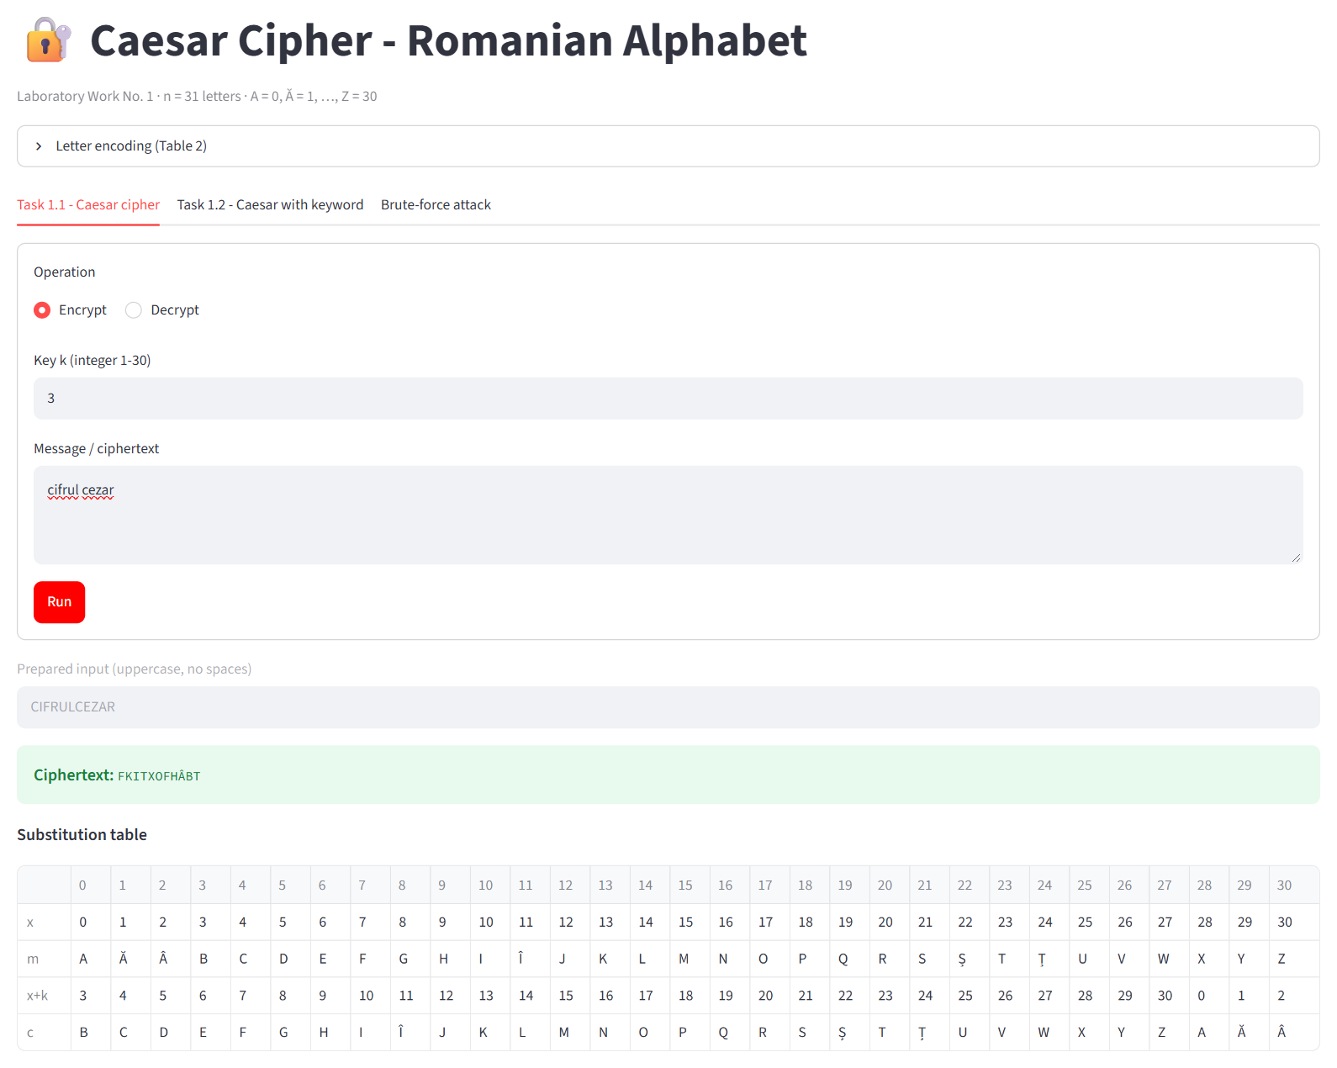
Figure 4.1 Task 1.1 - encryption of “cifrul cezar” with k = 3
Decrypting FKITXOFHÂBT with the same key restores the original message CIFRULCEZAR (Figure 4.2).
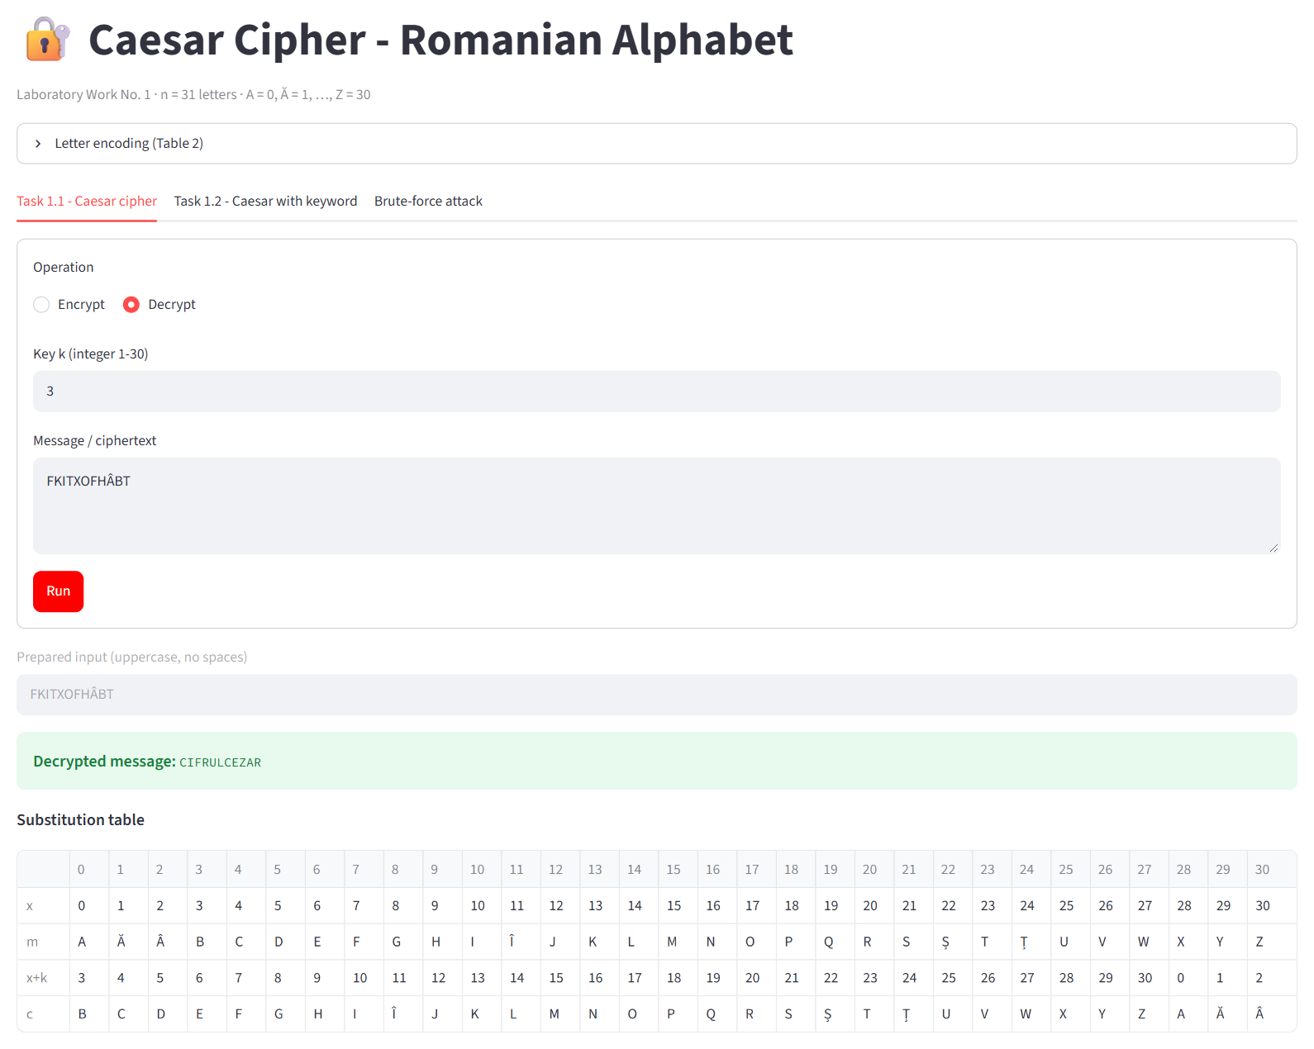
Figure 4.2 Task 1.1 - decryption of FKITXOFHÂBT with k = 3
Figure 4.3 shows a message with Romanian diacritics typed partly with the cedilla variants (Ştiinţa) and partly with comma-below letters (și țara). Both forms are accepted and treated as the same letters Ș and Ț.
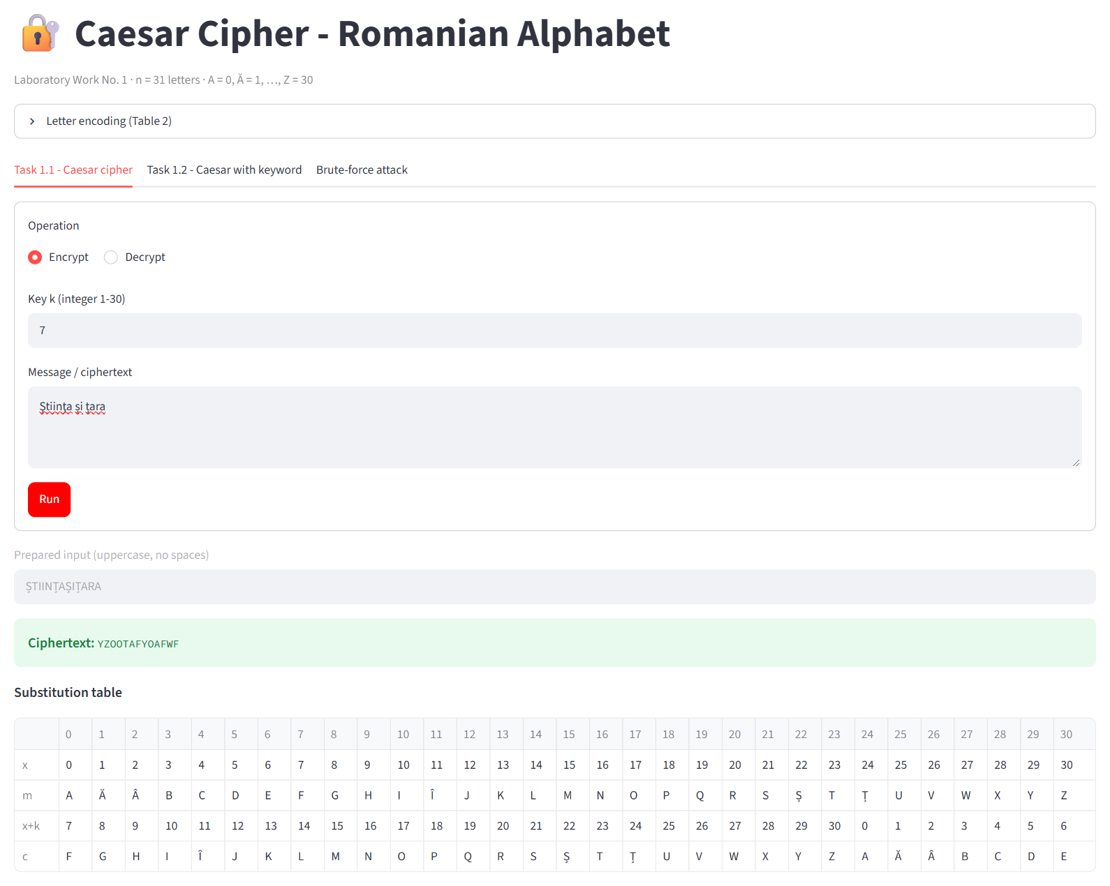
Figure 4.3 Task 1.1 - text with diacritics (cedilla and comma-below variants), k = 7

4.2 Task 1.2 - Caesar cipher with a permutation
For Task 1.2 the keys k₁ = 3 and k₂ = criptografie were used. The program displays the permuted alphabet CRIPTOGAFEĂÂBDHÎJKLMNQSȘȚUVWXYZ (identical to Table 2.2) and encrypts CIFRULCEZAR as POÂTXQPBIĂT (Figure 4.4).
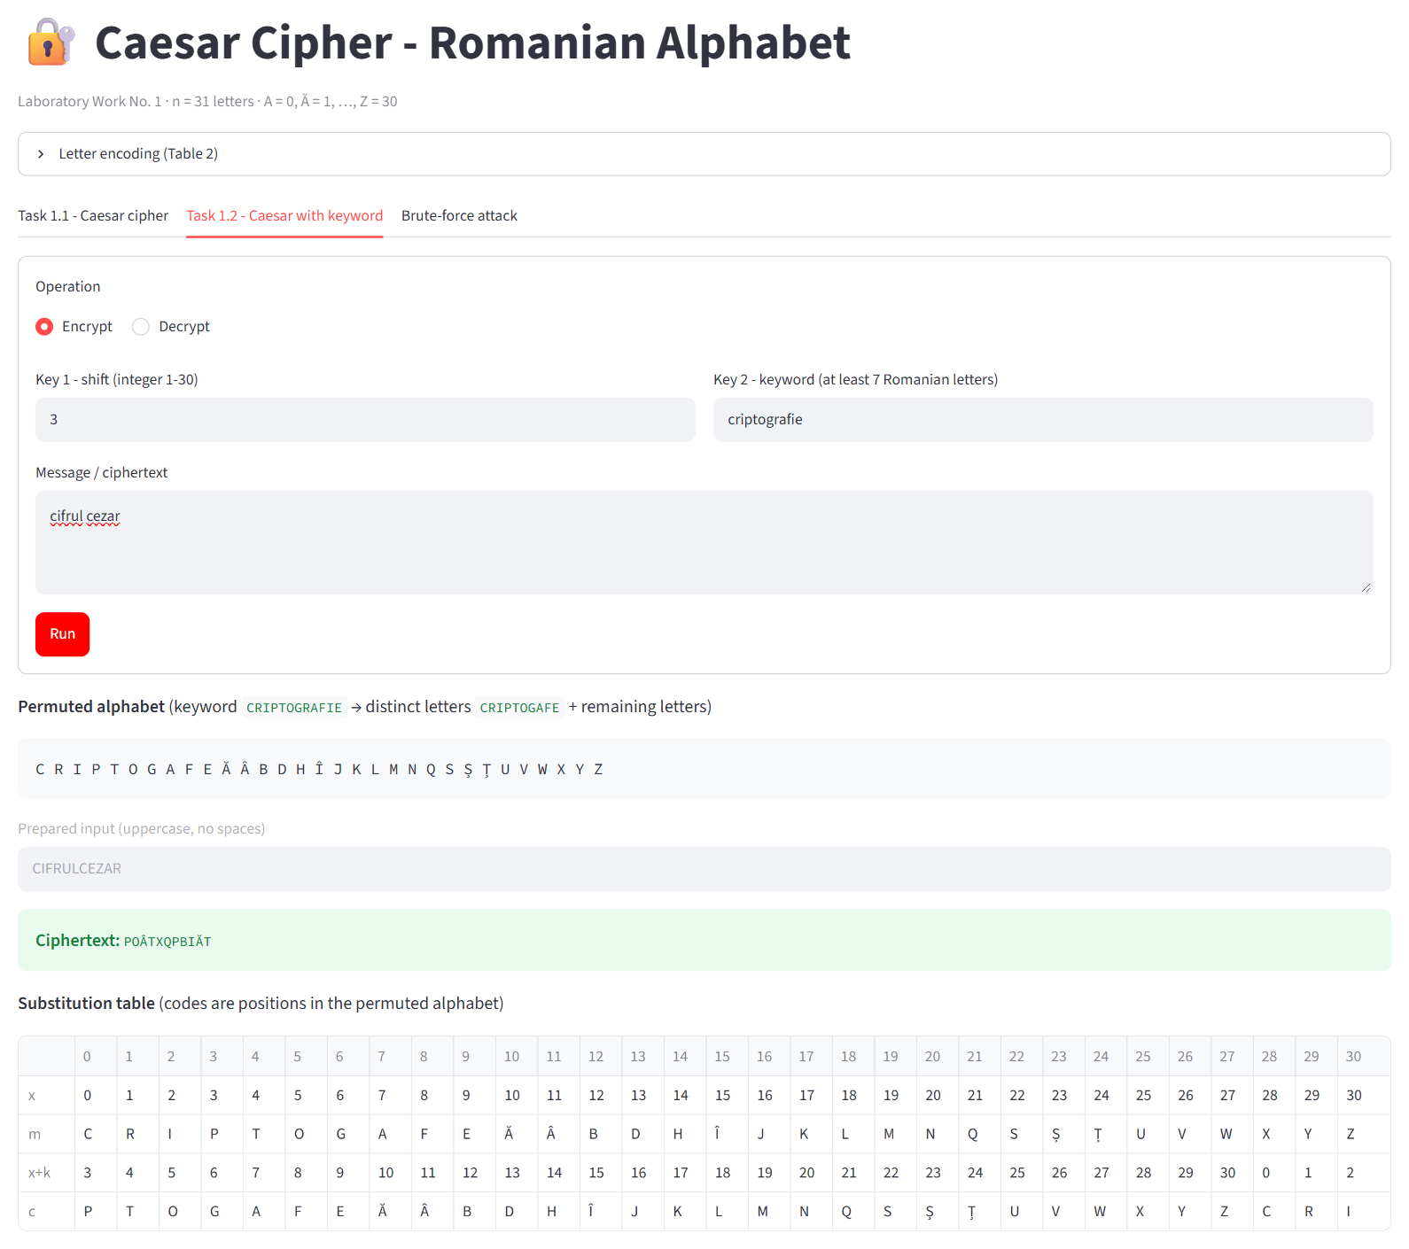
Figure 4.4 Task 1.2 - encryption with k₁ = 3, k₂ = CRIPTOGRAFIE
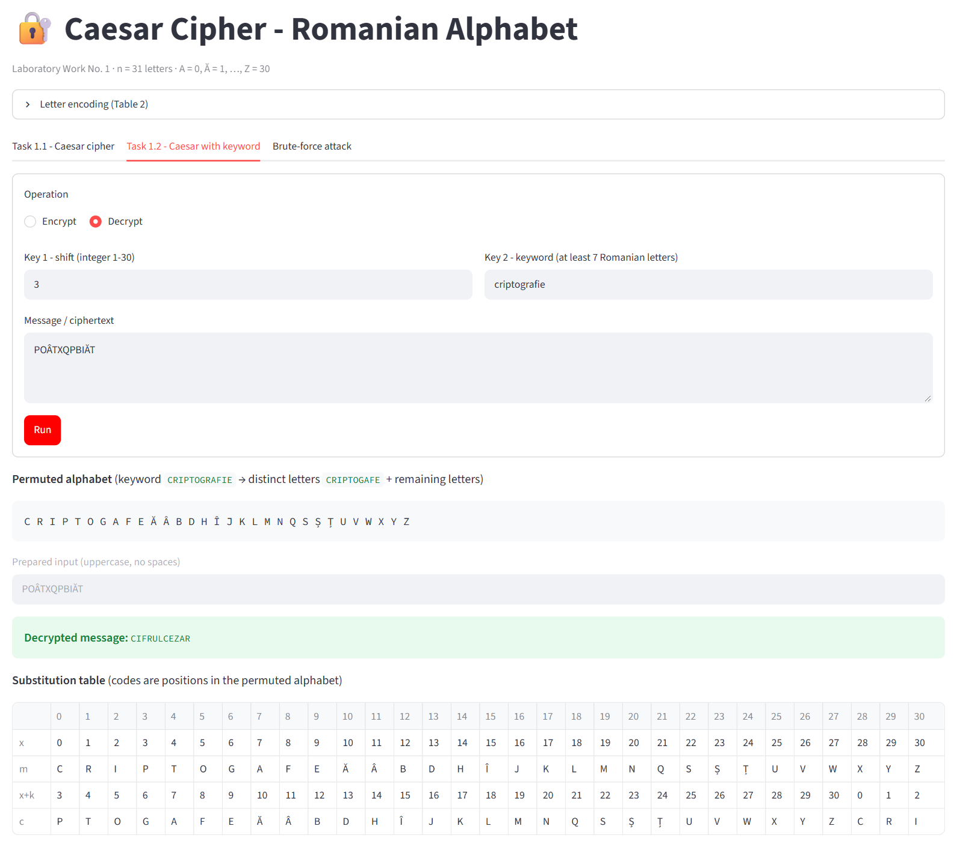
Figure 4.5 Task 1.2 - decryption of POÂTXQPBIĂT with k₁ = 3, k₂ = CRIPTOGRAFIE

4.3 Invalid input
The following figures show the messages displayed for invalid input: a key outside the range 1-30, a key that is not an integer, a text containing characters that are not Romanian letters, and a keyword that is too short. In each case the operation is not performed, the message states the allowed values and the user is asked to enter the value again.
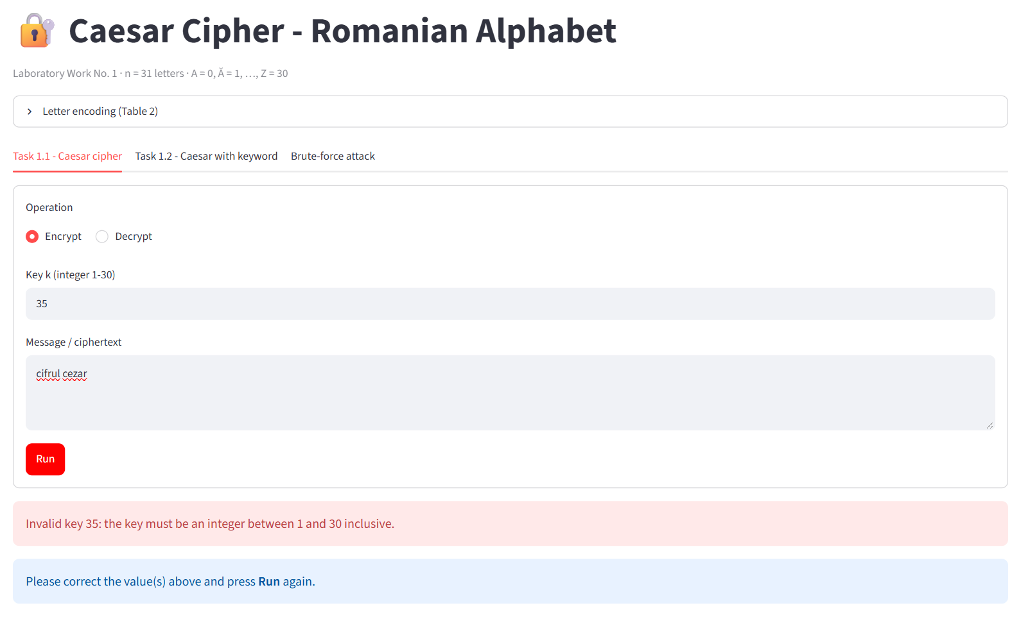
Figure 4.6 Key outside the allowed range (k = 35)
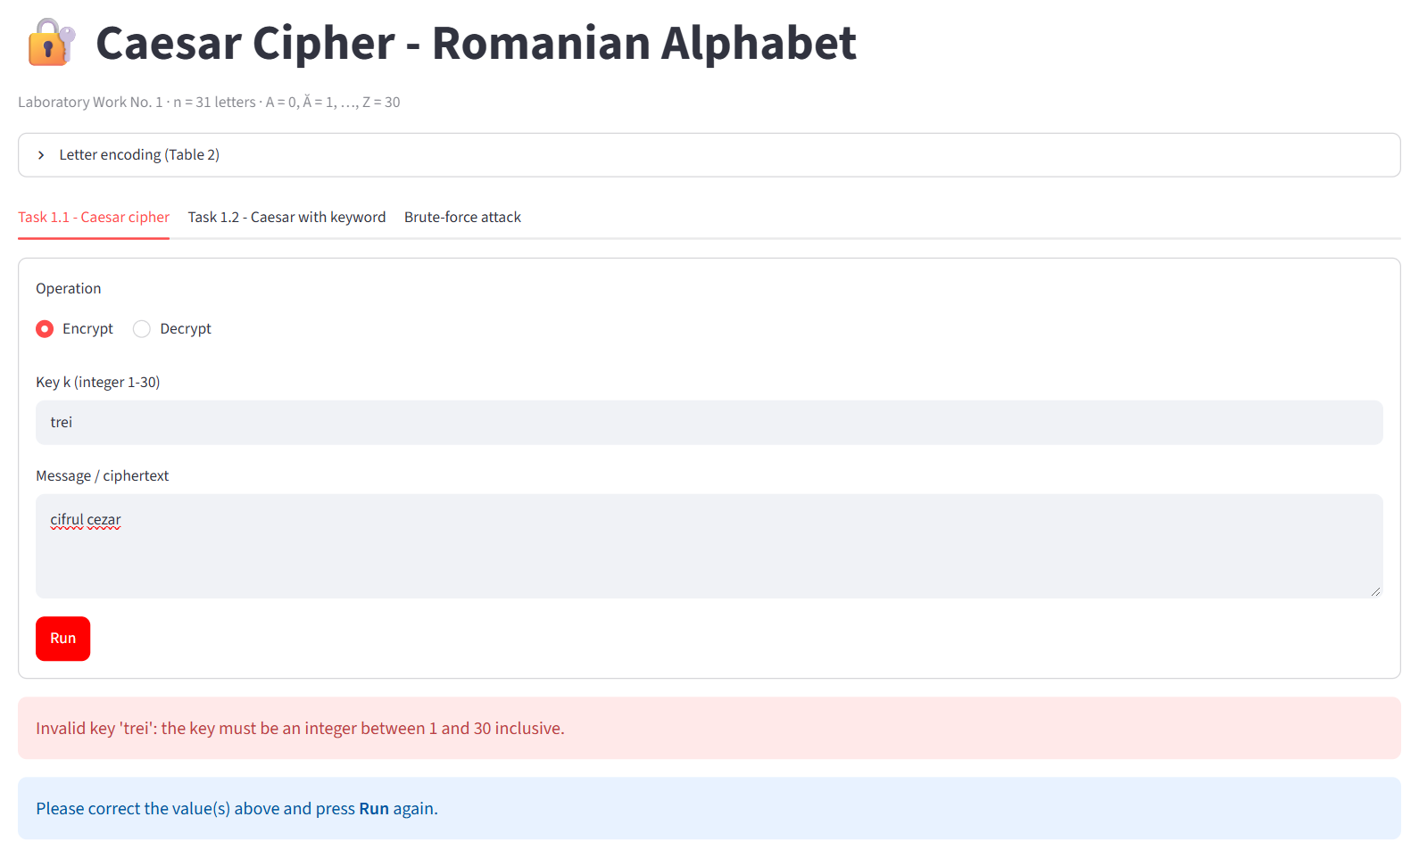
Figure 4.7 Key that is not an integer (“trei”)
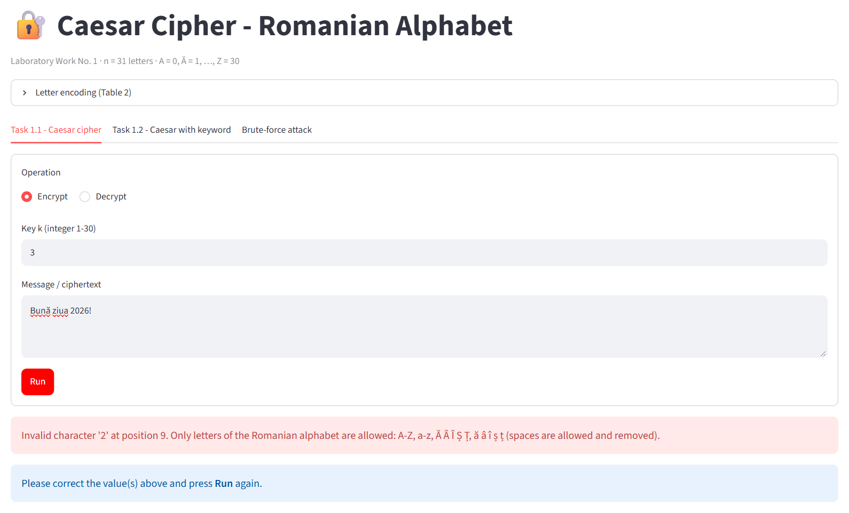
Figure 4.8 Text containing an invalid character
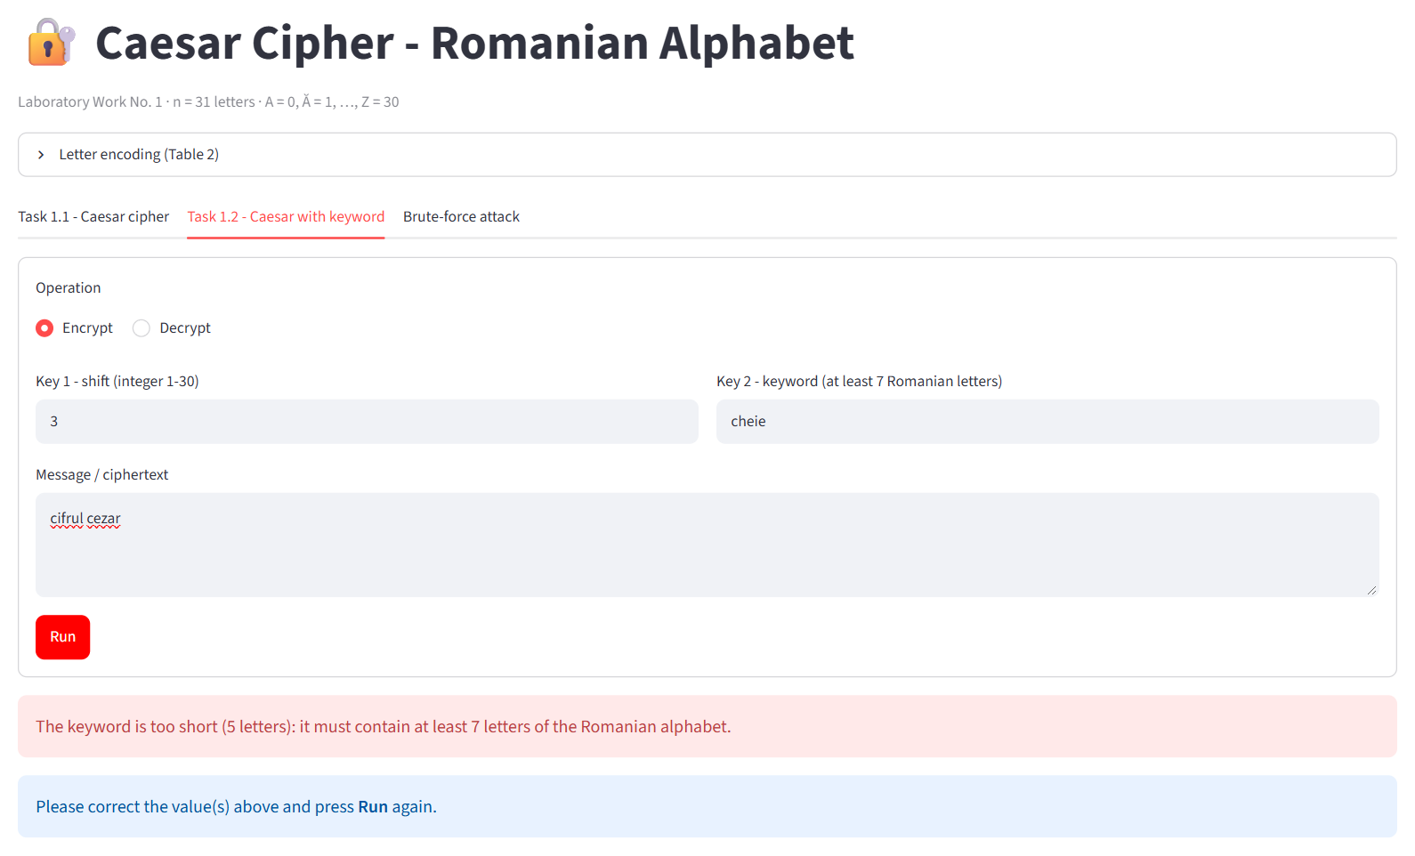
Figure 4.9 Keyword that is too short (“cheie”, 5 letters)
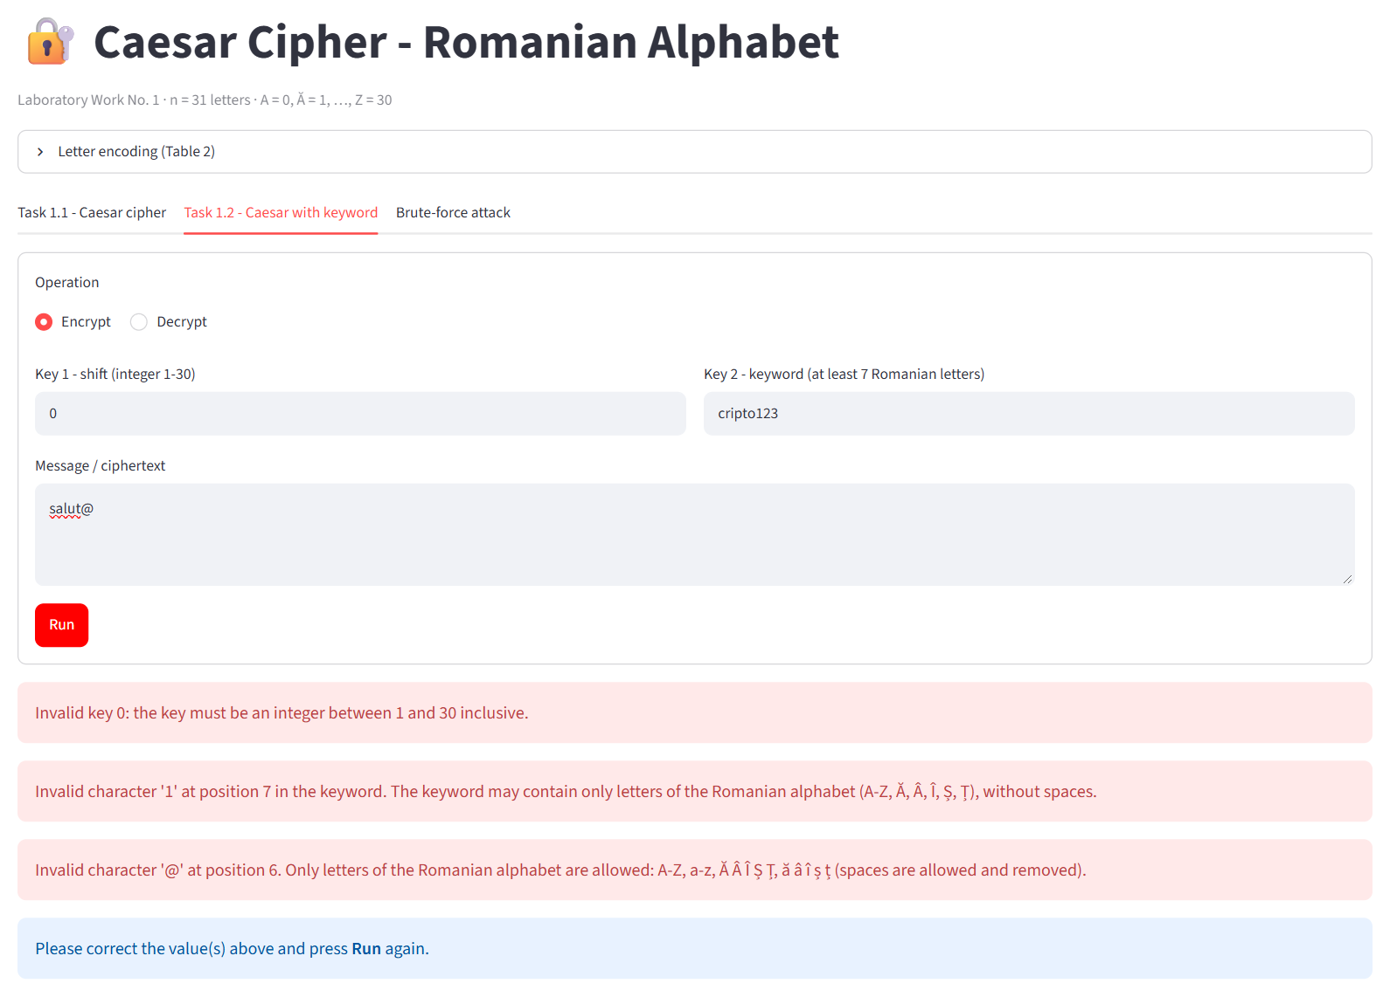
Figure 4.10 Several invalid values at once in Task 1.2
The console version behaves in the same way and asks for each value again until it is valid:
Task: 1
Operation - (e)ncrypt or (d)ecrypt: e
Key 1 (integer 1..30): 0
Error: Invalid key 0: the key must be an integer between 1 and 30 inclusive.
Key 1 (integer 1..30): 3
Message: cifrul cezar!
Error: Invalid character '!' at position 12. Only letters of the Romanian alphabet are
allowed: A-Z, a-z, Ă Â Î Ș Ț, ă â î ș ț (spaces are allowed and removed).
Message: cifrul cezar
Prepared input: CIFRULCEZAR
Ciphertext: FKITXOFHÂBT
Task: 2
Operation - (e)ncrypt or (d)ecrypt: d
Key 1 (integer 1..30): 3
Key 2 - keyword (min. 7 Romanian letters): cheie
Error: The keyword is too short (5 letters): it must contain at least 7 letters of the
Romanian alphabet.
Key 2 - keyword (min. 7 Romanian letters): criptografie
Permuted alphabet:
0 1 2 3 4 5 6 7 8 9 10 11 12 13 14 15 16 17 18 19 20 21 22 23 24 25 26 27 28 29 30
C R I P T O G A F E Ă Â B D H Î J K L M N Q S Ș Ț U V W X Y Z
Ciphertext: POÂTXQPBIĂT
Decrypted message: CIFRULCEZAR
Listing 4.1 Console version - invalid input and correct results

4.4 Brute-force attack on the Caesar cipher
To illustrate the weakness of the simple Caesar cipher, the ciphertext FKITXOFHÂBT was decrypted with all 30 possible keys (Figure 4.11). Only the key k = 3 produces meaningful Romanian text (CIFRULCEZAR), so the message is recovered without knowing the key.
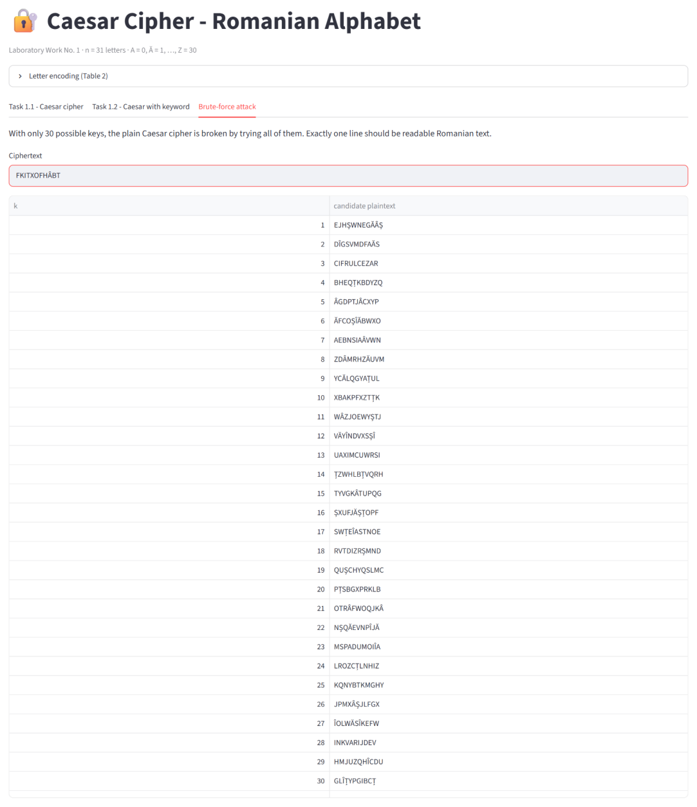
Figure 4.11 Brute-force attack - all 30 candidate decryptions

CONCLUSION
In this laboratory work the Caesar cipher and its strengthened version with a keyword-based permutation of the alphabet were studied and implemented in Python for the Romanian alphabet of 31 letters. The letters were encoded strictly according to the table from the laboratory guide, the keys and the text were validated, and clear messages were displayed for every kind of invalid input. Besides the console version, a Streamlit web interface was created, which shows the permuted alphabet and the complete substitution table, so that every result can be checked by hand.
The experiments confirmed that the simple Caesar cipher offers practically no security: with only 30 possible keys, the brute-force attack recovers the message instantly, since exactly one candidate is readable text. The version with a permuted alphabet increases the key space to 31! × 30 ≈ 2.47 × 10³⁶ key pairs, which makes exhaustive search impossible in practice. However, both versions remain monoalphabetic substitution ciphers: each letter is always replaced by the same letter, so the frequency distribution of the language is preserved and the cipher can be broken by frequency analysis given a sufficiently long ciphertext.
The work also showed the importance of details that are easy to overlook in cryptographic software: handling negative values of the modulo operation, using a well-defined letter encoding instead of the character codes of the programming language, and accepting different encodings of the same letter (Ș/Ş, Ț/Ţ). The main lesson is that a large key space is necessary but not sufficient for security - the cipher must also hide the statistical structure of the plaintext.

REFERENCES
- Laboratory Work No. 1. Caesar Cipher - laboratory guide, Cryptography and Security, Technical University of Moldova, 2026.
- Stallings, W. (2017). Cryptography and Network Security: Principles and Practice (7th ed.). Pearson.
- Katz, J., & Lindell, Y. (2020). Introduction to Modern Cryptography (3rd ed.). CRC Press.
- Singh, S. (1999). The Code Book: The Science of Secrecy from Ancient Egypt to Quantum Cryptography. Doubleday.
- Python Software Foundation. unicodedata - Unicode Database. Retrieved from https://docs.python.org/3/library/unicodedata.html
- Streamlit Inc. Streamlit documentation. Retrieved from https://docs.streamlit.io/
- Source code for the laboratory work https://github.com/inap235/CS_Labs.git

