
MINISTRY OF EDUCATION, CULTURE AND RESEARCH
OF THE REPUBLIC OF MOLDOVA
Technical University of Moldova
Faculty of Computers, Informatics and Microelectronics
Department of Software Engineering and Automation

Ina Pancenco FAF-242

Report
Laboratory Work No.3
Cryptography and Security
Topic: Polyalphabetic Ciphers. The Playfair Cipher
Variant 17 (Task 3.1)

Checked by:
Maia Zaica, university assistant
DISA, FCIM, UTM

Chișinău – 2026
Table of Contents
1 AIM OF THE WORK 3
1.1 Purpose of laboratory work 3
1.2 Problem statement 3
2 THEORETICAL BACKGROUND 4
2.1 Polyalphabetic ciphers 4
2.2 The Playfair cipher 4
2.3 Preparing the text 4
2.4 The encryption matrix 5
2.5 Encryption and decryption rules 5
2.6 Security of the Playfair cipher 6
3 ADAPTING THE CIPHER TO THE ROMANIAN ALPHABET 7
3.1 Alphabet and size of the matrix 7
3.2 Validation and normalization of the input 7
3.3 Filler letters 7
4 IMPLEMENTATION 9
4.1 Tools and project structure 9
4.2 Alphabet and validation 10
4.3 Building the matrix 11
4.4 Splitting the text into pairs 12
4.5 Encryption and decryption of a pair 13
4.6 The manual phase 13
4.7 User interfaces 14
4.8 Testing 14
5 RESULTS 15
5.1 Encryption 15
5.2 Decryption 16
5.3 Console version 17
5.4 Validation of the input 18
CONCLUSION 20
REFERENCES 21

1 AIM OF THE WORK

1.1 Purpose of laboratory work
The purpose of this laboratory work is to study polyalphabetic substitution ciphers and, in particular, the Playfair digraph cipher: how the text is prepared, how the encryption matrix is built from a key and how pairs of letters are encrypted and decrypted with the three rules of the algorithm.
A second objective is to adapt a classical algorithm, designed for the 26-letter English alphabet and a 5×5 matrix, to the 31 letters of the Romanian alphabet, and to implement it as a program that validates the user's input and shows every intermediate step of the computation.

1.2 Problem statement
The laboratory guide contains two tasks: Task 3.1 (the Playfair cipher) for students with an odd number in the group register and Task 3.2 (the Vigenère cipher) for students with an even number. The number in the register is 17 (the same as the variant of Laboratory Work No. 2), so Task 3.1 was implemented.
Task 3.1. Implement the Playfair algorithm in a programming language for messages in Romanian (31 letters). The characters of the text are between 'A' and 'Z', 'a' and 'z', and no other values are allowed; if the user enters other values, the correct range of characters must be suggested. The length of the key must not be smaller than 7. The user chooses the operation - encryption or decryption -, enters the key and the message or the cryptogram, and obtains the cryptogram or the decrypted message. The final phase of adding new spaces, according to the language and the logic of the message, is done manually.
The program was written in Python 3.13, in the same repository as the previous laboratory works. It has a console version and a Streamlit web interface; both use the same module with the algorithm.

2 THEORETICAL BACKGROUND

2.1 Polyalphabetic ciphers
The weakness of monoalphabetic ciphers (Laboratory Works No. 1 and 2) is that their frequency distribution reflects the distribution of the alphabet used: a letter is always replaced by the same letter, so the most frequent ciphertext letters correspond to the most frequent plaintext letters. A cipher is cryptographically stronger if its distribution is as flat as possible and gives no information to the cryptanalyst.
One way to flatten the distribution is to combine high and low frequencies: if a frequent letter (T) is sometimes encrypted as a and sometimes as b, and a rare letter (X) is also sometimes encrypted as a and sometimes as b, the result is a more moderate frequency for both a and b. In polyalphabetic ciphers the substitution of a character varies in the text depending on various parameters - its position, its context, etc. This leads to a much larger number of possible keys.
The best-known example is the Vigenère cipher (Task 3.2), which uses several Caesar shifts given by the letters of a key word: cᵢ = (mᵢ + kᵢ) mod n and mᵢ = (cᵢ − kᵢ) mod n. In the Playfair cipher the substitution of a letter depends on its context - on the other letter of the pair it belongs to - so the same plaintext letter is encrypted differently in different pairs.

2.2 The Playfair cipher
Although it bears the name of Baron Lyon Playfair, the algorithm was invented by his friend Charles Wheatstone and was first described in a document of 26 March 1854. It was initially rejected by the British Foreign Office as too difficult to understand; Playfair later convinced the government to adopt it, which is why it bears his name. It was used by the British army in the Boer War, and modified versions were used in World War I and by the Australian army in World War II.
Playfair is a digraph substitution cipher: it encrypts pairs of letters, not single letters. It is obsolete today - a computer finds the key in seconds - but it is one of the first algorithms that uses the principles of modern block ciphers: the plaintext is split into blocks (of two letters), and every block is transformed as a whole by a key-dependent function.
Encryption consists of three stages: a) preparing the text to be encrypted, b) building the encryption matrix and c) building the encrypted message.

2.3 Preparing the text
All letters are written in uppercase, without spaces and punctuation, and are split into pairs. Because the matrix of the classical cipher has only 25 cells, the letter J is replaced by I. Then:
– if the two letters of a pair are identical, a rare letter ('Q', 'X' or 'Z' in English) is inserted between them and the splitting continues from the second letter. For example, FR EE DO M becomes FR EX ED OM;
– if the prepared text has an odd number of letters, an additional letter chosen by the person who encrypts is added at the end.
The rule for double letters is necessary because the encryption rules are not defined for a pair of identical letters. It also hides double letters, which are frequent in English and would help a cryptanalyst (for example in words such as miss or missing).

2.4 The encryption matrix
The repeated letters are removed from the key, starting with their second occurrence; for example the key dublura becomes dublra, and the key First Amendment becomes FIRSTAMEND. The matrix is filled row by row, starting from the upper-left corner, first with the letters of the processed key and then with the remaining letters of the alphabet in alphabetical order (Table 2.1).
 | 0 | 1 | 2 | 3 | 4
0 | F | I | R | S | T
1 | A | M | E | N | D
2 | B | C | G | H | K
3 | L | O | P | Q | U
4 | V | W | X | Y | Z
Table 2.1 Encryption matrix of the guide for the key First Amendment (5×5)
For an alphabet with a different number of letters the matrix can have other dimensions - 6×5, 5×6, 6×4, 4×6 etc. If there are not enough cells for all letters, a letter is replaced by another one (J by I) or the rarest letter of the language is eliminated and restored intuitively during decryption; if there are more cells than letters, the free cells can be filled with any symbols. The longer the key, the harder the ciphertext is to cryptanalyze.

2.5 Encryption and decryption rules
Every pair of letters is replaced by another pair according to the position of the two letters in the matrix (Table 2.2). The examples refer to the matrix in Table 2.1.
Position of the letters | Encryption | Decryption | Example
different rows and columns (rectangle) | each letter is replaced by the letter in the same row and in the column of the other letter | the same as encryption | NP → EQ
same row | each letter is replaced by the next one to the right; the last letter of the row by the first one | the letter to the left; the first letter of the row by the last one | IT → RF
same column | each letter is replaced by the letter below; the last letter of the column by the first one | the letter above; the first letter of the column by the last one | CW → OI
Table 2.2 The rules of the Playfair cipher
Decryption reverses all the steps: the ciphertext is split into pairs, the same matrix is built from the same key and the rules are applied in the opposite direction. The result still contains the inserted filler letters and has no spaces; these are removed and added by a human, according to the language and the meaning of the message.

2.6 Security of the Playfair cipher
Compared with a monoalphabetic cipher, Playfair has several advantages:
– the units of encryption are pairs: instead of 26 letters there are 25·24 = 600 possible digraphs for the English matrix and 30·29 = 870 for the Romanian 5×6 matrix, so frequency analysis of single letters does not work;
– the same letter is encrypted differently depending on its pair, and the letter frequencies of the ciphertext are flatter than in the plaintext;
– the key is a permutation of the matrix: 25! ≈ 1.55·10²⁵ matrices for English and 30! ≈ 2.65·10³² for the Romanian matrix (fewer distinct keys, since cyclic shifts of rows and columns give equivalent matrices).
Its weaknesses, which make it breakable with pen and paper in minutes and by a computer in seconds:
– the digraph statistics of the language are kept: frequent digraphs (TH, HE, … in English; DE, RE, ȘI, … in Romanian) produce frequent ciphertext digraphs;
– if AB → XY then BA → YX, so reversed words such as receiver / departed keep a visible pattern;
– a letter is never encrypted into itself and a ciphertext pair never contains two identical letters;
– a ciphertext letter is always in the same row or in the same column as the plaintext letter it replaces, which strongly limits the candidates, and the key can be found by hill climbing or simulated annealing with digraph or quadgram statistics, starting from a few hundred letters of ciphertext.

3 ADAPTING THE CIPHER TO THE ROMANIAN ALPHABET

3.1 Alphabet and size of the matrix
The Romanian alphabet has 31 letters. They are used in the same order as in Laboratory Work No. 1 (Table 3.1).
A | Ă | Â | B | C | D | E | F | G | H | I | Î | J | K | L | M
N | O | P | Q | R | S | Ș | T | Ț | U | V | W | X | Y | Z
Table 3.1 The 31 letters of the Romanian alphabet, in order
31 is a prime number, so there is no rectangular matrix that contains exactly 31 letters. The possible solutions are:
– a 6×6 matrix (36 cells) with all 31 letters and 5 additional symbols - rejected, because these symbols (for example digits) would then appear in the ciphertext, while the task allows only letters;
– a 4×8 matrix (32 cells) with one additional symbol - rejected for the same reason;
– a 5×6 matrix (30 cells), in which one letter is merged with another - chosen.
As in the classical algorithm and in the example of the guide, the letter J is written as I. J is one of the rarer letters of Romanian, and an I read in place of J is easily restored from context in the manual phase (IOI → JOI). The other letters of the Romanian alphabet, including Ă, Â, Î, Ș and Ț, have their own cell, so words that differ only in diacritics (fata / fată, peste / pește) are not confused. The matrix therefore has 5 rows and 6 columns.

3.2 Validation and normalization of the input
The task allows only the letters 'A'-'Z' and 'a'-'z'; for Romanian messages the letters Ă, Â, Î, Ș, Ț (in both cases) are also accepted. Spaces are allowed and removed. Any other character - a digit, a punctuation sign, a letter of another alphabet - is rejected with a message that names the character, its position and the correct range of characters. Before validation the text is normalized: decomposed diacritics (a + combining breve) are composed, the letters Ş and Ţ with cedilla, often produced by keyboards, are converted to the correct Ș and Ț with comma below, and the text is converted to uppercase.
The key must contain at least 7 letters (counted after removing spaces, before removing repeated letters) and may contain only the same letters. The ciphertext is additionally checked: it cannot contain J (which is not in the matrix), it must have an even number of letters and no pair may consist of two identical letters, since such a pair is never produced by the encryption.

3.3 Filler letters
The guide uses Q, X or Z as filler letters, the rarest letters in English. In Romanian Z is a common letter (zi, zece, azi, ziua), so it is not a good filler. The program uses X to separate identical letters and Q for a second consecutive insertion (SSS → SX SQ S…), as in the example of the guide, where two consecutive fillers are different. X and Q are both rare in Romanian; Q appears practically only in foreign words. A filler is never equal to the letter it separates (XX → XQ X…). If the prepared text has an odd length, X is added at the end (or Q if the last letter is X).

4 IMPLEMENTATION

4.1 Tools and project structure
The laboratory work was implemented in Python 3.13, in the same repository and virtual environment as the previous works. No new dependencies were needed: the algorithm uses only the standard library, and the web interface uses Streamlit and pandas (Table 4.1).
File | Purpose
Lab3/playfair.py | Romanian alphabet, validation of the key, message and ciphertext, construction of the matrix, splitting into pairs, encryption and decryption rules, removal of fillers
Lab3/cli.py | Console program: asks again until every value is valid, prints the matrix, the pairs, the rules used and the result
Lab3/app.py | Streamlit interface: encryption / decryption with the matrix, a pair-by-pair table and the manual phase
Lab3/test_playfair.py | Tests: the example of the guide, the Romanian matrix, the filler rules, round trips, validation
Table 4.1 Project structure
.venv\Scripts\activate
python Lab3/cli.py # console version
streamlit run Lab3/app.py # web interface
python Lab3/test_playfair.py # tests
Listing 4.1 Running the programs

4.2 Alphabet and validation
def normalize(text: str) -> str:
"""Compose diacritics, map cedilla variants to comma-below, convert to uppercase"""
text = unicodedata.normalize("NFC", text)
text = "".join(CEDILLA_TO_COMMA.get(ch, ch) for ch in text)
return text.upper()

def letters_only(raw: str, what: str) -> str:
"""Uppercase the text, remove spaces and check that every character is a letter"""
text = "".join(normalize(raw).split())
for pos, ch in enumerate(text, start=1):
if ch not in ALPHABET:
raise ValueError(f"Invalid character '{ch}' at position {pos} in the {what}. {ALLOWED_TEXT_MSG}")
if not text:
raise ValueError(f"The {what} is empty. {ALLOWED_TEXT_MSG}")
return text

def validate_key(raw: str) -> str:
"""Return the key in uppercase without spaces; it must contain at least 7 letters."""
key = letters_only(raw, "key")
if len(key) < KEY_MIN_LEN:
raise ValueError(
f"The key is too short ({len(key)} letters): it must contain at least {KEY_MIN_LEN} letters."
)
return key

def prepare_message(raw: str) -> str:
"""Message for encryption: letters only, uppercase, no spaces, J written as I."""
return "".join(REPLACE.get(ch, ch) for ch in letters_only(raw, "message"))

def prepare_ciphertext(raw: str) -> str:
"""Ciphertext for decryption: letters of the matrix, even length, no pair of equal letters."""
text = letters_only(raw, "ciphertext")
for pos, ch in enumerate(text, start=1):
if ch in REPLACE:
raise ValueError(
f"Invalid character '{ch}' at position {pos}: the letter {ch} is not in the matrix "
f"(it is encrypted as {REPLACE[ch]}), so it cannot appear in a ciphertext."
)
if len(text) % 2:
raise ValueError(
f"The ciphertext has an odd number of letters ({len(text)}); a Playfair ciphertext "
"always consists of pairs of letters."
)
for i in range(0, len(text), 2):
if text[i] == text[i + 1]:
raise ValueError(
f"Pair {i // 2 + 1} '{text[i:i + 2]}' contains two identical letters; this cannot "
"occur in a Playfair ciphertext."
)
return text
Listing 4.2 Normalization and validation of the input
letters_only is shared by the three kinds of input: it normalizes the text, removes all whitespace and checks every character against the 31-letter alphabet. Errors are reported with ValueError and a message that suggests the correct range; the interfaces catch the exception and ask for the value again. prepare_message replaces J with I, while prepare_ciphertext checks the properties that every Playfair ciphertext has.

4.3 Building the matrix
def key_letters(key: str) -> str:
"""Key without repeated letters (only the first occurrence is kept), J written as I."""
result = []
for ch in key:
ch = REPLACE.get(ch, ch)
if ch not in result:
result.append(ch)
return "".join(result)

@dataclass
class Matrix:
rows: list[list[str]]

def __post_init__(self):
self.position = {ch: (r, c) for r, row in enumerate(self.rows) for c, ch in enumerate(row)}

@property
def n_rows(self) -> int:
return len(self.rows)

@property
def n_cols(self) -> int:
return len(self.rows[0])

def build_matrix(key: str, alphabet=MATRIX_ALPHABET, cols: int = COLS) -> Matrix:
"""Key letters first (row by row), then the remaining letters of the alphabet in order."""
order = key_letters(key)
order += "".join(ch for ch in alphabet if ch not in order)
return Matrix([list(order[i:i + cols]) for i in range(0, len(order), cols)])
Listing 4.3 Processing the key and building the matrix
key_letters keeps only the first occurrence of every letter of the key (J counts as I). build_matrix appends the remaining letters of the alphabet in order and cuts the 30 letters into rows of 6. The Matrix class also stores a dictionary letter → (row, column), so the position of a letter is found in constant time. The alphabet and the number of columns are parameters, so the same function also builds the 5×5 English matrix of the guide, which is used for testing.

4.4 Splitting the text into pairs
def split_pairs(text: str, fillers=FILLERS, pad: str = PAD) -> list[str]:
"""Split the text into pairs, inserting a filler inside pairs of identical letters.

Consecutive insertions alternate between the fillers (SSS -> SX SQ S...), and a filler is
never equal to the letter it separates. An odd last letter is completed with `pad`.
"""
pairs = []
i, run = 0, 0
while i < len(text):
a = text[i]
b = text[i + 1] if i + 1 < len(text) else None
if b is None:
pairs.append(a + (pad if a != pad else next(f for f in fillers if f != a)))
i += 1
elif a == b:
choices = [f for f in fillers if f != a]
pairs.append(a + choices[run % len(choices)])
run += 1
i += 1
else:
pairs.append(a + b)
run = 0
i += 2
return pairs
Listing 4.4 Splitting the prepared text into pairs
The text is read from left to right. If the next two letters are different they form a pair and the index advances by two; if they are identical, the first letter is paired with a filler and the index advances by one, so the second letter starts the next pair. The counter run makes consecutive insertions alternate between X and Q. A single letter left at the end is completed with the pad letter.

4.5 Encryption and decryption of a pair
def transform_pair(pair: str, matrix: Matrix, direction: int) -> tuple[str, str]:
"""Apply the Playfair rules to one pair. direction = +1 encrypts, -1 decrypts.

Returns the new pair and the rule used: 'rectangle', 'row' or 'column'.
"""
(r1, c1), (r2, c2) = matrix.position[pair[0]], matrix.position[pair[1]]
if r1 == r2: # same row: letter to the right (encryption) / to the left (decryption)
c1, c2 = (c1 + direction) % matrix.n_cols, (c2 + direction) % matrix.n_cols
rule = "row"
elif c1 == c2: # same column: letter below (encryption) / above (decryption)
r1, r2 = (r1 + direction) % matrix.n_rows, (r2 + direction) % matrix.n_rows
rule = "column"
else: # rectangle: same row, column of the other letter
c1, c2 = c2, c1
rule = "rectangle"
return matrix.rows[r1][c1] + matrix.rows[r2][c2], rule

def encrypt_pairs(pairs: list[str], matrix: Matrix) -> list[str]:
return [transform_pair(p, matrix, +1)[0] for p in pairs]

def decrypt_pairs(pairs: list[str], matrix: Matrix) -> list[str]:
return [transform_pair(p, matrix, -1)[0] for p in pairs]

def encrypt(message: str, key: str) -> str:
"""Encrypt a raw message with a raw key (both are validated)."""
matrix = build_matrix(validate_key(key))
return "".join(encrypt_pairs(split_pairs(prepare_message(message)), matrix))

def decrypt(ciphertext: str, key: str) -> str:
"""Decrypt a raw ciphertext with a raw key (both are validated)."""
matrix = build_matrix(validate_key(key))
text = prepare_ciphertext(ciphertext)
return "".join(decrypt_pairs([text[i:i + 2] for i in range(0, len(text), 2)], matrix))
Listing 4.5 The three rules of the cipher
Encryption and decryption differ only in the direction of the shift: +1 (right / down) for encryption and −1 (left / up) for decryption. The modulo operation implements the wrap-around from the last to the first letter of a row or column; Python's % always returns a non-negative result, so (0 − 1) % 6 = 5. In the rectangle case the two columns are swapped, which is its own inverse. The function also returns the name of the rule, which is shown by both interfaces.

4.6 The manual phase
def remove_fillers(text: str, fillers=FILLERS, pad: str = PAD) -> str:
"""Suggestion for the manual phase: drop fillers that were probably inserted by split_pairs.

A filler is removed when it is the second letter of a pair and the next pair starts with
the same letter as the first one (SX SQ SH -> SSSH), and a final pad letter is removed.
The result must still be checked by a human, since such letters may also be genuine.
"""
pairs = [text[i:i + 2] for i in range(0, len(text), 2)]
out = []
for i, p in enumerate(pairs):
nxt = pairs[i + 1] if i + 1 < len(pairs) else None
if len(p) == 2 and p[1] in fillers and nxt and nxt[0] == p[0]:
out.append(p[0])
elif nxt is None and len(p) == 2 and (p[1] == pad or (p[0] == pad and p[1] in fillers)):
out.append(p[0])
else:
out.append(p)
return "".join(out)
Listing 4.6 Suggestion for removing the filler letters
The task requires the final phase - adding the spaces - to be done manually. The decrypted text is always shown exactly as it results from the matrix. To help the user, the program also proposes a version without the probable filler letters: an X or Q at the end of a pair whose first letter is repeated at the beginning of the next pair, and a final pad letter. This is only a suggestion: such letters may also be genuine, so the user checks it and writes the spaces in an editable field.

4.7 User interfaces
The console program (cli.py) asks for the operation, the key and the message or ciphertext; after every invalid value it prints the error and asks again. It then displays the processed key, the matrix, the prepared text, the pairs, the resulting pairs and the rule used for each pair (Listing 5.1).
The Streamlit interface (app.py) is a single page with a form containing the operation, the key and the text. After pressing Run all errors are shown at once; otherwise the page shows the matrix with the key letters highlighted, the prepared input, the pairs, the result, a table with the rule applied to every pair and, for decryption, an editable field for the manual phase.

4.8 Testing
The implementation was checked with the example of the guide: with the English alphabet, 5 columns and the key First Amendment, build_matrix gives exactly the matrix of Table 2.1, the pairs NP, IT and CW are encrypted as EQ, RF and OI, and the 115 prepared pairs of the guide are encrypted into exactly the 230-letter cryptogram OWEHEGRYTY… of the guide, which is then decrypted back into the same pairs.
While comparing the results, two inconsistencies were found in the prepared text of the guide. In "SHALL MAKE" the guide gives AL LM MA KE - the letter M appears twice, although the text contains it only once (the correct split is AL LM AK E…). In "FREE EXERCISE" the guide gives FR EX EZ EX ER, i.e. it treats the text as containing three consecutive E's, while FREE EXERCISE contains only two (the correct split is FR EX EX ER). The ciphertext of the guide corresponds to its prepared text, so the encryption rules agree completely; only these two splitting steps differ.
The other tests check the Romanian 5×6 matrix (30 distinct letters), the filler rules (SSS, XX, a single X or Z), the encryption and decryption of a Romanian message with all diacritics, 500 random round trips (random keys of 7-15 letters and random messages, with the check that no pair contains identical letters) and the rejection of invalid keys, messages and ciphertexts. All tests pass.
ok test_guide_matrix_and_ciphertext
ok test_romanian_matrix
ok test_split_pairs
ok test_roundtrip_romanian
ok test_random_roundtrip
ok test_validation
6 tests passed
Listing 4.7 Output of the tests

5 RESULTS

5.1 Encryption
The message m = "Întâlnirea secretă va avea loc joi la ora zece" was encrypted with the key k = "criptografie" (12 letters).
The matrix. Without repeated letters the key becomes CRIPTOGAFE; these letters fill the first row and the first four cells of the second row, followed by the other letters of the alphabet without J (Table 5.1).
 | 0 | 1 | 2 | 3 | 4 | 5
0 | C | R | I | P | T | O
1 | G | A | F | E | Ă | Â
2 | B | D | H | Î | K | L
3 | M | N | Q | S | Ș | Ț
4 | U | V | W | X | Y | Z
Table 5.1 Encryption matrix for the key CRIPTOGRAFIE (5×6)
Preparing the text. After removing the spaces, converting to uppercase and replacing J with I (JOI → IOI) the message becomes ÎNTÂLNIREASECRETĂVAAVEALOCIOILAORAZECE (38 letters). In "VA AVEA" the two A's fall into the same pair, so X is inserted (ĂV AX AV); the result has an odd number of letters, so X is added at the end:
ÎN TÂ LN IR EA SE CR ET ĂV AX AV EA LO CI OI LA OR AZ EC EX
Encryption. Every pair is transformed with the rule that corresponds to the position of its letters in Table 5.1 (Table 5.2).
# | Pair | Positions | Rule | Result | # | Pair | Positions | Rule | Result
1 | ÎN | (2,3) (3,1) | rectangle | DS | 11 | AV | (1,1) (4,1) | same column | DR
2 | TÂ | (0,4) (1,5) | rectangle | OĂ | 12 | EA | (1,3) (1,1) | same row | ĂF
3 | LN | (2,5) (3,1) | rectangle | DȚ | 13 | LO | (2,5) (0,5) | same column | ȚÂ
4 | IR | (0,2) (0,1) | same row | PI | 14 | CI | (0,0) (0,2) | same row | RP
5 | EA | (1,3) (1,1) | same row | ĂF | 15 | OI | (0,5) (0,2) | same row | CP
6 | SE | (3,3) (1,3) | same column | XÎ | 16 | LA | (2,5) (1,1) | rectangle | DÂ
7 | CR | (0,0) (0,1) | same row | RI | 17 | OR | (0,5) (0,1) | same row | CI
8 | ET | (1,3) (0,4) | rectangle | ĂP | 18 | AZ | (1,1) (4,5) | rectangle | ÂV
9 | ĂV | (1,4) (4,1) | rectangle | AY | 19 | EC | (1,3) (0,0) | rectangle | GP
10 | AX | (1,1) (4,3) | rectangle | EV | 20 | EX | (1,3) (4,3) | same column | ÎP
Table 5.2 Encryption pair by pair (positions are (row, column) in Table 5.1)
For example, ÎN: Î is in row 2, column 3 and N in row 3, column 1 - a rectangle, so Î is replaced by the letter of its row in the column of N (D) and N by the letter of its row in the column of Î (S): ÎN → DS. IR is in row 0, so each letter is replaced by the one to its right: IR → PI. SE is in column 3, so each letter is replaced by the one below it: SE → XÎ. In EX both letters are in column 3 and X is in the last row, so it wraps around to the first row: EX → ÎP.
The resulting cryptogram is c = DSOĂDȚPIĂFXÎRIĂPAYEVDRĂFȚÂRPCPDÂCIÂVGPÎP (40 letters).
Note that the same plaintext letter is encrypted differently in different pairs: A gives F in EA, E in AX, D in AV and Â in LA, and the pair EA, which occurs twice, gives ĂF both times - the cipher is a substitution of pairs, not of letters. Figure 5.1 shows the same encryption in the web interface.
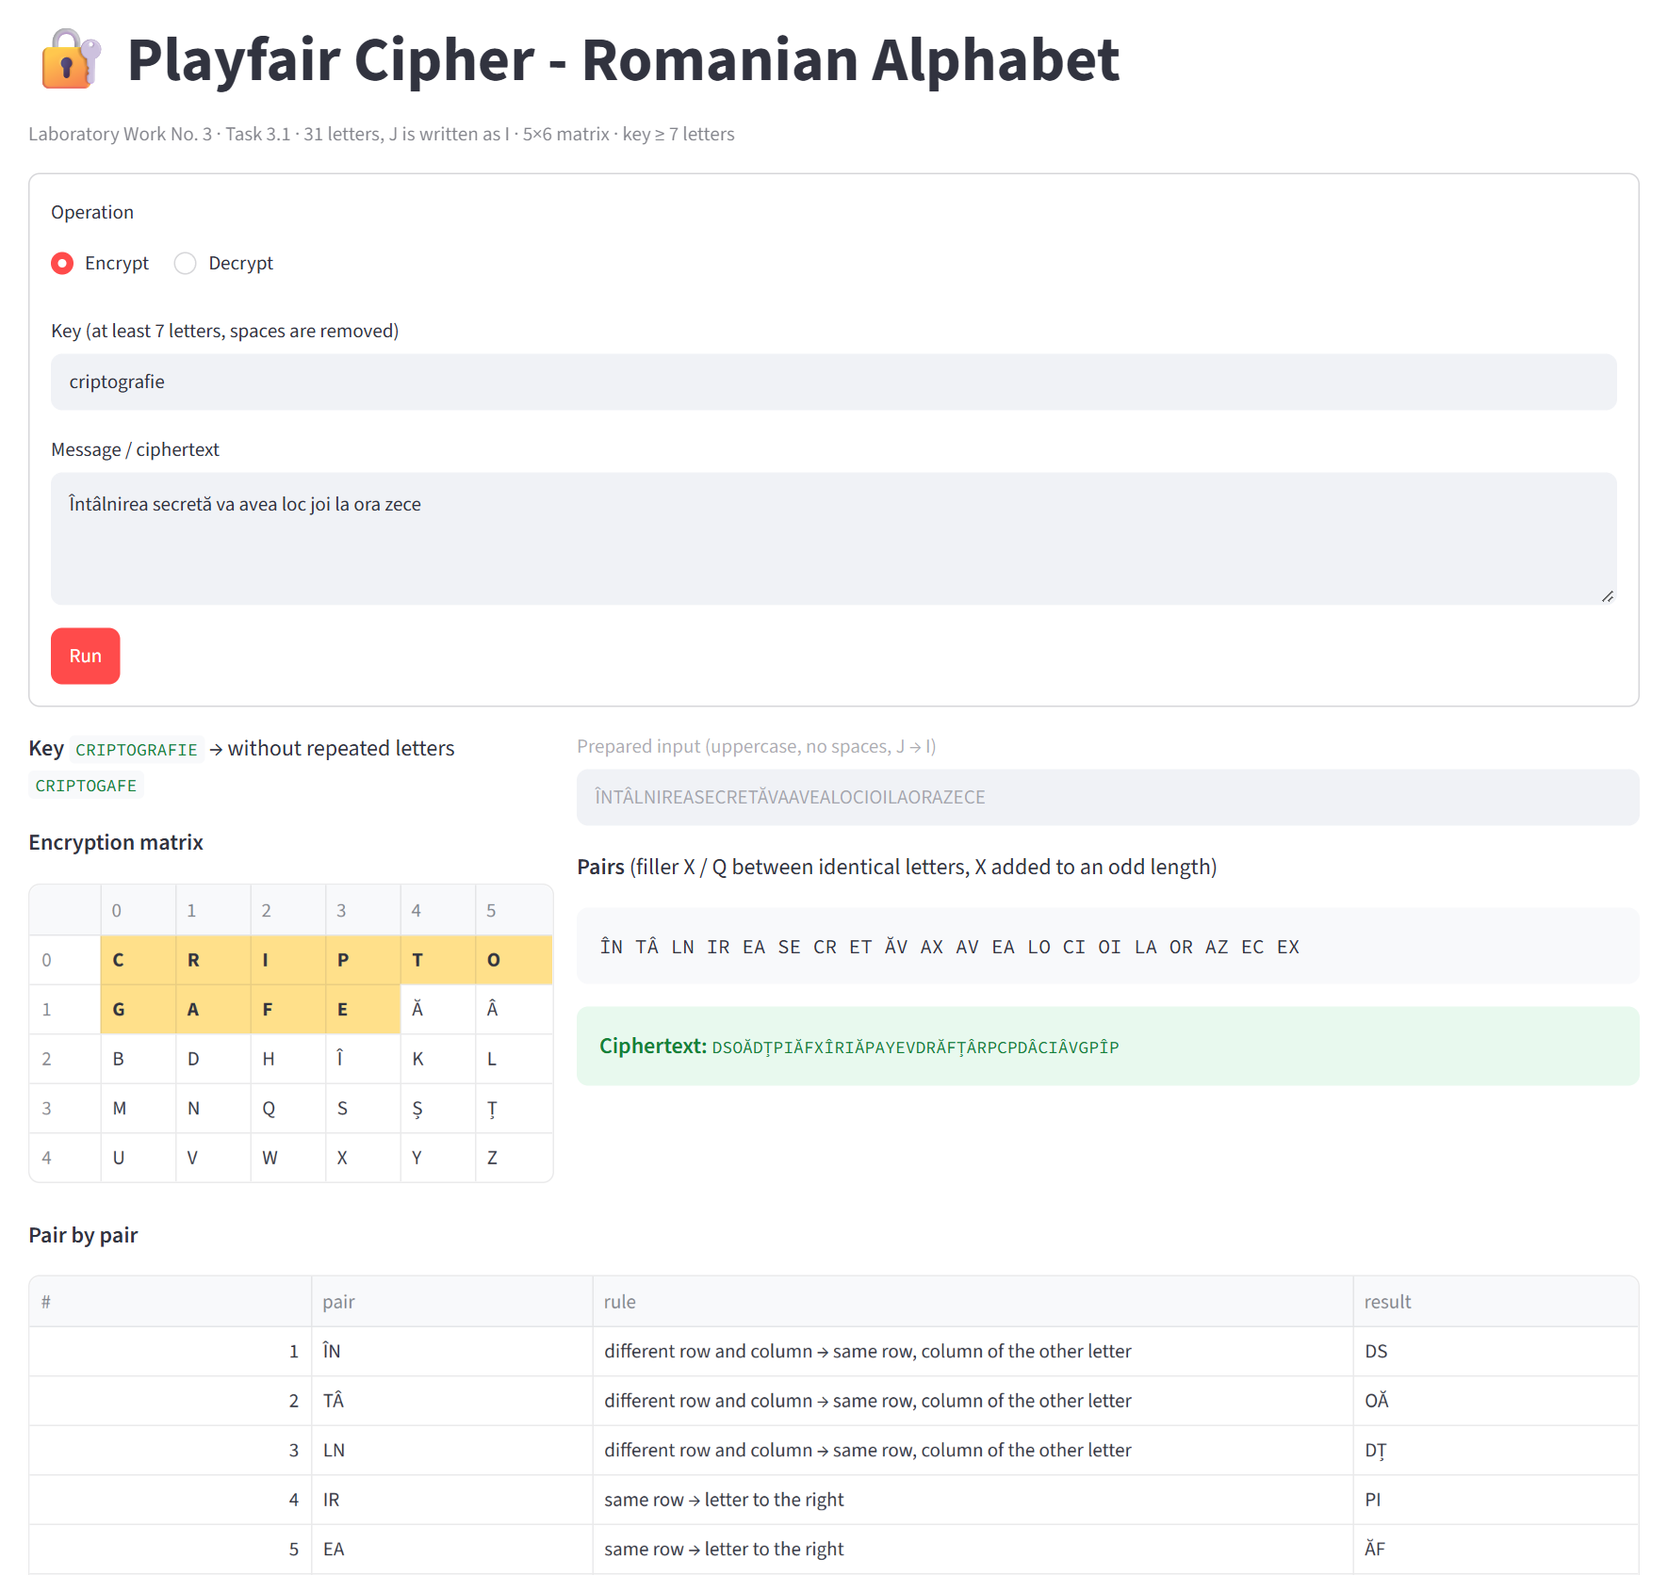
Figure 5.1 Encryption in the web interface (beginning of the pair-by-pair table)

5.2 Decryption
For decryption the cryptogram is split into pairs and the same matrix is used, with the rules applied in the opposite direction (letter to the left in a row, letter above in a column; the rectangle rule is unchanged):
DS OĂ DȚ PI ĂF XÎ RI ĂP AY EV DR ĂF ȚÂ RP CP DÂ CI ÂV GP ÎP
→ ÎN TÂ LN IR EA SE CR ET ĂV AX AV EA LO CI OI LA OR AZ EC EX
The decrypted text is ÎNTÂLNIREASECRETĂVAXAVEALOCIOILAORAZECEX. In the manual phase the filler X in VAXAVEA and the final X are removed, I is read as J in IOI, and the spaces and the diacritics of the original are restored according to the meaning:
ÎNTÂLNIREASECRETĂVAAVEALOCIOILAORAZECE → Întâlnirea secretă va avea loc joi la ora zece
The program proposes the text without fillers automatically (Figure 5.2); the replacement IOI → JOI and the spaces are added by the user.
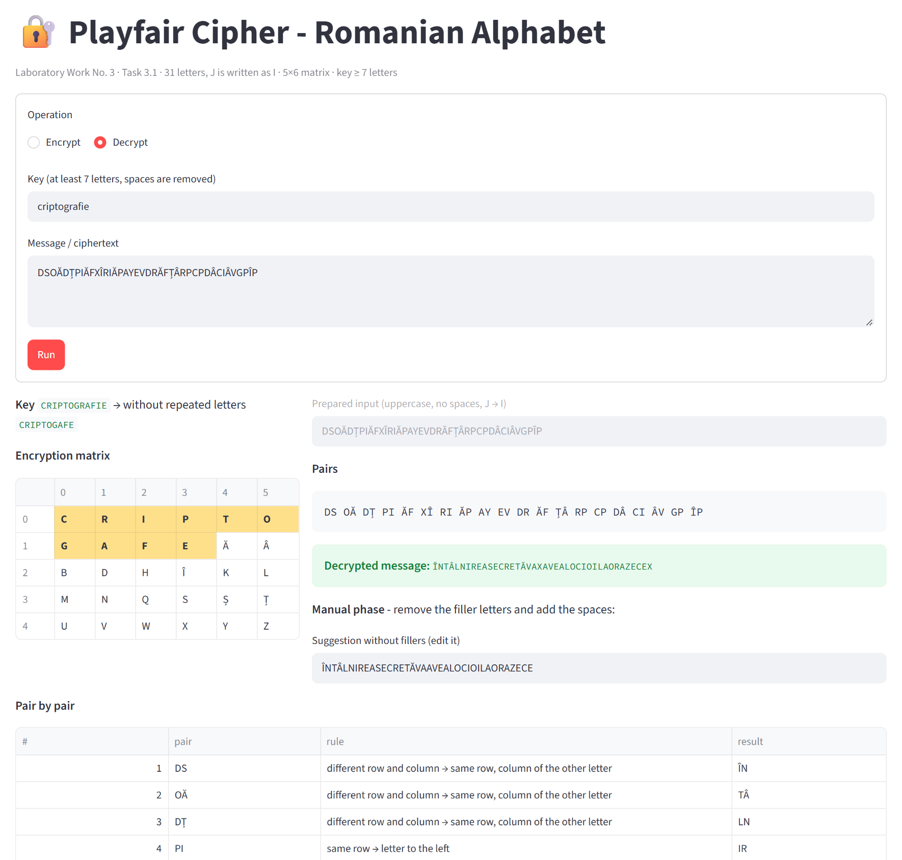
Figure 5.2 Decryption and the manual phase in the web interface

5.3 Console version
Listing 5.1 shows the same encryption and decryption in the console program, together with two invalid values (a key of 5 letters and a message containing digits), after which the program asks again.
Playfair cipher - Romanian alphabet (31 letters, J = I, 5x6 matrix)

Operation - (e)ncrypt, (d)ecrypt or e(x)it: e
Key (at least 7 letters): cheie
Error: The key is too short (5 letters): it must contain at least 7 letters.

Key (at least 7 letters): criptografie
Key without repeated letters: CRIPTOGAFE
Encryption matrix:
C R I P T O
G A F E Ă Â
B D H Î K L
M N Q S Ș Ț
U V W X Y Z
Message: Întâlnirea la 10
Error: Invalid character '1' at position 13 in the message. Only letters are allowed: 'A'-'Z', 'a'-'z' and the Romanian letters Ă Â Î Ș Ț / ă â î ș ț (spaces are allowed and removed).

Message: Întâlnirea secretă va avea loc joi la ora zece
Prepared input: ÎNTÂLNIREASECRETĂVAAVEALOCIOILAORAZECE
Pairs: ÎN TÂ LN IR EA SE CR ET ĂV AX AV EA LO CI OI LA OR AZ EC EX
Result pairs: DS OĂ DȚ PI ĂF XÎ RI ĂP AY EV DR ĂF ȚÂ RP CP DÂ CI ÂV GP ÎP
Rules: RE RE RE RO RO CO RO RE RE RE CO RO CO RO RO RE RO RE RE CO (RE = rectangle, RO = same row, CO = same column)
Ciphertext: DSOĂDȚPIĂFXÎRIĂPAYEVDRĂFȚÂRPCPDÂCIÂVGPÎP

Operation - (e)ncrypt, (d)ecrypt or e(x)it: d
Key (at least 7 letters): criptografie
Key without repeated letters: CRIPTOGAFE
Encryption matrix:
C R I P T O
G A F E Ă Â
B D H Î K L
M N Q S Ș Ț
U V W X Y Z
Ciphertext: DSOĂDȚPIĂFXÎRIĂPAYEVDRĂFȚÂRPCPDÂCIÂVGPÎP
Prepared input: DSOĂDȚPIĂFXÎRIĂPAYEVDRĂFȚÂRPCPDÂCIÂVGPÎP
Pairs: DS OĂ DȚ PI ĂF XÎ RI ĂP AY EV DR ĂF ȚÂ RP CP DÂ CI ÂV GP ÎP
Result pairs: ÎN TÂ LN IR EA SE CR ET ĂV AX AV EA LO CI OI LA OR AZ EC EX
Rules: RE RE RE RO RO CO RO RE RE RE CO RO CO RO RO RE RO RE RE CO (RE = rectangle, RO = same row, CO = same column)
Decrypted message: ÎNTÂLNIREASECRETĂVAXAVEALOCIOILAORAZECEX
Without fillers (suggestion, check manually): ÎNTÂLNIREASECRETĂVAAVEALOCIOILAORAZECE
Spaces between words are added manually.

Operation - (e)ncrypt, (d)ecrypt or e(x)it: x
Listing 5.1 A session of the console program

5.4 Validation of the input
Figures 5.3 and 5.4 show the messages of the web interface for invalid values: a key that is too short, a message with digits and punctuation (the first invalid character and the allowed range are indicated) and a ciphertext with an odd number of letters.
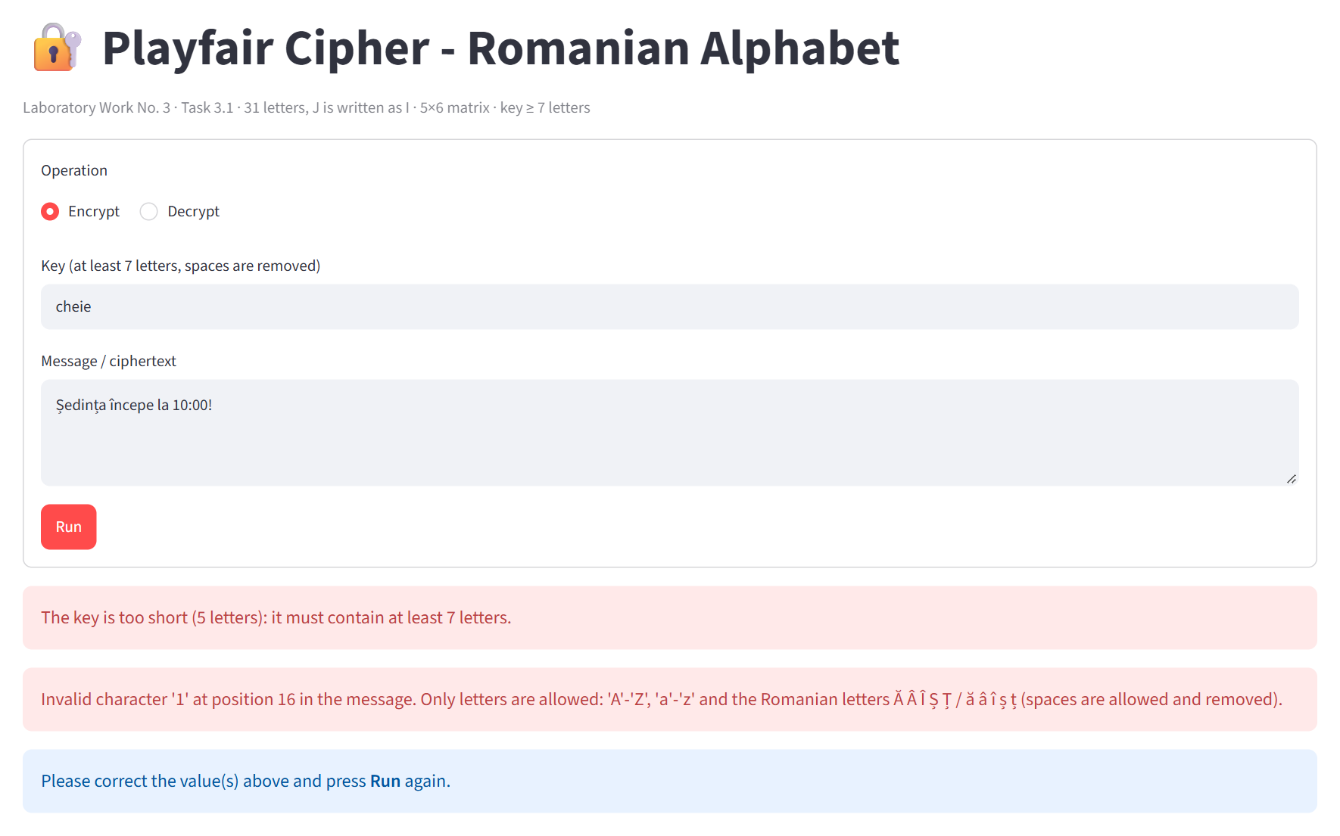
Figure 5.3 Invalid key and invalid message
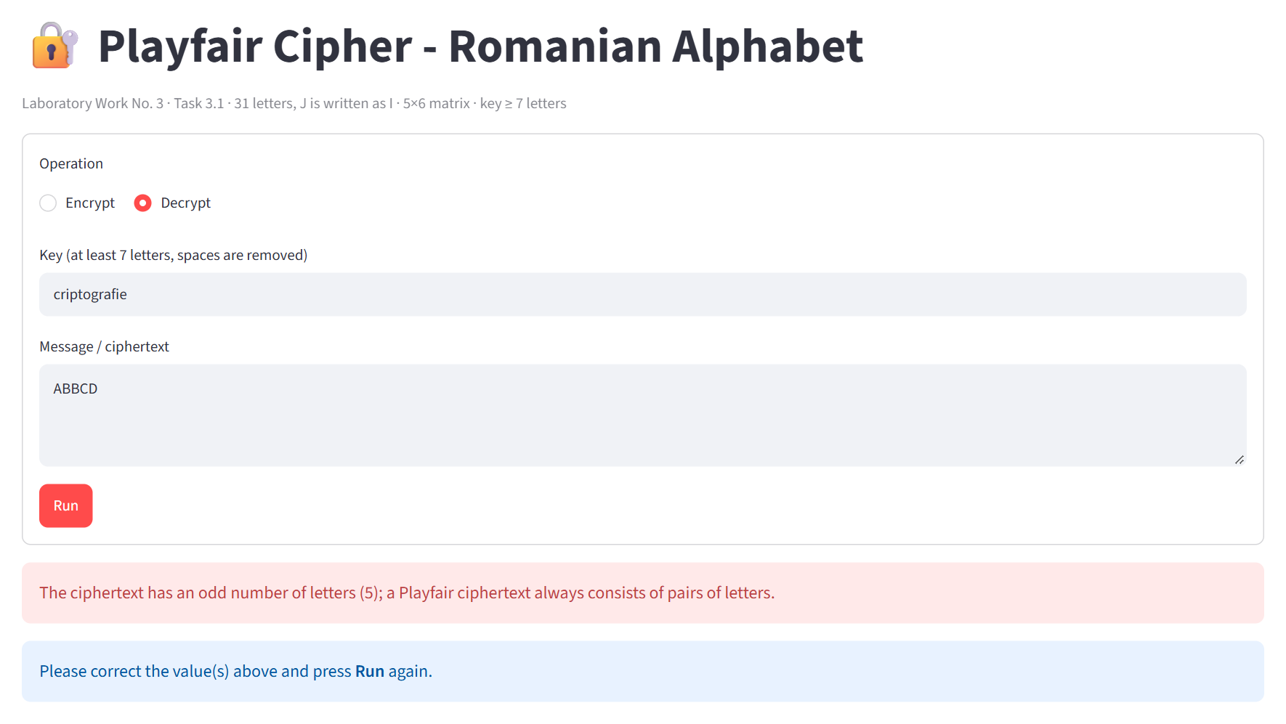
Figure 5.4 Invalid ciphertext

CONCLUSION
In this laboratory work the Playfair cipher was implemented for messages in Romanian. Since 31 letters do not fit into a rectangular matrix without extra symbols, the alphabet was reduced to 30 letters by writing J as I, as in the classical algorithm, and a 5×6 matrix was used; all diacritic letters keep their own cells. The program validates the key (at least 7 letters), the message and the ciphertext, suggests the allowed range of characters after invalid input, and shows every step of the algorithm: the processed key, the matrix, the pairs and the rule applied to each of them.
The correctness of the implementation was confirmed with the example of the guide: the same functions, called with the English alphabet and a 5×5 matrix, reproduce exactly the matrix and the 230-letter cryptogram. This comparison also revealed two errors in the prepared text of the guide (a duplicated M and a non-existent third E), which do not affect the encryption rules.
The work showed both the strength and the weakness of the cipher. The same letter is encrypted differently in different pairs, so frequency analysis of single letters, which broke the monoalphabetic cipher in Laboratory Work No. 2, no longer applies directly. However, Playfair is still a substitution - of pairs instead of letters - so identical pairs give identical results (EA → ĂF twice in the example), reversed pairs give reversed results, and the statistics of digraphs are preserved. With 870 possible digraphs in the Romanian matrix, the cipher only requires a longer ciphertext and digraph statistics to be broken, which is why it was replaced by mechanical and then by modern block ciphers.
The implementation also showed that a classical algorithm cannot be applied to another language without decisions specific to that language: the size of the matrix, the letter that is merged, and the filler letters (Z, suggested by the guide for English, is frequent in Romanian, so X and Q were used instead).

REFERENCES
1. Laboratory Work No. 3. Polyalphabetic ciphers - laboratory guide, Cryptography and Security, Technical University of Moldova, 2026.
2. Stallings, W. (2017). Cryptography and Network Security: Principles and Practice (7th ed.). Pearson.
3. Kahn, D. (1996). The Codebreakers: The Comprehensive History of Secret Communication from Ancient Times to the Internet. Scribner.
4. Singh, S. (1999). The Code Book: The Science of Secrecy from Ancient Egypt to Quantum Cryptography. Doubleday.
5. Lyons, J. Playfair Cipher. Practical Cryptography. Retrieved from http://practicalcryptography.com/ciphers/playfair-cipher/
6. Streamlit Inc. Streamlit documentation. Retrieved from https://docs.streamlit.io/
7. Source code for the laboratory work: https://github.com/inap235/CS_Labs.git

