
MINISTRY OF EDUCATION, CULTURE AND RESEARCH
OF THE REPUBLIC OF MOLDOVA
Technical University of Moldova
Faculty of Computers, Informatics and Microelectronics
Department of Software Engineering and Automation

Report
on laboratory works no. 11–13
Operating Systems
Topic: The Race and the Semaphore. Producer, Consumer and the Other Tools.
Semaphores in Your Own Kernel (xv6)

Done by:
st. gr. FAF-242, Ina Pancenco

Checked by:
Reițman Patricia, university assistant
DISA, FCIM, UTM

Chișinău – 2026
Table of Contents
1 PURPOSE OF THE WORK
1.1 Purpose of practical work
1.2 Problem statement
2 LABORATORY WORK 11: THE RACE AND THE SEMAPHORE
2.1 Part 1. See the race
2.1.1 Observations
2.2 Part 2. Fix it: mutex, then semaphore
2.2.1 Observations
2.3 Part 3. A semaphore as a signal
2.3.1 Observations
2.4 Part 4. A semaphore as a counter: the parking lot
2.4.1 Observations
2.5 Optional. No lock at all
3 LABORATORY WORK 12: PRODUCER, CONSUMER AND THE OTHER TOOLS
3.1 Part 1. Producer and consumer
3.1.1 Observations
3.2 Part 2. The condition variable
3.2.1 Observations
3.3 Part 3. Readers and writers
3.3.1 Observations
3.4 Part 4. Build a deadlock, then remove it
3.4.1 Observations
4 LABORATORY WORK 13: SEMAPHORES IN YOUR OWN KERNEL
4.1 Part 1. The numbers and the user side
4.2 Part 2. The kernel side
4.3 Part 3. A semaphore as a lock: mix
4.3.1 Observations
4.4 Optional. sem_trydown
CONCLUSION
REFERENCES
1 PURPOSE OF THE WORK
1.1 Purpose of practical work
The purpose of these three laboratory works is to understand what goes wrong when several threads or processes share data, and the tools that make sharing safe. In Laboratory Work 11 two threads add to the same counter without protection and lose additions (a race condition). The race is then fixed with a mutex and with a semaphore, and the same semaphore is used in three ways: as a lock (start value 1), as a signal (start value 0) and as a counter (start value 3, a parking lot).
In Laboratory Work 12 the tools work together on the two classic problems of synchronization, producer and consumer and readers and writers. The condition variable is introduced as a second way to wait for an event, and a deadlock is built on purpose with two mutexes and then removed by taking the locks in the same order.
In Laboratory Work 13 the semaphore is no longer taken from the C library, it is built inside the xv6 kernel as three new system calls: sem_init, sem_down and sem_up. A kernel semaphore is only a number, a spinlock that protects it, and the sleep and wakeup of the kernel, so a process that waits really sleeps and uses no CPU.
1.2 Problem statement
Laboratory Work 11 – The Race and the Semaphore (Track A, Linux):
- Part 1: race.c – two threads add 1 to the same counter one million times each, without protection.
- Part 2: mutex.c and sem.c – the same counter protected by a mutex and by a semaphore that starts at 1; the price of the lock measured with time.
- Part 3: order.c – a semaphore that starts at 0 makes thread B wait until thread A has written the message.
- Part 4: parking.c – six cars and three places, a semaphore that starts at 3 counts the free places.
- Optional: atomic.c – the counter of race.c with one atomic instruction per addition and no lock.
Laboratory Work 12 – Producer, Consumer and the Other Tools (Track A, Linux):
- Part 1: prodcons.c – a producer and a slow consumer around a buffer of 4 slots, with two semaphores and a mutex.
- Part 2: condvar.c – the problem of order.c solved with a mutex and a condition variable.
- Part 3: readers.c – many readers may read together, a writer must be alone.
- Part 4: deadlock.c – two threads take two mutexes in opposite order and hang; then the order is fixed.
Laboratory Work 13 – Semaphores in Your Own Kernel (Track B, xv6):
- Part 1: the numbers 24, 25 and 26, the declarations, the stubs, the test programs user/semtest.c and user/mix.c and the Makefile lines.
- Part 2: kernel/sem.c with sys_sem_init, sys_sem_down and sys_sem_up, the Makefile line and the system call table.
- Part 3: mix with and without a semaphore used as a lock.
- Optional: a fourth call, sem_trydown (number 27), that never sleeps.
All three works were carried out on an Ubuntu 24.04 Linux virtual machine in VirtualBox (host name ina-VirtualBox, user ina, 6 virtual CPUs), with gcc 13.3.0. The Linux programs were compiled with gcc -Wall -pthread, without -O2, as the handout asks, and without a single warning. xv6 was run in QEMU (3 harts) from the ~/xv6-riscv tree, which already contains the trace system call of Laboratory Work 10. For every part the commands and their output are given as screenshots of the terminal, followed by the answers to the Observe questions. The source files and the answer files (report.md for Labs 11 and 12, notes.txt for Lab 13) are pushed to the course repository.
2 LABORATORY WORK 11: THE RACE AND THE SEMAPHORE
2.1 Part 1. See the race
A working folder ~/os-lab11 was created and the programs were typed exactly as given in the handout. race.c starts two threads with pthread_create. Each thread runs add(), which executes counter++ one million times on the same global variable, and main waits for both with pthread_join. The right answer is 2 000 000. The program was run three times (Figure 2.1).
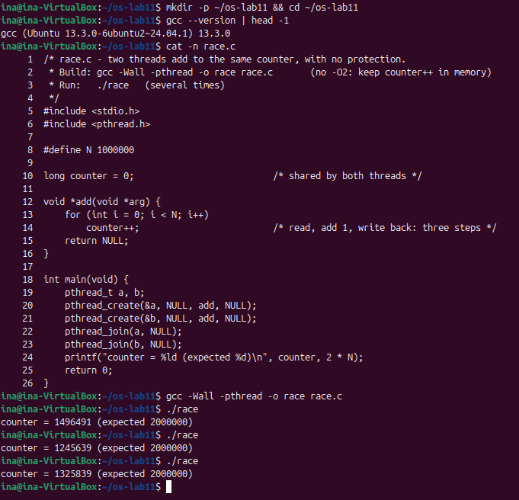
Figure 2.1 – The source of race.c and three runs: the result is never 2 000 000
None of the three runs gave the right answer: 1 496 491, 1 245 639 and 1 325 839. Between 500 000 and 750 000 additions were lost in each run, and the number is different every time.
2.1.1 Observations
Observe (Lab 11, Part 1)
(1) counter++ looks like one step. Write the three steps the CPU really does.
(2) Describe, with those steps, how two threads can lose one addition.
(3) Why is the result different at every run?
(1) Three steps
counter++ is compiled into three machine instructions: load the value of counter from memory into a register, add 1 to the register, and store the register back into memory. Without -O2 gcc keeps counter in memory and really does the load and the store at every addition.
(2) A lost addition
Let counter be 100. Thread A loads 100 into its register. Before A stores, thread B, on another CPU, also loads 100. A adds 1 and stores 101; B adds 1 to its own copy and also stores 101. Two additions were done, but the counter went up only by one, because the store of B overwrote the store of A. The three steps of one thread were cut by the steps of the other one.
(3) A different result every time
The result depends on the exact timing of the two threads: when the scheduler starts them, on which CPU they run, when they are interrupted, and how often their load and store fall between each other. This timing is never the same twice, so the number of lost additions changes from run to run. This is what makes a race condition hard to find: the program is wrong, but not in the same way every time.
2.2 Part 2. Fix it: mutex, then semaphore
In mutex.c counter++ is placed between pthread_mutex_lock and pthread_mutex_unlock. This line is the critical section: only one thread can be inside it. In sem.c the same is done with a semaphore that starts at 1: sem_wait takes the only unit (1 -> 0) and a second thread waits at sem_wait until sem_post gives it back (0 -> 1). Both programs were run three times (Figure 2.2).
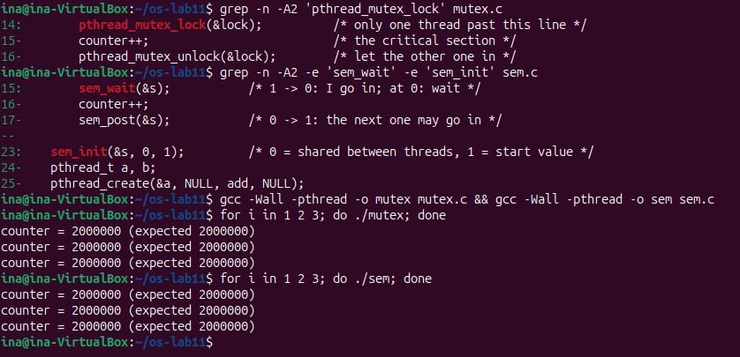
Figure 2.2 – The critical section in mutex.c and sem.c, and three runs of each
All six runs give exactly 2 000 000. Then the three programs were timed (Figure 2.3).
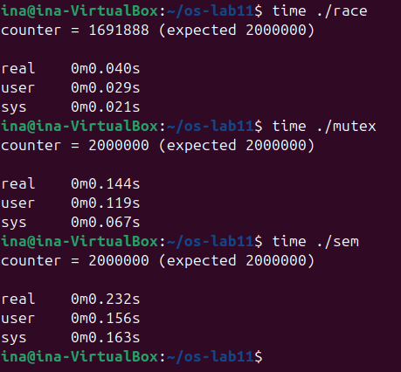
Figure 2.3 – The price of the lock: time of race, mutex and sem
Program | Result | real | sys
race | 1 691 888 (wrong) | 0.040 s | 0.021 s
mutex | 2 000 000 | 0.144 s | 0.067 s
sem | 2 000 000 | 0.232 s | 0.163 s
atomic (optional) | 2 000 000 | 0.078 s | 0.037 s

The order is the one given in the handout: race is the fastest and wrong, mutex is slower and correct, sem is the slowest. To test the start value of the semaphore, a copy of sem.c was made with sem_init(&s, 0, 2) (Figure 2.4).
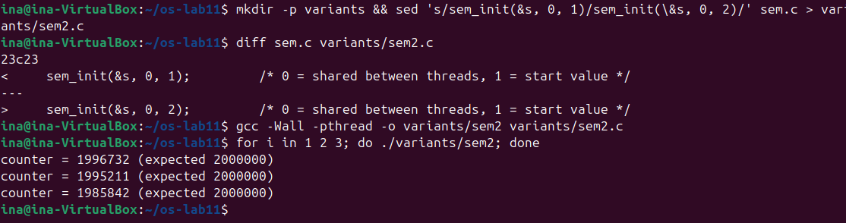
Figure 2.4 – sem.c with the start value 2: the race is back
2.2.1 Observations
Observe (Lab 11, Part 2)
(1) Run mutex and sem three times each. Is the answer always 2 000 000?
(2) What would happen in sem.c with sem_init(&s, 0, 2)? Try it and explain.
(3) Why is the locked version slower?
(1) Always 2 000 000
Yes, all six runs printed counter = 2000000 (Figure 2.2). Only one thread at a time can be between lock and unlock (or between sem_wait and sem_post), so the load, add and store of one thread are never mixed with those of the other one, and no addition is lost.
(2) Start value 2
The result is wrong again: 1 987 101, 1 994 665 and 1 995 304 (Figure 2.4). The start value is the number of threads that may be inside at the same time. With 2, both threads pass sem_wait together, and since the program only has two threads, the semaphore protects nothing. Fewer additions are lost than in race.c because the calls to sem_wait and sem_post take time and the two counter++ overlap less often, but the race is there.
(3) The price of the lock
Every addition now also costs a lock and an unlock. Each of them is an atomic instruction on the lock word, much slower than a normal add. When the lock is already taken, the other thread cannot continue: it spins for a moment or goes to sleep in the kernel through the futex system call, and is woken up later. This is why the sys time grows from 0.021 s to 0.067 s and 0.163 s. The two threads also no longer work in parallel, they take turns. sem is a bit slower than mutex because sem_wait and sem_post do more work than the mutex functions for the same job.
2.3 Part 3. A semaphore as a signal
In order.c the problem is not two threads at the same time but the order: thread B must read the message only after thread A has written it. The semaphore ready starts at 0, a closed door. B is created first on purpose; it prints its first line and blocks in sem_wait(&ready). A sleeps one second, writes "hello" and calls sem_post(&ready), which wakes B up (Figure 2.5, first run). Then a copy with the start value 1 was run.
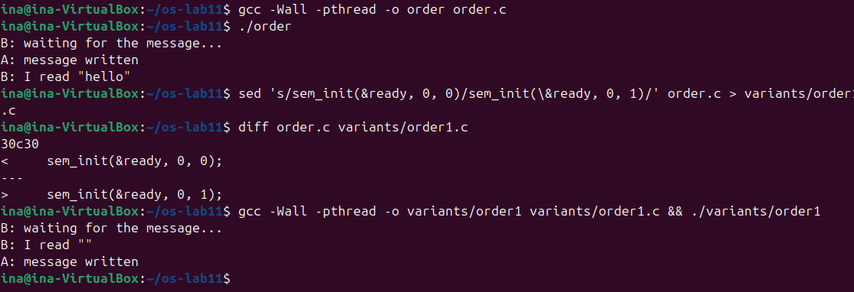
Figure 2.5 – order.c with the start value 0, then with the start value 1
2.3.1 Observations
Observe (Lab 11, Part 3)
(1) Change the start value to 1, compile, run. What does B read now, and why?
(2) Put it back to 0. In one sentence: what does a semaphore that starts at 0 mean?
(1) Start value 1
B reads an empty string: B: I read "" is printed before A: message written. The semaphore already has one unit, so sem_wait does not block. B takes the unit and reads message at once, while A is still in sleep(1) and has not written anything. message is a global array, so it is full of zeros, an empty string. The signal said "ready" before anything was ready.
(2) A semaphore that starts at 0
It means "the event has not happened yet": whoever calls sem_wait must wait until another thread calls sem_post to announce that it happened.
2.4 Part 4. A semaphore as a counter: the parking lot
parking.c starts six cars (threads) for three places. The semaphore places starts at 3 and counts the free places: a car takes a place with sem_wait(&places) and gives it back with sem_post(&places) after one second. The mutex is only there so that the change of inside and its printf stay together (Figure 2.6).
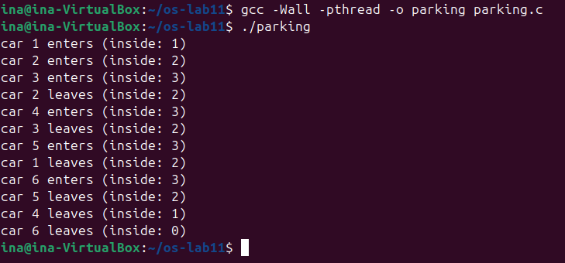
Figure 2.6 – Six cars, three places: inside never goes above 3
Then a copy with PLACES set to 1 was run with time (Figure 2.7).
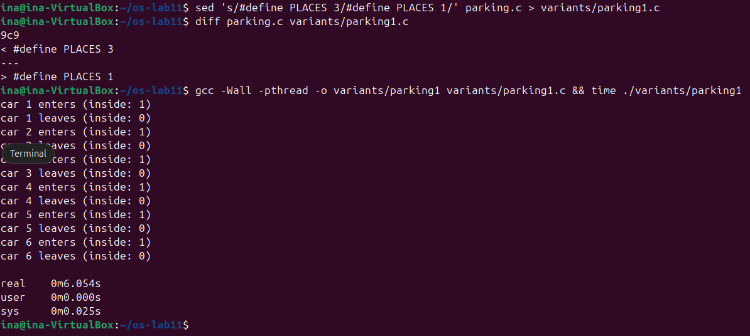
Figure 2.7 – The parking lot with one place: the cars go one by one, in 6 seconds
2.4.1 Observations
Observe (Lab 11, Part 4)
(1) What is the largest value of "inside" you see? Which line of code guarantees it?
(2) Set PLACES to 1. What does the semaphore become?
(1) At most 3
The largest value is 3. The line sem_wait(&places); guarantees it. The semaphore starts at 3 and every car that enters takes one unit, so the fourth car finds the value 0 and blocks there. It goes on only when a car leaves and calls sem_post(&places). In Figure 2.6 car 4 enters only after car 2 leaves, car 5 after car 3, car 6 after car 1.
(2) One place
With PLACES 1 the semaphore becomes a binary semaphore, a mutex: only one car can be inside at a time. In Figure 2.7 every "enters" is followed by "leaves" of the same car, inside is never more than 1, and the program takes 6.1 seconds (six cars, one second each) instead of about 2.
2.5 Optional. No lock at all
atomic.c uses an atomic_long counter and atomic_fetch_add(&counter, 1), which does load, add and store as one indivisible instruction of the CPU, so no thread can cut in between (Figure 2.8).
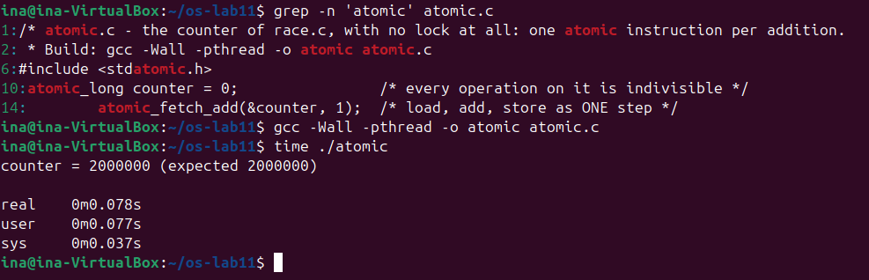
Figure 2.8 – atomic.c: the right answer without any lock
The result is 2 000 000 and the time is 0.078 s, about twice as fast as the mutex (0.144 s) in my run: there is no lock to take and no thread ever sleeps in the kernel. This works only for one simple operation on one variable; for a critical section of several lines a lock is still needed.
3 LABORATORY WORK 12: PRODUCER, CONSUMER AND THE OTHER TOOLS
3.1 Part 1. Producer and consumer
A working folder ~/os-lab12 was created. In prodcons.c a producer puts the items 1 to 8 into a circular buffer of 4 slots and a slow consumer takes them out (300 ms per item). Three tools work together: empty counts the free slots and starts at 4, full counts the filled slots and starts at 0, and a mutex protects the buffer and the indexes in and out (Figure 3.1).
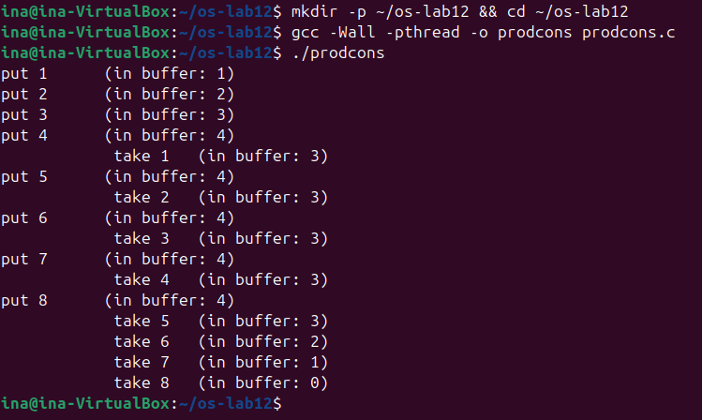
Figure 3.1 – Producer and consumer: the buffer never holds more than 4 items
The producer fills the 4 slots at once, then it can put one item each time the consumer takes one. To answer the third question a copy of prodcons.c was made in which the producer locks the mutex before sem_wait(&empty). It was started with timeout 5 (Figure 3.2).
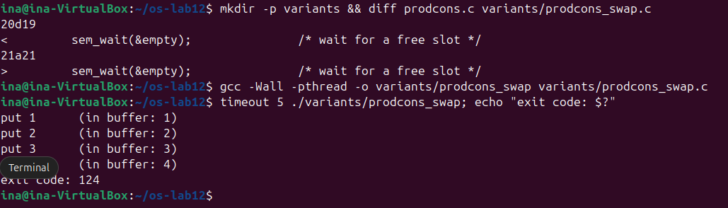
Figure 3.2 – The mutex taken before sem_wait(&empty): the program hangs after 4 items
3.1.1 Observations
Observe (Lab 12, Part 1)
(1) The producer is fast, yet "in buffer" never goes above 4. Which call stops it?
(2) Who waits at the start: the consumer or the producer? Which call makes it wait?
(3) In producer(), lock the mutex BEFORE sem_wait(&empty). What happens when the buffer is full, and why?
(1) What stops the producer
sem_wait(&empty) in producer(). empty starts at 4. After put 4 its value is 0, so the producer sleeps in sem_wait until the consumer takes an item and calls sem_post(&empty). This is why after the first four items every put comes right after a take.
(2) Who waits at the start
The consumer. It is created first, but full starts at 0 because there is nothing to take yet, so it blocks in sem_wait(&full). It wakes up when the producer has put item 1 and called sem_post(&full).
(3) The mutex before the semaphore
The program hangs after put 4 and timeout kills it (exit code 124, Figure 3.2). When the buffer is full the producer takes the mutex and then sleeps in sem_wait(&empty) still holding the mutex. The consumer passes sem_wait(&full), but then blocks in pthread_mutex_lock(&lock), so it can never take an item and call sem_post(&empty). The producer waits for the consumer and the consumer waits for the producer: a deadlock. The rule is to wait on the semaphore first and lock the mutex only for the short work on the buffer.
3.2 Part 2. The condition variable
condvar.c solves the problem of order.c from Lab 11 in another way. The state is a normal variable ready, protected by a mutex. The condition variable changed is only the place where B sleeps until A says that something changed. pthread_cond_wait(&changed, &lock) releases the mutex, sleeps, and takes the mutex again before it returns. A sets ready = 1 and calls pthread_cond_signal. Then a copy with if instead of while was run (Figure 3.3).
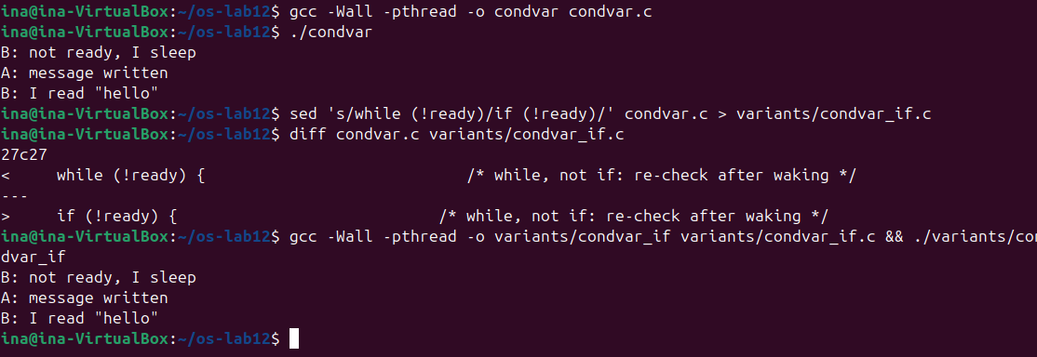
Figure 3.3 – condvar.c with while, then with if
3.2.1 Observations
Observe (Lab 12, Part 2)
(1) In order.c (Lab 11) the semaphore itself remembered that the message was ready. Here, which variable remembers it?
(2) Replace "while (!ready)" with "if (!ready)", compile, run. Does it still work here?
(3) Then why do we write while? Give one reason why a thread can wake up and still find ready == 0.
(1) The memory of the event
The normal variable ready (0, then 1), protected by the mutex lock. A condition variable has no value and remembers nothing: a pthread_cond_signal sent when no thread is waiting is simply lost. This is why B first looks at ready and waits only when it is 0.
(2) if instead of while
Yes, the output is the same three lines (Figure 3.3). In this program there is one writer, one reader and one signal, and ready is never set back to 0, so when B wakes up ready really is 1.
(3) Why while
A thread can come back from pthread_cond_wait while the condition is still false. POSIX allows spurious wakeups, returns from pthread_cond_wait without any signal. And with several waiting threads, or with pthread_cond_broadcast, another thread can wake up first, take the mutex and use the data (for example set ready back to 0) before this one gets the mutex. With while the thread checks the condition again and goes back to sleep; with if it would continue with data that is not there.
3.3 Part 3. Readers and writers
In readers.c three readers and two writers share the variable value. Two semaphores are used: room (1 = the room is free for a writer) and rlock, a lock around the counter readers. The first reader to enter takes room and the last one to leave gives it back, so the readers can read together while a writer is always alone (Figure 3.4).
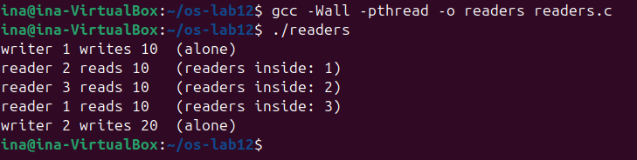
Figure 3.4 – Readers and writers: three readers inside together, each writer alone
Writer 1 writes 10 alone, then the three readers are inside at the same time (readers inside: 1, 2, 3, in the order the scheduler started them), and only after all of them leave does writer 2 write 20.
3.3.1 Observations
Observe (Lab 12, Part 3)
(1) Three readers are inside at the same time, but a writer is always alone. Which two lines of reader() make that possible?
(2) Why does the counter readers need its own lock (rlock)? What could go wrong without it?
(3) Imagine readers that keep arriving without a pause. What happens to writer 2?
(1) The first in and the last out
if (++readers == 1) sem_wait(&room); – the first reader in locks the room against the writers – and if (--readers == 0) sem_post(&room); – the last reader out lets the writers in. The readers in between do not touch room, so they enter without waiting. A writer needs room for itself, so it can enter only when no reader is inside, and while it is inside the first reader waits on room.
(2) The lock of the counter
++readers and --readers are load, add and store, the same race as counter++ in Lab 11. Without rlock two readers that enter together could both see the counter go to 1 and both call sem_wait(&room): the second one blocks forever. Two readers that leave together could both miss the value 0, nobody calls sem_post(&room), and the writers wait forever. The counter itself could also become wrong.
(3) Starvation
Writer 2 may never get in. As long as at least one reader is inside, readers never goes back to 0, so room is never given back, and every new reader enters past the waiting writer. The writer waits without end although the system as a whole keeps working. This is starvation; this solution gives priority to the readers.
3.4 Part 4. Build a deadlock, then remove it
In the original deadlock.c thread one locks A and then B, and thread two locks B and then A. sleep(1) between the two locks makes sure that each thread takes its first mutex before the other one asks for it. The program was started with timeout 5 (Figure 3.5).
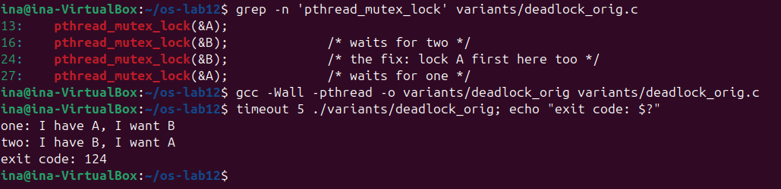
Figure 3.5 – The original deadlock.c: both threads stuck, killed by timeout
Both threads print their first line and then nothing happens until timeout kills the program with exit code 124. Then a copy without the two sleep(1) lines was run ten times (Figure 3.6).
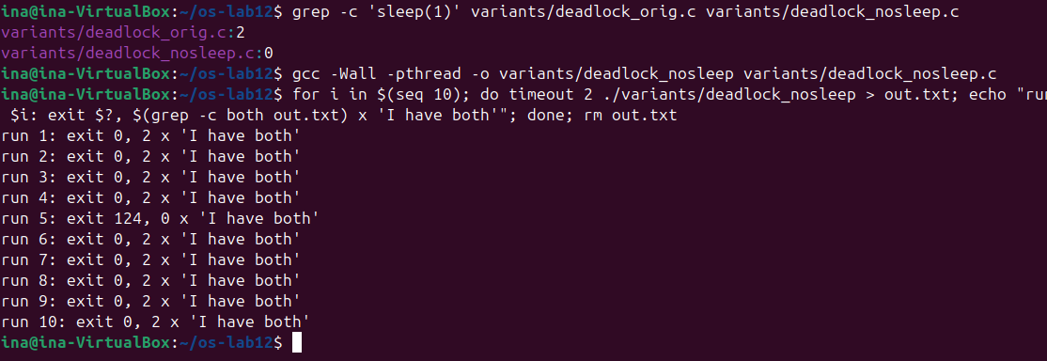
Figure 3.6 – Without sleep(1) the program hangs only sometimes (run 5)
Finally, in two() the order was changed to A first, then B, like in one(), and the unlocks were swapped too (Figure 3.7). The text of the printf lines was left as in the handout.
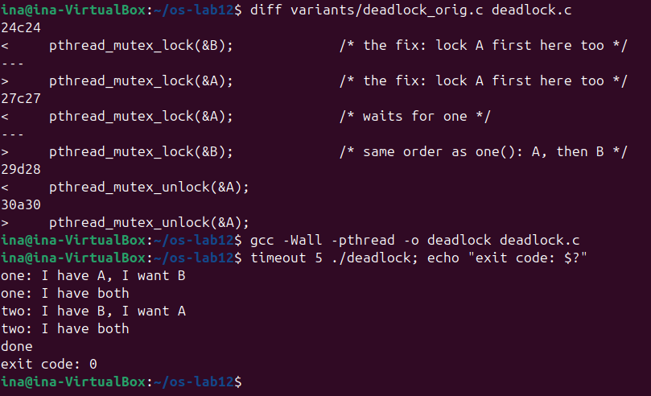
Figure 3.7 – The fixed deadlock.c: the same lock order in both threads
3.4.1 Observations
Observe (Lab 12, Part 4)
(1) In the stuck run, which thread holds which mutex, and which one is each thread waiting for? Draw the circle.
(2) Remove both sleep(1) lines from the ORIGINAL version and run it ten times. Does it still always hang? Why is that worse, not better?
(3) In one sentence: why can taking the locks in the same order never deadlock?
(1) The circle
Thread one holds A and waits for B; thread two holds B and waits for A. The waiting forms a circle that nobody can break:
Thread | Holds | Waits for (held by)
one | mutex A | mutex B (held by two)
two | mutex B | mutex A (held by one)

one → wants B → held by two → wants A → held by one → … (circular wait)
(2) Without sleep
No. In ten runs nine finished with done and exit code 0, and only run 5 hung (exit code 124, Figure 3.6). Without the pause thread one usually takes A and B before thread two starts, so the dangerous order of events is rare. This is worse, because the bug is still there but hidden: the program passes almost every test and then freezes once in a while, on another machine or under load, and the error is very hard to reproduce and to find.
(3) The same order
If every thread takes A before B, a thread that waits for B already holds A, so no thread can hold B while waiting for A and the circle of waiting can never close.
4 LABORATORY WORK 13: SEMAPHORES IN YOUR OWN KERNEL
4.1 Part 1. The numbers and the user side
The work was done in the ~/xv6-riscv tree, on the branch lab, which already has the trace system call of Laboratory Work 10 with the number 23. The recipe of Lab 10 was repeated three times: the numbers SYS_sem_init 24, SYS_sem_down 25 and SYS_sem_up 26 in kernel/syscall.h, the declarations in user/user.h, the stubs in user/usys.pl, and the two programs _semtest and _mix in UPROGS in the Makefile (Figure 4.1). The lines for the optional call sem_trydown (27) are also visible, they were added at the end.
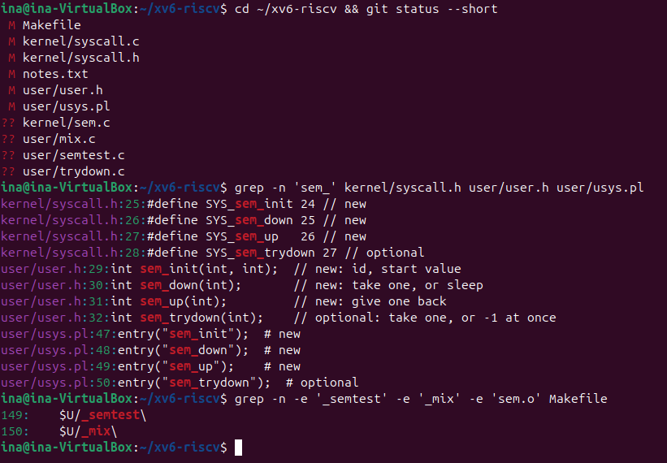
Figure 4.1 – The user side: numbers, declarations, stubs and the Makefile lines
user/semtest.c contains two tests. In the first one semaphore 0 starts at 0 and the child must wait in sem_down(0) until the parent, after pause(10), calls sem_up(0). In the second one ping and pong take turns with two semaphores that pass the turn to each other (1 = the turn of ping, 2 = the turn of pong). user/mix.c is needed in Part 3.
At this point the kernel did not know the new numbers. sem.o was not yet in the Makefile and the table had no entries, so semtest was run as Check 1 (Figure 4.2).
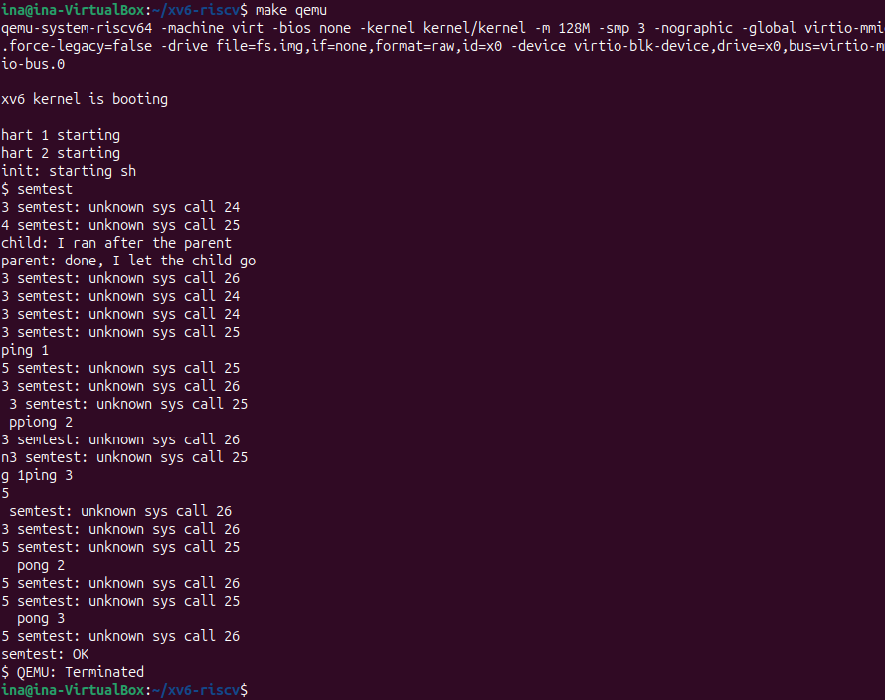
Figure 4.2 – Check 1: the calls reach the kernel, which does not know them yet
The first lines are exactly the ones in the handout: unknown sys call 24 and 25 from pids 3 and 4, then the line child: before the line parent:. Without semaphores sem_down returns -1 at once and the child does not wait. Ping and pong are mixed with the error lines.
4.2 Part 2. The kernel side
The new file kernel/sem.c (Figures 4.3 and 4.4) contains a table of NSEM = 8 semaphores, shared by all processes. Each one is a number and a spinlock that protects the number. sys_sem_init checks the id and the value and sets the value under the spinlock.
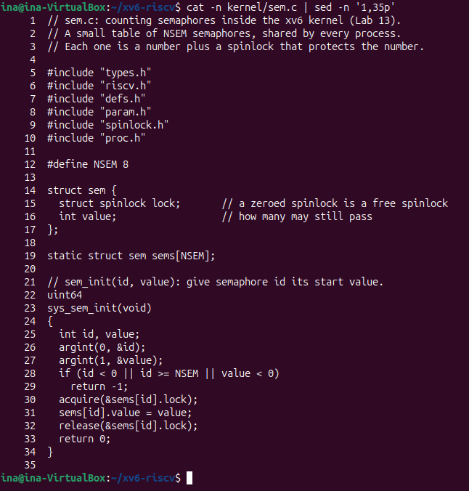
Figure 4.3 – kernel/sem.c: the table of semaphores and sys_sem_init
sys_sem_down is the heart of the work. While the value is 0, the process registers the address of the semaphore as the thing it waits for with sleep_prepare(s), releases the spinlock and calls sleep(). Our xv6 sleeps in these two steps, not with sleep(chan, lock) as in the xv6 book. After waking up it takes the spinlock again, checks if it was killed and tests the value again. When the value is not 0 it subtracts 1. sys_sem_up adds 1 and calls wakeup(s), which wakes every process sleeping on that address.
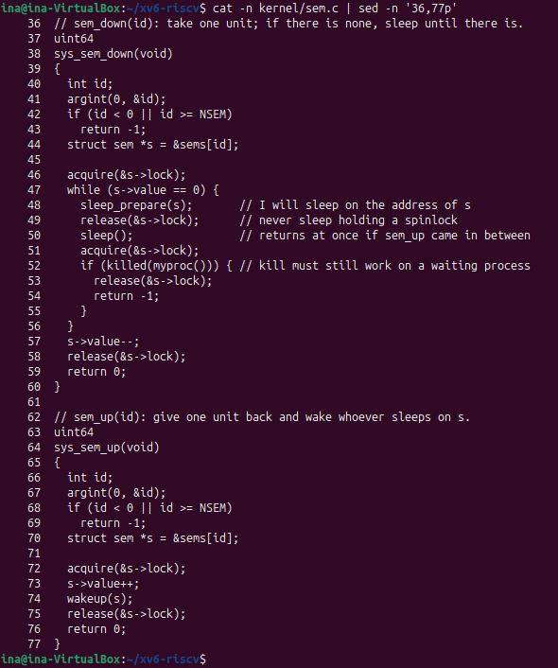
Figure 4.4 – kernel/sem.c: sys_sem_down and sys_sem_up
Then $K/sem.o was added to OBJS in the Makefile and the three functions were declared and put into the table in kernel/syscall.c. They were also added to the names table of trace from Lab 10, so that a trace mask with bits 24 to 27 does not read past the end of that array. semtest was run again (Figure 4.5).
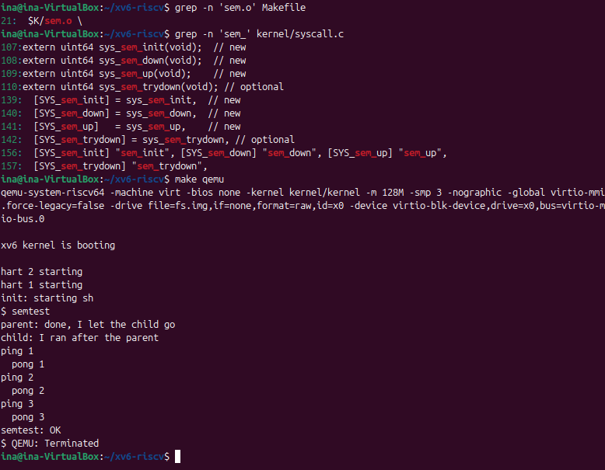
Figure 4.5 – Check 2: semtest prints the child after the parent, ping and pong in turn, then OK
The result is exactly the expected one. The parent waits 10 ticks before it lets the child go, and still the child prints second, because it was asleep in sem_down. Ping and pong alternate strictly, three times each, and semtest prints semtest: OK.
4.3 Part 3. A semaphore as a lock: mix
mix starts two processes that print five lines of 30 letters each, one letter per write() system call. Without an argument they use no lock; with mix lock semaphore 3, started at 1, is used as a lock around every line. make qemu runs 3 harts, so the two processes really run at the same time. mix was run twice without the lock and once with it (Figure 4.6).
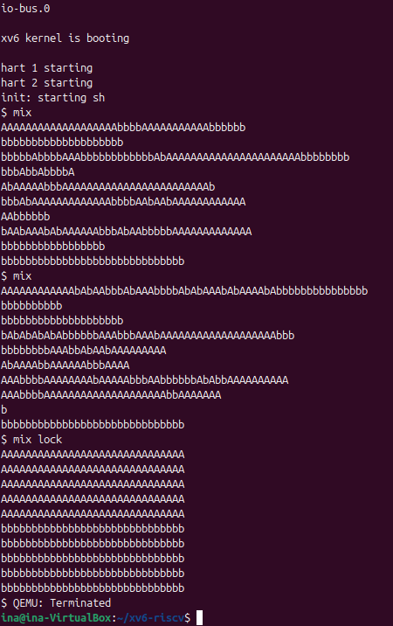
Figure 4.6 – mix twice without the lock (letters mixed), then mix lock (every line whole)
4.3.1 Observations
Observe (Lab 13, Part 3)
(1) Without the lock, why do the letters mix? (How many system calls does one line cost?)
(2) With the lock every line is whole. Which two lines of mix.c make one line a critical section?
(3) In sem_down the test is "while (s->value == 0)", not "if". Why can a process wake up and still find 0?
(4) sem_down calls release(&s->lock) BEFORE sleep(). What would go wrong if it slept holding the spinlock?
(1) Why the letters mix
One line costs 31 system calls: 30 letters and the new line, each in its own write(). The two processes run at the same time on different harts, and the kernel may also switch between them after any system call or timer interrupt. A line is not one action but 31 separate ones, so the letters of A and b are mixed in between, differently at every run.
(2) The critical section
The line sem_down(3); before the loop that writes one line and sem_up(3); after it (both under if (uselock)). Semaphore 3 starts at 1, so it works as a lock: while one process writes its whole line, the other one sleeps in sem_down(3). In Figure 4.6 the process A was the first to get it five times in a row, so its five lines come first, but every line is whole.
(3) while, not if
sem_up adds only 1 but wakeup(s) wakes every process sleeping on s. The first one that gets the spinlock takes the unit and the value is 0 again, so the others must test again and go back to sleep. A process that was not sleeping at all can also call sem_down and take the unit before the woken process gets the spinlock. The loop is also the place where the killed() check is done after every wakeup.
(4) Never sleep holding a spinlock
sem_up needs the same spinlock to add 1 and to call wakeup. If the sleeper kept it, sem_up would spin forever in acquire() on another hart and the sleeper would never be woken up: a deadlock. Moreover, in xv6 a process must not give up the CPU while it holds a spinlock other than p->lock, because interrupts are off while a spinlock is held: sched() checks this and the kernel stops with panic: sched locks. Calling sleep_prepare(s) before release(&s->lock) keeps the code correct: a sem_up that comes between the release and sleep() clears the channel, and sleep() returns at once, so no wakeup is lost.
4.4 Optional. sem_trydown
A fourth call, sem_trydown(id) with the number 27, was added in the same way as the other three (number, declaration, stub, table entry, name for trace). It takes the spinlock and, if the value is greater than 0, subtracts 1 and returns 0; if the value is 0 it returns -1 at once instead of sleeping. The small program user/trydown.c shows both answers (Figure 4.7).
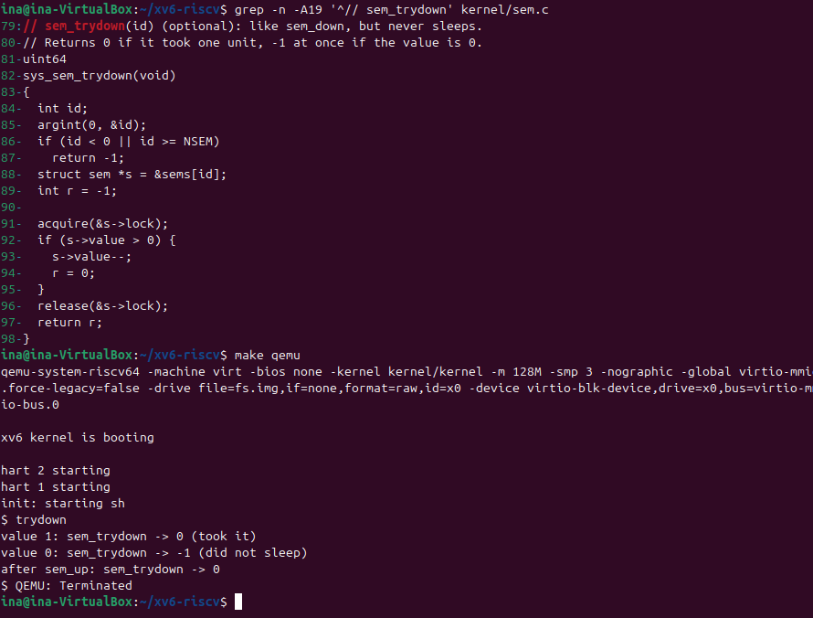
Figure 4.7 – sys_sem_trydown and user/trydown: 0 when a unit is taken, -1 at once when there is none
With the value 1 sem_trydown takes the unit and returns 0; with the value 0 it returns -1 immediately, without sleeping; after sem_up it can take the unit again. The xv6 tree, with semtest printing semtest: OK, was committed to git on the branch lab.
CONCLUSION
Laboratory Work 11 showed that a single line of C, counter++, is not one action for the CPU but three, and that two threads that run them at the same time lose hundreds of thousands of additions, a different number at every run. A mutex or a semaphore that starts at 1 makes the line a critical section and gives the right answer every time, at a price: the locked versions were about 4 to 6 times slower than the wrong one, and an atomic instruction is a cheaper fix for one simple variable. The same semaphore turned out to be three tools, depending only on its start value: a lock at 1, a signal at 0 (order.c, where the start value 1 made B read an empty message) and a counter at 3 (the parking lot, never more than three cars inside).
Laboratory Work 12 combined the tools. In producer and consumer two semaphores count the free and the filled slots and a mutex protects the buffer; the wrong order of sem_wait and mutex_lock was enough to freeze the program. The condition variable showed the difference between the state (the variable ready) and the place where a thread waits, and why the wait is always in a while loop. Readers and writers showed that a correct solution can still be unfair and starve the writers. Finally a deadlock was built with two mutexes taken in opposite order; without sleep it appeared only once in ten runs, which makes it more dangerous, and taking the locks in the same order removed it completely.
Laboratory Work 13 showed what is behind sem_wait and sem_post. A kernel semaphore is only an integer, a spinlock and the sleep and wakeup of the kernel: about seventy lines of C in kernel/sem.c and the same three-step recipe for system calls as trace in Lab 10. Check 1 showed the child running before the parent while the kernel did not know the calls, and with the kernel side the child really slept until the parent called sem_up, and ping and pong alternated strictly. The main lessons are the rules inside sem_down: test the value in a loop, register for the wakeup before releasing the spinlock, and never sleep while holding it.
REFERENCES
- Cox, R., Kaashoek, F., & Morris, R. xv6: a simple, Unix-like teaching operating system (RISC-V edition), chapter 6 "Locking" and chapter 7 "Scheduling" (sleep and wakeup). MIT. Retrieved from https://pdos.csail.mit.edu/6.1810/
- MIT PDOS. xv6-riscv source code repository: kernel/proc.c, kernel/spinlock.c, kernel/syscall.c, user/usys.pl. Retrieved from https://github.com/mit-pdos/xv6-riscv
- Arpaci-Dusseau, R. H., & Arpaci-Dusseau, A. C. (2018). Operating Systems: Three Easy Pieces, chapters 26–32 "Concurrency: An Introduction", "Locks", "Condition Variables", "Semaphores", "Common Concurrency Problems". Arpaci-Dusseau Books. Retrieved from https://pages.cs.wisc.edu/~remzi/OSTEP/
- The Linux man-pages project. pthread_create(3), pthread_mutex_lock(3p), pthread_cond_wait(3p), sem_init(3), sem_wait(3), sem_post(3), futex(2). Retrieved from https://man7.org/linux/man-pages/
- Pancenco, I. (2026). os-2026-InaPancenco: source code and reports of the Operating Systems laboratory works GitHub repository. Retrieved from: https://github.com/inap235/os-2026-InaPancenco

