
MINISTRY OF EDUCATION, CULTURE AND RESEARCH
OF THE REPUBLIC OF MOLDOVA
Technical University of Moldova
Faculty of Computers, Informatics and Microelectronics
Department of Software Engineering and Automation

Report
on laboratory work no. 4
Operating Systems
Topic: The xv6 Shell from the Outside

Done by:
st. gr. FAF-242, Ina Pancenco

Checked by:
Reițman Patricia, university assistant
DISA, FCIM, UTM

Chișinău – 2026
Table of Contents
1 PURPOSE OF THE WORK 3
1.1 Purpose of practical work 3
1.2 Problem statement 3
2 LABORATORY WORK 4: THE XV6 SHELL FROM THE OUTSIDE 4
2.1 Part 1. Fixing sleep for the current xv6 4
2.2 Part 2. bash versus the xv6 shell 5
2.2.1 Observations 8
2.3 Part 3. Who expands *? A program that prints its argv 9
2.3.1 Observations 12
2.4 Part 4. Reading the shell 13
2.4.1 Observations 14
CONCLUSION 16
REFERENCES 17

1 PURPOSE OF THE WORK

1.1 Purpose of practical work
The purpose of this laboratory work is to understand what a shell must do, by using the shell of the teaching operating system xv6 (user/sh.c, about 500 lines) side by side with bash. Before that, the sleep program from Laboratory Work 2 is made to build on the current xv6. By running the same commands in bash and in the xv6 shell, writing a program that prints the arguments it receives, and reading the source of the xv6 shell, the work establishes which features a shell must have and which ones are conveniences added by bash, and shows precisely who expands * and removes quotes.

1.2 Problem statement
Laboratory Work 4 – The xv6 Shell from the Outside (Track B, xv6):
- Part 1: fixing the sleep program from Lab 2 for the current xv6, where sleep() was renamed to pause().
- Part 2: running the same ten command lines in bash and in the xv6 shell and comparing the results.
- Part 3: writing args.c (xv6) and args_linux.c (Linux), which print their argv, to find out who expands * and removes quotes.
- Part 4: reading user/sh.c to find the kinds of commands, the handling of cd and the absence of * and $ handling.
The work was carried out on an Ubuntu Linux virtual machine in VirtualBox (host name ina-VirtualBox, user ina). For every part the commands, their output as screenshots, and the answers to the Observe questions are given.

2 LABORATORY WORK 4: THE XV6 SHELL FROM THE OUTSIDE

2.1 Part 1. Fixing sleep for the current xv6
cd ~/xv6-riscv
grep -n "pause\|sleep" user/user.h
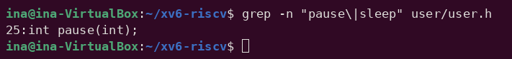
Figure 2.1 – The grep result in user.h
The only match is line 25, int pause(int);: the tree uses the new name, and no function called sleep is declared. This explains the compilation error obtained in Lab 2 ("implicit declaration of function 'sleep'"). The call in user/sleep.c was therefore changed to pause(), and the UPROGS list of the Makefile was checked to contain $U/_sleep\ (a TAB at the start, a backslash at the end and nothing after it):
#include "kernel/types.h"
#include "user/user.h"

int
main(int argc, char *argv[])
{
if(argc != 2){
fprintf(2, "usage: sleep <ticks>\n");
exit(1);
}
pause(atoi(argv[1])); // was sleep() before Aug 2025
exit(0);
}
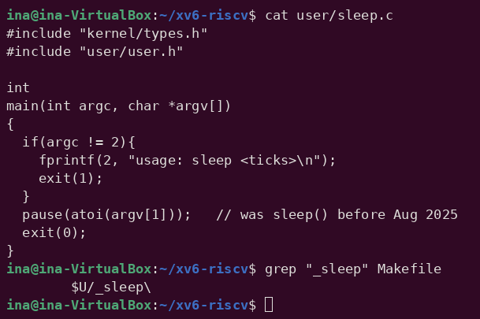
Figure 2.2 – The updated sleep.c
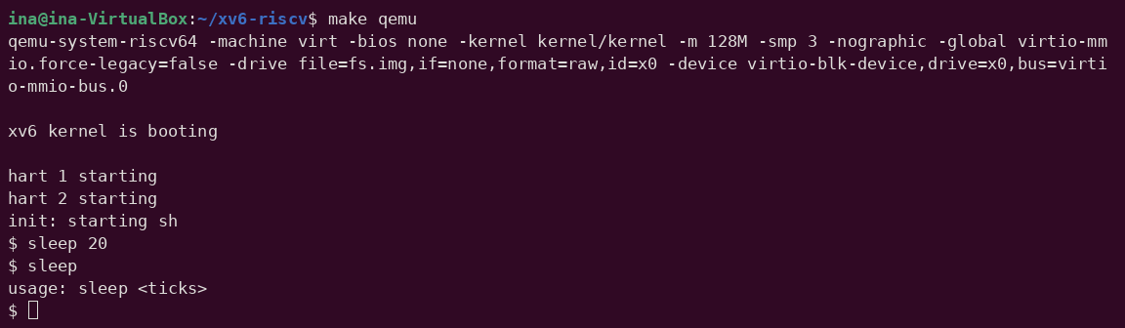
Figure 2.3 – sleep running in xv6, with and without an argument
After make qemu, sleep 20 paused for 20 ticks (about two seconds) before the $ prompt appeared again, and sleep without an argument printed "usage: sleep <ticks>". The program from Lab 2 now builds and works on the current xv6.

2.2 Part 2. bash versus the xv6 shell
Every command was run twice: in bash, in an empty folder ~/shtest containing only a file named README, and at the xv6 $ prompt.
mkdir ~/shtest && cd ~/shtest && touch README
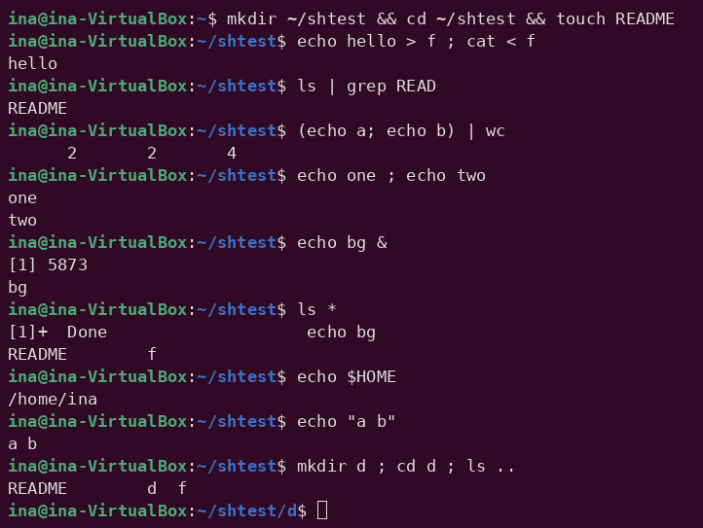
Figure 2.4 – The commands run in bash
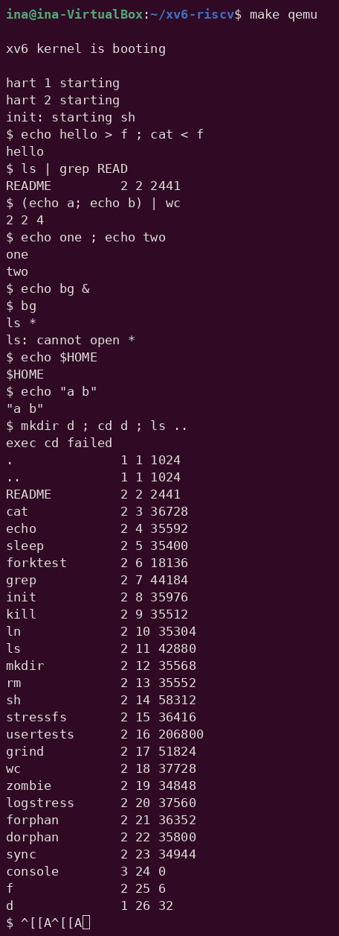
Figure 2.5 – The same commands run in xv6
Command | Tests | bash | xv6
echo hello > f ; cat < f | redirection | hello | hello – works
ls | grep READ | pipe | README | README 2 2 2441 – works (xv6 ls also prints type, inode and size)
(echo a; echo b) | wc | grouping, list | 2 2 4 | 2 2 4 – works
echo one ; echo two | sequence | one / two | one / two – works
echo bg & | background | [1] 5873, bg, later [1]+ Done | bg is printed after the prompt ("$ bg"); no job number, no jobs command
ls * | globbing | README f | ls: cannot open * – no globbing, * is passed literally
echo $HOME | variables | /home/ina | $HOME – no variables
echo "a b" | quotes | a b | "a b" – quotes are not special; they are printed, and the words are split into "a and b"
mkdir d ; cd d ; ls .. | PATH | README d f (the prompt moves to ~/shtest/d) | exec cd failed, then ls lists / – cd is recognised only at the start of a line
arrow up, Tab, Ctrl+R | history, completion | previous command, completion, search | ^[[A is printed literally; no history, no completion

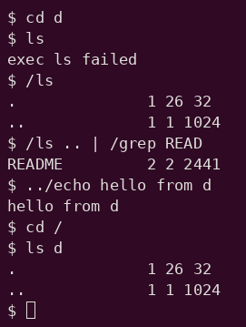
Figure 2.6 – ls failing after cd d, and the working alternatives
When cd d was typed on its own line, the directory changed, but then ls failed with "exec ls failed". Running the program by its full path, /ls, or by a relative path, ../echo, works; /ls .. | /grep READ shows that pipes work too as long as the programs are found.

2.2.1 Observations
Observe (Lab 4, Part 2)
(1) List the features both shells have, and the ones only bash has.
(2) In xv6, ls stops working after cd d. Why? Find a way to run ls from inside d anyway.
(3) Which missing feature would you miss most in daily work, and which would be easiest to add?
(1) Features
Both shells run programs with arguments and provide input and output redirection (<, >, >>), pipes (|), sequences (;), grouping with parentheses, background execution (&) and the built-in cd. Only bash has globbing (*, ?, [...]), variables and $ expansion, quote removal, command substitution $(...), arithmetic and brace expansion, the conditional operators && and ||, a PATH search for programs, job control (job numbers, jobs, kill %1, fg), aliases, command history with the arrow keys and Ctrl+R, Tab completion and line editing, and a full scripting language (if, for, functions).
(2) ls after cd d
xv6 has no PATH: the shell calls exec() with the name exactly as typed, and the kernel interprets "ls" as a path relative to the current directory. All xv6 programs live in the root directory /, so ls is found only while the current directory is /. Inside d there is no file named ls, and exec fails. Workarounds: give the path explicitly, /ls or ../ls (Figure 2.6), or go back with cd /. The same reason explains the combined line in the table: cd was not at the start of the line, so the shell tried to exec a program called cd, which does not exist, and ls ran in /, where it is found.
(3) Missing features
In daily work I would miss command history and Tab completion the most, since they save most of the typing and every typo would otherwise mean retyping the whole line. The easiest feature to add would be a minimal PATH: when exec(argv[0]) fails and the name contains no slash, the shell retries with "/" prepended. That is only a few lines in runcmd() in user/sh.c and would fix the ls-after-cd problem.

2.3 Part 3. Who expands *? A program that prints its argv
#include "kernel/types.h"
#include "user/user.h"

int
main(int argc, char *argv[])
{
printf("argc = %d\n", argc);
for(int i = 0; i < argc; i++)
printf("argv[%d] = [%s]\n", i, argv[i]);
exit(0);
}
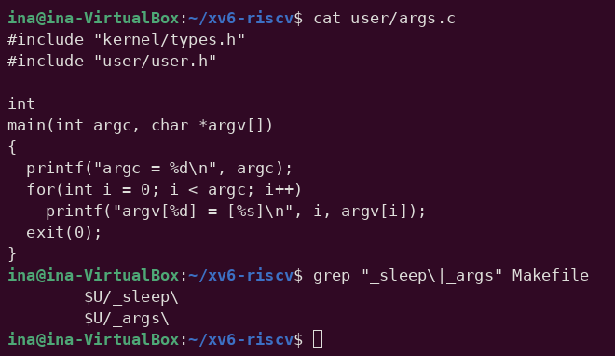
Figure 2.7 – args.c and the UPROGS line
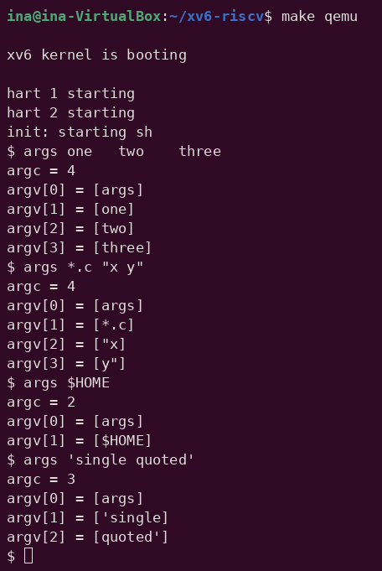
Figure 2.8 – args output in xv6
The Linux version, args_linux.c, differs only in the header (#include <stdio.h>) and in using return 0 instead of exit(0). It was compiled with gcc -o args args_linux.c and run as ./args in the folder ~/os-lab4, which contains three .c files (args.c, args_linux.c and sleep.c):
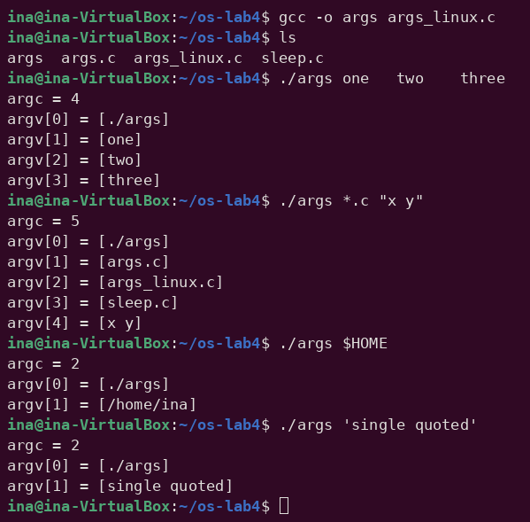
Figure 2.9 – args_linux output in bash
Command line | xv6 (args) | bash (./args)
args one two three | argc = 4: [args] [one] [two] [three] | argc = 4: [./args] [one] [two] [three]
args *.c "x y" | argc = 4: [args] [*.c] ["x] [y"] | argc = 5: [./args] [args.c] [args_linux.c] [sleep.c] [x y]
args $HOME | argc = 2: [args] [$HOME] | argc = 2: [./args] [/home/ina]
args 'single quoted' | argc = 3: [args] ['single] [quoted'] | argc = 2: [./args] [single quoted]

2.3.1 Observations
Observe (Lab 4, Part 3)
(1) Paste both outputs for args *.c "x y". How many arguments did each program receive?
(2) So who turns *.c into file names and removes the quotes: the program, the kernel, or the shell?
(3) What happened to the extra spaces in one two three?
(1) args *.c "x y"
In xv6 the program received argc = 4: [args] [*.c] ["x] [y"]. The * was not expanded, and the quotes stayed part of the words, so "x y" was split into two arguments, each with one quote character. In bash it received argc = 5: [./args] [args.c] [args_linux.c] [sleep.c] [x y]. The pattern became three file names, and "x y" became one argument containing a space, without the quotes.
(2) Who expands
The shell. The program code is identical in both systems and only prints what it receives, and the kernel's exec() simply copies the given strings into the new process. bash performs globbing, variable expansion and quote removal before it calls exec, while the xv6 shell does none of this, so the same program receives different arguments.
(3) Extra spaces
They disappeared in both shells: argc was 4 and the arguments were exactly one, two and three. Both shells split the line into words at runs of spaces or tabs, and the separators themselves are not passed to the program. In bash, spaces survive only inside quotes, as in "x y".

2.4 Part 4. Reading the shell
wc -l user/sh.c
grep -n "#define" user/sh.c # the kinds of commands
grep -n "case " user/sh.c # where each kind is run
grep -n "cd" user/sh.c | head
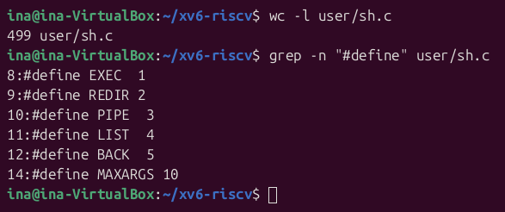
Figure 2.10 – Size of sh.c and the kinds of commands (#define)
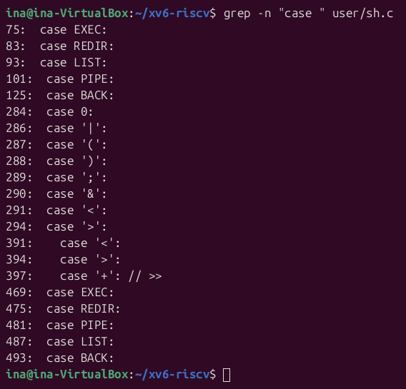
Figure 2.11 – Where each kind of command is parsed and run (case)
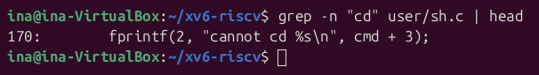
Figure 2.12 – Searching sh.c for cd
sh.c has 499 lines. The five #define constants EXEC, REDIR, PIPE, LIST and BACK (lines 8–12) are the kinds of commands; MAXARGS is only the limit of 10 arguments per command. The case lines appear in four places: runcmd() executes each kind (lines 75–125), gettoken() recognises the special characters | ( ) ; & < > (lines 284–294), parseredirs() builds a REDIR command for <, > and >> (lines 391–397), and nulterminate() (lines 469–493) finishes building each kind after parsing. grep "cd" finds only the error message on line 170, because the check in main() compares the characters one by one: cmd[0] == 'c' && cmd[1] == 'd' && cmd[2] == ' ', and then calls chdir(cmd + 3) in the shell process itself.

2.4.1 Observations
Observe (Lab 4, Part 4)
(1) Name the five kinds of command the xv6 shell knows and the character that produces each.
(2) Where is cd handled, and why is it not run as a separate program?
(3) Search sh.c for any code that handles * or $. What does that explain about Part 2?
(1) The five kinds of command
- EXEC – a plain command with its arguments (no special character).
- REDIR – a redirection, produced by < and > (and >> for appending).
- PIPE – a pipe between two commands, produced by |.
- LIST – a sequence of commands, produced by ;.
- BACK – a command run in the background, produced by &.
Parentheses ( ) do not create a separate kind; they only group a sub-command (parseblock). Each kind has its own struct, and runcmd() executes it in a switch with one case per kind.
(2) cd
cd is handled in main(), before the shell forks: if the line starts with the three characters "cd ", the shell removes the newline and calls chdir() itself, then reads the next line. Every other command is run with fork() and exec() in a child process, and a chdir() executed by a child would change only the child's directory, which disappears when the child exits. This is the same reason why cd is a built-in in bash (Lab 3, Part 1). Because the check looks only at the beginning of the line, a cd in the middle of a list, as in mkdir d ; cd d ; ls .., is treated as an ordinary program and fails with "exec cd failed".
(3) * and $
sh.c contains no code that handles * or $: the tokenizer gettoken() treats only the symbols < | > & ; ( ) specially (its symbols string is "<|>&;()"), and everything else is copied into argv unchanged. This explains Part 2 and Part 3: in xv6, ls * and args *.c received a literal *, echo $HOME printed $HOME, and quotes were passed through because the shell never removes them.

CONCLUSION
This laboratory work looked at the shell from the inside of a small operating system. After pause() replaced sleep() in the current xv6, the Lab 2 program was fixed and works. Comparing bash with the xv6 shell separated what a shell must provide, running programs, redirection, pipes, lists, background execution and a built-in cd, from the conveniences bash adds: globbing, variables, quote removal, PATH, history and completion. The args program made this visible: the same code received four arguments in xv6 and five in bash for the same line, which proves that it is the shell, not the program and not the kernel, that expands * and removes quotes. Reading sh.c confirmed it: its tokenizer knows only the characters < | > & ; ( ), and cd is handled in the parent process for the same reason it must be a built-in in bash.

REFERENCES
- GNU Bash Reference Manual. Free Software Foundation. Retrieved from https://www.gnu.org/software/bash/manual/
- The Linux man-pages project. bash(1), ls(1), grep(1), cut(1), sort(1), uniq(1), wc(1), passwd(5), execve(2). Retrieved from https://man7.org/linux/man-pages/
- Cox, R., Kaashoek, F., & Morris, R. xv6: a simple, Unix-like teaching operating system (RISC-V edition), chapter 1 "Operating system interfaces". MIT. Retrieved from https://pdos.csail.mit.edu/6.1810/
- MIT PDOS. xv6-riscv source code repository, user/sh.c. Retrieved from https://github.com/mit-pdos/xv6-riscv
- Shotts, W. (2019). The Linux Command Line (2nd ed.). No Starch Press.
- Pancenco, I. (2026). os-2026-InaPancenco: source code and reports of the Operating Systems laboratory works GitHub repository. Retrieved from: https://github.com/inap235/os-2026-InaPancenco

