MINISTRY OF EDUCATION, CULTURE AND RESEARCH
OF THE REPUBLIC OF MOLDOVA
Technical University of Moldova
Faculty of Computers, Informatics and Microelectronics
Department of Software Engineering and Automation

Report
on laboratory works no. 5–6
Operating Systems
Topic: The File System with Your Own Hands.
Inside the xv6 File System

Done by:
st. gr. FAF-242, Ina Pancenco

Checked by:
Patricia Reitman, university assistant
DISA, FCIM, UTM

Chișinău – 2026

Table of Contents
1 PURPOSE OF THE WORK
1.1 Purpose of practical work
1.2 Problem statement
2 LABORATORY WORK 5: THE FILE SYSTEM WITH YOUR OWN HANDS
2.1 Preparation
2.2 Part 1. The tree and the file types
2.2.1 Observations
2.3 Part 2. Inodes and links
2.3.1 An inode, and a name that is not part of it
2.3.2 Hard link, then remove the original
2.3.3 Symbolic link, then remove its target
2.3.4 Link counts of directories, and size versus space
2.3.5 Observations
2.4 Part 3. Permissions
2.4.1 Files and the umask
2.4.2 Directories: read versus execute
2.4.3 Special bits and other people's files
2.4.4 Observations
2.5 Part 4. Disks and the kernel as files
2.5.1 Observations
2.6 Stretch tasks
2.6.1 (a) Magic numbers
2.6.2 (b) Setuid programs
3 LABORATORY WORK 6: INSIDE THE XV6 FILE SYSTEM
3.1 Part 1. Read what xv6 shows you
3.1.1 Observations
3.2 Part 2. Write mystat
3.2.1 Observations
3.3 Part 3. Measure the limits
3.3.1 Observations
3.4 Part 4. Write find
3.4.1 Stretch: find with -n
CONCLUSION
REFERENCES

1 PURPOSE OF THE WORK

1.1 Purpose of practical work
The purpose of these two laboratory works is to understand the file system, the part of the operating system that turns a disk full of numbered blocks into a tree of named files. In Laboratory Work 5 the file system of a real Linux system is examined from the command line: the directory tree and the file types, the inodes that stand behind the names, hard and symbolic links, permissions and special bits, and the disks and pseudo-file systems underneath. No programming is involved; the work consists of commands, careful observation and short explanations.
In Laboratory Work 6 the same ideas are examined inside the teaching operating system xv6, whose file system has the same structure as ext4 (inodes, directories stored as tables of entries, hard links and a journal) in a few hundred readable lines. The output of the xv6 ls is decoded, a stat program (mystat) is written and used to watch hard links, the limits written in kernel/fs.h are measured, and finally a find program is written that walks the directory tree recursively.

1.2 Problem statement
Laboratory Work 5 – The File System with Your Own Hands (Track A, Linux):
- Part 1: the directory tree and the file types, as shown by ls -l and file, and the disk usage of /var/log and /usr.
- Part 2: inodes and links: stat, hard links, symbolic links, link counts of directories, and the difference between file size and disk space.
- Part 3: permissions of files and directories, the umask, and the special bits setuid and sticky.
- Part 4: disks, partitions and mounted file systems, and the kernel seen as files in /proc.
- Stretch: magic numbers (a) and the search for setuid programs (b).
Laboratory Work 6 – Inside the xv6 File System (Track B, xv6):
- Part 1: reading the output of the xv6 ls: file types, inode numbers and directory sizes.
- Part 2: writing user/mystat.c and using it to watch hard links being created and removed.
- Part 3: measuring the limits defined in kernel/fs.h: name length, maximum file size and disk layout.
- Part 4: writing user/find.c, which prints every path under a directory whose last component has a given name; stretch: the -n option, which also prints inode numbers.
Both works were carried out on an Ubuntu Linux virtual machine in VirtualBox (host name ina-VirtualBox, user ina), as a normal user and not as root. xv6 was run in QEMU from the ~/xv6-riscv tree. For every part the commands and their output are given as screenshots, followed by the answers to the Observe questions.

2 LABORATORY WORK 5: THE FILE SYSTEM WITH YOUR OWN HANDS

2.1 Preparation
The laboratory requires working as a normal user, because root ignores most permission checks and the experiments in Part 3 would give false results. whoami printed ina, not root. A working folder ~/os-lab5 was created and used for all experiments (Figure 5.1).

2.2 Part 1. The tree and the file types
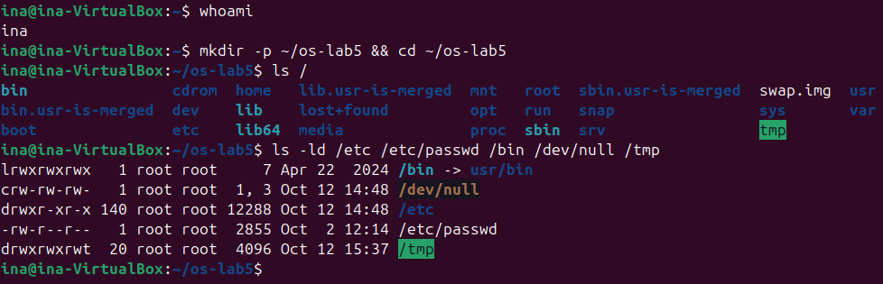
Figure 5.1 – whoami, the root directory and the types of five paths
ls / shows the top of the tree. Besides the usual directories (bin, etc, home, usr, var, dev, proc, tmp) there are the names bin.usr-is-merged, lib.usr-is-merged and sbin.usr-is-merged, which belong to the merged-/usr layout of recent Ubuntu, and swap.img, the swap file.
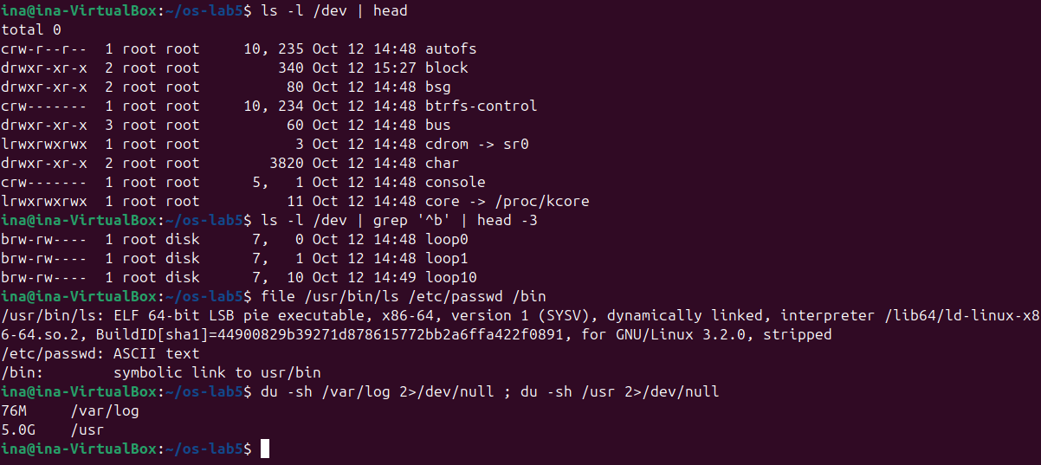
Figure 5.2 – Devices in /dev, the file command, and disk usage of /var/log and /usr

2.2.1 Observations
Observe (Part 1)
(1) For each path in the second line, write its type from the first letter of ls -l.
(2) What is /bin on your system: a directory or a link, and to where?
(3) Find one character device and one block device in /dev.
(4) Which is bigger on your laptop, /var/log or /usr, and by roughly how much?
(1) File types
Path | First letter | Type
/etc | d | directory
/etc/passwd | - | regular file (ASCII text)
/bin | l | symbolic link
/dev/null | c | character device (major 1, minor 3)
/tmp | d | directory (with the sticky bit t)

(2) /bin
/bin is not a directory but a symbolic link to usr/bin (ls shows /bin -> usr/bin and file prints "symbolic link to usr/bin"). Ubuntu uses the merged /usr layout, in which /bin, /sbin and /lib are links into /usr, so /bin/ls and /usr/bin/ls are the same file.
(3) Devices
Character devices start with c: for example /dev/null (1, 3), /dev/console (5, 1) and /dev/autofs (10, 235). Block devices start with b: for example /dev/loop0 (7, 0) and /dev/loop1 (7, 1), found with ls -l /dev | grep '^b'. The disk itself, /dev/sda (8, 0), is also a block device (Figure 5.10). For a device ls prints the major and minor numbers instead of a size: the major number selects the driver, and the minor number selects the device handled by that driver.
(4) /var/log versus /usr
/usr uses 5.0 GB and /var/log only 76 MB, so /usr is bigger by about 4.9 GB, roughly 67 times. /usr holds all installed programs and libraries, while /var/log holds only text logs, which are rotated and compressed.

2.3 Part 2. Inodes and links

2.3.1 An inode, and a name that is not part of it
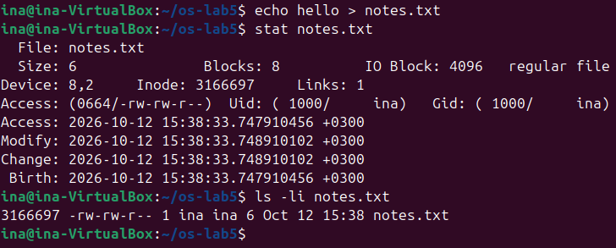
Figure 5.3 – stat and ls -li show the inode of notes.txt
stat shows all the metadata kept in the inode: size (6 bytes, "hello" plus a newline), blocks allocated (8 sectors of 512 bytes), type, inode number, link count, permissions, owner and group, and four time stamps. The file name does not appear in the inode: it is stored only in the directory.

2.3.2 Hard link, then remove the original
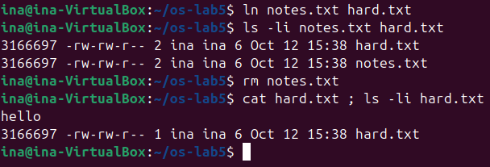
Figure 5.4 – A hard link shares the inode; removing one name keeps the file

2.3.3 Symbolic link, then remove its target
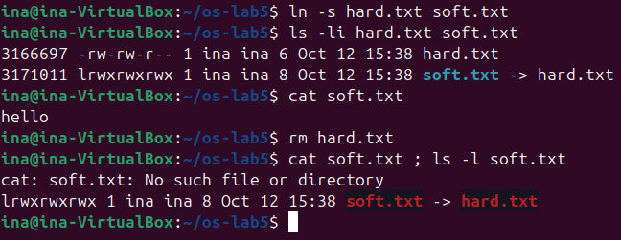
Figure 5.5 – A symbolic link has its own inode and breaks when its target is removed

2.3.4 Link counts of directories, and size versus space
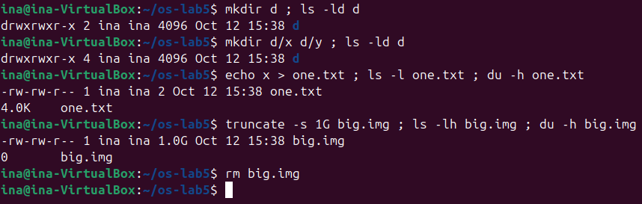
Figure 5.6 – Link counts of a directory, and size versus disk space

2.3.5 Observations
Observe (Part 2)
(1) Which number in stat is the inode, and which tells how many names the file has?
(2) After rm notes.txt, why could you still read hard.txt? What does rm really remove?
(3) Why did cat soft.txt fail at the end, although soft.txt still exists? How big is soft.txt and why exactly that size?
(4) A new directory has 2 links, and 4 after you create two subdirectories. Explain where each link comes from.
(5) Why does a 2-byte file use 4.0K, and a 1 GB file use 0?
(1) Inode and links
In the stat output, Inode: 3166697 is the inode number (ls -li prints the same number in the first column), and Links: 1 is the link count, the number of names (directory entries) that point to this inode.
(2) What rm removes
ln notes.txt hard.txt did not copy anything: it added a second directory entry pointing to the same inode 3166697, and the link count became 2. Both names are equally "the file"; there is no original and copy. rm notes.txt removed only one directory entry and decreased the link count to 1. rm (the unlink system call) removes a name, not the file. The inode and its data blocks are freed only when the link count reaches 0 and no process has the file open. That is why cat hard.txt still printed hello.
(3) The broken symbolic link
A symbolic link is a separate file with its own inode (3171011) whose content is just a path, here "hard.txt". When the link is opened, the kernel follows that path. After rm hard.txt the name no longer exists, so following the link fails with "No such file or directory", although soft.txt itself is still there (a dangling link, shown in red by ls). soft.txt is 8 bytes long because "hard.txt" has exactly 8 characters. The stored path has no newline and no terminating zero.
(4) Directory link counts
A new directory d has 2 links: the entry "d" in its parent directory (~/os-lab5), and the entry "." inside d itself. Each subdirectory contains an entry ".." that points back to its parent, so creating d/x and d/y adds two more links to d, giving 4 = 1 (name in parent) + 1 (.) + 2 (the .. of x and y). In general, the link count of a directory is 2 plus the number of its subdirectories.
(5) Size is not space
ext4 allocates space in whole blocks of 4096 bytes (IO Block: 4096 in stat). Even a 2-byte file needs one full block, so du reports 4.0K (8 sectors of 512 bytes). truncate -s 1G only sets the size field in the inode to 1 GB and allocates no blocks: it creates a sparse file, a file that consists entirely of a hole. Reading a hole returns zeros, so ls -l reports the size of 1.0G, but du counts the allocated blocks, which are 0.

2.4 Part 3. Permissions

2.4.1 Files and the umask
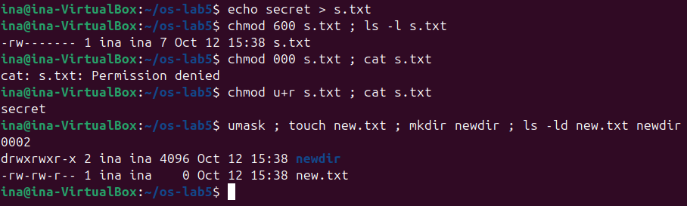
Figure 5.7 – Permissions of a file, and the effect of the umask

2.4.2 Directories: read versus execute
Before running the box experiment, the prediction was: with read only, ls can list the names but cat cannot open box/f; with execute only, ls fails but cat box/f works because the name is known. Figure 5.8 confirms both predictions. With read only, ls printed the name f, but it also printed "cannot access 'box/f'": ls is an alias with --color=auto, so it tries to stat each entry to choose a colour, and stat needs execute permission on the directory.
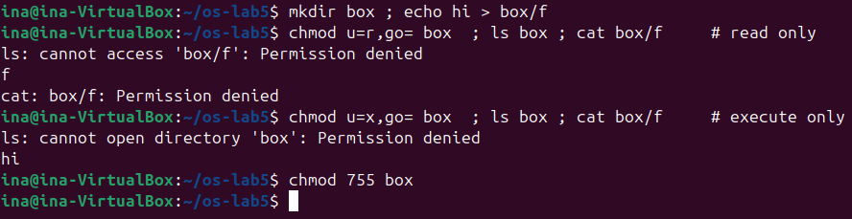
Figure 5.8 – The box experiment: read-only and execute-only directory

2.4.3 Special bits and other people's files
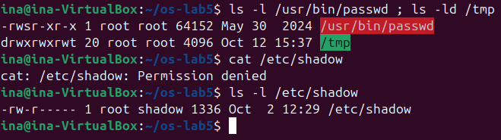
Figure 5.9 – setuid on passwd, sticky bit on /tmp, and the protected /etc/shadow

2.4.4 Observations
Observe (Part 3)
(1) Write 600, 644, 755 and 700 as rwx strings, and give one real use for each.
(2) With chmod 000 you own the file but cannot read it. Why does ownership not help?
(3) What is your umask, and how does it explain the permissions of new.txt and newdir?
(4) Explain the box experiment: what does r allow on a directory, and what does x allow?
(5) What do the s in /usr/bin/passwd and the t in /tmp mean, and why does passwd need the s?
(1) Octal modes
Octal | rwx string | Typical use
600 | rw------- | private files: ~/.ssh/id_ed25519, a mail box, s.txt above
644 | rw-r--r-- | ordinary readable files: /etc/passwd, documents, source code
755 | rwxr-xr-x | programs and public directories: /usr/bin/ls, a home page directory
700 | rwx------ | private directories and scripts: ~/.ssh, a personal script

(2) Ownership does not give access
The kernel checks permissions by class. If the process's user is the file's owner, only the owner bits are used, and they are --- after chmod 000. The group and other bits are not consulted, and ownership is not a bypass. Ownership gives one extra right: the owner may change the mode with chmod. That is why chmod u+r s.txt succeeded and cat then printed secret. Only root (with CAP_DAC_OVERRIDE) skips the check altogether.
(3) The umask
The umask is 0002. New files are created with the mode 666 and new directories with 777, and the bits in the umask are removed: 666 & ~002 = 664 (rw-rw-r--) for new.txt, and 777 & ~002 = 775 (rwxrwxr-x) for newdir, exactly as ls -ld shows. Ubuntu uses 002 because every user has a private group of the same name (ina), so group write permission is harmless.
(4) r and x on a directory
A directory is a table of names and inode numbers. r allows reading that table, so ls can list the names, but nothing can be done with the entries behind them. x (search) allows passing through the directory, looking up a name and reaching the inode behind it. With r only, ls box printed f, but cat box/f was refused. With x only, ls box failed ("cannot open directory"), but cat box/f printed hi, because the name was already known and the lookup was allowed.
(5) setuid and sticky
The s in place of the owner x of /usr/bin/passwd (-rwsr-xr-x root) is the setuid bit: the program runs with the effective user ID of the file's owner, root, and not of the user who started it. passwd needs it because it must write the new password hash to /etc/shadow, which is -rw-r----- root shadow, and which a normal user cannot even read (cat /etc/shadow: Permission denied). passwd itself checks that a normal user changes only their own password. The t in place of the others x of /tmp (drwxrwxrwt) is the sticky bit: everybody may create files in /tmp, but a file can be deleted or renamed only by its owner, the directory's owner, or root, so users cannot delete each other's files.

2.5 Part 4. Disks and the kernel as files
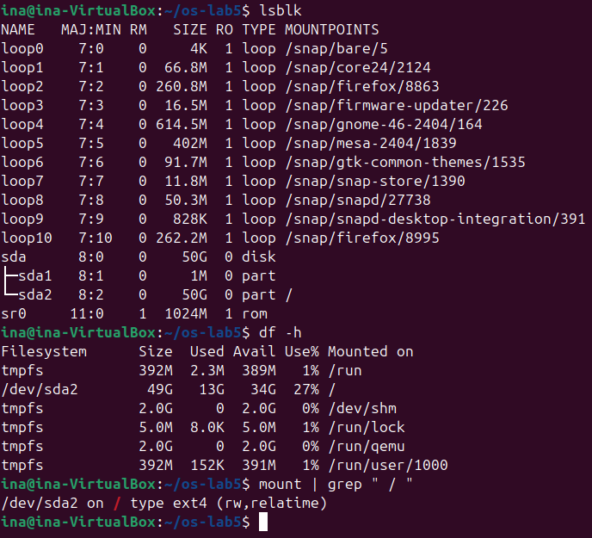
Figure 5.10 – Block devices, mounted file systems and the root mount
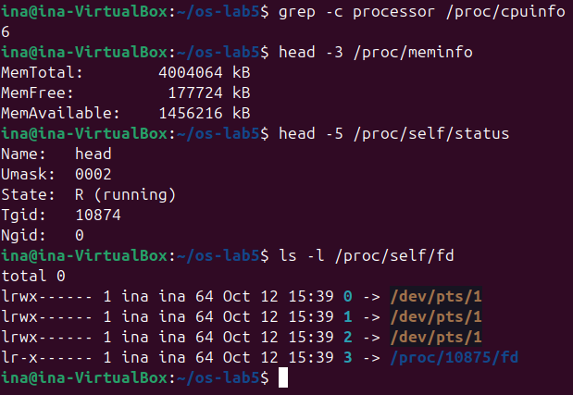
Figure 5.11 – CPU, memory, the current process and its file descriptors, read from /proc

2.5.1 Observations
Observe (Part 4)
(1) Draw your disk: disk name, partitions, which one is mounted at / and with what file system type.
(2) How full is your root file system?
(3) How many CPU cores and how much RAM does your laptop have, according to /proc?
(4) /proc/self/status showed the name of a program. Which one, and why that one?
(1) The disk
The virtual machine has a single 50 GB virtual disk, /dev/sda, with two partitions:
Device | Size | Type | Mounted at | Contents
sda | 50G | disk |  | whole virtual disk (GPT)
sda1 | 1M | part | not mounted | BIOS boot partition for GRUB
sda2 | 50G | part | / | ext4 root file system (rw, relatime)

The loop0 to loop10 devices are not disks: each one is a read-only snap package image (firefox, core24, gnome-46-2404 and others) mounted under /snap. sr0 is the virtual CD-ROM drive. The other mounted file systems (/run, /dev/shm, /run/lock, /run/user/1000) are tmpfs, which lives in RAM.
(2) Fill level
df -h shows /dev/sda2 with 49G size, 13G used and 34G available, so the root file system is 27% full.
(3) CPU and RAM
grep -c processor /proc/cpuinfo prints 6, so the virtual machine has 6 CPU cores (logical processors). MemTotal is 4004064 kB, about 3.8 GiB, which corresponds to the 4 GB given to the virtual machine minus the memory reserved by the kernel. These are the resources of the VM, not of the physical laptop.
(4) /proc/self
/proc/self/status showed Name: head. /proc/self is a symbolic link that the kernel resolves differently for each process: it always points to the directory of the process that opens it. The file was opened by head, not by the shell, so head saw its own status. Similarly, ls -l /proc/self/fd showed the descriptors of ls itself: 0, 1 and 2 connected to the terminal /dev/pts/1, and 3, the directory /proc/<pid>/fd that ls had opened to read.

2.6 Stretch tasks

2.6.1 (a) Magic numbers
Figure 5.12 – file recognises gzip data by its first bytes, not by the name
notes.txt has a .txt name, but file reports gzip compressed data. file ignores the name and looks at the content: every gzip stream starts with the magic bytes 1f 8b, followed by 08 (the compression method, deflate). The next bytes are flags and the time stamp, and then the original file name "passwd", which file also printed.

2.6.2 (b) Setuid programs
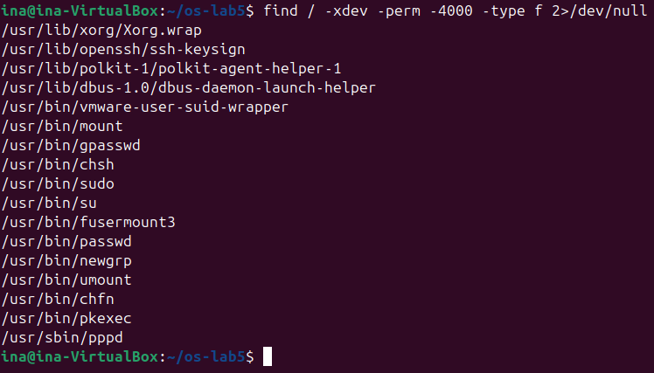
Figure 5.13 – All setuid programs on the root file system
17 setuid programs were found. The classic ones are passwd, chsh, chfn, gpasswd, newgrp, su, sudo, mount, umount and pkexec. Less obvious ones are fusermount3 (mounting user-space file systems), ssh-keysign, Xorg.wrap, polkit-agent-helper-1, dbus-daemon-launch-helper and pppd. vmware-user-suid-wrapper comes from the open-vm-tools-desktop package (the VMware guest tools), which the Ubuntu installer added although this machine runs in VirtualBox. ping is not in the list: on modern systems it uses file capabilities or unprivileged ICMP sockets instead of setuid root.

3 LABORATORY WORK 6: INSIDE THE XV6 FILE SYSTEM
Two new programs were added to ~/xv6-riscv: user/mystat.c and user/find.c, each registered in the UPROGS list of the Makefile with a line $U/_mystat\ and $U/_find\ (Figure 6.3). Before Part 1 and before Part 4, the disk was rebuilt from scratch with make clean followed by make, as the laboratory requires.

3.1 Part 1. Read what xv6 shows you
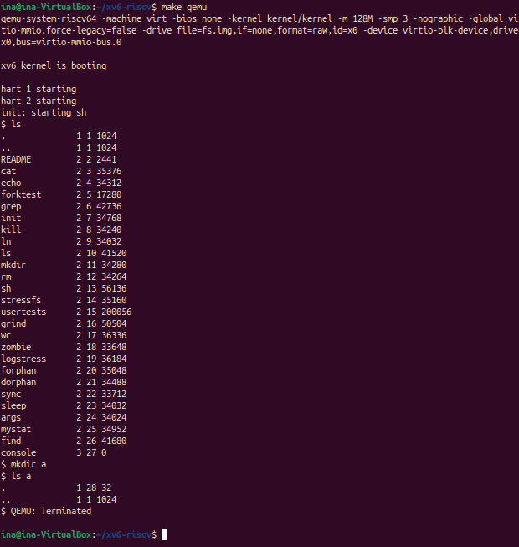
Figure 6.1 – ls in xv6 on a fresh disk, and the new empty directory a
Each line of the xv6 ls is: name, type, inode number and size in bytes. The inode numbers are larger than in the laboratory handout (console is inode 27 instead of 25) because this disk also contains the programs sleep and args from Lab 4 and the new mystat and find.

3.1.1 Observations
Observe (Lab 6, Part 1)
(1) What do types 1, 2 and 3 mean (kernel/stat.h)?
(2) Which inode number does the root directory have, and why are . and .. the same there?
(3) An empty directory a has size 32. A directory entry has a fixed size. How big is one entry, and which two entries does a contain?
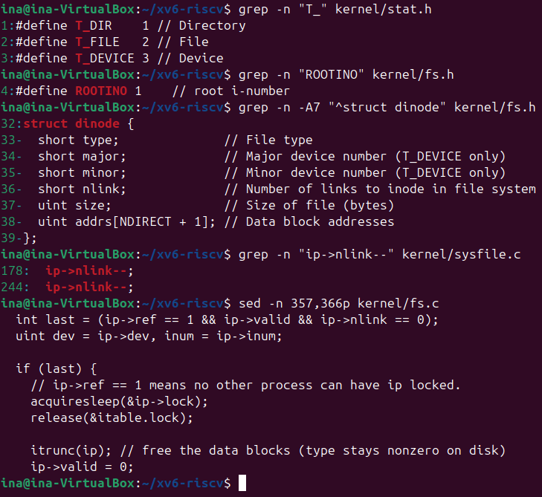
Figure 6.2 – File types, the root inode, the on-disk inode, and where unlink drops the link count
(1) Types
kernel/stat.h defines 1 = T_DIR (directory), 2 = T_FILE (regular file) and 3 = T_DEVICE (device). So . and .. are directories, README and the programs are files, and console is a device (size 0, because its data does not live on the disk).
(2) The root inode
The root directory has inode 1 (ROOTINO in kernel/fs.h; inode 0 means a free directory slot). The root has no parent, so mkfs stores in it an entry ".." that points to the root itself (mkfs/mkfs.c: strcpy(de.name, "..") with the root's own inum). That is why . and .. both show inode 1. Path lookup therefore stops at the root: cd .. in / stays in /.
(3) Directory entries
A directory is a file that holds an array of struct dirent { ushort inum; char name[DIRSIZ]; }, i.e. 2 + 14 = 16 bytes per entry. 32 bytes are exactly two entries, and ls a shows them: "." (inode 28, a itself) and ".." (inode 1, the root).

3.2 Part 2. Write mystat
mystat calls the stat() library function for each argument. stat() opens the file, calls fstat and closes it, filling a struct stat with dev, ino, type, nlink and size. typename() converts the type to a word with a switch on T_DIR, T_FILE and T_DEVICE. If stat fails, an error is printed to file descriptor 2 and the loop continues with the next argument, so one bad name does not stop the program.
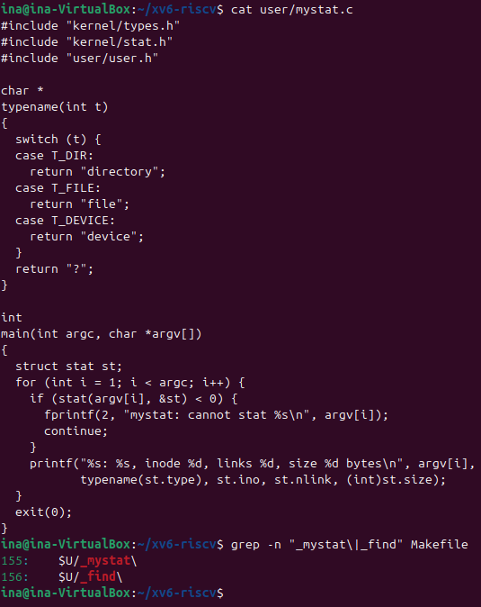
Figure 6.3 – user/mystat.c and the two new UPROGS lines in the Makefile
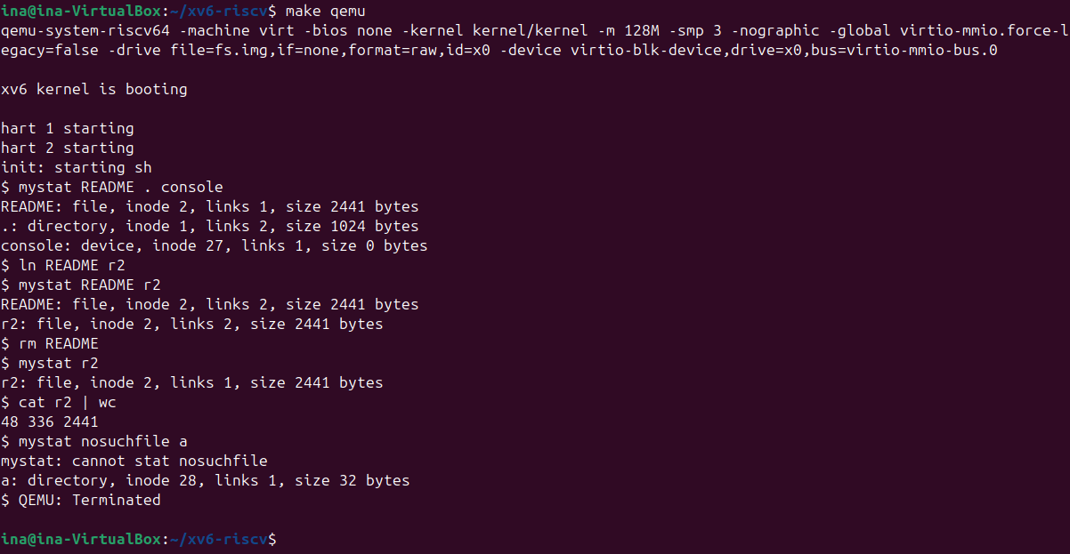
Figure 6.4 – mystat watching a hard link being created and the original name removed

3.2.1 Observations
Observe (Lab 6, Part 2)
(1) Paste the outputs after ln and after rm. What changed and what did not?
(2) Find the line in kernel/sysfile.c (sys_unlink) that decrements the link count. When are the data blocks freed?
(3) xv6 has no symbolic links and no permissions. Look at struct dinode in kernel/fs.h: which fields does an xv6 inode have?
(1) After ln and after rm
After ln README r2: "README: file, inode 2, links 2, size 2441 bytes" and "r2: file, inode 2, links 2, size 2441 bytes". After rm README: "r2: file, inode 2, links 1, size 2441 bytes". Only the link count changed (1 → 2 → 1). The inode number (2), the type, the size and the data did not change: cat r2 | wc still counts 48 lines, 336 words and 2441 bytes, the full README. As on Linux, ln added a second name for inode 2 and rm removed one name.
The root directory "." shows links 2, while the handout shows 1. This run was made after mkdir a in Part 1: the entry ".." of a points to the root, and create() in sysfile.c increments the parent's nlink for it (dp->nlink++; // for ".."). In xv6 the entry "." is deliberately not counted ("No ip->nlink++ for '.': avoid cyclic ref count"), which is why the new directory a has links 1 instead of 2 as on Linux.
(2) Where the link count drops, and when the blocks are freed
In sys_unlink the line is kernel/sysfile.c:244, ip->nlink--;, followed by iupdate(ip), which writes the inode back to disk. (Line 178 is the same statement in the error path of sys_link.) The blocks are not freed there. sys_unlink then calls iunlockput(ip), which calls iput(). In iput() (kernel/fs.c:357–366) the inode is truncated, and itrunc() frees all data blocks, only when ip->ref == 1 (this is the last in-memory reference, so no process has the file open) and ip->nlink == 0 (no directory entry names it any more). So the data blocks are freed when the last name is removed and the last open file descriptor is closed, whichever happens later. The whole operation runs between begin_op() and end_op(), so it is logged atomically.
(3) The xv6 inode
struct dinode has only six fields: type (free, directory, file or device), major and minor (device numbers, used only for T_DEVICE), nlink (number of directory entries), size (in bytes) and addrs[NDIRECT+1] (12 direct block numbers and one indirect block). Compared to ext4, there is no owner (uid/gid), no mode and permission bits, no time stamps and no generation number. Without a mode there are no permissions, and without a link type there are no symbolic links. The structure is 2·4 + 4 + 13·4 = 64 bytes, so 16 inodes fit in one 1024-byte block.

3.3 Part 3. Measure the limits
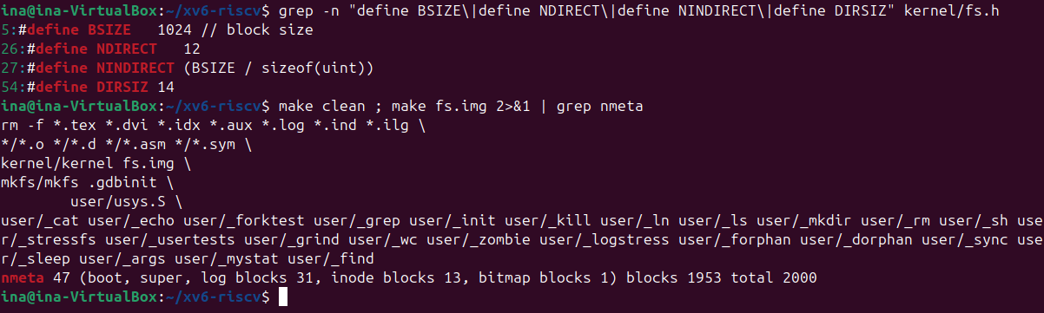
Figure 6.5 – The constants in kernel/fs.h and the disk layout printed by mkfs
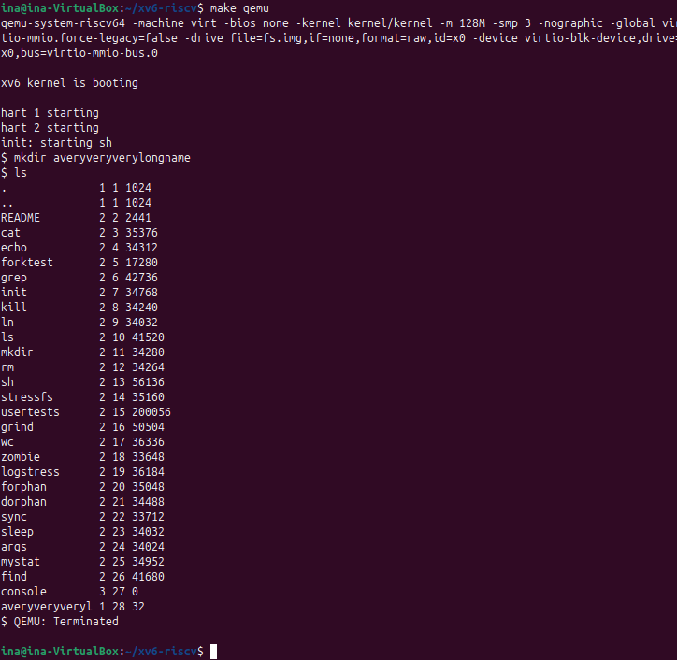
Figure 6.6 – A directory with a 21-character name, as seen by ls

3.3.1 Observations
Observe (Lab 6, Part 3)
(1) What does ls show for averyveryverylongname, and which constant explains it?
(2) Compute the largest file xv6 can hold. Show the calculation.
(3) From the nmeta line: how many blocks does the whole disk have, and how many are for the log, the inodes, and the data?
(1) Long names
ls shows averyveryveryl, only the first 14 characters of the 21-character name. The constant is DIRSIZ = 14: a directory entry has room for exactly 14 bytes of name. skipelem() in kernel/fs.c copies at most DIRSIZ bytes of each path component, so mkdir silently stored the truncated name. Because the name fills the whole field, there is no terminating zero in the entry; that is why ls (fmtname) and find copy it into a buffer of DIRSIZ + 1 bytes before using it as a string.
(2) Maximum file size
BSIZE = 1024 bytes. NDIRECT = 12 direct blocks. The indirect block holds NINDIRECT = BSIZE / sizeof(uint) = 1024 / 4 = 256 block numbers. MAXFILE = NDIRECT + NINDIRECT = 12 + 256 = 268 blocks, so the largest file is 268 × 1024 = 274 432 bytes = 268 KiB. The direct blocks cover only the first 12 KiB; everything after that goes through the single indirect block.
(3) Disk layout
The line "nmeta 47 (boot, super, log blocks 31, inode blocks 13, bitmap blocks 1) blocks 1953 total 2000" gives:
Region | Blocks | Explanation
boot | 1 | block 0, unused by xv6
superblock | 1 | describes the layout
log | 31 | 1 header + LOGBLOCKS = 3 × MAXOPBLOCKS = 30
inodes | 13 | NINODES 200 / 16 inodes per block + 1
bitmap | 1 | 2000 bits fit in one 8192-bit block
data | 1953 | 2000 − 47 metadata blocks
total | 2000 | FSSIZE = 2000 blocks of 1 KiB = 2 000 KiB

3.4 Part 4. Write find
find.c is built on user/ls.c. find(path, name) opens path and checks with fstat that it is a directory. It then reads struct dirent records one at a time, skipping free slots (inum == 0) and the entries "." and "..". For each remaining entry it appends the name to the path in buf, stats the result and compares the last path component with the wanted name using strcmp. Matching paths are printed, and directories are searched recursively. Every directory is closed before find returns: xv6 allows only NOFILE = 16 open files per process, and recursion keeps one descriptor open for each level. The path is checked against the size of the 512-byte buffer before an entry is appended. The program prints a usage message if it is called with the wrong arguments, and it also accepts the optional -n argument of the stretch task.
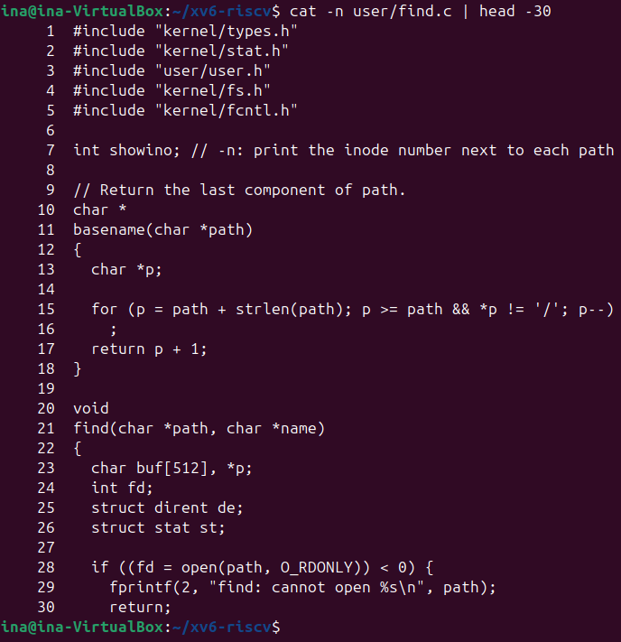
Figure 6.7 – user/find.c, lines 1–30
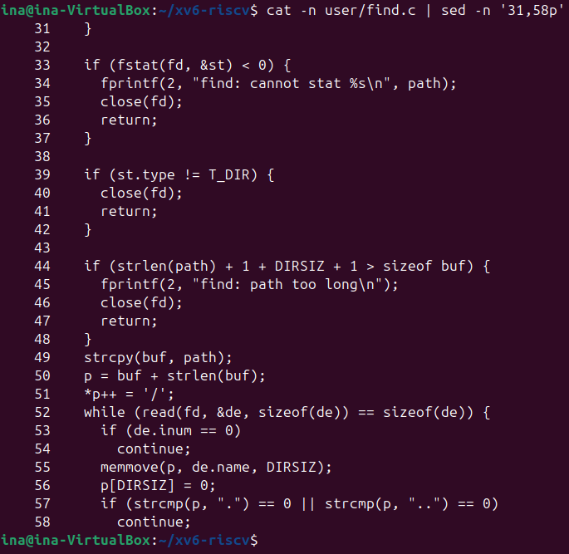
Figure 6.8 – user/find.c, lines 31–58
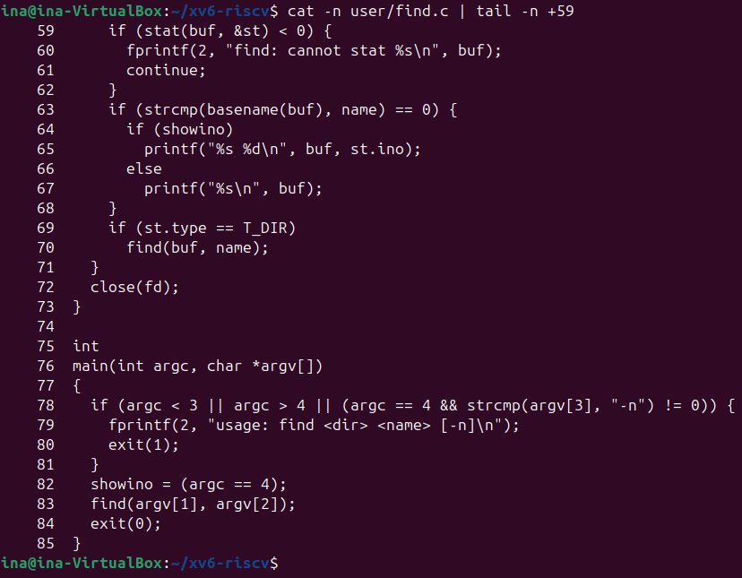
Figure 6.9 – user/find.c, lines 59–85
The test was run on a fresh disk (make clean, then make), with the commands from the laboratory handout and a few extra checks (Figure 6.10).
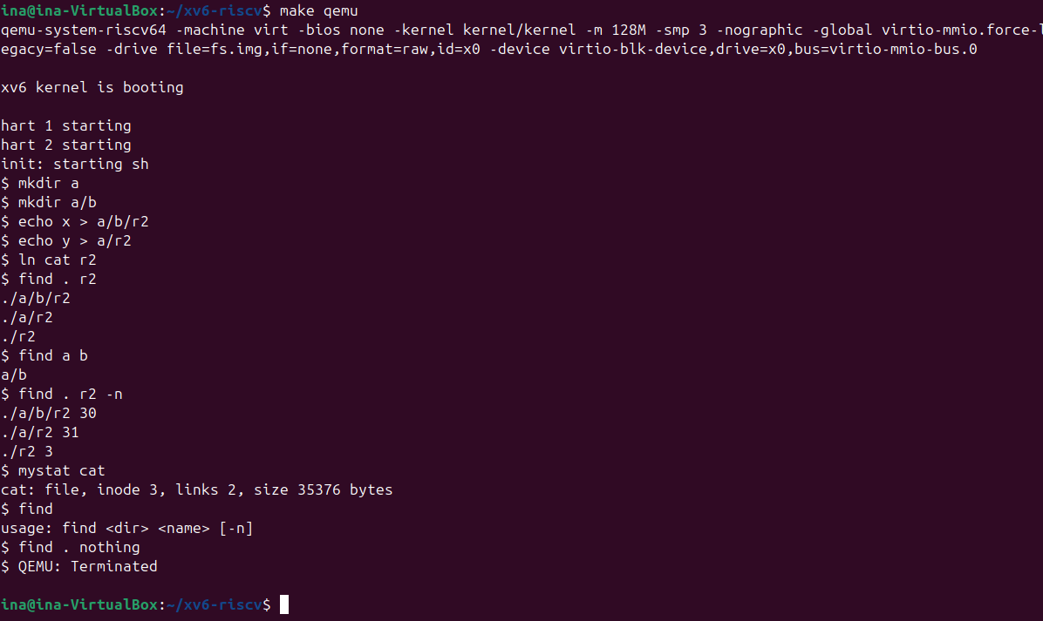
Figure 6.10 – find on a fresh disk, the -n stretch option, and error handling
find . r2 printed ./a/b/r2, ./a/r2 and ./r2, and find a b printed a/b, exactly the expected results. find without arguments prints the usage message, and a name that does not exist prints nothing.

3.4.1 Stretch: find with -n
find . r2 -n prints the inode number after each path: ./a/b/r2 is inode 30, ./a/r2 is inode 31 and ./r2 is inode 3. mystat cat shows that cat is also inode 3, with links 2. So only ./r2 is the same file as cat: ln cat r2 made a second name for the cat program. The other two r2 files are separate small files created by echo, with their own inodes.

CONCLUSION
Laboratory Work 5 showed that a file is not its name. Behind every name there is an inode, which holds the type, size, owner, permissions, time stamps and the location of the data, and a directory is only a table that maps names to inode numbers. With this model all the experiments become simple. A hard link is a second entry for the same inode, and rm only removes an entry, so the data survives as long as one name or one open descriptor remains. A symbolic link is a small file that contains a path, and it breaks when the path disappears. The link count of a directory comes from its name, its "." and the ".." of each subdirectory. Size and allocated space are different things, because space is given in whole blocks and holes are not stored. The permission experiments showed that r and x mean different things for a directory (list versus pass through), that the owner bits apply even to the owner, and that the setuid and sticky bits solve real problems: passwd must write a root-only file, and /tmp must be shared without users deleting each other's files. Finally, /proc showed the kernel itself as a file system, where /proc/self means something different for every process that reads it.
Laboratory Work 6 showed the same ideas in code small enough to read completely. The xv6 inode has only six fields, and the absence of owner and mode fields is exactly why xv6 has no permissions and no symbolic links. A directory entry is 16 bytes, which limits names to 14 characters, and the 12 direct block pointers plus one indirect block limit a file to 268 KiB. The disk of 2000 blocks is divided into boot, superblock, log, inodes, bitmap and data blocks. Writing mystat and watching the link count, then reading sys_unlink and iput, confirmed where a file really dies: data blocks are freed only when the link count is zero and no process holds the inode. Writing find required walking directories exactly as the kernel stores them: skipping free slots, never descending into . and .., building paths in a bounded buffer, and closing every directory to stay below the limit of 16 open files. The -n option made it visible that two names can lead to the same inode.

REFERENCES
- Cox, R., Kaashoek, F., & Morris, R. xv6: a simple, Unix-like teaching operating system (RISC-V edition), chapter 8 "File system". MIT. Retrieved from https://pdos.csail.mit.edu/6.1810/
- MIT PDOS. xv6-riscv source code repository: kernel/fs.h, kernel/fs.c, kernel/sysfile.c, kernel/stat.h, mkfs/mkfs.c, user/ls.c. Retrieved from https://github.com/mit-pdos/xv6-riscv
- MIT 6.1810 Fall 2024. Lab: Xv6 and Unix utilities (find). Retrieved from https://pdos.csail.mit.edu/6.1810/2024/labs/util.html
- The Linux man-pages project. stat(1), ln(1), chmod(1), umask(2), unlink(2), inode(7), symlink(7), path_resolution(7), proc(5). Retrieved from https://man7.org/linux/man-pages/
- The Linux Kernel documentation. ext4 Data Structures and Algorithms. Retrieved from https://docs.kernel.org/filesystems/ext4/
- Arpaci-Dusseau, R. H., & Arpaci-Dusseau, A. C. (2018). Operating Systems: Three Easy Pieces, chapters 39–40 "Files and Directories", "File System Implementation". Arpaci-Dusseau Books.

