
MINISTRY OF EDUCATION, CULTURE AND RESEARCH
OF THE REPUBLIC OF MOLDOVA
Technical University of Moldova
Faculty of Computers, Informatics and Microelectronics
Department of Software Engineering and Automation

Report
Practical Work No.1-2
Operating Systems
Topic: The OS as a Resource Manager.
Meet the OS You Will Build (xv6)

Done by:
st. gr. FAF-242, Ina Pancenco
Checked by:
Reițman Patricia, university assistant
DISA, FCIM, UTM

Chișinău – 2026

Table of Contents
1 AIM OF THE WORK 3
1.1 Purpose of practical work 3
1.2 Problem statement 3
2 THEORETICAL BACKGROUND 4
2.1 The operating system as a resource manager 4
2.2 File management 4
2.3 Process management 4
2.4 Memory management 4
2.5 Device and I/O management 4
2.6 Kernel space, user space and system calls 5
2.7 xv6, RISC-V and QEMU 5
2.8 Pipes and inter-process communication 5
3 LABORATORY WORK 1: THE OS AS A RESOURCE MANAGER 6
3.1 Environment setup 6
3.2 Part 1. Files and directories (File management) 7
3.2.1 Navigating and inspecting the file tree 7
3.2.2 Creating, copying, renaming and removing files 8
3.2.3 Ownership and permissions 10
3.2.4 Observations 10
3.3 Part 2. Processes (Process management) 11
3.3.1 Listing processes 11
3.3.2 Starting, finding and stopping a background process 12
3.3.3 Inspecting a process through /proc 13
3.3.4 Observations 14
3.4 Part 3. Memory (Memory management) 15
3.4.1 Observations 15
3.5 Part 4. Devices and storage (I/O management) 16
3.5.1 Observations 18
3.6 Wrap-up: the four resources managed by the OS 19
4 LABORATORY WORK 2: MEET THE OS YOU WILL BUILD (XV6) 20
4.1 Getting the xv6 source code 20
4.2 Installing the build tools 20
4.3 Part 1. Building and booting xv6 21
4.4 Part 2. Using xv6 as the Unix it is 21
4.4.1 Observations 24
4.5 Part 3. Reading the source code 25
4.5.1 A user program: ls.c and cat.c 25
4.5.2 The system call interface 27
4.5.3 Observations 29
4.6 Part 4. Writing the first xv6 program 29
4.6.1 The source code of user/sleep.c 29
4.6.2 Adding the program to the build 31
4.6.3 Testing the program 32
CONCLUSION 33
REFERENCES 34

1 AIM OF THE WORK

1.1 Purpose of practical work
The purpose of these two practical works is to meet the operating system from two complementary sides. In the first laboratory the OS is observed from the outside, as a resource manager: a real Linux kernel is examined through the command line while it manages files, processes, memory and devices. In the second laboratory the OS is seen from the inside: the small teaching operating system xv6 is compiled from source, booted in an emulator, used, read, and extended with a first user program that makes a real system call.
Together, the two works aim to develop the habit of interpreting what the system shows, not just typing commands, and to connect the abstract concepts of the lecture (kernel, user space, system calls, processes, the file system) with concrete code and concrete output. Lab 1 shows what the OS does; Lab 2 begins to show how it is done.

1.2 Problem statement
Laboratory Work 1 (Track A: the real OS, from the outside) consists of four parts, each dedicated to one of the core management functions of an operating system:
- Part 1 - File management: navigating the directory tree, creating, copying, renaming and deleting files, and changing access permissions.
- Part 2 - Process management: listing running processes, starting a background process, inspecting it through the /proc pseudo-filesystem and terminating it.
- Part 3 - Memory management: examining total, used and free RAM and swap, and the resident memory of a single process.
- Part 4 - Device and I/O management: examining mounted filesystems, block devices and the device files in /dev.
Laboratory Work 2 (Track B: build your own small OS) consists of four parts built around xv6:
- Part 1 - Build and boot: compiling the xv6 kernel and user programs and booting the system in QEMU.
- Part 2 - Use xv6: running its built-in programs (ls, cat, echo, grep, wc, usertests), including a pipe.
- Part 3 - Read the source: studying user programs (ls.c, cat.c), the list of system calls in user/user.h and their kernel implementation in kernel/sysfile.c.
- Part 4 - First xv6 program: writing user/sleep.c, adding it to the build and testing it inside xv6.
Both works were carried out on Ubuntu Linux running under WSL2 (Windows Subsystem for Linux, kernel 6.6.87.2-microsoft-standard-WSL2), a real Linux kernel running inside a lightweight virtual machine. For every part the executed commands, their output (as screenshots) and the answers to the "Observe" questions are presented.

2 THEORETICAL BACKGROUND

2.1 The operating system as a resource manager
An operating system (OS) is the software layer that controls the hardware of a computer and provides services to application programs. It can be viewed from two perspectives. From the top down, it is an extended machine: it hides the complicated details of the hardware behind clean abstractions such as files, processes and address spaces. From the bottom up, it is a resource manager: it allocates the processor, memory, storage and I/O devices among the competing programs in an orderly, fair and protected way.
The central part of the OS is the kernel, which runs in privileged (kernel) mode and has full access to the hardware. User programs run in user mode and must ask the kernel for services through system calls (for example open, read, fork, kill). Every command used in this laboratory is ultimately a user program that asks the kernel for information or for an action.

2.2 File management
The file system turns the raw blocks of a storage device into a hierarchical tree of named files and directories. In UNIX-like systems there is a single tree starting at the root directory "/", and other disks or partitions are attached (mounted) into this tree. Each file has an owner, a group and a set of permission bits that specify who may read (r), write (w) or execute (x) it. Permissions are grouped in three triplets: for the owner, the group and all other users, and can be set in octal form with chmod (r = 4, w = 2, x = 1).

2.3 Process management
A process is a program in execution, together with its own address space, open files, registers and other state. The OS creates processes, identifies each by a unique process identifier (PID), schedules them on the CPU and terminates them. In Linux the first user-space process, with PID 1, is init (on modern distributions, systemd), and all other processes descend from it. A process can be in several states, for example running (R), sleeping and waiting for an event (S), stopped (T) or zombie (Z). Processes communicate with the OS and with each other through signals; the kill command sends a signal (by default SIGTERM) asking a process to terminate.

2.4 Memory management
The memory manager shares the physical RAM among processes while giving each one its own private virtual address space. Only the pages that are actually used are kept in physical memory; the part of a process that is really in RAM is called its resident set size (RSS). When RAM becomes scarce, the OS can move rarely used pages to swap space on disk, which extends the usable memory at the cost of speed. Linux also uses otherwise idle RAM as a cache for disk data (buff/cache), which is why "free" memory is often low while "available" memory is much higher.

2.5 Device and I/O management
The I/O subsystem hides the details of every hardware controller behind device drivers and a uniform interface. In UNIX this is expressed by the principle "everything is a file": disks, terminals, random number generators and even the kernel's view of processes are accessible as entries in the file tree (in /dev, /proc and /sys) and can be manipulated with the same system calls used for ordinary files. Block devices (disks) are organized into filesystems which are mounted into the directory tree at mount points.

2.6 Kernel space, user space and system calls
Modern processors provide at least two privilege levels. The kernel runs in the privileged level (supervisor mode on RISC-V) and may execute any instruction and access any memory or device; ordinary programs run in user mode and are isolated from the hardware and from each other. When a user program needs a service that only the kernel can provide (reading a file, creating a process, allocating memory) it executes a system call: a special instruction (ecall on RISC-V) that traps into the kernel, which checks the arguments, performs the operation and returns the result. Library functions such as read() and write() in a C program are thin wrappers that only prepare the arguments and trigger this trap.

2.7 xv6, RISC-V and QEMU
xv6 is a teaching operating system developed at MIT as a modern re-implementation of Unix Version 6 (1975) by Dennis Ritchie and Ken Thompson. It is written in about 9,000 lines of ANSI C for the RISC-V architecture and contains all the essential parts of a real Unix kernel: processes and a scheduler, virtual memory with page tables, a file system with a log, pipes, a console and a disk driver, together with a small set of user programs and a shell. Because there is no real RISC-V board in the laboratory, xv6 runs inside QEMU, an emulator that simulates a complete RISC-V computer (processor cores, RAM and a virtio disk) as an ordinary program on the host. The kernel is built with a RISC-V cross-compiler, that is, a compiler that runs on x86_64 but produces RISC-V machine code.

2.8 Pipes and inter-process communication
A pipe is a kernel buffer with two ends, represented by two file descriptors: one for writing and one for reading. When the shell executes a command line such as ls | grep c, it creates a pipe, then creates two child processes with fork(), connects the standard output of the first and the standard input of the second to the two ends of the pipe (using close() and dup()), and loads the two programs with exec(). The kernel then transfers the data between the processes and blocks the reader when the pipe is empty and the writer when it is full, so the two programs cooperate without knowing about each other.

3 LABORATORY WORK 1: THE OS AS A RESOURCE MANAGER

3.1 Environment setup
Since the course virtual machine was not used, Ubuntu Linux was first installed on Windows through the Windows Subsystem for Linux. The command wsl --install downloaded and installed the Ubuntu distribution and asked for a default Unix user account, which was named ina:
PS C:\Users\Ina> wsl --install
Downloading: Ubuntu
Installing: Ubuntu
Distribution successfully installed.
Provisioning the new WSL instance Ubuntu
Create a default Unix user account: ina
passwd: password updated successfully
Before starting, a working folder was created and three basic commands were run to find out who the current user is, which kernel is managing the machine and how long the OS has been running.
mkdir -p ~/os-lab1 && cd ~/os-lab1
whoami # who am I to the OS
uname -a # which kernel is managing this machine
uptime # how long has this OS been running
Figure 3.1 – Creating the working folder and running whoami
The command whoami answered ina, the name under which the OS identifies the current user. Every file created and every process started in this session will be owned by this user.
Figure 3.2 – Kernel information reported by uname -a
uname -a shows that the machine is managed by the Linux kernel 6.6.87.2-microsoft-standard-WSL2, an SMP (multiprocessor) kernel with PREEMPT_DYNAMIC scheduling, compiled for the x86_64 architecture. The "microsoft-standard-WSL2" suffix indicates the kernel supplied by Microsoft for the Windows Subsystem for Linux.
Figure 3.3 – System uptime and load average
uptime reports that the system had been running for 15 hours and 53 minutes with one logged-in user. The three load averages (0.84, 1.04, 0.97) are the average number of processes that were running or waiting for the CPU over the last 1, 5 and 15 minutes, so the machine was only lightly loaded.

3.2 Part 1. Files and directories (File management)

3.2.1 Navigating and inspecting the file tree
pwd # where am I
ls -la / # the root of the whole tree
ls -la ~ # my home directory
cd /etc && ls | head
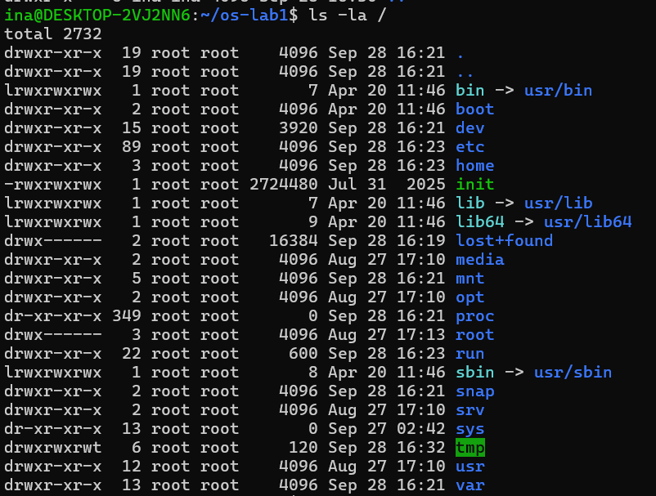
Figure 3.4 – Contents of the root directory (ls -la /)
The listing of "/" shows the top of the single directory tree. All top-level directories belong to root. Several interesting details are visible: bin, lib, lib64 and sbin are symbolic links (type l) to directories inside /usr, /proc and /sys have size 0 because they are virtual filesystems generated by the kernel, and /tmp has the permissions drwxrwxrwt, where the final "t" is the sticky bit (everyone may create files there, but only the owner may delete them). The file init in the root is the WSL init program started by Windows.
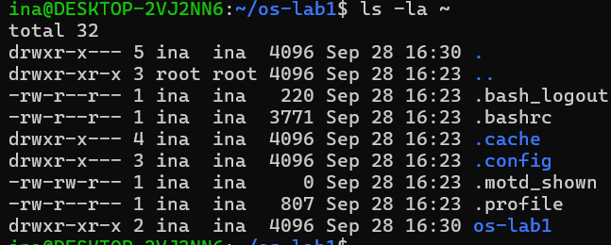
Figure 3.5 – Contents of the home directory (ls -la ~)
The home directory /home/ina is owned by user ina and contains hidden configuration files (whose names start with a dot, such as .bashrc and .profile) and the newly created os-lab1 folder.
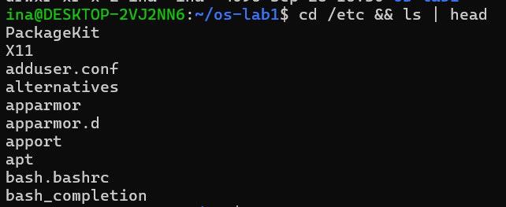
Figure 3.6 – First entries of the /etc directory
/etc contains system-wide configuration: files such as adduser.conf and bash.bashrc and directories such as apt (package manager settings) and apparmor.d (security profiles).

3.2.2 Creating, copying, renaming and removing files
cd ~/os-lab1
mkdir demo && cd demo
echo "hello operating systems" > note.txt
cp note.txt copy.txt
mv copy.txt renamed.txt
ls -l
rm renamed.txt
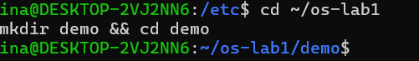
Figure 3.7 – Creating the demo directory
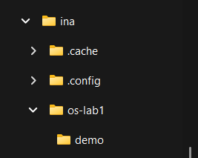
Figure 3.8 – The new demo directory seen from the Windows File Explorer
Because WSL exposes the Linux filesystem to Windows, each change made in the terminal was also visible in the File Explorer, which makes it possible to watch the tree change from "outside" Linux.
Figure 3.9 – Creating note.txt through output redirection
The shell redirection operator ">" asks the OS to create the file note.txt and to write the output of echo into it. Opening the file in a text editor confirms its contents:
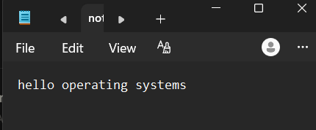
Figure 3.10 – Contents of note.txt opened in Notepad
Figure 3.11 – Copying note.txt to copy.txt
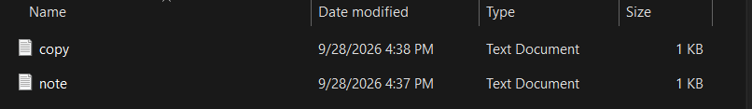
Figure 3.12 – Both note.txt and copy.txt present in the demo folder
cp creates a new, independent file with the same contents (a new inode). mv inside the same filesystem does not copy any data; it only changes the name in the directory entry, which is why the renamed file keeps its original modification time (16:38):
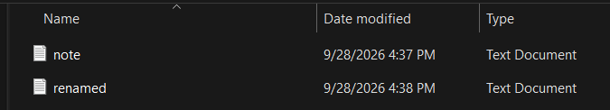
Figure 3.13 – copy.txt renamed to renamed.txt with mv
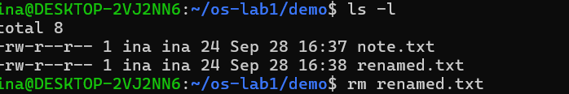
Figure 3.14 – Listing the directory and removing renamed.txt
ls -l shows both files with size 24 bytes ("hello operating systems" is 23 characters plus the newline added by echo). After rm renamed.txt only note.txt remains.

3.2.3 Ownership and permissions
ls -l note.txt # read the rwx / owner / group columns
chmod 600 note.txt # owner-only read+write
ls -l note.txt
chmod 644 note.txt
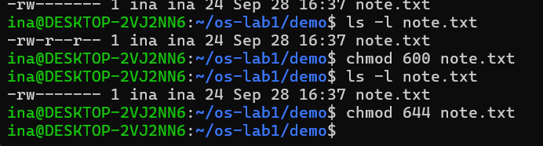
Figure 3.15 – Changing the permissions of note.txt with chmod
Initially the file has the permissions -rw-r--r-- (644): the owner can read and write, the group and others can only read. After chmod 600 the string becomes -rw-------, and after chmod 644 the original permissions are restored.

3.2.4 Observations
Observe (Part 1)
(1) Who owns the files you just created, and which group?
(2) What do the ten characters at the start of ls -l mean for note.txt after chmod 600?
(3) Name two directories directly under / and say, in one line each, what they hold.
(1) Owner and group of the created files
All the files created in the demo directory (note.txt, copy.txt, renamed.txt) are owned by the user ina and belong to the group ina, as shown in the third and fourth columns of ls -l. The OS assigns a new file to the user who created it and to that user's primary group; on Ubuntu every user gets a private group with the same name as the user.
(2) Meaning of -rw------- after chmod 600
- Character 1, "-": the entry is a regular file (a directory would show "d", a symbolic link "l").
- Characters 2-4, "rw-": the owner (ina) may read and write the file, but not execute it (6 = 4 + 2).
- Characters 5-7, "---": members of the group ina have no permissions at all (0).
- Characters 8-10, "---": all other users have no permissions at all (0).
In other words, after chmod 600 only the owner can open the file; the kernel will refuse any read or write attempt by another ordinary user.
(3) Two directories directly under /
- /etc holds the system-wide configuration files, such as adduser.conf, bash.bashrc and the apt settings seen in Figure 3.6.
- /home holds the personal directories of ordinary users, for example /home/ina with its dotfiles and the os-lab1 folder.
- /proc (additionally) is a virtual filesystem created by the kernel in memory, with one directory per running process and files describing the system state; this is why its size is shown as 0.

3.3 Part 2. Processes (Process management)

3.3.1 Listing processes
ps aux | head
ps aux | wc -l # how many processes exist right now
top # live view; press q to quit
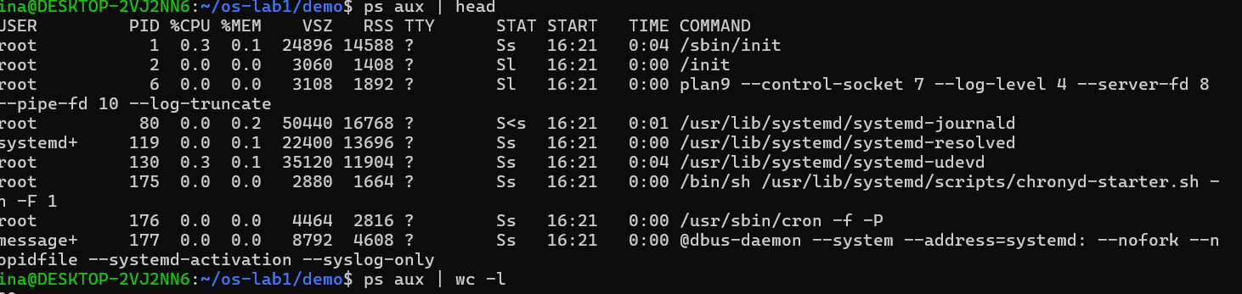
Figure 3.16 – First processes in the ps aux listing
ps aux lists every process on the system with its owner, PID, CPU and memory usage, virtual (VSZ) and resident (RSS) size, state (STAT), start time and command. The first entries are the system processes started at boot: /sbin/init (PID 1), the WSL init (PID 2), the plan9 file server used by WSL to share files with Windows (PID 6) and systemd services such as systemd-journald (logging), systemd-resolved (DNS), systemd-udevd (device events), cron (scheduled tasks) and dbus-daemon (inter-process messaging).
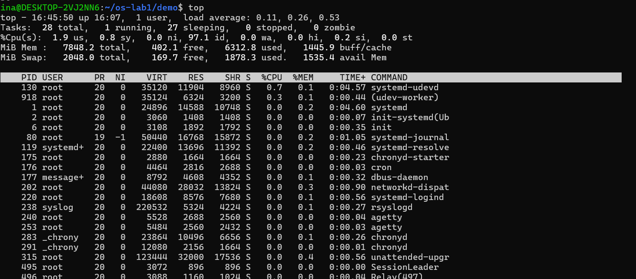
Figure 3.17 – Live process view in top
top gives a continuously refreshed view. Its header summarises the whole system: 28 tasks in total, 1 running and 27 sleeping, 0 stopped and 0 zombie; the CPU was 97.1 % idle; 7848.2 MiB of RAM and 2048 MiB of swap were configured. The table is sorted by CPU usage, and process 80 (systemd-journald) is shown with priority 19 and nice value -1, meaning it has been given a slightly higher scheduling priority than ordinary processes.

3.3.2 Starting, finding and stopping a background process
sleep 300 & # run in the background; note the PID printed
jobs # shell view of background jobs
ps -ef | grep sleep # find it among all processes
kill <PID> # ask the OS to terminate it
$ sleep 300 &
[1] 936
$ jobs
[1]+ Running sleep 300 &
$ ps -ef | grep sleep
ina 936 497 0 16:47 pts/0 00:00:00 sleep 300
ina 938 497 0 16:47 pts/0 00:00:00 grep --color=auto sleep
The shell printed the job number [1] and the PID 936 of the new process, and jobs showed it as Running. In the output of ps -ef | grep sleep the sleep process appears with PID 936 and parent PID (PPID) 497, the bash shell. The second line is the grep process itself (PID 938): since both programs of the pipe run at the same time, grep finds its own command line in the process list.
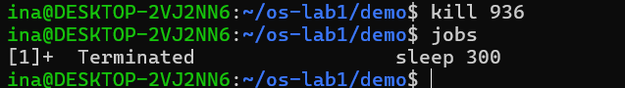
Figure 3.18 – Terminating the background sleep process with kill
The first attempts to type the command literally as kill <PID> failed with a bash syntax error, because < is the input redirection operator; the placeholder had to be replaced with the real number. After kill 936 the kernel delivered the SIGTERM signal to the process, and jobs reports "[1]+ Terminated sleep 300", confirming that the job has been stopped by the OS.

3.3.3 Inspecting a process through /proc
sleep 300 &
PID=$!
ls /proc/$PID/
cat /proc/$PID/status | head -20 # state, memory, threads
kill $PID
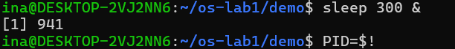
Figure 3.19 – Starting a new sleep process and storing its PID
This time the shell printed "[1] 941": job number 1 with PID 941. The special variable $! holds the PID of the most recently started background process, so it was saved in the variable PID to be reused in the following commands.
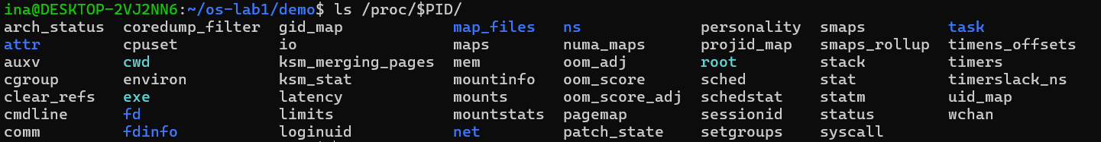
Figure 3.20 – Contents of the /proc/941 directory
For every process the kernel creates a directory /proc/<pid> that does not exist on any disk: its files are generated on the fly when they are read. Among them are cmdline (the command line), cwd (a link to the current working directory), exe (a link to the executable), fd (the open file descriptors), maps (the memory regions), status (a human-readable summary) and task (one subdirectory per thread).
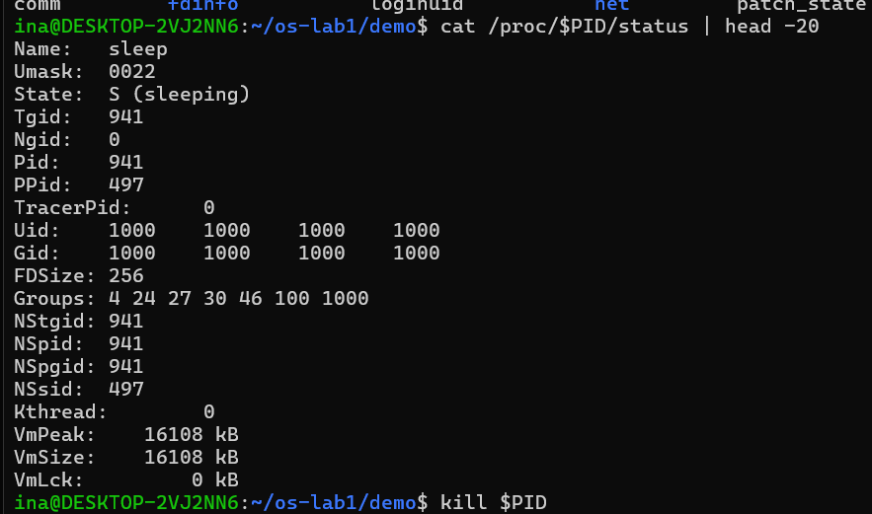
Figure 3.21 – The first 20 lines of /proc/941/status
The status file shows that the process is named sleep, its State is S (sleeping), its Pid is 941 and its parent (PPid) is 497, the bash shell from which it was started. Uid and Gid 1000 correspond to user ina, and Groups lists the supplementary groups of that user. VmPeak and VmSize (16108 kB) give the size of its virtual address space. At the end the process was terminated with kill $PID.
$ kill $PID
$ ls /proc/$PID/
ls: cannot access '/proc/941/': No such file or directory
[1]- Terminated sleep 300
After the process was killed, its directory disappeared from /proc immediately. This shows that /proc is not stored anywhere: the kernel generates it from its internal process table, and once the process no longer exists, neither does its directory.

3.3.4 Observations
Observe (Part 2)
(1) What is the PID of process number 1, and what is it (look it up)?
(2) Roughly how many processes were running on your idle VM?
(3) From /proc/<pid>/status, what does the "State:" line say for your sleeping process?
(1) Process number 1
The process with PID 1 is /sbin/init, which on this Ubuntu system is systemd (top displays it under the name systemd, since /sbin/init is a link to the systemd binary). It is the first user-space process started by the kernel after boot and the ancestor of all other processes: it starts and supervises system services, mounts filesystems and adopts orphaned processes whose parent has died. It runs as root and cannot be killed normally. Under WSL2 there is also a second init, /init with PID 2, which is Microsoft's helper that connects the Linux VM to Windows.
(2) Number of processes on the idle system
The system was running approximately 28-29 processes. ps aux | wc -l returned 30 lines, which is one header line plus 29 processes; this count also includes the ps and wc processes of the pipeline themselves. top, run a moment later, reported 28 tasks in total (1 running, 27 sleeping). This is a very small number compared to a desktop Linux installation, because WSL2 runs a minimal environment without a graphical desktop; almost all of the processes are sleeping and waiting for events.
(3) State of the sleeping process
The "State:" line in /proc/941/status shows S (sleeping) (Figure 3.21). The sleep process does not use the CPU at all: it asked the kernel to wake it up after 300 seconds, so the scheduler keeps it in the interruptible sleeping state until the timer expires or a signal such as SIGTERM arrives.

3.4 Part 3. Memory (Memory management)
free -h # total / used / free RAM and swap
cat /proc/meminfo | head -6
sleep 300 & PID=$!
grep VmRSS /proc/$PID/status # real RAM used by this process
kill $PID
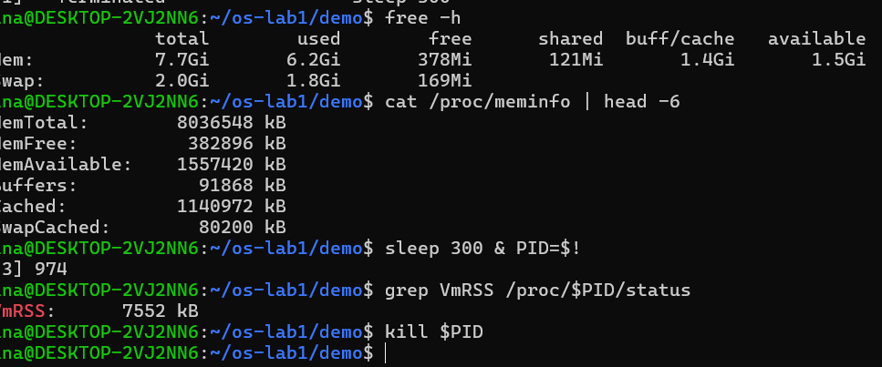
Figure 3.22 – Memory usage (free -h, /proc/meminfo) and the VmRSS of a sleep process
free -h summarises the physical memory and swap in human-readable units, while /proc/meminfo is the kernel file from which free takes its numbers (in kilobytes): MemTotal 8036548 kB, MemFree 382896 kB, MemAvailable 1557420 kB, Buffers 91868 kB and Cached 1140972 kB. A new sleep process (PID 974) was then started and its resident memory was read from its status file.

3.4.1 Observations
Observe (Part 3)
(1) How much total RAM does the VM have, and how much is free?
(2) What is swap, and how much is configured?
(3) How much resident memory (VmRSS) does a bare sleep process use, and does that surprise you?
(1) Total and free RAM
The VM has 7.7 GiB of RAM in total (MemTotal = 8036548 kB), of which 6.2 GiB are used and only 378 MiB are completely free. This does not mean the machine is almost out of memory: 1.4 GiB are used as buffer and page cache, which the kernel can release at any moment, so the memory available for new programs is 1.5 GiB (MemAvailable = 1557420 kB). Linux deliberately uses otherwise idle RAM as a disk cache.
(2) Swap
Swap is an area on disk to which the OS can move memory pages that are not being actively used, freeing physical RAM for active processes. It works as an overflow for RAM, but it is much slower, because disk access is orders of magnitude slower than memory access. On this system 2.0 GiB of swap is configured; lsblk (Figure 3.24) shows that it is a separate 2 GB virtual disk, sdc, marked [SWAP]. At the time of the measurement 1.8 GiB of it was in use and only 169 MiB was free, a sign that the host had been under memory pressure during its 16 hours of uptime.
(3) VmRSS of a sleep process
The bare sleep process had a VmRSS of 7552 kB (about 7.4 MB). This is somewhat surprising for a program that does nothing but wait: its own code and data are only a few kilobytes. The explanation is that the resident set also counts the pages of the shared libraries it has mapped, mostly the C library (libc) and the dynamic loader, which are loaded only once in physical RAM and shared by all processes that use them. The memory actually private to this process is much smaller, and its virtual size (VmSize, about 16 MB) is larger still because the kernel brings into RAM only the pages that are really touched.

3.5 Part 4. Devices and storage (I/O management)
df -h # mounted filesystems and free space
lsblk # the block devices (disks) themselves
du -sh ~/os-lab1 # size of your work folder
ls -l /dev | head # devices presented as files
mount | head
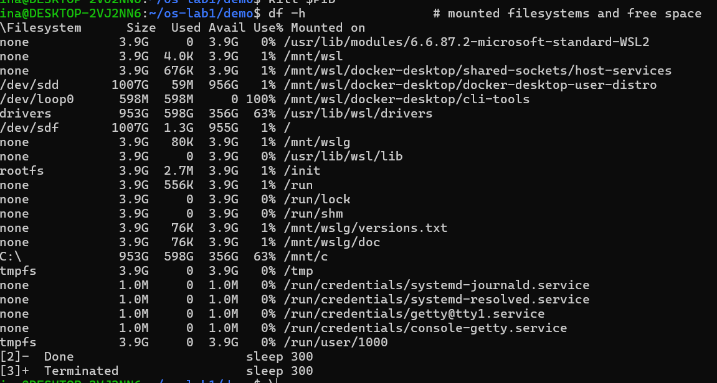
Figure 3.23 – Mounted filesystems and their free space (df -h)
df -h lists every mounted filesystem. Besides the root filesystem, the list contains many virtual (tmpfs) filesystems kept in RAM (/run, /tmp, /mnt/wsl), the Windows C: drive mounted at /mnt/c (953 GB, 63 % used), the Windows drivers shared at /usr/lib/wsl/drivers, and filesystems belonging to Docker Desktop, which is also installed on this machine.
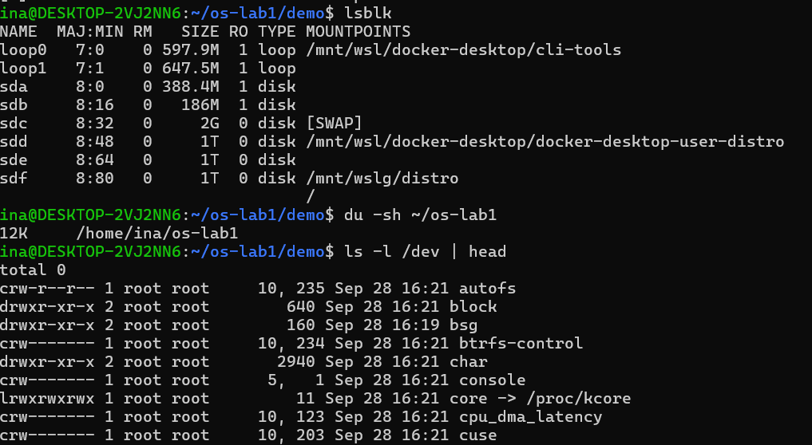
Figure 3.24 – Block devices (lsblk), size of the work folder (du) and the first entries of /dev
lsblk shows the block devices themselves: six virtual disks (sda to sdf) and two loop devices (files used as disks). sdc is the 2 GB swap disk and sdf (1 TB) holds the root filesystem. du -sh ~/os-lab1 reports that the whole work folder takes only 12 KB on disk. In the ls -l /dev listing the first character of each line shows the type of entry: "c" for character devices, "d" for directories and "l" for links, and instead of a size, device files show two numbers: the major number (which driver) and the minor number (which device of that driver).
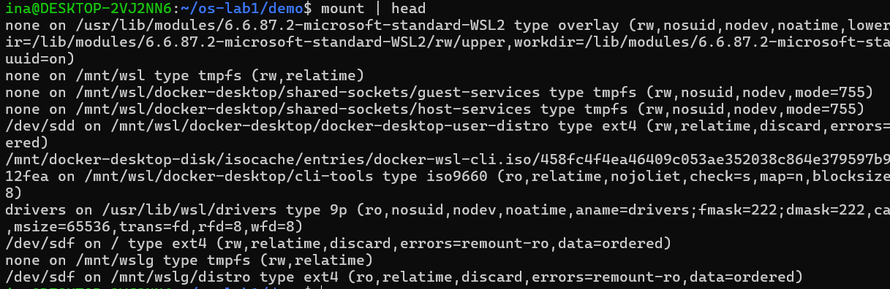
Figure 3.25 – The first mounted filesystems as reported by mount
mount gives the full details of every mount: /dev/sdf is mounted on / with the ext4 file system, read-write (rw), with the option errors=remount-ro that makes the kernel switch to read-only if disk errors appear. The Windows drivers directory uses the 9p network protocol, which WSL uses to share files between Windows and Linux.

3.5.1 Observations
Observe (Part 4)
(1) Which device is your root filesystem "/" mounted on?
(2) Give one entry from /dev and say what real thing it stands for.
(3) In one sentence: what does "everything is a file" mean, based on what you saw?
(1) Device of the root filesystem
The root filesystem "/" is mounted on /dev/sdf, a 1 TB (1007 GB) virtual disk formatted with ext4, of which only 1.3 GB is used (Figures 3.23 and 3.25). Under WSL2 this "disk" is in fact the virtual hard disk file (ext4.vhdx) of the Ubuntu distribution stored on the Windows drive and attached to the Linux VM.
(2) An entry from /dev
/dev/console (crw------- 5, 1) is a character device with major number 5 and minor number 1 that stands for the system console, the terminal to which the kernel and init write their messages. Similarly, /dev/sdf stands for the virtual disk holding the root filesystem, and /dev/core is a link to /proc/kcore, an image of the kernel's memory.
(3) "Everything is a file"
"Everything is a file" means that the OS presents disks, terminals, processes and kernel information as entries in one directory tree (/dev, /proc, /sys), so they can be listed, read and written with the same ordinary tools, as when /proc/941/status was read with cat or the console appeared in ls -l /dev like any other file.

3.6 Wrap-up: the four resources managed by the OS
The operating system manages files, which could be seen and modified with ls -l and chmod, by keeping a single tree of named objects with owners and permissions. It manages processes, which could be seen with ps aux and top, by creating, scheduling and terminating them and giving each a PID. It manages memory and devices, which could be seen with free -h and with lsblk and df -h, by sharing physical RAM among processes and by hiding every piece of hardware behind uniform, file-like interfaces.

4 LABORATORY WORK 2: MEET THE OS YOU WILL BUILD (XV6)

4.1 Getting the xv6 source code
The second laboratory uses xv6, the teaching operating system that will be extended during the semester. The source code was cloned from the official MIT repository into the home directory:
cd ~/xv6-riscv 2>/dev/null || \
git clone https://github.com/mit-pdos/xv6-riscv ~/xv6-riscv
cd ~/xv6-riscv
ls # kernel/ user/ Makefile README ...
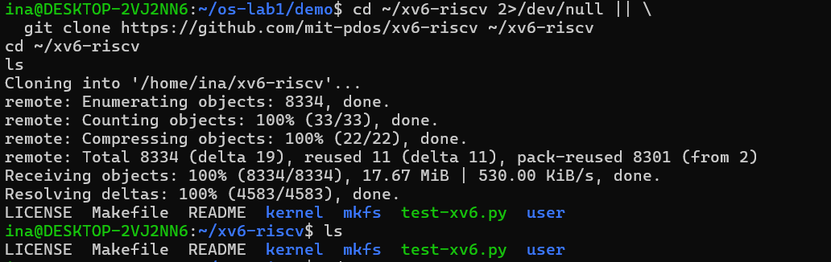
Figure 4.1 – Cloning the xv6-riscv repository
Since the folder did not exist yet, the first cd failed silently (its error was redirected to /dev/null) and the || operator started git clone, which downloaded 8334 objects (17.67 MiB). The top level of the tree is very small: the kernel folder (the operating system itself), the user folder (the programs running on top of it), mkfs (a host tool that builds the xv6 disk image), the Makefile, the README, the LICENSE and a test script.

4.2 Installing the build tools
The laboratory assumes a course VM on which the RISC-V toolchain and QEMU are already installed. On a freshly installed WSL Ubuntu none of them were present, so the first make qemu failed with "Command 'make' not found". Installing the tools took several steps:
- Package mirror. sudo apt install make could not connect to archive.ubuntu.com, although the network itself worked (ping 8.8.8.8 received replies). The mirror in /etc/apt/sources.list.d/ubuntu.sources was changed until sudo apt update succeeded; the security mirror still could not be resolved, but the main archive was enough.
- make and the cross-compiler. After make was installed, the build stopped with "Couldn't find a riscv64 version of GCC/binutils" and "gcc: No such file or directory". The compilers were installed with the command below (178 packages, 248 MB).
- QEMU for RISC-V. The kernel and fs.img were then built successfully, but the last step failed with "qemu-system-riscv64: No such file or directory": in this Ubuntu release the qemu-system-misc package no longer contains the RISC-V emulator, which is in the separate package qemu-system-riscv. After installing it, qemu-system-riscv64 --version reported QEMU 10.2.1.
sudo apt install make
sudo apt install build-essential gcc-riscv64-linux-gnu \
binutils-riscv64-linux-gnu qemu-system-misc
sudo apt install qemu-system-riscv
qemu-system-riscv64 --version # QEMU emulator version 10.2.1
This detour was itself instructive: building an operating system needs a cross-compiler (riscv64-linux-gnu-gcc, which runs on x86_64 but produces RISC-V code), a linker, a host C compiler for the mkfs tool, and an emulator for the target machine.

4.3 Part 1. Building and booting xv6
make qemu
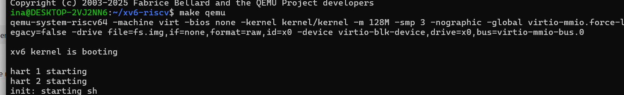
Figure 4.2 – Building xv6 and booting it in QEMU
mkfs/mkfs fs.img README user/_cat user/_echo ... user/_sync
nmeta 47 (boot, super, log blocks 31, inode blocks 13, bitmap blocks 1) blocks 1953 total 2000
balloc: first 983 blocks have been allocated
make qemu compiled every file of the kernel and of the user programs with the RISC-V cross-compiler, linked them (the linker warned that the kernel has a segment with read-write-execute permissions, which is expected for xv6), created the disk image fs.img with mkfs (2000 blocks, of which 47 are metadata: the boot block, the superblock, 31 log blocks, 13 inode blocks and 1 bitmap block), and then started the emulator. The printed QEMU command line describes the emulated computer: a 64-bit RISC-V "virt" machine without firmware (-bios none) that loads kernel/kernel directly, with 128 MB of RAM (-m 128M), 3 processor cores (-smp 3), no graphical window (-nographic, the console is the terminal itself) and a virtio block device backed by the file fs.img, which acts as the hard disk.
The boot messages show the OS starting: "xv6 kernel is booting" is printed by the first core (hart 0); "hart 1 starting" and "hart 2 starting" are printed by the other two cores ("hart" is the RISC-V name for a hardware thread, i.e. a CPU core); finally the first user process, init, starts the shell ("init: starting sh") and the $ prompt appears. This is the same boot sequence as in Linux, only much shorter: kernel initialisation, then process 1, then the shell.

4.4 Part 2. Using xv6 as the Unix it is
$ ls
$ cat README
$ echo hello xv6
$ ls | grep c # pipes work here too
$ wc README
$ usertests -q # the kernel test suite
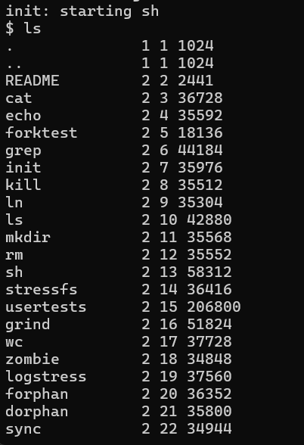
Figure 4.3 – Contents of the xv6 root directory
The xv6 ls prints four columns for each entry: the name, the type (1 = directory, 2 = regular file, 3 = device), the inode number and the size in bytes. The root directory contains the README and all the user programs, which are ordinary files on the xv6 disk image. The entry console, of type 3, is a device file: the terminal itself appears in the file system, just like /dev/console on Linux.
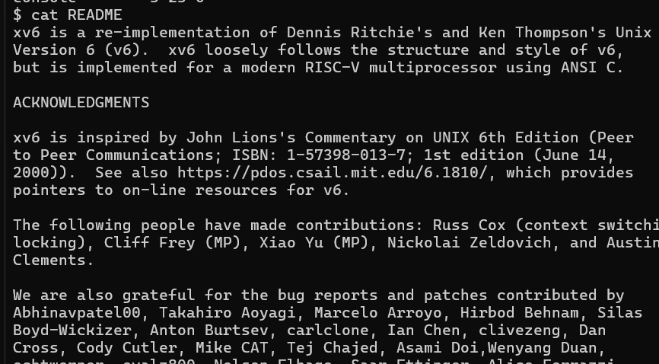
Figure 4.4 – The xv6 README displayed with cat
The README confirms what xv6 is: a re-implementation of Unix Version 6 by Dennis Ritchie and Ken Thompson for a modern RISC-V multiprocessor, written in ANSI C and inspired by John Lions's Commentary on UNIX 6th Edition.
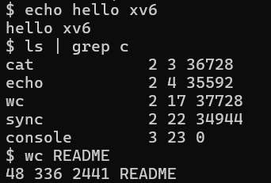
Figure 4.5 – echo, a pipe between ls and grep, and wc inside xv6
echo printed its argument, ls | grep c displayed only the entries whose line contains the letter c (cat, echo, wc, sync, console), and wc README counted 48 lines, 336 words and 2441 bytes; the byte count is exactly the size of README reported by ls.
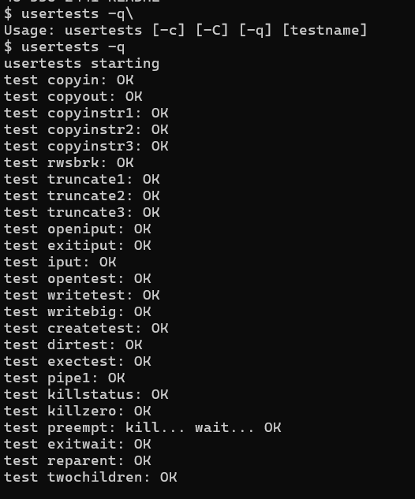
Figure 4.6 – Running the xv6 kernel test suite (usertests -q)
usertests -q runs the quick version of the kernel test suite. (The first attempt, typed with a stray backslash, only printed the usage message.) The tests check copying data between user and kernel space (copyin, copyout), the file system (truncate, createtest, dirtest, bigfile), exec, pipes, killing processes, preemption, parent and child processes (exitwait, reparent, forkfork), and memory allocation with sbrk. The run ended with ALL TESTS PASSED. Some tests (kernmem, MAXVAplus, nowrite, lazy_unmap) print many lines such as "usertrap(): unexpected scause 0xd" or "0xf": these tests deliberately make a child process read or write memory it is not allowed to access (for example kernel addresses). The resulting page fault (scause 0xd = load page fault, 0xf = store page fault) is caught by the kernel, which kills only the faulty process and continues running. These messages therefore prove that memory protection works.

4.4.1 Observations
Observe (Lab 2, Part 2)
(1) List three programs xv6 ships with.
(2) You just used a pipe ( | ) inside xv6. Which two OS features must exist for a pipe to work?
(3) In one sentence: how does the xv6 shell compare to the Linux shell from Lab 1?
(1) Three programs shipped with xv6
xv6 ships with, among others, cat (prints the contents of files), grep (prints the lines that match a pattern) and wc (counts lines, words and bytes). The full list seen with ls also contains echo, ls, mkdir, rm, ln, kill, sh, init, usertests, forktest, stressfs, grind and zombie.
(2) OS features needed for a pipe
A pipe needs, first, process management: the ability to create new processes (fork) and load programs into them (exec), so that ls and grep can run at the same time as two separate processes. Second, it needs inter-process communication through the kernel: the pipe() system call that creates a kernel buffer with a read end and a write end, together with file descriptors (and dup/close) so that the output of the first process is connected to the input of the second, while the kernel blocks and wakes them as data flows.
(3) The xv6 shell compared to the Linux shell
The xv6 shell works on the same principles as the bash shell from Lab 1 (it runs commands as child processes and supports pipes, redirection, ";" and "&"), but it is a minimal program of a few hundred lines without variables, scripting, command history, tab completion, wildcards or job control, and its prompt is simply "$".

4.5 Part 3. Reading the source code
After leaving QEMU (Ctrl-A, then X), the source tree was studied. The whole operating system is split into two folders: kernel/, the operating system itself, which runs in privileged mode (scheduler, memory, file system, system-call handlers), and user/, the ordinary programs that run on top of it (ls, cat, echo, the shell).

4.5.1 A user program: ls.c and cat.c
sed -n "1,40p" user/ls.c
sed -n "1,30p" user/cat.c
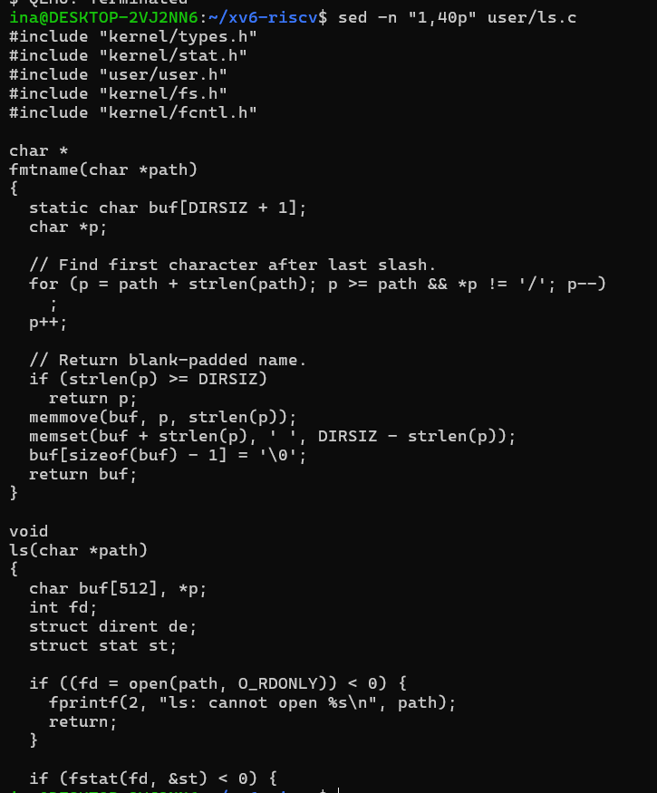
Figure 4.7 – The beginning of user/ls.c
ls.c looks like an ordinary C program: it includes a few headers, defines a helper fmtname() that pads a file name with spaces, and a function ls() that opens a path with open(), gets information about it with fstat() and, for directories, reads the directory entries (struct dirent) one by one. The program does not access the disk directly: every access to the file system goes through a system call. cat.c is even shorter: its cat() function repeatedly calls read() on a file descriptor into a 512-byte buffer and write()s the bytes to file descriptor 1 (standard output), and main() opens each file named on the command line, passes it to cat() and closes it, or reads from standard input (descriptor 0) when no file is given.
char buf[512];

void
cat(int fd)
{
int n;

while ((n = read(fd, buf, sizeof(buf))) > 0) {
if (write(1, buf, n) != n) {
fprintf(2, "cat: write error\n");
exit(1);
}
}
if (n < 0) {
fprintf(2, "cat: read error\n");
exit(1);
}
}
The excerpt above (from sed -n "1,30p" user/cat.c) shows the core of cat: a loop that reads at most 512 bytes at a time and writes exactly the bytes it received, stopping when read() returns 0 (end of file) and reporting an error if either call fails.

4.5.2 The system call interface
cat user/user.h # the list of system calls available to programs
grep -n "sys_read\|sys_write" kernel/sysfile.c | head
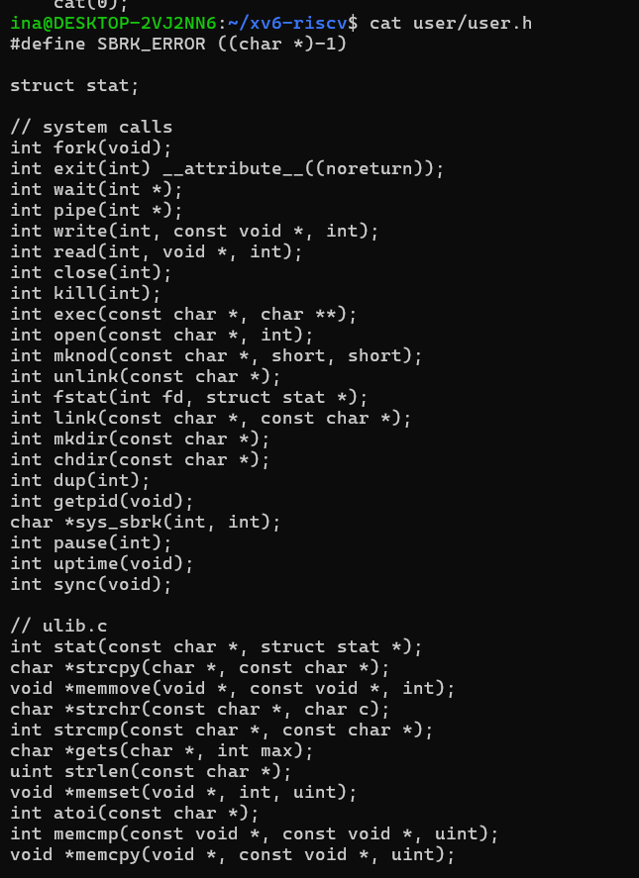
Figure 4.8 – user/user.h: the system calls available to user programs
user/user.h is the complete list of services that a user program can request from the xv6 kernel: only about twenty system calls, among them fork, exit, wait, pipe, read, write, close, kill, exec, open, mkdir, chdir, dup, getpid, sys_sbrk, pause and uptime. The second half of the file declares ordinary library functions from ulib.c (strcpy, strlen, memset, atoi...), which run entirely in user mode. The system-call functions themselves are generated as tiny assembly stubs (usys.S, produced by the script usys.pl) that put the call number in a register and execute the RISC-V ecall instruction to enter the kernel.
Figure 4.9 – Locating sys_read and sys_write in the kernel
grep shows that the kernel side of these calls is in kernel/sysfile.c: sys_read starts on line 69 and sys_write on line 83. These functions fetch the arguments of the call from the saved user registers, check them, and pass the work to the file layer of the kernel.

4.5.3 Observations
Observe (Lab 2, Part 3)
(1) Which system calls does user/cat.c use, and what does each one ask the kernel to do?
(2) In which kernel file, and on which line, is sys_read implemented?
(3) In one sentence: what is the difference between the code in kernel/ and the code in user/?
(1) System calls used by user/cat.c
- read(fd, buf, n) asks the kernel to copy up to n bytes from the open file (or console) fd into the buffer buf in the program's memory; it returns the number of bytes read, or 0 at the end of the file.
- write(fd, buf, n) asks the kernel to copy n bytes from buf to the file or device fd; cat uses descriptor 1, the standard output (the console).
- open(path, O_RDONLY) asks the kernel to find the file by name in the file system and give the process a new file descriptor for reading it.
- close(fd) asks the kernel to release a file descriptor that is no longer needed.
- exit(status) asks the kernel to terminate the process and report the status to its parent (the shell). Error messages printed with fprintf(2, ...) are also sent to the kernel through write() on descriptor 2.
(2) Location of sys_read
sys_read is implemented in kernel/sysfile.c, on line 69 (and sys_write right after it, on line 83), as shown by the grep output in Figure 4.9.
(3) kernel/ versus user/
The code in kernel/ is the operating system itself, which runs in privileged supervisor mode with direct access to all memory and hardware and implements the services, while the code in user/ consists of ordinary programs running in unprivileged user mode that can obtain those services only by asking the kernel through system calls.

4.6 Part 4. Writing the first xv6 program

4.6.1 The source code of user/sleep.c
The task was to add a new user program, sleep, which pauses for a given number of clock ticks by making a system call into the kernel. The file was created with the nano editor in the user folder:
#include "kernel/types.h"
#include "user/user.h"

int
main(int argc, char *argv[])
{
if(argc != 2){
fprintf(2, "usage: sleep <ticks>\n");
exit(1);
}
sleep(atoi(argv[1])); // system call into the kernel
exit(0);
}
The program first checks that exactly one argument was given; otherwise it prints a usage message on the standard error (descriptor 2) and exits with status 1. Otherwise it converts the argument from text to an integer with atoi() (a user-space library function) and makes the system call that asks the kernel to suspend the process for that many timer ticks (in xv6 one tick is about 1/10 of a second). While the process sleeps, the scheduler runs other processes, exactly like the sleeping process observed in /proc in Lab 1.
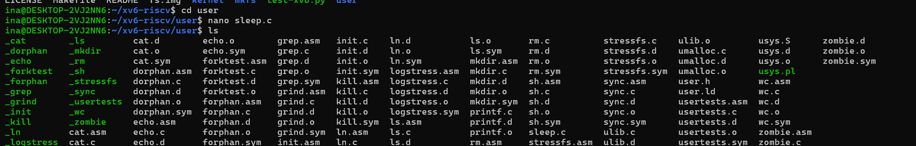
Figure 4.10 – Creating user/sleep.c with nano; sleep.c now appears in the user folder
The listing of the user folder also shows the files produced by the build for every program: the object file (.o), the disassembly (.asm), the symbol table (.sym) and the final executable, whose name begins with an underscore (_cat, _ls, _sh...). The underscore distinguishes the RISC-V executables from the source files; mkfs removes it when copying the programs into the xv6 disk image.

4.6.2 Adding the program to the build
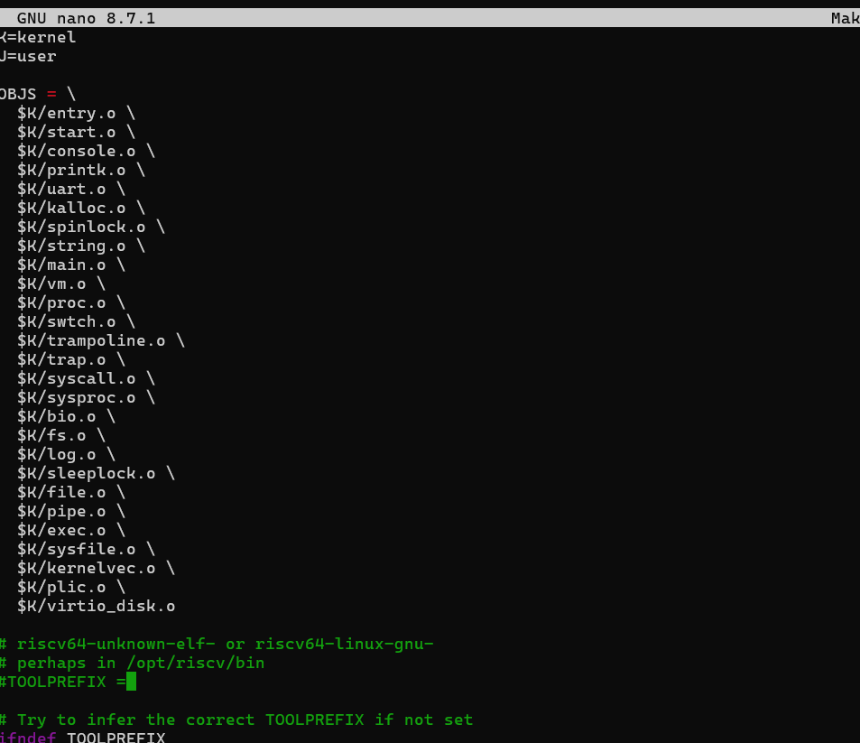
Figure 4.11 – The xv6 Makefile opened in nano: the list of kernel object files
The Makefile describes how the whole system is built. Its OBJS list shows the modules that make up the kernel: entry.o and start.o (the first code executed at boot), console.o and uart.o (the terminal), kalloc.o and vm.o (memory), proc.o, swtch.o and trap.o (processes, context switching and traps), syscall.o, sysproc.o and sysfile.o (system calls), bio.o, fs.o, log.o and file.o (the file system), pipe.o, exec.o, plic.o (interrupt controller) and virtio_disk.o (the disk driver). The TOOLPREFIX variable selects the RISC-V cross-compiler.
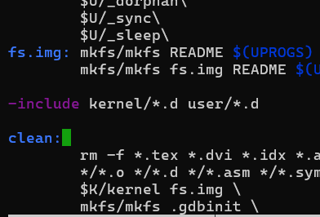
Figure 4.12 – The new entry $U/_sleep added to the UPROGS list
The line $U/_sleep\ was added at the end of the UPROGS list, with the same tab indentation and the trailing backslash that continues the list. UPROGS tells make which user programs to compile and which executables mkfs must copy into fs.img, so that sleep becomes a command available at the xv6 prompt. The first edit of the Makefile broke the build with "Makefile:155: *** recipe commences before first target": a line had been placed outside the UPROGS list, where make interpreted it as a command without a rule. After the stray line was removed, make clean succeeded and its output already listed user/_sleep among the programs.

4.6.3 Testing the program
The rebuild compiled the whole kernel again, but stopped at the new program:
riscv64-linux-gnu-gcc ... -c -o user/sleep.o user/sleep.c
user/sleep.c: In function ‘main’:
user/sleep.c:11:3: error: implicit declaration of function ‘sleep’
11 | sleep(atoi(argv[1]));
| ^~~~~
make: *** [<builtin>: user/sleep.o] Error 1
The compiler does not know any function called sleep(). The list of system calls in user/user.h (Figure 4.8) explains why: in the current version of xv6-riscv the sleep system call is exposed to user programs under the name pause(int), and there is no sleep() declaration. Because xv6 is compiled with -Wall -Werror, the missing declaration is treated as an error rather than a warning. The code given in the laboratory task was written for an older xv6 version, so in this version the call has to be changed to pause():
#include "kernel/types.h"
#include "user/user.h"

int
main(int argc, char *argv[])
{
if(argc != 2){
fprintf(2, "usage: sleep <ticks>\n");
exit(1);
}
pause(atoi(argv[1])); // the sleep system call (named pause in this xv6)
exit(0);
}
This error is a good illustration of the idea of Part 3: the name a user program uses must match exactly the interface that the kernel exports through user.h and the system-call stubs. The kernel side still implements the same operation (suspending the calling process for a number of timer ticks); only the user-level name changed.
make qemu
$ sleep 10 # pauses for 10 ticks, then the prompt returns
$ sleep # prints: usage: sleep <ticks>
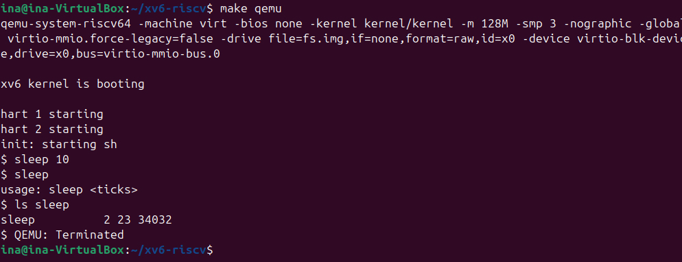
Figure 4.13 – Running sleep 10 and sleep without an argument inside xv6
With the corrected call (Figure 4.13), sleep 10 inside xv6 suspends the process for 10 ticks (about one second) before the $ prompt returns, and sleep without an argument prints the usage message. Note that the test must be run at the xv6 prompt inside QEMU: typing sleep 10 in the Linux terminal runs Linux's own /usr/bin/sleep, which pauses for 10 seconds and says nothing about the xv6 program.

CONCLUSION
These two laboratory works introduced the operating system from the outside and from the inside. In the first one, a real Linux kernel running under WSL2 was observed through the command line, and each of the four classic management functions could be seen directly: the file system as a single tree with owners and permission bits, the process table with systemd as PID 1 at its root, the division of 7.7 GiB of RAM into used, cached and available memory together with a 2 GiB swap disk, and the device layer that exposes disks and terminals as files in /dev and processes as directories in /proc.
Several observations stood out. The permission string of ls -l is a compact encoding of the file type and nine access bits that the kernel checks on every access. An idle Linux system was running only about 28 processes, almost all of them sleeping. The difference between free and available memory showed that Linux deliberately uses spare RAM as a disk cache, and the 7.4 MB resident size of a sleep process showed how shared libraries are counted in the memory of every process that maps them.
In the second laboratory the teaching operating system xv6 was compiled from source with a RISC-V cross-compiler and booted in QEMU on an emulated three-core machine. Its programs felt immediately familiar: ls, cat, grep, wc and even pipes work as on Linux, and the console appears as a device file, just like in Lab 1. Reading the source made visible what Linux had kept hidden: user programs such as cat.c only prepare requests, while the kernel code in kernel/sysfile.c (sys_read on line 69, sys_write on line 83) carries them out. Installing the toolchain on a fresh system (make, the RISC-V cross-compiler and the RISC-V QEMU) showed what building an OS actually requires. Finally, writing user/sleep.c showed the full path from a user program, through a system call, into a kernel we built ourselves; the compilation error caused by the sleep call, which this xv6 version exposes as pause(), was a direct lesson that user programs can use only the exact interface the kernel exports.
Overall, the two works established the central idea of the course: an operating system is a resource manager that protects and shares the hardware, and all interaction between programs and the hardware passes through the narrow and well-defined interface of system calls. Having the complete xv6 source in hand provides the foundation for the next laboratories, in which the kernel side will be changed as well.

REFERENCES
- Tanenbaum, A. S., & Bos, H. (2023). Modern Operating Systems (5th ed.). Pearson.
- Silberschatz, A., Galvin, P. B., & Gagne, G. (2018). Operating System Concepts (10th ed.). Wiley.
- Cox, R., Kaashoek, F., & Morris, R. xv6: a simple, Unix-like teaching operating system (RISC-V edition). MIT. Retrieved from https://pdos.csail.mit.edu/6.1810/
- MIT PDOS. xv6-riscv source code repository. Retrieved from https://github.com/mit-pdos/xv6-riscv
- Kerrisk, M. (2010). The Linux Programming Interface. No Starch Press.
- The Linux man-pages project. proc(5), ps(1), top(1), chmod(1), free(1), lsblk(8), mount(8). Retrieved from https://man7.org/linux/man-pages/
- QEMU Project. QEMU System Emulation documentation: RISC-V "virt" platform. Retrieved from https://www.qemu.org/docs/master/
- Microsoft. (2025). Windows Subsystem for Linux documentation. Retrieved from https://learn.microsoft.com/windows/wsl/
- Pancenco, I. (2026). os-2026-InaPancenco: source code and reports of the Operating Systems laboratory works GitHub repository. Retrieved from: https://github.com/inap235/os-2026-InaPancenco

