
MINISTRY OF EDUCATION, CULTURE AND RESEARCH
OF THE REPUBLIC OF MOLDOVA
Technical University of Moldova
Faculty of Computers, Informatics and Microelectronics
Department of Software Engineering and Automation

Report
on laboratory works no. 3–4
Operating Systems
Topic: The Command Line: Shell, Pipes and Text Filters.
The xv6 Shell from the Outside

Done by:
st. gr. FAF-242, Ina Pancenco

Checked by:
Reițman Patricia, university assistant
DISA, FCIM, UTM

Chișinău – 2026
Table of Contents
1 PURPOSE OF THE WORK 3
1.1 Purpose of practical work 3
1.2 Problem statement 3
2 LABORATORY WORK 3: THE COMMAND LINE 4
2.1 Preparation: the data set 4
2.2 Part 1. Move fast, find help 4
2.2.1 Tab completion and history search 4
2.2.2 Finding help without a browser 6
2.2.3 Observations 8
2.3 Part 2. What the shell does to your line 8
2.3.1 Predictions and results 9
2.3.2 Observations 10
2.4 Part 3. Redirection, chaining and jobs 11
2.4.1 Observations 12
2.5 Part 4. Answering questions with one-liners 13
2.6 Part 5. The first script 17
2.6.1 Observations 19
2.6.2 Bonus: running report.sh with cron 20
3 LABORATORY WORK 4: THE XV6 SHELL FROM THE OUTSIDE 21
3.1 Part 1. Fixing sleep for the current xv6 21
3.2 Part 2. bash versus the xv6 shell 22
3.2.1 Observations 25
3.3 Part 3. Who expands *? A program that prints its argv 26
3.3.1 Observations 29
3.4 Part 4. Reading the shell 30
3.4.1 Observations 30
CONCLUSION 32
REFERENCES 33

1 PURPOSE OF THE WORK

1.1 Purpose of practical work
The purpose of these two laboratory works is to understand the shell, the program that stands between the user and the operating system. In Laboratory Work 3 the Linux shell (bash) is used intensively: finding commands and help, predicting what the shell does to a command line before the command runs (globbing, quoting, expansions), redirecting the standard streams, chaining commands and controlling background jobs, answering questions about data with pipelines of small text filters, and finally turning such pipelines into a script.
In Laboratory Work 4 the same ideas are examined from the other side, using the shell of the teaching operating system xv6 (user/sh.c, about 500 lines). By running the same commands in bash and in the xv6 shell, writing a program that prints the arguments it receives, and reading the source of the xv6 shell, the work establishes which features a shell must have and which ones are conveniences added by bash, and shows precisely who expands * and removes quotes.

1.2 Problem statement
Laboratory Work 3 – The Command Line: Shell, Pipes and Text Filters (Track A, Linux):
- Part 1: tab completion, history search, built-in versus external commands, PATH, exit codes and offline help.
- Part 2: predicting and checking globbing, quoting and expansions.
- Part 3: redirection of stdout and stderr, the operators ; && ||, and background jobs.
- Part 4: answering questions Q1–Q8 about a 500-line access log with one-line pipelines (oneliners.sh).
- Part 5: a first script, report.sh, with argument checking, error handling and a loop.
Laboratory Work 4 – The xv6 Shell from the Outside (Track B, xv6):
- Part 1: fixing the sleep program from Lab 2 for the current xv6, where sleep() was renamed to pause().
- Part 2: running the same ten command lines in bash and in the xv6 shell and comparing the results.
- Part 3: writing args.c (xv6) and args_linux.c (Linux), which print their argv, to find out who expands * and removes quotes.
- Part 4: reading user/sh.c to find the kinds of commands, the handling of cd and the absence of * and $ handling.
Both works were carried out on an Ubuntu Linux virtual machine in VirtualBox (host name ina-VirtualBox, user ina). For every part the commands, their output as screenshots, and the answers to the Observe questions are given.

2 LABORATORY WORK 3: THE COMMAND LINE

2.1 Preparation: the data set
A working folder ~/os-lab3 was created and the artificial web access log for Part 4 was generated with the loop given in the laboratory task. Each of the 500 lines has the form date, time, user, result (OK or FAIL) and page. The check at the end printed 500 access.log, so the file was generated correctly.
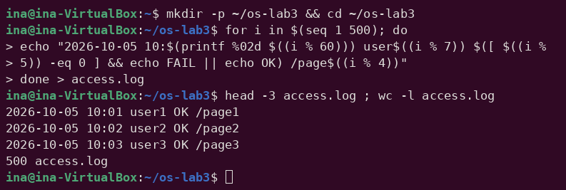
Figure 2.1 – Generating access.log and checking its size

2.2 Part 1. Move fast, find help

2.2.1 Tab completion and history search
ls /usr/sh<Tab><Tab>
cd /et<Tab>
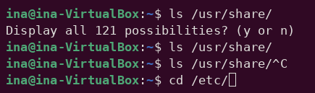
Figure 2.2 – Tab completion
In the first case the first Tab completed /usr/sh to /usr/share/, because it was the only match; the second Tab tried to list all the possible continuations inside /usr/share/ and, since there were more than 100, bash asked "Display all 121 possibilities? (y or n)" (answered n, then the line was cancelled with Ctrl+C). In the second case a single Tab completed /et to /etc/ immediately, because /etc is the only entry of / that begins with "et". Tab completion is done entirely by the shell (the readline library), before any command runs.
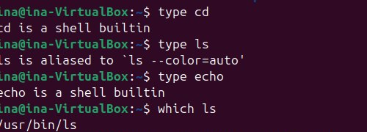
Figure 2.3 – Output of type and which
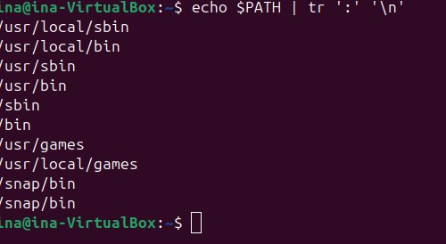
Figure 2.4 – The directories in PATH
type asks the shell itself how it would interpret a name: cd and echo are shell builtins, and ls is an alias for ls --color=auto, which in turn runs an external program. which ls searches the directories of PATH and finds the executable /usr/bin/ls.
Figure 2.5 – Exit code of a missing command
For a command that does not exist, bash prints "nosuchprog: command not found" and sets the exit code $? to 127. (The characters ^[[200~ and ~ around the line are only the terminal's bracketed-paste markers, which appeared because the line was pasted; they do not affect the result.)
date
hostname
pwd
<Ctrl+R> da <Enter>
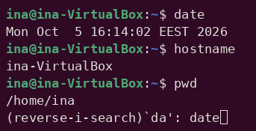
Figure 2.6 – Reverse history search with Ctrl+R
After three commands were run, Ctrl+R opened the reverse incremental search: typing "da" immediately found the most recent command in the history that contains these letters, date, and Enter executed it again. This is much faster than pressing the Up arrow many times.

2.2.2 Finding help without a browser
man ls # inside: /sort, then n for next, q to quit
ls --help | head
man -k "list directory"
help cd
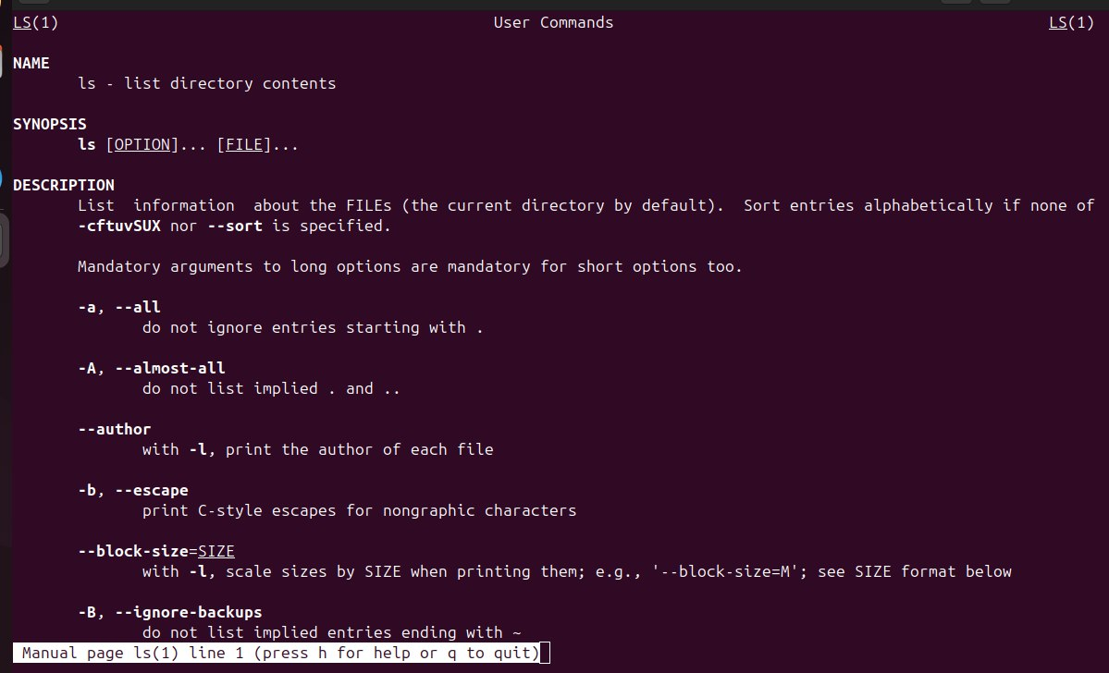
Figure 2.7 – The manual page of ls
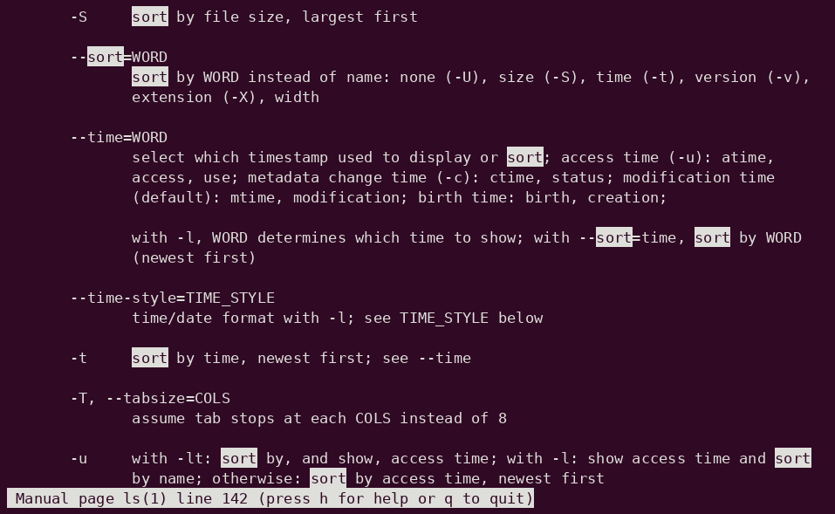
Figure 2.8 – Searching the manual page for "sort" (/sort, then n)
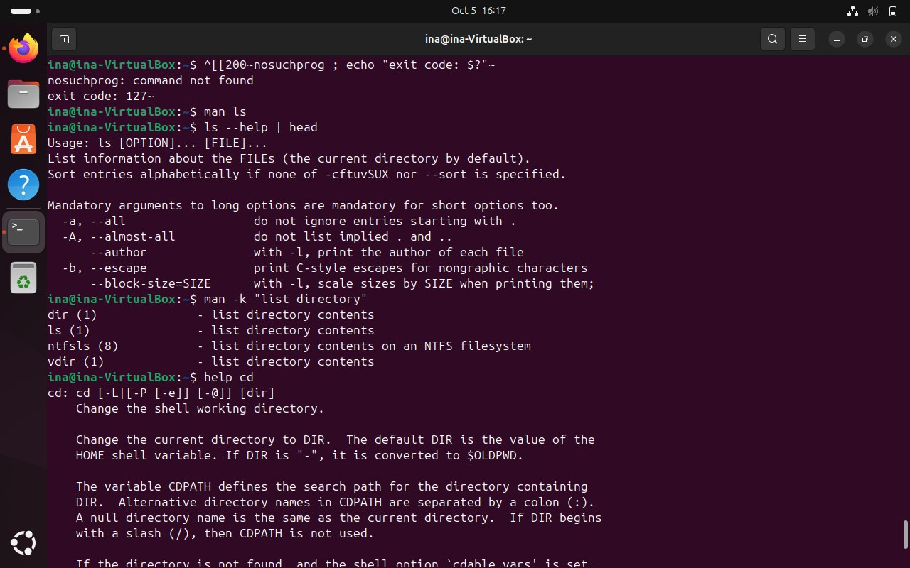
Figure 2.9 – ls --help, man -k and help cd
man ls opens the full manual page; inside it, /sort highlights every occurrence of the word and n jumps to the next one, which quickly leads to the -t option. ls --help prints a short summary of the options directly in the terminal. man -k "list directory" searches the one-line descriptions of all manual pages (it found dir, ls, ntfsls and vdir), which is useful when the name of the command is not known. Since cd is a builtin, it has no manual page of its own; its help is given by the bash builtin help cd.

2.2.3 Observations
Observe (Part 1)
(1) Which of cd, ls, echo are built-ins, and why MUST cd be one?
(2) How many directories are in your PATH, and in which one is ls?
(3) What exit code does a command that is not found return?
(4) Which option of ls sorts by modification time? (find it in man ls)
(1) Built-ins
cd and echo are shell built-ins; ls is an external program (/usr/bin/ls, reached through the alias ls --color=auto). cd must be a built-in because the current working directory is an attribute of each process. An external cd program would run in a separate child process, change its own working directory and then exit, leaving the working directory of the shell unchanged. Only code running inside the shell process itself can change the shell's directory.
(2) PATH
PATH contains 10 entries: /usr/local/sbin, /usr/local/bin, /usr/sbin, /usr/bin, /sbin, /bin, /usr/games, /usr/local/games, /snap/bin and /snap/bin again, i.e. 9 different directories, since /snap/bin appears twice. ls is in /usr/bin (/usr/bin/ls); because /bin is a symbolic link to usr/bin on modern Ubuntu, the same file is also reachable as /bin/ls.
(3) Exit code of a missing command
A command that is not found returns exit code 127 (Figure 2.5). By convention, 0 means success, 126 means that the command was found but could not be executed, and 127 means that it was not found at all.
(4) Sorting by modification time
The option -t sorts by time, newest first (by default the modification time), as found in man ls (Figure 2.8). It is often combined with -l and -r: ls -ltr lists the most recently modified files last.

2.3 Part 2. What the shell does to your line
mkdir -p ~/os-lab3/play && cd ~/os-lab3/play
touch a.c b.c file1.txt file2.txt notes.txt "alfa beta.txt"
ls
Figure 2.10 – Files created in the play directory
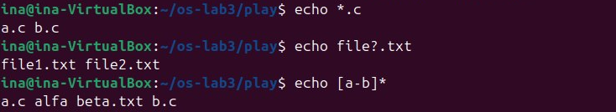
Figure 2.11 – Globbing results
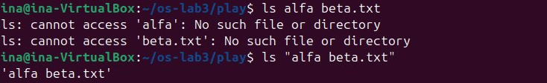
Figure 2.12 – The ls error on a name with a space, and the fix
Figure 2.13 – Single quotes, double quotes and backslash
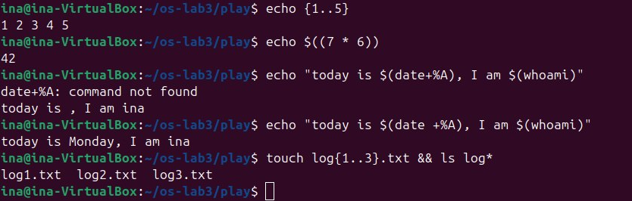
Figure 2.14 – Brace expansion, arithmetic expansion and command substitution
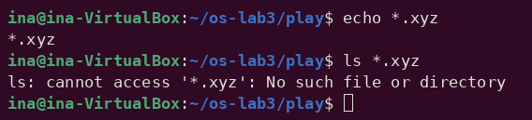
Figure 2.15 – A glob that matches nothing

2.3.1 Predictions and results
Command | My prediction | Real output | Explanation (if different)
echo *.c | a.c b.c | a.c b.c | –
echo file?.txt | file1.txt file2.txt | file1.txt file2.txt | –
echo [a-b]* | a.c b.c | a.c alfa beta.txt b.c | I forgot that "alfa beta.txt" also begins with a. The glob produced one word containing a space, which echo printed with the others.
echo *.xyz | an empty line | *.xyz | When a glob matches nothing, bash leaves the pattern unchanged and passes it literally (the nullglob option is off by default).
ls alfa beta.txt | an error | ls: cannot access 'alfa' ... and 'beta.txt' ... | Correct, but there were two errors: the shell split the name into two arguments.
ls "alfa beta.txt" | alfa beta.txt | 'alfa beta.txt' | ls adds quotes around a name containing a space when it writes to a terminal (see below).
echo '$HOME' "$HOME" \$HOME | $HOME /home/ina $HOME | $HOME /home/ina $HOME | –
echo {1..5} ; echo $((7 * 6)) | 1 2 3 4 5  42 | 1 2 3 4 5  42 | –
echo "today is $(date +%A), I am $(whoami)" | today is Monday, I am ina | today is Monday, I am ina | The first attempt was mistyped as $(date+%A): without the space, the shell looked for a command named "date+%A" (command not found) and substituted an empty string.
touch log{1..3}.txt && ls log* | log1.txt log2.txt log3.txt | log1.txt log2.txt log3.txt | –

2.3.2 Observations
Observe (Part 2)
(1) For each line: your prediction, the real output, and one sentence if they differ.
(2) echo knows nothing about files, yet echo *.c printed file names. Who produced them?
(3) Why did ls alfa beta.txt fail? Give two different ways to fix it.
(4) What is the difference between single and double quotes?
(1) Predictions
See the table in section 2.3.1. The two real surprises were [a-b]*, which also matched the file with a space in its name, and *.xyz, which bash passed on unchanged because it matched nothing.
(2) Who produced the file names
The shell did. Before running a command, bash performs pathname expansion (globbing): it replaces *.c with the sorted list of matching file names in the current directory. echo is then started with the arguments a.c and b.c and simply prints them; it never sees the * at all.
(3) Why ls alfa beta.txt failed
Unquoted spaces separate words, so the shell split the line into three words and ls received two arguments, alfa and beta.txt, neither of which exists. Fixes: quote the name, ls "alfa beta.txt" or ls 'alfa beta.txt'; escape the space with a backslash, ls alfa\ beta.txt; or let Tab completion or a glob such as ls alfa* produce the name.
(4) Single versus double quotes
Inside single quotes everything is literal: no expansion at all takes place, so '$HOME' stays $HOME. Inside double quotes the shell still performs parameter expansion ($HOME), command substitution $(...) and arithmetic expansion, but it does not perform word splitting or globbing, so "$HOME" becomes /home/ina as one single word. A backslash quotes just the next character (\$HOME prints $HOME).
Note on the quotes shown by ls: when its output goes to a terminal, ls uses the "shell-escape" quoting style and writes 'alfa beta.txt' in quotes, so that the name is unambiguous (otherwise it would look like two files) and can be copied and pasted back into a command. When the output goes into a pipe or a file, ls prints the plain name.

2.4 Part 3. Redirection, chaining and jobs
cd ~/os-lab3
ls /etc /nope > out.txt 2> err.txt
wc -l out.txt ; cat err.txt
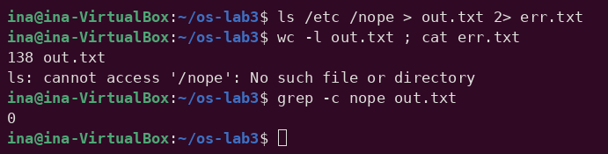
Figure 2.16 – stdout and stderr in separate files
ls /etc /nope > all.txt 2>&1 ; tail -2 all.txt
ls /etc /nope 2>&1 > all.txt
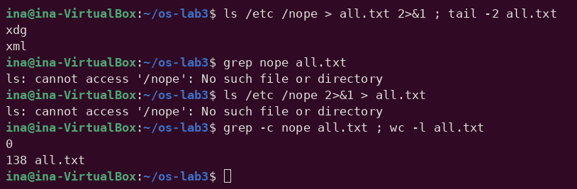
Figure 2.17 – Comparing the order of redirections
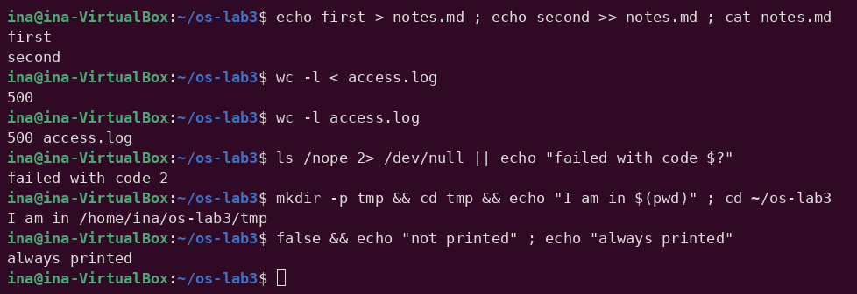
Figure 2.18 – Appending, input redirection and the ; && || operators
sleep 100 &
jobs ; kill %1 ; jobs
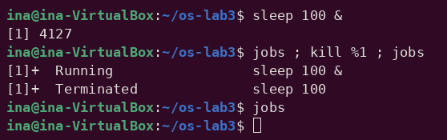
Figure 2.19 – Running a background job and stopping it
echo first > notes.md created (or truncated) the file, and >> appended the second line, so cat printed both. sleep 100 & started sleep in the background: the shell printed the job number [1] and the PID and returned the prompt immediately. The first jobs showed the job as Running; kill %1 sent the SIGTERM signal to job 1, and the second jobs reported it as Terminated. A last jobs printed nothing, because the finished job had been removed from the table.

2.4.1 Observations
Observe (Part 3)
(1) Which file got the error message, and which got the listing?
(2) What is the difference between > all.txt 2>&1 and 2>&1 > all.txt?
(3) Why does wc -l < access.log print only a number, while wc -l access.log also prints the file name?
(4) Explain each operator in one sentence: ; && ||
(1) Separate files
out.txt received the listing (stdout, file descriptor 1): 138 lines, the "/etc:" header followed by the names, and no line containing "nope". err.txt received the error message (stderr, file descriptor 2): "ls: cannot access '/nope': No such file or directory". Nothing appeared on the screen.
(2) Order of redirections
Redirections are processed from left to right, and 2>&1 means "make descriptor 2 a copy of what descriptor 1 is right now". In > all.txt 2>&1, stdout is first sent to all.txt and then stderr is copied from it, so both the listing and the error end up in the file. In 2>&1 > all.txt, stderr is first copied from stdout while stdout is still the terminal, and only afterwards is stdout moved to the file; therefore the error was printed on the screen and all.txt contains only the listing (grep -c nope all.txt printed 0).
(3) wc -l < access.log versus wc -l access.log
With < it is the shell that opens access.log and connects it to the standard input of wc; wc only receives an anonymous stream and has no file name to print, so it prints only 500. With wc -l access.log the name is passed as an argument, wc opens the file itself, and therefore it knows the name and prints 500 access.log.
(4) The operators ; && ||
- ; runs the next command after the previous one finishes, regardless of its result.
- && runs the next command only if the previous one succeeded (exit code 0), as in mkdir -p tmp && cd tmp && echo ....
- || runs the next command only if the previous one failed (non-zero exit code), as in ls /nope 2> /dev/null || echo "failed with code $?", which printed "failed with code 2".

2.5 Part 4. Answering questions with one-liners
Every question was answered with one command line built from small filters joined by pipes, run inside ~/os-lab3. All the lines were saved in oneliners.sh, each preceded by the question as a comment.
Q1. How many requests failed?
grep -c FAIL access.log
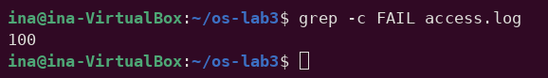
Figure 2.20 – Number of failed requests
grep -c FAIL counts the lines that contain FAIL: 100 requests failed (every fifth request, i % 5 = 0).
Q2. How many different pages were requested, and which?
cut -d' ' -f5 access.log | sort -u | nl
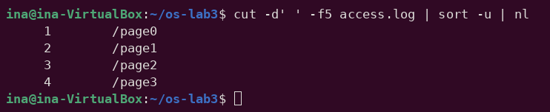
Figure 2.21 – The different pages requested
cut extracts field 5 (the page), sort -u keeps each value once and nl numbers the lines: 4 pages, /page0, /page1, /page2 and /page3.
Q3. How many requests did each page get?
cut -d' ' -f5 access.log | sort | uniq -c
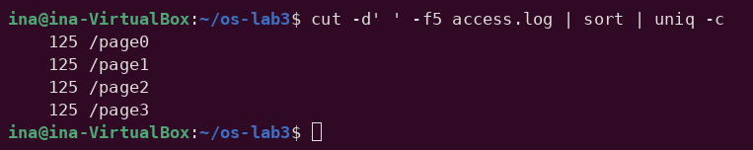
Figure 2.22 – Number of requests per page
sort | uniq -c counts equal adjacent lines: each page received 125 requests; 4 × 125 = 500, the number of lines in the log, as required.
Q4. Which user or users have the most failed requests, and how many?
grep FAIL access.log | cut -d' ' -f3 | sort | uniq -c | sort -rn | grep -w "$(grep FAIL access.log | cut -d' ' -f3 | sort | uniq -c | sort -rn | head -1 | tr -s ' ' | cut -d' ' -f2)"
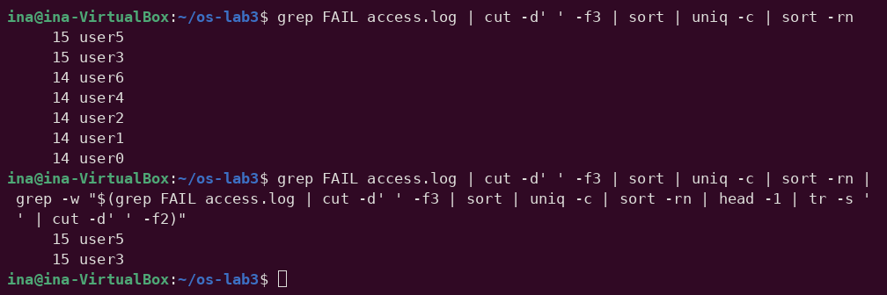
Figure 2.23 – Users with the most failed requests
The full ranking shows user3 and user5, with 15 failures each; the other five users have 14 each. The sum 15 + 15 + 5 × 14 = 100 equals the answer to Q1. Because there is a tie, the one-liner does not use head -1 (which would show only one of them): it takes the maximum count and keeps every line with that count.
Q5. How many requests did user3 make, and how many of them failed?
echo "user3: $(grep -cw user3 access.log) requests, $(grep -w user3 access.log | grep -c FAIL) failed"
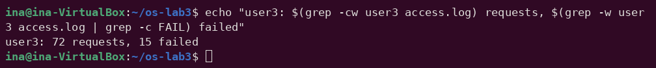
Figure 2.24 – Requests and failures of user3
user3 made 72 requests, of which 15 failed. grep -w matches user3 only as a whole word.
Q6. Print the last 3 failed requests, showing only time and user.
grep FAIL access.log | tail -3 | cut -d' ' -f2,3
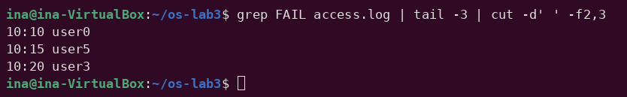
Figure 2.25 – The last three failed requests
The last three failed requests were at 10:10 user0, 10:15 user5 and 10:20 user3 (lines 490, 495 and 500 of the log).
Q7. Which login shells appear in /etc/passwd, and how many accounts use each?
cut -d: -f7 /etc/passwd | sort | uniq -c | sort -rn
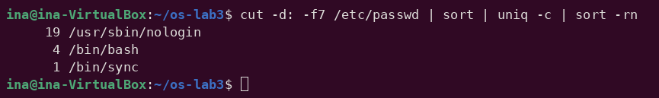
Figure 2.26 – Login shells in /etc/passwd
Field 7 of /etc/passwd (separator :) is the login shell. Most accounts are system accounts with /usr/sbin/nologin (19), which cannot log in; /bin/bash is used by 4 accounts and /bin/sync by 1.
Q8. Why do ls /etc | wc -l and ls -l /etc | wc -l differ by exactly one?
ls /etc | wc -l ; ls -l /etc | wc -l ; ls -l /etc | head -1
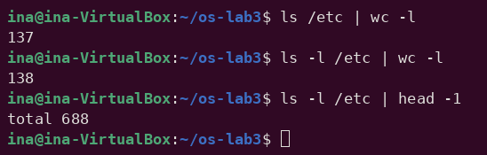
Figure 2.27 – Comparing ls and ls -l line counts
PREDICT: the long listing has an extra header line. Result: 137 and 138. ls -l prints the line "total 688" (the total number of 1 KiB blocks used by the listed files) before the entries, while plain ls prints only the names, one per line when its output is a pipe. Every entry produces exactly one line in both cases, so the difference is exactly that one header line.
Full file oneliners.sh
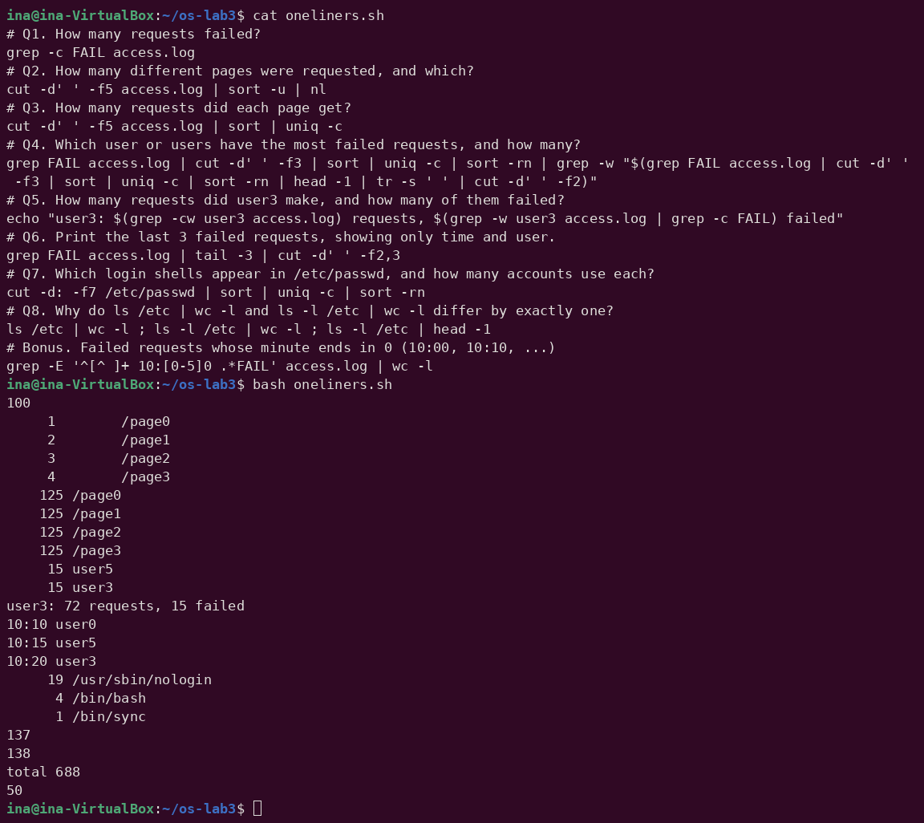
Figure 2.28 – Full run of oneliners.sh
The check from the task is satisfied: the Q3 counts add up to 500, and the per-user failure counts behind Q4 add up to 100, the answer to Q1. The file runs with bash oneliners.sh inside ~/os-lab3.
Bonus: failed requests whose minute ends in 0
grep -E '^[^ ]+ 10:[0-5]0 .*FAIL' access.log ; grep -cE '^[^ ]+ 10:[0-5]0 .*FAIL' access.log
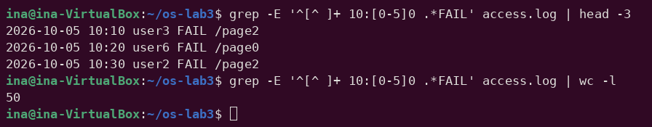
Figure 2.29 – Bonus: failed requests at minutes ending in 0
The extended regular expression matches the date, then 10: followed by a minute whose second digit is 0, and FAIL later on the line. The first grep prints the matching lines (10:00 user4, 10:10 user0, ... 10:20 user3) and the second one, with -c, counts them. There are 50 such lines. This is not a coincidence: the minute is i % 60, so it ends in 0 exactly when i is a multiple of 10, and every multiple of 10 is also a multiple of 5, so all those requests failed. They are exactly half of the 100 failures.

2.6 Part 5. The first script
The best one-liners were turned into the script report.sh. The TODO was completed with a for loop over the numbers 0 to 6 which counts the FAIL lines of each user:
#!/bin/bash
# usage: ./report.sh access.log
log=$1
if [ ! -f "$log" ]; then
echo "no such file: $log" >&2
exit 1
fi
total=$(wc -l < "$log")
fails=$(grep -c FAIL "$log")
echo "$total requests, $fails failed"
for n in $(seq 0 6); do
echo "user$n: $(grep -w "user$n" "$log" | grep -c FAIL) failures"
done
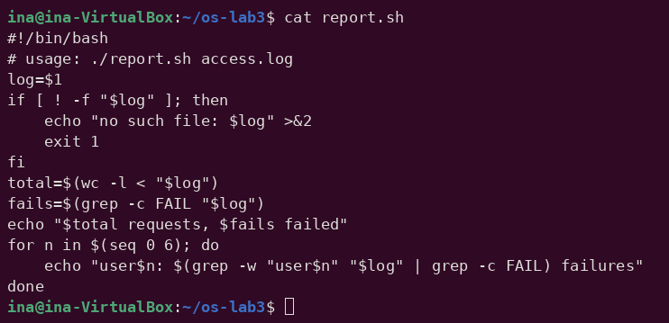
Figure 2.30 – Contents of report.sh
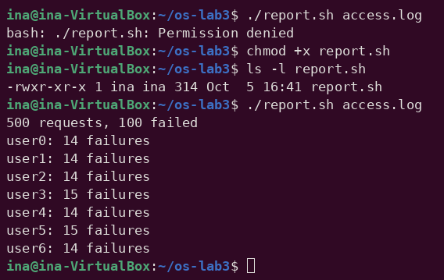
Figure 2.31 – Running the script on access.log
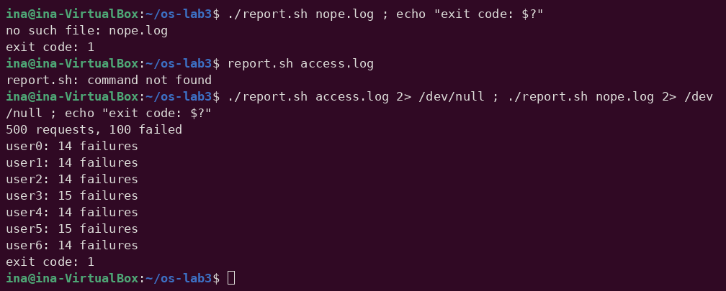
Figure 2.32 – Error handling for a missing file
Before chmod +x, the attempt to run the script failed with "Permission denied"; after it the file has the permissions -rwxr-xr-x and the script printed "500 requests, 100 failed" followed by the failures of every user, which again add up to 100. With a missing file the script printed "no such file: nope.log" and returned exit code 1. Redirecting stderr to /dev/null hides the error message but not the normal output, which shows that the two go to different streams.

2.6.1 Observations
Observe (Part 5)
(1) What does the first line #!/bin/bash do, and what happens if you run ./report.sh before chmod +x?
(2) Why must you type ./report.sh and not just report.sh?
(3) Why does the script write the error with >&2 and end with exit 1?
(1) The shebang line
#!/bin/bash (the "shebang") tells the kernel which interpreter to use: when the file is executed, the kernel sees the #! at the start and actually runs /bin/bash with the script's path as an argument, so the script runs in bash whatever shell started it. Before chmod +x the file has no execute permission, so the kernel refuses to execute it and bash reports "Permission denied" (Figure 2.31). It could still be run as bash report.sh, since then bash is the program being executed and the script is just a file it reads.
(2) Why ./report.sh
A command name without a slash is searched only in the directories of PATH, and the current directory is not in PATH, so report.sh gives "command not found" (Figure 2.32). ./report.sh contains a slash, which tells the shell to use exactly that path, the file in the current directory. Leaving . out of PATH is a security measure: a malicious file named like a common command (ls, for example) placed in a directory cannot be run by accident.
(3) >&2 and exit 1
>&2 sends the error message to standard error instead of standard output, so it is not mixed with the real results: if the output of the script is redirected to a file or a pipe, the error still appears on the screen and does not corrupt the data. exit 1 sets a non-zero exit code, which tells the caller that the script failed; other commands can react to it with && and ||, and echo $? printed exit code: 1.

2.6.2 Bonus: running report.sh with cron
cron is a daemon that runs commands on a schedule. A line was added to the user crontab, the per-user table that crontab -e edits (five time fields followed by the command); * * * * * means every minute. Because cron starts jobs with a minimal environment and in the home directory, every path is absolute, and >> ... 2>&1 appends both stdout and stderr to the log, so a possible error message would also be kept:
* * * * * /home/ina/os-lab3/report.sh /home/ina/os-lab3/access.log >> /home/ina/os-lab3/report.log 2>&1
After waiting a little over two minutes, the log contained 3 identical reports, one per minute, each with the totals and the failures of every user:
500 requests, 100 failed
user0: 14 failures
user1: 14 failures
user2: 14 failures
user3: 15 failures
user4: 14 failures
user5: 15 failures
user6: 14 failures
500 requests, 100 failed
user0: 14 failures
user1: 14 failures
user2: 14 failures
user3: 15 failures
user4: 14 failures
user5: 15 failures
user6: 14 failures
500 requests, 100 failed
user0: 14 failures
user1: 14 failures
user2: 14 failures
user3: 15 failures
user4: 14 failures
user5: 15 failures
user6: 14 failures
Then the line was removed with crontab -r (it was the only line in the crontab), and crontab -l confirmed it with "no crontab for ina", so the job stopped running.

3 LABORATORY WORK 4: THE XV6 SHELL FROM THE OUTSIDE

3.1 Part 1. Fixing sleep for the current xv6
cd ~/xv6-riscv
grep -n "pause\|sleep" user/user.h
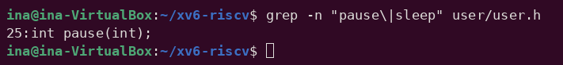
Figure 3.1 – The grep result in user.h
The only match is line 25, int pause(int);: the tree uses the new name, and no function called sleep is declared. This explains the compilation error obtained in Lab 2 ("implicit declaration of function 'sleep'"). The call in user/sleep.c was therefore changed to pause(), and the UPROGS list of the Makefile was checked to contain $U/_sleep\ (a TAB at the start, a backslash at the end and nothing after it):
#include "kernel/types.h"
#include "user/user.h"

int
main(int argc, char *argv[])
{
if(argc != 2){
fprintf(2, "usage: sleep <ticks>\n");
exit(1);
}
pause(atoi(argv[1])); // was sleep() before Aug 2025
exit(0);
}
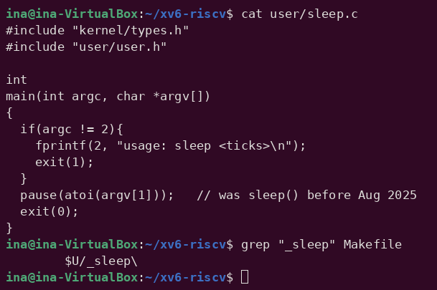
Figure 3.2 – The updated sleep.c
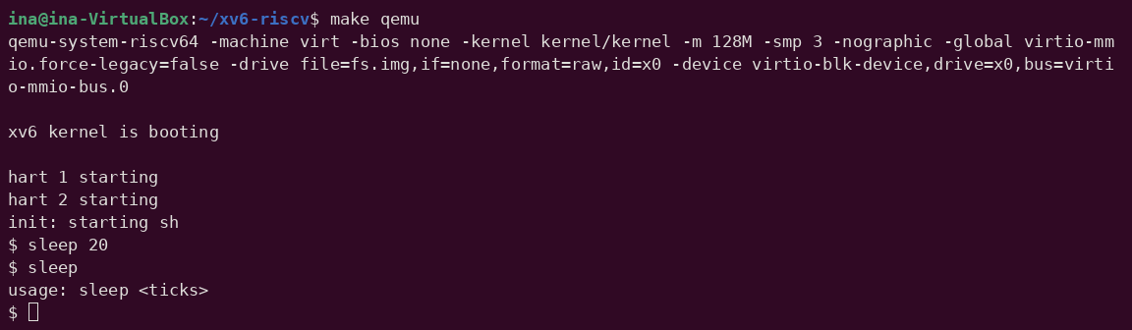
Figure 3.3 – sleep running in xv6, with and without an argument
After make qemu, sleep 20 paused for 20 ticks (about two seconds) before the $ prompt appeared again, and sleep without an argument printed "usage: sleep <ticks>". The program from Lab 2 now builds and works on the current xv6.

3.2 Part 2. bash versus the xv6 shell
Every command was run twice: in bash, in an empty folder ~/shtest containing only a file named README, and at the xv6 $ prompt.
mkdir ~/shtest && cd ~/shtest && touch README
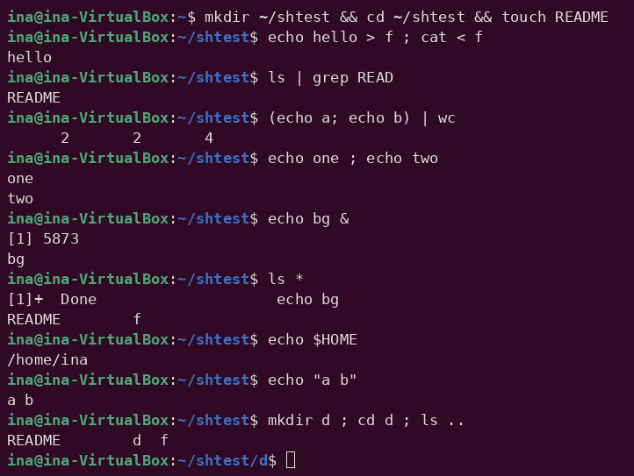
Figure 3.4 – The commands run in bash
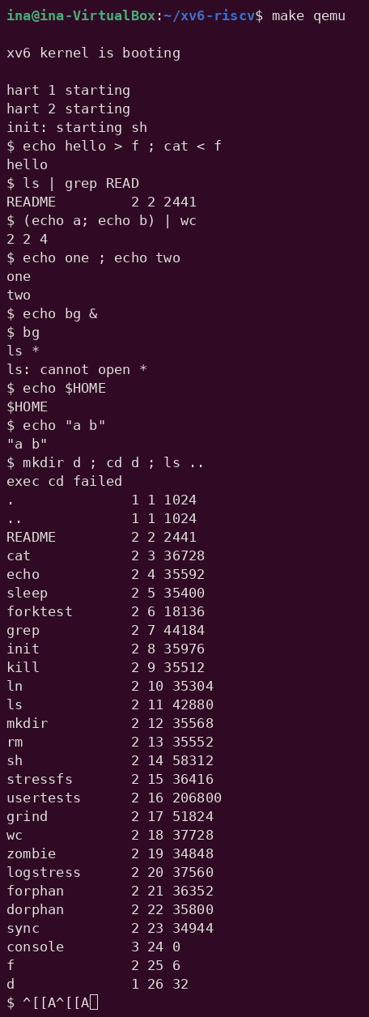
Figure 3.5 – The same commands run in xv6
Command | Tests | bash | xv6
echo hello > f ; cat < f | redirection | hello | hello – works
ls | grep READ | pipe | README | README 2 2 2441 – works (xv6 ls also prints type, inode and size)
(echo a; echo b) | wc | grouping, list | 2 2 4 | 2 2 4 – works
echo one ; echo two | sequence | one / two | one / two – works
echo bg & | background | [1] 5873, bg, later [1]+ Done | bg is printed after the prompt ("$ bg"); no job number, no jobs command
ls * | globbing | README f | ls: cannot open * – no globbing, * is passed literally
echo $HOME | variables | /home/ina | $HOME – no variables
echo "a b" | quotes | a b | "a b" – quotes are not special; they are printed, and the words are split into "a and b"
mkdir d ; cd d ; ls .. | PATH | README d f (the prompt moves to ~/shtest/d) | exec cd failed, then ls lists / – cd is recognised only at the start of a line
arrow up, Tab, Ctrl+R | history, completion | previous command, completion, search | ^[[A is printed literally; no history, no completion

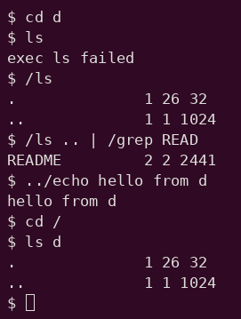
Figure 3.6 – ls failing after cd d, and the working alternatives
When cd d was typed on its own line, the directory changed, but then ls failed with "exec ls failed". Running the program by its full path, /ls, or by a relative path, ../echo, works; /ls .. | /grep READ shows that pipes work too as long as the programs are found.

3.2.1 Observations
Observe (Lab 4, Part 2)
(1) List the features both shells have, and the ones only bash has.
(2) In xv6, ls stops working after cd d. Why? Find a way to run ls from inside d anyway.
(3) Which missing feature would you miss most in daily work, and which would be easiest to add?
(1) Features
Both shells run programs with arguments and provide input and output redirection (<, >, >>), pipes (|), sequences (;), grouping with parentheses, background execution (&) and the built-in cd. Only bash has globbing (*, ?, [...]), variables and $ expansion, quote removal, command substitution $(...), arithmetic and brace expansion, the conditional operators && and ||, a PATH search for programs, job control (job numbers, jobs, kill %1, fg), aliases, command history with the arrow keys and Ctrl+R, Tab completion and line editing, and a full scripting language (if, for, functions).
(2) ls after cd d
xv6 has no PATH: the shell calls exec() with the name exactly as typed, and the kernel interprets "ls" as a path relative to the current directory. All xv6 programs live in the root directory /, so ls is found only while the current directory is /. Inside d there is no file named ls, and exec fails. Workarounds: give the path explicitly, /ls or ../ls (Figure 3.6), or go back with cd /. The same reason explains the combined line in the table: cd was not at the start of the line, so the shell tried to exec a program called cd, which does not exist, and ls ran in /, where it is found.
(3) Missing features
In daily work I would miss command history and Tab completion the most, since they save most of the typing and every typo would otherwise mean retyping the whole line. The easiest feature to add would be a minimal PATH: when exec(argv[0]) fails and the name contains no slash, the shell retries with "/" prepended. That is only a few lines in runcmd() in user/sh.c and would fix the ls-after-cd problem.

3.3 Part 3. Who expands *? A program that prints its argv
#include "kernel/types.h"
#include "user/user.h"

int
main(int argc, char *argv[])
{
printf("argc = %d\n", argc);
for(int i = 0; i < argc; i++)
printf("argv[%d] = [%s]\n", i, argv[i]);
exit(0);
}
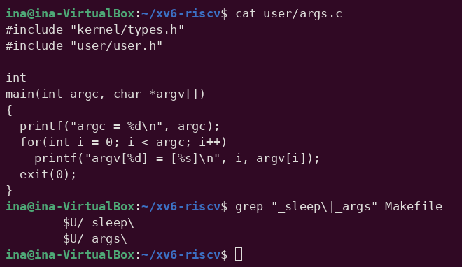
Figure 3.7 – args.c and the UPROGS line
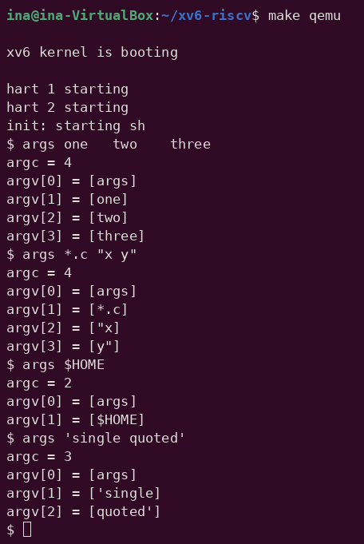
Figure 3.8 – args output in xv6
The Linux version, args_linux.c, differs only in the header (#include <stdio.h>) and in using return 0 instead of exit(0). It was compiled with gcc -o args args_linux.c and run as ./args in the folder ~/os-lab4, which contains three .c files (args.c, args_linux.c and sleep.c):
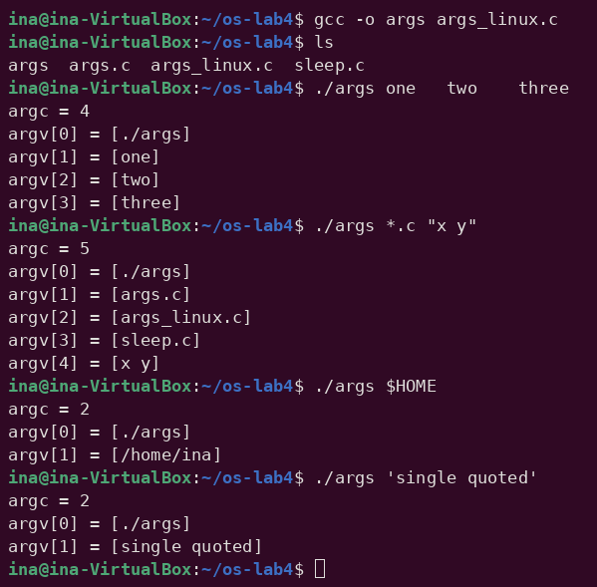
Figure 3.9 – args_linux output in bash
Command line | xv6 (args) | bash (./args)
args one two three | argc = 4: [args] [one] [two] [three] | argc = 4: [./args] [one] [two] [three]
args *.c "x y" | argc = 4: [args] [*.c] ["x] [y"] | argc = 5: [./args] [args.c] [args_linux.c] [sleep.c] [x y]
args $HOME | argc = 2: [args] [$HOME] | argc = 2: [./args] [/home/ina]
args 'single quoted' | argc = 3: [args] ['single] [quoted'] | argc = 2: [./args] [single quoted]

3.3.1 Observations
Observe (Lab 4, Part 3)
(1) Paste both outputs for args *.c "x y". How many arguments did each program receive?
(2) So who turns *.c into file names and removes the quotes: the program, the kernel, or the shell?
(3) What happened to the extra spaces in one two three?
(1) args *.c "x y"
In xv6 the program received argc = 4: [args] [*.c] ["x] [y"]. The * was not expanded, and the quotes stayed part of the words, so "x y" was split into two arguments, each with one quote character. In bash it received argc = 5: [./args] [args.c] [args_linux.c] [sleep.c] [x y]. The pattern became three file names, and "x y" became one argument containing a space, without the quotes.
(2) Who expands
The shell. The program code is identical in both systems and only prints what it receives, and the kernel's exec() simply copies the given strings into the new process. bash performs globbing, variable expansion and quote removal before it calls exec, while the xv6 shell does none of this, so the same program receives different arguments.
(3) Extra spaces
They disappeared in both shells: argc was 4 and the arguments were exactly one, two and three. Both shells split the line into words at runs of spaces or tabs, and the separators themselves are not passed to the program. In bash, spaces survive only inside quotes, as in "x y".

3.4 Part 4. Reading the shell
wc -l user/sh.c
grep -n "#define" user/sh.c # the kinds of commands
grep -n "case " user/sh.c # where each kind is run
grep -n "cd" user/sh.c | head
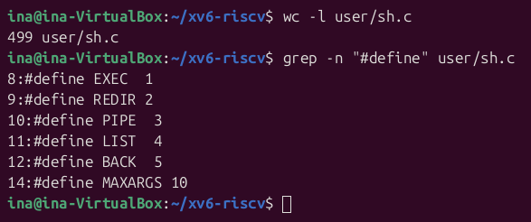
Figure 3.10 – Size of sh.c and the kinds of commands (#define)
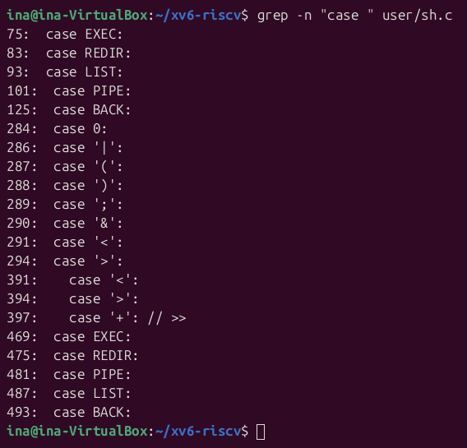
Figure 3.11 – Where each kind of command is parsed and run (case)
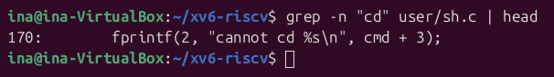
Figure 3.12 – Searching sh.c for cd
sh.c has 499 lines. The five #define constants EXEC, REDIR, PIPE, LIST and BACK (lines 8–12) are the kinds of commands; MAXARGS is only the limit of 10 arguments per command. The case lines appear in four places: runcmd() executes each kind (lines 75–125), gettoken() recognises the special characters | ( ) ; & < > (lines 284–294), parseredirs() builds a REDIR command for <, > and >> (lines 391–397), and nulterminate() (lines 469–493) finishes building each kind after parsing. grep "cd" finds only the error message on line 170, because the check in main() compares the characters one by one: cmd[0] == 'c' && cmd[1] == 'd' && cmd[2] == ' ', and then calls chdir(cmd + 3) in the shell process itself.

3.4.1 Observations
Observe (Lab 4, Part 4)
(1) Name the five kinds of command the xv6 shell knows and the character that produces each.
(2) Where is cd handled, and why is it not run as a separate program?
(3) Search sh.c for any code that handles * or $. What does that explain about Part 2?
(1) The five kinds of command
- EXEC – a plain command with its arguments (no special character).
- REDIR – a redirection, produced by < and > (and >> for appending).
- PIPE – a pipe between two commands, produced by |.
- LIST – a sequence of commands, produced by ;.
- BACK – a command run in the background, produced by &.
Parentheses ( ) do not create a separate kind; they only group a sub-command (parseblock). Each kind has its own struct, and runcmd() executes it in a switch with one case per kind.
(2) cd
cd is handled in main(), before the shell forks: if the line starts with the three characters "cd ", the shell removes the newline and calls chdir() itself, then reads the next line. Every other command is run with fork() and exec() in a child process, and a chdir() executed by a child would change only the child's directory, which disappears when the child exits. This is the same reason why cd is a built-in in bash (Lab 3, Part 1). Because the check looks only at the beginning of the line, a cd in the middle of a list, as in mkdir d ; cd d ; ls .., is treated as an ordinary program and fails with "exec cd failed".
(3) * and $
sh.c contains no code that handles * or $: the tokenizer gettoken() treats only the symbols < | > & ; ( ) specially (its symbols string is "<|>&;()"), and everything else is copied into argv unchanged. This explains Part 2 and Part 3: in xv6, ls * and args *.c received a literal *, echo $HOME printed $HOME, and quotes were passed through because the shell never removes them.

CONCLUSION
Laboratory Work 3 showed that most of what happens on a command line is done by the shell before any program runs. Tab completion, history search, globbing, quoting and the various expansions all transform the line first, and only then is a program started with the resulting arguments. The surprises in the prediction table, [a-b]* matching the name with a space and *.xyz being passed unchanged, came from not thinking like the shell. The redirection experiments made the role of file descriptors concrete: stdout and stderr are separate streams, and the order of redirections matters because 2>&1 copies a descriptor at the moment it is processed. The one-liners answered every question about the log by combining grep, cut, sort, uniq, wc, head, tail and nl, and the self-checks (125 × 4 = 500, 15 + 15 + 5 × 14 = 100) confirmed the pipelines. report.sh turned them into a small program with a proper interface: a shebang, an argument check, errors on stderr and a meaningful exit code.
Laboratory Work 4 looked at the same mechanisms from the other side. After pause() replaced sleep() in the current xv6, the Lab 2 program was fixed and works. Comparing bash with the xv6 shell separated what a shell must provide, running programs, redirection, pipes, lists, background execution and a built-in cd, from the conveniences bash adds: globbing, variables, quote removal, PATH, history and completion. The args program made this visible: the same code received four arguments in xv6 and five in bash for the same line, which proves that it is the shell, not the program and not the kernel, that expands * and removes quotes. Reading sh.c confirmed it: its tokenizer knows only the characters < | > & ; ( ), and cd is handled in the parent process for the same reason it must be a built-in in bash.

REFERENCES
- GNU Bash Reference Manual. Free Software Foundation. Retrieved from https://www.gnu.org/software/bash/manual/
- The Linux man-pages project. bash(1), ls(1), grep(1), cut(1), sort(1), uniq(1), wc(1), passwd(5), execve(2). Retrieved from https://man7.org/linux/man-pages/
- Cox, R., Kaashoek, F., & Morris, R. xv6: a simple, Unix-like teaching operating system (RISC-V edition), chapter 1 "Operating system interfaces". MIT. Retrieved from https://pdos.csail.mit.edu/6.1810/
- MIT PDOS. xv6-riscv source code repository, user/sh.c. Retrieved from https://github.com/mit-pdos/xv6-riscv
- Shotts, W. (2019). The Linux Command Line (2nd ed.). No Starch Press.
- Pancenco, I. (2026). os-2026-InaPancenco: source code and reports of the Operating Systems laboratory works GitHub repository. Retrieved from: https://github.com/inap235/os-2026-InaPancenco

