
MINISTRY OF EDUCATION, CULTURE AND RESEARCH
OF THE REPUBLIC OF MOLDOVA
Technical University of Moldova
Faculty of Computers, Informatics and Microelectronics
Department of Software Engineering and Automation

Report
on laboratory works no. 7–8
Operating Systems
Topic: Three Small Programs: Processes, Redirection, a Pipe.
The Same Calls, Inside Your Own OS (xv6)

Done by:
st. gr. FAF-242, Ina Pancenco

Checked by:
Reițman Patricia, university assistant
DISA, FCIM, UTM

Chișinău – 2026
Table of Contents
1 PURPOSE OF THE WORK 3
1.1 Purpose of practical work 3
1.2 Problem statement 3
2 LABORATORY WORK 7: THREE SMALL PROGRAMS 4
2.1 Preparation 4
2.2 Part 1. fork + exec + wait 4
2.2.1 Observations 5
2.3 Part 2. A zombie, on purpose 6
2.3.1 Observations 7
2.4 Part 3. Redirection: ls -l > out.txt 7
2.4.1 Observations 9
2.5 Part 4. A pipe: ls /etc | wc -l 9
2.5.1 Observations 11
2.6 Optional. Three stages 11
3 LABORATORY WORK 8: THE SAME CALLS, INSIDE YOUR OWN OS (XV6) 13
3.1 Preparation 13
3.2 Part 1. run, inside xv6 13
3.2.1 Observations 15
3.3 Part 2. pingpong 16
3.3.1 Observations 17
3.4 Optional. primes 18
CONCLUSION 20
REFERENCES 21

1 PURPOSE OF THE WORK

1.1 Purpose of practical work
The purpose of these two laboratory works is to understand how a process is born, where a program writes its output and how two programs are connected by a pipe. In Laboratory Work 7 three small C programs are compiled and run on Linux. Each one does by hand what the shell does for a familiar command: fork, exec and wait for ls -l, a redirection for ls -l > out.txt, and a pipe for ls /etc | wc -l. One line of each program is then changed on purpose to see what breaks: an exec that fails, a parent that does not wait (a zombie) and a pipe end that is not closed (a process that never ends).
In Laboratory Work 8 the same system calls are used inside xv6, the small teaching operating system built during the semester. The run program is written again for xv6, where there is no C library, only the system calls of the compiled kernel, and two processes are made to talk through two pipes (pingpong). As an optional task a prime sieve is built from a chain of processes connected by pipes.

1.2 Problem statement
Laboratory Work 7 – Three Small Programs: Processes, Redirection, a Pipe (Track A, Linux):
- Part 1: run.c – fork, execlp and waitpid; then the child runs date and a program that does not exist.
- Part 2: zombie.c – the parent sleeps 20 seconds before waitpid, so the finished child is seen as a zombie in ps.
- Part 3: redirect.c – close(1) and open() in the child make ls -l write into out.txt.
- Part 4: pipeline.c – one pipe, two forks and dup build ls /etc | wc -l; then the parent forgets to close the write end.
- Optional: pipeline3.c – ls /usr/bin | grep x | wc -l with two pipes and three children.
Laboratory Work 8 – The Same Calls, Inside Your Own OS (Track B, xv6):
- Part 1: user/run.c – fork, exec and wait inside xv6; the child becomes echo, then ls, then a program that does not exist.
- Part 2: user/pingpong.c – the parent and the child exchange one byte through two pipes.
- Optional: user/primes.c – the primes from 2 to 35 printed by a chain of processes connected by pipes.
Both works were carried out on an Ubuntu 24.04 Linux virtual machine in VirtualBox (host name ina-VirtualBox, user ina), with gcc 13.3.0. xv6 was run in QEMU from the ~/xv6-riscv tree. For every part the commands and their output are given as screenshots of the terminal, followed by the answers to the Observe questions. The source files and the answer files (report.md for Lab 7, notes.md for Lab 8) are pushed to the course repository.

2 LABORATORY WORK 7: THREE SMALL PROGRAMS

2.1 Preparation
A working folder ~/os-lab7 was created, and gcc was checked. The four programs were typed exactly as given in the laboratory handout (Figure 2.1 shows run.c). All of them compile with gcc -Wall -Wextra without a single warning.
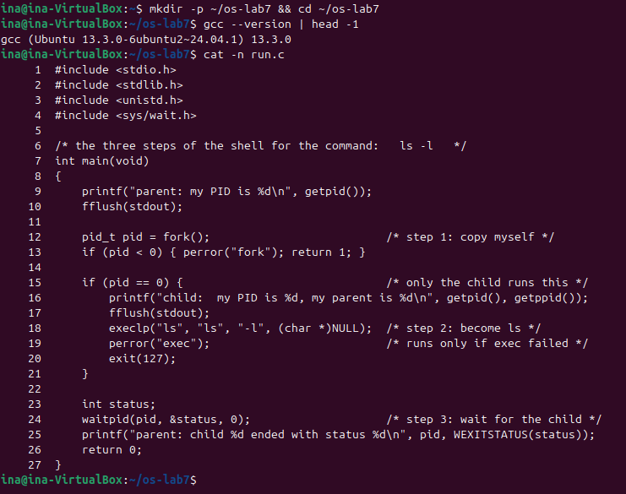
Figure 2.1 – The working folder, the gcc version and the source of run.c

2.2 Part 1. fork + exec + wait
run.c does what the shell does for ls -l: the parent prints its PID and calls fork(), which creates a copy of the process. fork returns twice: 0 in the child and the PID of the child in the parent. The child prints its own PID and its parent's PID, then calls execlp("ls", "ls", "-l", NULL), which replaces the program of the child with /usr/bin/ls. The parent calls waitpid(), sleeps until the child ends and prints its exit status. The fflush(stdout) calls make sure the text is written before fork and exec, otherwise the buffered text would be copied into the child or lost by exec.
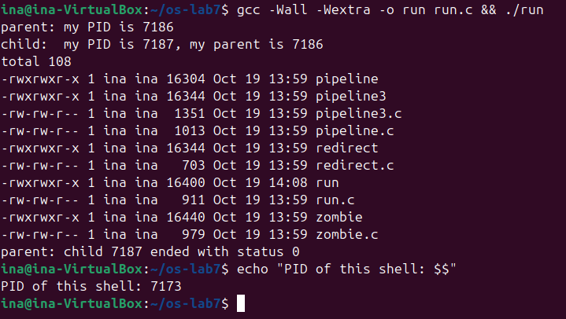
Figure 2.2 – run: the parent, the child that becomes ls -l, and the exit status 0
The order of the lines is the one expected: the parent line, the child line, the listing produced by ls, and finally the parent line with the status. The parent line comes last because waitpid blocks the parent until ls has finished. To make the next two experiments, the execlp line was changed in two copies of run.c (run_date.c and run_nosuch.c), so that the original run.c stays as the handout gives it. grep shows the changed line before each build (Figure 2.3).
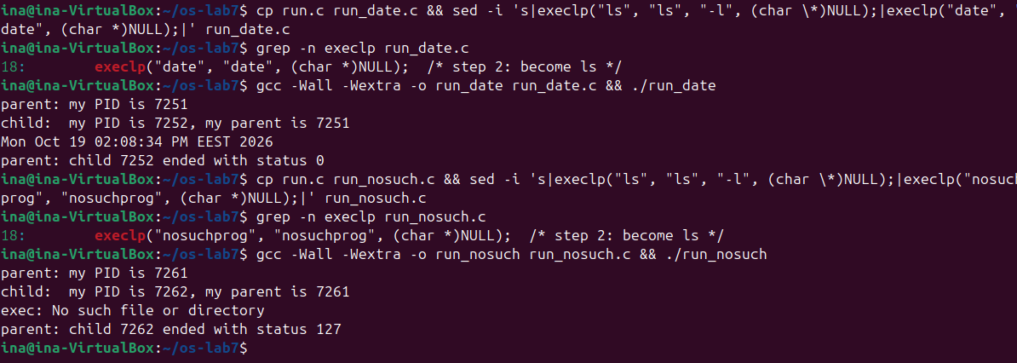
Figure 2.3 – The child runs date, then a program that does not exist

2.2.1 Observations
Observe (Part 1)
(1) The line perror("exec") is in the child, right after execlp. Why is it printed only with nosuchprog?
(2) Which number does the child print as "my parent", and whose PID is it?
(3) What status does the parent see with ls, and what status with nosuchprog?
(1) exec does not return
A successful exec never returns. It throws away the whole memory image of the child (code, data, heap and stack) and loads the new program in its place, keeping only the PID and the open file descriptors. After execlp("ls", ...) or execlp("date", ...) the code of run.c, including the perror line, no longer exists in the child, so it cannot run. With nosuchprog, execlp searched every directory of PATH, found nothing and returned -1 with errno = ENOENT. Only then does the old code continue, perror prints "exec: No such file or directory", and the child calls exit(127).
(2) The parent of the child
The child printed "my parent is 7186", the same number that the parent printed on the first line ("parent: my PID is 7186"). It is the PID of the ./run process that called fork. The shell that started ./run has a different PID (7173, printed with echo $$); the shell is the parent of ./run, the grandparent of the child.
(3) Exit status
With ls (and with date) the parent sees status 0: the program succeeded and returned 0 from main. With nosuchprog the parent sees status 127, the number passed to exit(127) after the failed exec. 127 is also the code that bash itself uses for "command not found". WEXITSTATUS(status) extracts this number from the status word filled in by waitpid.

2.3 Part 2. A zombie, on purpose
zombie.c is run.c with one more line, sleep(20), just before waitpid (diff shows the only difference). The program was started in the background with its output sent to /dev/null, and ps was run after 2 seconds and again after 20 more seconds (Figure 2.4).
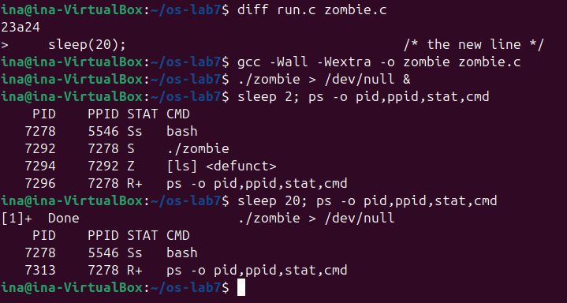
Figure 2.4 – The finished ls stays as a zombie until the parent calls waitpid

2.3.1 Observations
Observe (Part 2)
(1) Which letter does ls have in the STAT column, and what does it mean?
(2) After 20 seconds, is the [ls] <defunct> line still there? Which line of zombie.c made it disappear?
(1) The state Z
ls (PID 7294, parent 7292 = ./zombie) has the letter Z, zombie, and ps shows it as [ls] <defunct>. ls has already finished: its memory and its open files were released and it will never run again. The kernel keeps only its entry in the process table, with the PID and the exit status, because the parent may still ask for that status with wait. The parent ./zombie is in state S (sleeping), because it is inside sleep(20) and has not called waitpid yet.
(2) Who removes the zombie
After 20 seconds the [ls] <defunct> line is gone. It was removed by the line waitpid(pid, &status, 0);: when the parent woke up from sleep it called waitpid, received the exit status of ls, and the kernel freed the process table entry. Right after that ./zombie itself ended, and bash, its parent, reaped it in turn and reported "[1]+ Done ./zombie > /dev/null". A zombie therefore costs only a slot in the process table, but a parent that never waits would fill the table with them.

2.4 Part 3. Redirection: ls -l > out.txt
redirect.c does what the shell does for ls -l > out.txt. In the child it closes descriptor 1 (standard output), opens out.txt for writing, prints the descriptor that open returned on standard error (descriptor 2) and executes ls -l. The parent waits for the child and prints a message on its own standard output, which was never changed (Figures 2.5 and 2.6).
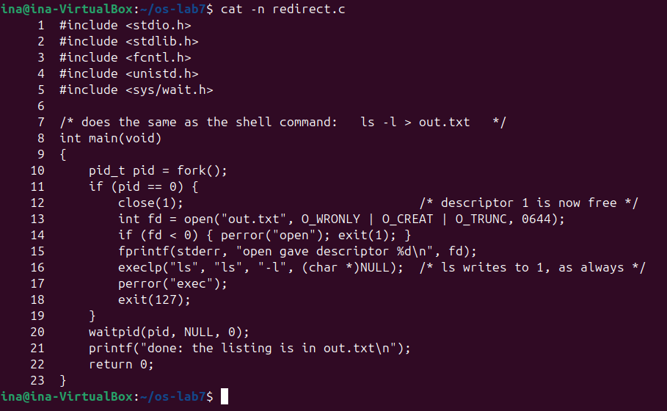
Figure 2.5 – The source of redirect.c
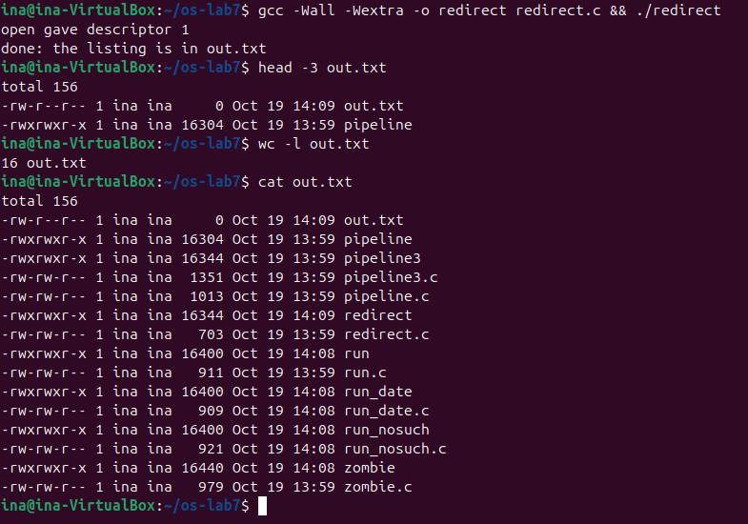
Figure 2.6 – open gives descriptor 1, and the listing of ls goes into out.txt

2.4.1 Observations
Observe (Part 3)
(1) Which number did open give, and why exactly that one?
(2) ls was not changed at all. Why does its listing not appear on the screen?
(3) To redirect the errors instead (like 2> err.txt), which descriptor would you close before open?
(1) The smallest free descriptor
open returned descriptor 1. The kernel always gives the lowest-numbered free descriptor. In the child, descriptors 0 (standard input) and 2 (standard error) were still open to the terminal and 1 had just been closed, so 1 was the smallest free number. This rule is what makes redirection possible without changing any program.
(2) Why ls writes into the file
ls writes its listing to descriptor 1, as every program does; it does not know what 1 refers to. Open descriptors are kept across exec, so when the child became ls, its descriptor 1 already pointed to out.txt instead of the terminal. Therefore the listing went into the file: out.txt has 16 lines, starting with "total 156". Only two lines reached the screen: "open gave descriptor 1", which was written to descriptor 2, and "done: ...", which was printed by the parent, whose descriptor 1 is still the terminal. out.txt appears in its own listing with size 0, because open created (and truncated) it before ls started, and ls read the directory before writing anything.
(3) Redirecting errors
To get the effect of 2> err.txt, close descriptor 2 before open. open then returns 2, and everything the program writes to standard error goes into err.txt, while standard output stays on the terminal.

2.5 Part 4. A pipe: ls /etc | wc -l
pipeline.c builds the pipeline by hand. pipe(p) creates a pipe with a read end p[0] and a write end p[1]. The first child closes 1 and calls dup(p[1]), which copies the write end into the smallest free descriptor, 1; then it closes both original ends and becomes ls /etc. The second child does the same with descriptor 0 and the read end and becomes wc -l. The parent closes both ends and waits for the two children (Figure 2.7).
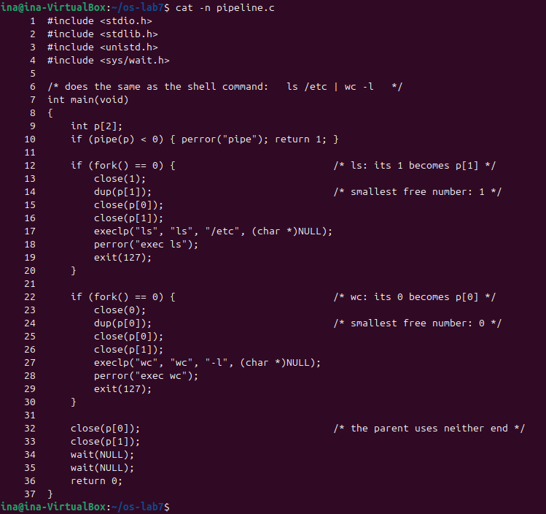
Figure 2.7 – The source of pipeline.c
The program printed the same number as the shell. Then the line close(p[1]) of the parent was turned into a comment in a copy of the program (pipeline_noclose.c, see the diff in Figure 2.8). This version did not end. It was started in the background so that ps could show which processes were still alive, and was then stopped with Ctrl-C (SIGINT, sent with kill -INT %1).
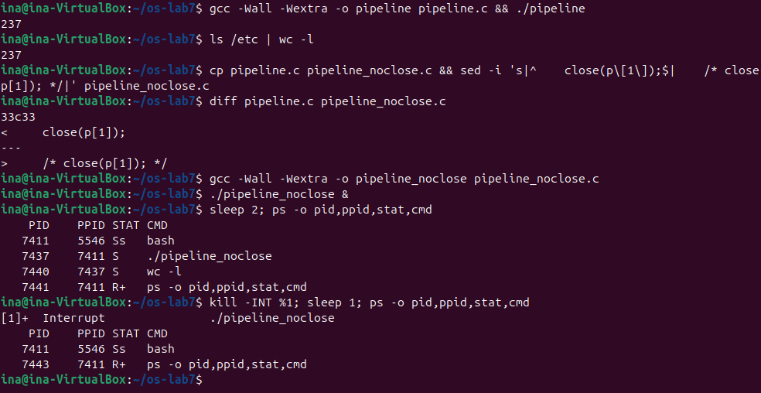
Figure 2.8 – pipeline gives the same count as the shell; without close(p[1]) wc never ends

2.5.1 Observations
Observe (Part 4)
(1) Did ./pipeline and ls /etc | wc -l give the same number?
(2) After the change, which of the two children never ends, ls or wc?
(3) Why, in one sentence: what is wc waiting for?
(1) The same result
Yes. Both ./pipeline and ls /etc | wc -l printed 237, the number of entries in /etc. The program does exactly what the shell does.
(2) The child that never ends
wc never ends. ps shows ./pipeline_noclose and wc -l, both sleeping (S), and no ls: ls wrote its 237 names into the pipe, exited normally and was reaped by the first wait(NULL). The parent is blocked in the second wait(NULL), waiting for wc.
(3) What wc is waiting for
wc is waiting for end of file on the pipe, which read() returns only when every write end of the pipe is closed, and the parent still holds p[1] open while it waits for wc, so the end of file never comes. This is a deadlock: the parent waits for wc, and wc waits for the parent to close the pipe. This is why every process must close the pipe ends it does not use.

2.6 Optional. Three stages
pipeline3.c builds ls /usr/bin | grep x | wc -l with two pipes and three children. The pipe p connects ls to grep and the pipe q connects grep to wc. grep needs two redirections: its 0 becomes p[0] and its 1 becomes q[1]. Every child, after its dup calls, closes all four pipe ends with a small helper function, and so does the parent; otherwise grep or wc would never see the end of file, as in Part 4 (Figure 2.9).
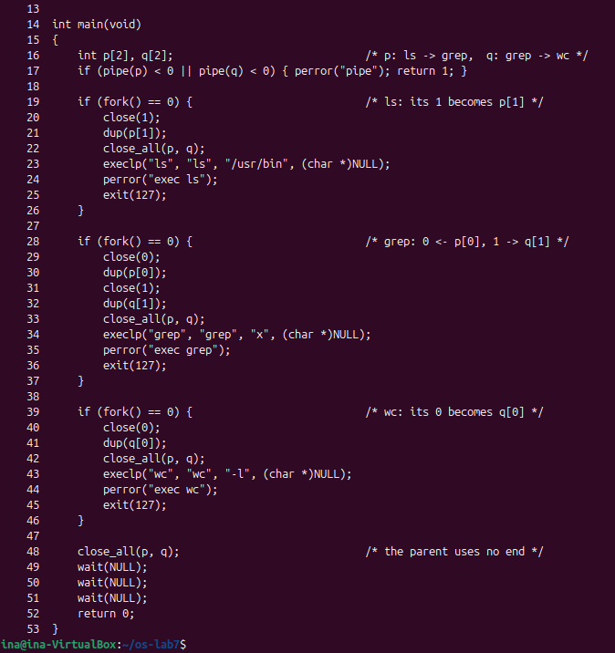
Figure 2.9 – The source of pipeline3.c
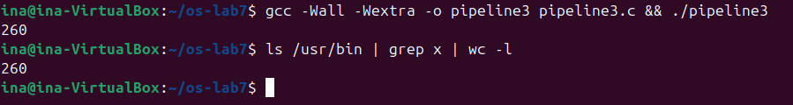
Figure 2.10 – pipeline3 and the shell give the same count, 260
Both the program and the shell print 260, so the three-stage pipeline works.

3 LABORATORY WORK 8: THE SAME CALLS, INSIDE YOUR OWN OS (XV6)

3.1 Preparation
Three new programs were added to ~/xv6-riscv: user/run.c, user/pingpong.c and user/primes.c. Each one is registered in the UPROGS list of the Makefile with a line $U/_run\, $U/_pingpong\ and $U/_primes\, which starts with a tab and has nothing after the backslash (Figure 3.1). The programs from the previous labs (sleep, args, mystat, find) stay in the list. In xv6 a user program can include only kernel/types.h and user/user.h: there is no glibc, and fork, exec, wait, pipe, read and write are thin stubs (user/usys.S) that jump directly into the kernel.
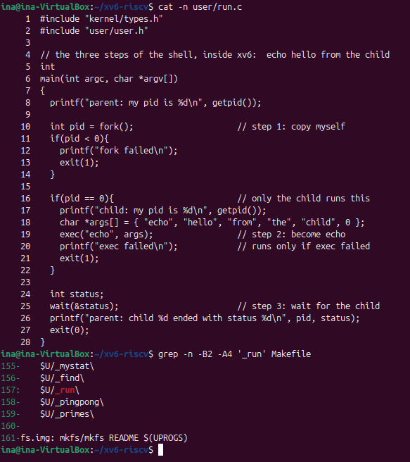
Figure 3.1 – user/run.c and the new UPROGS lines in the Makefile

3.2 Part 1. run, inside xv6
xv6 was built and started with make qemu, and run was typed at the xv6 shell. The child becomes echo with the arguments "hello from the child" (Figure 3.2). Ctrl-A X stops QEMU.
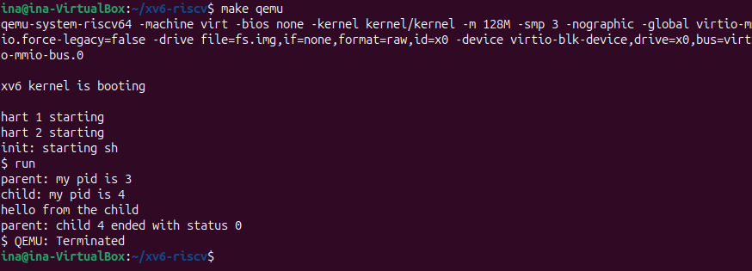
Figure 3.2 – run inside xv6: the child becomes echo
Next, the two lines of the child were changed so that it becomes ls, and xv6 was rebuilt (Figures 3.3 and 3.4). ls in the child lists the root directory, with the new programs run, pingpong and primes at the end, and the parent again sees status 0.
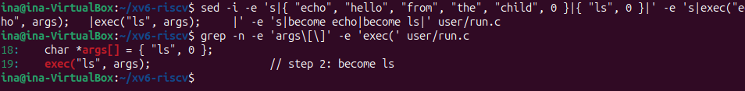
Figure 3.3 – The child is changed to run ls
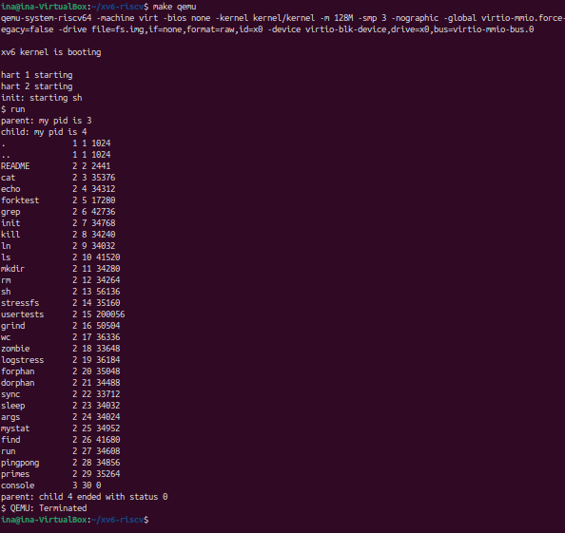
Figure 3.4 – run inside xv6: the child becomes ls
Finally exec was given a program that does not exist (Figure 3.5). After this test user/run.c was restored to the echo version from the handout, which is the version pushed to the repository.
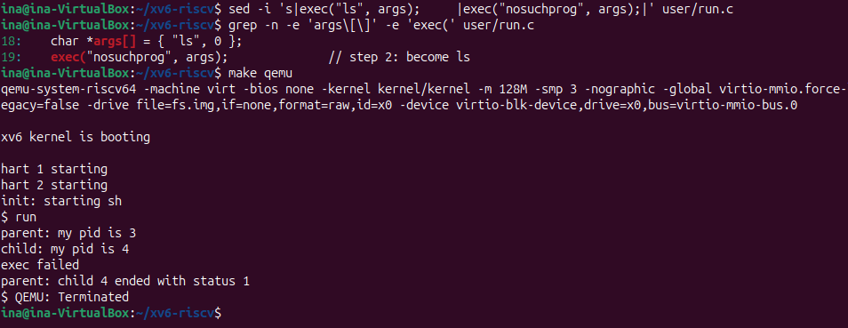
Figure 3.5 – exec of a program that does not exist: "exec failed" and status 1

3.2.1 Observations
Observe (Lab 8, Part 1)
(1) Write the three calls that run.c uses in xv6 and the three calls run.c used on Linux in Lab 7. What is the same?
(2) Who prints "hello from the child": the code of run, or echo?
(3) Why is the status 1 here and 127 on Linux? (Look at the exit line after exec in both programs.)
(1) The same three calls
Step | Linux (Lab 7) | xv6 (Lab 8)
1. copy myself | fork() | fork()
2. become a program | execlp("ls", "ls", "-l", NULL) | exec("echo", args)
3. wait for the child | waitpid(pid, &status, 0) | wait(&status)

The model is exactly the same. fork creates a copy of the calling process and returns the PID of the child in the parent and 0 in the child. exec replaces the memory of the child with a new program, keeps the PID and the open descriptors, and returns only if it fails. wait blocks the parent until a child exits and gives back its exit status. Only the details of the interface differ: execlp is a glibc function that takes a variable list of arguments, searches the directories of PATH and then calls the execve system call, while xv6 exec is the system call itself, takes an argv array and a path (here "echo", found in the current directory /). waitpid can wait for one specific child, while xv6 wait waits for any child.
(2) Who prints "hello from the child"
echo prints it. After a successful exec the code of run is no longer in the child: the process (still pid 4) now runs the program /echo, which prints its arguments separated by spaces. The last line printed by the code of run in the child is "child: my pid is 4". This is also why "exec failed" appears only when exec cannot load the program.
(3) Status 1 versus 127
The status is simply the number that the child passes to exit, and each program chose its own number: the xv6 run.c calls exit(1) after a failed exec, while the Linux run.c called exit(127). The kernel does not invent the value; it only stores it and hands it to the parent. In xv6, exit(status) stores it in p->xstate and wait copies it directly to the parent (kernel/proc.c). Linux packs it into a status word with other information, which is why the Linux program needed WEXITSTATUS(status) to get the 127 back.

3.3 Part 2. pingpong
In pingpong the parent creates two pipes before fork: p2c (parent to child) and c2p (child to parent). After fork each process closes the two ends it does not use. The parent writes one byte into p2c[1] and then reads from c2p[0]. The child reads the byte from p2c[0], prints "<pid>: received ping", writes the byte back into c2p[1] and exits. The parent then prints "<pid>: received pong" and waits for the child. The return value of read is checked, so that an unexpected end of file is reported instead of printing a false message (Figure 3.6).
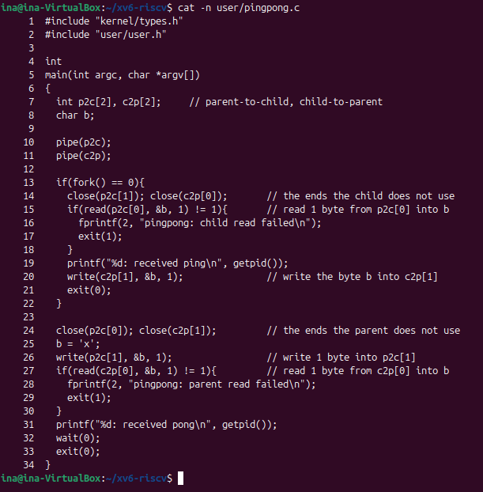
Figure 3.6 – The source of user/pingpong.c with the TODO lines completed
pingpong was run twice, followed by run, in the same xv6 session (Figure 3.7). The child always prints "ping" first, and the pids grow with every new process.
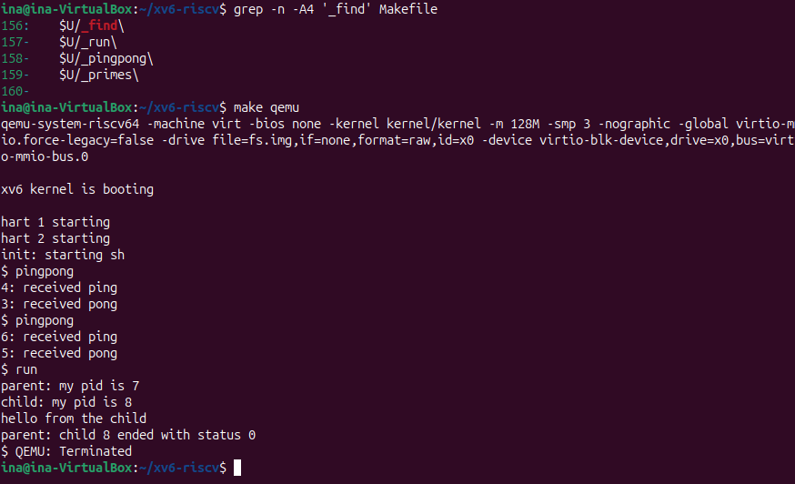
Figure 3.7 – pingpong inside xv6: ping from the child, then pong from the parent

3.3.1 Observations
Observe (Lab 8, Part 2)
(1) Why do you need TWO pipes, and not one for both directions?
(2) Nothing in your code says "wait until the child has replied". Which call makes the parent wait?
(1) Two pipes
A pipe carries data in one direction only: what is written into p[1] comes out of p[0], and nothing marks who wrote it. With one pipe for both directions, both processes would keep both ends open, and the parent, after writing the ping, could read its own byte back before the child got it (or the child could read its own pong). The exchange would depend on scheduling, and a process could block forever. With one pipe per direction each process writes only to its outgoing pipe and reads only from its incoming pipe, so the order is guaranteed.
(2) The call that waits
read(c2p[0], &b, 1) in the parent. Reading from an empty pipe blocks: in kernel/pipe.c, piperead puts the process to sleep until data is written or until all write ends are closed. The pipe c2p stays empty until the child writes the byte back, so the parent cannot print "received pong" before the child has printed "received ping". The child is synchronised in the same way by its read on p2c. The final wait(0) does not order the messages; it only collects the exit status of the child so that it does not remain a zombie.

3.4 Optional. primes
primes.c implements the pipeline sieve with a chain of processes. The first process writes the numbers 2 to 35 into a pipe. Each stage reads its first number p, which must be a prime because every smaller prime already removed its multiples, prints "prime p", creates a new pipe and a child for the next stage, and forwards only the numbers not divisible by p. When a stage sees the end of file it closes the write end of its right pipe, so the end of file travels down the chain, and every stage waits for its child before exiting. Every unused pipe end is closed right after fork, otherwise xv6 would run out of descriptors (16 per process) and the end of file would never arrive (Figures 3.8 and 3.9).
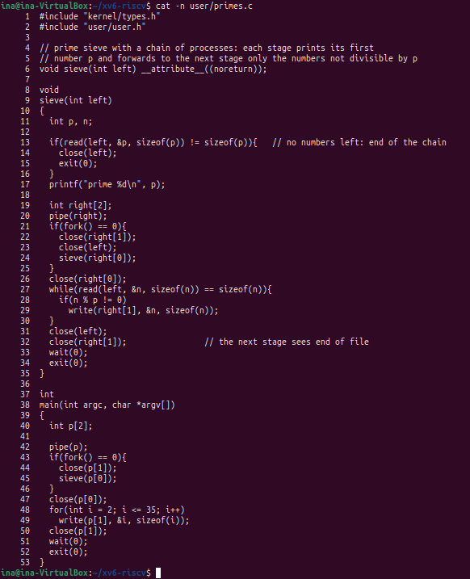
Figure 3.8 – The source of user/primes.c
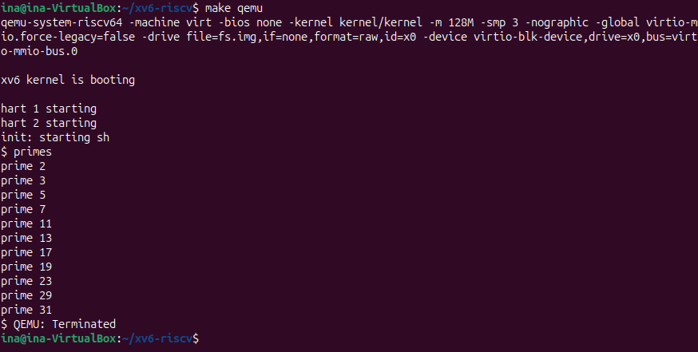
Figure 3.9 – primes inside xv6: the primes from 2 to 31

CONCLUSION
Laboratory Work 7 showed that the shell has no magic: three small programs reproduce ls -l, ls -l > out.txt and ls /etc | wc -l with only a handful of system calls. fork copies a process and returns twice, exec replaces the program but keeps the PID and the open descriptors, and wait collects the exit status. A failed exec returns and lets the old code report the error and choose an exit code (127). A child that has ended but has not been waited for remains in the process table as a zombie (state Z) until its parent calls waitpid. Redirection works because open and dup always return the lowest free descriptor and descriptors survive exec, so a program that writes to descriptor 1 can be sent to a file or a pipe without being changed. The broken pipeline showed the most common pipe bug: a reader sees end of file only when all write ends are closed, so one forgotten close(p[1]) is enough for wc to wait forever.
Laboratory Work 8 showed that the same model works unchanged in xv6, a kernel small enough to read completely. run.c needed almost no changes: fork, exec and wait behave the same way, and the only differences are in the interface (an argv array instead of a variable argument list, no PATH search, wait instead of waitpid) and in the exit code chosen by the program. pingpong showed that two processes need two pipes to talk in both directions, and that a blocking read is enough to synchronise them, with no explicit "wait for the reply" in the code. The optional primes sieve combined all of it: a chain of processes connected by pipes, where closing every unused end is what makes the end of file travel down the chain.

REFERENCES
- Cox, R., Kaashoek, F., & Morris, R. xv6: a simple, Unix-like teaching operating system (RISC-V edition), chapter 1 "Operating system interfaces". MIT. Retrieved from https://pdos.csail.mit.edu/6.1810/
- MIT PDOS. xv6-riscv source code repository: kernel/proc.c, kernel/pipe.c, kernel/exec.c, user/user.h. Retrieved from https://github.com/mit-pdos/xv6-riscv
- MIT 6.1810 Fall 2024. Lab: Xv6 and Unix utilities (pingpong, primes). Retrieved from https://pdos.csail.mit.edu/6.1810/2024/labs/util.html
- The Linux man-pages project. fork(2), execve(2), exec(3), wait(2), pipe(2), dup(2), open(2), ps(1). Retrieved from https://man7.org/linux/man-pages/
- Arpaci-Dusseau, R. H., & Arpaci-Dusseau, A. C. (2018). Operating Systems: Three Easy Pieces, chapter 5 "Interlude: Process API". Arpaci-Dusseau Books. Retrieved from https://pages.cs.wisc.edu/~remzi/OSTEP/
- Pancenco, I. (2026). os-2026-InaPancenco: source code and reports of the Operating Systems laboratory works GitHub repository. Retrieved from: https://github.com/inap235/os-2026-InaPancenco

