
MINISTRY OF EDUCATION, CULTURE AND RESEARCH
OF THE REPUBLIC OF MOLDOVA
Technical University of Moldova
Faculty of Computers, Informatics and Microelectronics
Department of Software Engineering and Automation

Report
on laboratory works no. 9–10
Operating Systems
Topic: Watching System Calls with strace.
Add Your Own System Call: trace (xv6)

Done by:
st. gr. FAF-242, Ina Pancenco

Checked by:
Reițman Patricia, university assistant
DISA, FCIM, UTM

Chișinău – 2026
Table of Contents
1 PURPOSE OF THE WORK 3
1.1 Purpose of practical work 3
1.2 Problem statement 3
2 LABORATORY WORK 9: WATCHING SYSTEM CALLS WITH STRACE 4
2.1 Preparation 4
2.2 Part 1. See the calls of a real command 4
2.2.1 Observations 6
2.3 Part 2. A program that calls the kernel directly 6
2.3.1 Observations 7
2.4 Part 3. Count one kind of call 8
3 LABORATORY WORK 10: ADD YOUR OWN SYSTEM CALL 9
3.1 Preparation 9
3.2 Part 1. The number and the user side 9
3.3 Part 2. The kernel side 10
3.4 Part 3. Play with the mask 12
3.4.1 Observations 14
CONCLUSION 15
REFERENCES 16

1 PURPOSE OF THE WORK

1.1 Purpose of practical work
The purpose of these two laboratory works is to understand the system call, the door between a program and the kernel, first by watching it from the outside and then by adding a new one. In Laboratory Work 9 the tool strace is used on Linux to print every system call of a real command, ls -l, and of a small program that uses open, write, read and close directly. One kind of call is then counted with a single command.
In Laboratory Work 10 the kernel itself is changed for the first time. A new system call, trace, is added to xv6, the small teaching operating system built during the semester. It makes a process print every system call it makes, which is what strace did on Linux. The work follows one number, 23, from a user program, through the ecall instruction, down to a function in the kernel.

1.2 Problem statement
Laboratory Work 9 – Watching System Calls with strace (Track A, Linux):
- Part 1: strace on ls -l – find the call that prints to the screen and its descriptor, and count the system calls of one ls.
- Part 2: syscalls.c – a program that uses open, write, read and close, then watched with strace.
- Part 3: one command that counts one kind of call.
Laboratory Work 10 – Add Your Own System Call: trace (Track B, xv6):
- Part 1: the number 23, the declaration, the stub, the program user/trace.c and the Makefile line.
- Part 2: the mask in struct proc, the handler sys_trace, the table entries, the print in syscall() and the copy in fork().
- Part 3: running trace with different masks and explaining the results.
Both works were carried out on an Ubuntu 24.04 Linux virtual machine in VirtualBox (host name ina-VirtualBox, user ina), with gcc 13.3.0, strace 6.8 and QEMU 8.2.2. xv6 was run in QEMU from the ~/xv6-riscv tree. For every part the commands and their output are given as screenshots of the terminal, followed by the answers to the Observe questions. The source files and the answer files (report.md for Lab 9, notes.txt for Lab 10) are in the course repository.

2 LABORATORY WORK 9: WATCHING SYSTEM CALLS WITH STRACE

2.1 Preparation
A working folder ~/os-lab9 was created, and strace and gcc were checked. The program syscalls.c was typed exactly as given in the laboratory handout (Figure 2.1).
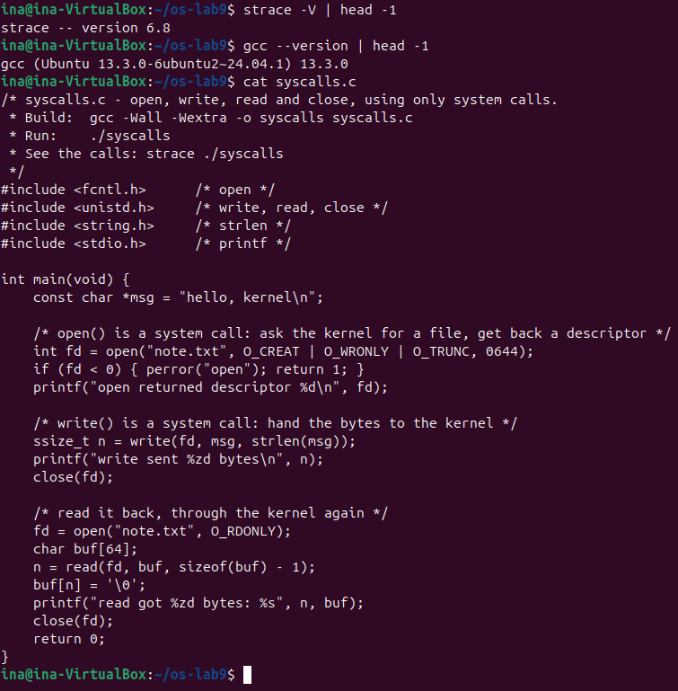
Figure 2.1 – The versions of strace and gcc and the source of syscalls.c

2.2 Part 1. See the calls of a real command
strace runs a command and prints each of its system calls beside the normal output. With -e trace=openat,read,write,close only these four calls are shown. The output is longer than one screen, and Figure 2.2 shows its end. At the start of the program there is a burst of openat, read and close while libraries, locale files, /etc/passwd and /etc/group are read. The writes come at the very end, mixed with the listing itself, because strace and ls print to the same terminal.
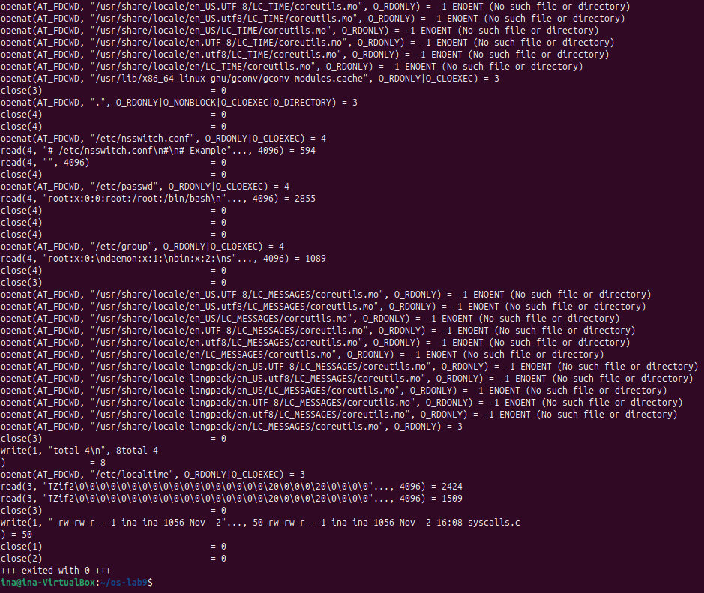
Figure 2.2 – The end of the output of strace on ls -l
To count the calls, strace was told to write its report into a file with -o, so that the listing stays on the screen and every call becomes one line of the file (Figure 2.3). The file also has one last line for "+++ exited with 0 +++", which is not a call.
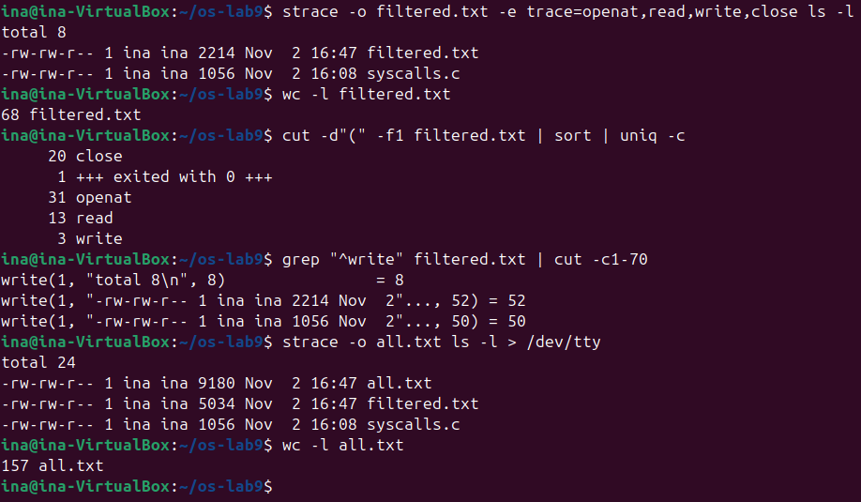
Figure 2.3 – Counting the system calls of one ls -l

2.2.1 Observations
Observe (Part 1)
Which system call does ls use to print to the screen? To which descriptor does it write?
Count, roughly, how many system calls one simple ls makes.
The call and the descriptor
ls prints with write, on descriptor 1, standard output: every line in Figure 2.3 starts with write(1, ...). There are three writes because the listing has three lines, "total 8" and two files. When standard output is a terminal, the C library sends each line separately.
How many calls
One ls -l in a folder with two files made 67 calls of the four traced kinds: 31 openat, 20 close, 13 read and 3 write (68 lines minus the exit line). Without the filter it made 156 system calls of all kinds (157 lines minus the exit line). A command that only prints three short lines therefore crosses the door to the kernel about 150 times.

2.3 Part 2. A program that calls the kernel directly
syscalls.c opens note.txt, writes one line into it, closes it, opens it again and reads the line back. It compiles with gcc -Wall -Wextra without a single warning, and the output is the one expected by the handout (Figure 2.4).
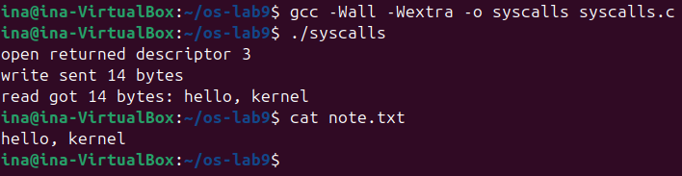
Figure 2.4 – syscalls: compiled, run, and the file it wrote
The same program was then watched from the outside (Figure 2.5). After the setup lines, where the loader opens and reads the C library, come the calls of the program: open in C became openat in the kernel, with AT_FDCWD meaning "relative to the current directory", while write, read and close kept their names. The read asks for 63 bytes, sizeof(buf) - 1, and gets 14. The writes on descriptor 1 between them are the printf lines of the program, each one printed by the terminal right after strace announces it.
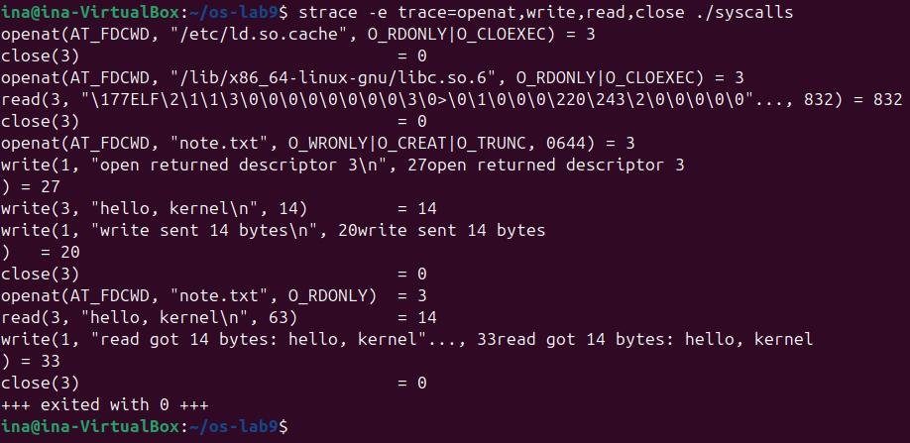
Figure 2.5 – strace on syscalls: the three C calls become real system calls

2.3.1 Observations
Observe (Part 2)
The descriptor returned by the first openat is 3, not 0, 1 or 2. Why are those three already taken?
Descriptors 0, 1 and 2
Every process starts with three descriptors already open: 0 (standard input), 1 (standard output) and 2 (standard error). They are inherited from the shell through fork and exec, and here all three point to the terminal, as Figure 2.6 shows for ls itself (descriptor 3 in that figure is the directory that ls opened in order to list it). The kernel always gives the lowest free descriptor, so the first file that a program opens gets 3. The earlier openat calls of the loader also got 3, but they were closed again before the program started.
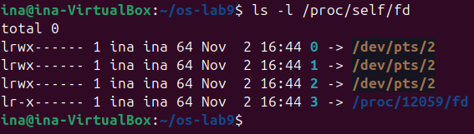
Figure 2.6 – Descriptors 0, 1 and 2 of a new process all point to the terminal

2.4 Part 3. Count one kind of call
The command below counts how many times ls -l calls openat (Figure 2.7). strace writes its lines to standard error, so 2>&1 sends them into the pipe, and >/dev/null, which comes after it, throws away the listing of ls. grep -c then counts the lines that start with openat. The result, 31, is confirmed by strace -c, which prints a table instead of the calls. The table also shows that 17 of the 31 calls failed: these are mostly the searches for locale files seen in Figure 2.2, which end with ENOENT.
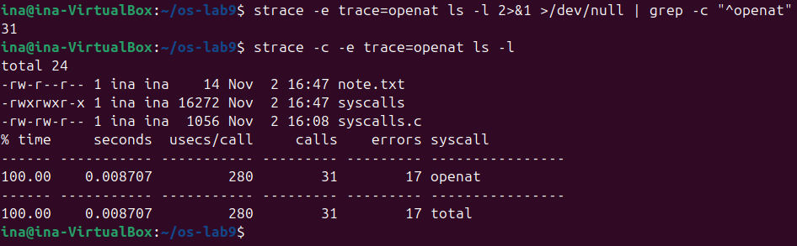
Figure 2.7 – One kind of call counted in two ways: 31 calls of openat

3 LABORATORY WORK 10: ADD YOUR OWN SYSTEM CALL

3.1 Preparation
The work was done in the ~/xv6-riscv tree, which already held the programs of the earlier laboratory works. The handout warns that this xv6 is newer than the MIT 6.1810 instructions: the number 22 is already taken by sync, so trace gets 23, and the kernel print function is called printk, not printf. Both were checked in the tree: kernel/syscall.h ended with SYS_sync 22, and kernel/defs.h declares printk.

3.2 Part 1. The number and the user side
Five small edits teach the user side to ask for the new call (Figure 3.1). kernel/syscall.h gets the number, user/user.h the declaration, and user/usys.pl the stub. At build time this script writes user/usys.S, where trace becomes three instructions: li a7, SYS_trace; ecall; ret. The program user/trace.c sets the mask on itself and then becomes the command with exec. The mask stays, because exec keeps the process. The Makefile line puts the program on the xv6 disk.
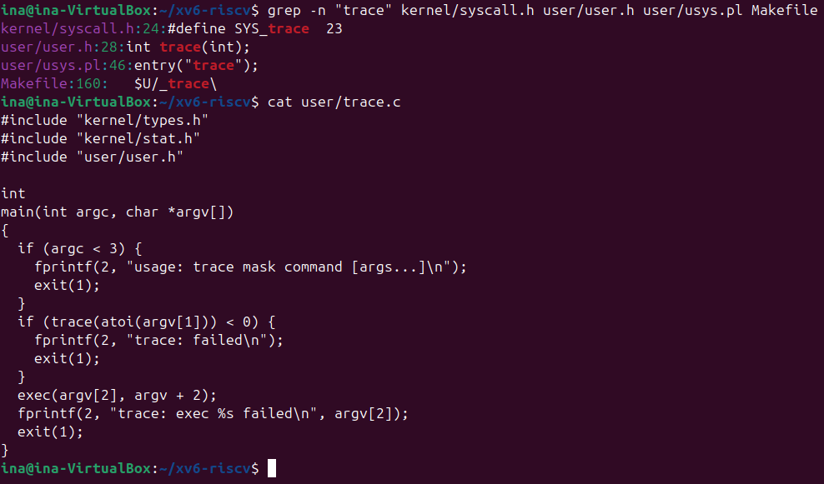
Figure 3.1 – The four one-line edits and the source of user/trace.c
At this point the kernel has no function for 23, so it must complain. It does, with exactly the message from the handout (Figure 3.2). This is good news: the program ran ecall with a7 = 23 and the kernel received the number.
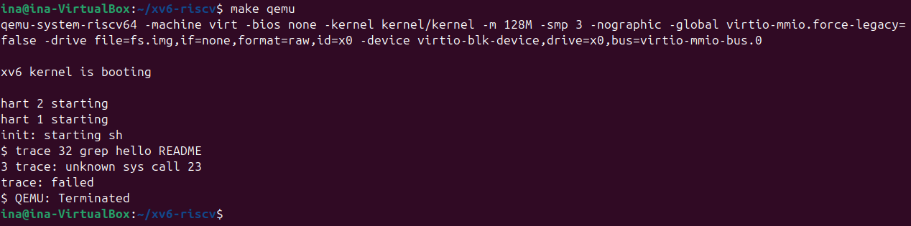
Figure 3.2 – Check 1, with only Part 1 built: the number reaches the kernel

3.3 Part 2. The kernel side
Each process remembers its own mask, so struct proc gets a new field, trace_mask. The handler sys_trace reads argument 0 (register a0) with argint and stores it on the process. In fork the mask is copied to the child (Figure 3.3).
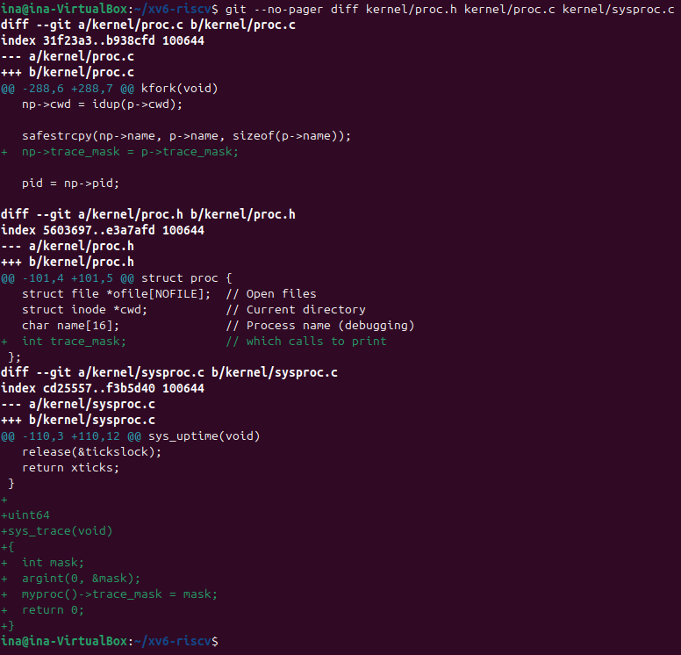
Figure 3.3 – The mask in struct proc, the copy in fork and the handler sys_trace
In kernel/syscall.c the function gets place 23 in the table of system calls. Because the kernel only knows numbers, a second table gives every call its name, just above syscall(). The print itself goes inside syscall(), right after the line that runs the call, so that the return value is already in a0 (Figure 3.4). Nothing is printed unless bit num of the mask is on: (p->trace_mask >> num) & 1.
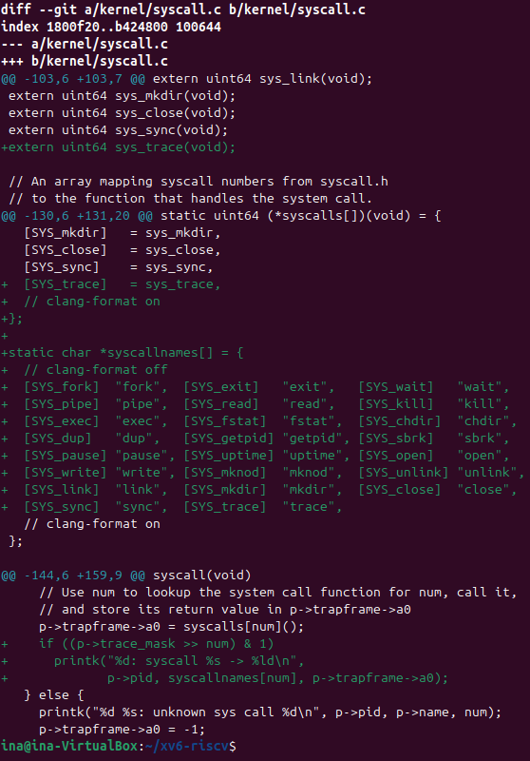
Figure 3.4 – The table entry, the names and the print in syscall()
The full path of the number is now complete: trace(32) in user/trace.c, the stub in usys.S puts 23 in a7 and runs ecall, the trap reaches syscall(), syscalls[23] is sys_trace, and sys_trace saves the mask. After a rebuild, the output has exactly the numbers from the handout (Figure 3.5): 1023 + 965 + 453 = 2441, the size of README read in three pieces, then 0 for the end of the file.
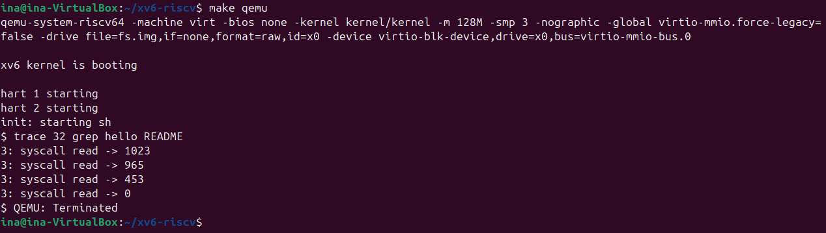
Figure 3.5 – Check 2: trace works
To check that the change breaks nothing else, the full test suite was run with usertests -q, which ended with ALL TESTS PASSED.

3.4 Part 3. Play with the mask
The mask is a number read in binary: bit N on means "print call number N". With all the bits on (Figure 3.6) the whole life of grep is seen, starting with the trace call itself. exec returns 3 because the return value of exec becomes argc in the new program, and grep hello README has three arguments.
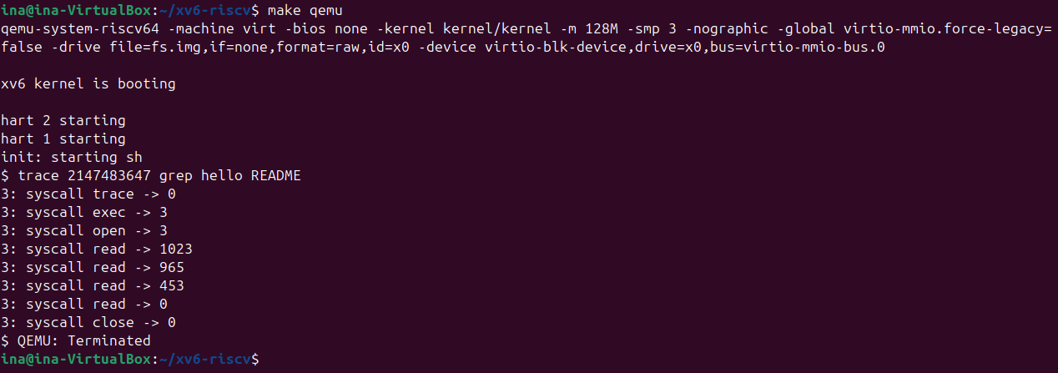
Figure 3.6 – All the calls, mask 2147483647
The mask 2 turns on only bit 1, fork. forkforkfork forks until the process table is full, so a fork finally fails and returns -1, which the test allows, and it still ends with OK. The output is longer than one screen, and Figure 3.7 shows its end.
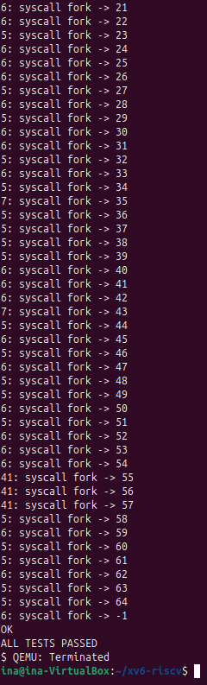
Figure 3.7 – The end of the output for only fork, mask 2
The mask 65536 turns on only bit 16, write (Figure 3.8).
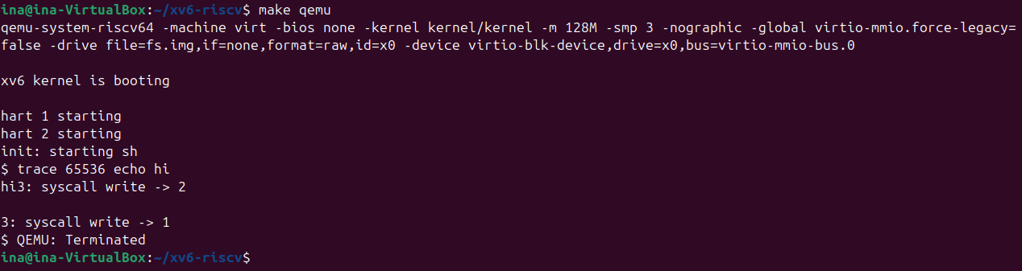
Figure 3.8 – Only write, mask 65536

3.4.1 Observations
Observe (Lab 10, Part 3)
(1) In trace 32 grep hello README why do you see only read, and not open or close?
(2) In forkforkfork, different pids print lines. Which line of code from Part 2 makes that possible?
(3) In trace 65536 echo hi the trace line is printed between "hi" and the new line. Why? (How many times does echo call write?)
(4) Which mask traces both open (15) and close (21), and nothing else?
(1) Only read
The mask 32 is 2^5, so only bit 5 is on, and 5 is SYS_read. The kernel prints a call only if its own bit is on: open is 15 and close is 21, and those bits are off. grep does call open and close, as Figure 3.6 shows. They are just not printed.
(2) Many pids
The line np->trace_mask = p->trace_mask; in fork(), in kernel/proc.c. Each child copies the mask of its parent, so the children, and their children, are traced too. In Figure 3.7 the pids 5, 6, 7 and 41 all print lines. Without this line only the first process would print, because a new struct proc would not have the mask.
(3) Why the line is in the middle
echo calls write two times: once for "hi", which returns 2, and once for the new line, which returns 1 (user/echo.c). The kernel prints the trace line after each call has finished, on the same console. So the order is "hi", the trace line of the first write, the new line, and the trace line of the second write.
(4) The mask
The mask is 2^15 + 2^21 = 32768 + 2097152 = 2129920. Figure 3.9 confirms it: only open and close are printed.
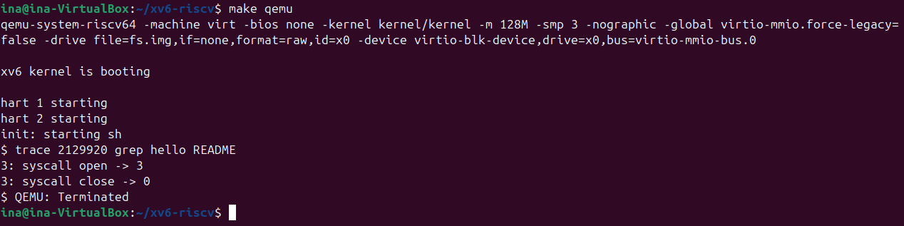
Figure 3.9 – Only open and close, mask 2129920

CONCLUSION
Laboratory Work 9 showed how much work is hidden behind a simple command. strace made the system calls visible: one ls -l, which prints three short lines, crossed into the kernel about 150 times, and it printed with write on descriptor 1. The small program syscalls.c showed that open, write, read and close in C are thin wrappers around real system calls, with open actually being openat, and that a first file gets descriptor 3 because 0, 1 and 2 are inherited already open. A single command was enough to count one kind of call, 31 calls of openat, of which 17 failed.
Laboratory Work 10 turned the same idea around: instead of watching system calls, one was added. Following the number 23 showed the whole path: a declaration and a stub on the user side, ecall with the number in a7, then the table in syscall() and a handler in the kernel. Three small facts gave the most interesting behaviour. The mask is kept per process, it survives exec because exec keeps the process, and fork copies it, so one line in fork makes a whole tree of processes traced. The numbers from README and the masks 2129920 and 2147483647 all behaved as calculated, and the full usertests suite still passed with the changed kernel.

REFERENCES
- Cox, R., Kaashoek, F., & Morris, R. xv6: a simple, Unix-like teaching operating system (RISC-V edition), chapter 4 "Traps and system calls". MIT. Retrieved from https://pdos.csail.mit.edu/6.1810/
- MIT PDOS. xv6-riscv source code repository: kernel/syscall.c, kernel/sysproc.c, kernel/proc.c, user/usys.pl. Retrieved from https://github.com/mit-pdos/xv6-riscv
- MIT 6.1810 Fall 2024. Lab: system calls. Retrieved from https://pdos.csail.mit.edu/6.1810/2024/labs/syscall.html
- The Linux man-pages project. strace(1), syscall(2), open(2), write(2), read(2), close(2). Retrieved from https://man7.org/linux/man-pages/
- Arpaci-Dusseau, R. H., & Arpaci-Dusseau, A. C. (2018). Operating Systems: Three Easy Pieces, chapter 6 "Mechanism: Limited Direct Execution". Arpaci-Dusseau Books. Retrieved from https://pages.cs.wisc.edu/~remzi/OSTEP/
- Pancenco, I. (2026). os-2026-InaPancenco: source code and reports of the Operating Systems laboratory works GitHub repository. Retrieved from: https://github.com/inap235/os-2026-InaPancenco

