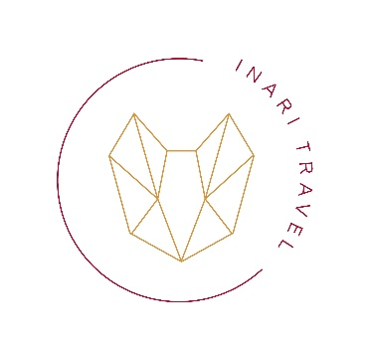
2026/02/26

HOTEL VOUCHER № 260303-2

Thank you very much for using our company's reservation service. We would like to confirm the hotel details as follows:
Date: 9 Mar ～ 12 Mar 2026
Hotel: HOTEL THE MITSUI KYOTO, a Luxury Collection Hotel & Spa
Address: Aburano-Koji St. Nijo-Sagaru, Nakagyo-Ku, 284 Nijoaburanokojicho, Nakagyo Ward, Kyoto, 604-0051
TEL: 075-468-3100
Room: Garden Room King, 3 pax, breakfast included; Deluxe King, 1 pax, breakfast included
Booking number: 91445812, 91426926

Name of tourists:
Mr MIKHAIL ZUSMAN
Mrs EKATERINA ZUSMAN
Ms SARA ZUSMAN
Mrs MARINA TISHCHENKO
We are looking forward to welcoming you in Japan.

INARI TRAVEL
LICENSED TOUR AGENT № 7153
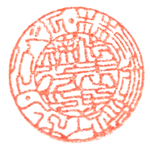
Osaka-pref., Mino, Senbahigashi
2-1-20-712
Mob. +81 80-5047-2274

