mAdserve SDK Integration Guide
Version 3.0 (i 1.3)

1. Quick Integration

1. Start Eclipse

2. Create a new Android Project:

File -> New -> Android Project

3. Enter your Project Name, select the Android Version (minimum is 1.6), and enter the Application Properties:

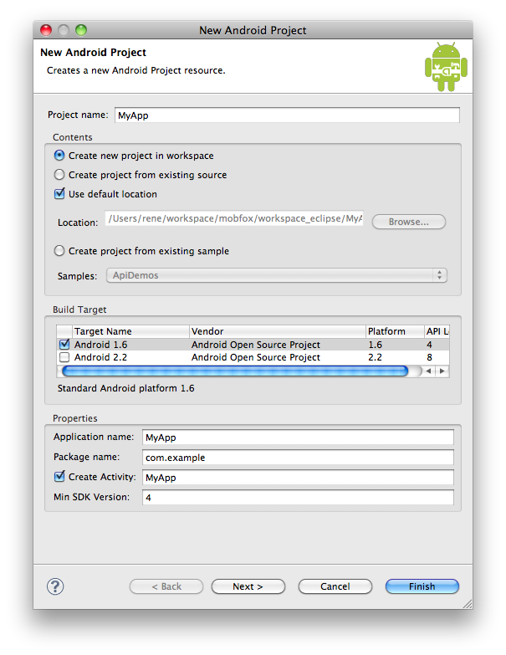

4. Now create a new source folder in your Project called ‘lib’. Then drag the madservesdk-1.3.jar into the ‘lib’ folder.

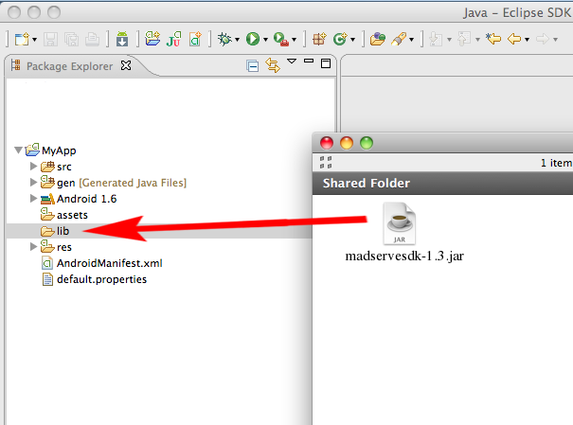
Also add the mAdserve library to your java build path! (under Project properties)

5. Open the AndroidManifest.xml and add the following permissions:

<uses-permission android:name="android.permission.INTERNET"></uses-permission>
<uses-permission android:name="android.permission.READ_PHONE_STATE"></uses-permission>

Why mAdserve SDK needs those permissions:

1. INTERNET
This permission is obviously needed to connect to the ad-server and fetch an ad.

2. READ_PHONE_STATE
Used to access a unique identifier we require to track impressions and conversions for the advertisers (See: http://
developer.android.com/reference/android/telephony/TelephonyManager.html#getDeviceId() ).

The reason we chose not to use ANDROID_ID for unique identification is this bug:
http://code.google.com/p/android/issues/detail?id=10603

6. Now, add the following activity:
<activity android:name="com.madserve.sdk.InAppWebView"/>

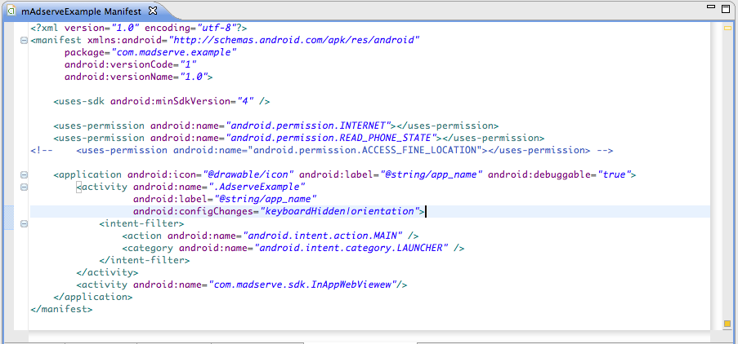

7. Open the layout/main.xml and include the AdserveView:

<com.madserve.sdk.AdserveView
android:id="@+id/mAdserveView"
android:layout_width="fill_parent"
android:layout_height="50dp"
serverUrl="<enter your server url here>"
publisherId="<enter your publisher id here>"
/>

Info
mAdserve ads are 50 device independent pixels high (dip or dp). By defining the ad's size in dip, the ad will be scaled properly across the different Android screen sizes.

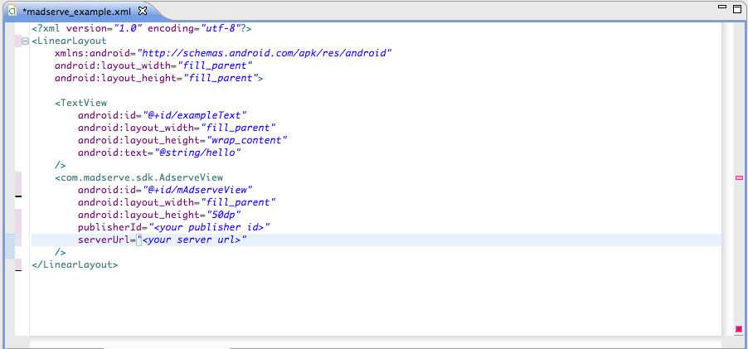

That’s all!
Now, run your application and you should see a MobFox Test-Banner!

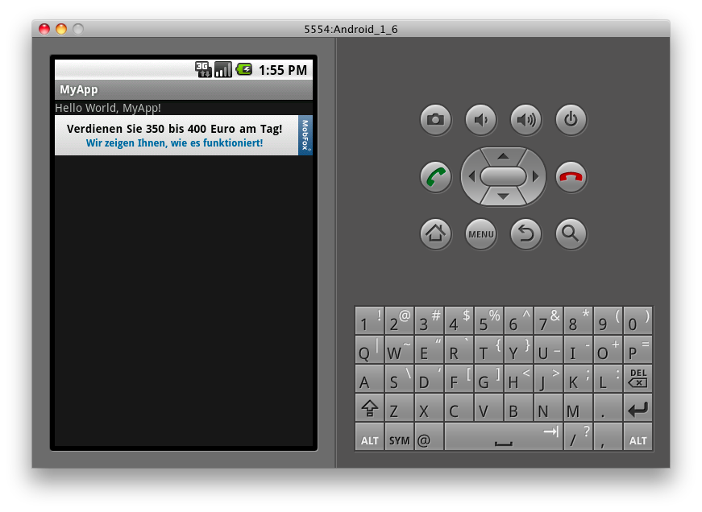

All Options for the AdserveView
<com.madserve.sdk.AdserveView
android:id="@+id/mAdserveView"
android:layout_width="fill_parent"
android:layout_height="50dp"
serverUrl="<enter your server url here>"
publisherId="<enter your publisher id here>"
mode="test/live"
includeLocation="true/false"
animation="true/false"/>

- serverUrl: the url to your mAdserve server
- publisherId: your publisher Id for mAdserve
- mode: test for test mode, and live for live mode
- includeLocation: true the location is included in the ad request (even better eCPM!)

If set to true the following permission must be added to the AndroidManifest.xml:

<uses-permission android:name="android.permission.ACCESS_FINE_LOCATION"></uses-permission>

- animation: true the banners are animated (fade-in and refresh animations)

The AdserveView can also be created dynamically in your view with the following code:

String serverUrl = “...”;
String publisherId = “...”;
boolean includeLocation = false;
boolean animation = true;
AdserveView mAdserveView = new AdserveView(this, publisherId, serverUrl, includeLocation, animation);
layout.addView(mAdserveView);

or

String serverUrl = “...”;
String publisherId = “...”;
boolean includeLocation = false;
Mode mode = Mode.Test;
boolean animation = true;
AdserveView mAdserveView = new AdserveView(this, publisherId, serverUrl, test, includeLocation, boolean animation);

The AdserveView also needs to know when the activity is paused and resumed, so override the onPause and onResume in your Activity class an call the proper methods on the AdserveView object:

@Override
protected void onPause() {
super.onPause();
mAdserveView.pause();
}

@Override
protected void onResume() {
super.onResume();
mAdserveView.resume();
}

If you want to avoid that an ad request is performed when the phone is rotated and the orientation changes then you have to add following to your app:

Insert the following attribute to the Activity’s node in the AndroidManifest.xml
android:configChanges="keyboardHidden|orientation"

Then override the following method in your Activity and pause and resume the MobFoxView:

@Override
public void onConfigurationChanged(Configuration newConfig) {
super.onConfigurationChanged(newConfig);
mAdserveView.pause();
mAdserveView.resume();
}

If no ad is available or the ad request has failed a notification is sent from AdserveView to the registered BannerListener: (noAdFound means that there is currently no ad available for the ad request – you can try to request an ad from a secondary network if this happens)

Everytime a new ad is received, the registered BannerListener will receive a bannerLoadSucceeded notification from AdserveView. You can use this notification to show the view only after receiving an ad.

Everytime an ad is clicked, the registered BannerListener will receive a adClicked notification from AdserveView.

AdserveView mAdserveView = new AdserveView(this, "...", false);
mAdserveView.setBannerListener(new BannerListener() {
@Override public void bannerLoadSucceeded() {
// do something
}
@Override public void bannerLoadFailed(RequestException cause) {
// do something
}
@Override public void noAdFound() {
// do something
}
@Override public void adClicked() {
// do something
}
});

