Stock Recommendation System

Inavamsi Bhaskar Enaganti
Computer Science
New York University, Courant
Institute of Mathematical Sciences
New York, USA
ibe214@nyu.edu
Himani Amrish Shah
Computer Science
New York University, Courant
Institute of Mathematical Sciences
New York, USA
has482@nyu.edu
Anasse Bari
Computer Science
New York University, Courant
Institute of Mathematical Sciences
New York, USA
abari@nyu.edu

Abstract—The aim of this project is to personalize recommending stocks to an individual by understanding their preferences from a purely mathematical perspective. This can be done by learning purely mathematical attributes from their current portfolio. Attributes range from simple metrics like volatility to more complex underlying structures in the stock.

In this paper, we propose a novel content-based filtering recommendation system for stocks. It is based mainly on time series clustering. A large set of stocks are clustered with multiple clustering strategies. These clusters are then used to infer associations between stocks. Based on user input inferred associations are used to provide recommendations for similar stocks.

Keywords—Stocks recommendation, k-means, hierarchical, PAM, swarm clustering, fractal dimension, APRIORI, association rules, correlation, volatility, standard deviation, collaborative item-based recommendation, time series.

introduction
Machine learning has been used for a recommendation in e-commerce industry as it gives insight for better sales and for improved customer satisfaction. Use of machine learning to analyze the historical data, future predictions and projections can be performed on many different subjects. Even though it is affected by various external events, in this application project, similar stocks are grouped together, and behaviour of the stocks can be predicted can be on basis of the peer stocks. Although the project only focuses on unsupervised learning, efforts have been made to draw insights from behaviour observed.

The model takes a set of stocks as input and recommends similar stocks using a multitude of methods. We apply K-means, Hierarchical Clustering, Swarm Clustering and Fractal Dimensions for clustering similar stocks on basis of multiple similarity measures like Volatility, Correlation and Standard Deviation. Apriori Algorithm is then used mine association rules between stocks. Associations between stocks are mined. These associations are used in conjugation with the user’s input stocks, so we can provide similar stocks as a recommendation.

The entire process in a nutshell basically is a content-based filtering system. The underlying core of the project is for the machine to learn similarities between stocks based purely on their time series data alone. Multiple assumptions have been used and clearly stated throughout the project. Finally, a few conjectures were drawn from the insights.

literature survey
Stock Prediction and recommendation has been implemented presently in various ways. [1] uses associative mining to find a relationship between stocks and the recommend the stocks based on the results from Apriori algorithm. Moreover, the algorithm is optimized based on Particle Swarm Optimization algorithm for improving speed. [2] uses correlation between Guba-based sentiment of the retail investors and the stock market trends. Sentiment analysis is used for recommendation and prediction in [3][4]. They use financial markets and finance expert’s data for a better recommendation. [6][8] use clustering algorithms, i.e. k-means and hierarchical clustering is used for prediction of stocks, which is done by clustering similar stocks. Big data technologies are used in [8] as the data used is large. In [5] a new fractal based mathematical model has been proposed for a recommendation.

data used
NASDAQ and NYSE data of 24 stocks have been used in this project. The dataset has daily data for the past 15 years. And has attributes like Highest price, Lowest price, opening price, closing price and Volume traded.

proposed model

High-level interface
Portfolio of stocks would be recommended to the user based on an input set of stocks.

User Perspective
Input
Set of Stocks (To find similar stocks)

Output
Stock 1
Stock 2

Sample
Input: Google, Microsoft

Output: Amazon, Facebook, IBM

- User Perspective

Workflow

Preprocess data

Clean Data by removing Missing Value.

Feature Selection/Dimensionality Reduction.

Normalize the Data by adding a Percent Change column.

Find Optimal k value for clustering using an ensemble of around 30 algorithms

Apply clustering algorithms like K-Means, Hierarchical Clustering, Swarm Clustering, KMedoids/PAM clustering, KMeans++, MeanShift Clustering and Fractal Dimensions using Volatility, percentage change in price and popularity.

Apply Apriori algorithm to get association rules.

Recommend based on the rules.

data preprocessing

Data Cleaning
The data contained few missing values which
could be replaced with the highest value, lowest value, average value, zero or by eliminating the corresponding row containing the missing value.
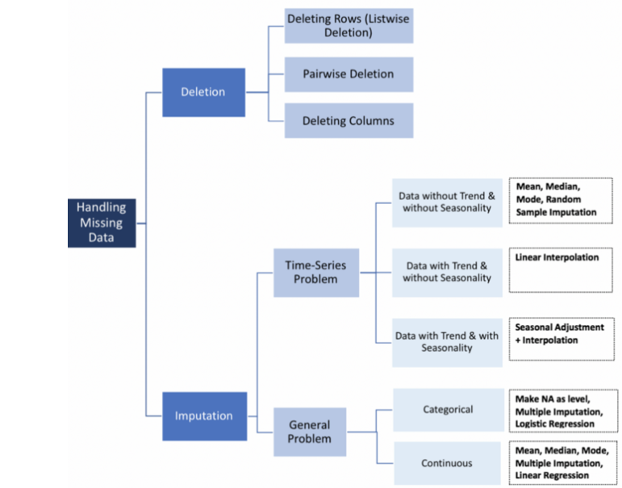
- Missing Data
As our stock dataset has no trend and is without seasonality and the data was Missing at random (MAR) i.e. the propensity for a data point to be missing was not related to the missing data, but it is related to some of the observed data. The rows with the missing values were replaced by the mean value of the corresponding column in the dataset.

Data Normalization
By looking at the existing stock data trends in Fig.3 following was observed:

The price range for each stock is different, hence we need to normalize the data or use similarity measures for comparing these stocks. To do so we could use one of the following algorithms:

Percentage change in price
As the percentage change in the price would normalize the data i.e. the scale (-100 to 100) would be consistent across all the stocks, this is one of the ways we used to normalize data.

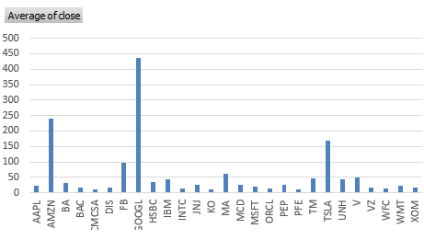
- Average of closing price for each stock.

Min-Max scaling
Subtract the minimum value and divide by the range of each stock.

Standardization scaling
Subtract the mean and divide by the standard deviation of each stock.

We used Percentage change in Price for data normalization as we wanted to take risk factor into consideration.

Dimensionality Reduction
PCA was used to reduce the dimensions from 4 (opening price, closing price, highest price and lowest price) to one dimension. Also, PCA helped in clustering, but the values obtained in the end could not be used to analyse the risk/profit percentage. Hence was not used in this project.

Feature Selection

Forward and backward feature selection
Important features are chosen by using Knime. Feature selection was done using both forward feature selection and backward feature elimination techniques. These techniques use threshold variance for choosing the best features. The most important feature using both the techniques was the closing price amongst all other features related to price. The features in the order of priority for forward feature selection were:
- Volume
- Closing price
- High Price
- Opening Price
- Low Price

Feature importance using ensembles of decision trees
Methods that use ensembles of decision trees can also compute the relative importance of each attribute. Feature selection process can be done on the importance values. Problem with this technique is that it requires target label i.e. it can only be used in dataset with target labels.

We have clustered using either only the closing price or combination of one or more attributes (open, close, high, low, volume)

modelling

Finding an optimal number of clusters (k value)

Elbow Method
It finds the best k value by choosing k with minimum within-cluster variance.
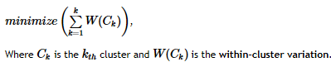
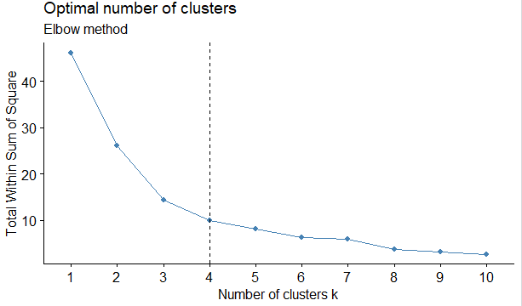
- Elbow Method

Average Silhouette method
Silhouette method measures the quality of clustering. That is, it determines how well each object lies within its cluster. Higher the average silhouette width better is the clustering. It can be calculated as:

Si=(b(i)−a(i))/max(a(i), b(i))

For an i in the data,
a(i): the mean distance of point i to all the other points in the cluster its assigned A.
b(i): the mean distance of point i to other points to its closest neighboring cluster B.
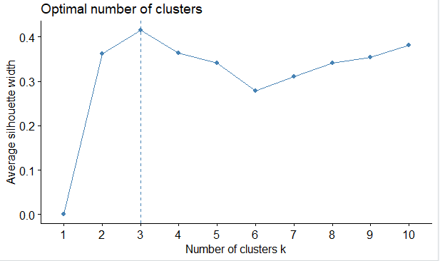
- Avg Silhouette Method

Nbclust
Thirty indices were used for determining the relevant number of clusters and the best clustering scheme from the different results were obtained by varying all combinations of a number of clusters, distance measures, and clustering methods, and voting to choose the best amongst them.

We used Nbclust in this project.

Similarity Measures

Volatility
Number of times the stock changes direction in a month i.e. standard deviation of stock.

The algorithm used for the same:
For each stock,
- Divide the data into a period of 4 months.
- Determine each period's standard deviation.
- Calculate the mean of these deviations by assigning higher weights to the recent deviations to get the final standard deviation for that stock
- Cluster the stocks on basis of this final standard deviation value.

Percentage Change
Percentage change in closing price.

Correlation
We use correlation of two stocks in a month to do hierarchical clustering. We considered the Pearson Correlation coefficient which gives a value between -1 and 1 inclusive.

P = covariance (x, y)/ (std-dev x * std-dev y)

Popularity
It is the total amount in value traded. It is basically the product of closing price and volume traded.

Clustering
Given the above stocks, we use multiple clustering strategies. We have multiple similarity variants which each output a different cluster for the same clustering algorithm.

K-Means Clustering
Clustering consists of defining clusters so that the total intra-cluster variation is minimized.
Data to label Mapping for the stocks is:
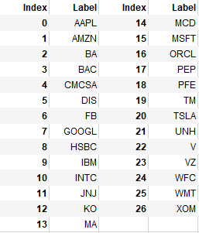
- Stocks to Index Mapping

Output obtained are shown in Fig.6 and Fig.7
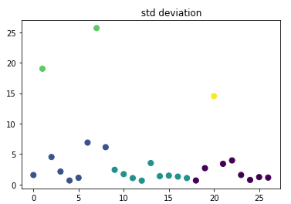
- Kmeans/Hierarchical/Kmeans++ Based on Volatility
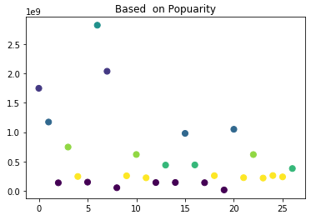
- Kmeans/Hierarchical/Kmeans++ Based on Popularity

Hierarchical Clustering
Agglomerative or bottom-up clustering method was used to join the two most similar clusters in this project.
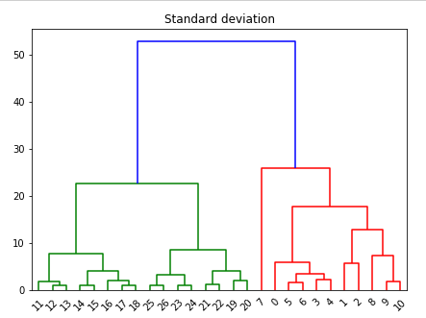
- Dendogram based on Volatility
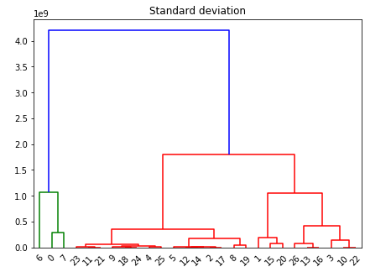
- Dendogram based on Popularity

KMeans++
It works like KMeans with a difference that centroids are initialized in the beginning for faster and better clustering.

Algorithm:
- 1. select one data item at random as first mean
- 2. loop k-1 times
- 3. compute distance from each item to closest mean
- 4. select an item that has large distance-squared as next initial mean
- 5. Goto 2
Output obtained are shown in Fig.7 and Fig.6

Partitioning Around Mediods Algorithm
It is a partitioning based clustering algorithm which partitions on basis of medoids.
It uses the following formula to calculate the dissimilarity:
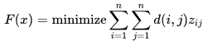
Subject to,
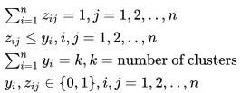

Where,
F(x) is the main function to minimize
D (i, j) is the dissimilarity measurement between the entities i and j
zij is a variable that ensures that only the dissimilarity between entities from the same cluster will be computed in the main function

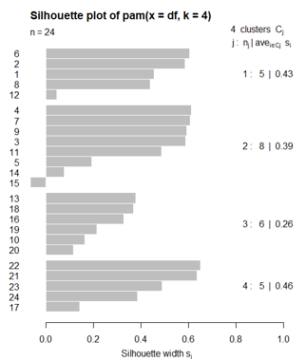
- PAM Clustering

Swarm Clustering

Introduction
‘Birds of the same feather flock together.’
Inspiration was drawn from the following paper: [9]Flock by Leader - Abdelghani Bellaachia, Anasse Bari

Each stock is modelled as a bird with just three rules - Cohesion, Alignment, Separation.

Cohesion:
Attraction to Birds of the same species.
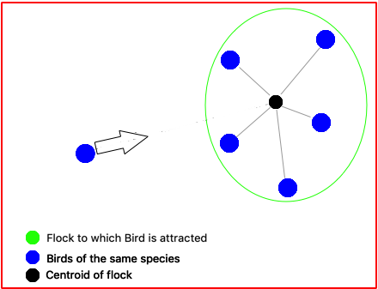
- Cohesion
Separation
Maintain a minimum distance of separation between all birds.
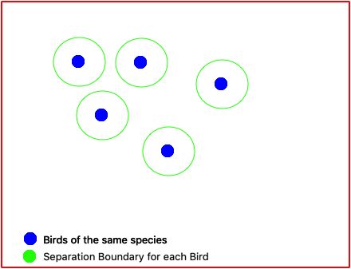
- Separation
Alignment
The entire flock always has the same aligned direction.

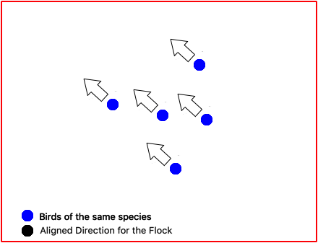
- Alignment

Algorithm

Algorithm: Leaderless Swarm clustering

Input: Algorithm Parameters, Similarity values for particles

Output: Final Clusters

Initialize the population randomly.
While ~StopCondition() do
For each particle in Space
Find same species
Update Direction
Update Velocity
If within Constraints()
Move()
Else
Wait()
Output Space

Approach and Implementation
The approach has been explained in the following sections.
- Coordinate Space
The Swarm Clustering algorithm involves having individual entities moving around in space. To simulate a boundaryless space a novel approach is used which consists of transforming a 2-Dimensional NxN Grid into a continuous toroidal space. This is required as flocks should never meet a boundary as it will obstruct free flocking behaviour. An alternate approach could be to model the space on a sphere or a graph.
The 2-Dimensional space is transformed by merging both the boundaries along the x-axis and respectively for the y-axis. This is visually represented as below.
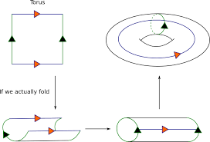
- Linear to Torus representation

A Torus can be represented parametrically as:
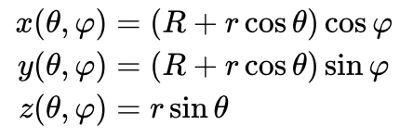
Where
θ, φ are angles which make a full circle, so that their values start and end at the same point,
R is the distance from the center of the tube to the center of the torus,
r is the radius of the tube.

- Similarity
To find Birds of the same species a scale from 0 to 1 and a threshold value t were implemented. All birds which have a similarity value greater than t is a fellow of the same species.\ for the specific period of time.
The similarity measure to identify a bird of the same species was the percentage increase in the Closing price of two stocks on a day to day basis. The percentage increase is calculated after normalizing to a value of 1.
It is more complicated to consider intraday values and apply swarm clustering on the same. One of the reasons is as follows: the maximum change can be either a 20% increase or 20% decrease. At the start of each day, the NYSE sets three circuit breaker levels at levels of 7% (Level 1), 13% (Level 2) and 20% (Level 3). Trading Halts occur at these intervals.

- Modelling a Stock as a Bird
A toroidal surface is constructed to model our swarms on. This is shown in the Coordinate space section.

The stocks here are represented by birds which are initially randomly spawned all across the map.

A bird is modelled with the following attributes:
Position: (x,y) coordinates
Direction: The direction the bird is moving towards - Calculated as a vector sum of the attraction vector, alignment vector and a small part of original direction called momentum.
Speed: Speed of a bird is proportional to multiple factors including number of birds of the same species in its neighborhood.

Every stock is assigned a separate bird and each bird is aware of only the history of its stock and knows similar birds at any given stage of time.

The history of every bird is tracked and finally the clusters they form after a definite amount of time.

- Time Period
A time period is the smallest unit of time in which an observable action can be taken in our model. These actions involve the movement of a bird in the space.
In a given time period every bird has 9 options. To move in one of the 8 directions or stay in its position due to constraints which include separation and model design.

- Attributes
Attraction vector
The Attraction vector is along the line joining bird and centroid of the flock of same species.

Alignment Vector
The alignment vector is the mean direction of the flock of same species.

Momentum
Flocks tend to swirl in one specific direction during periods where all stocks rally together and fall together over a prolonged period of time. An example is the Dec 2015 to March 2016 where the market plunged by over 1600 points in a matter of a couple of days and after a period if time they drastically jumped back up. Momentum has been used to handle these cases.

Speed
The speed is proportional to the distance to centroid of the flock, taking into account a threshold distance so all the birds near the centroid have the same speed.

A variation of the Acceptance-rejection Sampling was used to enforce speed in a 2D grid where in a given time period a bird can only move to the adjacent box or wait.

If distance to centroid() < threshold distance :
speed=0.5
Else:
speed=0.5 + distance to centroid() / N (Grid Length)

R <= Random number
If (R<speed):
return d
Else:
return (0,0)

Direction
A vector sum of the Attraction vector to flock, Alignment vector of flock and momentum with respect to original direction.
Arbitrary direction in polar coordinates have been reduced to one of the 4 fundamental directions in a 2D space by randomly selecting from a weighted distribution proportional to the direction.

(u,v) <= Direction vector
R <= Random number between 0 and 1
If R<u/(u+v):
d=(u/(abs(u)),0)
Else:
d=(0,v/(abs(v)))

Threshold
The Threshold value has been set to 0.7, optimal value was chosen using Brute force.

Separation Distance
Each square in the grid is scaled to the minimum separation distance and hence the separation rule is enforced by simply constraining at most one bird to a box in the grid.

Line of Sight Radius
Every bird is set with a variable parameter line of sight, which is the maximum distance up to which it can recognize birds of the same species. So, the bird exhibits flocking behaviour with respect to birds present in this radius. This has been set to N/3 where N is the Grid Length. So, a bird has access to a an area Π/9 the of the entire space.

Total simulation duration
A common duration for all stocks between the years 2013-2018 was chosen. Every day of the Stock Market being open represents one Time Period as defined in Section 6.3.c.

Observations and Insights
The following innovations have been introduced to traditional Swarm Clustering algorithms which have been mentioned above.
- Toroidal surface to ensure continuous swarming without interrupting local planarity.
- Momentum due to Swirling effect. But too much momentum leads to a situation where birds cannot get out of the swirling effect if by some chance they start swirling.
- Monte Carlo methods and Sampling to simulate direction and speed on a 2D Grid, that has only up down left right movement.
Output obtained is shown in Fig.15
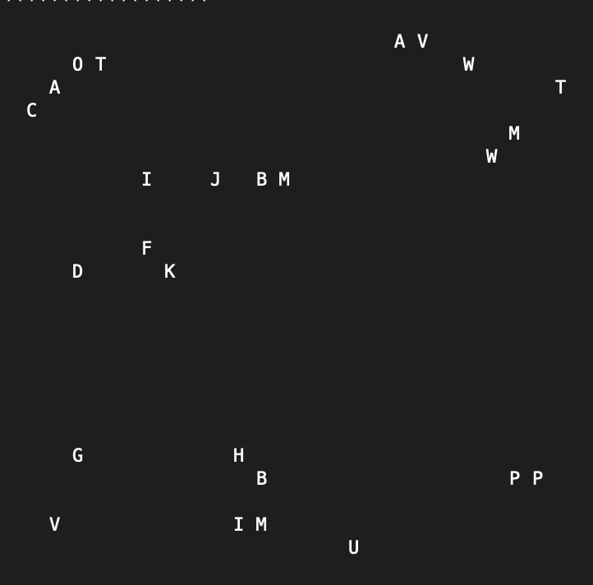
- Swarm Clustering

Fractal Dimension

Introduction
The following method has taken inspiration from [6]” Clustering in stock market based on fractal theory” ,Zeng Zhen, Peng Hong, Zeng Hiu.

Fractal is a detailed, recursive, and infinitely self-similar mathematical set whose Hausdorff dimension strictly exceeds its topological dimension.
Fractal Dimension is the ratio measuring a statistical index of how details of an object changes with scale.
Time Unit is the smallest length of time used in the model. It is a Day in this implementation.
Scale is the scalar quantity representing the ratio of size of time period to the size of a time unit.

Methods
The following methods can be used to compute the fractal dimension of a stock.
- Simulation using the Shadow Method
- Neural Net
- Slope method - similar to Richardson effect
The following metrics can be used to represent a statistical meaning to fractal dimension.
- Higuchi Dimension
- Box Counting Dimension
- Correlation Dimension
- Information Dimension

Higuchi Dimension
H = log(L(k)) / log k
L(k)- Total length in terms of k units (Time series is 1 Dimensional)
k - Scale

For this project Higuchi dimension was used.

- Total time of n units is taken.
- A set of scale values is chosen, preferentially exponential as log-log plot will be used to derive insights.
- For every stock x:
i. For each scale value s:
-n units is divided into n/s intervals.
-Mean of each interval is calculated
-Total length is calculated for s. Total length refers to the summation of absolute differences between means of consecutive intervals.
-Total Length is stored for every s
ii. A log( s )- log( Total Length(s) ) plot is drawn up.
iii. Approximate regression line is found, and its slope is computed.

- Stocks are clustered based on the slope value.

Observations and Insights
6 Clusters and 4 Outliers were obtained from 27 stocks.

Stocks were seen to follow the power law. The log-log plot was approximately a straight line. This implies that certain intrinsic structure is maintained by a stock.

Given below is an example for the Walmart Stock.
The semi log plot (Fig.17):
- X axis: log(Total length w.r.t. Scale)
- Y axis: Scale
The log-log plot (Fig.18):
- X axis : log( Total length w.r.t. Scale )
- Y axis : log( Scale )

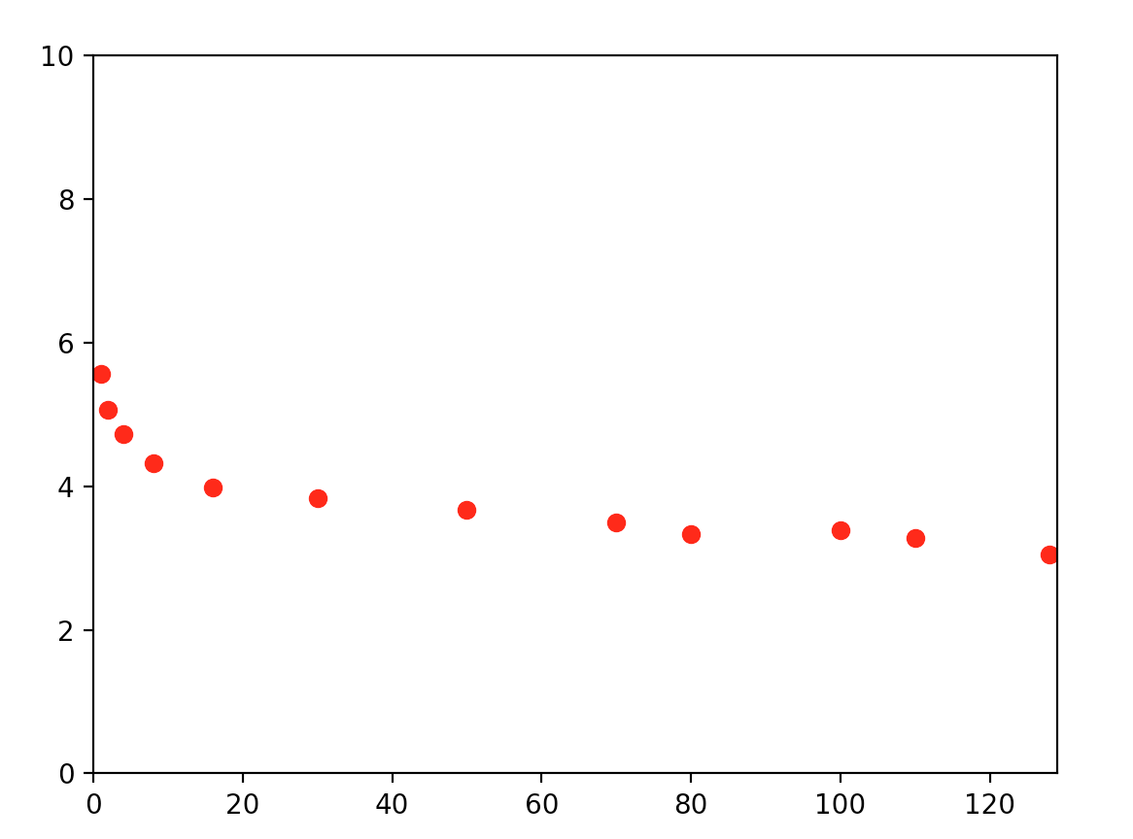
- Semi-Log Plot
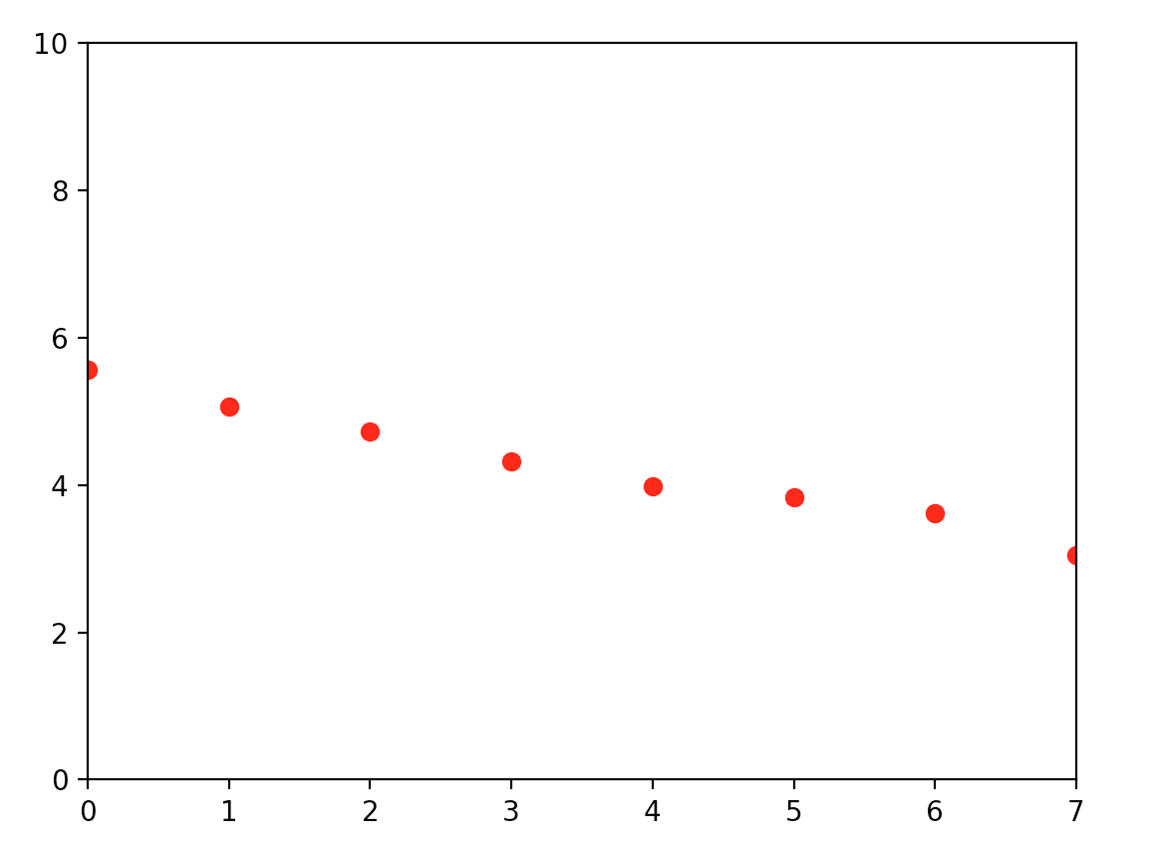
- Log-log plot
Output obtained is shown in Fig.18
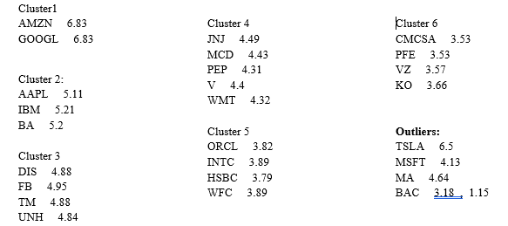
- Fractal Dimension

Recommendation Model
We have used collaborative item-based recommendation model.
The recommendation model involves the following steps:

- Assigning a weight to each Cluster based on duplicates and redundancy.
- Run Apriori algorithm where every single cluster of clustering is treated as a transaction with a weight equal to weight of the clustering.
- Obtain frequent itemsets with Support = sqrt(Total Stocks)
- Mine associations using Support and Confidence.
- Match associations with User input and output accordingly.

A weighted form of Apriori algorithm has been used where every transaction has a weight between 0 and 1 as opposed to the traditional Apriori where every transaction has weight 1. For example, the clusters obtained using KMeans, and KMeans++ are same whereas the output obtained using Fractal Dimensions is different hence they can be given 0.5, 0.5 and 1 weights respectively.

results

- Clusters Obtained
Multiple clusters have been obtained from a variety of clustering algorithms. The clusters have been shown above in Fig.6, Fig.7, Fig.10, Fig.15 and Fig.18.

- Inferred Association Rules
A small dataset of 27 stocks only involving multi- billion-dollar famous brands were used. Due to a small and specific dataset only, a few association rules could be mined. Here are a few association rules from our final result.
- GOOGL => AMZN
- AMZN => GOOGL
- APPL => INTC, J&J

evaluation

Evaluation can be done only on basis of user feedback hence is out of scope in this project. Some manual testing by considering few scenarios and the output obtained.
offline setting has been used for evaluation where recommendation approaches are compared without user interaction,
then reviewing user studies, where a small group of subject’s experiments with the system and
report on the experience, and finally describe large scale online experiments, where real user populations interact with the system.

conclusion

A small dataset of 27 stocks only involving multi-billion-dollar famous brands were used. Due to a small and specific dataset only, a few association rules could be mined. With a large and varied dataset this model can be scaled to provide a consistent recommendation system.

It was noted that Tesla was an outlier in most clusters and was not part of any subsequent item sets during the apriori process. Through this process it can be conjectured that this model can be used to detect anomalous stock entities such as Tesla in view of recent allegations.

future scope

- Extend the model to Options and Futures, thus broadening investment portfolio
- Explore other evaluation strategies
- Use Hadoop and CLARA(Clustering LARge Applications) to process a large number of stocks.

references

- “A stock market portfolio recommender system based on association rule mining”, Applied Soft Computing, Volume 13, Issue 2, February 2013, Pages 1055-1063,by PreetiParanjape-Vodite and UmeshDeshpande
- “An automated stock recommendation system from stock investment research using domain specific information extraction”,Tayida Tapjinda,Potsawee zechpanich, Nutchaya Leelasupakul,Nakornthip Prompoon,Chate Pata
- “A Discrete Stock Price Prediction Engine Based on Financial News”, Robert P. Schumaker and Hsinchun Chen
- “Stock Market Investment Advice: A Social Network Approach”,N. Koochakzadeh , K. Kianmehr ,A. Sarraf ,R. Alhajj ,
- “Neural Network Predictions of Stock Price Fluctuations” ,Gabriel Iuhasz, Monica Tirea and Viorel
- “Clustering in stock market based on fractal theory” ,Zeng Zhen, Peng Hong, Zeng Hiu
- “Clustering Stock Market Companies via K- Means algorithm” ,Mansoor Momeni, Maryam Mohseni, Mansour Soofi
- “Stock Price Prediction based on Stock Big Data and Pattern Graph Analysis”, Seungwoo Jeon1, Bonghee Hong1, Juhyeong Kim1 and Hyun-jik Lee2
- “Flock by Leader” - Abdelghani Bellaachia, Anasse Bari
- ”Fractional Differencing” JRM Hosking 1981
- ”Estimating the fractal dimension of the S&P 500 index using wavelet analysis”

