All outputs:

Elbow Method:

KMeans:

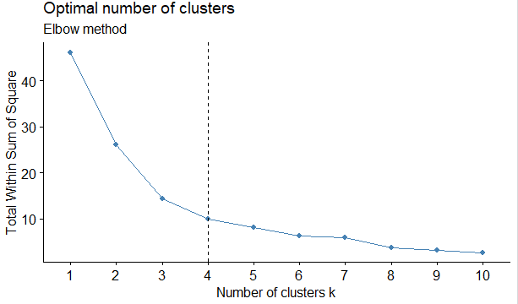

Hierarchical Clustering:

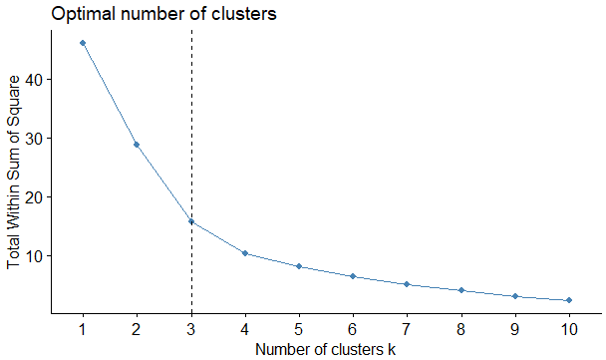

PAM Clustering

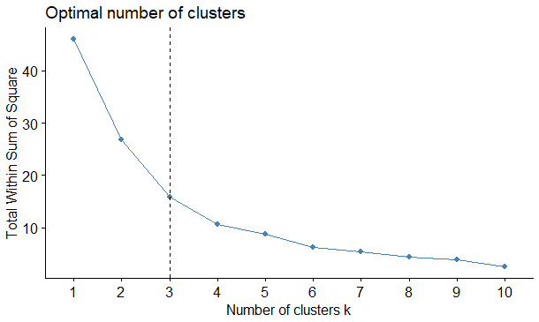

Average silhouette method

KMeans:

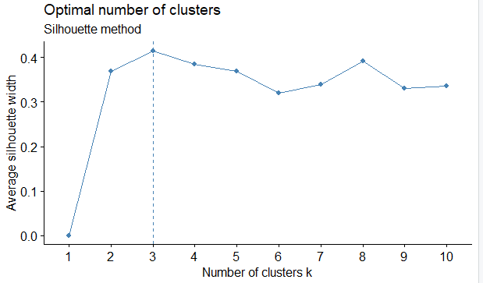

Hierarchical Clustering:

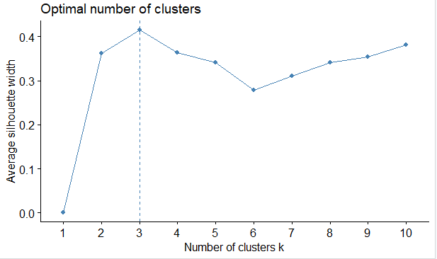

PAM Clustering

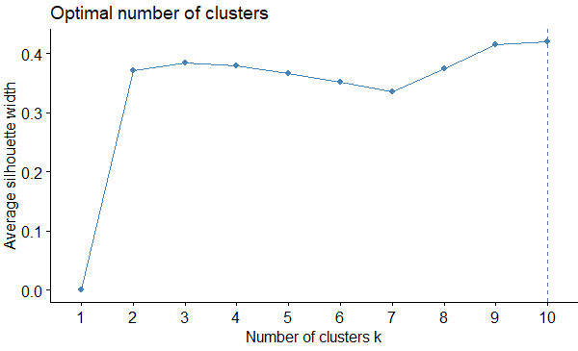

Gap statistics:

K-Means:

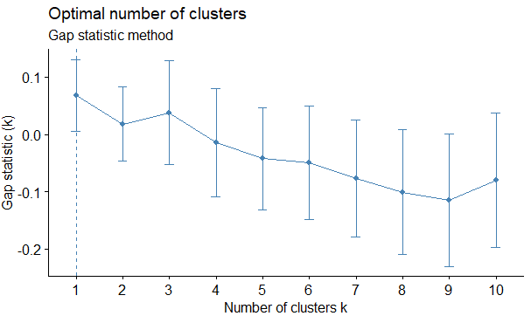

Hierarchical Clustering:

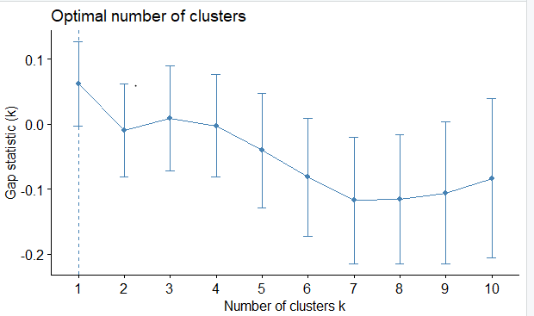

PAM Clustering:

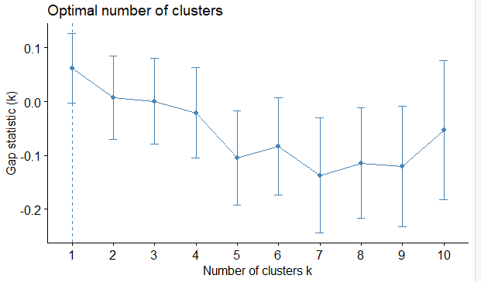

Nbcluster()

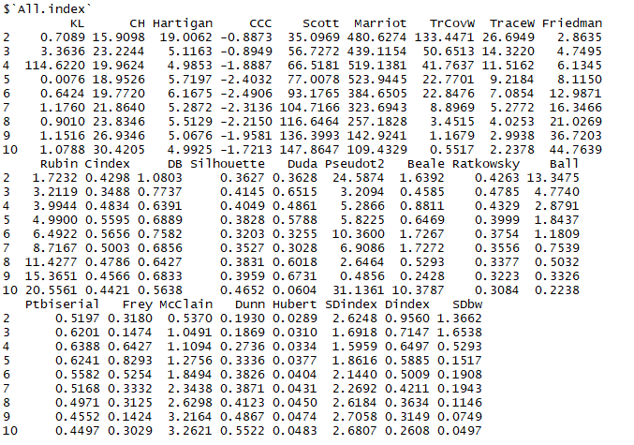

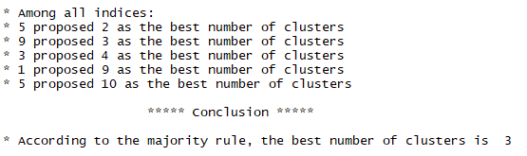

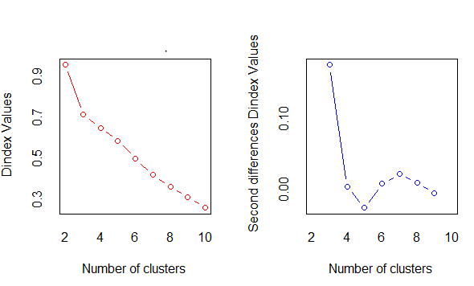

Dictionary of numbers to Labels

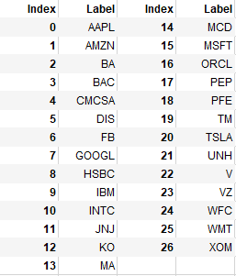

DIANA

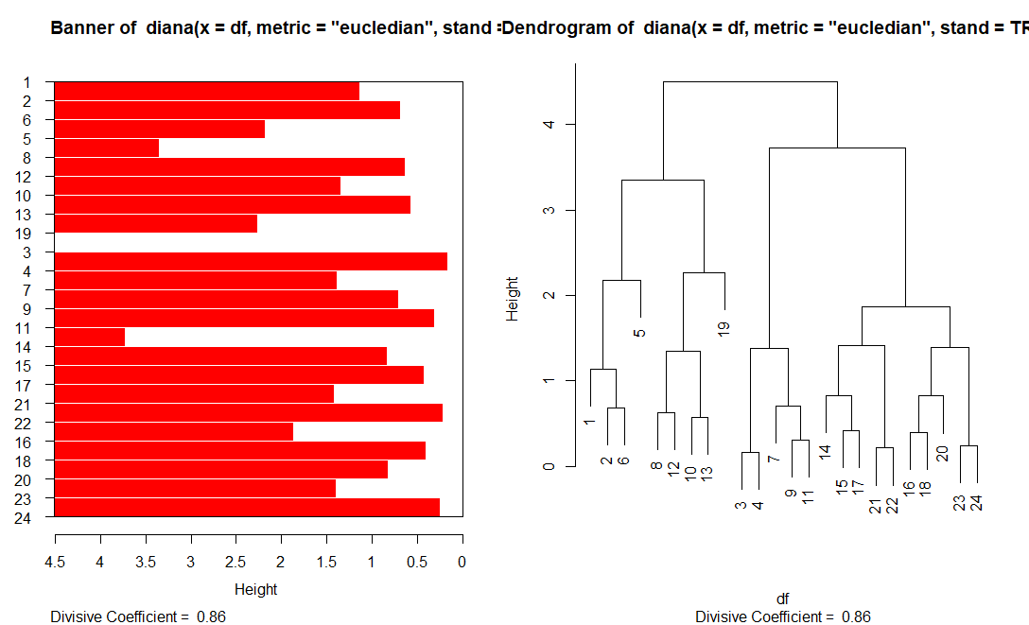

ANGES :

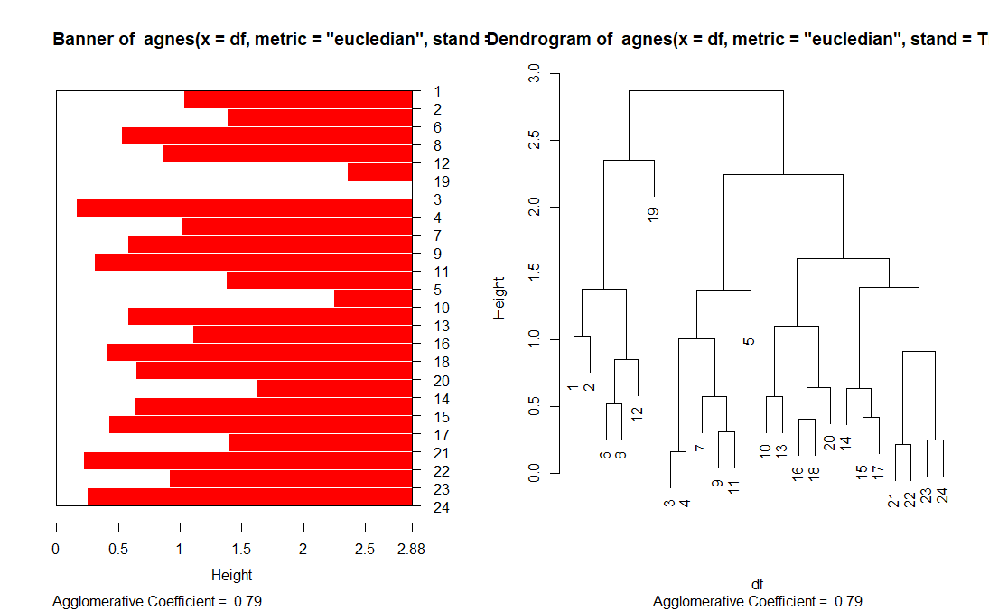

Correlation between stocks:

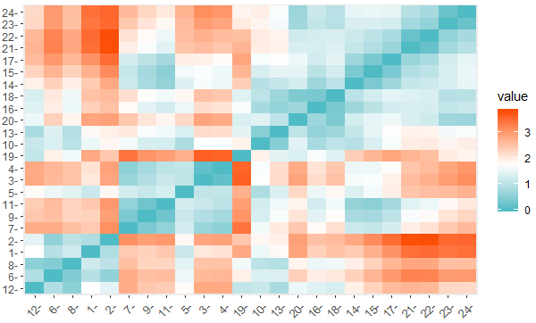

Clustering using Standard Deviation(Volatility):

K-Means/Hierarchical/KMeans++ Clustering:

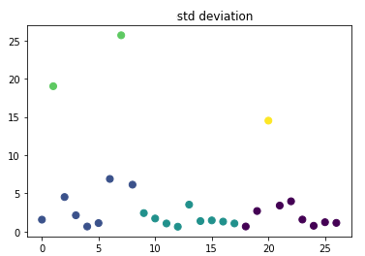

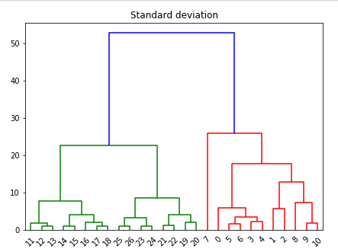

PAM Clustering:

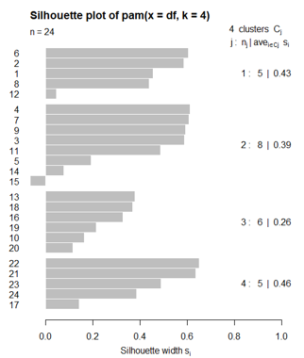

MeanShift Clustering

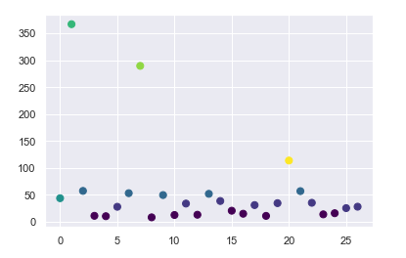

**Fractal Dimension Clustering**

Cluster1

AMZN 6.83

GOOGL 6.83

Cluster 2:

AAPL 5.11

IBM 5.21

BA 5.2

Cluster 3

DIS 4.88

FB 4.95

TM 4.88

UNH 4.84

Cluster 4

JNJ 4.49

MCD 4.43

PEP 4.31

V 4.4

WMT 4.32

Cluster 5

ORCL 3.82

INTC 3.89

HSBC 3.79

WFC 3.89

Cluster 6

CMCSA 3.53

PFE 3.53

VZ 3.57

KO 3.66

**Outliers:**

TSLA 6.5

MSFT 4.13

MA 4.64

BAC 3.18 , 1.15

**Swarm Clustering**

**Sample Swarm After clustering with specific attribute values.**

