**MONGO DB**

**QUESTION 1:**

Find all the information about each products

**ASNWER:**

db.product.find({}).pretty()

**OUTPUT:**

{

"_id" : ObjectId("61d45e8036b42e38f94192e7"),

"id" : "1",

"product_name" : "Intelligent Fresh Chips",

"product_price" : 655,

"product_material" : "Concrete",

"product_color" : "mint green"

}

{

"_id" : ObjectId("61d45e8036b42e38f94192e8"),

"id" : "2",

"product_name" : "Practical Fresh Sausages",

"product_price" : 911,

"product_material" : "Cotton",

"product_color" : "indigo"

}

{

"_id" : ObjectId("61d45e8036b42e38f94192e9"),

"id" : "3",

"product_name" : "Refined Steel Car",

"product_price" : 690,

"product_material" : "Rubber",

"product_color" : "gold"

}

{

"_id" : ObjectId("61d45e8036b42e38f94192ea"),

"id" : "4",

"product_name" : "Gorgeous Plastic Pants",

"product_price" : 492,

"product_material" : "Soft",

"product_color" : "plum"

}

{

"_id" : ObjectId("61d45e8036b42e38f94192eb"),

"id" : "5",

"product_name" : "Sleek Cotton Chair",

"product_price" : 33,

"product_material" : "Fresh",

"product_color" : "black"

}

{

"_id" : ObjectId("61d45e8036b42e38f94192ec"),

"id" : "6",

"product_name" : "Awesome Wooden Towels",

"product_price" : 474,

"product_material" : "Plastic",

"product_color" : "orange"

}

{

"_id" : ObjectId("61d45e8036b42e38f94192ed"),

"id" : "7",

"product_name" : "Practical Soft Shoes",

"product_price" : 500,

"product_material" : "Rubber",

"product_color" : "pink"

}

{

"_id" : ObjectId("61d45e8036b42e38f94192ee"),

"id" : "8",

"product_name" : "Incredible Steel Hat",

"product_price" : 78,

"product_material" : "Rubber",

"product_color" : "violet"

}

{

"_id" : ObjectId("61d45e8036b42e38f94192ef"),

"id" : "9",

"product_name" : "Awesome Wooden Ball",

"product_price" : 28,

"product_material" : "Soft",

"product_color" : "azure"

}

{

"_id" : ObjectId("61d45e8036b42e38f94192f0"),

"id" : "10",

"product_name" : "Generic Wooden Pizza",

"product_price" : 84,

"product_material" : "Frozen",

"product_color" : "indigo"

}

{

"_id" : ObjectId("61d45e8036b42e38f94192f1"),

"id" : "11",

"product_name" : "Unbranded Wooden Cheese",

"product_price" : 26,

"product_material" : "Soft",

"product_color" : "black"

}

{

"_id" : ObjectId("61d45e8036b42e38f94192f2"),

"id" : "12",

"product_name" : "Unbranded Plastic Salad",

"product_price" : 89,

"product_material" : "Wooden",

"product_color" : "pink"

}

{

"_id" : ObjectId("61d45e8036b42e38f94192f3"),

"id" : "13",

"product_name" : "Gorgeous Cotton Keyboard",

"product_price" : 37,

"product_material" : "Concrete",

"product_color" : "sky blue"

}

{

"_id" : ObjectId("61d45e8036b42e38f94192f4"),

"id" : "14",

"product_name" : "Incredible Steel Shirt",

"product_price" : 54,

"product_material" : "Metal",

"product_color" : "white"

}

{

"_id" : ObjectId("61d45e8036b42e38f94192f5"),

"id" : "15",

"product_name" : "Ergonomic Cotton Hat",

"product_price" : 43,

"product_material" : "Rubber",

"product_color" : "mint green"

}

{

"_id" : ObjectId("61d45e8036b42e38f94192f6"),

"id" : "16",

"product_name" : "Small Soft Chair",

"product_price" : 47,

"product_material" : "Cotton",

"product_color" : "teal"

}

{

"_id" : ObjectId("61d45e8036b42e38f94192f7"),

"id" : "17",

"product_name" : "Incredible Metal Car",

"product_price" : 36,

"product_material" : "Fresh",

"product_color" : "indigo"

}

{

"_id" : ObjectId("61d45e8036b42e38f94192f8"),

"id" : "18",

"product_name" : "Licensed Plastic Bacon",

"product_price" : 88,

"product_material" : "Steel",

"product_color" : "yellow"

}

{

"_id" : ObjectId("61d45e8036b42e38f94192f9"),

"id" : "19",

"product_name" : "Intelligent Cotton Chips",

"product_price" : 46,

"product_material" : "Soft",

"product_color" : "azure"

}

{

"_id" : ObjectId("61d45e8036b42e38f94192fa"),

"id" : "20",

"product_name" : "Handcrafted Wooden Bacon",

"product_price" : 36,

"product_material" : "Concrete",

"product_color" : "lime"

}

Type "it" for more

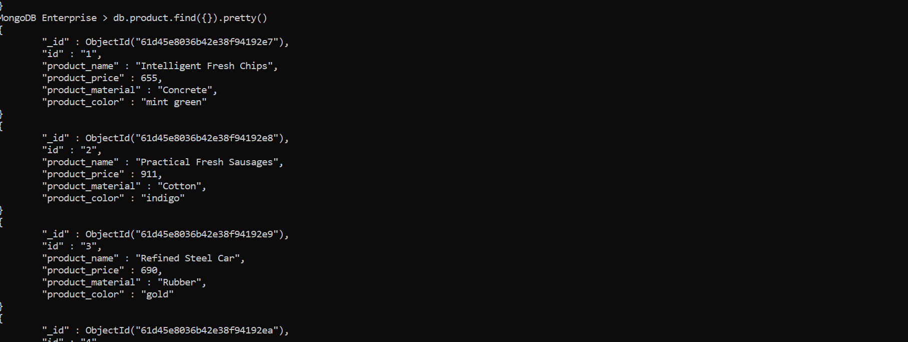

**QUESTION 2:**

Find the product price which are between 400 to 800

**ASNWER:**

**db.product.find({**

"$and": [

{

"product_price": {

"$gte": 400

}

},

{

"product_price": {

"$lte": 800

}

}

]

})

**OUTPUT:**

{

"_id": ObjectId("5a934e000102030405000000"),

"id": "1",

"product_color": "mint green",

"product_material": "Concrete",

"product_name": "Intelligent Fresh Chips",

"product_price": 655

},

{

"_id": ObjectId("5a934e000102030405000002"),

"id": "3",

"product_color": "gold",

"product_material": "Rubber",

"product_name": "Refined Steel Car",

"product_price": 690

},

{

"_id": ObjectId("5a934e000102030405000003"),

"id": "4",

"product_color": "plum",

"product_material": "Soft",

"product_name": "Gorgeous Plastic Pants",

"product_price": 492

},

{

"_id": ObjectId("5a934e000102030405000005"),

"id": "6",

"product_color": "orange",

"product_material": "Plastic",

"product_name": "Awesome Wooden Towels",

"product_price": 474

},

{

"_id": ObjectId("5a934e000102030405000006"),

"id": "7",

"product_color": "pink",

"product_material": "Rubber",

"product_name": "Practical Soft Shoes",

"product_price": 500

}

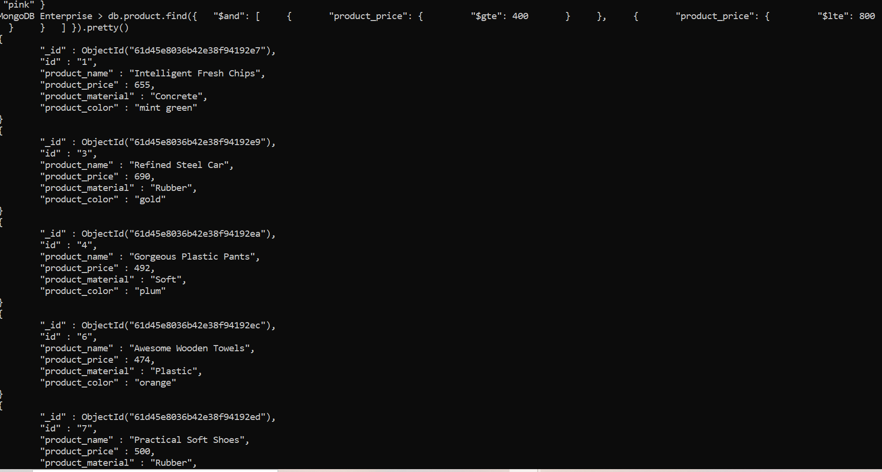

**QUESTION 3:**

Find the product price which are not between 400 to 600

**ASNWER:**

db.product.find({

"$or": [

{

"product_price": {

"$lte": 400

}

},

{

"product_price": {

"$gte": 800

}

}

]

})

**OUTPUT:**

{

"_id" : ObjectId("61d45e8036b42e38f94192e8"),

"id" : "2",

"product_name" : "Practical Fresh Sausages",

"product_price" : 911,

"product_material" : "Cotton",

"product_color" : "indigo"

}

{

"_id" : ObjectId("61d45e8036b42e38f94192eb"),

"id" : "5",

"product_name" : "Sleek Cotton Chair",

"product_price" : 33,

"product_material" : "Fresh",

"product_color" : "black"

}

{

"_id" : ObjectId("61d45e8036b42e38f94192ee"),

"id" : "8",

"product_name" : "Incredible Steel Hat",

"product_price" : 78,

"product_material" : "Rubber",

"product_color" : "violet"

}

{

"_id" : ObjectId("61d45e8036b42e38f94192ef"),

"id" : "9",

"product_name" : "Awesome Wooden Ball",

"product_price" : 28,

"product_material" : "Soft",

"product_color" : "azure"

}

{

"_id" : ObjectId("61d45e8036b42e38f94192f0"),

"id" : "10",

"product_name" : "Generic Wooden Pizza",

"product_price" : 84,

"product_material" : "Frozen",

"product_color" : "indigo"

}

{

"_id" : ObjectId("61d45e8036b42e38f94192f1"),

"id" : "11",

"product_name" : "Unbranded Wooden Cheese",

"product_price" : 26,

"product_material" : "Soft",

"product_color" : "black"

}

{

"_id" : ObjectId("61d45e8036b42e38f94192f2"),

"id" : "12",

"product_name" : "Unbranded Plastic Salad",

"product_price" : 89,

"product_material" : "Wooden",

"product_color" : "pink"

}

{

"_id" : ObjectId("61d45e8036b42e38f94192f3"),

"id" : "13",

"product_name" : "Gorgeous Cotton Keyboard",

"product_price" : 37,

"product_material" : "Concrete",

"product_color" : "sky blue"

}

{

"_id" : ObjectId("61d45e8036b42e38f94192f4"),

"id" : "14",

"product_name" : "Incredible Steel Shirt",

"product_price" : 54,

"product_material" : "Metal",

"product_color" : "white"

}

{

"_id" : ObjectId("61d45e8036b42e38f94192f5"),

"id" : "15",

"product_name" : "Ergonomic Cotton Hat",

"product_price" : 43,

"product_material" : "Rubber",

"product_color" : "mint green"

}

{

"_id" : ObjectId("61d45e8036b42e38f94192f6"),

"id" : "16",

"product_name" : "Small Soft Chair",

"product_price" : 47,

"product_material" : "Cotton",

"product_color" : "teal"

}

{

"_id" : ObjectId("61d45e8036b42e38f94192f7"),

"id" : "17",

"product_name" : "Incredible Metal Car",

"product_price" : 36,

"product_material" : "Fresh",

"product_color" : "indigo"

}

{

"_id" : ObjectId("61d45e8036b42e38f94192f8"),

"id" : "18",

"product_name" : "Licensed Plastic Bacon",

"product_price" : 88,

"product_material" : "Steel",

"product_color" : "yellow"

}

{

"_id" : ObjectId("61d45e8036b42e38f94192f9"),

"id" : "19",

"product_name" : "Intelligent Cotton Chips",

"product_price" : 46,

"product_material" : "Soft",

"product_color" : "azure"

}

{

"_id" : ObjectId("61d45e8036b42e38f94192fa"),

"id" : "20",

"product_name" : "Handcrafted Wooden Bacon",

"product_price" : 36,

"product_material" : "Concrete",

"product_color" : "lime"

}

{

"_id" : ObjectId("61d45e8036b42e38f94192fb"),

"id" : "21",

"product_name" : "Unbranded Granite Chicken",

"product_price" : 90,

"product_material" : "Metal",

"product_color" : "gold"

}

{

"_id" : ObjectId("61d45e8036b42e38f94192fc"),

"id" : "22",

"product_name" : "Ergonomic Soft Hat",

"product_price" : 99,

"product_material" : "Rubber",

"product_color" : "black"

}

{

"_id" : ObjectId("61d45e8036b42e38f94192fd"),

"id" : "23",

"product_name" : "Intelligent Steel Pizza",

"product_price" : 95,

"product_material" : "Cotton",

"product_color" : "azure"

}

{

"_id" : ObjectId("61d45e8036b42e38f94192fe"),

"id" : "24",

"product_name" : "Tasty Rubber Cheese",

"product_price" : 47,

"product_material" : "Frozen",

"product_color" : "orchid"

}

{

"_id" : ObjectId("61d45e8036b42e38f94192ff"),

"id" : "25",

"product_name" : "Licensed Steel Car",

"product_price" : 20,

"product_material" : "Cotton",

"product_color" : "indigo"

}

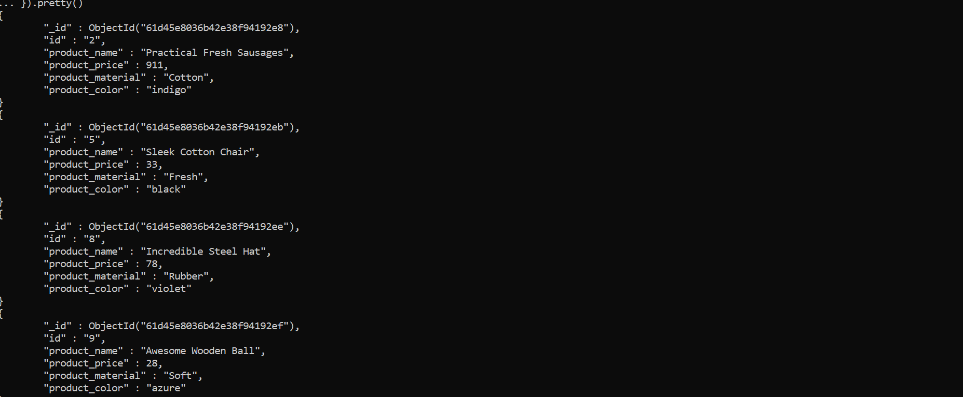

**QUESTION 4:**

List the product which are grater than 500 in price

**ASNWER:**

db.product.find({

"product_price": {

"$gt": 500

}

})

**OUTPUT:**

{

"_id" : ObjectId("61d45e8036b42e38f94192e7"),

"id" : "1",

"product_name" : "Intelligent Fresh Chips",

"product_price" : 655,

"product_material" : "Concrete",

"product_color" : "mint green"

}

{

"_id" : ObjectId("61d45e8036b42e38f94192e8"),

"id" : "2",

"product_name" : "Practical Fresh Sausages",

"product_price" : 911,

"product_material" : "Cotton",

"product_color" : "indigo"

}

{

"_id" : ObjectId("61d45e8036b42e38f94192e9"),

"id" : "3",

"product_name" : "Refined Steel Car",

"product_price" : 690,

"product_material" : "Rubber",

"product_color" : "gold"

}

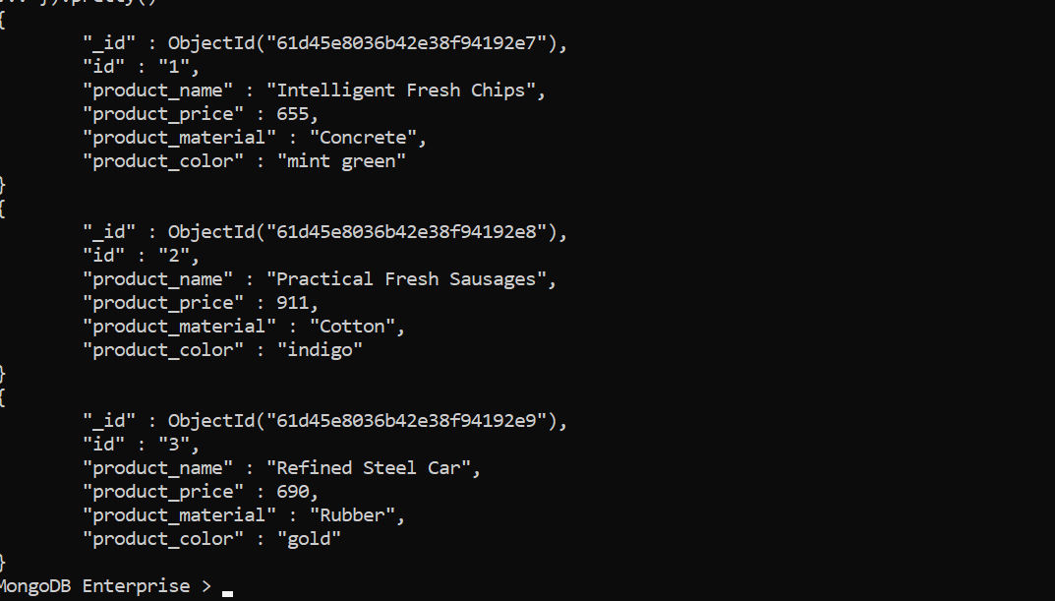

**QUESTION 5:**

Find the product name and product material of each products

**ASNWER:**

db.product.find({},

{

_id: 0,

id: 0,

product_price: 0,

product_color: 0

})

**OUTPUT:**

{ "product_name" : "Refined Steel Car", "product_material" : "Rubber" }

{ "product_name" : "Gorgeous Plastic Pants", "product_material" : "Soft" }

{ "product_name" : "Sleek Cotton Chair", "product_material" : "Fresh" }

{ "product_name" : "Awesome Wooden Towels", "product_material" : "Plastic" }

{ "product_name" : "Practical Soft Shoes", "product_material" : "Rubber" }

{ "product_name" : "Incredible Steel Hat", "product_material" : "Rubber" }

{ "product_name" : "Awesome Wooden Ball", "product_material" : "Soft" }

{ "product_name" : "Generic Wooden Pizza", "product_material" : "Frozen" }

{ "product_name" : "Unbranded Wooden Cheese", "product_material" : "Soft" }

{ "product_name" : "Unbranded Plastic Salad", "product_material" : "Wooden" }

{

"product_name" : "Gorgeous Cotton Keyboard",

"product_material" : "Concrete"

}

{ "product_name" : "Incredible Steel Shirt", "product_material" : "Metal" }

{ "product_name" : "Ergonomic Cotton Hat", "product_material" : "Rubber" }

{ "product_name" : "Small Soft Chair", "product_material" : "Cotton" }

{ "product_name" : "Incredible Metal Car", "product_material" : "Fresh" }

{ "product_name" : "Licensed Plastic Bacon", "product_material" : "Steel" }

{ "product_name" : "Intelligent Cotton Chips", "product_material" : "Soft" }

{

"product_name" : "Handcrafted Wooden Bacon",

"product_material" : "Concrete"

}

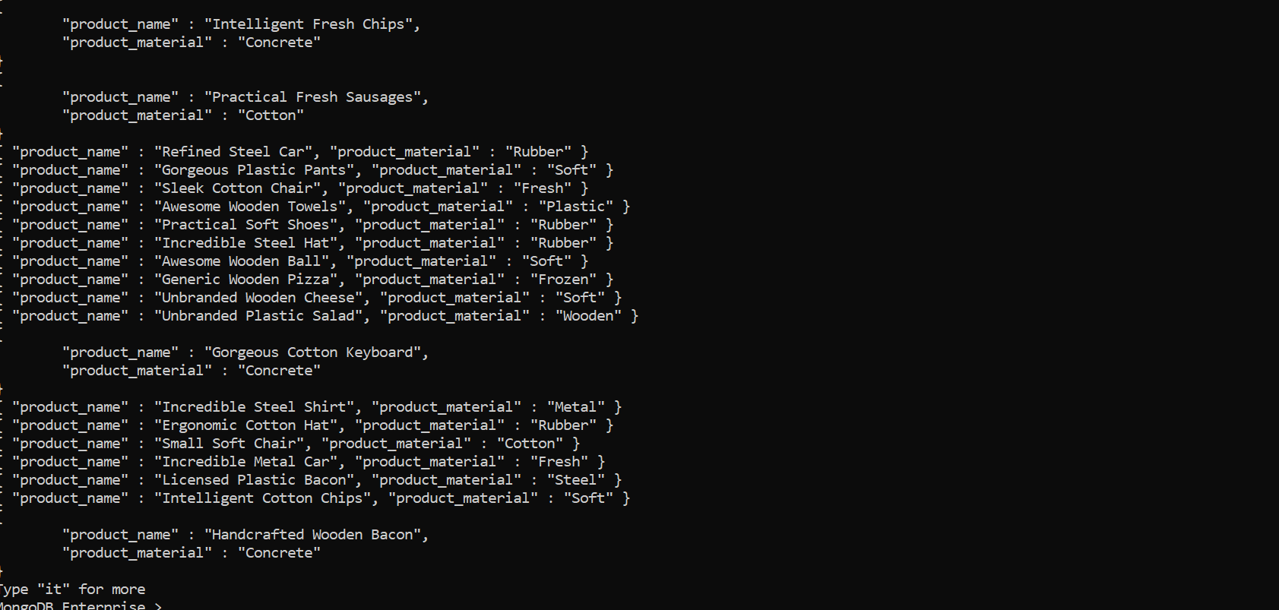

**QUESTION 6:**

Find the product with a row id of 10

**ASNWER:**

db.product.find({

id: "10"

})

**OUTPUT:**

{

"_id" : ObjectId("61d45e8036b42e38f94192f0"),

"id" : "10",

"product_name" : "Generic Wooden Pizza",

"product_price" : 84,

"product_material" : "Frozen",

"product_color" : "indigo"

}

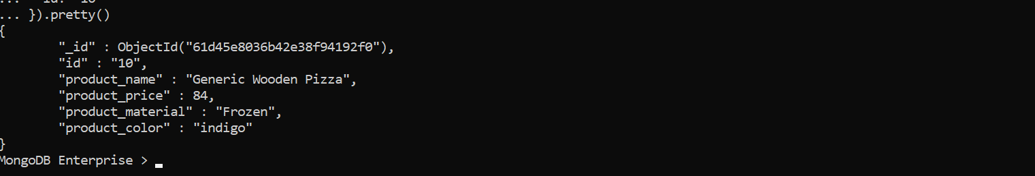

**QUESTION 7:**

Find only the product name and product material

**ASNWER:**

**SIMILAR TO QUESTION 5**

db.product.find({},

{

_id: 0,

id: 0,

product_price: 0,

product_color: 0

})

**QUESTION 8:**

Find all products which contain the value of soft in product material

**ASNWER:**

db.product.find({"product_material":"Soft"})

**OUTPUT:**

{

"_id" : ObjectId("61d45e8036b42e38f94192ea"),

"id" : "4",

"product_name" : "Gorgeous Plastic Pants",

"product_price" : 492,

"product_material" : "Soft",

"product_color" : "plum"

}

{

"_id" : ObjectId("61d45e8036b42e38f94192ef"),

"id" : "9",

"product_name" : "Awesome Wooden Ball",

"product_price" : 28,

"product_material" : "Soft",

"product_color" : "azure"

}

{

"_id" : ObjectId("61d45e8036b42e38f94192f1"),

"id" : "11",

"product_name" : "Unbranded Wooden Cheese",

"product_price" : 26,

"product_material" : "Soft",

"product_color" : "black"

}

{

"_id" : ObjectId("61d45e8036b42e38f94192f9"),

"id" : "19",

"product_name" : "Intelligent Cotton Chips",

"product_price" : 46,

"product_material" : "Soft",

"product_color" : "azure"

}

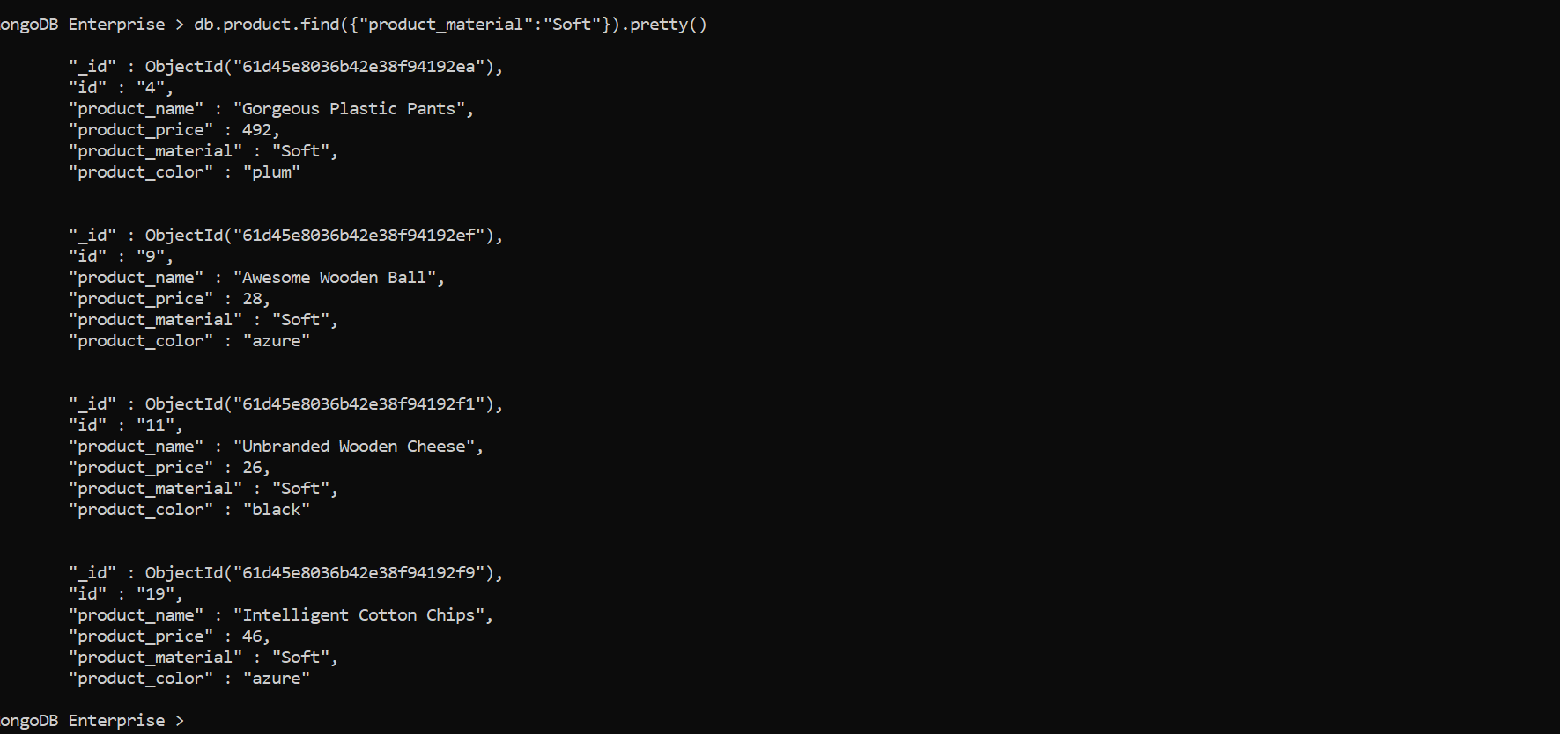

**QUESTION 9:**

Find products which contain product color indigo and product price 492.00

**ASNWER:**

db.product.find({"product_color":"indigo","product_price":492})

**OUTPUT:**

**No document found.**

With colour indigo the prices are 911, 84, 36, 20. No product with price 491

**QUESTION 10:**

Delete the products which product price value are same

**ASNWER:**

**db.product.aggregate([**

**{**

**$sortByCount: "$product_price"**

**}**

**]).pretty()**

**Get the count of prices like below output**

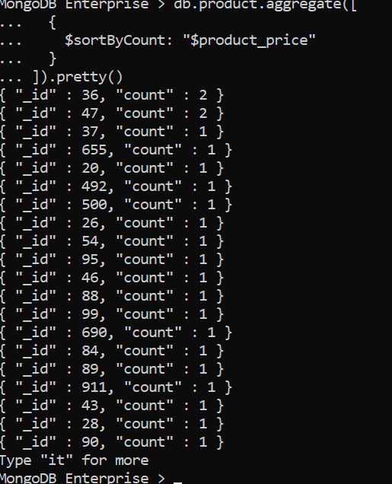we can see 36, 47 are repeating so we can delete it

**db.product.deleteMany({"product_price":36})**

**db.product.deleteMany({"product_price":47})**

**OUTPUT:**

