**QUESTION:**

|  |
| --- |
| Design database for Zen class programme |
|  | users |
|  | codekata |
|  | attendance |
|  | topics |
|  | tasks |
|  | company_drives |
|  | mentors |

**ANSWER:**

db.users.insertMany(

[

{

"name":"Ashish",

"email":"ashish@gmail.com",

"password":"asish",

"phone":"9898983989"

} ,

{

"name":"Reema",

"email":"reema@yahoo.com",

"password":"reema",

"phone":"883838393"

} ,

{

"name":"Chris",

"email":"chris@gmail..com",

"password":"chris",

"phone":"92353537773"

} ,

]

)

**----------------------**

db.codekata.insertMany(

[

{

"topic":"HTML",

"total":50,

"solved":[{"user":"Reema",problems:2},{"user":"Chris",problems:16}]

} ,

{

"topic":"CSS",

"total":50,

"solved":[{"user":"Chris",problems:7}]

} ,

{

"topic":"JS",

"total":150,

"solved":[{"user":"Ashish",problems:72},{"user":"Reema",problems:54},{"user":"Chris",problems:22}]

}

]

)

**----------------------**

db.attendance.insertMany(

[

{

"date":new Date("2020-09-03"),

"batch":"b1",

"persent":[{"name":"Ashish","status":1},{"name":"Reema","status":1}],

"absent":[{"name":"Chris","status":1}]

},

{

"date":new Date("2020-09-21"),

"batch":"b1",

"persent":[{"name":"Ashish","status":1},{"name":"Reema","status":1},{"name":"Chris","status":1}],

"absent":[]

},

{

"date":new Date("2020-10-05"),

"batch":"b1",

"persent":[{"name":"Ashish","status":1},{"name":"Chris","status":1}],

"absent":[{"name":"Reema","status":1}]

},

{

"date":new Date("2020-10-16"),

"batch":"b1",

"persent":[{"name":"Chris","status":1}],

"absent":[{"name":"Ashish","status":1},{"name":"Reema","status":1}]

},

{

"date":new Date("2020-10-30"),

"batch":"b1",

"persent":[{"name":"Ashish","status":1},{"name":"Reema","status":1},{"name":"Chris","status":1}],

"absent":[]

},

]

)

**----------------------**

db.topics.insertMany(

[

{

"topic":"topic1",

"date":new Date("2020-09-03")

},

{

"topic":"topic2",

"date":new Date("2020-09-21")

},

{

"topic":"topic3",

"date":new Date("2020-10-05")

},

{

"topic":"topic4",

"date":new Date("2020-10-16")

},

{

"topic":"topic5",

"date":new Date("2020-10-30")

},

]

)

**----------------------**

db.tasks.insertMany(

[

{

"task":"topic2",

"date":new Date("2020-09-21"),

"submitted":[{"name":"Ashish","status":1},{"name":"Reema","status":1},{"name":"Chris","status":1}],

"missed":[]

} ,

{

"task":"topic3",

"date":new Date("2020-10-05"),

"submitted":[{"name":"Reema","status":1},{"name":"Chris","status":1}],

"missed":[{"name":"Ashish","status":1}]

} ,

{

"task":"topic5",

"date":new Date("2020-10-30"),

"submitted":[{"name":"Chris","status":1}],

"missed":[{"name":"Ashish","status":1},{"name":"Reema","status":1}]

}

]

)

**----------------------**

db.company_drives.insertMany(

[

{

"name":"CompanyA",

"date":new Date("2020-09-27"),

"attended":[{"student":"Ashish"}]

} ,

{

"name":"CompanyB",

"date":new Date("2020-10-17"),

"attended":[{"student":"Ashish"},{"student":"Reema"},{"student":"Chris"}]

} ,

{

"name":"CompanyC",

"date":new Date("2020-10-31"),

"attended":[{"student":"Chris"},{"student":"Reema"}]

} ,

]

)

**----------------------**

db.mentors.insertMany(

[

{

"mentor":"Mentor1",

"students":20

} ,

{

"mentor":"Mentor2",

"students":12

} ,

{

"mentor":"Mentor3",

"students":25

}

]

)

**----------------------**

**QUESTION:**

Find all the topics and tasks which are thought in the month of October **ANSWER:**

db.tasks.find({

"$and": [

{

"date": {

"$gte": new Date("2020-10-01")

}

},

{

"date": {

"$lte": new Date("2020-10-31")

}

}

]

})

---

db.topics.find({

"$and": [

{

"date": {

"$gte": new Date("2020-10-01")

}

},

{

"date": {

"$lte": new Date("2020-10-31")

}

}

]

}) **OUTPUT:**

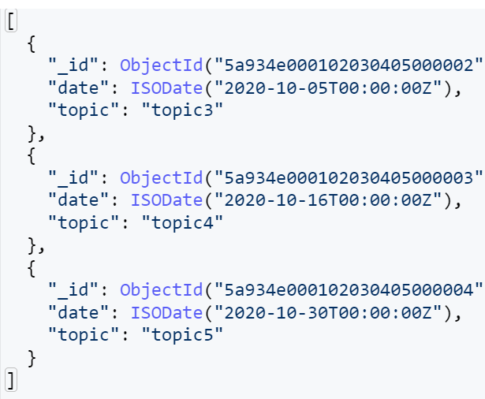

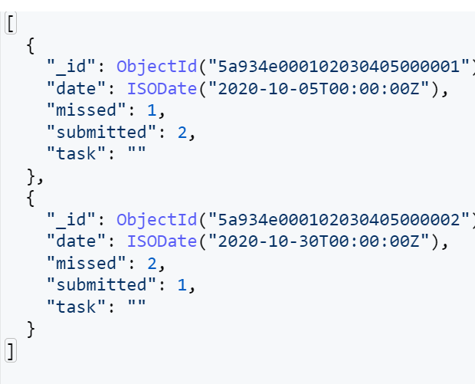

**QUESTION:**

Find all the company drives which appeared between 15 oct-2020 and 31-oct-2020 **ANSWER:**

db.company_drives.find({

"$and": [

{

"date": {

"$gte": new Date("2020-10-15")

}

},

{

"date": {

"$lte": new Date("2020-10-31")

}

}

]

},

{

"name": 1

})  
 **OUTPUT:**

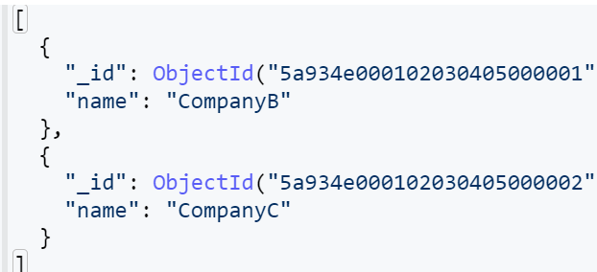

**QUESTION:**

Find all the company drives and students who are appeared for the placement. **ANSWER:**

db.company_drives.find({}) **OUTPUT:**

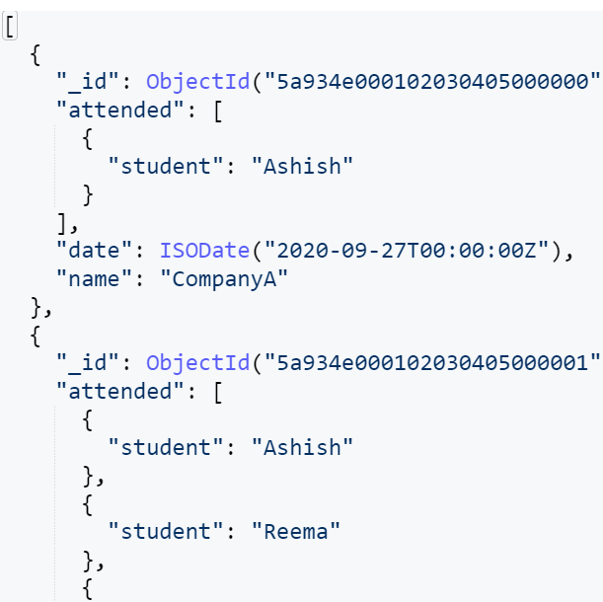

**QUESTION:**

Find the number of problems solved by the user in codekata **ANSWER:**

db.codekata.aggregate([

{

"$unwind": "$solved"

},

{

"$group": {

"_id": "$solved.user",

"total_codekata_problems_solved": {

"$sum": "$solved.problems"

}

}

}

])  
  
**OUTPUT:**

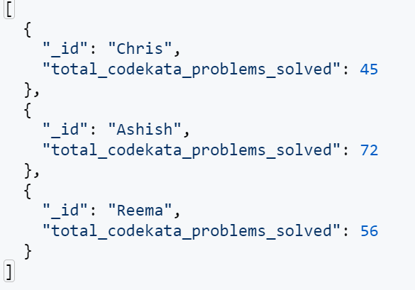

**QUESTION:**

Find all the mentors with who has the mentee's count more than 15 **ANSWER:**

db.mentors.find({

"students": {

"$gt": 15

}

}) **OUTPUT:**

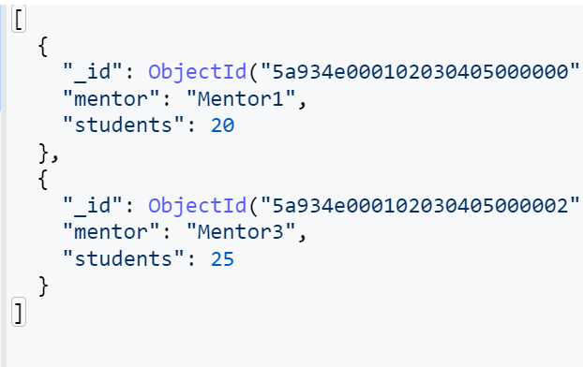

**QUESTION:**

Find the number of users who are absent and task is not submitted between 15 oct-2020 and 31-oct-2020 **ANSWER:**

db.tasks.aggregate([

{

"$match": {

"$and": [

{

"date": {

"$gte": new Date("2020-10-15")

}

},

{

"date": {

"$lte": new Date("2020-10-31")

}

}

]

}

},

{

"$unwind": "$missed"

},

{

"$group": {

"_id": "$date",

"field": {

"$sum": "$missed.status"

}

}

},

])

db.attendance.aggregate([

{

"$match": {

"$and": [

{

"date": {

"$gte": new Date("2020-10-15")

}

},

{

"date": {

"$lte": new Date("2020-10-31")

}

}

]

}

},

{

"$unwind": "$absent"

},

{

"$group": {

"_id": "$date",

"field": {

"$sum": "$absent.status"

}

}

},

])

**OUTPUT:**

